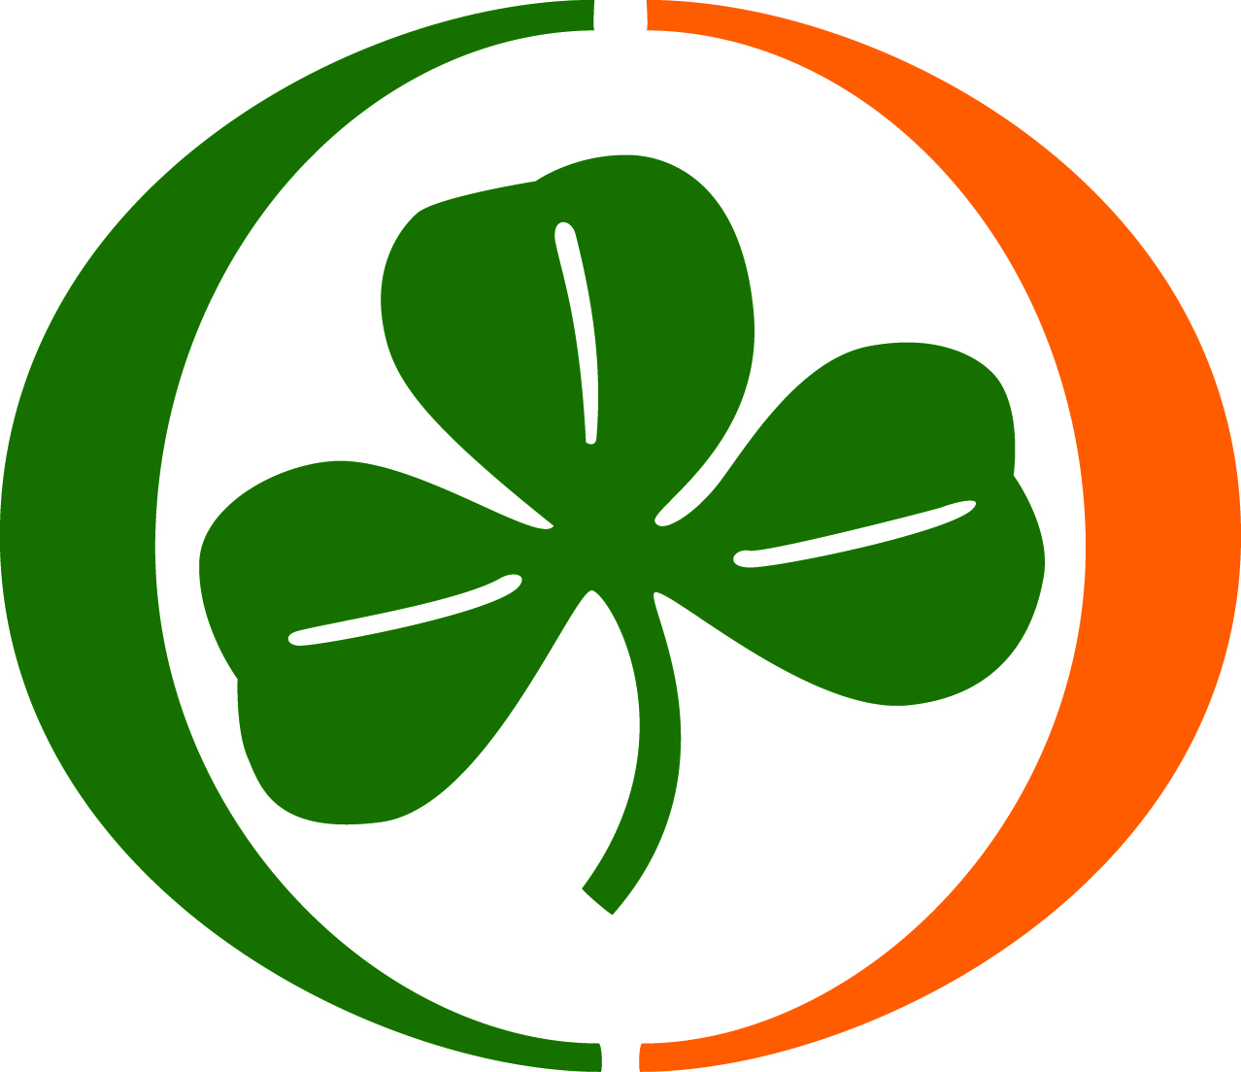
2023-2024
EAU CLAIRE HIGH SCHOOL
VARSITY WRESTLING SCHEDULE

DATE | OPPONENT | TIME | SITE
December 5, 2023 | Spring Valley/Ridge View | 5:30 | Spring Valley
December 7, 2023 | Lower Richland | 5:30 | Eau Claire
December 13, 2023 | Westwood | 5:30 | Eau Claire
December 14, 2023 | Whitmire/Abbeville | 5:30 | Whitmire
January 9, 2024 | Whitmire/CA Johnson | 5:30 | Whitmire
January 17, 2024 | Westwood | 5:30 | Westwood
January 20, 2024 | Edisto | 5:30 | Edisto
January 22, 2024 | Region IV Meet | 5:30 | TBD
January 24, 2024 | Wagner-Sally | 5:30 | Eau Claire
February 16-17, 2024 | Individual State | TBD | Greenville
February 23-24, 2024 | State Championship | TBD | Greenville
Principal: Ekemam Montgomery www.eauclaireathletics.org
Head Coach: Eugene Jacobs
Athletic Director: Jamil Canada

