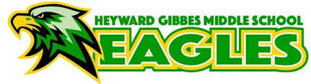
Club | Staff Club Assigned
ANIME | Mrs. Coleman
ARTS & CRAFTS | Ravel/Green
BEATS | Frierson
CHECKERS | Sims/Henderson
COLORING 1 | Sweeney/Ekeh
COLORING 2 | Jaggi/Campbell
CULTURAL DIVERSITY | Marshall
DACE (Decorating & Catering) | Albert-Hampton
DEBATE | Barton/Rogers
FUTURE BUSINESS LEADERS OF AMERICA | Seymore/Lewis
GARDENING & BEAUTIFICATION | Burton-Scott/Johnson/Palmer-Williams
HOT TOPICS | Andrews/Mastrovito
MODEL MAKING | Branic
PROJECT LIT & DESIGN | Moses
SOAP/CANDLE MAKING | Segars/Loncon
Social Media Club | Anouro/Singleton
SPORTS | Chisholm/Pickett
STUDENT ATHLETES | Bethea/Anthony/Scott
TECHNOLOGY | Williams-Perry

