Click in this column to take you to the website | Description
 | The SAG-AFTRA Foundation’s award-winning children’s literacy website, Storyline Online, streams videos featuring celebrated actors reading children’s books alongside creatively produced illustrations. Readers include Viola Davis, Chris Pine, Lily Tomlin, Kevin Costner, Annette Bening, James Earl Jones, Betty White and dozens more.
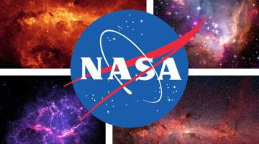 | No matter if you enjoy taking or just watching images of space, NASA has a treat for you. They have made their entire collection of images, sounds, and video available and publicly searchable online. It’s 140,000 photos and other resources available for you to see, or even download and use it any way you like.
 | The Character Tree is an educational video subscription series for K - 2. Every episode, hosted by a real 1st-grade teacher, discusses an important positive character trait exemplified by prominent figures like Kindness & Mister Fred Rogers or Perseverance & Dr. Martin Luther King Jr.
 | Google Earth for Virtual Tours of National Parks across the United States and the Virgin Islands..
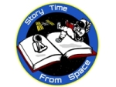 | “Storytime from Space!” Astronauts Reading from Space.
New England Aquarium | Virtual Aquarium Tour of Boston’s New England Aquarium
 | Museum Exhibits to Visit from Your Couch
 | Broadway Plays & Musicals You Can Watch on Stage from Home
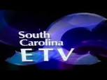 | South Carolina ETV and the S. C. Department of Education have partnered to use the power of television to broadcast streamlined, curriculum-based programming for the state's pre-K through 12th grade students. Content will align with current state and federal standards and will be broadcast three days each week beginning Tuesday, March 24 from 8 a.m. - 6 p.m.
 | Free online books to read including books in Spanish.

