Richland County School District One

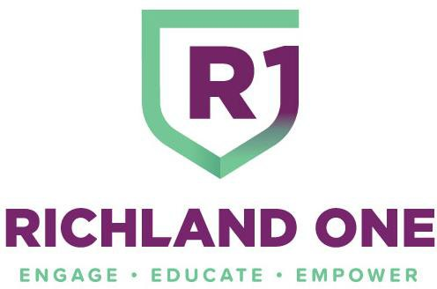

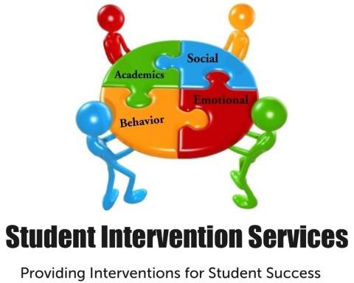

Multi-Tiered System of Supports Guide Student Intervention Services

2021 - 2022

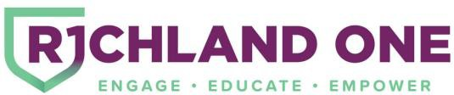





**Table of Contents**

Why MTSS? 4

What is MTSS? 5

Academics and Behavior within the Tiers 6

MTSS & Universal Screening 8

Process Overview 11

MTSS & Academic Overview 13

MTSS and Behavior Overview 15

MTSS & Academics 16

MTSS & Behavior 32

MTSS Teams Roles & Responsibilities 38

MTSS & Parents 41

MTSS & Problem Solving Protocol 44

MTSS & Progress Monitoring 47

MTSS & Fidelity 50

Forms/Form Links 58

Glossary 64

Appendix A 72

Appendix B 77

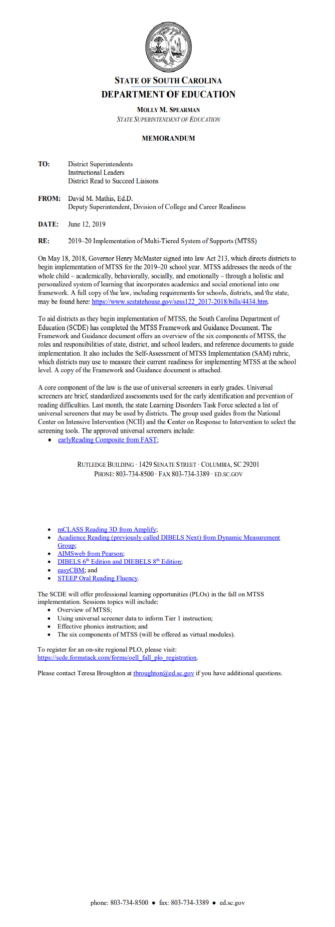

## Why MTSS?



## What is MTSS?

### Multi-Tiered System of Support (MTSS) involves Quality Core Instruction, assessment, and intervention to ensure that ALL students receive the level of support they need to be successful. The Multi-Tiered System of Supports (MTSS) is a school-wide, data driven, proactive framework for improving both learning and behavioral outcomes for all students. It utilizes evidenced based practices and an effective system to improve core instruction and intervention. It gives students immediate access to academic and behavioral support through the combination of Response to Intervention (RTI) and Positive Behavior Intervention and Supports (PBIS). Multi- Tiered System of Support focuses on meeting the academic, behavioral, social, and emotional needs of each student.

### The multi-tiered framework organizes resources, processes, and support to ensure student success. The three- tiered system increases the focus and intensity of support and aligns with identified levels of student need to provide them differentiated services. It is a “Response to Intervention” approach with an additional focus on behavior, which facilitates the determination of students who should be considered for Special Services.

### MTSS supplies the framework and structure for schools to provide students, in need of additional support, evidence-based, data informed, instruction and interventions. Utilizing evaluative practices and processes that identifies students with academic and / or behavioral needs, this framework provides specific and targeted interventions and monitors student’s progress aligned with their established goals.

**The essential components of MTSS include:**

* A school-wide instructional and behavioral system with a proactive and preventive focus on student success
* Data-based decision using the problem-solving model
* Universal screenings which identify students who may be at risk for poor learning outcomes
* Data analyzation that identifies students who are struggling academically and/or behaviorally
* Progress monitoring that helps educators guide both instruction and intervention
* Collaboration and communication between students, families, teachers, and administrators to ensure that every student receives the best possible instruction

### **Tier I (All Students) -** provides **Quality Core Instruction** and school-wide positive behavior programs that meets the academic and behavioral needs of all students. Tier I instruction consists of scientific, research-based programs and frameworks that align to state standards and best practices proven to be effective for all students.

### **Tier II (Some Students) -** provides focused supports and targeted interventions for the students who continue to need support beyond Quality Core Instruction and/or the school-wide behavior plan. Student progress continues to be monitored towards a specific goal by the MTSS Team.

### **Tier III (Few Students) -** provides interventions that are more focused, intensive, and longer in duration in addition to the support received in Tiers I and II. Academic and behavioral supports adjust to the student’s response to Quality Core Instruction and previous interventions. Progress monitoring is more intensive for those students with greater academic or behavioral needs and for those considered for a different placement.



**‘**

## Academics and Behavior within the Tiers

**Tier 1**

**Academic**

### Tier I: focuses on Quality Core Instruction and support that meet the academic needs of all students. Tier I instruction consists of scientific, research-based programs and frameworks that align to state standards and best practices proven to be effective for all students.

**Behavior**

### Tier I: is an effective, proactive, preventative and school-wide behavior support system that comes from a district-wide effort that focuses on consistency and prepares students developmentally for their future in college and careers. Tier I behavior practices consist of school-wide plans and positive behavior systems that implement scientific, research-based programs.

**Tier 2**

**Academic**

### Tier II: involves extra instruction and support beyond Tier I that serve students identified as needing more help. Often, this help is provided to these children in small groups. These students require strategic interventions that match their learning styles and additional support in addition to the core curriculum.

**Behavior**

### Tier II involves targeted groups of students in need of focused behavioral instruction and interventions. Tier II requires focused interventions that provide additional support to meet specific needs of students to conform to the school-wide behavior plan.

**Tier 3**

**Academics and Behavior**

### Tier III interventions are more intensive and longer in duration. Tier III requires that academic and behavioral supports adjust to the student’s response to Quality Core Instruction and previous interventions. Tier III supports all students in need of individualized, intensive strategies to achieve or maintain desired student outcomes and prevent future difficulties.

### The Tiers do not have “start” and “stop” points. Students do not have to demonstrate progress in Tier I or Tier II before receiving Tier III supports, should data and evidence suggest intensive support is warranted.

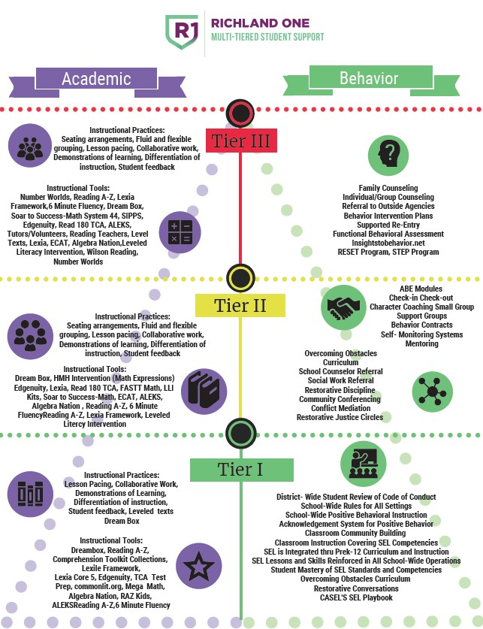

**Tools and Resources for Tiered Intervention**



# MTSS & Universal Screening



**What is Universal Screening?**

### Universal Screening is a general outcome measure used to identify underperforming students and to determine the rate of increase for the district, school, classroom, and students in reading and math. A universal screening will not identify why students are underperforming; rather it will identify which students are not at the expected performance criteria for a given grade level in reading and mathematics.

### Universal Screening assessments are typically brief, conducted with all students at a grade level, and followed by additional testing or short-term progress monitoring to corroborate students’ risk status. In screening, attention should focus on fidelity of implementation and selection of evidence-based tools with consideration for cultural and linguistic responsiveness and recognition of student strengths. For a screening measure to be useful, it should meet the following criteria (Jenkins, 2003):

### It should identify students who require further assessment.

### It should be practical.

### It should generate positive outcomes by accurately identifying students without consuming resources that could be put to better use.

### It should identify individuals in need of further assessment and possible movement to Tier II interventions.

### It should provide feedback about class performance to help school leadership identify when a teacher might require support.

### It should be implemented on a regular basis across grade levels, identify false negatives—(i.e. students who slip through the screening at one level, but are then identified at later points during the year).

### Richland One’s criteria for evaluating Universal Screeners:

### Easily Administered

### Research-based

### Highly correlated to skills being assessed

### Benchmark or predictor of future performance

### Reliability and validity

### Sensitive to small increments of change

### Data analysis and reporting component

### District and school level administrators are expected to routinely review assessment data. The use of Richland One’s summative assessments (Mastery Connect) will be used to progress monitor.

### Based on the above criteria Richland One has decided to use Renaissance STAR Early Literacy Reading and Math as the Universal Screener.

**When do I administer a Universal Screening?**

### Universal Screenings should be administered per the instrument requirements and, at a minimum of three times a year (fall, winter, spring) in reading and math for students who demonstrate a need for additional support. Data from universal screenings will be maintained in a system database that is used for instructional data base decision making. The following are options in Richland County School District One that may be used in addition to **Renaissance STAR Early Literacy Reading, and Math:**

### Pre-Kindergarten

### MyIGDIS-Literacy and Numeracy

### Clarity BrightBytes

### Primary Level (Kindergarten - Grade 1)

### Fountas & Pinnell Benchmark Assessment System

### Clarity BrightBytes

### Fountas & Pinnell Benchmark Assessment System

### Elementary Level (Grades 2—5)

### Fountas & Pinnell Benchmark Assessment System

### AIMS Web not a district provided, but it is approved.

### Clarity BrightBytes

### Middle School Level (Grades 6 – 8)

### AIMS Web not a district provided, but it is approved.

### Clarity BrightBytes

### High School Level (Grades 9 – 12)

### Clarity BrightBytes

**Note: Where there is the availability and utilization of an Universal Behavior Screener, it should be administered at a minimum three times a year.**

Screening is completed in approximately one to three minutes per student using an iPad, Chromebook, desktop or laptop style device.

# Process Overview

##### MTSS PROCESS FLOW

##### RICHLAND ONE

**Universal**

**Screening**

**MULTI-TIERED STUDENT SUPPORT**

Determine if the data indicates that the problem is an individual problem, a small group problem or a systemic (class, school, district) problem)

**A!HiiihHii**►**&&diHM441rltj!Mi4**►**HIM·dl!Hi**

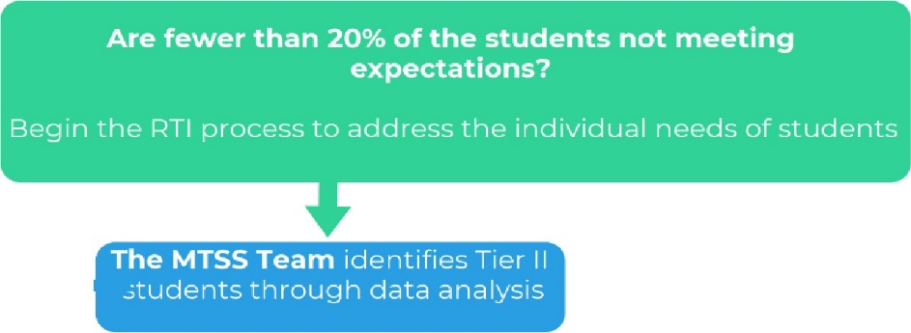

***l***

- --

-

- - -

**Are 20% or more of students not meeting expectations?**

Intervene at systemic level by examining instruction, curriculum, and environment as needed

Correct Implementation Issues and monitor progress for 4 to 6 weeks

The team collaborates and decides on the best prescriptive intervention(s) to meet student needs. **Tier II Interventions are implemented with fidelity,** and teacher monitors progress for 4 to 6 weeks

**Questionable or Poor Student Response**

Evaluate the fidelity of implementation

**Evaluate Student Progress after 4 to 6 weeks.**

**Positive Student Response**

Return student to a lower tier of Intervention or Quality Core Instruction

**TheMTSS team** may recommend the student to receive intervention at the next Tiered level

Modify Intervention to narrow the focus and/or increase the intensity of the current tiered intervention and monitor progress for 4 to 6 weeks.

**Evaluate Student Progress after 4to 6weeks.**



The team collaborates and decides on the best prescriptive intervention(s) to meet student needs. **Tier Ill Interventions are implemented with fidelity,** and teacher monitors progress

for 4 to 6 weeks

**Positive Student Response**

**Questionable or Poor Student Response**

Evaluate the fidelity of implementation

Return student to a lower tier of Intervention or Quality Core Instruction

**TheMTSS team** may recommend the student to receive intervention at the next Tiered level

**The MTSS team** recommends additional testing. (Possible 504 or Special Services)

Modify Intervention to narrow the focus and/or increase the intensity of the current tiered intervention and monitor progress for 4to 6 weeks.

Correct Implementation Issues and monitor progress for 4 to 6 weeks

# MTSS & Academic Overview

|  |  |
| --- | --- |
| **After Universal Screening** | * Determine if the data indicates that the problem is an individual student problem, a small group problem or a systemic (class, school, district) problem.   + Are 20% or more of students not meeting expectations?     - Intervene at systemic level by examining instruction, curriculum, and environment for needed adjustments.   + Are fewer than 20% of students not meeting expectations?     - Begin the MTSS process to address the individual needs of students. |
| **TIER I** | * Conduct, compile and evaluate Universal Screening Data   + If student does meet standard on the Universal Screening and/or grade level standards:     - Continue Quality Core Instruction     - Provide and monitor targeted differentiated instruction for a 4-6 week cycle     - Conduct and document weekly progress monitoring and gather data from multiple sources. * If the response is Positive, continue with Quality Core Instruction. * If the response is Poor, the student should be recommended to the MTSS Team for Tier 2 Interventions.   + Meet in grade level/department PLCs to review monitoring data and plan for Tier 2 Interventions. |
| **TIER II** | * PLC/MTSS facilitator prepares for MTSS Team meeting. * MTSS Team meeting is held. MTSS team evaluates data and determines appropriate intervention(s) for student success. * Implement and monitor Tier 2 interventions. (Instruction should occur beyond the regular instructional time, but during the school day). * Administrator monitors instruction. * Teacher monitors student progress for 4-6 weeks.   + Progress monitoring documentation is entered in Enrich by the classroom teacher and additional interventionist(s). * If the response is Positive, the student may return to Tier I and continue with Quality Core Instruction. * If the response is Questionable:   + Evaluate the fidelity of the intervention’s implementation. If fidelity is not the problem, the MTSS Team may increase the intensity or narrow the focus of the intervention for a specific time and then reassess its effectiveness.   + Return to problem solving and find a different intervention if the rate of progress does not improve. * If the response is Poor, the student should be recommended to the MTSS Team for Tier III Interventions.   + Evaluate the fidelity of the intervention’s implementation. If fidelity is not the problem, return to problem solving and find a different intervention.   + The MTSS team may recommend the student to receive Tier III Interventions. |
| **TIER III** | * Conduct MTSS Team meeting to determine appropriate intensive Tier III interventions * Implement and monitor Tier III instruction. (Instruction beyond the regular instructional time during the school day)   + Administrator monitors effective teaching.   + Small group instructor/tutor will monitor student progress.   + Teacher monitors student progress for 4-6 weeks.   + Progress monitoring documentation is entered in Enrich by the classroom teacher and additional interventionist(s) * School MTSS Team reviews data and makes recommendations for next steps. * If the response is Positive, the student may return to Tier II and continue with Quality Core Instruction. * If the response is Questionable:   + Evaluate the fidelity of the intervention’s implementation. If fidelity is not the problem, the MTSS Team may increase the intensity or narrow the focus of the intervention for a specific time and then reassess its effectiveness.   + Return to problem solving and find a different intervention if the rate of progress does not improve. * If the response is Poor, the student should be recommended to the MTSS Team for modified or different Tier III Interventions.   + Evaluate the fidelity of the intervention’s implementation. If fidelity is not the problem, return to problem solving and find a different intervention.   + The MTSS team may recommend the student to receive additional district provided services. |

## MTSS and Behavior Overview

### [PBIS World](http://www.pbisworld.com/), [Overcoming Obstacles](https://www.overcomingobstacles.org/curriculum/), The SEL Playbook, and [Intervention Central](http://www.interventioncentral.org/) have proven research-based strategies for behaviors. MTSS Teams should focus on 1 or 2 of the most impactful behaviors the student demonstrates which disrupt the learning environment. The MTSS Team can target other areas of concern after progress is made in these beginning areas using multiple points of relevant data such as (discipline referrals, behavior, etc.)

|  |  |
| --- | --- |
| **TIER** | **ACTION** |
| **Tier I – All Students (100%)** | * Schools set school-wide expectations for all students (PBIS or whatever term the school might use)   + Teachers will create a positive classroom culture and align their classroom expectations and rules with the school. * If the student’s behavior is inappropriate while operating with the Tier 1 strategies, the teacher will implement additional research-based strategies directly related to the concerning behavior(s) for 4 to 6 weeks. * If the student’s behavior does not improve, the teacher will begin the Checklist for Tier II in Enrich |
| **Tier II—Some Students (15-20%)** | * The MTSS team will begin a weekly Behavior Checklist/Log which includes strategies and goals that address specific concern(s) and/or behavior(s). * The Teacher monitors progress and documents it in Enrich. * Staff members (such as School Counselor, Behavior Management Specialist* (ISS Supervisor), Social Worker, etc.) who work with the student on behavior join the team, help to set goals, and monitor progress in Enrich. * After 4-6 weeks, the MTSS Team evaluates progress monitoring data, evaluates the fidelity of the intervention’s implementation, and recommends that the student:   + Exits Tier II   + Remains in Tier II with modifications   + Is recommended for Tier III support. |
| **Tier III—Few Students (<5%)** | * The School Psychologist and MTSS Team develops A Functional Behavior Assessment and Behavior Intervention Plan *(as appropriate)*. * Teacher and others who work with the student conduct weekly (at a minimum) progress monitoring with numeric data in Enrich that indicates a starting and ending point for the goal(s). * The MTSS team reviews progress and data after 4-6 weeks, modifying interventions if necessary. * After 4-6 weeks, the MTSS Team evaluates progress monitoring data, evaluates the fidelity of the intervention’s implementation, and recommends that the student:   + Return to Tier II.   + Remain in Tier III with modifications   + Is recommended for additional testing (Possible 504 plan or Special Education services) |

# MTSS & Academics

**MTSS and Academics**

The interventions should enhance the learning that is occurring in the Tier I classroom, address identified weaknesses in basic skills, and accelerate learning toward individual expectations. Continuous monitoring of the implementation of the intervention (fidelity) and progress monitoring data is critical to shaping the impact on student achievement. Schools have the responsibility to use scientifically researched and evidence-based intervention procedures to give students the best opportunities to succeed.

Specified interventions may include research or evidence-based interventions which are specialized in being specific to identifying certain individual students or groups of students with particular types of academic and behavioral problems. Research based and evidence-based interventions are evaluated with sound experimental designs that result in providing evidence of socially significant behavior changes.

###### Interventions can be categorized into three groups: scientifically proven, research based, and evidence-based.

Scientifically proven interventions mean that scientific results have already been published in peer reviewed journals using the scientific rigor described in the definition from NCLB (see chapter 3). Research based interventions mean the methods, content, materials, etc. were developed in guidance from the collective research and scientific community. Evidence-based interventions indicate that specific data is available that shows the intervention improves student outcomes.

**Interventions at Tier I** include the instructional practices and tools available for the teacher to use in the general education classroom. Teachers routinely address student needs and environmental factors to create the optimal learning environment. Tier I interventions include:

|  |  |
| --- | --- |
| Instructional | Behavioral |
| **Instructional Practices:**   * Gradual release of responsibility * Checking of understanding * Fluid and flexible grouping * Lesson pacing * Collaborative work with peers * Modeling of lessons * Differentiation of instruction * Student feedback * Leveled texts   **Instructional Tools:**  See pages 13-16 | * Code of conduct overview * Share school behavioral expectations * Social skills training * Liaison between school, family, community collaboration * Parent conferences, /MTSS meetings * Team/school behavior coaching * Home visits * DSS/ child abuse/neglect awareness * Consultation and analysis on collected data * Instructional consultants * Case findings (i.e. Child Find) * Awareness and education workshops and assemblies (i.e. attendance, support services, code of conduct, bullying, etc.) * Classroom rules review * Conscious Discipline * Trauma Informed Practices |

It is critical to respond to student performance in all classroom learning environments. Student success is dependent on the teacher’s ability to identify areas of concentration, scaffold the learning for the individual to reach the expectation, and solidify the new learning.

**Interventions at Tier II** are typically standard protocols employed by the district to address the learning and/or behavioral needs of identified students beyond the support and core instruction students receive in Tier I. These protocols are typically implemented in a specific sequence, based on evidence and research-based resources available in the school. For example, at Richland One, students who are identified as needing additional reading support will go to a specified intervention based on their needs. During the intervention block, the teacher uses specific evidence and research-based practices to address students needs, while keeping a clear focus on the state standards, grade level expectations in the content areas, and transfer of learning to the general classroom.

**Collaboration between the intervention teacher and the general teacher team is required**. During the intervention, progress monitoring is used to determine the student’s response to the intervention. The progress monitoring tool and frequency of implementation are collaboratively determined by the teaching team and the intervention teacher. Based on the progress monitoring data, the school standard protocol process may require individual students to continue in the intervention, move to another Tier II intervention, or move to Tier I interventions. For a few students, the data team may consider the need for Tier III interventions based on individual responses to Tier II interventions. Tier II interventions include:

|  |  |  |
| --- | --- | --- |
| Instructional | | Behavioral |
| **Instructional Practices:** • Workshops, seminars, Parent Universities | | |
| * Gradual release of responsibility * Checking and understanding * Fluid and flexible small group * Lesson pacing based on frequency and endurance * Collaborative work with peers * Modeling of lesson for learning * Differentiation of instruction * Student feedback * Leveled texts   **Instructional Tools:** | | * Volunteer functions * Student assessments-functional behavior assessments * Behavior Intervention Plans * Coordinate Crisis Intervention Team Training and Meeting * Attendance Intervention Plans (AIPs) * Group and individual interventions (i.e. problem solving, anger management, self- regulation, bully prevention, study skills) * 504 Plan * Mentoring programs * ISS (Solution Center) * Check-In/Check-Out |
| See pages 13-16 | * Check and Connect * Behavioral contracts * ECAT | |

**Interventions at Tier III** are tailored to the individual, and in some cases, small group (maximum of three students). The MTSS team should implement evidence and research -based protocols and aggressively monitor the student’s response to intervention and the transfer of learning to the general classroom.

Tier III interventions include:

|  |  |
| --- | --- |
| Instructional | Behavioral |
| **Instructional Practices:** • Parent support group (i.e. Family Solutions) | |
| Seating arrangements • Individual Education Plan (IEP)  Fluid and flexible grouping • Transitions planning for students and parents  Lesson pacing • Crisis Intervention Services  Collaborative work • Home visits/parent-teacher conferences  Demonstrations of learning • MTSS Multi-disciplinary teams for general and/or special Differentiation of instruction education services/needs  Student feedback • Facilitate and collaborate with teachers and administrators Leveled Texts on effective academic and behavioral strategies and  interventions for students   * School-based mental health referral   **Instructional Tools:** • DSS referrals (for abuse/neglect) | |
| See pages 13-16 • Transition/re-entry services   * Group/individual intervention and counseling * McKinney-Vento * MTSS team meeting * Progress monitoring * Project READY (Richland County Sheriff Department * Mentoring * Shadowing * Outside community services * Behavioral observations and consults * RESET Program (Elementary) * STEP Program (Pre-school) | |

|  |  |
| --- | --- |
| Instructional | Behavioral |
| Gradual release of responsibility • Parent support group (i.e. Family Solutions) | |
| Checking of understanding • Individual Education Plan (IEP) | |
| Fluid, flexible, and small groups Lesson pacing based on frequency and endurance  Collaborative work with peers Modeling of lesson for learning Differentiation of instruction Student feedback  Leveled Texts | * Transitions planning for students and parents * Crisis Intervention Services * Home visits/parent-teacher conferences * MTSS Multi-disciplinary teams for general * Facilitate and collaborate with teachers and administrators on effective academic and behavioral strategies and interventions for students * School-based mental health referral * DSS referrals (for abuse/neglect) * Transition/re-entry services * Group/individual intervention and counseling * McKinney-Vento * MTSS team meeting * Progress monitoring * Project READY (Richland County Sheriff Department * Mentoring * Shadowing * Outside community services * Behavioral observations and consults * RESET Program (Elementary) * STEP Program (Pre-school) |

**Tier I: Core Reading Program**

South Carolina Department of Education and Richland School District One recommends a three-tier, service-delivery model in which all students receive high-quality, scientific, research and evidence -based instruction. General education teachers and other professional staff deliver core instruction with fidelity and promote appropriate behavior expectations in classrooms and school-wide. Staff members conduct universal screenings two to three times a year and monitor students’ progress regularly. Parents actively participate in their children’s education and, at all tiers, help to implement instructional strategies.

Tier I is the foundation of a tiered instructional delivery model and refers to the universal instruction provided to all students in the school. The development and support of Tier I strategies are critical to a functioning MTSS system. In Tier I, teachers deliver research-supported, differentiated instruction with fidelity. Universal screening two to three times a year helps to document the progress of all students in this core instruction. If a significant number of students do not succeed with quality classroom instruction, the staff examines all variables (e.g., attendance, class size, behavior observations, instructional fidelity, staff development issues, curriculum choices, and student progress monitoring data) to determine how to strengthen Tier I instruction. Quality Tier I programs should assist between 80 to 90 percent of students in meeting grade-level standards. To implement MTSS with fidelity, school staff must critically evaluate and improve implementation of Tier I instructional and behavioral programs so that the vast majority of students are successful. In Richland One, we address Tier I instruction through the Balanced Literacy Framework. The following Instructional Framework can be used to plan, implement, and assess learning.

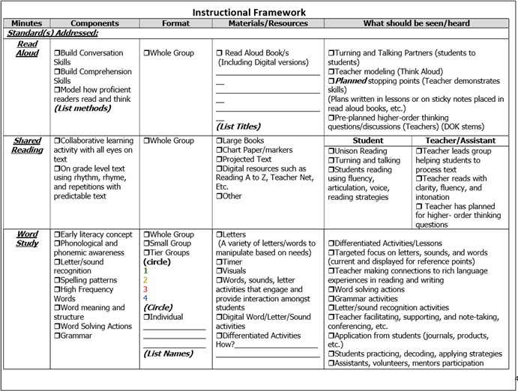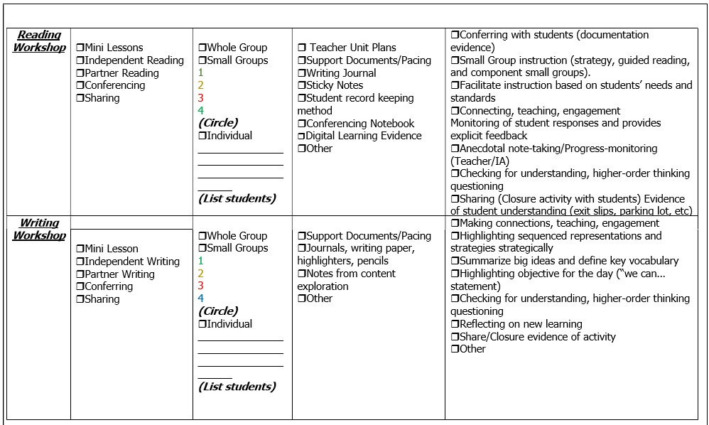

**Tier I Core Reading (Cont’d)**

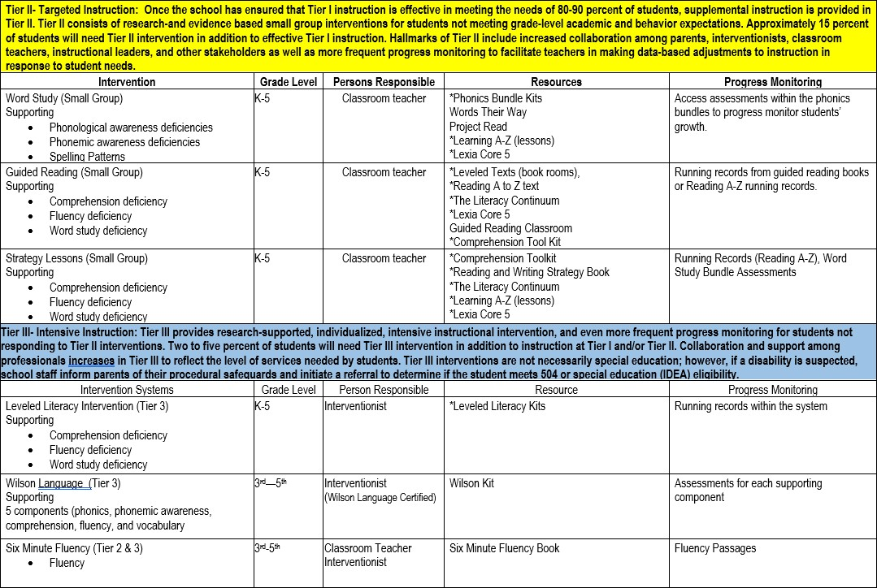

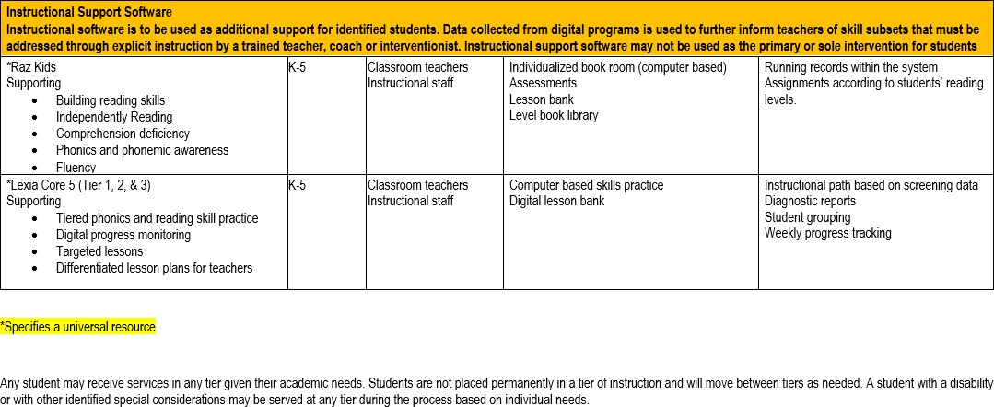

|  |  |  |  |
| --- | --- | --- | --- |
| **MTSS Tools/Resources ELA (6-8)** | | | |
|  | **TIER I**  Description: Tier I instruction occurs as a part of core, first time best instruction to help ensure that approximately 80% of students meet their learning goals.  During Tier I, the classroom teacher plans and provides strategies to extend and differentiate instruction for students.  The resources/tools listed are designed to be used to supplement, extend and remediate instruction. | **TIER II**  Description: Tier II instruction is strategic evidence-based instruction in addition to core instruction.  During Tier II, the classroom teacher uses formative assessments and results from small group instruction to identify students who need additional support by increased frequency or more individualized instruction.  During collaborative data meetings, grade level teachers may use formative assessment data to develop strategies to support students. | **TIER III**  Description: Tier III instruction is intensive strategic evidence based instruction in addition to Tier I and Tier II interventions.  Placement criteria for Tier III includes the following:  System 44 Next Generation   * STAR Reading PR in the Urgent Intervention band (below 10). * Have taken the Phonics Inventory and it has determined that System 44 is the appropriate placement. *A message will appear at the end of the Phonics Inventory notifying if the student should be placed in System 44.* * READ 180 Universal * STAR Reading percentile ranking (PR) at Urgent Intervention band (below 10) and at the lower end of the Intervention band (10-24). * Historical under-performance in ELA. * *A review of student attendance will be considered as well* |
| **Grade 6** | * Secondary ELA Instructional Framework * Secondary ELA Curriculum Guides * HMH Collections textbook and Close Reader student consumable * Discovery Education * Newsela * Flocabulary * CommonLit | * Newsela * Edgenuity “Content Recovery” | * System 44 Next Generation * READ 180 Universal *System44 NG and READ 180 U should be taught in a blended classroom* * Edgenuity “My Path” |

|  |  |  |  |
| --- | --- | --- | --- |
| **MTSS Tools/Resources ELA (6-8) Cont.** | | | |
| **Grades 7 – 8** | * Secondary ELA Instructional Framework * Secondary ELA Curriculum Guides * HMH Collections textbook and Close Reader student consumable * Discovery Education * Flocabulary * CommonLit | * Newsela * Edgenuity “Content Recovery” | * System 44 Next Generation * READ 180 Universal *System44 NG and READ 180 U should be taught in a blended classroom.* * Edgenuity “My Path” |

|  |  |  |  |
| --- | --- | --- | --- |
| **MTSS Tools/Resources ELA (9-12)** | | | |
|  | TIER I  Description: Tier I instruction occurs as a part of core, first time best instruction to help ensure that approximately 80% of students meet their learning goals.  During Tier I, the classroom teacher plans and provides strategies to extend and differentiate instruction for students.  The resources/tools listed are designed to be used to supplement, extend and remediate instruction. | TIER II  Description: Tier II instruction is strategic evidence based instruction in addition to core instruction.  During Tier II, the classroom teacher uses formative assessments and results from small group instruction to identify students who need additional support by increased frequency or more individualized instruction.  During collaborative data meetings, grade level teachers may use formative assessment data to develop strategies to support students. | TIER III  Description: Tier III instruction is intensive strategic evidence based instruction in addition to Tier I and Tier II interventions.  During Tier III, the classroom teacher provides students with additional literacy strategies and support to assist in completing courses that are required for graduation.  Tier III interventions at the high school level provide students to receive elective course credit.  Placement criteria for Tier III includes the following:  System 44 Next Generation   * STAR Reading PR in the Urgent Intervention band (below 10). * Have taken the Phonics Inventory and it has determined that System 44 is the appropriate placement. *A message will appear at the end of the Phonics Inventory notifying if the student should be placed in System 44.*   READ 180 Universal   * STAR Reading percentile ranking (PR) at Urgent Intervention band (below 10) and at the lower end of the Intervention band (10- 24). * Historical under- performance in ELA.   *A review of student attendance will be considered as well.* |

|  |  |  |  |
| --- | --- | --- | --- |
| **Grade 9** | * Secondary ELA Instructional Framework * Secondary ELA Curriculum Guides * HMH *Collections* textbook and *Close Reader* student consumable * Discovery Education * Newsela * Flocabulary   + CommonLit | * Newsela * Edgenuity “Content Recovery” * Critical Reading   + Critical Reading is a course intended to provide additional support to students in English 1. Course # 309931CW (9th grade only) | * System 44 Next Generation * READ 180 Universal *System44 NG and READ 180 U should be taught in a blended classroom.* * Edgenuity “My Path” * Online-independent student use; before school; after school; and/or Saturday Academy. |
| **Grade 10** | * Secondary ELA Instructional Framework * Secondary ELA Curriculum Guides * HMH *Collections* textbook and *Close Reader* student consumable * Discovery Education * Newsela * Flocabulary * CommonLit | * Newsela * Edgenuity “Content Recovery” | * System 44 Next Generation * READ 180 Universal *System44 NG and READ 180 U should be taught in a blended classroom.* * Edgenuity “My Path” * -online-independent student use; before school; after school; and/or Saturday Academy. |
| **Grades 11– 12** | * Secondary ELA Instructional Framework * Secondary ELA Curriculum Guides * HMH *Collections* textbook and *Close Reader* student consumable * Discovery Education * Newsela * Flocabulary * CommonLit | * Newsela * Edgenuity “Content Recovery” | * Edgenuity “My Path” * -online-independent student use; before school; after school; and/or Saturday Academy. |

**Tier 1: Core Mathematics Program**

The goal of developing a framework for multi-tiered system of supports framework in mathematics is to provide optimal instruction for every student at all levels of schooling. South Carolina Department of Education and Richland School District One also recommends a three-tier, service-delivery model in which all students receive high-quality, scientific, research and evidence -based instruction in math. A tiered framework should prevent failure

with mathematics through increasingly differentiated and intensified assessment and instruction. Assessment and instruction conducted by the classroom teacher are central to the success of MTSS and must address the needs of all students, including those from diverse socioeconomic, cultural and linguistic backgrounds. When core

mathematics instruction is not effective for a particular student, it should be modified to address the needs and abilities of that student more closely. Classroom teachers, at times in collaboration with other experts, must exercise their best professional judgment in providing responsive teaching and differentiation.

Tier I instruction is provided to all students. Core instruction in mathematics should occur for 60-90 minutes per day.

Differentiated instruction within Core instruction should occur based on students’ needs. The impact of solid Tier I instruction should result in approximately 80% of students achieving grade-level expectations (e.g., proficiency) or, in the case of a student performing far below grade level, making better than average growth in an effort to “catch them up.” For high-performing students, educators may need to consider extension opportunities that provide more depth and breadth of core instruction.

###### Tier I Instruction Provides:

* High-quality, comprehensive core instruction in mathematics, including a strong focus on the seven South Carolina College and Career Ready Mathematical Process Standards and the Content Standards
* Research-based instructional practices
* Differentiated instruction and grouping structures
* Valid assessment data to guide instructional decisions

### To implement MTSS with fidelity, school staff must critically evaluate and improve implementation of Tier I instructional and behavioral programs so that the vast majority of students are successful. In Richland One, we address Tier I math instruction through the use of Math Workshop. The following Instructional Framework can be used to plan, implement, and assess student’s learning.

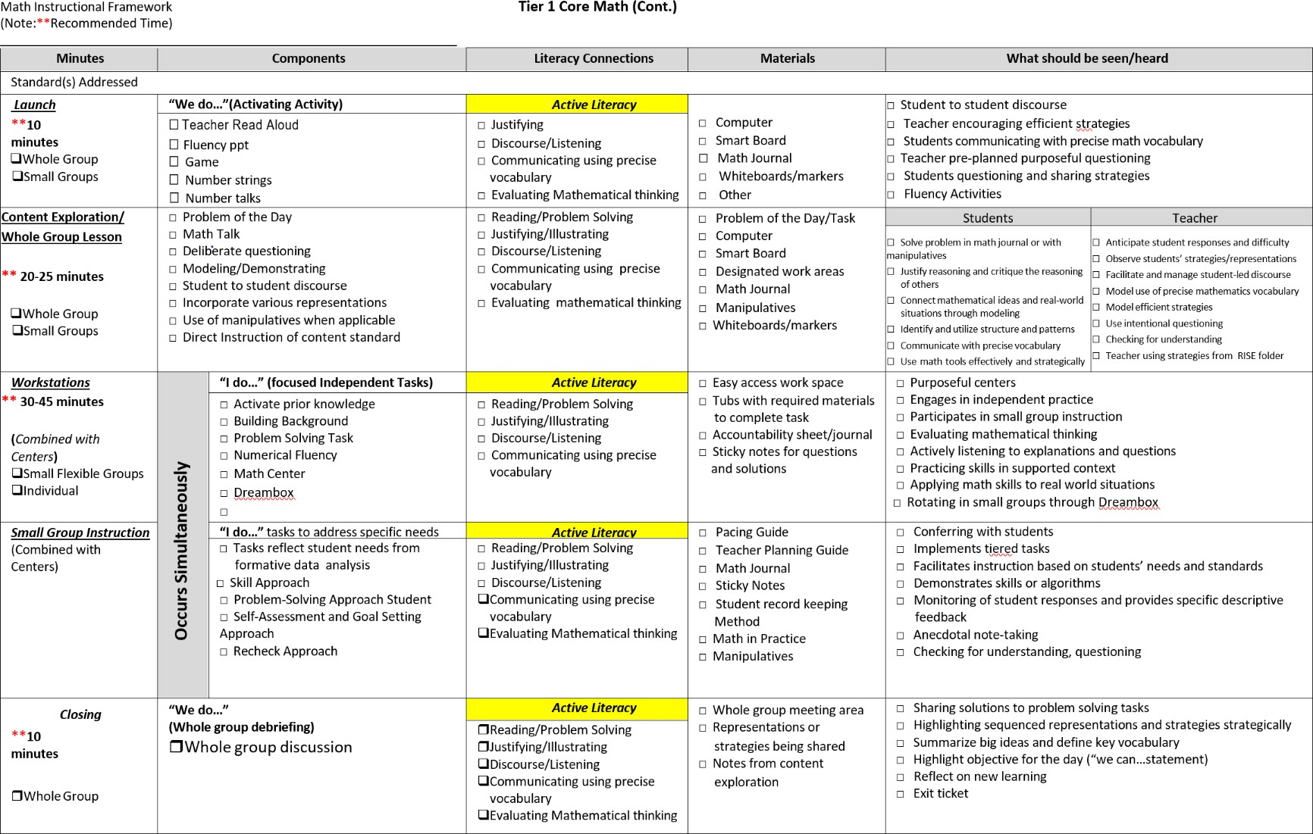

|  |  |  |  |  |
| --- | --- | --- | --- | --- |
| **Tier II – Targeted Instruction: Once the school has ensured that Tier I instruction is effective in meeting the needs of 80-90 percent of students, supplemental instruction is provided in Tier II. Tier I instruction includes the consistent and effective implementation of the Math Workshop, to include small group instruction, in grades K-5. Tier II consists of research and evidence-based small group interventions for students not meeting grade-level academic and behavior expectations. Approximately 15 percent of students will need Tier II intervention in addition to the small group instruction provided within Tier I instruction. Expectations for Tier II instruction includes increased collaboration among parents, interventionists, classroom teachers, instructional leaders, and other stakeholders, as well as, more frequent progress monitoring to facilitate teachers in making data-based adjustments to instruction**  **in response to student needs.** | | | | |
| **Intervention** | **Grade Level** | **Persons Responsible** | **Resources** | **Progress Monitoring** |
| Targeted Strategy Lessons (Small Group)   * Number Sense deficiency * Fluency deficiency | K-5 | Classroom Teacher | * Math in Practice * Dreambox Lessons * Big Ideas (Scaffolding Instruction) * Freckle   Do the Math  Hands-On Standards Math Mini-Lessons | **\***Dynamic  Assessment System  * Curriculum Unit CFAs  *STAR Math |

|  |  |  |  |  |
| --- | --- | --- | --- | --- |
| **Tier III – Intensive Instruction: Tier III provides research-supported, individualized instructional intervention, and even more frequent progress monitoring for students not responding to Tier II interventions. Two to five percent of students will need Tier III intervention in addition to instruction at Tier I and/or Tier II. Collaboration and support among professionals increases in Tier III to reflect the level of services needed by students. Tier III interventions are not necessarily special education; however, if a disability is suspected, school staff informs parents of their procedural safeguards and initiate a referral to determine if the student meets 504 or special education (IDEA)**  **eligibility.** | | | | |
| **Interven**  **tion Systems** | **Grade Level** | **Person Responsible** | **Resource** | **Progress Monitoring** |

|  |  |  |  |  |
| --- | --- | --- | --- | --- |
| Number Worlds Math Intervention Program | K - 5 | Math Interventionist | Number Worlds Kit | Number Worlds Monitoring  Assessment System |

|  |  |  |  |  |
| --- | --- | --- | --- | --- |
| **Instructional Support Software**  **Instructional Support software is to be used as additional support for identified students. Data collected from digital programs is used to further inform teachers of skill subsets that must be addressed through explicit instruction by a trained teacher, Math Interventionist, or CRT. Instructional support software may not be used as**  **the primary or sole intervention for students.** | | | | |
| Dreambox | K - 5 | Classroom Teachers Instructional Staff | Computer based skills practice | Adaptive Lessons Diagnostic Reports  Student Grouping Student Alerts |

|  |  |  |  |
| --- | --- | --- | --- |
| **MTSS Tools/Resources Mathematics (6-12)** | | | |
| **GRADE LEVELS** | **TIER I**  Description: Tier I instruction occurs as a part of core, first time best instruction to help ensure that approximately 80% of students meet their learning goals.  During Tier I, the classroom teacher plans and provides strategies to extend and differentiate instruction for students. | **TIER II**  Description: Formative assessments and results from small group instruction must be used to identify students who need additional support by increased frequency or more individualized instruction.  During collaborative data meetings, grade level teachers may use formative assessment  data to develop strategies to | TIER III  Description: Students who score between the 1st and 10th percentile on MI will need more frequent, intensive support from Tier III interventions.  Criteria for determining Tier III students include the following:   * Most recent MI results (1st – 10th Percentile) * SC Ready Results (not met) – if available * Low student course grades * Other diagnostic test results if available   *A review of student attendance will be considered as well.* |
|  | The resources/tools listed are | support Tier II students. |
|  | designed to be used to |  |
|  | supplement, extend and |  |
|  | remediate instruction. |  |
| **6**  ***Special Note:*** *See appendices for the District Protocol for Secondary Mathematics Resource* | * Secondary Math Instructional Framework * Secondary Math Curriculum Guides * Secondary Math Critical Skills Unit * Big Ideas Math student textbook * Big Ideas Math Student Journal with SC READY Prep * Big Ideas Math Skills Review Handbook * Big Ideas Math Assessment Book * Flocabulary * Discovery Education * ALEKS * Customized pathway | * ALEKS   + Customized pathway   + Quick Tables for fact fluency (multiplication and division) * Edgenuity “My Path”   + Big Ideas Math online access for resources grades K-8 | * ALEKS   + Customized pathway   + Quick Tables for fact fluency (addition, subtraction, multiplication and division) * Big Ideas Math online access for resources grades K-8 |

|  |  |  |  |
| --- | --- | --- | --- |
| **MTSS Tools/Resources ELA (9-12) Continued:** | | | |
| **7 – 8**  ***Special Note:*** *See appendices for the District Protocol for Secondary Mathematics Resource* | * Secondary Math Instructional Framework * Secondary Math Curriculum Guides * Secondary Math Critical Skills Unit * Big Ideas Math student textbook * Big Ideas Math Student Journal with SC READY Prep * Big Ideas Math Skills Review Handbook * Big Ideas Math Assessment Book * Flocabulary * Discovery Education * ALEKS   Customized pathway | * ALEKS   + Customized pathway   + Quick Tables for fact fluency (multiplication and division) * Edgenuity “My Path”   + Big Ideas Math online access for resources grades K-8 | * ALEKS   + Customized pathway   + Quick tables for fact fluency (addition, subtraction, multiplication, and division) * Big Ideas Math online access for resources grades K-8 |
| **9 - 10**  ***Special Note:*** *See appendices for the District Protocol for Secondary Mathematics Resource* | * ALEKS   + Customized Pathway * Pearson Realize Online textbook * Pearson Envision Mathematics South Carolina (Algebra 1) student consumable * Discovery Education   + Flocabulary | * ALEKS   + Customized Pathway * Flocabulary | * ALEKS   + Customized Pathway   o o Quick tables for fact fluency for multiplication |
| **11– 12**  ***Special Note:*** *See appendices for the District Protocol for Secondary Mathematics Resource* | * ALEKS   + Customized Pathway * Pearson Realize Online textbook * Pearson Envision Mathematics South Carolina (Algebra 1) student consumable * Discovery Education   Flocabulary | * ALEKS   + Customized Pathway * Flocabulary | * ALEKS   o o Customized pathway |

**MTSS and Behavior**

**Tier I Behavior**

**MTSS & Social and Emotional Learning**

Social and Emotional Learning (SEL) is the process through which children and adults acquire and effectively apply the knowledge, attitudes, and skills necessary to understand and manage emotions, set and achieve positive goals, feel and show empathy for others, establish and maintain positive relationships, and make responsible decisions.

SEL helps all students reach their full potential as caring, contributing, responsible, and knowledgeable friends, family members, coworkers, and citizens. It helps them build positive skills, such as greater self- awareness and self- management, improved relationship skills, and responsible decision-making in safe and supportive learning environments. These skills and behaviors are important in their own right, but they also benefit students in other ways. For example, a major review of research studies on SEL school programs revealed 11 percentile-point gains in academic performance.

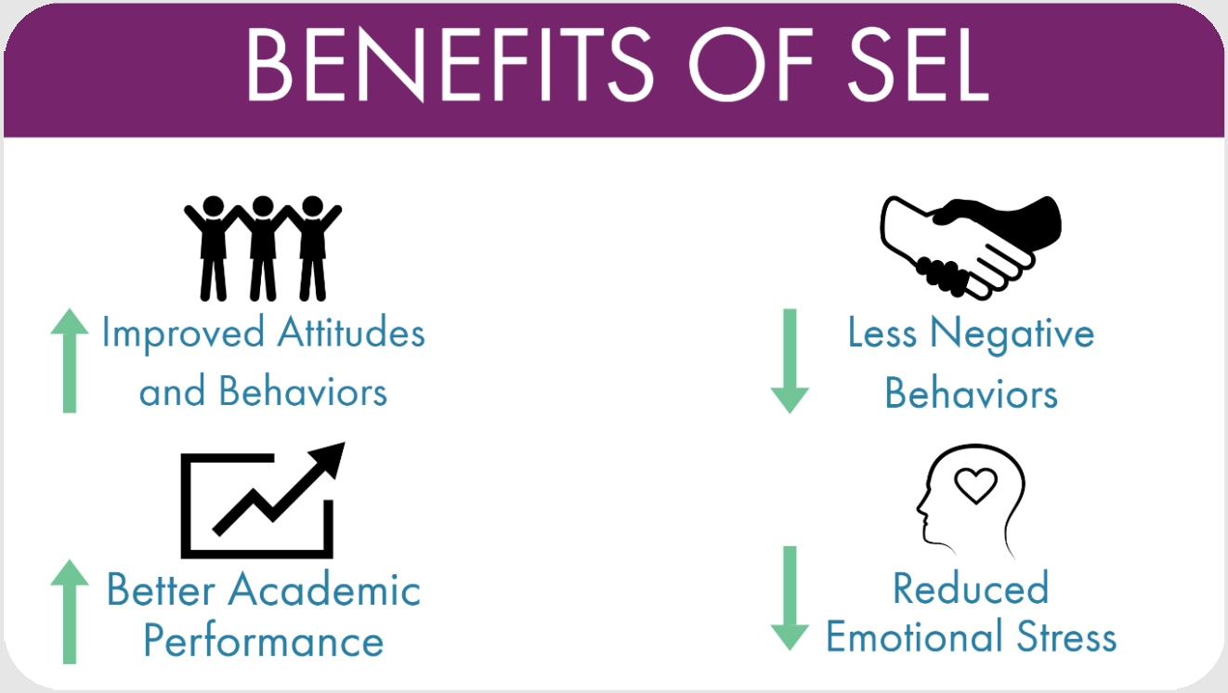

Overall, quality SEL yields an 11:1 return on investment, according to a 2015 Columbia University study. Three scholars from the fields of neuroscience, health, employment, psychology, classroom management, learning theory, economics, and youth development also have identified benefits. SEL also helps avoid or reduce negative outcomes for students. The implementation of SEL in schools has shown both immediate and long-term improvements in mental health, social skills, and academic achievement.

*“Educating the mind without educating the heart is no education at all.”*

**—Aristotle.**

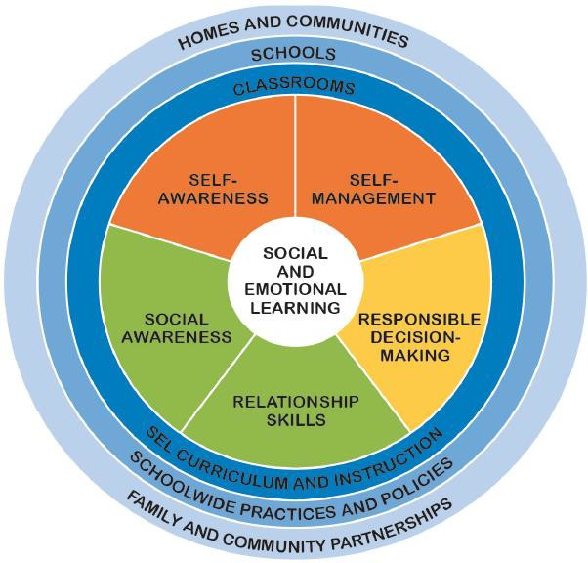Tier I Behavior

**CASEL and Social- Emotional Learning**

The Collaborative for Academic, Social, and Emotional Learning (CASEL) defined SEL more than two decades ago. Today, they collaborate with leading experts and support districts, schools, and states nationwide to drive research, guide practice, and inform policy. Through research, practice, and policy, they collaborate with thought leaders to equip educators and policymakers with the knowledge and resources to advance social and emotional learning in equitable learning environments so all students can thrive.

The Collaborative for Academic, Social, and Emotional Learning (CASEL) is a trusted source for knowledge about high- quality, evidence-based social and emotional learning (SEL). CASEL supports educators and policy leaders and enhances the experiences and outcomes for all PreK-12 students.

Their work is critical at a time when educators, parents, students, and employers increasingly recognize the value of SEL. Together, we are united in our call for schools to educate the whole child, equipping students for success in school and in life. They have consolidated SEL Skills into 5 Core Competencies.

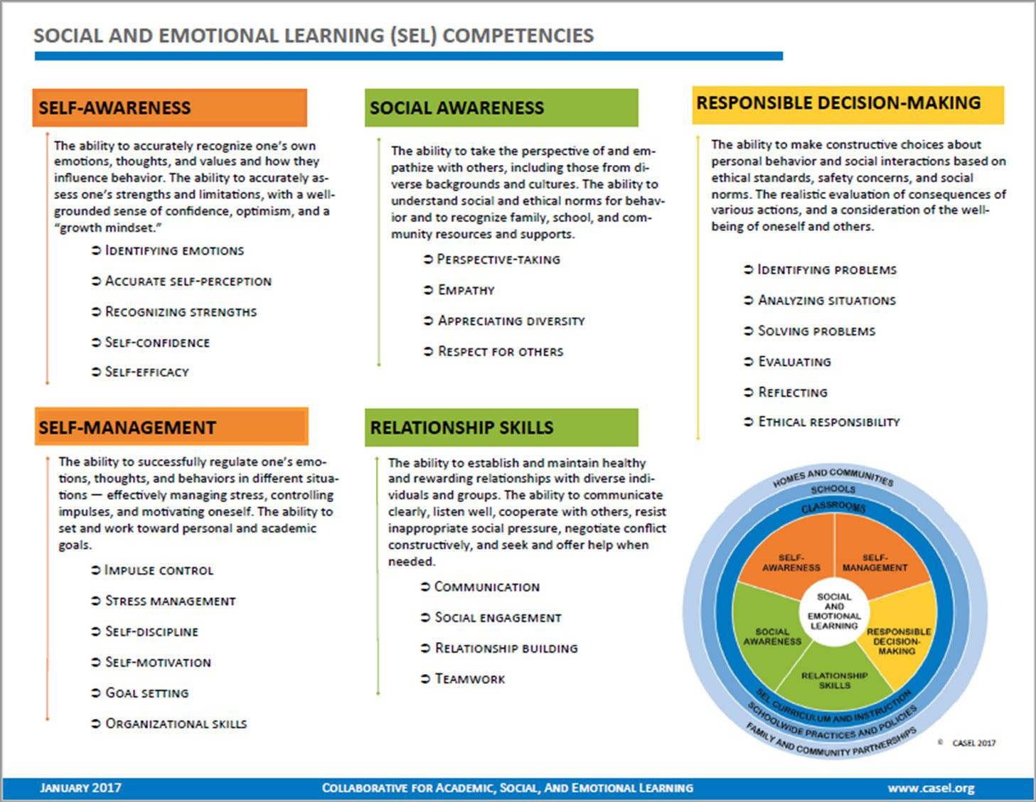

**Tier I-Behavior**

**MTSS, Student Advocacy, and SEL**

With implementing the MTSS approach, the strategic plan initiative is to provide each student direct access with a caring, responsible adult through a well-organized student advocacy program. In a student advocacy program, each student in the school is assigned a teacher or staff member who assists the student in achieving his or her academic and personal goals. Advocacy usually has two distinct parts: an advocacy class, similar to a home room, and one-to-one advisement to address personal issues. While their goals are similar, schools organize and implement their advocacy programs in a variety of ways depending on the needs of the school community. Each school’s MTSS team will be responsible for key aspects of the student advocacy programs.

Advocacy schedules typically range from 15 - 30 minutes daily, to 30 - 45 minutes once or twice week. (A period of less than 15 minutes is too short to have any real effect.) Some schedules alternate when feasible, with a group meeting one week and individual advisement the next. The student advocacy schedule must reflect its goals for its advisory program and its larger vision for students’ educational experience. While student advocacy consists of many facets, a student advocacy program addressing students’ needs should include the following action steps for implementation:

* Identify three to five students to advocate and provide feedback on the effectiveness of the student advocacy programs. This should occur a minimum of three times a year during MTSS team meetings.
* Establish a process for administering a universal screening for academic, behavioral, and emotional barriers to learning. See below recommended screening on a bi-yearly basis.
  1. Student Advocacy Survey Form
* Implement high-quality, rigorous curricula that address core academic competencies, social–emotional learning principles, mental and behavioral wellness, and positive behavior.
  1. [Overcoming Obstacles](https://www.overcomingobstacles.org/)
  2. [SEL Playbook](https://casel.org/resources-guides/)
* Establish a process for regularly reviewing student data (both behavioral and academic) located in the following resource:
  1. [BrightBytes](https://clarity.brightbytes.net/users/sign_in)
  2. [ScholarChip-ABE Behavior Management](https://www.scholarchip.com/student-behavior/abe/)
  3. [Powerschool](https://powerschool.richlandone.org/admin)
* Ensure access to a range of high-quality, evidence-based interventions to address the comprehensive needs of students by referring them to the appropriate personnel.
  1. **Responsive Classroom:** an approach that empowers educators to create safe, joyful, and engaging learning communities where all students have a sense of belonging and feel significant. [Responsive](https://www.responsiveclassroom.org/) [Classroom](https://www.responsiveclassroom.org/)
  2. **Collaborative Problem Solving**: identify and teach the skills the student is struggling with that cause challenging behaviors. [ScholarChip-ABE Behavior Management](https://www.scholarchip.com/student-behavior/abe/)
  3. **Progress Monitoring:** Use data collected through ABE, BrightBytes, Classroom observations, PowerSchool to identify if adequate progress is made towards reaching behavioral and SEL goals.

|  |  |  |  |
| --- | --- | --- | --- |
| **Behavioral and SEL Resources** | | | |
| **Resources** | **Tier I** | **Tier II** | **Tier III** |
| SEL Playbook | **X** | **X** |  |
| ABE Intervention | **X** | **X** |  |
| Overcoming Obstacles Curriculum | **X** | **X** |  |
| Second Step Curriculum | **X** | **X** |  |
| **Recommended Behavioral and SEL Strategies** | | | |
| **Strategies** | **Tier I** | **Tier II** | **Tier III** |
| Reteaching | **X** |  |  |
| Whole Class and/or Advisory Group of SEL Instruction | **X** |  |  |
| Check In/ Check Out |  | **X** |  |
| Small Group Behavior Skill Training |  | **X** |  |
| Individual Behavior Skill Training |  |  | **X** |
| Referrals to Outside Agencies and/or In-House Clinical Practitioners |  |  | **X** |

# MTSS Teams Roles & Responsibilities

##### DISTRICT LEVEL MTSS TEAM

**MTSS Teams**

Representatives from each level (K-12) and subject area will evaluate the effectiveness of strategies and processes. The team will make recommendations for additions, changes and deletions to the MTSS process as maintained in Enrich. The team will meet quarterly for review purposes.

###### The School Level MTSS Team

The MTSS process is a collaborative problem-solving process that follows the Problem-Solving Protocol. Every school needs a school based **MTSS Team led** by a **MTSS Chairperson** to ensure that it is implemented with fidelity.

Administrators, teachers, and other personnel involved with student achievement and learning at the school level should make up this team.

The **MTSS Team’s Mission** is to

* **Identify** struggling students who may be “at risk” and determine their academic and/or behavioral needs.
* **Recognize** high achieving students who may benefit from enrichment experiences
* **Provide** students the academic, behavioral, and social supports they need to succeed by **implementing** assorted strategies and interventions within the general education classroom which support **Quality Core Instruction and the Positive Behavior Intervention System.**

The **MTSS Team** should meet on a weekly basis to analyze school-wide data drawn from grades, assessment results, absences, and behavior. (It is acceptable for Secondary teams to meet twice a month if caseloads permit.)

The **MTSS Team** should use the insight gained from their data analyzation to identify specific students for support. They should prescribe interventions and create school-wide intervention schedules that provides time for intervention implementation within the core curriculum (Tier II). They should also provide opportunities for extra small group (Tiers II and III) and one-on-one instruction (Tier III).

|  |  |
| --- | --- |
| **Roles of MTSS Team Members** | |
| **MTSS Chairperson** | **Recorder** |
| * **Schedules the meetings** * **Gathers information in advance of the meetings** * **Sends notifications to parents** * **Chairs the meetings** | * **Takes notes** * **Fills outforms** * **Organizes documents** |
| **Timekeeper** | **Data Manager** |
| * **Monitor time during MTSS meetings.** | * **Stays in contact with referring teacher to monitor progress of intervention** |

**Roles and Responsibilities**

|  |  |  |
| --- | --- | --- |
| **Principal/Assistant Principal** | **Teachers** | **MTSS Chair** |
| -Be familiar with the three-tier structure of MTSS and purpose/specifics of each tier.   * Select an MTSS Coordinator and establish an MTSS Team.   -Ensure that the MTSS Coordinator, classroom and intervention teachers, and other staff providing intervention are utilizing the MTSS program in Enrich in accordance to the MTSS Reference Guide and Enrich/MTSS Handbook.   * Develop action plans for prevention and intervention services by teachers/staff needed for all MTSS Tiers.   -Develop a Master Schedule for instruction, intervention and team meetings.  -Establish a system and supervise monitoring all tiers of interventions - behavioral and academic.  -Provide professional development for staff as needed on all aspects of MTSS process. | **Classroom Teachers-**  **-**Gather universal screening data and ongoing formative/summative data (including behavioral data if applicable.)  - Identify and implement differentiated instructional strategies that will be used within the classroom to address student need.  -Implement Interventions with fidelity.  -Monitor data and progress with collaborative team. (All tiers) | -Facilitate MTSS Team Meetings for students in Tier II and Tier III.  -Approve and support the creation of the Tier II and Tier III Plans in Enrich.  -Ensure that all teachers are utilizing the MTSS program in Enrich in accordance to the MTSS Reference Guide.  -Provide guidance to teachers for inputting required documentation in Enrich through the MTSS process.  -Ensure fidelity of intervention and progress monitoring of all Tiers, for all students.  - Obtain hearing/vision screening results for students in Tier II.  -Arrange speech screening for students in Tier II if there are articulation concerns.  -Facilitate communication to inform parents of student progress in Tier II and Tier III.  -Upload any documents into Enrich with/requiring a parent signature.  -If student moves to another school, communicate with the MTSS Chair of  the new school. |
| **Intervention Teachers-**  - Support the MTSS team to ensure appropriate choice and application of instructional/behavioral strategies by recommending researched-based strategies, interventions and assessments.  -Support and collaborate with classroom teachers on developing and monitoring Tier II and Tier III plans.  -Implement interventions and monitor progress for students served in Tier II and Tier III in accordance to the MTSS  Reference Guide. |
| **Instructional Coaches/ Curriculum Consultants (Tiers II & III)** | **Student Support Personnel (Tiers II & III)** | **Special Area Personnel (Tier III)** |
| * Work with teachers to implement appropriate strategies, interventions and continuous progress monitoring for all Tiers.   -Coordinate and provide embedded professional development on all tier interventions.   * Annually (at a minimum) review strategies in Enrich for effectiveness with other instructional coaches and make recommendations as needed for revision.   **Note:** Instructional Coaches are not to serve as the MTSS Chairperson. | - Communicate with all stakeholders when working with students in need of additional academic or behavior support. (All Tiers)  -Assist as appropriate to develop action plans and progress monitoring for students who need additional academic or behavior support. (All Tiers)  -Provide individual and small group counseling in accordance to the ASCA model for Tier II and Tier III students and document their work with students.  **Note:** School Counselors are not to serve as the MTSS Chairperson | Tier III participation, observation and/or consultation as needed in Tiers I & II  -ESOL specialist (if ESOL student has an MTSS concern not related to language acquisition)  -Speech/Language Therapists  -Social Worker  -Behavior Management Specialist* (ISS Supervisor)  -School Psychologist (Tier III only)  -Nurse: Hearing/vision screening conducted in Tier II.  -Resource/SPED Teacher: Tier III and consultation for Tiers II and III if student has an IEP and the team determines MTSS is necessary. |

# MTSS & Parents

**MTSS and Parents**

Parents want the best for their children, including a successful and positive school experience. When a child is struggling in school, there is no time to waste. Working together, parents and teachers can keep the students on the road to school success and graduation.

As the parent of a struggling student, it is important for caretakers to:

* Communicate with your child’s teacher
* Ensure that your child attends school regularly
* Encourage your child to do well in school
* Be specific with expectations when speaking with your child
* Understand the assessments your child takes
* Ask how you can help your child at home
* Understand and exercise your rights as a parent
* Collaborate with your child’s school

Your child may be having difficulties in school if he or she exhibits any of the following:

###### Lack of motivation, interest, or attention

Child is unwilling to participate in school activities or assignments; may be inattentive in class.

###### Homework frustrations

Child argues about doing homework, cries or has tantrums, or requires assistance with completing the work

###### Behavior problems

Child is acting up in class or seeking attention from classmates.

###### Slipping grades

Grades are steadily declining. Child indicates work is too difficult or student lacks necessary skills.

###### Low self esteem

Child becomes withdrawn or makes negative comments about his or her abilities.

###### Questions parents may want to ask:

* + Is the school using MTSS to provide extra help to struggling students?
  + How will the school provide parents with information about the specific MTSS process being used?
  + What are the interventions and instructional programs being used?
  + Will parents receive information on how to help their child at home?
  + Will students receiving interventions miss important instruction?
  + How will intervention be delivered so the student does not feel he/she is treated differently?

Parental involvement in education has been widely reviewed and found to be highly linked to student learning and achievement. Their participation is key component for an effective MTSS framework within a school. Schools need to include parent communication and input in all phases of the problem-solving process.

**Parental Involvement within the Tiers**

The following is an example of what level of involvement and communication should take place respective to the level of tiered instruction:

|  |  |  |
| --- | --- | --- |
| **Tier** | **Activity** | **How to involve parents** |
| Tier I | Preparation for opening of school | Collaborate with Parents whose students have identified in a previous year. |
| Tier I | Beginning of school events | Send MTSS parent brochure. |
| Tier I | Universal screenings | Provide student data to parents, upon request Conduct parent-teacher conferences for effective strategies. |
| Tier II | Teacher team meetings | Obtain parental input. |
| Tier II | Documentation of progress MTSS team meeting | Send home progress reports.  Involve parents in intervention process.  Provide strategies for at-home academic support. |
| Tier III | MTSS follow-up meeting  Home interventions suggested by school personnel | Invite parent to MTSS meeting. Communicate with parents about interventions and progress monitoring. |
| Tier III | Screening | Inform parents of the screening process |

# MTSS & Problem Solving Protocol

**The Problem-Solving Protocol**

### Richland One’s educators who are involved in the systematic Multi-Tiered System Support (MTSS) implementation share the following beliefs about the ideal educational conditions for promoting student achievement. Using the following beliefs to guide our efforts is one way to ensure consistent movement toward maximizing student achievement:

### Highly effective personnel deliver scientific, research-based instruction and evidence- based practices.

### Curriculum and instructional approaches have a high probability of success for most students.

### Instruction is differentiated to meet individual learning needs.

### Reliable, valid, and instructionally relevant assessments include the following:

### **Screening Measures:** Assessment tools designed to collect data to measure the effectiveness of core instruction.

### **Diagnostic Measures**: Formal assessment tools that measure skill strengths and weaknesses, identify skills in need of improvement, and assist in determining why a problem is occurring.

### **Progress Monitoring Measures:** Ongoing assessment conducted to guide instruction, monitor student progress, and evaluate instruction/intervention effectiveness.

### **Formative Measures:** Formal or informal ongoing assessment within effective teaching to guide instructional decisions.

### **Summative (Outcome) Measures:** Typically administered near the end of an intervention cycle to give an overall perspective of the effectiveness of the instructional program.

### Ongoing, systematic problem-solving is consistently used, from enrollment to graduation for all students, to make decisions across a continuum of student needs.

### Student data is used to guide meaningful decision-making.

### Professional development and follow-up coaching with modeling are provided to ensure effective instruction at all levels.

### Actively engaged administrative leadership for data-based decision making is inherent to the school culture.

### All students and their parent(s) are part of one proactive and seamless educational system.

**District Problem Solving Process**

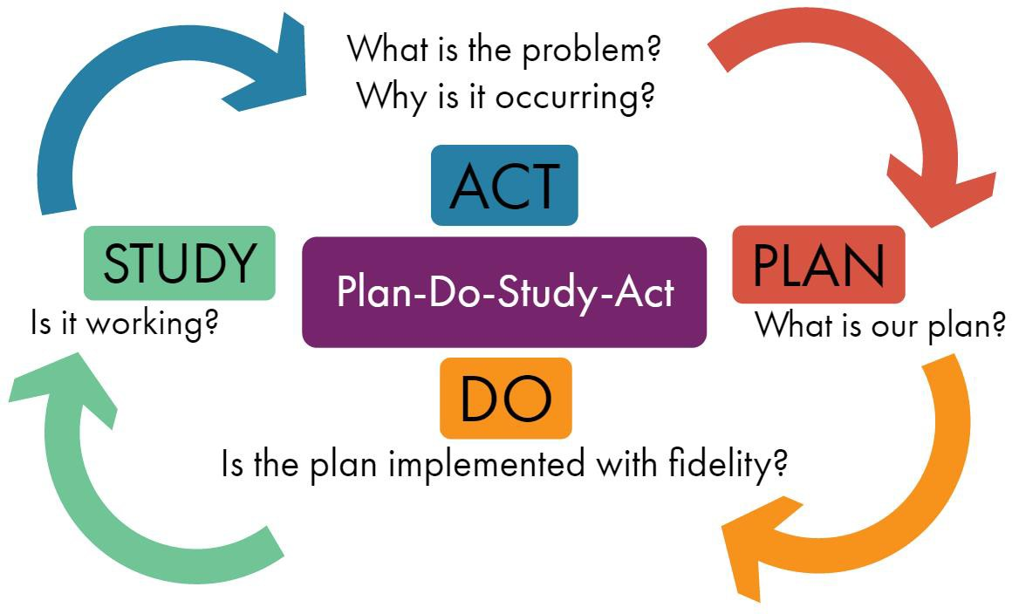

# MTSS & Progress Monitoring

**What is progress monitoring and how does it fit with MTSS?**

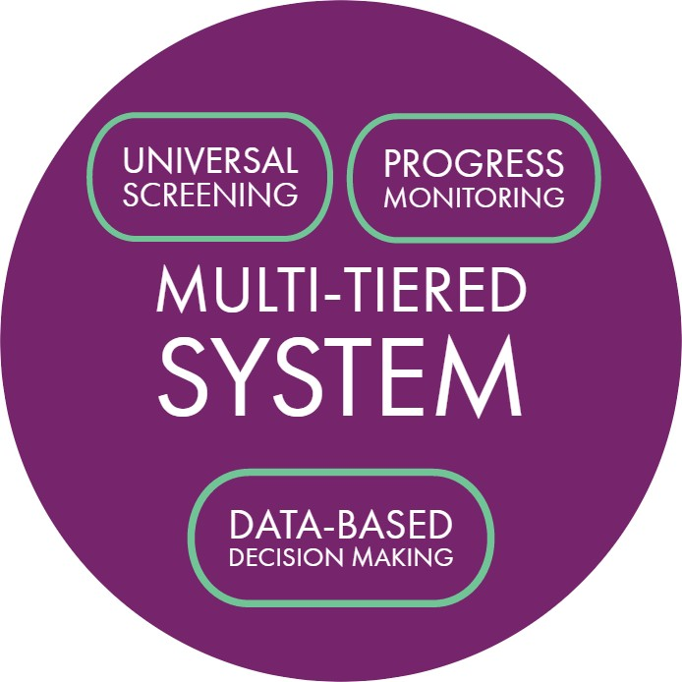

Progress Monitoring is a process used to assess a student’s academic and behavioral performance and measure student improvement or responsiveness to instruction and intervention. In fact, the goal of progress monitoring is to determine the effectiveness of an intervention on student learning. It can be formal or informal.

Progress monitoring can be implemented with individuals or groups of students, a class, an entire grade or a school system. Within a classroom, teachers should know their students through assessments.

Understanding that learning occurs at a different pace for all students, teachers should incorporate frequent opportunities for students to “show what they know.” The assessment strategy used for these frequent formative assessments should be deeply aligned with grade level state standards for any content area. The frequency of progress monitoring will increase with the intensity of an intervention or additional challenge.

When data shows that students are progressing, interventions are maintained until student meet identified goals. When data reveals that students are not making progress, a change in intervention is often needed.

Several organizational structures need to be in place to support progress monitoring. First, schools should create schedules that allow for collaborative planning. The importance of a common understanding of state standards and expectations by teacher teams is essential. Secondly, schools should initiate content area vertical articulation (across grade levels K-12) to review data, instructional needs for mastery, and assessments. Also, schools should establish a clear professional learning plan designed to support the use of a variety of assessment and intervention strategies.

The intensity of the progress monitoring increases as students move through the tiers of Richland School District One’s Pyramid of Intervention. A suggested timeline for MTSS is below.

|  |  |  |
| --- | --- | --- |
| **MONTH** | **ACTIVITIES** | **RESOURCES** |
| August – September | Ensure that school MTSS teams are in place at each school.  Ensure PLC/MTSS training has occurred.  Administer first universal screening to all students  Review student data at the school level with administration, grade levels teams, and parents. | MTSS Guide  **Universal Screeners (3 times per year)**  STAR Reading and Math (K-9)  Fountas and Pinnell Benchmark Assessment System (BAS - grades K-3) |
| September | Tier I: Monitor core instruction during PLC meetings.  .  Tier II: Monitor progress twice monthly (increase as needed).  Tier III: Monitor progress weekly.  (Progress monitoring should be aligned with the established goal in order to determine student growth). | Richland One interventions Enrich data reviews |
| October – December | Review STAR results and other assesment data.  Ensure MTSS meeting are being held and documented.  Review interventions and resources to ensure fidelity of implementation. | STAR reports BAS data  Data from CFAs  Richland One Interventions |
| January | Conduct second universal screening.  Review listing of priority students (who have not received mastery)  Revise student intervention plans as needed.  Conduct MTSS meetings for students in danger of failure | **Universal Screeners (3 years per year)**  STAR Reading and Math (K-9)  Fountas and Pinnell Benchmark Assessment System (BAS - grades K-3) |
| February – April | Monitor student progress  Review data during PLC and MTSS meetings  Continue with interventions | Enrich data reviews Richland One interventions |
| March (exact date TBA) | Deadline for referral to special services |  |

# MTSS & Fidelity

**What Is Fidelity**

### Fidelity is the continuous monitoring of the implementation of interventions that are critical to determining the true impact on student achievement. Fidelity can have a tremendous impact in student achievement and must also address the integrity with which screening and progress monitoring are completed. Fidelity is important at these levels:

### District

### School

### Teacher

### Parent

### Student

### How can schools ensure fidelity of implementation?

### Link interventions to improved outcomes (credibility)

### Definitively describe operations, techniques, and components

### Clearly define responsibilities of specific persons

### Create a data system for measuring operations, techniques, and components

### Create a system for feedback and decision making (formative)

### Create accountability measures for non-compliance

### Schools in Richland County School District One have a responsibility to ensure each teacher in the building is versed in the language of standards-based teaching. As data teams in the schools review student achievement results, an awareness of the level of implementation of standards- based instruction in the building is key. With this school-wide standards based classroom implementation data, the team can begin to determine how tier instruction is impacting student performance.

### The implementation of any intervention design requires monitoring by administrators and data team members in order to determine whether the level of intervention is carried out with fidelity and to determine whether the level of student response or non-response to intervention is or is not connected to the delivery.

### Implementation fidelity can be impacted by a wide range of factors that schools should consider (Allen & Blackston, 2003; Yeaton & Sechrest, 1981):

### Intervention complexity

### Time and material resources required for the intervention

### The number of intervention agents

### Efficacy (actual and as perceived by the intervention agents and stakeholders)

### The motivation of the intervention agents and stakeholders

### Fidelity has a great impact on student achievement. Research based teaching and learning

### practices are built on a foundation of fidelity to high standards of practice. Higher performing schools embed assessment of the fidelity of interventions. Often, the more intensive the intervention and instructional practices, the more need for rigorous fidelity checks to ensure efficacy. It is critical for schools to embrace and embed the importance of fidelity; what it is, who is involved, and more importantly, how it can be assessed for improved student achievement.

**Monitoring the Fidelity Roles and Responsibilities**

|  |  |
| --- | --- |
| **School Leadership:** | **Classroom Teachers and Intervention Specialists:** |
| * Implement and share the school’s MTSS plan including monitoring interventions and program fidelity. * Create a school-wide focus on having assessment driven instruction. * Develop staff understanding of the MTSS process. * Establish schedules to provide various times for intervention. * Ensure that tiered standards-based instruction occurs and be prepared to seek out resources for additional support ***(include in lesson plans).*** * Establish standard protocols of support for students in all tiers and follow up to ensure effectiveness. * Establish a system for accountability among all participants | * Implement intervention system with fidelity and with the belief that it can improve student achievement. * Implement tiered instruction based on student data. * Consistently use Formative and Summative assessments to guide classroom instruction and to develop tiered lessons (Keep documentation records to share with MTSS teams). * Consistently communicate and be prepared for all stakeholders; especially intervention team members, parents, administration, and students. * MTSS Chair |
| **Parents and Families:** | **School Psychologists, Social Workers and Counselors:** |
| * Participate in informal and formal consultations with stakeholders by attending parent/student conferences or other school/district information sessions regarding academic achievement. * Regularly communicate with teacher to ensure understanding or to provide support | * Participate in informal and formal consultations with teaching teams at all tiers with a focus on standards-based instruction. * Provide training, direction, and support for progress monitoring and selection of interventions. * Support foundational understanding of school-wide MTSS |

#### Tier I—Universal screenings are used for reading, math and/or behavior for all students at all levels. Classroom teachers use frequent common formative assessments to measure progress. Teachers assist with determining benchmark criteria for success, use the data to collaboratively discuss instructional approaches, and design learning opportunities to address individual needs. Progress monitoring data is purposefully collected and organized, shared with students and parents, and is the driving force of the instructional program. It helps answer the question, “How well am I meeting the needs of the student?”

#### Tier II—Students identified for Tier II interventions are regularly assessed to measure understanding and transfer of learning to core classrooms. The progress monitoring process used for the intervention is pre-identified at the district level based on the intervention components and should include curriculum-based measures and/or standardized assessments. Benchmarks for expected progress are set and student progress toward these benchmarks is closely monitored through assessments.

Tier III—Students identified for Tier III interventions will be closely monitored based on the interventions designed by the school’s MTSS team during the problem-solving process. At this level, clear documentation of progress monitoring data is needed to support the deep focus on the individual. Graphs or charts of assessment trends are recommended to show progress and identify whether transfer of learning to the core classroom is occurring.

|  |  |  |  |  |
| --- | --- | --- | --- | --- |
| **Academic Fidelity Checklist** | | | | |
| **Allocating Sufficient Contact Time & Assuring Appropriate Student-Teacher Ratio**  The cumulative time set aside for an intervention and the amount of direct teacher contact are two factors that help to determine that intervention’s ‘strength’ (Yeaton & Sechrest, 1981). | | | | |
| Critical Item? | | Intervention Element | Notes | |
|  | | **Time Allocated**. The time set aside for the intervention is appropriate for the type and level of student problem (Burns & Gibbons, 2008;Kratochwill, Clements & Kalymon, 2007). When evaluating whether the  amount of time allocated is adequate, consider:   * Length of each intervention session * Frequency of sessions (e.g.., daily, 3 times per week) * Duration of intervention period (e.g., 6 instructional weeks) |  | |
|  | | **Student-Teacher Ratio.** The student receives sufficient contact from the teacher or other person delivering the intervention to make that intervention effective. NOTE: Generally, supplemental intervention groups should be  limited to 6-7 students (Burns & Gibbons, 2008). |  | |
|  | **Matching the Intervention to the Student Problem**  Academic interventions are not selected at random. First, the student academic problem(s) is defined clearly and in detail. Then, the likely explanations for the academic problem(s) are identified to understand which intervention(s) are likely to help—and which should be avoided. | | |  |
| Critical Item? | | Intervention Element | Notes | |
|  | | **Problem Definition.** The student academic problem(s) to be addressed in the intervention are defined in clear, specific, measureable terms (Bergan, 1995; Witt, VanDerHeyden & Gilbertson, 2004). The full problem definition describes:   * Conditions. Describe the environmental conditions or task demands in place when the academic problem is observed. * Problem Description. Describe the actual observable academic behavior in which the student is engaged. Include rate, accuracy, or other quantitative information of student performance. * Typical or Expected Level of Performance. Provide a typical or expected performance criterion for this skill   or behavior. |  | |
|  | | **Student-Teacher Ratio.** The student receives sufficient contact from the teacher or other person delivering the intervention to make that intervention effective. NOTE: Generally, supplemental intervention groups should be limited to 6-7 students (Burns & Gibbons, 2008). |  | |

|  |  |  |
| --- | --- | --- |
|  | **Appropriate Target.** Selected intervention(s) are appropriate for the identified student problem(s) (Burns, VanDerHeyden & Boice, 2008). TIP: Use the Instructional Hierarchy (Haring et al., 1978) to select academic interventions according to the four stages of learning:   * Acquisition. The student has begun to learn how to complete the target skill correctly but is not yet accurate in the skill. Interventions should improve accuracy. * Fluency. The student is able to complete the target skill accurately, but works slowly. Interventions should increase the student’s speed of responding (fluency) as well as to maintain accuracy. * Generalization. The student may have acquired the target skill but does not typically use it in the full range of appropriate situations or settings. Or the student may confuse the target skill with ‘similar’ skills. Interventions should get the student to use the skill in the widest possible range of settings and situations, or to accurately discriminate between the target skill and ‘similar’ skills. * Adaptation. The student is not yet able to modify or adapt an existing skill to fit novel task-demands or situations. Interventions should help the student to identify key concepts or elements from previously learned skills that can be adapted to the new demands   or situations. |  |
|  | **‘Can’t Do/Won’t Do’ Check.** The teacher has determined whether the student problem is primarily a skill or knowledge deficit (‘can’t do’), or whether student motivation plays a main or supporting role in academic underperformance (‘wont do’). If motivation appears to be a significant factor contributing to the problem, the intervention plan includes strategies to engage the student (e.g., high interest learning activities; rewards/incentives; increased student choice in academic assignments, etc.) (Skinner, Pappas &  Davis, 2005; Witt, VanDerHeyden & Gilbertson, 2004). |  |
| **Incorporating Effective Instructional Elements**  These effective ‘building blocks’ of instruction are well-known and well-supported by the research. They should be considered when selecting or creating any academic intervention. | | |
| Critical Item? | Intervention Element | Notes |
|  | **Explicit Instruction.** Student skills have been broken down “into manageable and deliberately sequenced steps” and the teacher provided“ overt strategies for students to learn and practice new skills” (Burns,  VanDerHeyden & Boice, 2008, p.1153). |  |

|  |  |  |
| --- | --- | --- |
|  | **Appropriate Level of Challenge**. The student experienced sufficient success in the academic task(s) to shape learning in the desired direction as well as to maintain student motivation (Burns, VanDerHeyden &  Boice, 2008). |  |
|  | **Active Engagement**. The intervention ensures that the student is engaged in ‘active accurate responding’ (Skinner, Pappas & Davis, 2005) at a rate frequent enough to capture student attention and to optimize  effective learning. |  |
|  | **Performance Feedback.** The student receives prompt performance feedback about the work completed  (Burns, VanDerHeyden & Boice, 2008). |  |
|  | **Maintenance of Academic Standards**. If the intervention includes any accommodations to better support the struggling learner (e.g., preferential seating, breaking a longer assignment into smaller chunks), those accommodations do not substantially lower the academic standards against which the student is to be evaluated and are not likely to reduce the student’s rate of learning (Skinner, Pappas & Davis,  2005). |  |
| **Verifying Teacher Understanding & Providing Teacher Support**  The teacher is an active agent in the intervention, with primary responsibility for putting it into practice in a busy classroom. It is important, then, that the teacher fully understands how to do the intervention, believes that he or she can do it, and knows whom to seek out if there are problems with the intervention. | | |
| Critical Item? | Intervention Element | Notes |
|  | **Teacher Responsibility**. The teacher understands his or her responsibility to implement the academic  intervention(s) with integrity. |  |
|  | **Teacher Acceptability.** The teacher states that he or  she finds the academic intervention acceptable. |  |
|  | **Step-by-Step Intervention Script.** The essential steps of the intervention are written as an ‘intervention script’-- a series of clearly described steps—to ensure teacher understanding and make implementation easier  (Hawkins, Morrison, Musti-Rao & Hawkins, 2008). |  |
|  | **Intervention Training.** If the teacher requires training to carry out the intervention, that training has been  arranged. |  |
|  | **Intervention Elements:** Negotiable vs. Non-Negotiable. The teacher knows all of the steps of the intervention.  Additionally, the teacher knows which of the  intervention steps are ‘non-negotiable’ (they must be completed exactly as designed) and which are  ‘negotiable’ (the teacher has some latitude in how to carry out those steps) (Hawkins, Morrison, Musti-Rao & Hawkins, 2008).` |  |

|  |  |  |  |  |
| --- | --- | --- | --- | --- |
|  | | | **Assistance With the Intervention.** If the intervention cannot be implemented as designed for any reason (e.g., student absence, lack of materials, etc.), the teacher knows how to get assistance quickly to either fix the problem(s) to the current intervention or to change the intervention. |  |
| **Verifying Teacher Understanding & Providing Teacher Support**  The teacher is an active agent in the intervention, with primary responsibility for putting it into practice in a busy classroom. It is important, then, that the teacher fully understands how to do the intervention, believes that he or she can do it, and knows whom to seek out if there are problems with the intervention. | | | | |
| Critical Item? | | | Intervention Element | Notes |
|  | | | **Intervention Documentation.** The teacher understands and can manage all documentation required for this intervention (e.g., maintaining a log of intervention  sessions, etc.). |  |
|  | | | **Checkup Date**. Before the intervention begins, a future checkup date is selected to review the intervention to determine if it is successful. Time elapsing between the start of the intervention and the checkup date should be short enough to allow a timely review of the intervention but long enough to give the school sufficient time to judge with confidence whether the  intervention worked. |  |
|  |  |  | **Baseline**. Before the intervention begins, the teacher has collected information about the student’s baseline level of performance in the identified area(s) of academic concern (Witt, VanDerHeyden & Gilbertson,  2004). |  |
|  | | |
|  | | | **Goal**. Before the intervention begins, the teacher has set a specific goal for predicted student improvement to use as a minimum standard for success (Witt, VanDerHeyden & Gilbertson, 2004). The goal is the expected student outcome by the checkup date if the  intervention is successful. |  |
|  | | | **Progress-Monitoring.** During the intervention, the teacher collects progress-monitoring data of sufficient quality and at a sufficient frequency to determine at  the checkup date whether that intervention is successful (Witt, VanDerHeyden & Gilbertson, 2004). |  |

# Forms/Form Links

### Who: Teacher

**Student Instructional Plans**

### Why: To Record Classroom Level Intervention Data

### When: After Universal Screening, before starting two rounds of Tier I intervention, and ongoing.

### Who: Teacher

**Referral for MTSS Meeting**

### Why: To Schedule MTSS Meeting

### When: After two rounds of Tier I Intervention, before the MTSS Meeting.

### Who: MTSS Chair

**Referral Log**

### Why: To Document Efficiency of MTSS Processes

### When: After receiving Referral for MTSS Meeting, before the MTSS Meeting, and ongoing.

### Who: MTSS Chair

**Notice of MTSS Meeting**

### Why: To Invite Stakeholders to the MTSS Meeting

### When: After receiving Referral for MTSS Meeting, and before the MTSS Meeting,

### Who: MTSS Chair

**Parent Notice and Parent Confirmation**

### Why: To Invite Parents to the MTSS Meeting and Confirm their Attendance. When: After receiving Referral for MTSS Meeting, and before the MTSS Meeting,

### Who: MTSS Chair

**Parent Follow-Up**

### Why: To Inform Parents of the Results of the MTSS Meeting. When: After receiving the MTSS Meeting.



Referral for MTSS Meeting

|  |  |
| --- | --- |
| To: **School:** | |
| O;,tc: | |
| **(N:t.me of** TNm **Member)** | |
| The following .student b bci"' referred to the MTSS Te::am: | |
| N mc: Gr,dc: Oom:un: | |
| O:1tc: Rrst Refer !: YCJ/No | |
| Student , civ6S04Ac-commodotlo : V /No Student **Sctwd by** SPED: Ye,JNo | |
| To:MTSSTc.im  t request th:t the :tbovc n:lir'Md tudent berevicWff by the MTSS Tc:1m to :u.sl t In **ptov**  \q **lmptOYC** hl cr ovcn,11 pcrloNTDnc:c. | lntc,vcntions U\AIL |
| **Spcdfk** Ate ofConcc_rn:  tnitllll lcvclof **Perlorm:anc:c** ( line): Current **lcnlcl of Pmorm.tnc:c** : tntefVCn11on **Golll:** | |
| **the tc:Khcr brinl the student to theu,mmitt** I **willprovidePU*s>l* the followi :,ppllcablc doaJfflC!nt:ttion:**   * Gr **Jdes /RJ:port** CJ rd * Common As!.<:isme it!./ 8enthmM / Petformanct! OJtJ * **l.ci!.On p** M * ntcr\•c:ntioni. usc:d and prog,cn monitorin * AttcndJnce rcoon:h * **Beh..w,or** Loo (Cop11: ***d*** D.iscip e Referr.:**Records/** fntcr\'c:ntions) | |
| **To be cc,mpl,ctcd bVthe MTSSTc:,m:**   * n t..sb ,)·1d CJte of receipt o!student rdesr.sl: * Cntcr **:.tudc:"t 01 MTSS** Tc:Jm **RdettJI** l : * O.stc o' MTSS Team Mt:et"I · * Scl\d lotitc:of MeC't g O.:tcs. * Sc:Nf PJrent Notif"ic.: on & Conf&tmJtion Letter: | |

RICHLAND ONE Mui Tltted Stud Support

siudcnt port *��i�*

1110 Lyonstuct **38**

Ci!li.; *!iC* 2 '..!Ol



Notice of MTSSMcctins

To: School:

(N:imc of Tc m Member)

The follOW1ng student b bch'S referred to the MTSS Tc:lffl:

N:sme: 

Qnitilll rcfett:sl to MTSS TNm

O:ttc: of Mtttin : Tlme of Mectin:



□Review

###### Loc:won:

**Check** :all .uc:a.s of concern ttu1t ly:

|  |  |  |
| --- | --- | --- |
| tnvlro nt:  0 Frequail T d'  0 Frequct1l .10$<:RCC'S  0 Frequent b;,thrcom brt:.s nur$C vi:. ts  0 Often lacb !.UPP c.:.  0 unu:.u.s' wc·gtit or Ion  0 Appear) f t "utd or ov«ty *ctr,�*  0 Frequa,t phy,-iCJI in,uri  0 C.dily d1w.x.ted  0 Ii. .ltc:d s..e from otheu  0 Ch.,:,gc ,n pet:r • oup  a llic:S obl.et:ne l.sn •uJ e and  t:1tUfc)  0 Other. | lmtruction:  0 F:1 to complete  homcwork/M:. n-nt:nts  C Tum a:.sig.nment:. f te  0 P.lrtic1p.>te) rel 1t..·1in  clJ room att...·1· :Jcfiscu:. n  0 F.s J to re:.pond to rcdir tion  0 F.1 .s to re:.pond to $ffl • group  inwut1ion  0 04rupu s byt lkir.g out  0 Oc!moni,trat ,, .iknc:!..S in:  0 Other: | Aucs t:  0 Pr rc:..s h.nd«t cd  0 t, otmce ing :.t.,ndard on fo,m.:.,tivi: umtnb (lcxtlcr made telbt  0 81:nch--n le ore:.bclOIA'  **:.t3ndJrd**  0 Other: ------- |
| Tc:,chcr Comments: | | |
|  | | |
|  | | |
|  | | |

Pie;, provide re1,po."l:.c: below to the MTSS ch • b• •.

I •,Illbe b c to ttc:r.d the met:ti : 0Yts □*lo*

S, n.sture:

RICHL DO E Support



Parent Notification Letter

#### Date:

#### Dear Parent/Guardian of: _

#### Our school uses a problem-solving mode called Multi-Tiered Systems of Support {MTSS). MTSS is a process designed to address the needs of all students and·s·ntended as an earty intervention to prevent long term academic failure. our MTSS Team meets on a regular basis to offer assrstance to students, teachers, and parents regarding student success here in school.I

#### A referral has been made to t e MTSS Team regarding your child's progress. The team will be reviewing all available information in order to develop an intervention plan and ma e other recommendations as appropriate, to better assist your ch.Id i making successful progress in school.

#### This letter isto provide you with written notice that t e MTSS Team viii be gathering data rom a

#### ,•ide variety of sources including the stude t's cumu at,ve file, school health records, teacher reports, other schoo records, and classroom work. If you have any add. ional information that you v ould be villing to prov·de that might he p the 'TSS Team in planning effe tive educafon strategies and recommer,dation for your child, please contact me. Ve will have an MTSS meeting regarding your child. You are invited to be in attendance eeting details are below

|  |  |
| --- | --- |
| Date: |  |
| Time: |  |
| Locafon: |  |
| Address: |  |
| Phone: |  |
| contact: |  |

#### Sincerely

#### MT-SS Team

#### Chairperson:

**RICHL ND O** E

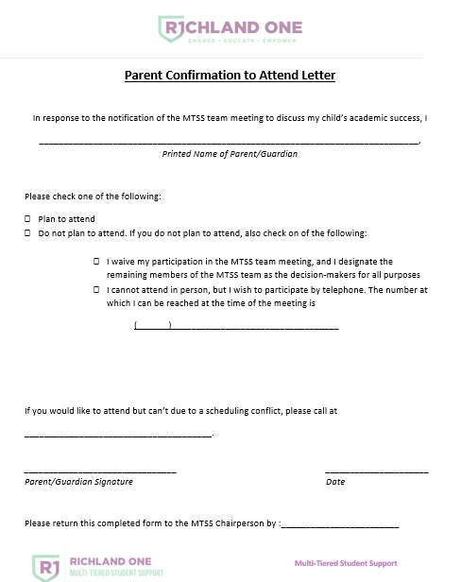

63

# Glossary

**Acceleration** – Interventions that are implemented to increase the speed at which students acquire skills.

**Accommodation** – Changes in instruction that enable children to demonstrate their abilities in the classroom or assessment/test setting. Accommodations are designed to provide equity, not advantage, for children with disabilities. When used appropriately, they reduce or even eliminate the effects of a child’s disability but do not reduce or lower the standards or expectations for content.

**Alternate Assessment** – An assessment aligned with alternate achievement standards for children with the most significant cognitive disabilities; designed by the state and required in lieu of regular statewide assessments, when determined necessary by the child’s IEP team.

**Anchor Paper(s)** – A sample of student work that exemplifies a specific level of performance. Raters use anchors to score student work, usually comparing the student performance to the anchor. For example, if student work was being scored on a scale of 1-5, there would typically be anchors (previously scored student work) exemplifying each point on the scale.

**Assessment** – Assessment is a broad term used to describe the collection of information about student performance in a particular area. Assessments can be formative or summative; and formal or informal.

**At Risk** – An at-risk student is a student with specific needs that may hinder academic achievement, graduation, or ability to successfully transition to college or career opportunities. Students may need support in any of the following areas

•Academic

•Social/Emotional

•Behavior/Health/Physical

•Graduation/Advisement/Advocacy

**Baseline** – An initial observation or measurement that serves as a comparison upon which to determine student progress.

**Behavior Intervention Plan**- A plan developed for students who are exhibiting behavioral difficulties that include targeted behaviors, intervention strategies, reinforcers and consequences, and a plan for collecting and monitoring data. Behavior Intervention Plans should include positive behavioral support. For special education student, a BIP must be preceded by a Functional Behavior Assessment (FBA).

**Benchmark** – A detailed description of a specific level of student performance expected of students at particular ages, grades, or developmental levels. Benchmarks are often represented by samples of student work. A set of benchmarks can be used as "checkpoints" to monitor progress toward meeting performance goals within and across grade levels.

**Benchmark Assessments** – Student assessments used throughout a unit or course to monitor progress toward learning goals and to guide instruction. Effective benchmark assessments check understanding and application of knowledge and skills rather than recall; consequently, effective benchmark assessments include performance tasks. Benchmark assessments may involve pre- and post-assessments.

**Benchmarks for Progress Monitoring** – Measures that are used to determine student progress and to guide instruction. These measures may assess a specific skill such as number of correct words read per minute (reading fluency).

**CASEL** – The Collaborative for Academic, Social, and Emotional Learning which developed a 5 Core SEL Competencies including self-awareness, self-management, social awareness, relationship skills, and responsible decision making.

**Common Assessments** – Common assessments are the result of collaboration about what students should know, understand, and be able to do according to the standards at given time periods throughout the instructional year. Common assessments assess the standards and provide teachers a means for looking at student work.

**Comprehensive Evaluation** – In-depth evaluation provided when there is a suspected disability. It is conducted to determine if a student has a disability and to determine the educational needs of the student.

**Concept Map** – A concept map is a document that outlines the concepts, essential questions or enduring understandings, vocabulary, instructional tools, and assessments for each unit.

**Content Standards** – Content standards are broad statements of what students should know and be able to do in a specific content area. They state the purpose and direction the content is to take and are generally followed by elements.

**Culturally and linguistically Responsiveness** – Planning instruction and selecting resources with consideration of the cultural knowledge, prior experiences and performance styles of diverse students to make learning more appropriate and effective. It is culturally validating and affirming.

**Curriculum Map** – A curriculum map provides an outline of the course content by units and may provide a suggested time schedule for each unit.

**Data-based Instruction** – An instructional approach in which student performance data is used to assess the effectiveness of the instruction and to make changes in instruction based on the data.

**Data Point** – A single point of data on a graph or chart that illustrates a student’s performance/progress.

**Data teams** – Teams of educators responsible for data analysis and decision making and that function at the level of the district, school, and grade (or content area) as well as across grade levels in the same content area (i.e., vertical teams); they may include school administrators, school psychologists, grade/content area general educators, various specialists and other behavioral/mental health personnel.

**Depth of Knowledge** – Depth of knowledge (DOK) is a term that refers to the substantive character of the ideas in the performance standards. DOK classifies the various levels of understanding that students must demonstrate as they encounter and master the content and skills within the performance standards. This schema for evaluating standards has four levels of knowledge: (a) recall, (b) skill/concept, (c) strategic thinking, and (d) extended thinking. Operational definitions and labels vary by subject.

**Differentiation** – Differentiation is a broad term referring to the need of educators to tailor the curriculum, teaching environments, and practices to create appropriately different learning experiences for students. To differentiate instruction is to recognize students’ varying interest, readiness levels, and learning profiles and to react responsively. There are four elements of the curriculum that can be differentiated: content, process, products, and learning environment.

**Elements** – Elements support the content standard to identify specific learning goals associated with the standard.

**Enduring Understanding** – An enduring understanding is a big idea that resides at the heart of a discipline and has lasting value outside the classroom. Enduring understandings should be transferable between units of a course and between courses in the same content area.

**English Learner (EL)** – (formerly English Language Learner, ELL) Refers to students whose first language is other than English and whose command of English is limited. The term is sometimes used interchangeably with Limited English Proficient (LEP).

**English to Speakers of Other Languages (ESOL)** – ESOL is a state funded instructional program for eligible English Learners (ELs) in Grades K-12.

**Essential Question** – An essential question gets to the heart of a particular enduring understanding and helps students relate the factual knowledge to the concepts on the unit.

**Evaluation** – The process of making judgments about the level of student understanding or performance.

**Evidence-based interventions** – Specific interventions supported by well designed, independent research studies. There is evidence that the interventions improve student outcomes. (Rathvon, 1999).

**Exemplars** – An example of student work which provides a model product.

**Feedback** – Descriptive comments provided to or by a student that provide specific information about what a student is/is not doing in terms of performance needed to meet identified standards/learning goals.

**Fidelity of implementation and instruction** – Fidelity refers to the provision or delivery of instruction in the manner in which it was designed or prescribed. Other related terms to fidelity are intervention integrity or treatment integrity which often refers to the same principle.

**Flexible Grouping** – A type of differentiation in which students are organized into groups based on interests and/or needs. Groups are not static and teachers use data to establish and modify the composition of the student groups. Students may change groups based on performance and needs.

**Fluency** – The ability to read a text accurately, quickly, and with proper expression and comprehension. The ability to automatically recognize conceptual connections, perform basic calculations, and apply appropriate problem solving strategies.

**Formative Assessment** – A formative assessment is an evaluation tool used to guide and monitor the progress of student learning during instruction. Its purpose is to provide continuous feedback to both the student and the teacher concerning learning successes and progress toward mastery. Formative assessments diagnose gaps in skill and knowledge, measure progress, and evaluate instruction. Teachers use formative assessments to determine what concepts require more teaching and what teaching techniques require modification. Educators use results of these assessments to improve student performance.

**Frameworks** – Frameworks are intended to be models for articulating desired results, assessment

processes, and teaching-learning activities that can maximize student achievement relative to the State adopted Standards and Curriculum. They may provide enduring understandings, essential questions, tasks/activities, culminating tasks, rubrics, and resources for the units.

**Functional Behavior Assessment** – A problem-solving process for student behavior that uses techniques to identify what triggers a given behavior and to identify interventions that directly address it.

**Gifted (student that has been labeled gifted)** – A gifted student is one who demonstrates a high degree of intellectual and/or one or more creative abilities, exhibits an exceptionally high degree of motivation, and/or excels in specific academic fields, and needs special instruction and/or special ancillary services to achieve at levels commensurate with his or her abilities.

**Guidance** – Information provided to the student about what to do next, including steps or strategies to try in order to improve and progress toward identified standards/ learning goals.

**Individualized Education Program (IEP)** – A written document that outlines the special education and related services specifically designed to meet the unique educational needs of a student with a disability. It is developed, reviewed, and revised in accordance with IDEA 2004.

**Individualized Education Program Team (IEP Team)** – Individuals who are responsible for developing, reviewing, or revising an IEP for a student with a disability.

**Interventions** – Targeted instruction that is based on student needs. Interventions supplement the general education curriculum. Interventions are a systematic compilation of well researched or evidence- based specific instructional strategies and techniques and include progress monitoring.

**Lexile** – (also known as the Lexile Score or Lexile Measure) a standard score that matches a student’s reading ability with difficulty of text material. A Lexile can be interpreted as the level of book that a student can read with 75% comprehension. Experts have identified 75% comprehension level as offering the reader a certain amount of comfort and yet still offering a challenge. Lexiles range between BR (for Beginning Reader) and 1700.

**Modifications** – Alterations that change, lower, or reduce learning expectations. Modifications can increase the gap between the achievement of students with disabilities and expectations for proficiency at a particular grade level. Consistent use of modifications can negatively impact grade level achievement outcomes. Modifications in statewide assessments may invalidate the results of the assessment.

**Performance Level Descriptors** – A verbal statement describing each performance level in terms of what the student has learned and can do. These statements are available for each state-mandated assessment for each content area and grade level where applicable.

**Performance Levels** – A range of scores that define a specific level of performance as articulated in the Performance Level Descriptors. Each student receives a scale score and a performance level designation (e.g., does not meet standard, meets standard, or exceeds standard) when assessed on a state-mandated assessment. The Performance Level and Performance Level Descriptors provide more meaning to the scale score.

**Problem Solving Process** - Problem Solving is a process that uses the skills of professionals from different disciplines to study student achievement, implement scientifically based interventions, and evaluate

impact on performance. More specifically, it is a four-step process that includes: What is the problem? Why is it happening? What is our plan?

**Problem Solving Team** – A team of people, which may include school staff and parents, who use a problem-solving approach to address a problem or area of need for a student.

**Process Standards** – Process standards define the means used to determine patterns of thought and behavior that lead to conceptual understanding.

**Professional Learning Community** – A group of individuals who seek and participate in professional learning on an identified topic.

**Progress Monitoring** – Progress monitoring is a scientifically based practice that is used to assess students’ academic and behavioral performance and evaluate the effectiveness of instruction. Progress monitoring can be implemented with individual students or an entire class.

**Pyramid of Interventions** – It is a conceptual framework whose purpose is to enable all students to make great gains in school. It is a graphic organizer that illustrates layers of increasingly intense instructional efforts that can be provided to students according to their individual needs and progress.

**Research Based Intervention** – one where the methods, content, materials, etc. were developed with guidance from the collective research and scientific community. (Harn, 2007)

**Response to Intervention** – Response to Intervention (RTI) is a practice of academic and/or behavioral interventions designed to provide early, effective assistance to underperforming students. Research- based interventions are implemented and frequent progress monitoring is conducted to assess student response and progress. The student’s response is used as feedback to more accurately target interventions. When students do not make progress, increasingly more individualized interventions are introduced.

**Rubrics** – Based on a continuum of performance quality and a scale of different possible score points, a rubric identifies the key traits or dimensions to be examined and assessed and provides key features of performance for each level of scoring.

**Scaffolding** – Scaffolding is the instructional technique of using teacher support to help a student practice a skill at a higher level than when performed independently. The opportunity to practice the skill at this level helps students advance to the point where they can operate at this high level on their own.

**Schoolwide Positive Behavior Support** – “A broad range of systematic and individualized strategies for achieving important social and learning outcomes while preventing problem behavior with all students.” (Sugai et al., 2005) Positive Behavior Support (PBS) is based on a problem-solving model and aims to prevent inappropriate behavior through teaching and reinforcing appropriate behaviors. (OSEP Technical Assistance Center on Positive Behavioral Interventions & Supports, 2007).

**Scientifically-Based Research (SBR)** – Research that applies rigorous, systematic, and objective procedures to obtain valid knowledge relevant to core academic development, instruction, and difficulties; and includes research that: (a) employs systematic, empirical methods that draw on observation or experiment; (b) involves rigorous data analyses that are adequate to test the stated

hypotheses and justify the general conclusions drawn; (c) relies on measurements or observational methods that provide valid data across evaluators and observers and across multiple measurements and observations; and (d) has been accepted by a peer-reviewed journal or approved by a panel of independent experts through a comparably rigorous, objective, and scientific review. [Section 9101(37) of ESEA; 34 C.F.R. § 300.35]

**Scoring Rubric** – A scoring guide that enables teachers to make reliable judgments about student work and enables students to self-assess their work. A rubric is based on a continuum of performance quality and is built upon a scale of different possible score points to be assigned. A rubric identifies the key traits or dimensions to be examined and assessed and provides key features of performance for each level of scoring (descriptors) which signify the degree to which the criteria have been met.

**Social and Emotional Learning** (SEL) is the process through which children and adults acquire and effectively apply the

knowledge, attitudes, and skills necessary to understand and manage emotions, set and achieve positive goals, feel and show empathy for others, establish and maintain positive relationships, and make responsible decisions.

**Standard** – An indicator established by authority as a rule for the measure of quantity, weight, extent, value or quality. It defines the broad expectations for an area of knowledge in a given domain and may include an expectation of the degree to which students express understanding of that knowledge.

**Standard Protocol Intervention** – A process where a school or system uses pre-determined scientifically based interventions in a specific sequence with identified students, usually implemented at Tier 2.

**Standards-Based Classroom** – a classroom where teachers and students have a clear understanding of the expectations (standards). They know what they are teaching/learning each day, why the day’s learning is important to know or know how to do, as well as how to do it. They also know that they are working toward meeting standards throughout the year and that standards-based learning is a process, not an event.

**Standards-Based Instructional Bulletin Board** – one that is strategically placed in the classroom that provides examples of student work that have been correlated to the standards by elements. Generally, the student work, the task, the standard, and commentary on the work are posted; students and others can refer to it as a model or exemplar of student work that meets or approaches meeting the standard(s).

**Strand** – A strand is an organizing tool used to group standards by content.

**Strategy** – A loosely defined collective term that is often used interchangeably with the word “intervention”; however strategies are generally considered effective, solitary instructional/behavioral practices rather than a set of prescribed instructional procedures, systematically implemented.

**Student Commentary** – A student’s oral or written self-reflective, metacognitive comments that self- assess his or her progress toward the specified standard(s) and that provide feedback to the teacher about student understanding; as a result of effective self-assessment, students develop the skills necessary to self-adjust and become more independent learners.

**Student with a Disability** – Refers to a child evaluated as having an intellectual disability, a hearing

impairment (including deafness), a speech or language impairment, a visual impairment (including blindness), a serious emotional disturbance (referred to in this part as emotional disability), an orthopedic impairment, autism, traumatic brain injury, other health impairment, or a specific learning disability who needs special education and related services.

**Student Work** – Student work may or may not demonstrate that the student is meeting a standard. Student work should be used by the teacher to show the student what meeting the standard means.

**Summative Assessment** – A summative assessment is an evaluation tool generally used at the end of an assignment, unit, project, or course. In an educational setting, summative assessments tend to be more formal kinds of assessments (e.g., unit tests, final exams, projects, reports, and state assessments) and are typically used to assign students a course grade or to certify student mastery of intended learning outcomes for S. C. state standards and the state adopted curriculum where applicable.

**Tasks** – Tasks provide the opportunity for students to demonstrate what they can do, what knowledge they have, what understanding they have that relates to specific standards or elements. This demonstration may occur at any time during the course or at the end of the course.

**Teaching Rubric** – Teaching rubrics are explicitly designed to support as well as to evaluate student learning. Teaching rubrics have several features that support learning:

* Teaching rubrics are written in language that students can understand;
* Teaching rubrics are created with students as a result of the teaching that has occurred in the classroom (not before the teaching takes place);
* Teaching rubrics define and describe quality work;
* Teaching rubrics refer to common weaknesses in students' work and indicate how those weaknesses can be avoided, and;
* Teaching rubrics can be used by students to assess their works-in-progress and guide revision and improvement.

**Tiered Instruction** – Varying levels of instructional intensity within a tiered delivery model.

**Trend Line** – Line of a graph that connects data points. This is used to compare against the aim line to determine responsiveness to interventions. The trend line is what the student has actually achieved vs. the aim line which is the desired performance score.

**Universal Screening** – A quick process of assessing student performance, usually of an entire grade level and typically three times per year, to determine progress in relation to student benchmarks and thereby identify struggling students early; related directly to student learning standards.

### Appendix A State Law – ACT 213

###### South Carolina General Assembly

122nd Session, 2017-2018

##### A213, R251, H4434 STATUS INFORMATION

General Bill

Sponsors: Reps. Clary, Elliott, Cogswell, Collins, Henderson-Myers, Felder, Pope, Taylor, Ott, Thayer, Govan, Cole and King

Document Path: l:\council\bills\agm\19230wab18.docx Companion/Similar bill(s): 3414

Introduced in the House on January 9, 2018 Introduced in the Senate on February 22, 2018 Last Amended on May 8, 2018

Passed by the General Assembly on May 8, 2018 Governor's Action: May 18, 2018, Signed

Summary: Dyslexia

##### HISTORY OF LEGISLATIVE ACTIONS

|  |  |  |
| --- | --- | --- |
| Date | Body | Action Description with journal page number |
| 12/13/2017 | House | Prefiled |
| 12/13/2017 | House | Referred to Committee on **Education and Public Works** |
| 1/9/2018 | House | Introduced and read first time (House Journal-page 111) |
| 1/9/2018 | House | Referred to Committee on **Education and Public Works** (House Journal-page 111) |
| 1/11/2018 | House | Member(s) request name added as sponsor: Felder |
| 2/6/2018 | House | Member(s) request name added as sponsor: Pope |
| 2/7/2018 | House | Member(s) request name added as sponsor: Taylor |
| 2/13/2018 | House | Member(s) request name added as sponsor: Ott |
| 2/15/2018 | House | Committee report: Favorable with amendment **Education and Public Works** |
|  |  | (House Journal-page 50) |
| 2/20/2018 |  | Scrivener's error corrected |
| 2/20/2018 | House | Member(s) request name added as sponsor: Thayer |
| 2/21/2018 | House | Member(s) request name added as sponsor: Govan, Cole, King |
| 2/21/2018 | House | Amended (House Journal-page 37) |
| 2/21/2018 | House | Requests for debate-Rep(s). Loftis, Hill, Magnuson |
| 2/21/2018 | House | Read second time (House Journal-page 37) |
| 2/21/2018 | House | Roll call Yeas-106 Nays-2 (House Journal-page 42) |

|  |  |  |
| --- | --- | --- |
| 2/22/2018 | House | Read third time and sent to Senate (House Journal-page 11) |
| 2/22/2018 | Senate | Introduced and read first time (Senate Journal-page 8) |
| 2/22/2018 | Senate | Referred to Committee on **Education** (Senate Journal-page 8) |
| 2/22/2018 |  | Scrivener's error corrected |
| 3/15/2018 | Senate | Committee report: Favorable with amendment **Education** (Senate Journal-page 13) |
| 3/16/2018 |  | Scrivener's error corrected |
| 4/17/2018 | Senate | Committee Amendment Amended and Adopted (Senate Journal-page 16) |
| 4/17/2018 | Senate | Amended (Senate Journal-page 16) |
| 4/17/2018 | Senate | Read second time (Senate Journal-page 16) |
| 4/17/2018 | Senate | Roll call Ayes-38 Nays-0 (Senate Journal-page 16) |
| 4/18/2018 |  | Scrivener's error corrected |
| 4/24/2018 | Senate | Read third time and returned to House with amendments (Senate Journal-page 17) |
| 5/1/2018 | House | Non-concurrence in Senate amendment (House Journal-page 78) |
| 5/1/2018 | House | Roll call Yeas-0 Nays-109 (House Journal-page 79) |
| 5/2/2018 | Senate | Senate insists upon amendment and conference committee appointed Sheheen, |
| 5/3/2018 | House | Martin, Hembree (Senate Journal-page 51)  Conference committee appointed Felder, Clary, Brown (House Journal-page 37) |
| 5/8/2018 | House | Free conference powers granted (House Journal-page 21) |
| 5/8/2018 | House | Free conference committee appointed Felder, Clary, Brown (House Journal-page 21) |
| 5/8/2018 | House | Roll call Yeas-102 Nays-0 (House Journal-page 21) |
| 5/8/2018 | House | Free conference report adopted (House Journal-page 27) |
| 5/8/2018 | House | Roll call Yeas-101 Nays-0 (House Journal-page 33) |
| 5/8/2018 | Senate | Free conference powers granted (Senate Journal-page 25) |
| 5/8/2018 | Senate | Roll call Ayes-42 Nays-0 (Senate Journal-page 25) |
| 5/8/2018 | Senate | Free conference committee appointed Sheheen, Martin, Hembree (Senate |
| 5/8/2018 | Senate | Journal-page 25)  Free conference report adopted (Senate Journal-page 28) |
| 5/8/2018 | Senate | Roll call Ayes-42 Nays-0 (Senate Journal-page 28) |
| 5/9/2018 | House | Ordered enrolled for ratification (House Journal-page 4) |
| 5/14/2018 |  | Ratified R 251 |
| 5/18/2018 |  | Signed By Governor |
| 5/25/2018 |  | Effective date 05/18/18 |
| 5/31/2018 |  | Act No. 213 |

##### VERSIONS OF THIS BILL

12/13/2017

2/15/2018

2/20/2018

2/21/2018

2/22/2018

3/15/2018

3/16/2018

4/17/2018

4/18/2018

5/8/2018

(A213, R251, H4434)

##### AN ACT TO AMEND THE CODE OF LAWS OF SOUTH CAROLINA, 1976, BY ADDING ARTICLE 5 TO CHAPTER 33, TITLE 59 SO AS TO DEFINE NECESSARY TERMS; TO REQUIRE THE STATE DEPARTMENT OF EDUCATION TO PROVIDE TRAINING AND SUPPORT FOR A STATEWIDE MULTI-TIERED SUPPORT SYSTEM SCHOOLING MODEL WHICH MUST INCLUDE A UNIVERSAL SCREENING PROCESS TO IDENTIFY WHO MAY BE AT RISK OF EXPERIENCING ACADEMIC DIFFICULTIES AND SOCIAL-EMOTIONAL DEVELOPMENT DIFFICULTIES; TO PROVIDE LOCAL SCHOOL DISTRICTS SHALL USE THE UNIVERSAL SCREENING PROCESS FOR CERTAIN STUDENTS BEGINNING WITH THE 2019-2020 SCHOOL YEAR, SUBJECT TO GENERAL ASSEMBLY FUNDING; TO PROVIDE SCREENING MAY BE REQUESTED BY PARENTS, GUARDIANS, AND CERTAIN SCHOOL PERSONNEL; TO PROVIDE SCHOOL DISTRICTS SHALL CONVENE SCHOOL-BASED TEAMS TO ANALYZE DATA FROM SCREENINGS TO PLAN AND IMPLEMENT APPROPRIATE INSTRUCTION AND INTERVENTIONS FOR ALL STUDENTS AT RISK OF EXPERIENCING ACADEMIC DIFFICULTIES; TO REQUIRE DISTRICTS TO PROVIDE PARENTS OF SUCH AT-RISK STUDENTS WITH NOTICE OF SCREENING FINDINGS AND RELATED SUPPORT INFORMATION; TO REQUIRE DISTRICTS TO PROVIDE AT-RISK STUDENTS WITH CERTAIN INTERVENTIONS AND TO MONITOR THE EFFECTIVENESS OF THESE INTERVENTIONS AND STUDENT PROGRESS; TO REQUIRE THE DEPARTMENT TO PROVIDE EDUCATORS WITH CERTAIN PROFESSIONAL DEVELOPMENT TRAINING AND RESOURCES CONCERNING THE STATEWIDE MULTI-TIERED SUPPORT SYSTEM AND RELATED IDENTIFICATION AND INTERVENTION METHODS; TO REQUIRE THE DEPARTMENT TO DEVELOP AND REPORT FINDINGS CONCERNING THE IMPLEMENTATION OF THE STATEWIDE MULTI-TIERED SUPPORT SYSTEM; TO CREATE THE LEARNING DISORDERS TASK FORCE TO WORK WITH THE DEPARTMENT IN MATTERS RELATING TO READING DISORDERS; AND TO PROVIDE FOR THE COMPOSITION AND MISCELLANEOUS FUNCTIONS OF THE TASK FORCE, AMONG OTHER THINGS.

Be it enacted by the General Assembly of the State of South Carolina:

###### Screenings, interventions, training, reporting, task force

SECTION 1. Chapter 33, Title 59 of the 1976 Code is amended by adding:

“Article 5 Dyslexia Screenings

Section 59-33-510. As used in this section:

1. ‘Evidence-based reading instruction’ means reading, writing, and spelling instruction that employs direct instruction of systematic and cumulative content, with the sequence beginning with the easiest and most basic elements, and progressing methodically to more difficult material. Each step also must be based on steps already learned. Components of evidence-based reading instruction include instruction targeting phonemic awareness, phonics, fluency, vocabulary, and comprehension.
2. ‘Dyslexia-specific intervention’ means evidence-based, specialized reading, writing, and spelling instruction that is multisensory in nature, equipping students to simultaneously use multiple senses, such as vision, hearing, touch, and movement. Dyslexia-specific intervention requires greater intensity, such as smaller groups, increased frequency of instruction, and individualized progression through steps, than typical evidence-based reading instruction.
3. ‘Multi-tiered system of supports’ or ‘MTSS’ means an evidence-based model of schooling that uses data-based problem solving to integrate academic and behavioral instruction and intervention. The integrated academic and behavioral supports are delivered to students at varying intensities by means of multiple tiers based on student need. Need-driven decision making seeks to ensure that district resources reach the appropriate students at their schools at the appropriate levels to accelerate the performance of all students to fulfill the profile of the South Carolina Graduate.
4. ‘Response to Intervention’ or ‘RTI’ means the process of providing high-quality instruction and intervention matched to student needs using learning rate over time and level of performance to make important instructional decisions. To ensure

efficient use of resources, schools begin with the identification of trends and patterns using schoolwide data and grade level data. Students who need instructional intervention beyond what is provided universally for positive behavior or academic content areas are provided with targeted, supplemental interventions delivered individually or in small groups at increasing levels of intensity. RTI is a process that is driven by the use of a problem-solving model and is used for the purpose of revealing what works best for groups of students and individual students, regardless of placement.

1. ‘Tiered instruction’ means instruction and intervention provided with increasing intensity in response to student needs. This instruction is typically provided in an RTI process depicted as a three-tier model. Data is collected at each tier and is used to measure the efficacy of the instruction and intervention so that meaningful decisions may be made about how instruction and intervention should be maintained and layered. Tier 1 is the foundation and consists of scientific, research-based core instructional and behavioral methodologies, practices, and supports designed for all students in the general curriculum. Tier 2 consists of supplemental, targeted instruction and interventions that are provided in addition to and in alignment with effective core instruction and behavioral supports to groups of targeted students who need additional instructional support, behavioral support, or both. Tier 3 consists of intensive instructional or behavioral interventions provided in addition to and in alignment with effective core instruction with the goal of increasing an individual student’s rate of progress. Tier 3 interventions are developed for individual students using a problem-solving process. Students receiving Tier 3 level supports may or may not be eligible for specially designed instruction and related services in accordance with the Individuals with Disabilities Education Improvement Act.
2. ‘Problem-solving model’ means a problem-solving method used to match instructional resources to educational need. The problem-solving model uses data to define the problem, establish performance goals, develop intervention plans, monitor progress, and evaluate outcomes.
3. ‘Universal screening process (USP)’ means the process a district employs to screen all students who may be experiencing academic and/or social-emotional difficulties. The screening tools and the process must be based on approval and guidelines provided by the department, which must include screening tools that must be administered at no cost to the district.

Section 59-33-520. (A)(1) The State Department of Education shall establish and provide training and support for a statewide MTSS framework that must contain a common data-based problem-solving model, on-going student assessment, and a layered continuum of supports using evidence-based practices. As part of the assessment, a universal screening process must be used to identify students who may be at risk of experiencing academic difficulties in reading, math, or writing, and who also may be at risk of experiencing difficulties in social-emotional development.

* 1. Beginning with the 2019-2020 School Year, to the extent funding is provided or that approved screening tools are available at no cost, a local school district shall use the universal screening process to screen each student in the district who is in kindergarten through first grade three times each school year and as needed in second grade as outlined in the district’s universal screening procedures, and any other student as required by the department, for reading difficulties, including dyslexia, and the need for intervention.
  2. In addition to screening required by this subsection, screening also may be requested for a student by his parent or guardian, teacher, counselor, or school psychologist.

1. The district, following the universal screening procedures it conducted, shall convene a school-based team to analyze screening data and progress monitoring data to assist teachers in planning and implementing appropriate instruction and evidence-based interventions for all students who, based on the screening, are at risk of experiencing academic difficulties, including those students who exhibit the characteristics of dyslexia, as provided by the department. Guidance may include suggestions of tiered interventions, dyslexia-specific interventions, academic and social-emotional supports, and supplemental technology as appropriate for the student’s access to assistive technology.
2. If the RTI process conducted by the district indicates that a student is at risk for experiencing academic difficulties, including dyslexia, the district shall:
   1. notify the parent or legal guardian of the student;
   2. provide the parent or legal guardian of the student with information and resource material so that they may assist and support learning for their child;
   3. provide the student with tiered, evidence-based intervention as defined in Section 59-33-510; and
   4. monitor and evaluate the effectiveness of the intervention and the student’s progress.

Section 59-33-530. The department shall provide appropriate professional development training and resources for all educators in the area of MTSS and the identification of, and evidence-based intervention methods for, students who are at risk of experiencing academic difficulties, including students with dyslexia.

Section 59-33-540. The State Board of Education shall create a reporting template and guidelines for districts and charter schools to complete the template. School districts and charter school authorizers shall complete the template and provide the compiled results to the department annually by June thirtieth, commencing June 30, 2020. The department shall provide the compiled information to the State Board of Education, State Superintendent of Education, and the Chairs of the House Education and Public Works Committee and Senate Education Committee by July thirty-first of each year commencing July 31, 2020. The template must include the following:

1. Identification of the screening tool used;
2. the type and amount of professional development specifically applicable to reading difficulties including, but not limited to, dyslexia and other related disorders that are provided to faculty and staff;
3. the number of students screened and the number who were identified as having reading difficulties including, but not limited to, dyslexia and who required intervention, and the interventions employed by the school; and
4. Longitudinal data reported by grade that separately identifies academic growth for students who are identified as having reading difficulties including, but not limited to, dyslexia and provided intervention services, and students who do not receive services. Individual students must not be identified.

Section 59-33-550. (A) There is created a Learning Disorders Task Force for the purpose of working with the department in matters relating to reading disorders to include, but not be limited to, dyslexia. The State Superintendent of Education shall convene the first meeting at which time a chair shall be elected by the task force. The task force is composed of nine members as follows:

* 1. an education specialist in school psychology appointed by the State Superintendent of Education, for a term of three years;
  2. a representative from the South Carolina branch of the International Dyslexia Association, appointed by the president of the association for a term of three years;
  3. a special education teacher with an understanding of reading difficulties including, but not limited to, dyslexia, appointed by the State Superintendent of Education for a term of three years;
  4. a primary school teacher, appointed by the State Superintendent of Education for a term of three years;
  5. a middle school teacher, appointed by the State Superintendent of Education for a term of three years;
  6. a high school teacher, appointed by the State Superintendent of Education for a term of three years;
  7. a parent of a child with dyslexia, appointed by the State Superintendent of Education for a term of three years;
  8. a certified school speech pathologist, appointed by the State Superintendent of Education for a term of three years;

and

* 1. a member in good standing of the South Carolina Optometric Physicians Association, appointed by that

association’s board of directors for a term of three years.

1. Initially, the members representing subsection (A)(1), (3), (5), (7), and (9) shall serve terms of five years or until their successors are appointed and qualified. At the end of the first appointment term for these members, new appointments shall serve terms of three years or until their successors are appointed and qualified. All appointments must be provided to the State Superintendent of Education by July 1, 2018. The terms of the members shall commence July 1, 2018.
2. A vacancy must be filled in the same manner of the original appointment for the unexpired portion of the term. A member may be appointed to successive terms.
3. The members of the task force shall serve without compensation, mileage, per diem, or subsistence allowances.
4. The task force shall meet at least quarterly. A quorum consists of a majority of the membership of the task force.
5. The task force shall coordinate with the department and the South Carolina branch of the International Dyslexia Association in the identification of universal screening tools to be used pursuant to Section 59-33-520, and collaborate with the department in the creation of the reporting guidelines required by Section 59-33-540.”

###### Time effective

SECTION 2. This act takes effect upon approval of the Governor.

Ratified the 14th day of May, 2018. Approved the 18th day of May, 2018.

## Appendix B

Supporting Social Emotional Learning Interventions during E-Learning

###### How Can Teachers Increase Positive Behavior in a Virtual Setting?

There isn’t one solution for increasing learner engagement and motivation. Online teachers need to combine multiple strategies to reach learners, such as strengthening relationships with learners, engaging families and helping learners connect with their peers. But building strong relationships online is difficult.

###### Engagement Matters!

|  |  |  |
| --- | --- | --- |
|  | **Synchronous** | **Asynchronous** |
| **Content Delivery** | •Live instruction  •Pre-record instruction followed by a live session | •Pre-record instruction  •Sequence content in a learning management system |
| **Responding to Questions** | •Chat box  •Hold up a solution or work sample to the camera  •Give a hand signal (e.g., thumbs up) | •Use discussion forums that allow students to respond via:  •Text response  •Video response  •Image/picture response |
| **Peer Interactions** | •Use breakout rooms  •Create a shared document for peer  workgroups | •Create small group discussion boards  •Partner students to complete a “think, pair,  share” post |

###### How Teachers Can Increase Learner Engagement in a Remote Classroom

One of the most consistent findings in engagement research is that a teacher has an enormous impact on the student’s experience, influencing everything from students’ perceived learning and self efficacy to their motivation. Being an engaged teacher online means being visible in the class, whether that’s through discussion posts, announcements or assignment feedback. Teachers can emphasize their visibility and overall engagement in a remote classroom by implementing these practices:

* **Post regular announcements:** A funny video or meme along with a hello and a weekly reminder of due dates can go a long way in reconnecting learners.
* **Reply early and often:** Students need to feel that teachers are immediately available to help and may feel isolated when educators take a full business day to respond to a request for help. Quick communication builds connection.
* **Vary communication tools:** Teachers should consider the communication preferences of individual students and make sure that their tools are best positioned to respond to students’ questions. Phone calls, synchronous video tools, instant messaging or texting are all good options to use in combination, depending on the district’s communication policies and student preferences.
* **Use feedback to build relationships:** Providing personalized feedback to let students know their work has been reviewed can strengthen relations. Video feedback is also effective in building a connection with learners.
* **Physical connections under social distancing:** Teacher parades and [chalk messages](https://www.goodmorningamerica.com/family/story/teachers-students-driveways-drew-encouraging-messages-chalk-69808688) on students' sidewalks are a great example of recent efforts teachers have taken to demonstrate their level of commitment to maintain high levels of engagement with their students. Similar online approaches such as recorded or live book readings and virtual office hours can be just as effective.

###### How Teachers Can Facilitate Connections Between Students in a Remote Classroom

Research shows that students who feel connected to other learners are more engaged. In connecting with other learners, students feel that they are part of a classroom community. When motivation for the content itself is lacking, the desire to socialize with other learners can keep a student coming back to the work of a remote classroom. Teachers can improve peer engagement in a virtual setting by implementing these practices:

* **Use prompts to spark discussion:** Discussion boards can be a great space for conversations, especially when teachers use prompts that are open-ended, stir debate or force deeper learning. Prompts can also be used to generate video discussions using a social learning tool like Flipgrid or an online debate tool such as [Tricider](https://www.tricider.com/).
* **Student talk during synchronous learning:** Lectures and focused learning can happen through recorded videos but synchronous sessions offer an opportunity to share and talk to each other as a community. Sessions hosted through Zoom or Google Meet can incorporate traditional classroom activities like jigsaws, small group activities in breakout rooms or discussion protocols.
* **Group assignments:** Learners can create collaborative group projects through a shared Google doc or Google site. For instance, students can collaborate on the creation of an Editor’s Toolbox website with grammar tips by assigning groups of students to each page within the site.
* **Student-led tech support:** Students who are exceptionally gifted in technology might troubleshoot or a teacher can create a “Tech Help” forum that students can moderate. Teachers should take care to set up structured guidelines for classroom use.
* **Carving out time to share:** Teachers can allow time and space for students to showcase their expertise, hobbies or projects using a Padlet or Pinterest board.

###### How Can I Monitor and Measuring Engagement?

Measuring success of engagement is extremely difficult due to its subjective nature, however, here are some recommendations on how to measure behavioral, cognitive, and emotional engagement.

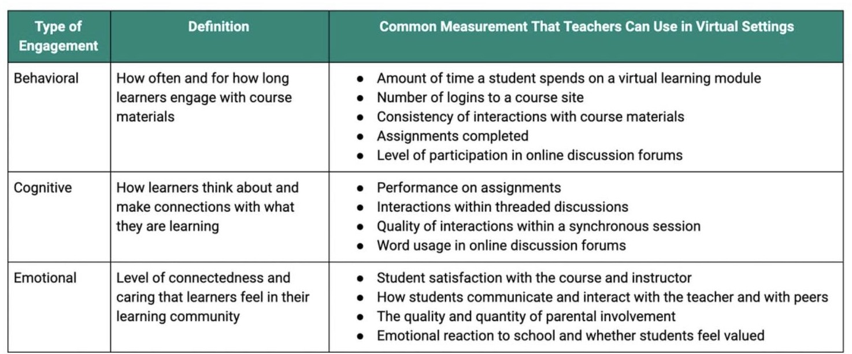

###### Blended Supports for Intensive Intervention:

###### How Can I Provide Supports to Student in a Virtual Setting to Increase Positive Behaviors?

The best way to decrease the likelihood of a a student displaying unwanted behaviors, their academic needs must be met. The best way to meet those academic needs is to ensure the delivery of intervention strategies and differentiation. Below you will find some way to provide academic interventions to increase on-task time.

|  |  |  |
| --- | --- | --- |
| **Intensification Practice Categories** | **Synchronous** | **Asynchronous** |
| 1. Change intervention dosage or time | •Virtual features to increase response opportunities (e.g., polling, annotation)  •Shorter and more frequent sessions | •Access to recorded intervention sessions  •Supports for parents and families to practice with their student |
| 2. Change learning environment to promote  attention and engagement | •Small group or individual breakout groups  •Visual cues to remain on-task | •Virtual class resource space  •Multimedia resources and activities |
| 3. Combine cognitive processing strategies with academic learning | •Virtual note-taking templates and graphic organizers  •Self-regulation and self- monitoring supports | •Support with offline organization skills  •Self-regulation and self-monitoring supports |
| 4. Modify delivery of instruction | •Explicit, systematic instruction with visual and auditory aids  •Virtual features to increase feedback opportunities (e.g., chat pod, breakouts) | •Structured independent practice opportunities with feedback (e.g., submission of video, online quiz, etc.) |

(The National Center for Intensive Intervention)

###### The Critical Role of Families How Teachers Can Increase Parent Engagement in a Remote Classroom

[Research](https://files.eric.ed.gov/fulltext/EJ1085792.pdf) has shown that the involvement of a responsible adult, typically a parent, is critical to the success of online learners. K-12 learners need the support of a caring adult to build executive functioning, manage their workload and maintain motivation. Teachers can support parents in this role by implementing a few key practices:

* **Connect with parents:** Phone calls and emails help parents feel connected, realizing that the teacher is there to support the entire family and considering their needs.
* **Provide a schedule:** Parents can use a schedule that shows the days and times of synchronous classes and includes what activities students should be working on each day to help keep students on task.
* **Offer tech support:** Teachers can create short videos to help parents understand how to access their online content.
* **Less is more:** Parents can quickly become inundated with well-intentioned emails from various teachers. Keeping emails short, focused, and transparent is best.
* **Survey parents:** Periodic, brief surveys can help teachers understand what support parents need.
* **Provide Resources**: Connect parents, families, and community members to Mental health/community health speakers, record videos and share with school community and/or provide them with sample lessons to try at home

###### How Can I Use Reinforcers as a Digital Intervention Strategy?

Reinforcers can be used to address challenging behavior(s) that result in a student receiving a reward/reinforcer (e.g., attention) for the removal of something undesired to avoid predictable behaviors.

Implementation Procedure:

1. Identify the problem behavior and the hypothesized function (e.g., attention, escape, avoidance, sensory).
2. Develop a fixed schedule of reinforcement in order to provide the student with reinforcement before the problem behavior occurs.
3. Adapt the schedule of reinforcement based on the student’s needs and developmental level. For young students or students with severe behavior problems, a very dense schedule of reinforcement should be used (i.e., once every 30 seconds).
4. Provide reinforcement based on the schedule chosen. Use planned ignoring when the problem behavior first reoccurs. After planned ignoring has been used for a short time (e.g., 15–30 seconds), the teacher may reorient the student to the task in a manner that provides limited attention.
5. Monitor the student’s behavioral performance and decrease the frequency of reinforcement as the behavior

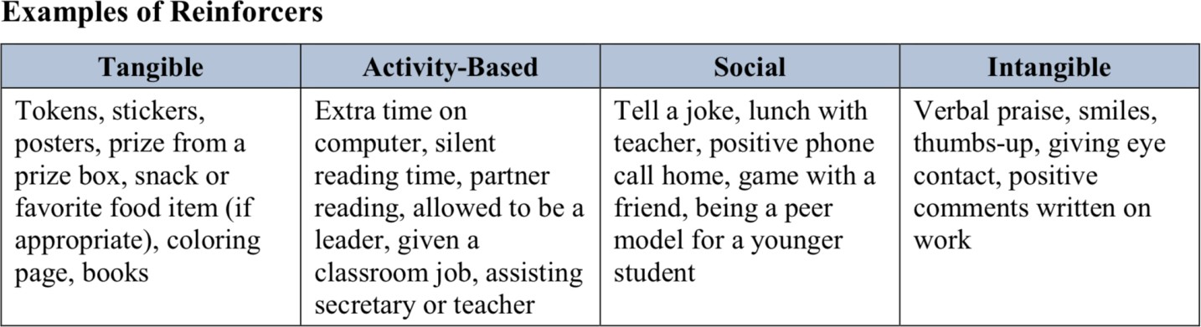

improves.

Other reinforcers for obtaining attention can be as simple as allowing students additional time with activity of choice:

* + Teacher has a one-on-one “virtual snack time” with student
  + Coordinator plays a virtual game with student or facilitates virtual social time with other students from the class (e.g., lunch bunch)
  + Earned “breaks” from online learning or extended lunch time
  + Additional student sharing time online

–Telling Joke/Story

–Developing and sharing a video (e.g., using Flipgrid), etc

**Social Emotional Learning Intervention Menu**

|  |  |  |  |  |
| --- | --- | --- | --- | --- |
| **Intervention** | **Intervention Description** | **Domain** | **Tier** | **Grades** |
| **2x10**  **Relationship Building** | The 2 x 10 intervention is spending 2 minutes per day with a student for 10 consecutive school days to talk with the student about anything they want to talk about for relationship building or to offer extra social-emotional support. | Behavior | Tier 2 | PK-12 |
| **Asking for Help** | Help students identify areas in their lives in which they could use support and construct an explicit request for support. | SEL | Tier 2 | K-12 |
| **Attendance Incentive Plan** | Create an individualized attendance success plan with the student and his/her family. Provide positive reinforcement using the student's preferred incentive when the student  makes consistent progress getting to school on time. | Attendance | Tier 2,  Tier 3 | PK-12 |
| **Bear Belly Breathing** | A simple activity for young children to help introduce them to mindful breathing. | SEL | Tier 1,  Tier 2 | PK-5 |

|  |  |  |  |  |
| --- | --- | --- | --- | --- |
| **Behavior Improvement Plan** | A Behavior Intervention Plan (BIP) is a written plan that teaches and rewards a desired behavior and decreases the frequency of an unexpected or maladaptive behavior. The plan has three main parts: 1. Detailed description of the undesired behavior (frequency of occurrence, time of day, setting, reinforcers, etc.) 2. Detailed description of the replacement behavior 3. Preventative strategies (changes to the physical environment or supports to make the behavior less likely) 4. Teaching strategies - meaningful practice opportunities for the replacement behavior 5.  Reinforcers and supports for the desired behavior 6. Data collection plan for progress monitoring. | Behavior | Tier 3 | PK-12 |
| **Body Scan** | A mindfulness activity to guide students in relaxing and exploring their sensory awareness skills. | SEL | Tier 1,  Tier 2 | K-8 |
| **Calm-Breathing Techniques** | Help students understand what it feels like to be calm and to learn and practice several calm-breathing techniques. | SEL | Tier 1,  Tier 2 | PK-5 |
| **Challenge the Challenging** | Use this move from [CharacterStrong](http://www.characterstrong.com/) to connect with your students beyond the classroom material & build stronger relationships. | SEL | Tier 2 | K-12 |
| **Counseling** | School counselors offer counseling to help students resolve personal or interpersonal problems or target specific skills; for example, improving social skills, impulse control, or regulating emotions. | SEL, Behavior | Tier 3 | PK-12 |
| **Emotion Menu** | Use a visual aid, such as a poster, to teach students to identify their feelings. | SEL, Behavior | Tier 2 | PK-5 |
| **Empathy Exercise** | Encourage students to be more empathetic and increase perceptions of “connectedness” in your classroom using a short self-reflection questionnaire. | SEL | Tier 1,  Tier 2 | 6-12 |
| **Feelings Journal** | Support students in becoming more aware of their feelings and what they can do to regulate strong feelings by journaling for 1 week. | SEL | Tier 1,  Tier 2 | PK-8 |
| **Feelings Journal** | Help students become more aware of their feelings and what they can do to regulate strong feelings. | SEL | Tier 1,  Tier 2 | K-8 |
| **Guardian Meeting** | A meeting with a student's parents/ guardians to discuss a specific concern about the student, understand the family's perspective, and collaboratively generate solutions. | Attendance, Behavior, SEL, ELA, Math, Other Academic | Tier 1,  Tier 2,  Tier 3 | PK-12 |
| **Home Visit** | Visits by teachers to student’s homes to meet with parents/ guardians to create connections and build trust that can help foster parent involvement. | Attendance, Behavior, SEL, ELA, Math, Other  Academic | Tier 1,  Tier 2,  Tier 3 | PK-12 |
| **Lunch Bunch** | A "Lunch Bunch" is a small group of students who meet with a teacher or counselor away from their usual lunch place. For teachers, it’s an important time to build connections and learn about students. For counselors, it's | Behavior, SEL | Tier 2,  Tier 3 | K-12 |

|  |  |  |  |  |
| --- | --- | --- | --- | --- |
|  | a space to work towards a specific goal. Goals and duration vary between groups |  |  |  |
| **Make a Face** | Children learn a simple way to “make change” – by changing their facial expression, they can change how  they’re feeling and acting and, by extension, how others experience them. | SEL | Tier 1,  Tier 2 | PK-5 |
| **Mind Sweep** | This SEL intervention from Panorama Playbook partner [CharacterStrong](http://www.characterstrong.com/) helps students reframe negative  thoughts and turn them into productive energy. | SEL | Tier 1,  Tier 2 | K-12 |
| **Nudge Letter** | Improve student attendance by mailing "nudge" letters to families to raise family awareness about their student's absences. Write a personalized letter to the student's family including the number of days the student has missed so far this school year and a comparison of that tally to the average number of absences in the student's  class or school. | Attendance | Tier 1,  Tier 2 | PK-12 |
| **Peer Mentoring** | Peer mentoring is a structured relationship in which a more experienced or knowledgeable peer helps to guide a less experienced or knowledgeable peer. Models can be the same grade or mixed age; one-on-one, or small group.  When the focus is on building caring, empathic, and supportive relationships, the strongest effects for mentees appear to be increases in school attitudes (e.g., connectedness), relationships with adults (both teachers and parents) and peers, and improvements in internal  affective states (e.g., self-esteem). | SEL, Behavior | Tier 1,  Tier 2 | 4-12 |
| **Phone Call Home** | There are many reasons to call home: relationship building, positive reinforcement, solicit support, or share a concern. | Attendance, Behavior, SEL, ELA, Math, Other Academic | Tier 1,  Tier 2,  Tier 3 | PK-12 |
| **Positive Self- Talk** | Help students learn to define and practice using positive self-talk. | SEL | Tier 2 | PK-5 |
| **Rapid Positive Reinforcement** | Rapid Positive Reinforcement encourages students to increase the frequency of a target behavior by providing consistent, immediate positive reinforcement. | Behavior | Tier 2,  Tier 3 | PK-8 |
| **Repeated Readings** | Repeated reading is an academic practice that aims to increase oral reading fluency. Repeated reading can be used with students who have developed initial word reading skills but demonstrate inadequate reading fluency  for their grade level. | ELA | Tier 2;  Tier 3 | K-8 |
| **Rose, Bud, Thorn** | Students will be able to identify positive moments and areas where they need support. | SEL | Tier 1,  Tier 2 | K-12 |

|  |  |  |  |  |
| --- | --- | --- | --- | --- |
| **Self- Monitoring** | Self-monitoring strategies are individualized plans used to increase independence and awareness in academic, behavioral, and social areas. The student measures and records his or her own behavior and then compares that to behavior recorded by the teacher or an academic exemplar.   1. Define the target behavior or skill. 2. Select or develop the self-monitoring checklist. 3. Introduce goal/ exemplar and self-monitoring checklist to the student. Invest him/ her in increasing awareness/ independence. Practice procedure for recording behavior   and comparing to teacher/ exemplar.   1. Determine a self-monitoring schedule and reserve time to reflect with the student on a daily or weekly cadence. | Behavior, SEL | Tier 1,  Tier 2,  Tier 3 | K-12 |
| **Storytime: Seeing Inside** | Integrated with everyday story time, this perspective-  taking activity gives children an opportunity to practice seeing the world from multiple points of view. | SEL | Tier 1,  Tier 2 | PK-5 |
| **Temperature Check** | The intentional practice (designed by Panorama Playbook partner [CharacterStrong](http://www.characterstrong.com/)) of proactively checking in with your students at least once per week as a way of giving students a voice by enabling them to share how they are doing and what they are thinking about their experiences in class. | SEL | Tier 1,  Tier 2 | K-12 |
| **The Positive Pivot** | The Positive Pivot is a scale that is used to help students examine the different types of responses they have to conflicts and challenging situations. In this exercise, students are introduced to the Positive Pivot scale and are taught how it can be used. | SEL | Tier 2 | K-12 |
| **Two Word Check-In** | A simple yet powerful exercise that enhances emotional awareness, promotes authenticity, and builds community. | SEL | Tier 1,  Tier 2 | K-5 |
| **WOOP** | WOOP stands for Wish, Outcome, Obstacle, and Plan. WOOP helps you to explore what your wish is as well as the barriers that hold you back from fulfilling this desire. | SEL | Tier 1,  Tier 2 | K-12 |