What does it mean to be a Paideia School?

* Seminars: Students focus on a text and discuss the ideas and values within it, building social and communication skills in the process. Such texts can be songs, paintings, books, videos, photographs and so much more.

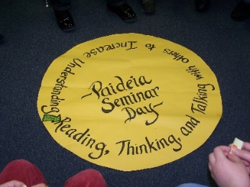

* Coached Projects: Students study a topic from grade level South Carolina state standards and work to create and then present a final product or performance that is shared with an authentic audience.

* Student-led Conferences: Students share portfolios of their work with their family, discussing what they learned, celebrations from the nine weeks, and goals for the following nine weeks.

**Meadowfield Elementary School**

**Laura Gisler, Paideia Lead Teacher**