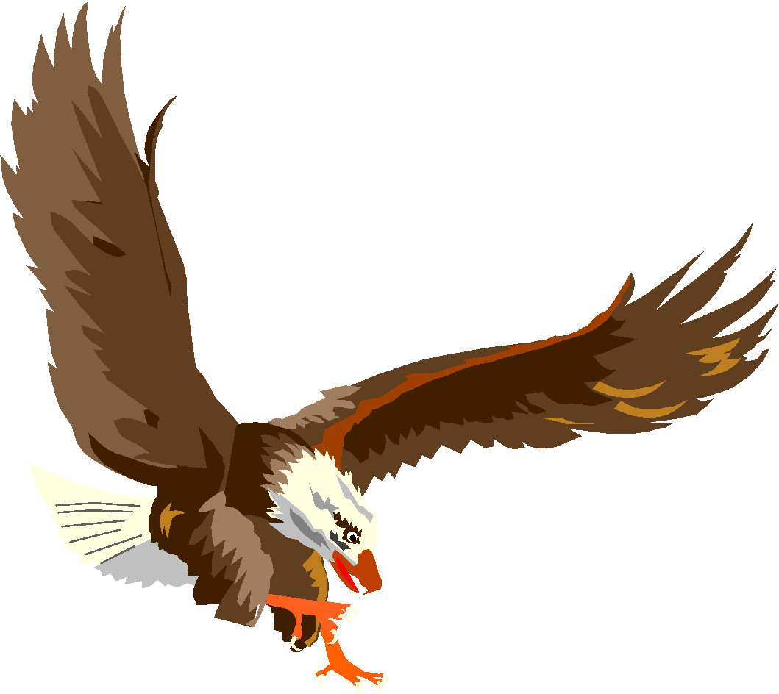

***BERMUDIAN SPRINGS***

***BASEBALL***

***2023 - 2024***

|  |  |  |  |
| --- | --- | --- | --- |
| **UNIFORM #** | **NAME** | **CLASS** | **POSITION** |
| 1 | Brayden Heller | Sophomore | INF/OF/P |
| 2 | Branson Diller | Sophomore | INF/P |
| 3 | Cal Chubb | Junior | OF |
| 4 | Ayden Knight | Sophomore | OF/P |
| 5 | Dakota Laughman | Sophomore | OF |
| 6 | Ethan Shearer | Senior | INF/P |
| 7 | Skyler Gentzler | Junior | INF/P |
| 8 | Gabe Kline | Senior | INF/OF/P |
| 9 | Liam Cook | Senior | INF/P/C |
| 11 | Ben Ogle | Senior | INF/OF/P |
| 12 | Evan Shearer | Senior | INF |
| 13 | Dylan Hubbard | Junior | OF |
| 14 | Nate Ogle | Freshman | OF/P |
| 17 | Myles Shearer | Senior | INF/P |
| 18 | Jaxsyn Stottlemyer | Sophomore | INF/OF/P |
| 19 | Ryder Powell | Sophomore | INF |
| 20 | Aiden Aponte | Junior | INF |
| 21 | Nathan Keller | Junior | INF/P |
| 22 | Tyson Carpenter | Senior | INF/P |
| 23 | Lane Hubbard | Sophomore | INF/P |
| 24 | Zackary Thomas | Junior | INF/P |
| 25 | Linkoln Heagy | Sophomore | OF/P |
| 26 | Landon Kaltreider | Sophomore | INF |
| 27 | Mason Diaz | Senior | INF/C/P |
| 28 | Gavin Reinert | Freshman | OF/P |
| 29 | Levi Stahl | Sophomore | OF |
| 32 | William Oyler | Junior | INF/OF/C |
| 33 | Teegan Byers | Sophomore | INF/C/P |
| 34 | Austin Reinert | Senior | INF/P |
| 35 | Kaine Klindinst | Freshman | INF/C |
| 39 | Trenton Smith | Junior | INF/OF |

**Head Coach: Jeff Carpenter**

**Varsity Assistant Coach: Doug Speelman**

**Volunteer Varsity Assistant Coach: Brendan Reinert**

**Volunteer Varsity Assistant Coach: Dan Hubbard**

**JV Head Coach: Travis Byers**

**JV Assistant Coach: Aden Juelich**

**Volunteer JV Assistant Coach: Mike Moore**

**Volunteer JV Assistant Coach: Paul Fredericksen**