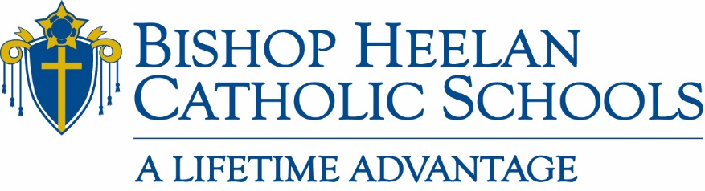

Board of Education Meeting Minutes
Tuesday, June 15, 2021
Administration Office

Members Present: Fr. Brad Pelzel, Rick Bertrand, Dan Kriener, Jacki Kelly, Fr. David Esquiliano, Tim Brown, Tim Swedean, Fr. Terry Roder

*via phone conference: Doug Skinner, Melissa Uhl, Nick Hegarty

Members Absent: Fr. David Hemann, Luis Villalobos, Fr. Dan Rupp, Bridget Breen

Staff Present: John Flanery, Jeanette Frey, Marisa O’Connell
Business
- Opening Prayer – 5:00 p.m. led by Fr. David Esquiliano

- Approval of May 18, 2021 board meeting minutes
Motion by Fr. David Esquiliano; Seconded by Tim Swedean
All in favor: Aye

- President’s report
      - Enrollment Report
        - Budgeted for 1520 students.
        - 43 families were on hold.
          - 8 of those holds were released.
          - 17 have responded.
          - 18 families are a concern for next year.
        - Jeanette will research amount of tuition dollars not collected.

      - Advancement
        - Director of Annual Giving
          - Second candidate did not work out for position.
          - A six month to one year solution will be implemented which will be to divide Director of Annual Giving duties between Tammy and Janet, plus we have a 1-year contract with Prenger to utilize.
        - Auction Recap
          - Over 400 tickets sold.
          - Approximately $325,000 range for funds raised.
          - All food vendors donated the cost of food towards event.
          - Sound system was biggest issue – next year will add speakers in correct areas.
          - Alcohol vendor not fully prepared – require better clarification regarding our needs for event.

      - Textbook Projections
          - Schools have not been good at replacing schoolbooks in the past.
          - Consolidate state funds to distribute to schools.
          - Attachment provided shows different options regarding textbook needs and options.
          - Board voted for Option #1
              - Motion to Approve Option #1-Fr. Brad Pelzel
              - Seconded by-Fr. Roder
              - All in favor-Aye
      - EANS Funds
          - Fr Brad Pelzel stated that Patty Lansink is now trying to contact the governor to discuss EANS funds due to a lack of response from original contact (Ann LeBo).
          - John met with principals regarding initial tech needs per school.
          - Some items need prior approval before being purchased.
          - One option is for BHCS to buy items and submit for reimbursement.

      - Personnel Updates
          - Head Strength & Conditioning Coach-Trevor Westhoff
          - Holy Cross Principal-Wendy Roder
          - Co-Athletic Directors (both have verbally accepted)
            - Andy Foster
            - Jay Wright
          - Contracts for 1 year to determine success.
          - Looking for 2 varsity basketball coaches
          - Middle school athletic directors report to high school athletic directors for consistency
          - Move Gold Club duties to Athletic Dept. and away from Advancement team.

- Sub-Committee Reports
      - Academics
        - Luis Villalobos unavailable for update.
      - Catholic Identity
        - Music selection for games and in weight room was discussed.
          - Can limit or block certain music through “Sonos”.
          - Check with Fr. Shane Deman regarding this system.
        - New member should be identified in July,2021.
      - Enrollment & Marketing
        - Committee met, but we were unable to get an update today.
      - Finance
        - Jeanette to research the tuition balance for families on hold.
        - Jeanette to research what tuition balances were during the month of May for last 2 years.
        - Need to identify internal process as to “when” families are turned over to collections.
        - If families are turned over to collections, Yvette reverses all tuition assistance given to them.
        - At this time, we do not turn over any active students or families to collections.
        - We are averaging 16-18% in uncollected receivables.
        - Letter blast to approximately 40 families regarding their accounts.
        - End of June, statements along with letters will be sent to families.
        - Letters will contain verbiage explaining 1/10th payment, link to Infinite Campus and additional directions regarding processes for 2021-2022 school year.
        - This is the first year we have implemented a “hold” process.
        - Vote on Lunchtime Solutions proposal
          - Motion by Tim Swedean
          - Seconded by Fr. Brad Pelzel
          - All in favor: Aye
      - Leadership & Governance
        - Proposed that the board of education review Diocesan policies on an annual basis.
        - Will attend meeting in fall at Storm Lake to discuss policies.
        - Looking for volunteers for committee.

Next meeting Tuesday, July 20, 2021 at 5:00 p.m.

