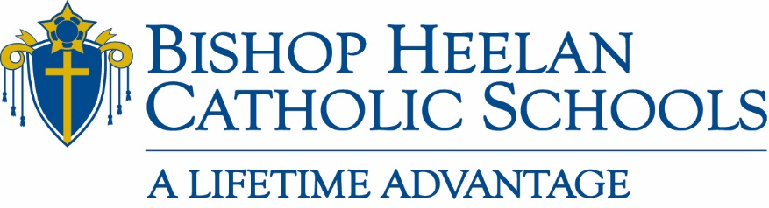

Board of Education Meeting Minutes
Tuesday, September 21, 2021
Administration Office

Members Present: Nick Hegarty, Tim Swedean, Doug Skinner, Fr. Brad Pelzel, Rick Bertrand, Jacki Kelly, Dan Kriener, Fr. David Esquiliano, Jennifer Rose-Bass, Melissa Uhl

*via phone conference: Luis Villalobos

Members Absent: Fr. David Hemann, Bridget Breen, Fr. Terry Roder

Staff Present: John Flanery, Jeanette Frey, Laurie Dougherty, Marisa O’Connell
Business
- Opening Prayer – 5:00 p.m. led by Fr. Brad Pelzel

Note following corrections to the August 17,2021 Board of Education Meeting Minutes
- Jeanette Frey did not attend August 17,2021 Board of Education meeting
- Approval of board meeting minutes should state for July 15,2021 meeting instead of
June 15, 2021
- Diocesan Corporate Resolution – Board chair, Nick Hegarty, made a motion to amend August board meeting minutes to note Diocesan Corporate Resolution was voted on and unanimously approved

- Approval of August 17,2021 board meeting minutes
Motion by Dan Kriener; Seconded by Melissa Uhl
All in favor: Aye

- Laurie Dougherty – Enrollment Report
  - 20-21 beginning enrollment - 1504
  - 20-21 end of year enrollment - 1518
  - 20-21 students withdrew - 242
  - 21-22 beginning enrollment - 1560
  - 21-22 students withdrew (primarily due to financial reasons) – 283
  - Largest Freshman class in several years
  - 17 states have started utilizing “voucher systems”
  - Affordability:
    - $55,000 median family income
    - Suggested a good lobbyist to represent our needs at the state level – lobby for state to issue funds to our school system from taxes, roads etc. that public schools receive
  - Rick Bertrand felt that ESA’s would be a topic in the Iowa Legislature again this year
  - Superintendents will go to Des Moines in January, suggested that Laurie be in attendance

- President’s Report
  - Covid Update
  - District court voted to allow mask mandates
  - Diocesan press release stated that we will not be changing our current procedures regarding masks. We do not fall under the judges ruling
  - Averaging 4 new Covid cases a week system wide
  - Advancement
  - Staffing
    - Director of Annual Giving, Patty Considine, will begin October 25th
  - Siouxland Big Give
    - Big Give will be for the Crusader Courtyard, picnic tables and benches. We purchased 29 tables, 8 benches. We are getting trash receptacles and 4 handicapped accessible tables.
  - MLTF
    - Goal has not been met since 2018
    - Increase tax credits up 75% - 18.1% sold so far
  - Gold Club
    - 9/16/2021 - $147,308 – Goal is $160,000 (need for chartered buses)
  - EANS Funds
  - Reimbursement begins in October (Thompson contract, Best Buy, cleaning supplies)
  - Second round most likely available in January 2022
  - FIRE Update
  - Fundraising event held – good success
  - BVU professor, Karen Shromeyer, met with teachers; IEP meeting at Holy Cross
  - Sioux City schools working better with us regarding students with IEP’s
  - Personnel Updates
  - Short 1 PE teacher position at Holy Cross
  - Volunteers or substitute teachers cannot fill position
  - Hispanic Heritage Event
  - Kermesse festival to be held on Sunday, September 26th, 11:00 – 3:00
  - Encourage more participation from Hispanic community
  - Fundraiser involving Hispanic families

- Sub-Committee Reports
  - Academics
  - Per Luis Villalobos, no report at this time
  - Catholic Identity
  - Reviewed and approved Catholicism 101
  - 75 students went to Rochester for Steubenville conference
  - Rekindle Retreat – October 17th in Carroll
  - Enrollment & Marketing
  - Parent/Ambassador program is having great success
  - Representative from Holy Cross will be joining committee
  - Push for utilizing “Win/Win Referral Program” this fall
  - Finance
  - 1/10th of tuition balance is required to be paid each month (August-May)
    - Jeanette to provide budgeted vs actual tuition received
    - Jeanette to provide number of families with children in school with a prior year balance and no payment plan in place
  - Central Bank line of credit expired; need new line of credit with $500,000 limit, 3.75% variable rate
    - Motion to Approve new line of credit outlined above by Dan Kriener
    - Seconded by Tim Swedean
    - All in favor: Aye
  - Pride III Loan Refinance; 5 years at 3.5 fixed rate
    - Motion to Approve refinance by Tim Swedean
    - Seconded by Fr. Brad Pelzel
    - All in favor: Aye
  - Director of Lunch Program position
    - Motion to Approve position; Nick Hegarty Motion to Approve position at $45,000 with benefits, go back to Holy Cross to backfill at $20,000
    - Seconded by Rick Bertrand
    - All in favor: Aye
  - Leadership & Governance
  - Melissa requested more time during October 19th board meeting to review items committee has covered
  - Student to teacher ratios was mentioned – what would be the minimum & maximum numbers?

- Other Business
  - Diocesan meeting on Thursday, September 23rd
  - Rick Bertrand comments
    - Good transition at Holy Cross schools – kids are happy and things are looking very positive!
    - Coach Foster has been doing a great job! The golf tournament with donors was a success and Coach Foster really stepped up his game especially with players at the gate checking into the event
    - The Olympus half-time show was concerning to some parents due to content
  - John shared that approximately 500 students attended the Mary’s place dedication and conducted themselves politely and respectfully. It was a proud moment for our school.
  - Sacred Heart school received a glowing email from a family that has seen an incredible difference with their child since attending Sacred Heart school! Kudos to Sacred Heart – keep up the great job!!

Next meeting Tuesday, October 19, 2021, at 5:00 p.m.

