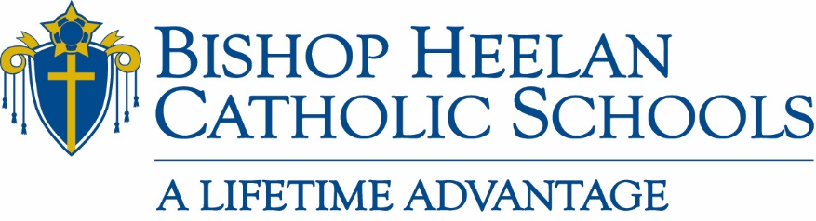

Board of Education Meeting Minutes
Tuesday, November 16,, 2021
Administration Office

Members Present: Nick Hegarty, Tim Swedean, Doug Skinner, Fr. Terry Roder, Fr. Brad Pelzel, Rick Bertrand, Jacki Kelly, Dan Kriener, Fr. David Esquiliano, Jennifer Rose-Bass

Members Absent: Fr. David Hemann, Bridget Breen, Luis Villalobos, Melissa Uhl

Staff Present: John Flanery, Jeanette Frey, Marisa O’Connell

Guest: Mary Fischer, Mater Dei School Principal
Business
- Opening Prayer – 5:00 p.m. led by Fr. Brad Pelzel

- Approval of September 21,2021 board meeting minutes
Motion by Jennifer Rose Bass; Seconded by Fr. Terry Roder
All in favor: Aye

- Mary Fischer – Mater Dei School Update
- Mater Dei School consists of two different buildings
  - Nativity Center
  - Immaculate Conception Center
- Power Point presentation outlining school activities
  - Life Teams for Thanksgiving, Advent, Prayer, Care for the Earth, Lent
  - Children pick theme for year – banner for each building “I can do all things through Christ that strengthens me”
  - Technology improvements due to EAN funds such as 1 to 1 on chrome books, interactive tv’s, 3D printer was also donated

- Sub-Committee Reports have been moved to beginning of board meeting to allow more time to focus on key items
- Report from each committee chair due to John no later than noon on Monday before board meeting
- If sub-committee is keeping minutes from their meetings that will work as the requested report
- Those reports will be included in board packet

- President’s Report
  - Covid Update
    - Student numbers are low
    - Mater Dei had 4 teachers out with covid
    - High School had nearly 10% illness rate for 2 days not Covid related (RSV, sinus, strep) – if we had hit this percentage, we would have needed to contact Siouxland District Health
  - Enrollment
    - Tuition Model Committee will be meeting
    - Add Rick Bertrand to list of committee members
  - Youth Athletics – We Are Heelan
    - Parental meeting on November 3rd to discuss winter sports program expectations
    - AD’s, John Flanery, Fr. Shane will speak with parents
    - Involve high school Athletic Directors and varsity coaching staff with system wide recruitment of athletes from elementary and up
  - Diversity Committee and Tech Committee
    - Reconvene in November
    - High school and elementary groups
  - Emergency Connectivity Fund
    - BHCS will receive $145,280 (for devices only)

- Sub-Committee Reports
  - Academics
  - No update at this time
  - Catholic Identity
  - Pro-life month - Crusaders for Life will be doing some events at Mary’s shelter
  - Middle school retreat in Carroll, IA for forty 7th & 8th graders
  - Bible studies on Thursdays – Lexie will be having more of these sessions
  - Rick Bertrand to be added to list of committee members (meet on Tuesdays)
  - Enrollment & Marketing
  - Kemesse Festival (no expense) raised $2700
  - Create a “task force” for next year’s Kemesse Festival
  - Homecoming program was not well received – need to revamp for next year (perhaps move parade time back for better attendance)
  - Win/Win marketing update through PTO/PTA to maintain guidelines and consistency
  - Kris Brown and Kerry Hope joined the Enrollment and Marketing committee
  - Fyi…Goal to look like one unified school system, our high school and elementary plaids should match – will work on this process
  - Finance
  - Director of Lunch Program
    - Have 8 applicants – Yvette will be reaching out to do preliminary calls this week
  - 75 letters mailed to inactive accounts regarding tuition payments
  - Will mail letters to 85-90 active students this week requesting meetings to do payment plans
  - Currently have 45 payment plans for total of $585,000
  - As of 6/30/21, collected $367,800
  - Auditors
    - Will be gathering more information for auditors
    - Feedback so far has been encouraging
    - Finance Committee to meet with auditors to discuss “Ongoing Concern Opinion” status
    - Jeanette to get a “Covenant Waiver” from Diocese for an extension to December 30, 2021
  - Leadership & Governance
  - No update at this time
- Other Business
  - John to forward email to Board regarding meeting on November 8, 2021 at 5:00 p.m. at the Administration building to meet with Meitler Group
  - Jake Weist and Joe Meyer are National Merit Semi-Finalists
- Motion to Adjourn
  - Motion to adjourn – Fr. Brad Pelzel
  - Seconded – Tim Swedean

Next meeting Tuesday, November 16, 2021, at 5:00 p.m.

