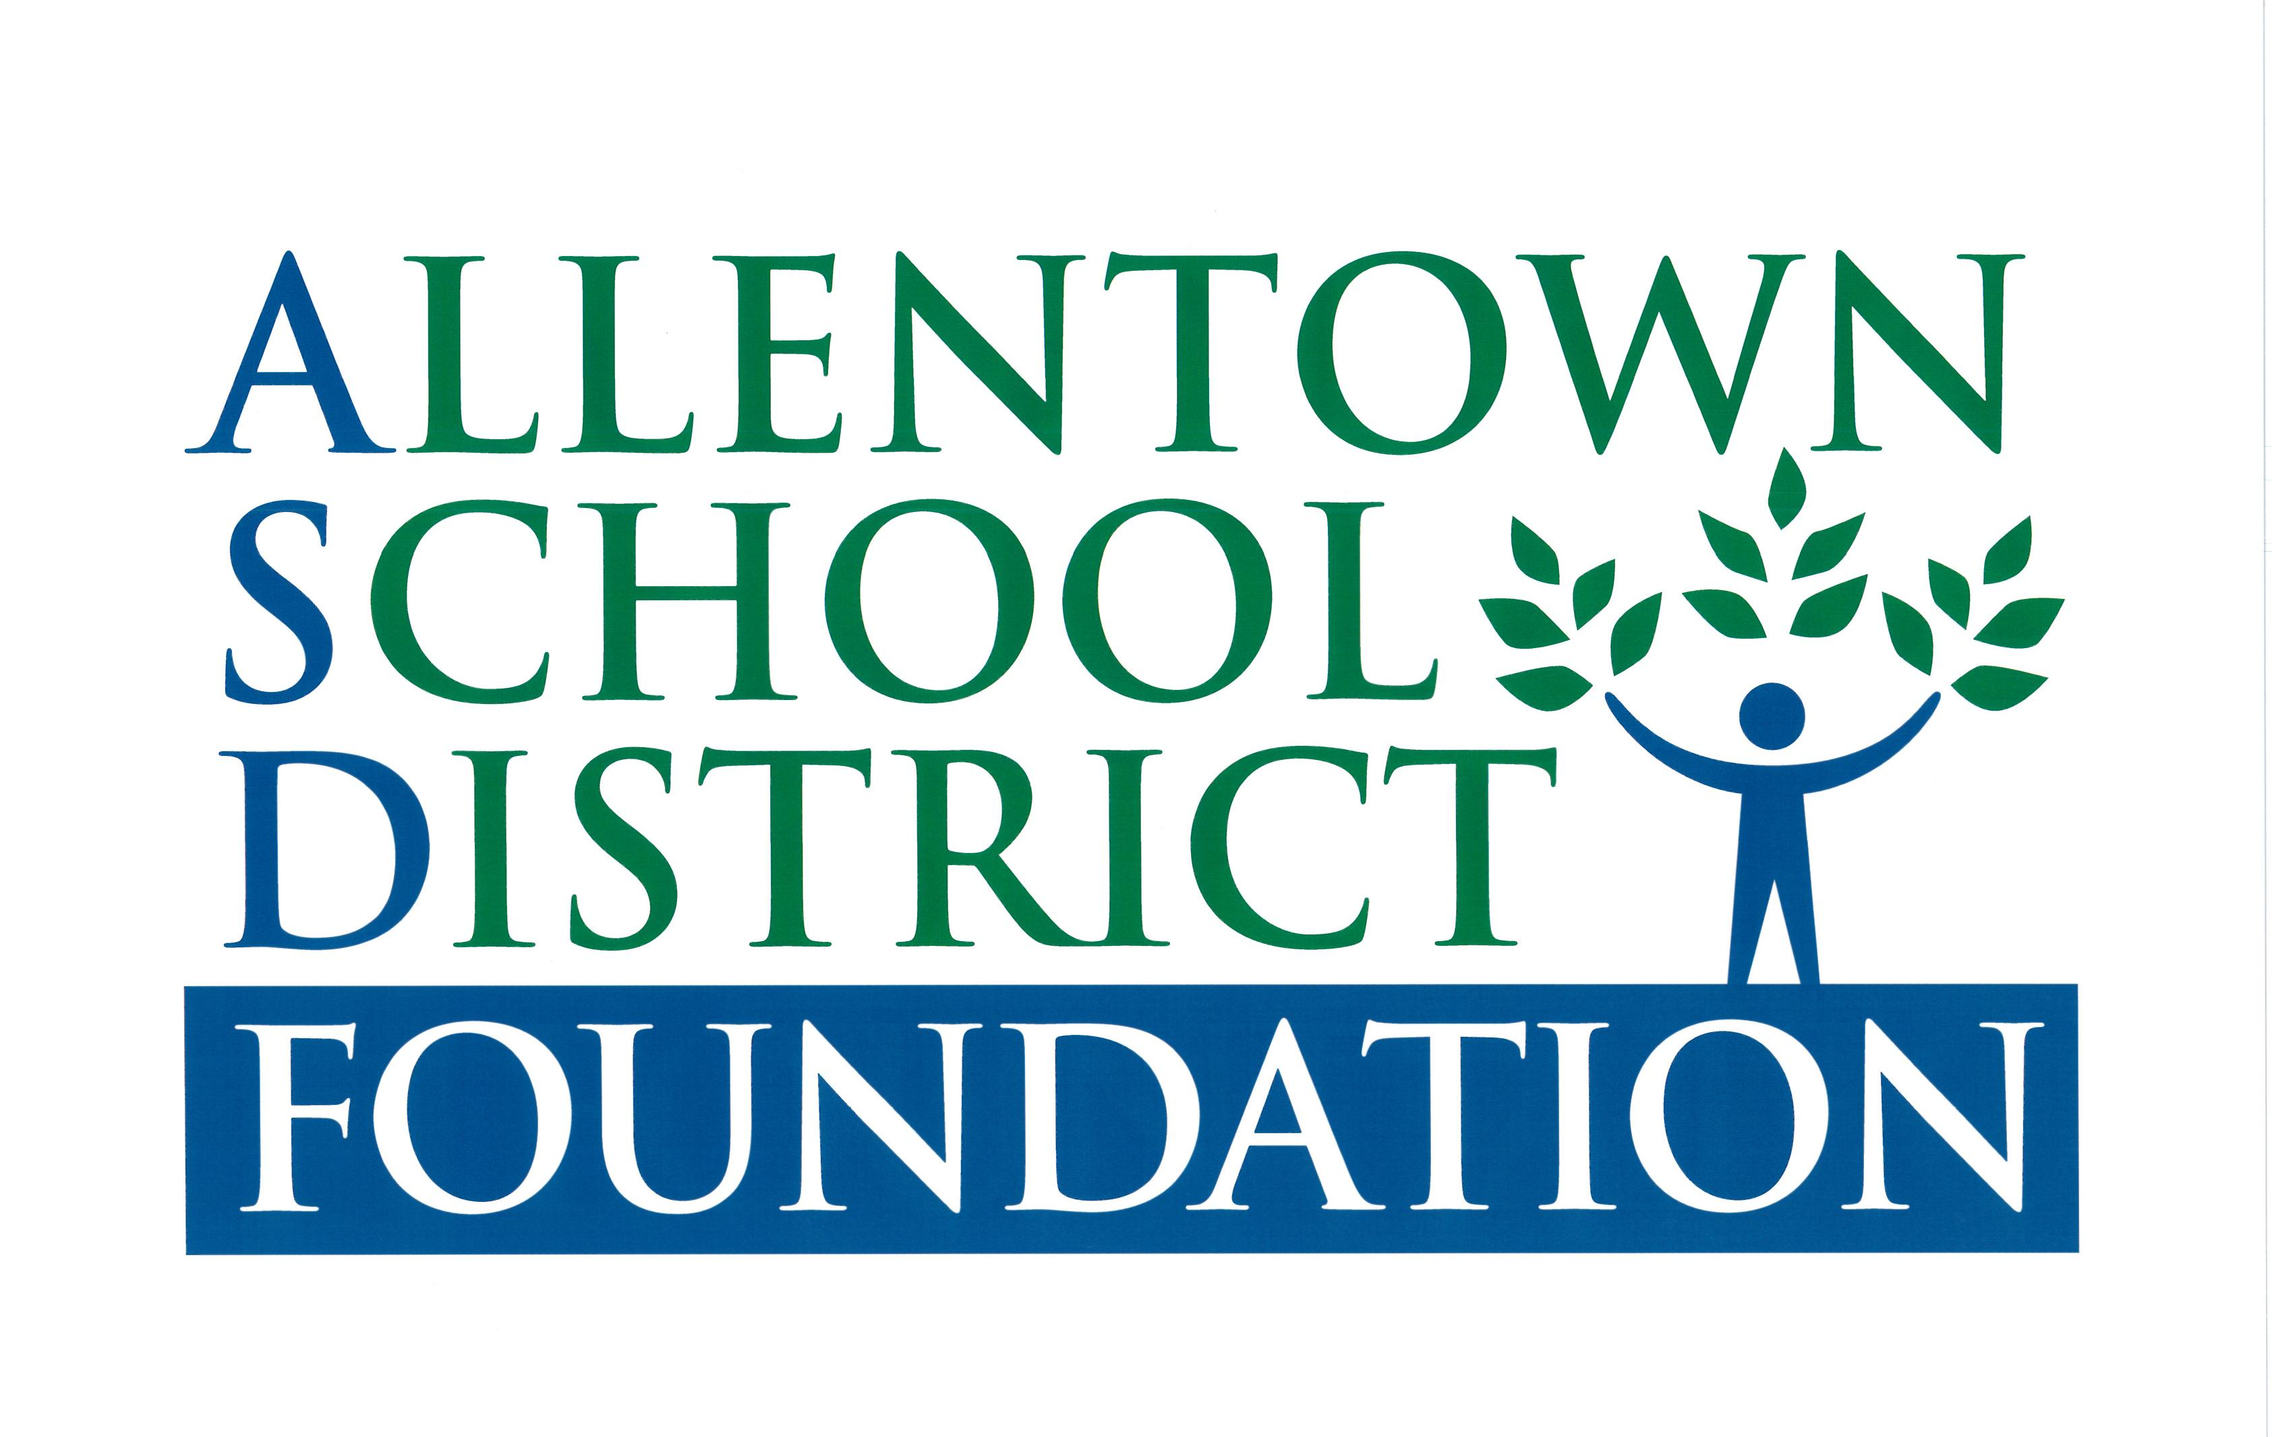

**31 South Penn Street, P.O. Box 328, Allentown, PA 18105**

**484-765-4121**

**IN-KIND DONATION FORM**

The mission of The Allentown School District Foundation (ASDF) is to encourage, promote, support and fund positive educational experiences for students in the Allentown School District.

ASDF supports and encourages independent gifts which will benefit the Allentown School District and its students and which fall outside of the Foundation’s strategic priorities and programming and normal fundraising efforts.

Because the Foundation is a 501(c)(3) not for profit corporation, individuals and corporations may make tax deductible inkind donations to the Foundation for the direct benefit of the District. Just a few examples of past inkind gifts include technology and computers, musical instruments, athletic gear and field equipment, theatre costumes, lighting and sound, playground physical improvements and art and literacy materials. As a 501(c)(3) corporation, ASDF serves as a pass-through for these tax-deductible gifts which benefit the District.

If you have an interest in making an inkind donation, please complete the form below and return it to ASDF, 31 S. Penn Street, P.O. Box 328, Allentown, PA 18105. If you have any questions concerning this form, please call the Foundation at 484-765-4121. Please note that the Foundation’s 501(c)(3) tax exempt number is 27-0743152.

Date: ________________

Donor(s) Name(s): __________________________________________________________________________

Organization Name and Contact Person: ________________________________________________________

Address: __________________________________________________________________________________

Phone:__________________________________ Email: ___________________________________________

Description of Item(s) (include quantities): _______________________________________________________

__________________________________________________________________________________________

Estimated Fair Market Value: $________________

Donor(s) Signature: _____________________________________________________Date _______________

ASD Superintendent (or Designee) Signature: _________________________________Date _______________

ASDF Executive Director Signature:__________________________________________Date_______________

**INKIND DONATION GUIDELINES**

* Inkind donations must meet the standard charitable organization rules as outlined by the Federal Accounting Standards Board (FASB). Donations will be recognized and recorded.
* The following criteria must be met: (1) the donation must be useful; (2) the service creates or enhances a non-financial asset.
* Inkind contributions require the completion of the ASDF Inkind Donation Form. All supporting documentation for the inkind gift should be included with the form.
* The Estimated Fair Market Value (FMV) must be completed by the donor. The Foundation cannot place a FMV amount or interpret the value of any non-financial donations.
* Inkind contributions require the approval of the ASDF Executive Committee and the Superintendent of the Allentown School District or his or her designee.
* A formal letter will be sent to the donor and a copy of the notice will be retained for our records.
* In-kind gifts are non-cash contributions of goods or services. They may be considered conduit contributions but require this form to be completed.