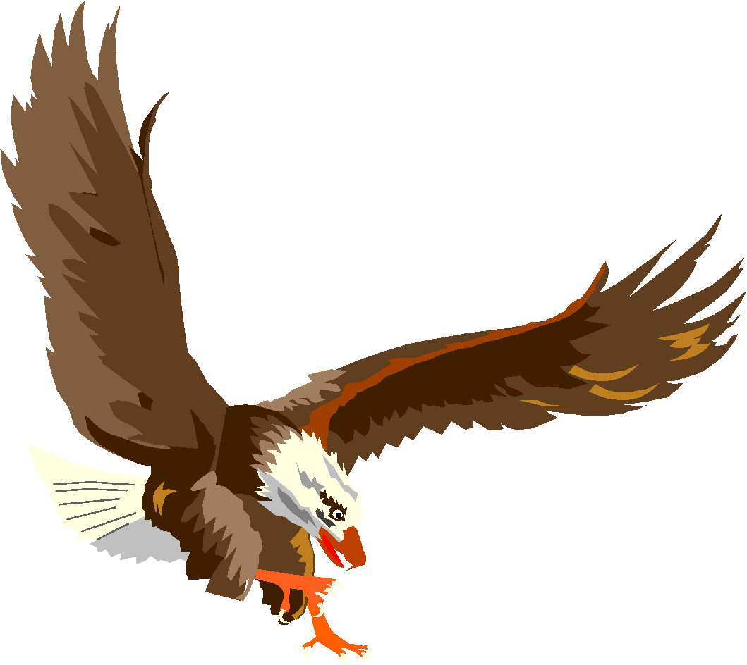

***2022 BERMUDIAN SPRINGS***

***JH FOOTBALL CHEERLEADING***

|  |  |
| --- | --- |
| **NAME** | **CLASS** |
| Peyten Snyder | 2028 |
| Autumn Hoffman | 2028 |
| Rylee Bolyard | 2028 |
| Kierstyn Thomas | 2028 |
| Zoey Harget | 2028 |
| Layla Mummert | 2028 |
| Jaelyn Johnson | 2028 |
| Ella Zeltwanger | 2028 |
| Emma Chubb | 2028 |
| Mackenzie Price | 2028 |
| Leah Ginter | 2028 |
| Violet Corallo | 2029 |
| Jorja Noel | 2029 |
| Elizabeth Miller | 2029 |
| Cordelia Yost | 2029 |
| Lillian Bothe | 2029 |
| Kenley Long | 2029 |
| Addyson Robertson | 2029 |
| Riley Powers | 2029 |
| Eishally Lua | 2029 |
| Aine Driscoll | 2029 |

**JH Football Cheerleading Coach: Suzy Schaer**