***2023 BERMUDIAN SPRINGS*** 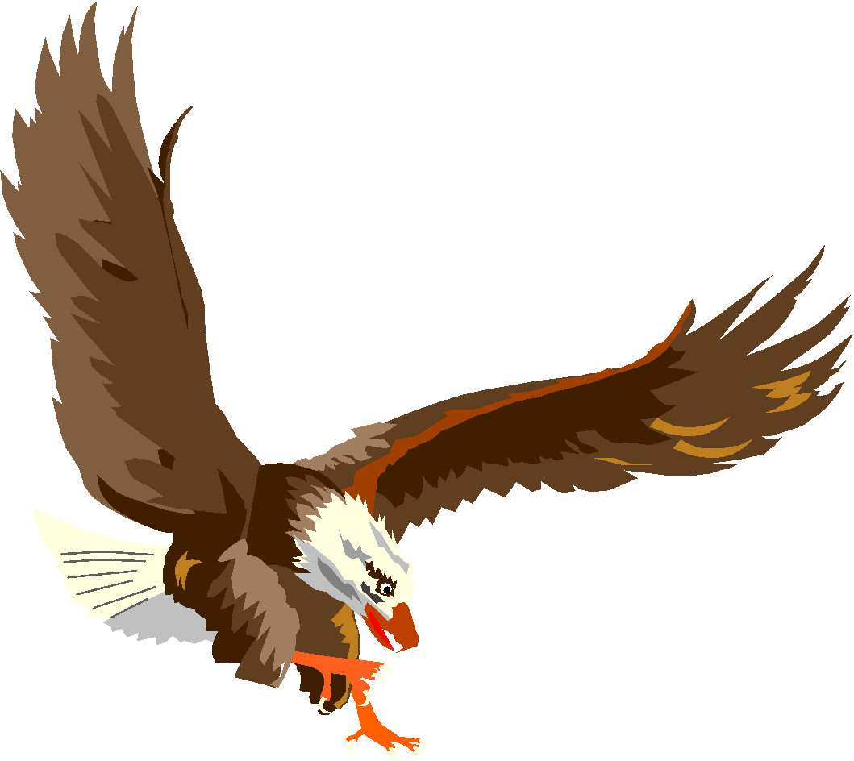

***VARSITY FOOTBALL CHEERLEADING***



| Clarissa Prosser | 2024 |
| --- | --- |
| Brieah Reed | 2024 |
| Valarie Starner | 2024 |
| Rylie Litzinger | 2025 |
| Tayler Bechtel | 2026 |
| Anna Foreman | 2026 |
| Kylee Hermansen | 2026 |
| Nevaeh Lener | 2026 |
| Tori Livelsberger | 2026 |
| Victoria Starner | 2026 |
| Aubree Berwager | 2027 |
| Nylee Himes | 2027 |
| Camdyn Kittinger | 2027 |
| Kali Kline | 2027 |
| Cameryn McIlwee | 2027 |
| Lorraine Reever | 2027 |

**Varsity Cheerleading Coach: Kim Friedman**

**Assistant Cheerleading Coach: Trudy Livelsberger**

**Volunteer Coach: Erin Friedman**