***2023 BERMUDIAN SPRINGS GOLF***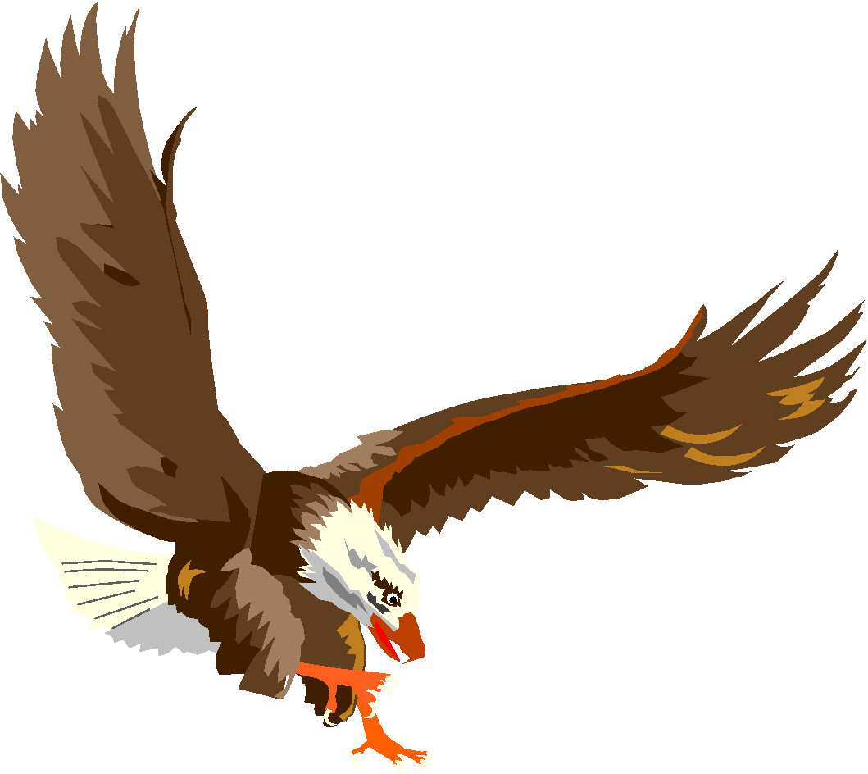



| **NAME** | **CLASS** |
| --- | --- |
| Mason Diaz | Sr. |
| Colby Kyzer | Sr. |
| Liam Cook | Sr. |
| Austin Reinert | Sr. |
| Mitchell McClintic | Sr. |
| James Downey | Sr. |
| Ethan Shearer | Sr. |
| Zachery Thomas | Jr. |
| Derek Freeman | Jr. |
| Lincoln Heagy | So. |
| Leila Derieux | So. |
| Halleigh Minck | So. |
| Brady Harder | So. |
| Ryder Powell | So. |
| Teegan Byers | So. |
| Cameron Henning | Fr. |

**Head Coach: Paul Fredericksen**

**Assistant Coach: Brian Oswald**