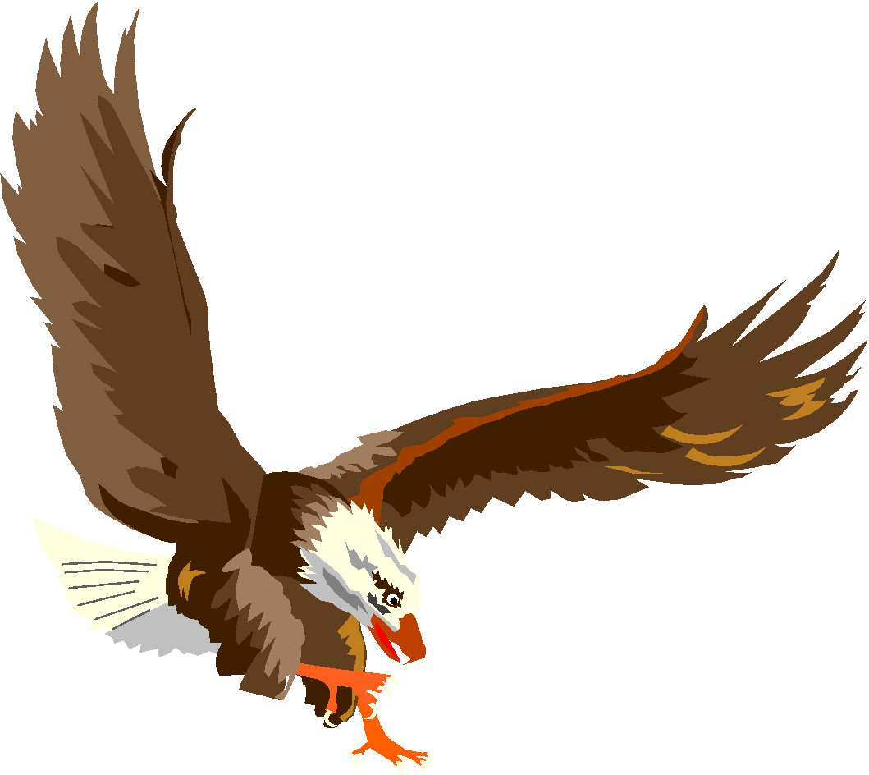

***2023-2024***

***BERMUDIAN SPRINGS***

***JH WINTER CHEERLEADING***

| **NAME** | **CLASS** |
| --- | --- |
| Zoey Harget | 2028 |
| Autumn Hoffman | 2028 |
| Layla Mummert | 2028 |
| Rylee Bolyard | 2028 |
| Ella Zeltwanger | 2028 |
| Kailee Lener | 2028 |
| Addyson Robertson | 2029 |
| Riley Powers | 2029 |
| Elizabet Miller | 2029 |
| Andrea Kaiser-Hoover | 2029 |
| Cordelia Yost | 2029 |

**Head JH Winter Cheerleading Coach: Suzy Schaer**