***BERMUDIAN SPRINGS*** 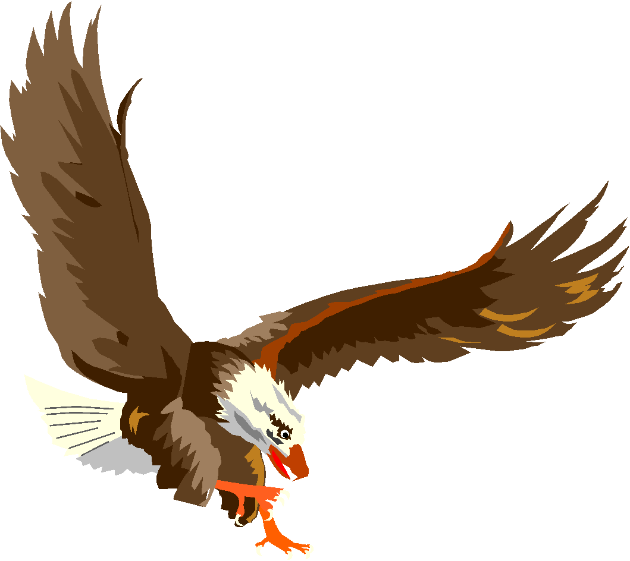

***JUNIOR HIGH WRESTLING***



| **NAME** | **GRADE** |
| --- | --- |
| **Riley Jackson** | **8** |
| **Leila Light** | **8** |
| **Noah Smith** | **8** |
| **Evan Botterbusch** | **8** |
| **Micah Danner** | **8** |
| **Ethan Hughes** | **8** |
| **Camdyn Storm** | **8** |
| **Parker Marchi** | **8** |
| **Noah Weiser** | **8** |
| **Caidyn Laughman** | **8** |
| **Blake Bolyard** | **7** |
| **Bently Solalinde Diaz** | **7** |
| **Justin Martinez** | **7** |
| **Landon Rivera** | **7** |
| **Edwin Flores-Rico** | **7** |
|  |  |
| **Head Coach - Chris King** |  |
| **Assistants - Nick Storm** |  |
| **Rick Marchi** |  |
| **Keith Jackson** |  |
|  |  |
|  |  |
|  |  |