***2023 BERMUDIAN SPRINGS***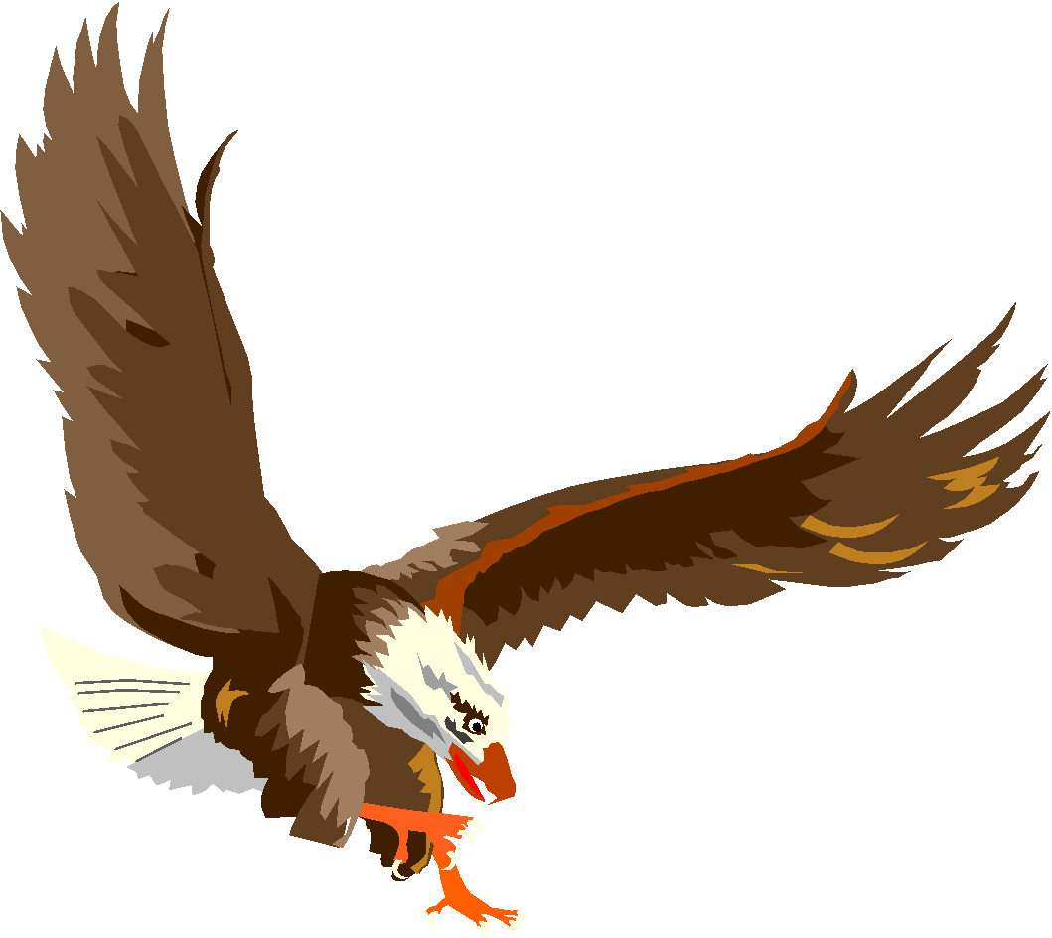

***JUNIOR HIGH FIELD HOCKEY***



| **UNIFORM #** | **NAME** | **CLASS** | **POSITION** |
| --- | --- | --- | --- |
| 13 | Liliana Felipe | 8 | Offense/Defense |
| 1 | Lexi Grim | 8 | Offense/Defense |
| 28 | Lily Hann | 8 | Offense/Defense |
| 4 | Riley Jackson | 8 | Offense/Defense |
| 40 | Leila Light | 8 | Offense/Defense |
| 8 | AnnaBella Needle | 8 | Offense/Defense |
| 33 | Evelyn Peters | 8 | Offense/Defense |
| 15 | Emily Antoun | 7 | Offense/Defense |
| 10 | Elizabeth Estrada | 7 | Offense/Defense |
| 5 | Mina Frantz | 7 | Offense/Defense |
| 6 | Kenzie Garben | 7 | Offense/Defense |
| 12 | Adalyn Juelich | 7 | Offense/Defense |
| 43 | Emily Leader | 7 | Offense/Defense |
| 22/95 | Addelyn Miller | 7 | Offense/Defense |
| 7 | Allie Miller | 7 | Goal/Offense/Defense |
| 21/95 | Sawyer Myers | 7 | Goal/Offense/Defense |
| 30 | Kendall Roomsburg | 7 | Offense/Defense |
|  | Isabella Nye | 8 |  |
|  |  |  |  |

**Head Junior High Coach: Stefanie Yost**

**Assistant Junior High Coach: Mandi Ruberg**