1. Select Formspace in Eduphoria

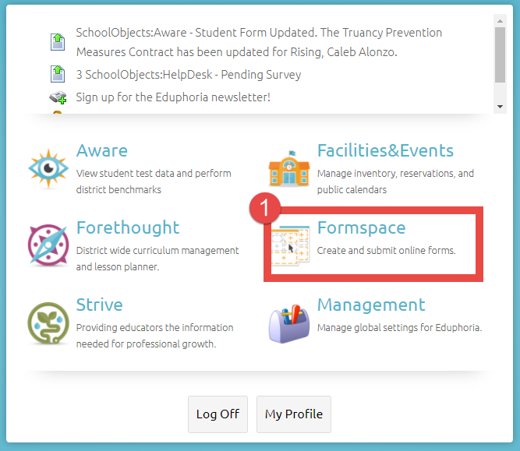

1. Click Select New Form, bottom left corner
2. Click DAEP

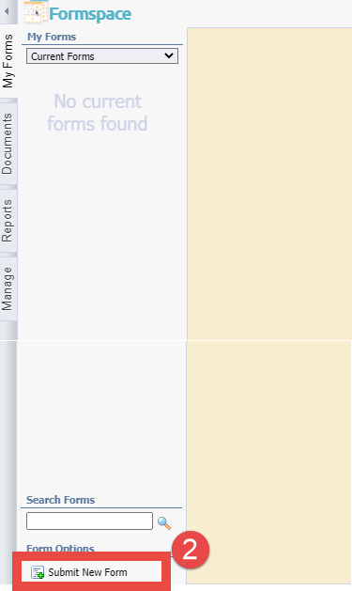 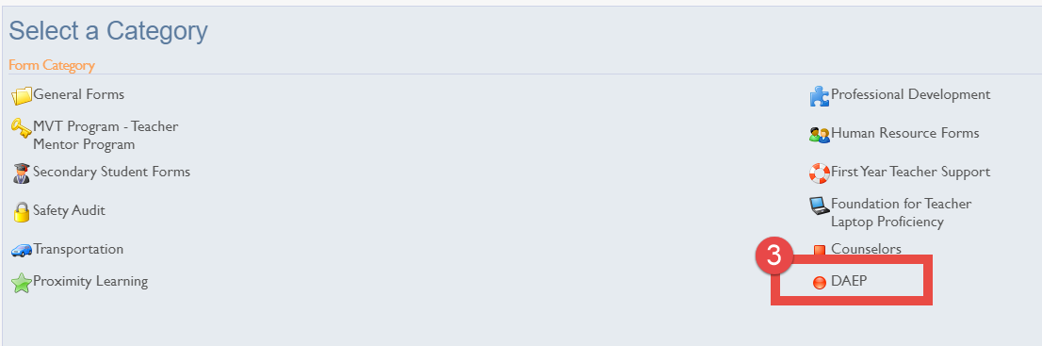

1. Select DAEP Placement Form

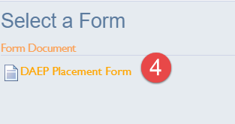

1. Fill out the three pages and hit submit form.

