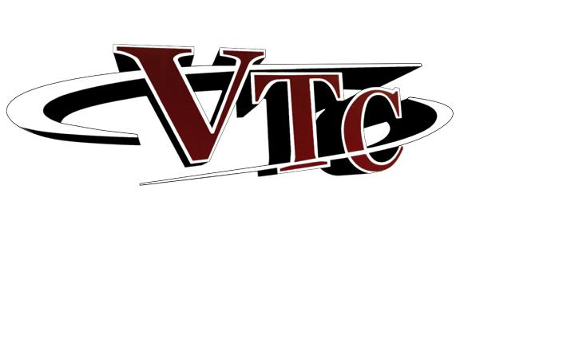   
**What is Certified Co-op?**

Cooperative Education is a course available to recommended students enrolled in Venango Technology Center. The goal of the program is to supplement formal classroom instruction with relevant on-the-job experience so that you may:

* Apply concepts and skills learned in VTC classes to a work station
* Acquire job-related skills not available within the school environment
* Gain work experience through responsibilities encountered on the job



**What advantages does Co-op Offer?**

* Job experience directly related to your career interest
* Secure a future job reference
* Learn skills that can’t be taught in the classroom setting
* Possibly secure a permanent full-time position with your Co-op employer
* Earn graduation credits
* Earn a paycheck
* Make informed career choices
* Earn a state skill certificate

**How do I apply?**

1. Earn a recommendation from your instructor by having good attendance, good attitude and good skills
2. With your instructor’s approval, make an appointment with the Co-op Coordinator at the Co-op office.
3. Complete the application forms
4. Submit a typed resume
5. Be available for employment interviews

**How am I graded?**

As a Co-op student, you attend Co-op classes that correspond with your work experience. Your course grade will be based on the following information given to your VTC instructor.

* Your attendance and participation at the

monthly Co-op classes

* Your employer’s evaluation of your job

performance

* Your completion of the day-to-day log

required for your Co-op employment

**Co-op Employers**

Participating employers make the final hiring decision and determine hourly rates. An employer agrees to hire a Co-op student for the duration of the school year. An employer may end your position for any reason they would normally terminate an employee. The student must agree to keep good attendance, good attitude and work diligently to improve their skills.

