BVMS Traffic Map
Morning Drop-off and Afternoon Pick-up
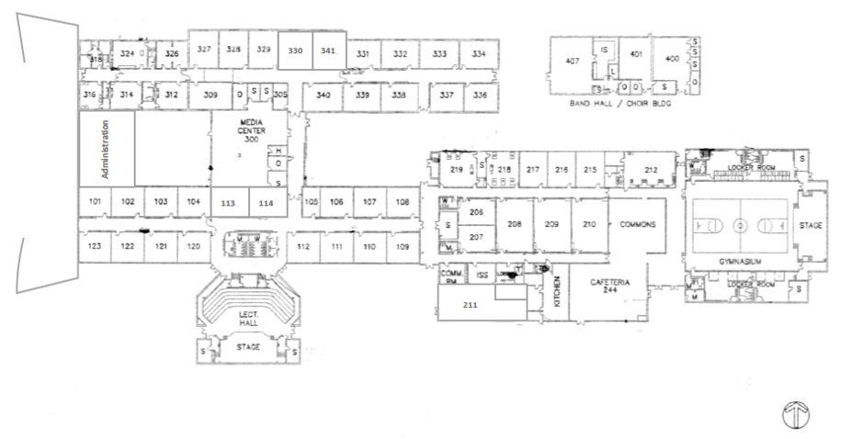
Morning Drop-Off:
Students may start arriving on campus at 7:30 am.
- ZONE 1: Both lanes are available to drop-off for 6th and 7th Grade students (without 8th grade siblings) who are not purchasing breakfast.
- ZONE 2: Please do not drop students off in this area.
- ZONE 3: Right Lane - Buses only; Left Lane – Student Drop-off
  - Please use the east entrance of 43rd Street to access the car line. Students dropped off here include –
    - 6th and 7th Grade students purchasing breakfast
    - All 8th graders along with their 6th and 7th grade siblings.
ZONE
1
Please be mindful of our traffic procedures and drop-off/pick-up your children in the designated areas.
Student safety is our priority!
Afternoon Pick-up:
Bus and car-riders will be dismissed starting at 3:05. Walkers will be dismissed at 3:15 after school traffic has decreased.
- ZONE 1: Please use the north side of Chamberlain to access the car line. Both lanes are available to pick-up the following—
  - 6th and 7th Grade students
  - Any 8th Graders with siblings in 6th and 7th grade
- ZONE 2: 8th Graders without siblings attending BVMS may be picked up here. Please use the east entrance of 43rd Street to access the car line.
- ZONE 3: Only buses will be allowed to enter ZONE 3 to pick up students.
Chamberlain Avenue

43rd Street
ZONE
3
ZONE
2
(Afternoons Only)

