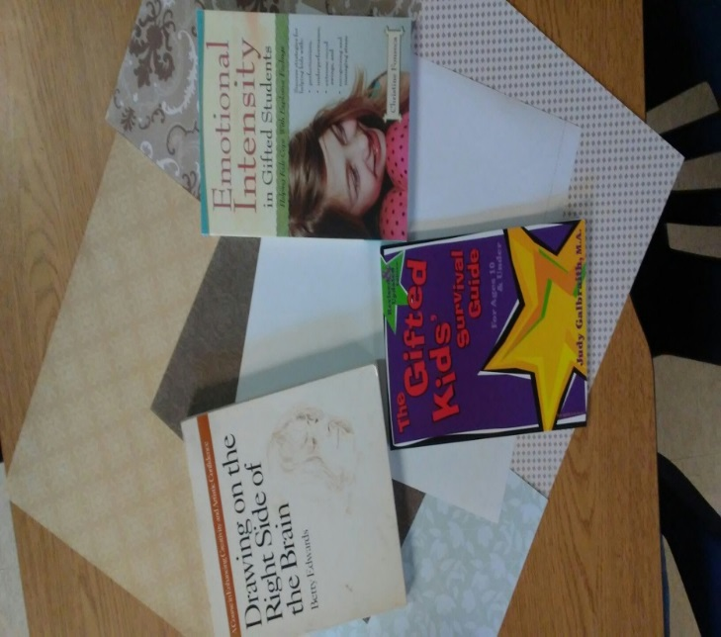

**Quest Teacher and Parent Resources for Gifted Children**

**Emotional Intensity**

Designed to provide support for the difficult job of parenting and teaching gifted children. Helps kids cope with explosive feelings:

* perfectionism,
* underperformance,
* extreme mood swings, and
* recognizing and managing stress

**The Gifted Kids’ Survival Guide**

Self-Help for kids to understand their giftedness.

**Drawing on the Right Side of the Brain**

This book will teach and enhance creativity andartistic confidence.

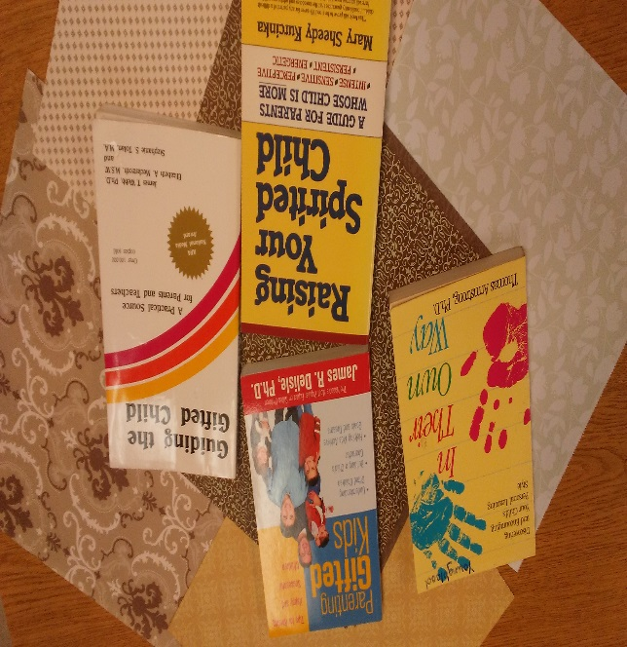

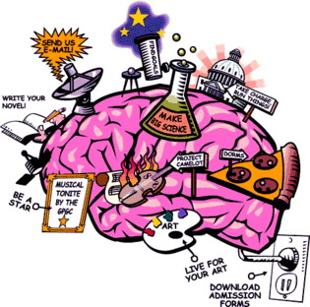

**Parenting Gifted Kids**

* **Tips for Raising Happy and Successful Children**
* **Helping Kids Achieve Goals and Dreams**

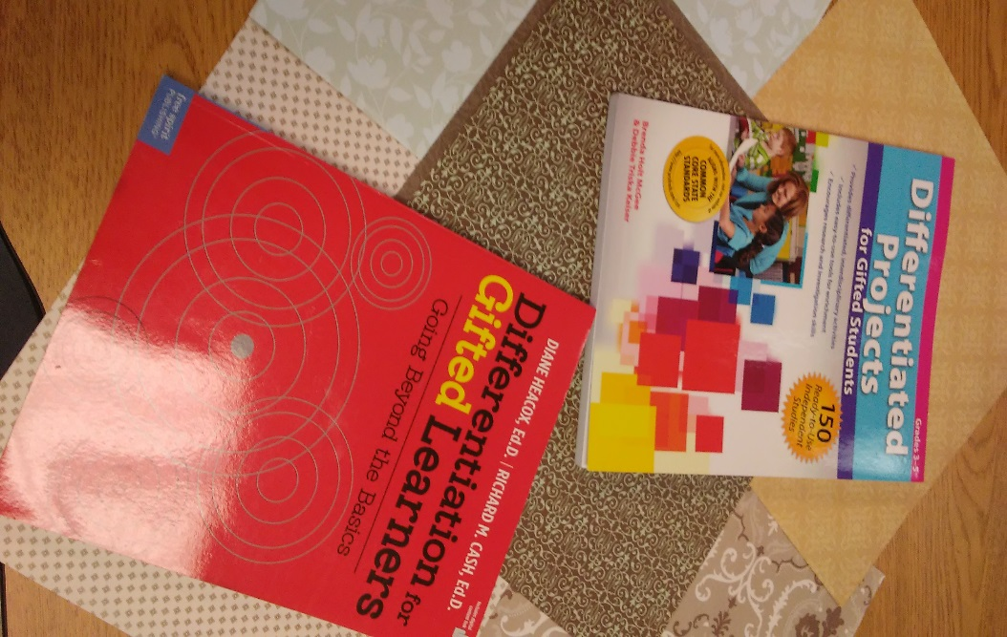

Gifted Curriculum

**Differentiated Projects for Gifted Students**

Kids love exploring complex topics, and the more than 150 ready to use projects in this book will get their minds working and their hands investigating as they complete fun tasks.

These books are full of practical suggestions for classroom teachers, gifted education specialists, and principals.

**Differentiation for Gifted Learners**

* How can I lead my community to better differentiate for our advanced students?
* How do I apply Common Core State Standards to my gifted learners?
* How can I ensure advanced courses are rigorous enough for them?
* Which school-wide gifted program models work best and why?

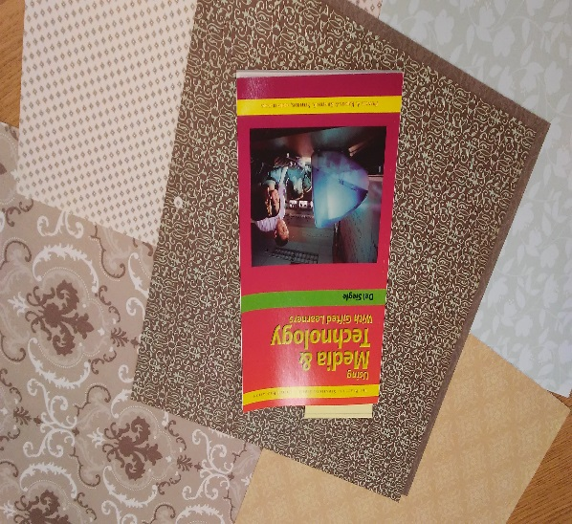

**The Practical Strategies Series In Gifted Education**

This is a unique series of monographs authored by the foremost authorities in the field in the field of education.

As technology has become a ubiquitous part of education in the 21st century, it is now imperative that students become technologically literate by knowing what technology is, how it works, and how it can be put to use to attain goals

Dual Diagnosis

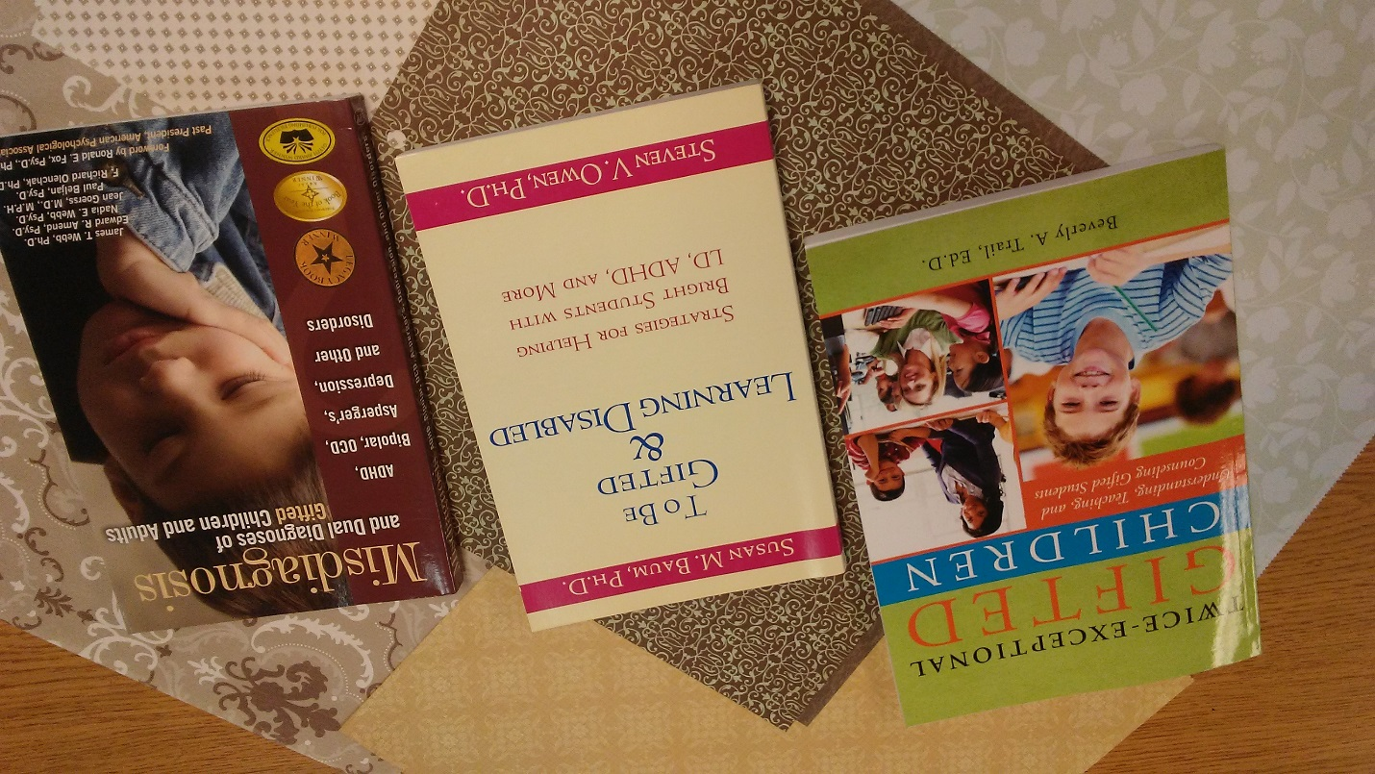

“Twice-exceptional (2E) children live a daily struggle trying to understand themselves and the educational world they face. We often hear their frustration, anger, stress, anxiety, and denial. We often see their depressive symptoms, fear of failure, dependency, and social distress. They struggle to maintain a precarious balance between dealing with the expectations of being gifted and desperately trying to cope with learning, emotional, and social difficulties.”

 Schuler, P (2008)

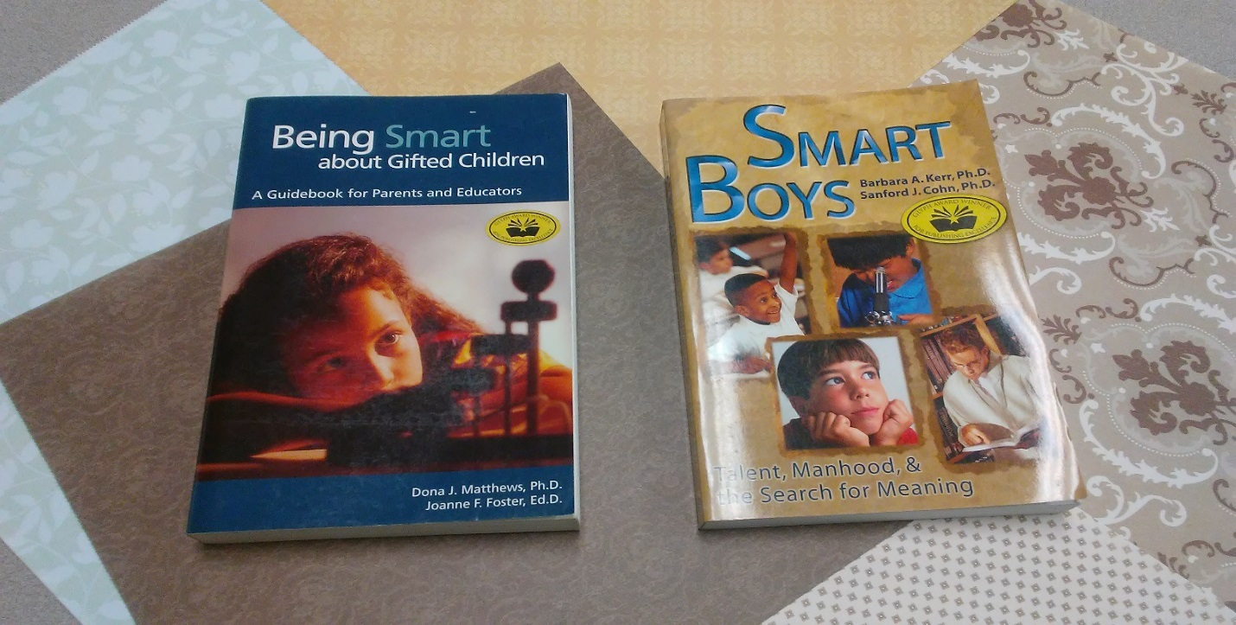

Being Smart for our Children

Drs. Matthews and Foster present practical strategies to help parents and educators identify and nurture exceptionally high ability in children. They also offer much helpful information about testing. Being Smart addresses identification procedures, learning issues, social and behavioral concerns, teacher development processes, gifted education trends, and parenting strategies.

Smart Boys Dr. Barbara Kerr and Dr. Sandy Cohn describe issues faced by our brightest boys and men, and the concerns of those around them. This book addresses bright beginnings, adolescent gifted boys, gifted minority boys, relationships, family issues, self-actualization, and guiding gifted men.

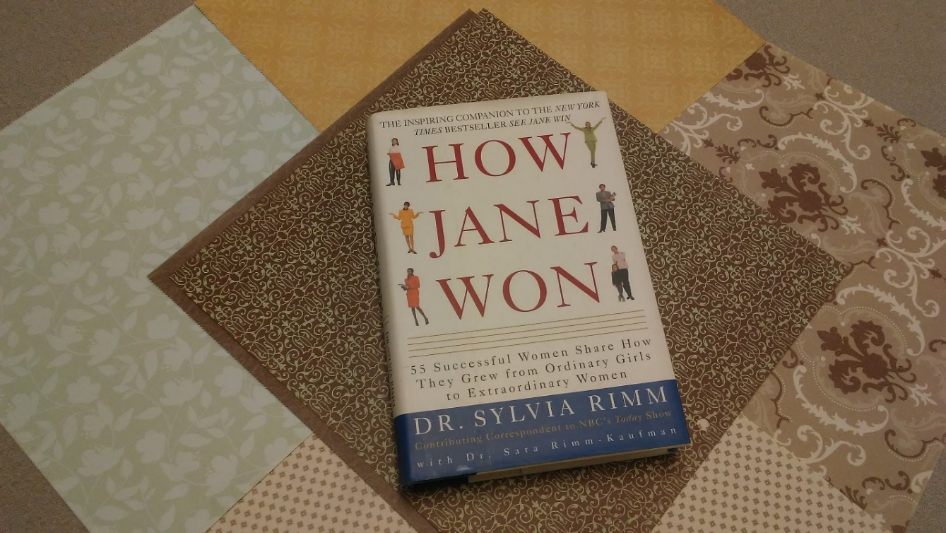

What is Success

How do you define success? In Dr. Rimm’s definition, success is more than a six-figure paycheck or fancy title; it’s a sense of happiness and satisfaction in what you do. Sometimes the first step to success is believing it’s possible. How Jane Won shows the many roads from possibility to achievement and the inspiration you need to make your own unique journey.

**These books may be checked out by any teacher or parent in the Gulfport School District.**

Revised 10-28-16