Hello families!

The **Affordable Connectivity Program** is a program sponsored by the Federal Communications Commission (FCC) to help households pay for internet services. It provides up to a **$30 credit** on the consumers' monthly internet service. **BTC Fiber is a participating provider.** Since the Sequatchie County School System is receiving the USDA Community Eligibility Provision (CEP), **ALL STUDENTS** enrolled in Sequatchie County Schools qualify for this program.

Please visit the school website (<https://www.sequatchieschools.net/>). Scroll down on the home page and look for what you see below on the left hand side. There is a helpful video with directions on how to upload your enrollment verification form.

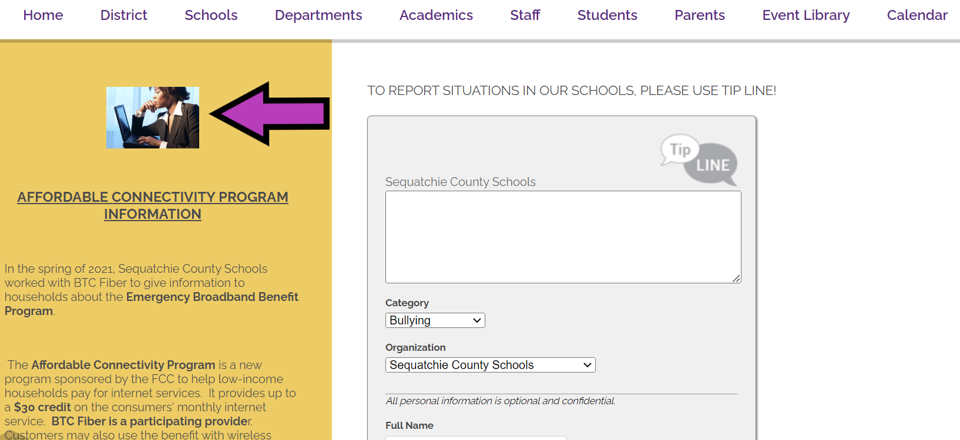

We hope this will be a helpful resource for you!