Leticia Arce-Miranda  Assistant Principal  Susana Jones  Counselor  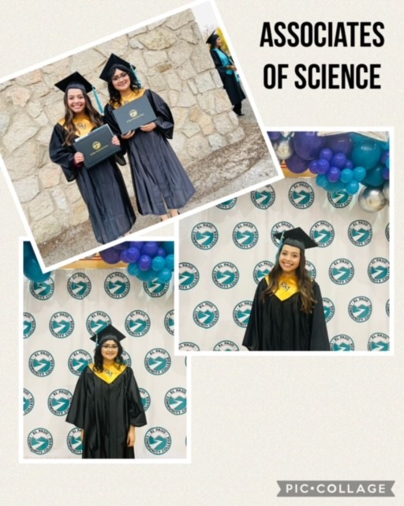  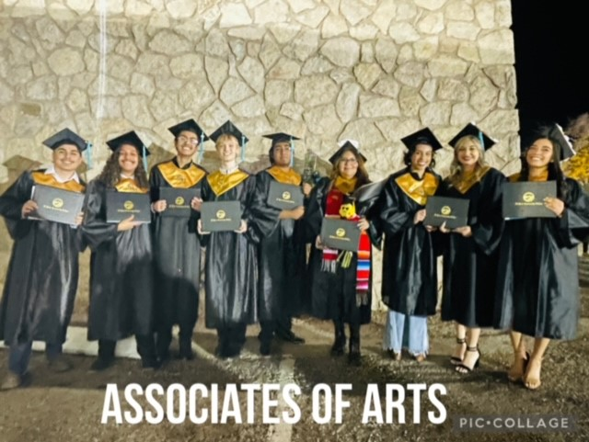 |  | Cotton Valley Early College Program at Fabens H.S.  Fabens ISD  601 N. E. “G” Ave  (915) 765-2620  (915) 764-4953 Fax |  |  | Cotton Valley Early College Program at  Fabens H.S.  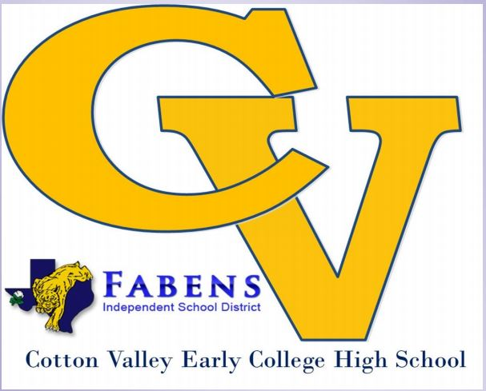  Established 2010

How can you apply for the Early College Program?  During the Spring semester all 8th grade students must submit a CVECHS application form (which can be found in the CVECHS website). There are no criteria for placement into the Early College Program (except for the student’s willingness to commit to this program).  Who can apply for the Early College Program?  Fabens or interested open enrollment students can apply. (If current freshmen students are interested in applying talk to the CVECHS counselor and/or the Director of program as soon as possible).  Summer Bridge Program:  The summer bridge program is mandatory. Incoming students must attend to gain a perspective of the expectations of what it would be like to being an early college student. The program includes visit to the EPCC Campus. | Impressive Opportunities  - Any student that ATTENDS will not only will have the opportunity to earn a college credits but to earn an Associate’s Degree.  - Small school setting in which students will be able to get help, and interact with other students, for guidance.  - Free college education, while attending high school.  - You do NOT have to be a straight “A” Student to apply.  - Opens door for college scholarships.  - Through the ECHS scholarship, UTEP offers CVEC students up to 18 additional college hours towards their Bachelor’s Degree while still enrolled in high school.  EPCC Spring 2022 Commencement-Class of 2022/2023  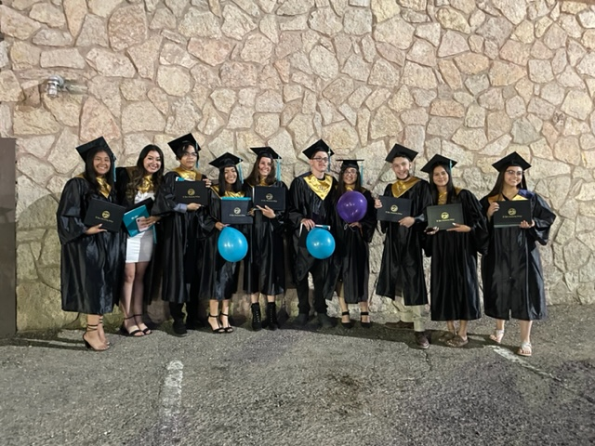 | What is an Early College H.S. Program?  This program will provide the unique educational opportunity to attend both High School and College in a special campus environment that will challenge students to excel in their academic and personal endeavors. The Early College H.S. is a successful model because this program works with a partnership between Fabens ISD and the El Paso Community College which provides students with a higher education. This has proved to be a more efficient way for a student to obtain HIGHER levels of student success.  EPCC Fall Commencement Class of 2023

