| **COMPREHENSIVE SCHOOL IMPROVEMENT PLAN** | | | |
| --- | --- | --- | --- |
| **School Name: Church Street Elementary School** | | | **District Name:**  **Clayton County Public Schools** |
| **Principal Name: Monica S. Goree** | | | **School Year:** 2023-2024 |
| **School Mailing Address: 7013 Church Street Riverdale, GA 30274** | | | |
| **Telephone: 770-994-4000** | | | |
| **District Title I Director Name:** Katrina Thompson | | | |
| **District Title I Director Mailing Address:** 1058 Fifth Avenue, Jonesboro, GA 30236 | | | |
| **Email Address:** katrina.thompson@clayton.k12.ga.us | | | |
| **Telephone:** 678-817-3081 | | | |
| **ESSA ACCOUNTABILITY STATUS—Check only if applicable.** | | | |
| **Comprehensive Support** ☐ | **Targeted Support**  ☐ | | **Promise School** ☐ |
| **BUDGET MODEL – Check all that apply.** | | | |
| **Title I, Part A Budget** ☐ | | **Title I School Improvement Grant (SIG)** ☐ | |
| **L4GA Budget** ☐ | |  | |
| **SIGNATURES AND REVISION DATE** | | | |
| **Principal’s Signature: Monica S. Goree** | | | **Date: July 30, 2023** |
| **Title I Director’s Signature:** | | | **Date:** |
| **Assistant Superintendent’s Signature:** | | | **Date:** |
| **TLSI Deputy Superintendent’s Signature:** | | | **Date:** |
| **Revision Date:** | **Revision Date:** | | **Revision Date:** |

**CSIP Planning Committee:**

The Principal attests that at least one committee meeting was held with a variety of stakeholders to work collaboratively throughout the plan’s development. The following stakeholders collaborated on this CSIP. Agendas and sign-in sheets for all planning meetings must be submitted with the Comprehensive School Improvement Plan.

| **NAME** | **POSITION/ROLE** |
| --- | --- |
| Monica S. Goree | Principal |
| Rochelle Taylor | Assistant Principal |
| Keri Sims | Title I Academic Coach |
| Trayon Henderson | Title I Academic Coach |
| Nicole Long | EIP Teacher |
| Tambria Jennings | Parent Liaison |
| LeKeisha Anderson (parent) | Former Assistant Principal/Parent |
| Octavia Ferguson-Chenault | Counselor |
| Tonya Rankin | Counselor |
|  |  |
|  | Choose an item. |
|  | Choose an item. |
|  | Choose an item. |
|  | Choose an item. |
|  | Choose an item. |
|  | Choose an item. |
|  | Choose an item. |
|  | Choose an item. |
|  | Choose an item. |
|  | Choose an item. |
|  | Choose an item. |
|  | Choose an item. |

**Data:**

Include student achievement data charts/graphs and a written summary of the data that represent the schools’ various subgroups (Academics, Discipline, and Attendance). Samples of student achievement data reports (MAP, Access Reports, EOC, Milestones).

**Minimally include and summarize the following data if available for the school.**

1. **2 years of the current GMAS data (2021-2022 and 2022-2023). Provide displays of data by subgroups.**
2. **2 or 3 years of the current MAP scores, if available. Provide displays of grade level data by subgroups.**
3. **The current and 3 years of prior years’ student attendance data.**
4. **The current and 3 years of prior years’ student discipline data.**

**GMAS Data**

**Math**

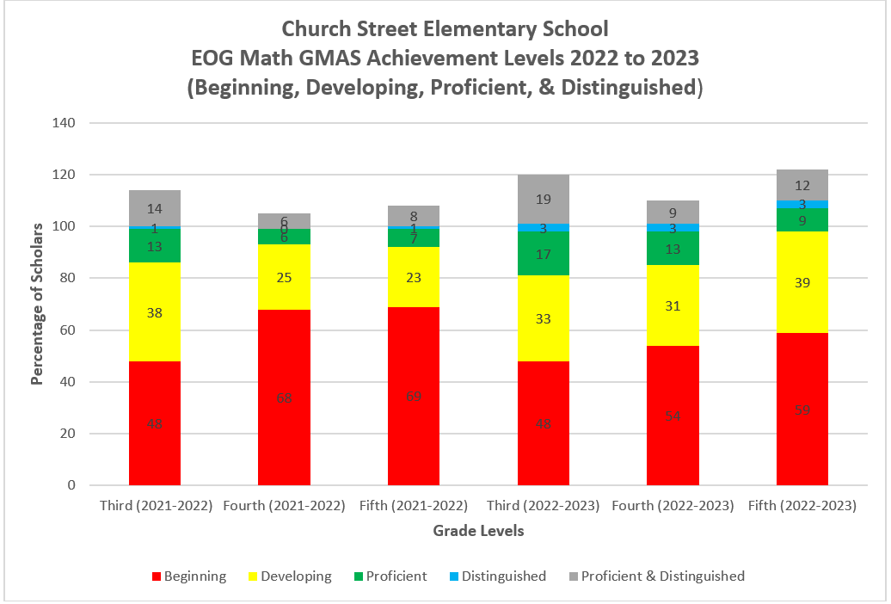

**Math GMAS Summary**

**3rd Grade Math:**

There was 0% change in the number of Beginning Learners from 2022 to 2023 (48% in 2022 to 48% in 2023). The number of Developing Learners decreased by 5% from 2022 to 2023 (38% in 2022 to 33% in 2023). The number of Proficient Learners increased by 4% from 2022 to 2023 (13% in 2022 to 17% in 2023). The number of Distinguished Learners increased by 2% from 2022 to 2023 (1% in 2022 to 3% in 2023). The number of Proficient and Distinguished Learners increased by 5% from 2022-2023 (14% in 2022 to 19% in 2023).

**4th Grade Math:**

There was a 14% decrease in the number of Beginning Learners from 2022 to 2023 (68% in 2022 to 54% in 2023). The number of Developing Learners increased by 6% from 2022 to 2023 (25% in 2022 to 31% in 2023). The number of Proficient Learners increased by 7% from 2022 to 2023 (6% in 2022 to 13% in 2023). The number of Distinguished Learners increased by 9% from 2022 to 2023 (0% in 2022 to 3% in 2023). The number of Proficient and Distinguished Learners increased by 3% from 2022-2023 (6% in 2022 to 9% in 2023).

**5th Grade Math:**

There was a 10% decrease in the number of Beginning Learners from 2022 to 2023 (69% in 2022 to 59% in 2023). The number of Developing Learners increased by 6% from 2022 to 2023 (23% in 2022 to 29% in 2023). The number of Proficient Learners increased by 2% from 2022 to 2023 (7% in 2022 to 9% in 2023). The number of Distinguished Learners increased by 2% from 2022 to 2023 (1% in 2022 to 3% in 2023). The number of Proficient and Distinguished Learners increased by 4% from 2022-2023 (8% in 2022 to 12% in 2023).

**ELA**

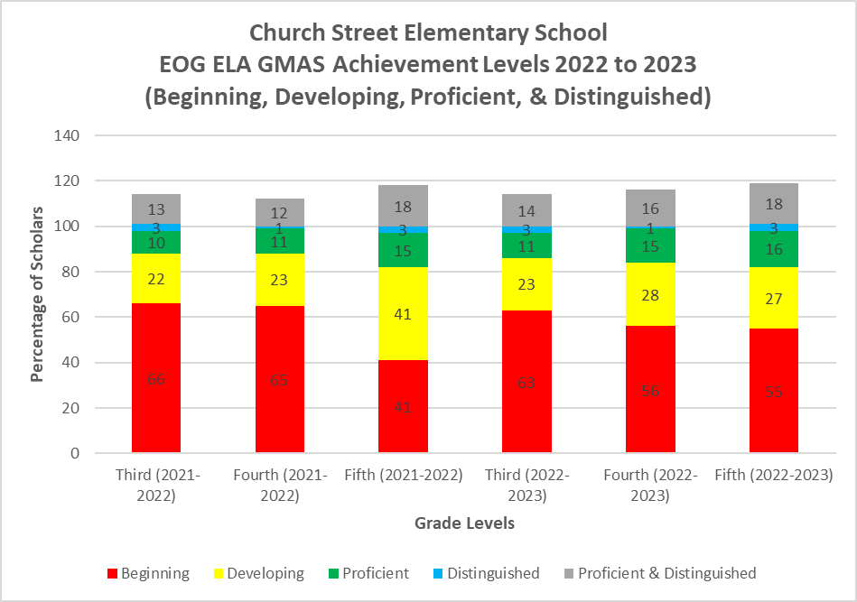

**ELA GMAS Summary**

**3rd Grade ELA:**

There was a 3% decrease in the number of Beginning Learners from 2022 to 2023 (66% in 2022 to 63% in 2023). The number of Developing Learners increased by 1% from 2022 to 2023 (22% in 2022 to 23% in 2023). The number of Proficient Learners increased by 1% from 2022 to 2023 (10% in 2022 to 11% in 2023). There was no change in the number of Distinguished Learners from 2022 to 2023 (3% in 2022 to 3% in 2023). The number of Proficient and Distinguished Learners increased by 1% from 2022-2023 (13% in 2022 to 14% in 2023).

**4th Grade ELA:**

There was a 9% decrease in the number of Beginning Learners from 2022 to 2023 (65% in 2022 to 56% in 2023). The number of Developing Learners increased by 5% from 2022 to 2023 (23% in 2022 to 28% in 2023). The number of Proficient Learners increased by 4% from 2022 to 2023 (11% in 2022 to 15% in 2023). There was no change in the number of Distinguished Learners from 2022 to 2023 (1% in 2022 to 1% in 2023). The number of Proficient and Distinguished Learners increased by 4% from 2022-2023 (12% in 2022 to 16% in 2023).

**5th Grade ELA:**

There was a 14% increase in the number of Beginning Learners from 2022 to 2023 (41% in 2022 to 55% in 2023). The number of Developing Learners decreased by 14% from 2022 to 2023 (41% in 2022 to 27% in 2023). There was no change in the number of Proficient Learners from 2022 to 2023 (15% in 2022 to 15% in 2023). There was no change in the number of Distinguished Learners from 2022 to 2023 (3% in 2022 to 3% in 2023). There was no change in the number of Proficient and Distinguished Learners from 2022-2023 (18% in 2022 to 18% in 2023).

The number of 3rd grade scholars reading below grade level in 2023 is 56% and the number of scholars reading at or above grade level is 44%. The number of 4th grade scholars reading below grade level in 2023 is 68% and the number of scholars reading at or above grade level is 32%. The number of 5th grade scholars reading below grade level in 2023 is 58% and the number of scholars reading at or above grade level is 42%.

**Science**

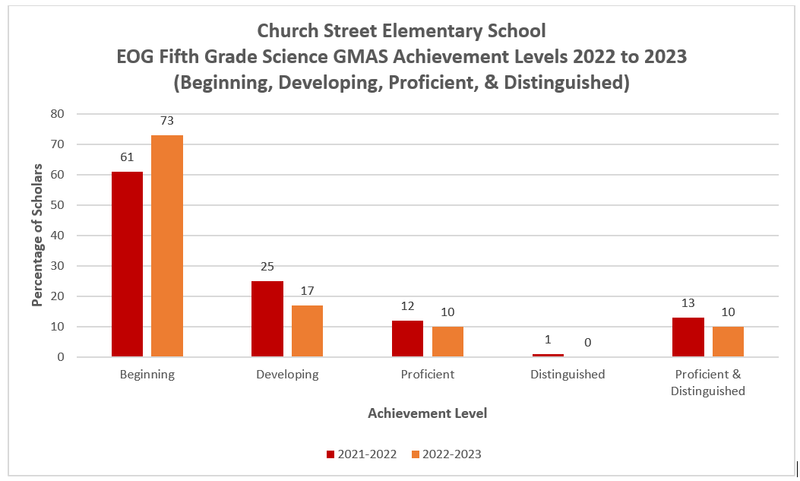

**5th Grade Science:**

There was a 12% increase in the number of Beginning Learners from 2022 to 2023 (61% in 2022 to 73% in 2023). The number of Developing Learners decreased by 8% from 2022 to 2023 (25% in 2022 to 17% in 2023). There was a 2% decrease in the number of Proficient Learners from 2022 to 2023 (12% in 2022 to 10% in 2023). There was a 1% decrease in the number of Distinguished Learners from 2022 to 2023 (1% in 2022 to 0% in 2023). There was a 3% decrease in the number of Proficient and Distinguished Learners from 2022-2023 (13% in 2022 to 10% in 2023).

**GMAS Subgroup Data**

**ELA**

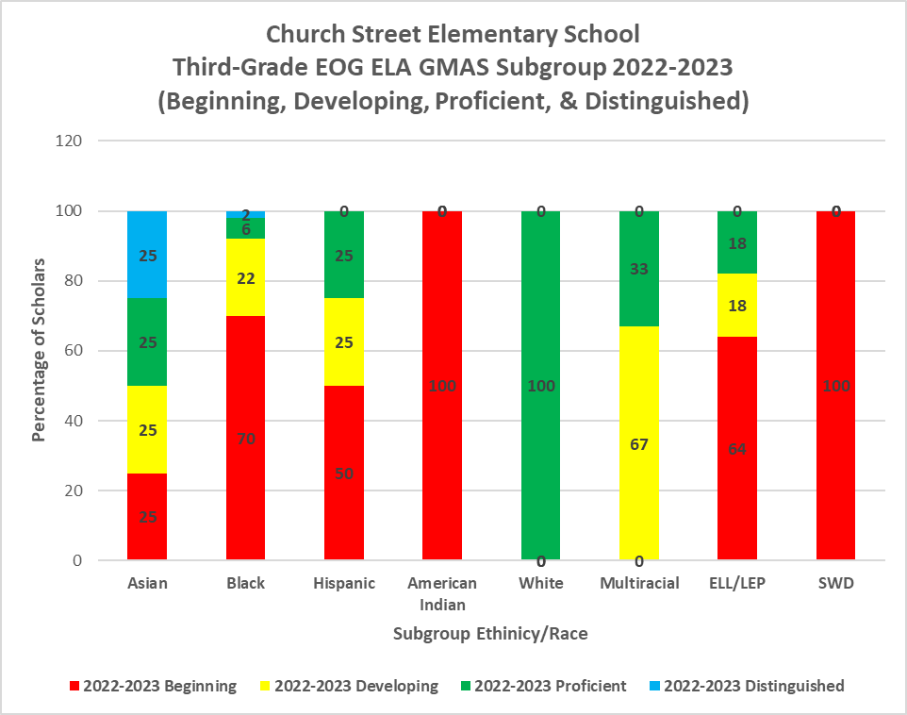

**3rd Grade ELA Subgroups:**

The number of Asian scholars scoring at Proficient and Distinguished is 50% in 2023; Black scholars performing at Proficient and Distinguished is 8% in 2023; Hispanic scholars performing at Proficient and Distinguished is 25% in 2023; American Indians scholars performing at Proficient and Distinguished is 0% in 2023; White scholars performing at Proficient and Distinguished is 100% in 2023; Multiracial scholars performing at Proficient and Distinguished is 33% in 2023; ELL/LEP scholars performing at Proficient and Distinguished is 18% in 2023; and SWD scholars performing at Proficient and Distinguished is 0% in 2023

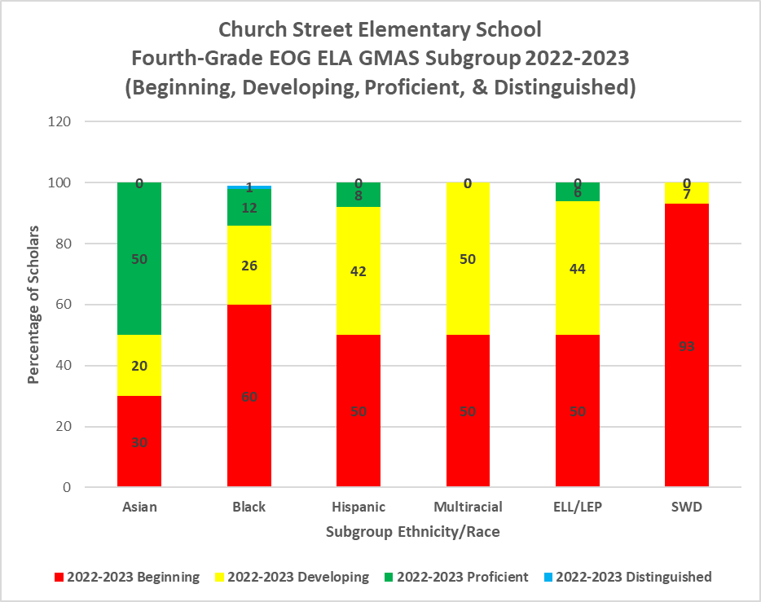

**4th Grade ELA Subgroups:**

The number of Asian scholars scoring at Proficient and Distinguished is 50% in 2023; Black scholars performing at Proficient and Distinguished is 14% in 2023; Hispanic scholars performing at Proficient and Distinguished is 8% in 2023; Multiracial scholars performing at Proficient and Distinguished is 0% in 2023; ELL/LEP scholars performing at Proficient and Distinguished is 6% in 2023; and SWD scholars performing at Proficient and Distinguished is 0% in 2023.

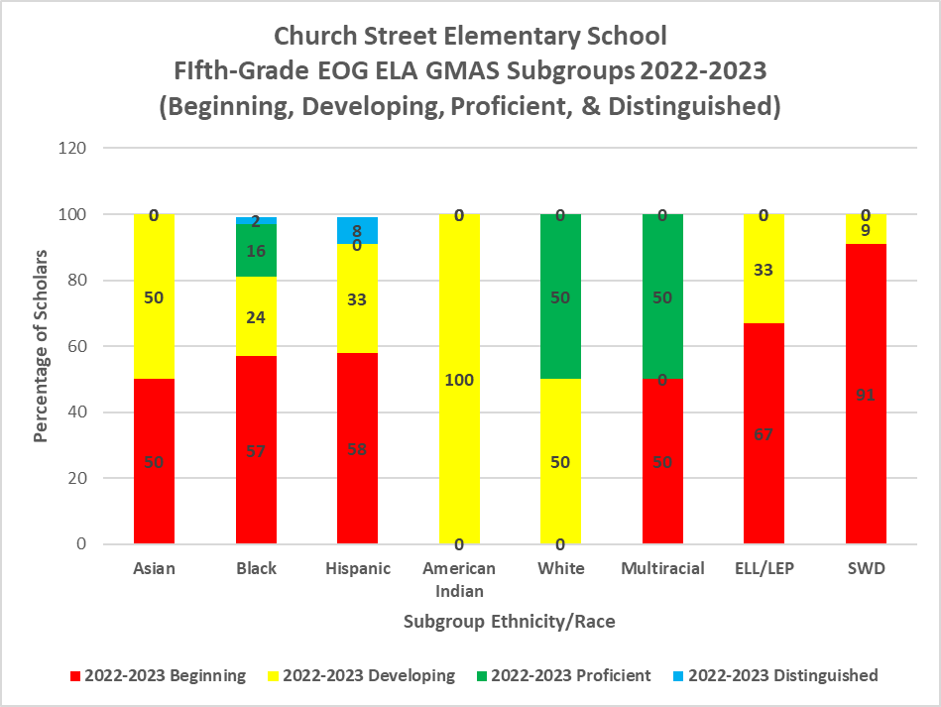

**5th Grade ELA Subgroups:**

The number of Asian scholars scoring at Proficient and Distinguished is 0% in 2023; Black scholars performing at Proficient and Distinguished is 18% in 2023; Hispanic scholars performing at Proficient and Distinguished is 8% in 2023; American Indians scholars performing at Proficient and Distinguished is 0% in 2023; White scholars performing at Proficient and Distinguished is 50% in 2023; Multiracial scholars performing at Proficient and Distinguished is 50% in 2023; ELL/LEP scholars performing at Proficient and Distinguished is 0% in 2023; and SWD scholars performing at Proficient and Distinguished is 0% in 2023.

**ELA GMAS Subgroup Summary**

The number of Proficient and Distinguished SWD scholars in ELA is consistently 0% in 3rd, 4th, and 5th grade. The same can be said for Multiracial, Asian, and American Indian scholars whose Proficient and Distinguished achievements are also 0%, but it is not consistent across all grade levels. All other subgroups are making progress of in a range of 8% or more (Asians: 50% in 3rd grade and 50% in 4th grade; Blacks: 8% in 3rd grade, 14% in 4th grade, and 18% in 5th grade; Hispanic: 25% in 3rd grade, 8% in 4th grade, and 8% in 5th grade; White: 100% in 3rd grade and 50% in 5th grade; Multiracial: 33% in 3rd grade and 50% in 5th grade; ELL/LEP: 18% in 3rd grade and 6% in 4th grade).

**Math**

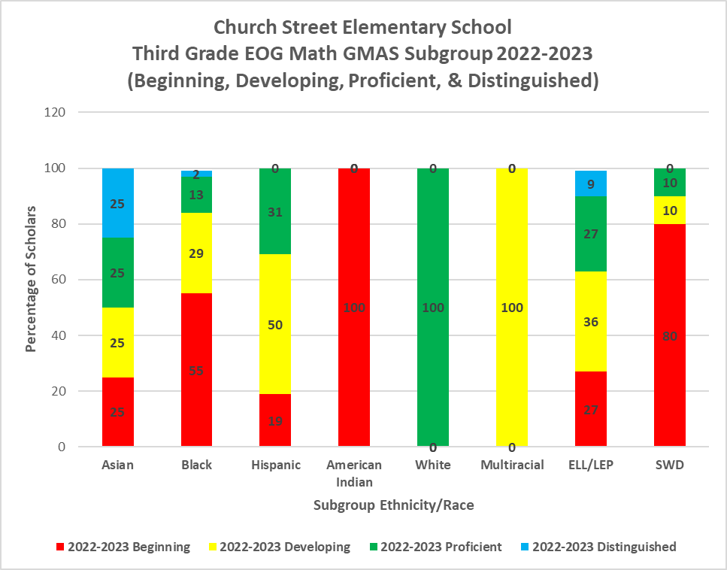

**3rd Grade Math Subgroups:**

The number of Asian scholars scoring at Proficient and Distinguished is 50% in 2023; Black scholars performing at Proficient and Distinguished is 15% in 2023; Hispanic scholars performing at Proficient and Distinguished is 31% in 2023; American Indians scholars performing at Proficient and Distinguished is 0% in 2023; White scholars performing at Proficient and Distinguished is 100% in 2023; Multiracial scholars performing at Proficient and Distinguished is 0% in 2023; ELL/LEP scholars performing at Proficient and Distinguished is 36% in 2023; and SWD scholars performing at Proficient and Distinguished is 10% in 2023.

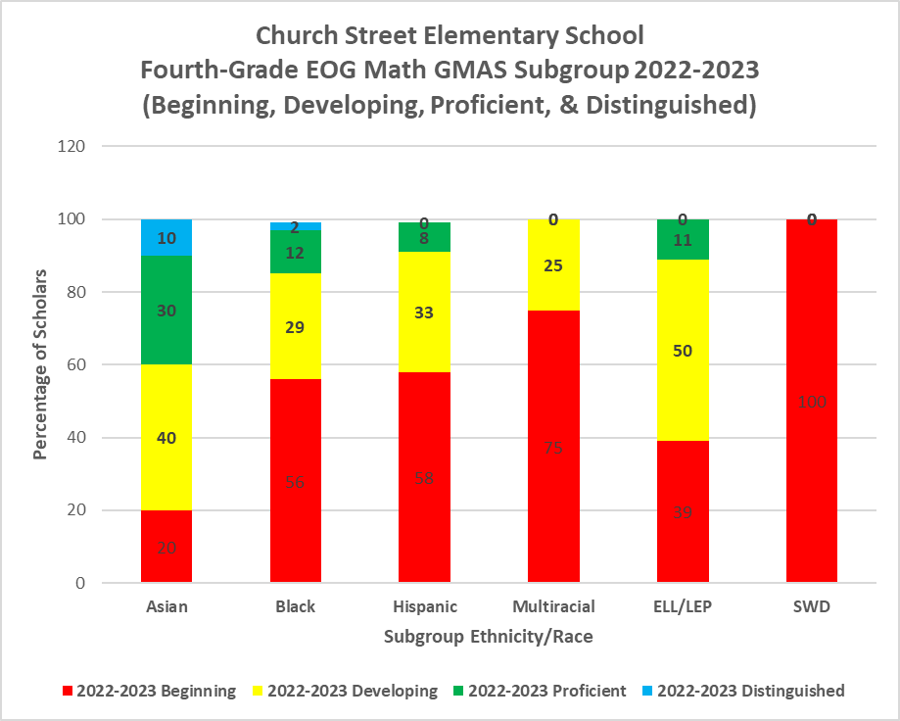

**4th Grade Math Subgroups:**

The number of Asian scholars scoring at Proficient and Distinguished is 40% in 2023; Black scholars performing at Proficient and Distinguished is 14% in 2023; Hispanic scholars performing at Proficient and Distinguished is 8% in 2023; Multiracial scholars performing at Proficient and Distinguished is 0% in 2023; ELL/LEP scholars performing at Proficient and Distinguished is 11% in 2023; and SWD scholars performing at Proficient and Distinguished is 0% in 2023.

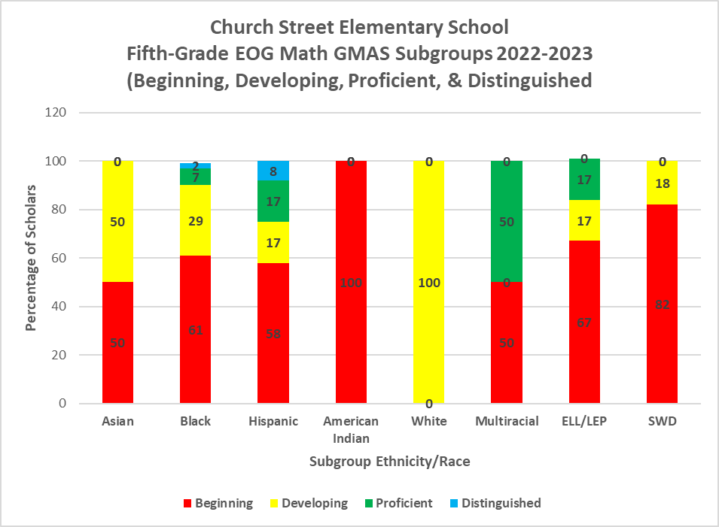

**5th Grade Math Subgroups:**

The number of Asian scholars scoring at Proficient and Distinguished is 0% in 2023; Black scholars performing at Proficient and Distinguished is 9% in 2023; Hispanic scholars performing at Proficient and Distinguished is 25% in 2023; American Indians scholars performing at Proficient and Distinguished is 0% in 2023; White scholars performing at Proficient and Distinguished is 0% in 2023; Multiracial scholars performing at Proficient and Distinguished is 50% in 2023; ELL/LEP scholars performing at Proficient and Distinguished is 17% in 2023; and SWD scholars performing at Proficient and Distinguished is 0% in 2023.

**Math GMAS Subgroup Summary**

Three out of six subgroups made progress in math in a range of 8% or more (Blacks: 15% in 3rd grade, 14% in 4th grade, and 9% in 5th grade; Hispanic: 31% in 3rd grade, 8% in 4th grade, and 25% in 5th grade; ELL/LEP: 36% in 3rd grade, 11% in 4th grade, and 17% in 4th grade).

**Science**

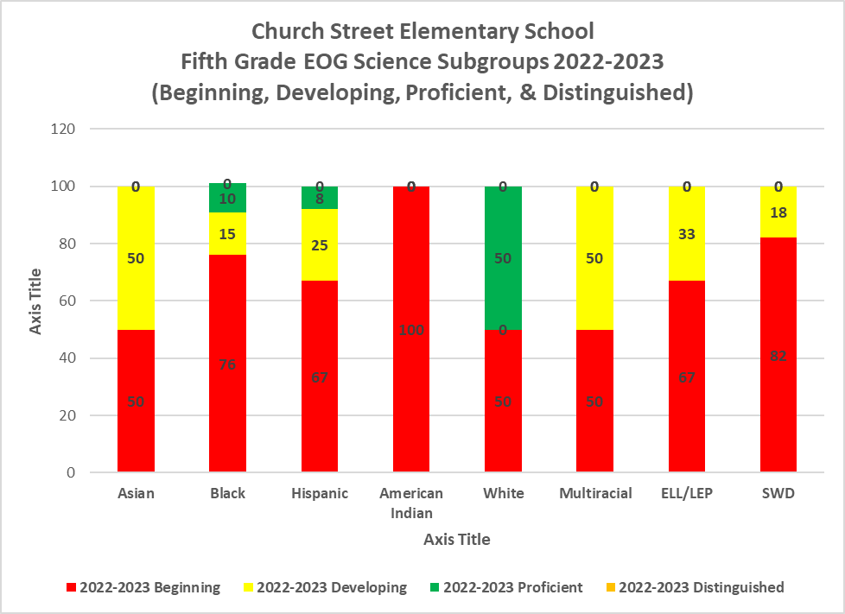

**Science GMAS Subgroup Summary**

**5th Grade Science Subgroups:**

There are 8%-50% Black, Hispanic, and White scholars performing at the Proficient and Distinguished levels in 2023; Black scholars performing at Proficient and Distinguished is 10% in 2023; Hispanic scholars performing at Proficient and Distinguished is 8% in 2023; White scholars performing at Proficient and Distinguished is 50% in 2023. All other subgroups did not demonstrate Proficient and/or Distinguished achievements.

**MAP Data**

**Math**

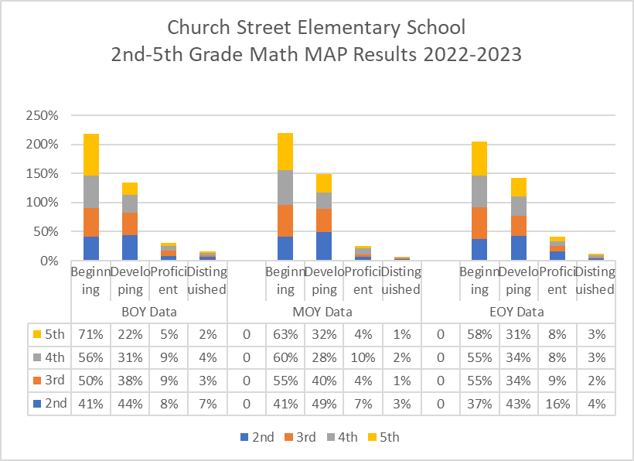

**2nd-5th Grade MAP Math:**

**Summary of 2nd-5th Grade Math MAP Performance from August 2021-May 2023**

The percentage of 2nd-5th grade students performing at the beginning level increased by 6% from the BOY to MOY administration of the Math MAP for the 2021-2022 school year. The percentage (5%) of proficient 2nd-5th grade students remained the same from the BOY to EOY administration of the Math MAP. The EOY Math MAP was not administered to students.

From the 2022-2023 BOY to the EOY administration of the Math MAP assessment, the percentage of 2nd-5th grade students performing at proficient or above decreased by 2%. The number of 5th grade students performing at the distinguished level increased by 1% (2% to 3%) by the EOY administration of the Math MAP.

**Reading**

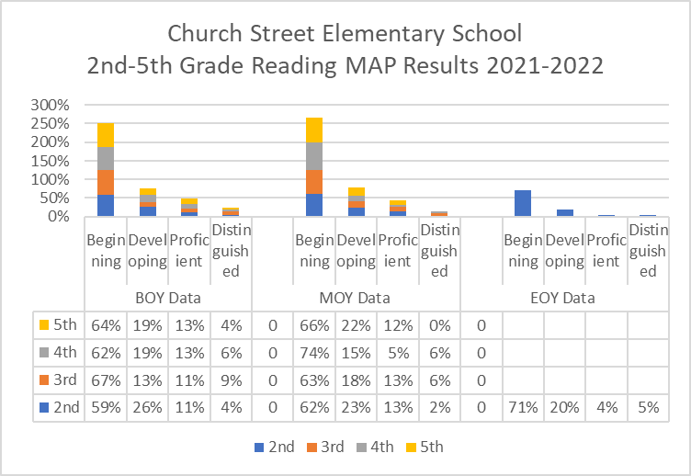

**2nd-5th Grade MAP Reading:**

**Summary of 2nd-5th Grade’s MAP Reading Performance from August 2021-May 2022**

The percentage of 2nd graders performing at the beginning level increased by 12% from the BOY to EOY administration of the Reading MAP. The percentage of 2nd graders performing at the distinguished level increased by 15 from the BOY to EOY administration of MAP.

The percentage of 3rd graders performing at the beginning level decreased by 4%. The percentage of 3rd graders performing at the developing level remained the same at 13% from the BOY to MOY administration of MAP. The 3rd graders were not administered the EOY MAP Reading for the 2021-2022 school year.

The percentage of 4th graders performing at the beginning level on the Reading MAP assessment increased by 12% from the BOY to MOY administration. There was an 8% decrease in the percentage of 4th graders performing at the proficient level from the BOY to MOY administration. The percentage of 4th graders performing at the distinguished level remained the same at 6% from the BOY to MOY administration of MAP Reading. The 4th graders were not administered the EOY MAP Reading for the 2021-2022 school year.

The percentage of 5th grade students that scored at the proficient level on the Reading MAP assessment decreased by 1% from the BOY to MOY administration. The percentage of 5th grade students that performed at the developing level increased by 3% from the BOY to MOY administration of MAP Reading. The 5th graders were not administered the EOY MAP Reading for the 2021-2022 school year.

The percentage of 2nd-5th grade students that scored at the developing level remained the same at 19% from the BOY to MOY 2021-2022 MAP Reading administration. The percentage of 2nd-5th grade students that scored at the proficient or higher level decreased by 3% from the BOY to MOY 2021-2022 MAP Reading administration.

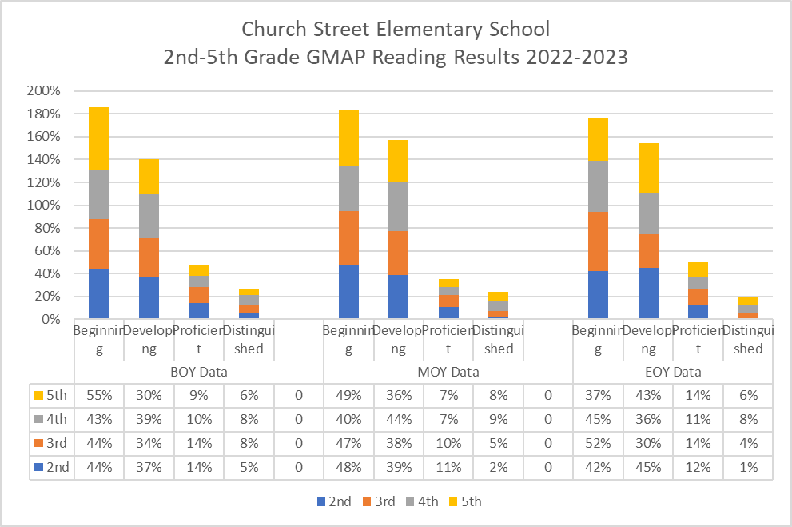

**2nd-5th Grade MAP Reading Results Summary August 2022 - May 2023:**

The number of Proficient and Distinguished Learners in 2nd grade decreased by 6% from the beginning of the year to the middle of the year (BOY: 19% to MOY: 13%) in 2022-2023. The number of Proficient and Distinguished Learners in 2nd grade remained constant from the middle of the year to the end of the year (MOY: 13% to EOY: 13%) in2022-2023. The number of Proficient and Distinguished Learners decreased by 6% from the beginning of the year to the end of the year (BOY: 19% to EOY: 13%) in 2022-2023.

The number of Proficient and Distinguished Learners in 3rd grade decreased by 7% from the beginning of the year to the middle of the year (BOY: 22% to MOY: 15%) in 2022-2023. The number of Proficient and Distinguished Learners in 3rd grade increased by 3% from the middle of the year to the end of the year (MOY: 15% to EOY: 18%) in 2022-2023. The number of Proficient and Distinguished Learners decreased by 4% from the beginning of the year to the end of the year (BOY: 22% to EOY: 18%) in 2022-2023.

The number of Proficient and Distinguished Learners in 4th grade decreased by 2% from the beginning of the year to the middle of the year (BOY: 18% to MOY: 16%) in 2022-2023. The number of Proficient and Distinguished Learners in 4th grade increased by 3% from the middle of the year to the end of the year (MOY: 16% to EOY: 19%) in 2022-2023. The number of Proficient and Distinguished Learners decreased by 1% from the beginning of the year to the end of the year (BOY: 18% to EOY: 19%) in 2022-2023.

The number of Proficient and Distinguished Learners in 5th grade remained constant from the beginning of the year to the middle of the year (BOY: 15% to MOY: 15%) in 2022-2023. The number of Proficient and Distinguished Learners in 5th grade increased by 5% from the middle of the year to the end of the year (MOY: 15% to EOY: 20%) in 2022-2023. The number of Proficient and Distinguished Learners decreased by 5% from the beginning of the year to the end of the year (BOY: 15% to EOY: 20%) in 2022-2023.

**ELA**

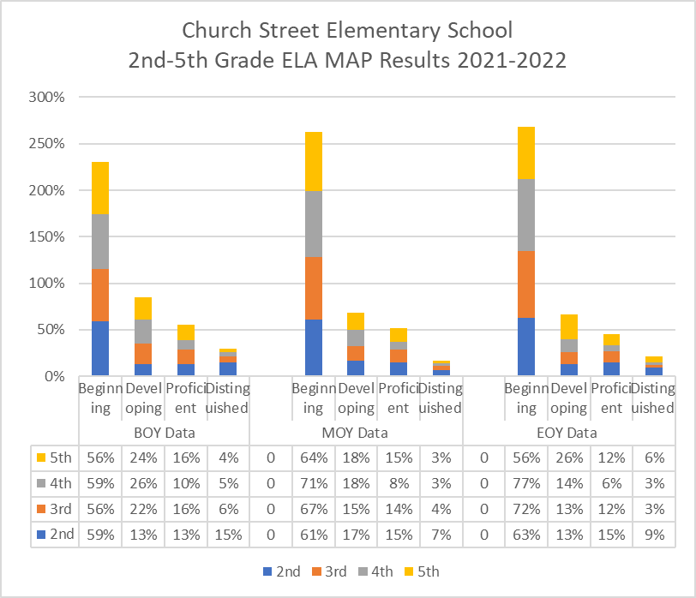

**2nd-5th Grade MAP ELA:**

**2nd-5th Grade MAP ELA Results Summary August 2021 - May 2022:**

The percentage of 2nd grade students that scored at the proficient level on the ELA MAP decreased by 4% from the BOY to EOY 2021-2022 administration of the assessment. The percentage of 2nd graders that performed at the developing level remained the same at 13% from the BOY to EOY 2021-2022 ELA MAP administration.

The percentage of 3rd grade students that scored at the beginning level on the ELA MAP increased by 16% from the BOY to EOY administration of the 2021-2022 assessment. The percentage of 3rd grade students that scored at the proficient or above level on the ELA MAP decreased by 7% from the BOY to EOY administration of the 2021-2022 assessment.

The percentage of 4th graders that scored at the proficient or above level on the ELA MAP 2021-2022 assessment decreased by 6% from the BOY to EOY administration.

The percentage of 5th grade students that scored at the developing level on the ELA MAP 2021-2022 assessment remained the same at 56% from the BOY to EOY administration. There was a 4% decrease in the percentage of 5th grade students that scored at the proficient level on the ELA MAP 2021-2022 assessment. The percentage of 5th grade students that scored distinguished increased by 2% from the BOY to EOY administration.

There was a 5% decrease in the percentage of 2nd-5th grade students scoring at the proficient or higher level on the ELA MAP 2021-2022 assessment from the BOY to EOY administration.

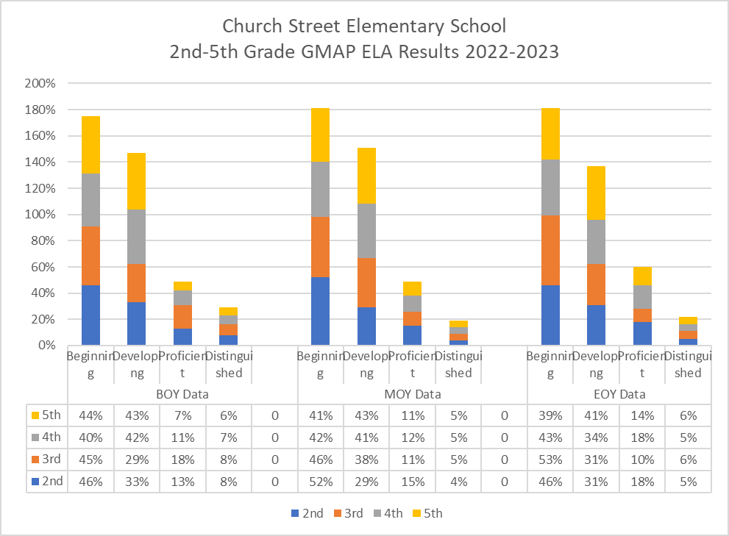

**2nd-5th Grade MAP ELA Results Summary August 2022 - May 2023:**

The number of Proficient and Distinguished Learners in 2nd grade decreased by 2% from the beginning of the year to the middle of the year (BOY: 21% to MOY: 19%) in 2022-2023. The number of Proficient and Distinguished Learners in 2nd grade increased by 4% from the middle of the year to the end of the year (MOY: 19% to EOY: 23%) in 2022-2023. The number of Proficient and Distinguished Learners increased by 2% from the beginning of the year to the end of the year (BOY: 21% to EOY: 23%) in 2022-2023.

The number of Proficient and Distinguished Learners in 3rd grade decreased by 10% from the beginning of the year to the middle of the year (BOY: 26% to MOY: 16%) in 2022-2023. The number of Proficient and Distinguished Learners in 3rd grade remained constant from the middle of the year to the end of the year (MOY: 16% to EOY: 16%) in 2022-2023. The number of Proficient and Distinguished Learners decreased by 10% from the beginning of the year to the end of the year (BOY: 26% to EOY: 16%) in 2022-2023.

The number of Proficient and Distinguished Learners in 4th grade decreased by 1% from the beginning of the year to the middle of the year (BOY: 18% to MOY: 17%) in 2022-2023. The number of Proficient and Distinguished Learners in 4th grade increased by 6% from the middle of the year to the end of the year (MOY: 17% to EOY: 23%) in 2022-2023. The number of Proficient and Distinguished Learners increased by 5% from the beginning of the year to the end of the year (BOY: 18% to EOY: 23%) in 2022-2023.

The number of Proficient and Distinguished Learners in 5th grade increased by 3% from the beginning of the year to the middle of the year (BOY: 13% to MOY: 16%) in 2022-2023. The number of Proficient and Distinguished Learners in 5th grade increased by 4% from the middle of the year to the end of the year (MOY: 16% to EOY: 20%) in 2022-2023. The number of Proficient and Distinguished Learners increased by 7% from the beginning of the year to the end of the year (BOY: 16% to EOY: 20%) in 2022-2023.

**Science**

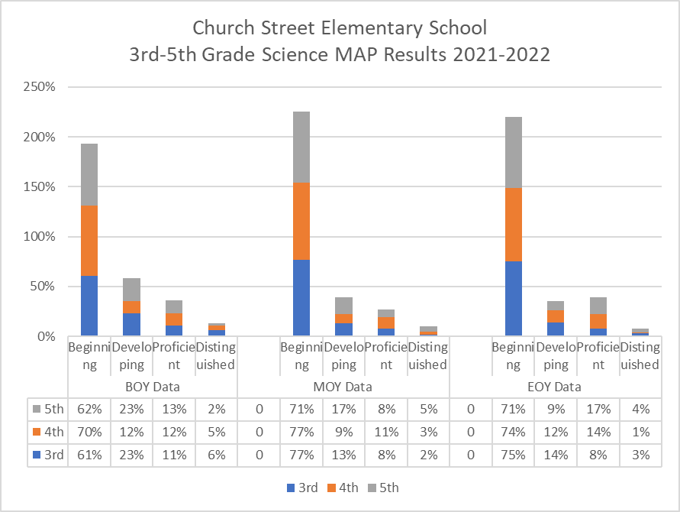

**3rd-5th Grade MAP Science:**

The percentage of 3rd grade students that scored at the beginning level on the 2021-2022 Science MAP assessment increased by 8% from the BOY to EOY administration. The percentage of 3rd grade students that scored at the proficient level or higher on the 2021-2022 Science MAP assessment decreased by 10% from the BOY to EOY administration.

The percentage of 4th grade students that scored at the beginning level on the 2021-2022 Science MAP assessment increased by 3% from the BOY to EOY administration. The percentage of 4th grade students that scored at the proficient level or higher on the 2021-2022 Science MAP assessment increased by 5% from the BOY to EOY administration,

The percentage of 5th grade students that scored at the beginning level on the 2021-2022 Science MAP assessment decreased by 5% from the BOY to the EOY administration. The percentage of 5th grade students scoring at the distinguished level remained the same at 6% from the BOY to EOY administration of the 2021-2022 Science MAP assessment.

The percentage of 3rd-5th grade students that scored at the proficient or higher level on the 2021-2022 Science MAP assessment remained the same at 16% from the BOY to EOY administration. The percentage of 3rd-5th grade students that scored at the beginning level on the 2021-2022 MAP assessment increased by 9% from the BOY to EOY administration.

| Church Street Elementary School  3rd-5th Grade Science Results 2022-2023 |
| --- |

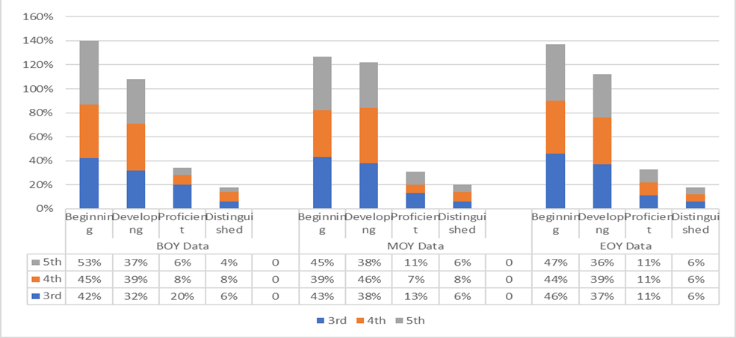

**3rd-5th Grade MAP Science Results Summary August 2022 - May 2023:**

The number of Proficient and Distinguished Learners in 3rd grade decreased by 7% from the beginning of the year to the middle of the year (BOY: 26% to MOY: 19%) in 2022-2023. The number of Proficient and Distinguished Learners in 3rd grade decreased by 2% from the middle of the year to the end of the year (MOY: 19% to EOY: 17%) in 2022-2023. The number of Proficient and Distinguished Learners decreased by 9% from the beginning of the year to the end of the year (BOY: 26% to EOY: 17%) in 2022-2023.

The number of Proficient and Distinguished Learners in 4th grade decreased by 1% from the beginning of the year to the middle of the year (BOY: 16% to MOY: 15%) in 2022-2023. The number of Proficient and Distinguished Learners in 4th grade increased by 2% from the middle of the year to the end of the year (MOY: 15% to EOY: 17%) in 2022-2023. The number of Proficient and Distinguished Learners increased by 1% from the beginning of the year to the end of the year (BOY: 16% to EOY: 17%) in 2022-2023.

The number of Proficient and Distinguished Learners in 5th grade increased by 7% from the beginning of the year to the middle of the year (BOY: 10% to MOY: 17%) in 2022-2023. The number of Proficient and Distinguished Learners in 5th grade remained constant from the middle of the year to the end of the year (MOY: 17% to EOY: 17%) in 2022-2023. The number of Proficient and Distinguished Learners increased by 7% from the beginning of the year to the end of the year (BOY: 10% to EOY: 17%) in 2022-2023.

**Attendance Data**

**Summary of the Monthly Attendance 2020-2021**

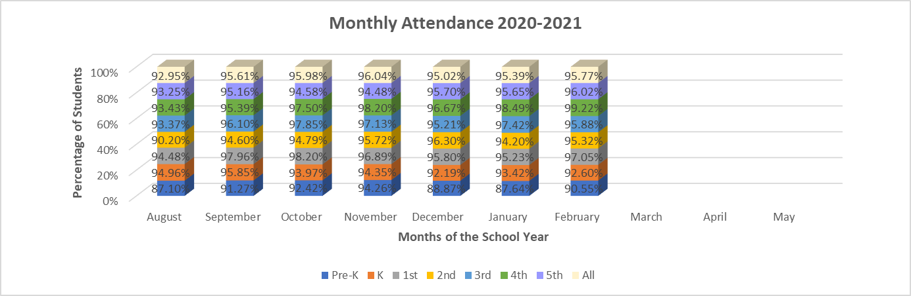

For the school year 2020-2021, the data suggest that although the attendance fluctuated between the months of August 2020- February 2021, it only accounted for a 1-3% change within each grade level. However, the unsuspected pandemic that ensued shortly thereafter in March of 2021, caused a major disturbance in students attendance therefore, data for the months of March 2021-May 2021 is unavailable.

**Summary of the Monthly Attendance 2021-2022**

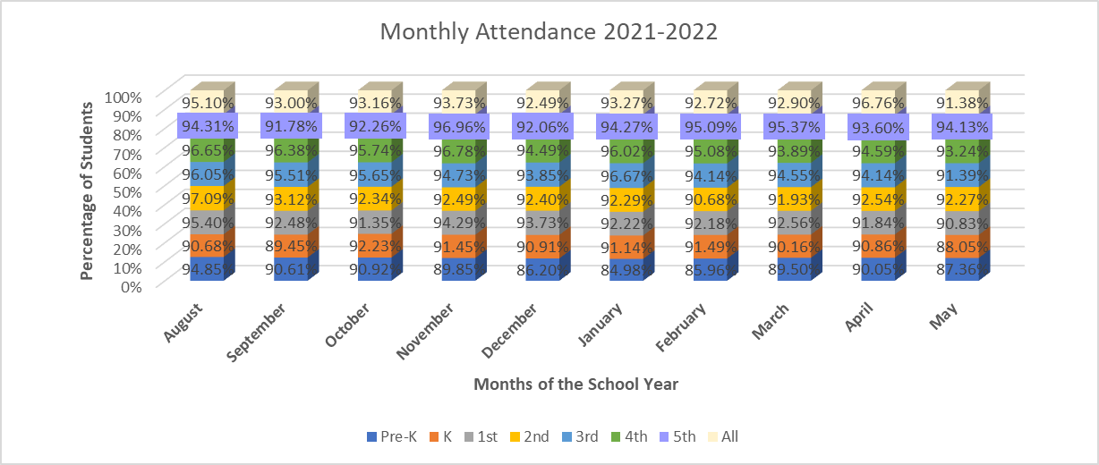

The unsuspected nature of the pandemic during the latter part of the previous school year of 2020-2021, created hesitation which impacted student attendance. Although routines were put into place upon students’ return in August 2021 and the data increased within the grade levels,the pandemic’s effect on schoolwide student attendance declined for the 2021-2022 school year.

**Summary of the Monthly Attendance 2022-2023**

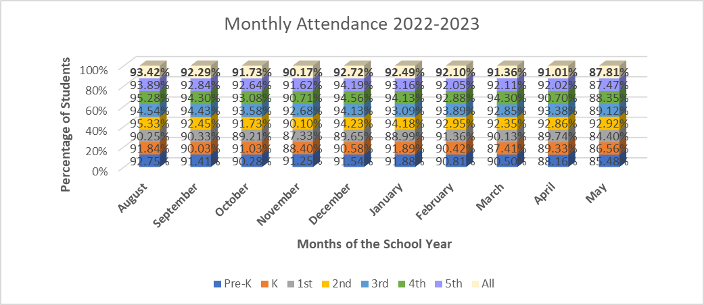

For the school year 2022-2023, the data suggest that although the overall attendance fluctuated early on each month of 1-2% for each grade level, the biggest effect occurred during the last month of school for all grade levels. The data also shows that there was a continued percentage decline from the lower grades of Pre-Kindergarten and; however, it remained steady in grades First Grade-Fifth Grade.

**Discipline Data**

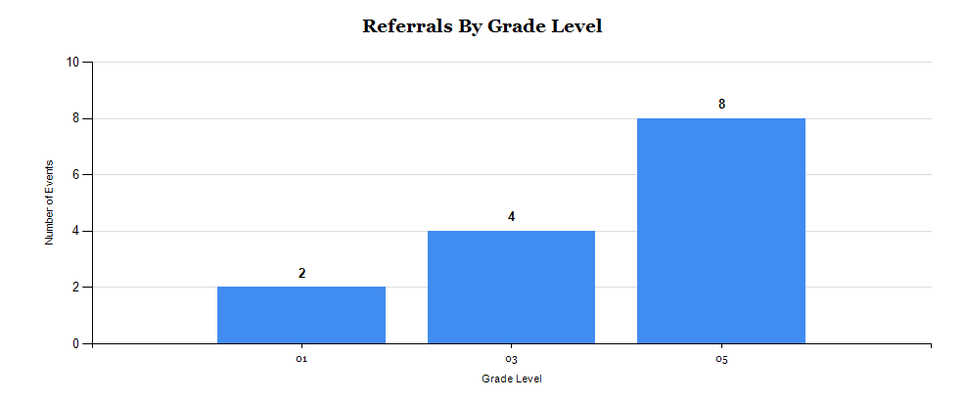\ 2021-2022 Discipline Data

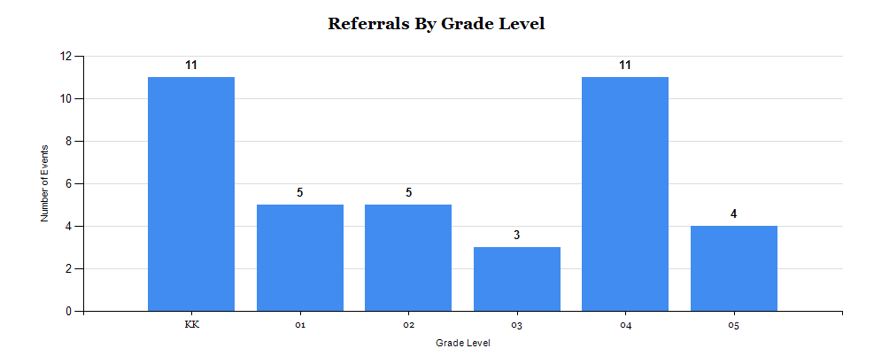

**2022-2023 Discipline Data**

The data shows an increase in discipline behavior for the 2022-2023 school year in comparison to the 2021-2022 school year. During the 2021-2022 school year, a significant number of students were still attending school virtually. During the 2022-2023 school year, the hybrid model ended and students were required to attend school face to face, unless they enrolled in the district’s virtual learning program. There was an increase in student behavior because we had more students in the building and students exhibited an increase in various types of behavior due to 2022-2023 being the first year since 2020 that all students were required to attend school face to face. Students had challenges adjusting to being in a structured environment after being home learning virtually for approximately 1 ½ years. The PBIS Framework is presently being implemented school-wide in an effort to improve student behavior.

**Comprehensive Needs Assessment:**

| **1. Comprehensive Needs Assessment: Sec. 1114(b)(1)(A)** |
| --- |
| Is based on a comprehensive needs assessment of the entire school that considers information of the academic achievement of children in relation to the challenging State academic standards, **particularly the needs of those children who are failing, or are at-risk of failing**, to meet the challenging State academic standards and any other factors as determined by the local educational agency; **Sec. 1114(b)(1)(A)** |
| **Describe the Comprehensive Needs Assessment Process used to develop your needs and goals for your school for this year’s Comprehensive Schoolwide Improvement Plan.** |
| We have developed our school-wide plan with the participation of individuals who will carry out the comprehensive school-wide/school improvement program plan. A number of stakeholders were involved in the process of compiling data for the school’s profile. The stakeholders that were involved in completing the needs assessment were students, parents, teachers and community partners. Following the sessions, the results were compiled and analyzed by the school leadership team. Grade level meetings were held to assist in identifying the strengths and weaknesses of Church Street’s instructional and organizational effectiveness. Test scores, student performance and teaching techniques were analyzed. Once the feedback had been received, members of the leadership team met to share the results with our stakeholder community.   * 1. Church Street Elementary reflected on current achievement data (GMAS and MAP, iReady, DIBELS, benchmark and common assessment data) to help the school understand the subjects and skills in which teaching and learning need to be improved. The following instruments, procedures, processes and/or data were also reviewed as part of this process: * Parent Surveys and Student Surveys * Teacher and Student Attendance * MAP/iReady are comprehensive summative assessment pro​grams that measure how well students have learned the knowledge and skills outlined in each of the state-adopted content standards via BOY, MOY and EOY data reports. * Students with Disabilities (SWD/ DES) data * Retention Rate * Student Discipline Data (OSS, bus and/or Circle of Support information. PBIS SWIS data, Big 7 Reports from Infinite Campus) * GKIDS (The Georgia Kindergarten Inventory of Developing Skills is a year-long, performance-based assessment whose goal is to provide teachers with information about the level of instructional support needed by individual students entering kindergarten and first grade). * Parental Involvement * RTI/SST * 504 Accommodations * Students qualifying for Early Intervention Services (EIP) * Ongoing Benchmark performance in relationship to actual outcome * DIBELS (Dynamic Indicators of Early Literacy Skills). * Individual Education Plans |
| **Review your data by subgroup and note areas of deficit, specifically the needs of those children who are failing or are at-risk of failing. (ED, EL, Race, Migrant, Foster Care, SWD, Gifted)** |
| After a thorough review of our assessment data, we have found the following areas of concern:  The majority of students across all grade levels (and all contents) are still performing at the Beginning and Developing Learner levels. Writing continues to be an area of improvement across all bands (K-5). Gaps still exist between SWD and all other subgroups.  In addition to reviewing our current data as well as our three-year trend data, Church Street Elementary School will continue to reflect on practices including e-walks, walkthroughs, formative and summative assessments, student work and teacher/student commentary and professional development as identified by teacher surveys and TKES data.   * 1. Migrant Population   Church Street does not have a migrant student population. However, in the event the school gains a migrant population the schools will follow district, state and federal guidelines to ensure that migratory students will achieve the same goals set for all students. We will diagnose their needs, create and maintain a profile based on the needs assessment, plan engaging instruction, teach the Georgia Standards of Excellence (GSE), assess for mastery, reteach with appropriate interventions/RTI and administer summative assessments to determine if mastery is achieved or further interventions are required. In addition, all parents or guardians enrolling a child in the school will receive a survey that determines if the child will be identified as a migrant. This information will be maintained in the cumulative folder of each child.   * 1. We have reflected on current achievement data that will help the school understand the   subjects and skills in which teaching and learning needs to be improved. We reviewed our data for math, science, writing, social studies and ELA. We work with our teachers to extend our students' learning in order for each child to gain a deeper understanding of the content. However, our data reveals that improvement is still needed across all content areas (math, ELA, writing, science and social studies).   * 1. We have based our plan on information about all students in the school and identified students and groups of students who are not yet achieving to the State academic content standards and the State student academic achievement standard including:      + Economically disadvantaged students are our largest sub-group with most students being identified in multiple subgroups.      + Students from major racial and ethnic groups are present at Church Street with Black being the largest group and American Indian/Alaskan Native being the smallest, closely followed by White.      + Students with disabilities as a sub-group have increased this year in numbers, and constitute a large population of identified students who are in multiple sub-groups.      + Students with limited English proficiency are the fastest growing subgroup at Church Street. Most of these students also fall into the economically disadvantaged sub-group.   E. The data has helped us reach conclusions regarding achievement or other related data.   * + - A strength includes the point changes that each grade level made on the GMAS from 2022 to 2023 in 3rd-5th grade even though the percentage of proficient learners and distinguished learners are still relatively low.     - The weaknesses we see are that we had the fewest proficient and distinguished learners in 5th grade Math in 2023. Also, the majority of our scholars in 3rd-5th are reading below grade level. The overall percentage of proficient plus distinguished learners on the GMAS in 3rd-5th grade is still lower than the percentage of developing learners and beginning learners in those same grades.     - Some opportunities that we discussed as a result of the data is that we should be more intentional with our strategies to increase the number of our SWD scholars scoring at the developing, proficient, and distinguished levels.     - Threats that we are concerned about are the attendance of our SWD scholars as well as the fact that all of our DES teachers are new, the behavior of our scholars that results in them missing class/instructional time.     - The barriers that are confronting us from making progress have to do with the following: Each year we get teachers who are new and therefore, we are constantly working to get them trained so that they can provide rigorous and meaningful instruction.   The specific academic needs will be addressed through the implementation of explicit instruction/gradual release model with fidelity, enhanced academic vocabulary instruction and timely professional development. We will continue to implement best teaching practices while  adhering to the district’s instructional priorities to ensure that all of our students are proficient or distinguished in all content areas (Math, Science, ELA, Writing and Social Studies).  Teams of stakeholders, including parents, teachers, and administrators, used a variety  of protocols and tools to identify root causes that explain our low student performance  in Mathematics, English/Language Arts, Science and Social Studies. What the team  discovered primarily centered on the following causes:   * + Teachers not implementing all components of the new ELA/Reading HMH series with fidelity.   + Teachers not collaboratively planning with student/data as the focus to drive instruction.   + Limited number of students attending programs that were designed to be safety nets.   + Student Lexile scores below grade level expectations.   + Parents don’t understand how to fully support their child’s learning at home. |
| **Based on the CSIP team data analysis, prioritization of needs, and agreed upon root causes list the prioritized foci and root causes.** |
| | **Foci** | **Root Causes** | | --- | --- | | Reading: Implement a rigorous and relevant reading curriculum with a focus on vocabulary. | * Scholars lack vocabulary acquisition. * The ELA Curriculum lacks a robust vocabulary component. | | Reading: Use quantitative data to improve the core reading curricula, instructional practices, and interventions to accelerate and remediate our students' learning. | * Lack of small group lesson planning. * Lack of implementing small groups in the classrooms (especially 2nd-5th). | | Reading: Implement a rigorous and relevant reading curriculum with a focus on phonics. | * Lack of focus on phonics using decodable readers. * Lack of small group instruction that focuses on phonemic awareness and phonics. | | Implement evidence-based practices that support effective Collaborative Extended Planning focusing on the following: *Plan units/lessons using the S.T.A.R.T.S. model and High Impact Practices for rigorous instruction: Higher Order Questions, Academic Discourse/Discussions, & Evidence-based Writing. *Discuss formative and summative data for flexible groupings to accommodate learning needs (for Walk to Read and other data driven lessons) *Develop common assessments | * Looking at our 2019 CCRPI content mastery data, it is evident that we must continue to work on planning more rigorous lessons (in lesson planning). * Not enough usage of High Impact Practices (especially in 2nd – 5th). * Inconsistent with using the data to truly drive our instruction. | |

**Goals and Strategies: (Identify 3 to 4 SMART goals based on school needs.)**

| **2. Address the School-wide reform strategies that the school will implement to meet the school needs, including a description of how such strategies will: Section 1114 (b)(7)(A)(i-iii)(I-V)**  **a) provide opportunities for all children, including each of the subgroups of students (economically disadvantaged students, students with disabilities, English learners, gifted, and foster/homeless students) to meet the State’s challenging academic standards; 1111(c)(2)**  **b) use methods and instructional strategies an academic program in the school, will increase the amount and quality of learning time, and help provide an enriched and accelerated curriculum, which may include programs, activities, and courses necessary to provide a well-rounded education;** | | | | |
| --- | --- | --- | --- | --- |
| **Goal 1:**  By June 2024, the total number of proficient and distinguished learners in 3rd-5th grades will demonstrate eight percentage points growth in ELA as measured on the GMAS. Thus increasing from a total of 48% of our scholars in 3rd -5th grades scoring proficient or distinguished in ELA (in 2023) to a total of 56% of our scholars in 3rd-5th grades scoring proficient and distinguished in ELA (in 2024). | | | | |
| **Evidenced Based Strategies and Interventions** | **Timeline for Implementation** | | **Funding Source** | **Person/Position Responsible** |
| Teachers will implement the use of the new CCPS lesson plan template (for planning for their HMH lessons). | August 2023-May 2024 | | NA | Title I Academic Coach: Ms. Henderson  Principal: Ms. Goree  Assistant Principal: Mrs. Screen  District Level Coordinators |
| Teachers will implement the new CCPS Instructional Framework during ELA instruction. | August 2023-May 2024 | | NA | Title I Academic Coach: Ms. Henderson  Principal: Ms. Goree  Assistant Principal: Mrs. Screen  District Level Coordinators |
| Teachers will participate in weekly, 90 minute, Collaborative Extended Planning sessions to conduct a student progress review that will inform small groups and instructional strategies. | September 2023-April 2024 | | NA | Title I Academic Coach: Ms. Henderson  Principal: Ms. Goree  Assistant Principal: Mrs. Screen |
| Mentoring/Coaching/Training of teachers implementing/teaching differentiated instructional strategies in ELA. | August 2023 to May 2024 | | NA | Title I Academic Coach: Ms. Henderson  Principal: Ms. Goree  Assistant Principal: Mrs. Screen  District Level ELA Coordinator or Lead from Teaching & Learning & Strategic Improvement |
| **Supplemental Supports: What supplemental action steps will be implemented for these subgroups?** | | | | |
| **Economically Disadvantaged** | | **Foster and Homeless** | | |
| 100% of Church Street Elementary students are in the Economically Disadvantaged subgroup. The instructional strategies and interventions provided by teachers and staff for this group of students will support other subgroups as well. Students will benefit from technology-based remediation programs, in-class intervention support specialists, and extended learning opportunities focused on acceleration through a variety of digital learning platforms.  School administrators will periodically review student performance data and work with teachers to identify and institute professional development opportunities based on identified and/or requested needs. TKES observations and informal visits will be used to provide support in the areas of instructional strategies, collaborative planning, differentiated instruction and academically challenging learning environment. School leaders will work with our Lead Mentor and Teacher Leaders to undergird our new teachers and offer professional development specifically aligned to their unique needs. | | Our school counselors will continue to lead the charge in working with our staff and the Homeless Education department to bridge the gap for students who may not have access to all of the instructional resources and supplies they need.  Collaboratively, the counselors and teachers will look for and work together to remove any hindrances identified as preventing our foster and homeless students from participating in learning opportunities that have been extended to all students.  Our counselors will contact the identified students and guardians to determine what resources are needed in order to help the families transition into our school environment. Periodic pulse checks will be held with the guardian/parents and students in order to address any social, emotional or learning needs that have presented themselves. | | |
| **English Learners** | | **Students with Disabilities** | | |
| In support of our English Learners, our ESOL teacher, department chairs and Academic Coaches will work to identify language arts instructional resources to be used in class to improve our students' understanding of how they perceive and comprehend the English language.  Professional development/training opportunities will be provided to introduce strategies that help students produce and use words and sentences to strengthen their overall communication skills.  Our school staff will conduct a “pulse” check every 4 ½ week grading period to gauge student progress and assist parents/guardians as needed. | | Our teachers and Academic Coaches will work with our Students With Disabilities staff to identify language arts instructional resources to be used in class to benefit students and teachers.  Teachers and para/support staff will attend training sessions and implement the research- based strategies to accommodate the learning needs of our students with disabilities.  Our school staff will conduct a “pulse” check every 4 ½ week grading period to gauge student progress and assist parents/guardians as needed. | | |
| **Gifted Learners** | | | | |
| In support of our Gifted Learners, our Gifted teacher, department chairs, and Academic Coaches will work to provide enrichment activities that will extend the learning from their day to day lessons. Teachers will receive information from the Gifted teacher (i.e. Professional Development) to introduce strategies that will extend their scholars’ learning in their classrooms. | | | | |

| **2. Address the School-wide reform strategies that the school will implement to meet the school needs, including a description of how such strategies will: Section 1114 (b)(7)(A)(i-iii)(I-V)**  **a) provide opportunities for all children, including each of the subgroups of students (economically disadvantaged students, students with disabilities, English learners, gifted, and foster/homeless students) to meet the State’s challenging academic standards; 1111(c)(2)**  **b) use methods and instructional strategies an academic program in the school, will increase the amount and quality of learning time, and help provide an enriched and accelerated curriculum, which may include programs, activities, and courses necessary to provide a well-rounded education;** | | | | |
| --- | --- | --- | --- | --- |
| **Goal 2:** By June 2024, the number of proficient and distinguished learners in 3rd-5th grades will demonstrate eight percentage points growth in Math as measured on the GMAS. Thus increasing from a total of 46% of our scholars in 3rd -5th grades scoring proficient or distinguished in math (in 2023) to a total of 54% of our scholars in 3rd-5th grades scoring proficient and distinguished in math (in 2024). | | | | |
| **Evidenced Based Strategies and Interventions** | **Timeline for Implementation** | | **Funding Source** | **Person/Position Responsible** |
| Teachers will implement the use of the new CCPS lesson plan template (for planning their math lessons). | August 2023-May 2024 | | NA | Title I Academic Coach: Ms. Sims  Principal: Ms. Goree  Assistant Principal: Mrs. Screen  District Level Coordinators |
| Teachers will implement the new CCPS Instructional Framework during math instruction | August 2023-May 2024 | | NA | Title I Academic Coach: Ms. Sims  Principal: Ms. Goree  Assistant Principal: Mrs. Screen  District Level Coordinators |
| Teachers will participate in weekly, 90 minute, Collaborative Extended Planning sessions to conduct a student progress review that will inform small groups and instructional strategies | September 2023-April 2024 | | NA | Title I Academic Coach: Ms. Sims  Principal: Ms. Goree  Assistant Principal: Mrs. Screen |
| Utilize district level support who will help side by side coach and/or model the implementation of best practices that align with the Math curriculum as well as collaborate with the Title I Academic Coach to be sure to meet the support needs of the Math teachers. Professional Development will also be provided. | August 2023-May 2024 | | NA | Title I Academic Coach: Ms. Sims  Principal: Ms. Goree  Assistant Principal: Mrs. Screen  District Level Math Coordinator or Lead from Teaching & Learning & Strategic Improvement |
| **Supplemental Supports: What supplemental action steps will be implemented for these subgroups?** | | | | |
| **Economically Disadvantaged** | | **Foster and Homeless** | | |
| 100% of Church Street Elementary students are in the Economically Disadvantaged subgroup. The instructional strategies and interventions provided by teachers and staff for this group of students will support other subgroups as well. Students will benefit from technology-based remediation programs, in-class intervention support specialists, and extended learning opportunities focused on acceleration through a variety of digital learning platforms.  School administrators will periodically review student performance data and work with teachers to identify and institute professional development opportunities based on identified and/or requested needs. TKES observations and informal visits will be used to provide support in the areas of instructional strategies, collaborative planning, differentiated instruction and academically challenging learning environment. School leaders will work with our Lead Mentor and Teacher Leaders to undergird our new teachers and offer professional development specifically aligned to their unique needs. | | Our school counselors will continue to lead the charge in working with our staff and the Homeless Education department to bridge the gap for students who may not have access to all of the instructional resources and supplies they need.  Collaboratively, the counselors and teachers will look for and work together to remove any hindrances identified as preventing our foster and homeless students from participating in learning opportunities that have been extended to all students.  Our counselors will contact the identified students and guardians to determine what resources are needed in order to help the families transition into our school environment. Periodic pulse checks will be held with the guardian/parents and students in order to address any social, emotional or learning needs that have presented themselves. | | |
| **English Learners** | | **Students with Disability** | | |
| In support of our English Learners, our ESOL teacher, department chairs and Academic Coaches will work to identify language arts instructional resources to be used in class to improve our students' understanding of how they perceive and comprehend the English language.  Professional development/training opportunities will be provided to introduce strategies that help students produce and use words and sentences to strengthen their overall communication skills.  Our school staff will conduct a “pulse” check every 4 ½ week grading period to gauge student progress and assist parents/guardians as needed. | | Our teachers and Academic Coaches will work with our Students With Disabilities staff to identify language arts instructional resources to be used in class to benefit students and teachers.  Teachers and para/support staff will attend training sessions and implement the research- based strategies to accommodate the learning needs of our students with disabilities.  Our school staff will conduct a “pulse” check every 4 ½ week grading period to gauge student progress and assist parents/guardians as needed. | | |
| **Gifted Learners** | | | | |
| In support of our Gifted Learners, our Gifted teacher, department chairs, and Academic Coaches will work to provide enrichment activities that will extend the learning from their day to day lessons. Teachers will receive information from the Gifted teacher (i.e. Professional Development) to introduce strategies that will extend their scholars’ learning in their classrooms. | | | | |

| **2. Address the School-wide reform strategies that the school will implement to meet the school needs, including a description of how such strategies will: Section 1114 (b)(7)(A)(i-iii)(I-V)**  **a) provide opportunities for all children, including each of the subgroups of students (economically disadvantaged students, students with disabilities, English learners, gifted, and foster/homeless students) to meet the State’s challenging academic standards; 1111(c)(2)**  **b) use methods and instructional strategies an academic program in the school, will increase the amount and quality of learning time, and help provide an enriched and accelerated curriculum, which may include programs, activities, and courses necessary to provide a well-rounded education;** | | | | |
| --- | --- | --- | --- | --- |
| **Goal 3:** By June 2024, the total number of infractions in K-5th grade will decrease by 15 showing a reduction in discipline referrals/incidents. Thus the number of infractions will decrease from 39 (in 2023) to 24 (in 2024). | | | | |
| **Evidenced Based Strategies and Interventions** | **Timeline for Implementation** | | **Funding Source** | **Person/Position Responsible** |
| Implement the PBIS framework throughout the school. | August 2023-May 2024 | | $500 | PBIS Coach: Ms. Morley  Assistant  Pre-K -5th grade Teachers  Principal: Mrs. Screen  Principal: Ms. Goree |
| Implement and utilize the Opportunity Room as a restorative practice | August 2023-May 2024 | | NA | Student Engagement Specialist: Mr. Smith  Assistant Principal: Mrs. Screen  Principal: Ms. Goree |
| Implement and utilize a school-wide Classroom Management Plan. | August 2023-May 2024 | | NA | Pre-K-5th grade Teachers  PBIS Coach: Ms. Morley  Gifted Teacher: Mrs. Rawls  Assistant Principal: Mrs. Screen  Principal: Ms. Goree |
| **Supplemental Supports: What supplemental action steps will be implemented for these subgroups?** | | | | |
| **Economically Disadvantaged** | | **Foster and Homeless** | | |
| 100% of Church Street Elementary students are in the Economically Disadvantaged subgroup. The instructional strategies and interventions provided by teachers and staff for this group of students will support other subgroups as well. Students will benefit from technology-based remediation programs, in-class intervention support specialists, and extended learning opportunities focused on acceleration through a variety of digital learning platforms.  School administrators will periodically review student performance data and work with teachers to identify and institute professional development opportunities based on identified and/or requested needs. TKES observations and informal visits will be used to provide support in the areas of instructional strategies, collaborative planning, differentiated instruction and academically challenging learning environment. School leaders will work with our Lead Mentor and Teacher Leaders to undergird our new teachers and offer professional development specifically aligned to their unique needs. | | Our school counselors will continue to lead the charge in working with our staff and the Homeless Education department to bridge the gap for students who may not have access to all of the instructional resources and supplies they need.  Collaboratively, the counselors and teachers will look for and work together to remove any hindrances identified as preventing our foster and homeless students from participating in learning opportunities that have been extended to all students.  Our counselors will contact the identified students and guardians to determine what resources are needed in order to help the families transition into our school environment. Periodic pulse checks will be held with the guardian/parents and students in order to address any social, emotional or learning needs that have presented themselves. | | |
| **English Learners** | | **Students with Disability** | | |
| In support of our English Learners, our ESOL teacher, department chairs and Academic Coaches will work to identify language arts instructional resources to be used in class to improve our students' understanding of how they perceive and comprehend the English language.  Professional development/training opportunities will be provided to introduce strategies that help students produce and use words and sentences to strengthen their overall communication skills.  Our school staff will conduct a “pulse” check every 4 ½ week grading period to gauge student progress and assist parents/guardians as needed. | | Our teachers and Academic Coaches will work with our Students With Disabilities staff to identify language arts instructional resources to be used in class to benefit students and teachers.  Teachers and para/support staff will attend training sessions and implement the research- based strategies to accommodate the learning needs of our students with disabilities.  Our school staff will conduct a “pulse” check every 4 ½ week grading period to gauge student progress and assist parents/guardians as needed. | | |
| **Gifted Learners** | | | | |
| In support of our Gifted Learners, our Gifted teacher, department chairs, and Academic Coaches will work to provide enrichment activities that will extend the learning from their day to day lessons. Teachers will receive information from the Gifted teacher (i.e. Professional Development) to introduce strategies that will extend their scholars’ learning in their classrooms. | | | | |

| **2. Address the School-wide reform strategies that the school will implement to meet the school needs, including a description of how such strategies will: Section 1114 (b)(7)(A)(i-iii)(I-V)**  **a) provide opportunities for all children, including each of the subgroups of students (economically disadvantaged students, students with disabilities, English learners, gifted, and foster/homeless students) to meet the State’s challenging academic standards; 1111(c)(2)**  **b) use methods and instructional strategies an academic program in the school, will increase the amount and quality of learning time, and help provide an enriched and accelerated curriculum, which may include programs, activities, and courses necessary to provide a well-rounded education;** | | | |
| --- | --- | --- | --- |
| **Goal 4:** NA | | | |
| **Evidenced Based Strategies and Interventions** | **Timeline for Implementation** | **Estimated Budget** | **Person/Position Responsible** |
|  |  |  |  |
|  |  |  |  |
|  |  |  |  |
|  |  |  |  |
|  |  |  |  |
| **Supplemental Supports: What supplemental action steps will be implemented for these subgroups?** | | | |
| **Economically Disadvantaged** | **Foster and Homeless** | | |
|  |  | | |
| **English Learners** | **Students with Disability** | | |
|  |  | | |
| **Gifted Learners** | | | |
|  | | | |

| **2. Address the School-wide reform strategies that the school will implement to meet the school needs, including a description of how such strategies will: Section 1114 (b)(7)(A)(i-iii)(I-V)**  **c)**  **address the needs of all children in the school, but particularly the needs of those at risk of not meeting the challenging State academic standards through activities which may include:** |
| --- |
| **i)** **counseling, school-based mental health programs, specialized instructional support services, mentoring services, and other strategies to improve students’ skills outside the academic subject areas** |
| The school’s foundation at Church Street Elementary School is built on personalizing school for each learner. We will continue to provide academic and social support to help students reach their academic goals. With that as our focus, student support strategies that are used to address the needs of all students includes identifying students who need support by need and by subgroup. Church Street Elementary School teachers and administrators closely monitor students’ academic performance. We regularly review grades at each grading period to identify at-risk learners. We then use this information to design and implement learning supports that will help these students get back on track. Targeted populations such as ESOL and students with disabilities are well supported. Students in these subgroups are taught by highly qualified teachers who are held to the same high standards and level of expectation as our regular education teachers. Church Street general education teachers work collaboratively with special education, gifted, and ESOL teachers to disaggregate the data of assessment scores, interim assessments, and ELL ACCESS testing to determine if an achievement gap exists.  Our school counselors, Behavior Intervention Specialist, Behavioral Health Specialist, student engagement specialist and additional student/pupil services help us identify not only academic support for our students, but also social support as well. Monthly guidance sessions are conducted by our counselors with students to help them set goals and review their progress towards those goals. The Behavior Interventionist and Behavioral Health Specialist also support students weekly/bi-weekly. Special education students have Individualized Education Plans (IEP) that correlate to their grade level curriculum. Our EL students also have modification plans that allow the students to learn grade level content while learning English. Both our EL and Special Education teachers work collaboratively with general education teachers to support the students and provide differentiated instruction. |
| **ii) preparation for and awareness of opportunities for postsecondary education and the workforce, which may include career and technical education programs and broadening secondary school students’ access to coursework to earn postsecondary credit while still in high school (such as Advanced Placement, International Baccalaureate, dual or concurrent enrollment, or early college high schools** |
| Our school counselors and additional student/pupil services help us identify not only academic support for our students, but also social support as well. Monthly guidance sessions are conducted by our counselors with students to help them set goals and review their progress towards those goals. This is done in preparation for and creating an awareness of opportunities for postsecondary education and the workforce. School counselors share career and technical education programs with our students and provide access to websites to help students learn more about various careers or jobs within the workforce. |
| **iii) implementation of a schoolwide tiered model to prevent and address problem behavior, and early intervening services, coordinated with similar activities and services carried out under the Individuals with Disabilities Education Act (20 U.S.C. 1400 et seq.);** |
| Church Street Elementary has implemented the PBIS framework and aligned it with the SEL (Social Emotional Learning) program as a preventative measure to eliminate punishment and address problem behavior in a systematic approach school-wide. Our school-wide behavior program requires all teachers to teach all students our school-wide expectations. We have implemented a school-wide incentive program for our students that helps to reinforce our daily expectations for appropriate behavior.  We have a full-time SST Chair on staff to support students’ needs and parents’ requests for testing or additional support for their children. Our RTI/MTSS program also supports our students based on their individual needs. Response to Intervention is defined as “ the practice of providing high-quality instruction and interventions matched to student need, monitoring progress frequently to make decisions about changes in instruction or goals, and applying child response data to important educational decisions” (Batsche et al., 2005). In education, RTI/MTSS is a method of academic intervention used in the United States which is designed to provide early, effective assistance to children who are having difficulty learning.  We provide DES services and resources that are available to meet the unique needs of students with disabilities that support a range from less restrictive to more restrictive environments, depending on the specific needs of the student. Our DES department also supports students in ensuring students with disabilities appropriately access the Georgia Standards of Excellence and provide specialized instruction as determined necessary by the Individualized Education Plan (IEP) plan. Additionally, the department assists in the assessment process for determining special education eligibility. |
| **iv) professional development and other activities for teachers, paraprofessionals, and other school personnel to improve instruction and use of data from academic assessments, and to recruit and retain effective teachers, particularly in high need subjects; *(A list of proposed professional development offerings must be included in the******Professional Development (question 2 iv) section.)*** |
| List of Proposed Professional Development Offerings: *\*As a result of the time constraints, this information will be fleshed out more when we meet (again) as a team:*   1. *Differentiated Instructional Strategies for ELA (small group)* 2. *Differentiated Instructional Strategies for Math (small group)* 3. *Lesson planning using the Instructional Framework.*   We will include parents, parent liaison, student engagement specialists and teachers in professional development activities regarding the use of academic assessments to enable them to provide information on, and to improve, the achievement of individual students and the overall instructional program. Learning opportunities will take place through Saturday Parent Academies, PTA meetings, Family and Curriculum Nights and other evening meetings/training with parents – especially those sessions that will focus on how parents can assist/support their children at home. We will continue to consult with individual agencies to provide specific content or subject-matter training to parents. To encourage parent participation in these trainings, Title I funds will be used to provide parent resources and access to technology. To maximize funding, all professional development funds that include Title I, IDEA, Title II, District Professional Learning and other funds will be used to support training needs. A portion of the meetings will occur on site monthly during reserved professional learning times where teachers, paraprofessionals, parent liaison and administrators will be able to learn from subject matter experts.  A variety of strategies will be used to attract high-quality teachers to Church Street Elementary School. We will provide instruction by highly qualified teachers who meet the standards established by the state of Georgia staff roster. If there are potential certification deficiencies, we will work with the state/district to provide professional development and/or courses to address areas of growth/improvement. Additionally, some teachers who may not be certified, are a part of the TAPP Program that is offered by the CCPS Professional Learning Department.  We will continue to participate in all district staff recruitment and retention efforts. We will continue to take advantage of those opportunities afforded through the use of “social media” as well as other technology and “word of mouth” communications to share the great things that are happening at Church Street Elementary School.  Additionally, to attract and retain these highly qualified educators, we will:   * Create a culture of learning * Recruit early from approved Clayton County sources * Interview multiple applicants for any given position * Offer multiple opportunities for high quality professional development * Create a supportive and nurturing environment that encourages collaboration and team building * Maintain a mentoring program for all new teachers and veteran teachers utilizing TSS (Teacher Support Specialists) * Provide instructional support by the Principal and Academic Coaches * Maintain a sense of family and camaraderie with the faculty and staff * Seek faculty input with the interview selection * Provide caring, supportive administrators with open-door policies * Show teacher appreciation regularly throughout the school year from administrators, PTA, PIE (Partners In Education), and other stakeholders. |
| **v)** **strategies for assisting preschool children in the transition from early childhood education**  **programs to local elementary school programs. Middle and high schools, describe how the**  **school will implement strategies to facilitate effective transitions for students from middle to**  **high school and from high school to post-secondary education including, if applicable.** |
| The following are our plans for assisting preschool children in the transition from early childhood programs. Also included are transition plans for students entering middle school or high school and entering form private schools plus students entering our school throughout the school year. Our first transition period that is addressed is the transition from Pre-K to Kindergarten. This plan includes:   * In the spring, communication about Church Street Elementary will be distributed to local daycare centers and church programs via the school website, county communications, and school flyers. * In the spring, the Counselors and Kindergarten teachers will conduct a virtual meeting to discuss registration procedures and expectations for Kindergarten. * The students will tour the building in person or virtually, meet the staff, and participate in some Kindergarten activities. * Make sure all IEPs are current for easy transition for Students with Disabilities (SWD) into middle schools * Fifth Grade Transition to Riverdale and Kendrick Middle School involves Church Street Elementary and Riverdale and Kendrick Middle School. We utilize activities including plans for assisting Fifth grade students in the transition to Middle School. This plan includes an assembly presented to 5th grade students by 6th grade staff and students. During the face to face assembly, transition is discussed; changes in the instructional program, departmentalization, and a question/answer are held. In addition to these activities, a “final walkthrough” is held by our fifth graders at the end of their year to say goodbye as well as a promotional ceremony. |
| **vi) describe how the school will use and implement effective parent and family engagement strategies for parents of English Learners and Students with Disabilities.** |
| * 1. We will involve parents in the planning, review, and improvement of the comprehensive school-wide plan through a series of organized, ongoing and timely opportunities.   Parents will be informed through written communication and PTA meetings of their child’s school performance data; test scores and progress. The parents will be provided with information regarding interpretation of those scores and encouraged to ask questions. Additionally:   * Parents will participate on the Local School Council. The Local School Council meets four times a year and consists of teachers, community partners, parents, and principal. * Parents will be involved with updating the School Parent Involvement Policy. * Parents will be involved with teachers in developing online personalized learning plans for their student(s). * Parents will receive a letter from the Principal including a copy of the Title 1 Parent Involvement Policy. * Parent Involvement Surveys will be distributed to parents * Parents will participate in monthly workshops designed to help them “help” their child with improving their academic performance * Parents will participate in scheduled as well as unscheduled conferences * Parents will have access resources available in our Parent Resource Center * Parents will be notified of assessments results through parental meetings, report cards, parent-teacher conference, and written notifications   1. We have developed a parent involvement policy that will periodically be updated to meet the changing needs of our parents and school community in general. During our Annual Title 1 Meeting (held at different days and times), parents will assist in planning and developing and ultimately approving our School-wide Program Plan as well as other parental involvement documents. Our parent involvement policy:      + includes strategies to increase parental involvement (such as family literacy services)      + describes how the school will provide individual student academic assessment results, including an interpretation of those results      + makes the comprehensive school-wide program plan available to the LEA, parents, and the public (internet, newspaper, newsletters)      + Requires compacts – include with policy      + Includes a Parent Involvement checklist included   2. We will work collaboratively with our Parent Liaison who works exclusively to increase parental involvement. The Parent Liaison will organize workshops, attend Title 1 District meetings, call parents to remind them about meetings, etc. Activities to increase parent ability to help children will include Family Math/Reading Night and Academic Readiness Workshops. Other parental support options will include training on our technology platform for digital learning (for ELBC Days).   3. CCRPI (or end of year status) results will be explained to parents. Family Learning Night is an opportunity for parents to attend classes which will help them understand grade level standards/elements, develop, make, and take activities, and complete instructional tasks based on the Georgia Standards of Excellence. Parents are able to experience instructional lessons similar to those taught daily in school.   4. It is our intent to build positive relationships with our parents. We have developed several methods to assist in this effort: school website, REMIND 101, Class DoJo, emails from teachers/staff, School Messenger Calls, etc. These methods are used to communicate with parents to keep them well informed of school and/or community events that affect the child or their family.   5. We will provide parents with timely information regarding our School-wide Title I Program, how the curriculum is implemented at the school, and the array of assessments used at the school to measure student success.   6. The Church Street Elementary School parent volunteer program which includes parents, guardians, and community members volunteer their time and resources by assisting in the media center, parent center, student performances, and other areas. Representatives of our School Council (which includes parents) actively participate in our planning meetings and provide input and/or recommendations to improve overall school goals.   7. We will jointly develop our school-parent compact that outlines how parents, the entire school staff, and students will share the responsibility for improved student academic performance. Church Street has developed and annually revises a School-Parent Compact (along with parents, students, and members of the community). This compact sets the expectations of each of the parties responsible for the education of our students. This compact is sent home to all students and will be posted on the school’s website and in the parent center. This compact will be signed and dated by the teacher, student and parent(s). The School-Parent Compact will be revisited with parents during conferences and other Title I meetings.  1. We will provide assistance to parents as appropriate, regarding the state's academic content standards, the requirements of Title I, Part A, and how to monitor their child’s progress. Parents also have access to Infinite Campus via the district's website ([www.clayton.k12.ga.us](http://www.clayton.k12.ga.us)) which is our primary vehicle for parents to view their child’s grades, etc. By viewing their grades, parents will be able to easily monitor their child’s progress in each class/subject. 2. We will provide through our Parent Resource Center resources (materials and training) to help parents work with their child to improve their achievement. Some of the sessions will focus on literacy training, technology usage and (if needed) foster parental involvement to help students improve their academic achievement. The workshops/sessions will be provided by the Title I Parent Liaison, school counselors, Academic Coaches, external presenters, or other district personnel. Those parents who are unable to attend can request for the materials to be able to be sent to their home. 3. We will provide training to educate our teachers and school community on the importance of reaching out, communicating with and working with our parents as equal partners in their child’s academic success. We will also seek out the assistance of other district personnel (when applicable) to emphasize the value of positive parental contributions and involvement. 4. We will provide full opportunities, to the extent practicable, for the participation of parents with limited English proficiency, parents with disabilities, and parents of migratory children (if any), including providing information and school reports required under Section 1111 of the ESEA in an understandable and uniform format (including alternate formats upon request). When practical, interpretation will be provided for our Spanish and Vietnamese families. When appropriate, Title I funds will be used for childcare, interpreters, transportation, and technological services at parent involvement activities. 5. We will help students transition from elementary school to middle school. This service will be provided through activities provided by our school counselors. Parents will be supported during this transition process by our Parent Liaison, Student Engagement Specialist, and other school personnel.   We encourage parents/ guardians to become actively involved in the decision-making aspects of our school. Our Title I parent involvement policy openly states our expectations for parent engagement. Our calendar of events outlines the events that will be employed to aid in student achievement. Because of our strong beliefs in excellence, Church Street Elementary School acknowledges the immediate and consistent need for parental involvement at our school. |

**Plan Development and Evaluation:**

| **3**. **Evaluation of School-wide Plan ~ 34 CFR 200.26**  **a) Address the regular monitoring and the implementation of, and results achieved by, the schoolwide program, using data from the State’s annual assessments and other indicators of academic achievement.**  **b) Determining whether the schoolwide program has been effective in increasing the achievement of students in meeting the challenging State academic standards, particularly for those students who had been farther from achieving the standards.**  **c) Describe how the Schoolwide plan will be revised, as necessary, based on the regularly monitoring to ensure continuous improvement of students in the schoolwide program** |
| --- |
| The Title I Plan is subject to the school improvement provisions of Section 1116 which is to improve the academic achievement of disadvantaged students, and to involve stakeholders in the decision-making process. The plan is updated annually with stakeholder input and monitored throughout the school year. The school-wide Title I Plan is reviewed quarterly to evaluate the effectiveness of the plan and the specific goals that have been identified in the plan. The budget for the resources, materials, and professional development are also evaluated quarterly to evaluate the effectiveness of the school-wide programs that have been initiated based on this plan. Typically, district benchmarks and common assessments are used to determine the effectiveness of the programs and resources. The school-wide plan will be revised a minimum of two additional times during the school year. The Title I committee, as well as all stakeholders will be given an opportunity to provide input and make changes to the plan. The school was identified as a Promise School for the 2022-2023 school year. It is our hope that we will come off of the list during the 2023-2024 school year; therefore, it is very important that we implement our plan to ensure continuous school improvement. |

| **4. ESSA Requirements to Include in the Schoolwide Plan Section 1116 (b)(1)**  **Jointly develop with, and distribute to, parents and family members of participating children a written parental and family engagement involvement plan, agreed on by such parents, that shall describe the means for carrying out the requirements of Subsections (c) through (f). Parents shall be notified of the plan in an understandable and uniform format and, to the extent practicable, provided in a language the parents can understand. Such plan shall be made available to the local community and updated periodically to meet the changing needs of parents and the school.** |
| --- |
| Below you will find copies of our School-Parent Compact for Achievement for the 2022-2023 school year as well as our Parent and Family Engagement Plan for Shared Student Success also for the 2022-2023 school year. |

| **5. Schoolwide Plan Development ~ Section 1114 (2)(B)(i-iv)**  **a) is developed during a 1-year period**  **b) is developed with the involvement of parents and other members of the community including teachers, principals, school leaders, paraprofessionals, instructional support staff, and student (high school)**  **c)** **remains in effect for the duration of the school’s participation in a Title I School-Wide Program**  **d) is available to the school district, parents, and the public, in a language that parents can understand**  **e) is developed in coordination and integration with other Federal, State, and local services, resources, and programs, such as programs supported under this Act, violence prevention programs, nutrition programs, housing programs, Head Start programs, adult education programs, career and technical education programs, and schools implementing comprehensive support and improvement activities or targeted support and improvement activities under section 1111 (d), if appropriate and applicable.** |
| --- |
| *The information below has not been fleshed out in its entirety. Therefore, the budget has not been created yet. |

**Professional Development (question 2-iv)**

| **Professional Learning Topic** | **Professional Learning Timeline** | **Audience (grade/subject)** | **Position Responsible** |
| --- | --- | --- | --- |
| Differentiated Instructional Strategies for ELA (small group) | September 2023 | K-5 Teachers | Academic Coaches, District Level Leads or Coordinators |
| Differentiated Instructional Strategies for Math (small group) | September 2023 | K-5 Teachers | Academic Coaches, District Level Leads or Coordinators |
| Lesson planning using the Instructional Framework. | August 2023 | K-5 Teachers & all other teachers | Academic Coaches, District Level Leads or Coordinators |
|  |  |  |  |
|  |  |  |  |
|  |  |  |  |
|  |  |  |  |
|  |  |  |  |
|  |  |  |  |
|  |  |  |  |
|  |  |  |  |
|  |  |  |  |
|  |  |  |  |
|  |  |  |  |
|  |  |  |  |
|  |  |  |  |
|  |  |  |  |
|  |  |  |  |
|  |  |  |  |
|  |  |  |  |
|  |  |  |  |
|  |  |  |  |
|  |  |  |  |
|  |  |  |  |
|  |  |  |  |

**Parent and Family Engagement**

| **Parent Engagement Activities (include title/subject of curriculum workshops)** | **Scheduled Date(s) of Required Activity/Event** | **Person / Position Responsible** |
| --- | --- | --- |
| **Sent Home and Posted on School Website:**   * School-Family Compact * School PFEP * District PFEP | October 2023 | Parent Liaison |
| **School-Family Compact Discussion:**   * Parent-Teacher Conference (elementary) * Ongoing discussion (middle/high school) | September 2023 | Administrators,Teachers, Parents and Parent Liaison |
| **Annual Title I Parent Meeting:**   * Meeting held * Documents posted on school website | September 2023 | Administrators, Parents, and Parent Liaison |
| **Building Parent Capacity Fall: (**F2F or Zoom)  *Required Parent Capacity Events*  *(An event can be a workshop, night event, or a Zoom workshop. Checklists are required with every event, and the event must be aligned with the school goals.*   * Curriculum Workshop 1 | October 2023 | Administrators, Academic Coaches, Teachers, and Parent Liaison |
| **Building Parent Capacity Fall:**   * Curriculum Workshop 2 | November 2023 | Parent Liaison and Academic Coaches |
| **Building Parent Capacity Fall:**   * Technology/Copyright Piracy Workshop | October 2023 | Parent Liaison and IT Tech |
| **Building Parent Capacity Fall:**   * EL Parent Workshop (if applicable) | October 2023 | ESOL Teachers and Parent Liaison |
| **Building Parent Capacity Continuous Communications (Fall)**   * Continuous Communication 1 * Continuous Communication 2 * Continuous Communication 3 | August - December 2023 | Parent Liaison |
| **Building Staff Capacity (Fall)**: | September 2023 | Parent Liaison |
| **Building Staff Capacity Continuous Communications (Fall):**   * Continuous Communication 1 * Continuous Communication 2 * Continuous Communication 3 | August - December 2023 | Parent Liaison |
| **Fall October Data Dig:**   * PLC to review Dashboard Data | October 2023 | Parent Liaison |
| **Fall December Data Dig:**   * PLC to review Dashboard Data | December 2023 | Parent Liaison |
| **Building Staff Capacity (Spring):** | March 2023 | Parent Liaison |
| **Building Parent Capacity Spring:**   * Curriculum Workshop 3 | February 2023 | Academic Coaches and Parent Liaison |
| **Building Parent Capacity Spring:**   * Assessment Workshop | March 2023 | Parent Liaison |
| **Building Parent Capacity Spring:**   * Transition Meeting | May 2023 | Parent Liaison, Academic Coach, and Teacher |
| **Building Staff Capacity Continuous Communications (Spring):**   * Continuous Communication 1 * Continuous Communication 2 * Continuous Communication 3 | January - May 2024 | Parent Liaison |
| **Building Parent Capacity Continuous Communications (Spring)**   * Continuous Communication 1 * Continuous Communication 2 * Continuous Communication 3 | January - May 2024 | Parent Liaison |
| **Spring March Data Dig**   * PLC to review Dashboard data | March 2024 | Parent Liaison |
| **Spring May Data Dig**   * PLC to review Dashboard data | May 2024 | Parent Liaison |
| **Input Meeting (s) FY23:**   * Staff * Parents/Families * Students | March 2024 | Parent Liaison |

**Tentative Budget**