CREEKSIDE HIGH SCHOOL

Parent & Family Engagement Plan

2022– 2023

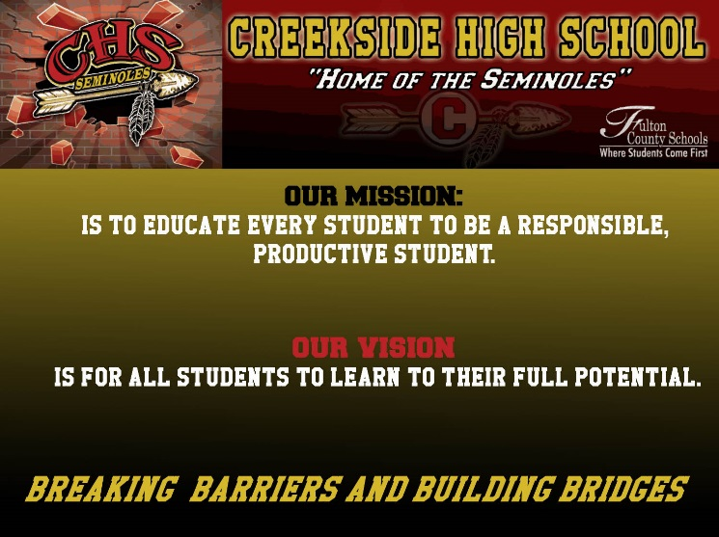

Dr. Terrell A. G. Awak, Principal

7405 Herndon Road

Fairburn, Georgia 30213

[www.creeksidehighschool.com](http://www.creeksidehighschool.com)

http://www.Fultonschools.org/creeksidehs

470-254-4300

Revised: Friday, August 4, 2022

 School: Creekside High School District/ LEA: Fulton County Schools

In support of strengthening student academic achievement, Fulton County School District receives Title I, Part A, Section 1116 of the Every Student Succeeds Act (ESSA) requires that each school served under Title I, Part A, develop jointly with, agree on with, and distribute to parents and family members of participating children a written parent and family engagement policy/plan.

different ways that Creekside High School will support parent engagement and how parents can help plan and participate in activities and events to promote student learning at school and at home.

**How was it developed and revised?**

This plan was jointly developed and revised with input from parents and guardians. Each year Creekside High School invites all parents to give input to revise our Parent and Family Engagement plan, as well as the School-wide Plan, our School-Family Compact and the Parent and Family Engagement Budget.

Parent input is gathered throughout the school year through a variety of sources, including e-mail, parent surveys, and school’s website. Parents also had an opportunity to provide input on how the 1% of parent engagement funds should be used.

If the school wide program plan under section 1114 (b) is not satisfactory to the parents of participating children, each school served under this part shall submit any parent comments on the plan when the school makes the plan available to the local educational agency, the district.

**Who is it for?**

All students participating in the Title I, Part A program, and their families are encouraged to fully participate in the opportunities described in this plan. Creekside High School will ensure the opportunity is available to parents with limited English, parents with disabilities, and parents of migratory children to participate.

**Where is it available?**

The CHS Parent & Family Engagement Plan can be found in the Parent Resource Center, on the school’s website, on the Information Board located in the main lobby, in the community at Fulton Public Library, and our local churches.

LOCATIONS:

* Fairburn Hobgood-Palmer Library

60 Valley View Drive, Fairburn, GA 30213

* South Fulton Community Christian Church

Rivertown Road, Fairburn, GA 30213

* Open Word Christian Ministries

6250 GA-92, Fairburn, GA 30213

* [www.creeksidehighschool.com](http://www.creeksidehighschool.com)
* QR Code will be in place (on school website)

**What is Title I?**

Title I is a federally funded program designed to ensure that all children have a fair, equal, and significant opportunity to obtain a high-quality education and reach, at a minimum, proficiency on challenging state academic standards and state academic assessments. The Title I program focuses on the academic needs of the most disadvantaged students.

**District Goals**

**School Wide Goals**

**What is the Parent and Family Engagement Plan?**

The Parent and Family Engagement Plan is a plan that describes how Creekside High School will provide opportunities to improve family engagement to support student learning. Creekside High School values the contributions and involvement of parents to establish an equal partnership for the common goal of improving student achievement. This plan describes the

¨ **Increase the graduation rate by 2.5% from summer 2022 to summer 2023.**

¨ **Increase the percentage of students meeting grade level expectations on the Reading/Language Arts Georgia Millstones Assessment by 3% from summer 2022 to summer 2023.**

**Creekside High School is committed to increase student proficiency in Literacy by 5% or higher by May 2023, which will be reflected on the Georgia Milestones End of Course (EOC) assessment.**

**School-Family Compact**

The School-Family Compact was jointly developed with input from parents/guardians, teachers, and students. The Compact explains how parents, teachers and students will work together and share responsibilities to make sure that students reach grade level standards. The School-Family Compact is reviewed and updated annually based on feedback from parents, students, and teachers during Parent Input meetings, via surveys, emails, and postings on the school’s website.

**Parent and Family Engagement**

Creekside High School believes that when parents are involved in their child’s education, it increases student learning and academic success by:

* Building and establishing confidence with assisting their child with learning at home.
* Encouraging two-way, and ongoing communication between home and school.
* Allowing opportunities for parents to be involved in decision-making forums.

**Communications**

* Creekside High School will communicate with all families and community members in a timely manner and on an ongoing basis regarding school and parent programs, meetings, and other school related activities. All information will be communicated and written in an understandable and uniform format, to the extent practicable, provided in a language the parents can understand. All communications are also available through social media, flyers, and the school’s website in parent-friendly language. We will use the QR Code, that will be posted on blackboard, email, school website, Instagram, Facebook, and Twitter for everyone to download.
* Creekside High School encourages two-way communication between parents and teachers and offers several opportunities throughout the school year for parents to offer input and be involved in school activities and other events.
* Ensure all meetings occur during days/times that are convenient for parents. The schedule will include flexible meeting times and all notices will be sent, at a minimum of 2 to 3 weeks prior to the event*.*
* Creekside High School will upload all documentation, webinars, and/or videos to the school’s website to allow parents who are unable to attend meetings the ability to access and review pertinent information.
* The residential facilities for students in the Creekside attendance area are included in the Family Engagement correspondences and activities.
* Due to Covid 19 restrictions, all Title I sponsored events will remain virtual until further notice.

**Coordination of Services**

Creekside High School will coordinate and integrate Parent and Family Engagement programs, workshops, activities, and strategies with our feeder middle school(s) to aid parents with eight grade student who are transitioning to ninth grade. The Parent Resource Center is also responsible for scheduling school tours, hosting transition meetings to provide information to parents, and distributing flyers to local businesses regarding school-related events/meetings. We will also coordinate various workshops and provide information about job fairs, college planning, and other post-secondary options for parents with students that are graduating.

**Parent and Family Engagement Standards**

Creekside High School and our parents have adopted the National PTA Standards for Family-School Partnerships as the school’s model in engaging parents, students, and the community. PTA membership is strongly encouraged to support meeting the PTA Standards outlined below:

* Welcoming All Families
* Communicating Effectively
* Supporting Student Success
* Speak Up for Every Child
* Sharing Power
* Collaborating with the Community

**Building Parent Capacity**

Creekside High School will take the following measures to promote and support parents as an important foundation of the school to strengthen the partnership between the school and parents. To reach our goals, we will:

* Ensure that all information related to school and parent programs, meetings, and other activities are posted on the school’s website for all parents.
* Provide information to parents regarding the Parent Resource Room on a consistent basis throughout the school year to make sure parents are aware of all academic resources and achievement standards available for check-out to help them and their child at home.
* Host meetings that discuss the curriculum and the State Standards for high school level students. We will also provide workshops focused on State tests that are mandatory for specific courses, such as the Georgia Milestones/End-of-Course tests. All parent workshops, meetings and activities will be posted on the school’s website, displayed throughout the school building, and sent via email. All parents and families are encouraged to attend.
* Use test scores to measure students’ progress in specific subject areas to determine the goals and academic focus for the next school year and to allow parents to give input on how they will help the school to ensure student success.
* Provide materials and trainings to help parents work with their children to improve their child’s achievement, such as literacy, training and using technology (including education about the harms of copyright piracy) as appropriate, to foster parent and family engagement.
* Provide full opportunities to all parents with limited English proficiency, disabilities, and parents of migratory children.

**Building Staff Capacity**

Creekside High School will take the following measures to build staff capacity:

* Provide quarterly meetings for staff during their planning periods or staff meetings to improve communication with parents; ideas to increase family engagement; and how to work with parents as equal partners, implement and coordinate parent programs, and build ties between home and school.
* Involve parents in the development of training for teachers, principals, and educators to improve the effectiveness of the training.
* Provide training to staff on the value and utility of contributions of parents.
* **Our Parent Resource Center offers support to parents and educators as they seek to build successful “partnerships” that benefit children in our communities.** The Parent Resource Center offers training to parents on Title I program procedures and requirements, parents' rights and responsibilities under the program, and leadership strategies for effective program planning through school- and district-level Title I advisory councils. The center also provides workshops on home teaching techniques and operates a library of parenting and educational resources. We want our parents to become more engaged in the education of their children.

**Parent and Family Engagement Program**

Creekside High School’s Parent and Family Engagement Program is designed to foster learning as a family unit. Innovative programs are designed for our students by our teachers. We like to capitalize on programs designed by parents and community businesses. Creekside High School will host events to build the capacity for strong parent and family engagement to support a partnership among the school, parents, and community to improve student achievement. The partnership will include the following:

* Offering curriculum-based and Principal approved parent idea workshops
* Providing resources for parents to check out in the Parent Resource Center
* Hosting an Open House for parents to learn how to access the Parent Portal to monitor their child’s academic progress

**Annual Title I Parent Meeting**

The Annual Title I Parent Meeting will take place at a convenient time for all parents of participating children shall be invited and encouraged to attend. During this meeting, parents will be provided with information pertaining to our school’s participation in Title I and an explanation about the requirements and the rights of the parents to be involved.

Our Annual Title I Parent Meeting will be held on **TBD,** virtually via Microsoft Teams. The Principal will review the goals and purpose of the Title I Program, the school’s academic progress, budget, School-Family Compact, Parent and Family Engagement Plan, and the role parents play in helping to make the school’s vision a reality. All meetings will be virtual, and recordings will be available CHS’s website after each event. The Microsoft Teams link for all parents, students, and stakeholders will be sent out through Blackboard, email, school’s website, Instagram, Facebook, and/or Twitter for those who would like to participate.

***All workshops and activities notifications will be posted on the website, displayed throughout the building, and sent via email***.

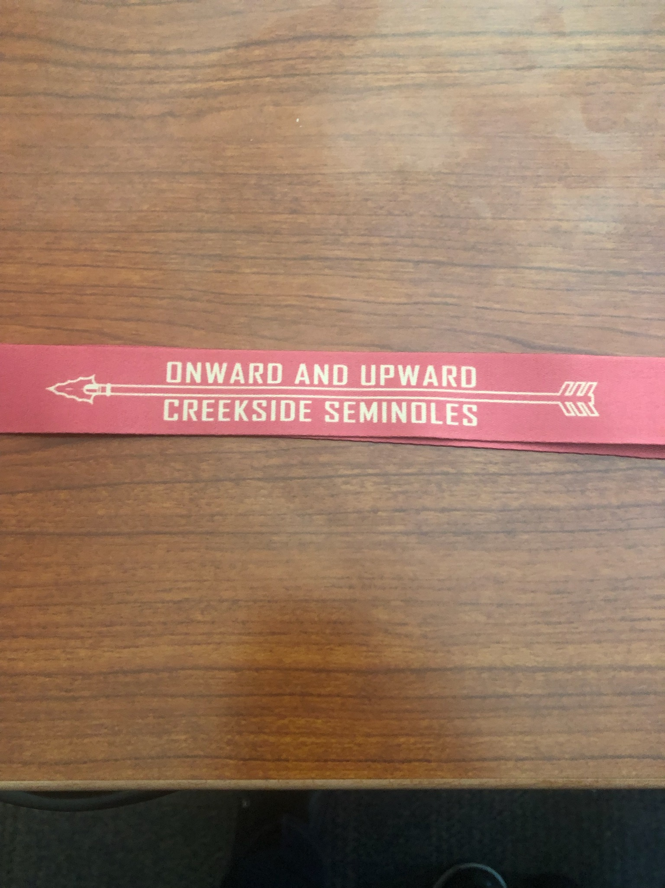

Onward and Upward

***We would like to thank all our parents who work so hard in helping Creekside High School be the best it can be. Your dedicated time and presence have not gone unnoticed. You all are simply the best!!!***

**To ensure that you stay connected and receive all parent event invitations and communications, please make sure that we have your email address on file by completing the Contact Form on the last page. You may also contact the main office or Ms. Jennifer A. Jones, the Parent Liaison, at your convenience to update your contact information.**

**Your Input Is Needed**

**We want to hear from you. If you have any suggestions or if there is any part of this Plan that you feel is not satisfactory with the students’ and/or the school’s goals for academic achievement, please feel free to provide your comments in the space provided below and return to your child’s teacher or the Parent Resource Room. You can also email your comments at the address listed below.**

**Name: *(Optional)* _____________________________________________________________________**

**Email/Phone: *(Optional)* _______________________________________________________________**

**Comments:______________________________________________________________________________________________________________________________________________________________________________________________________________________________________________________________________________________________________________________________________________________________________________________________________________________________________________________________________________________________________________________________________________________________________________________________________________________________________________________________________________________________________________________________________________________________________________________________________________________________________________________________________________________________________________________________________________________________________________________________________________________________________________________________________________________________________________________________________________________________________________________________________________**

**Parent Resource Center**

**Jennifer A. Jones, Parent Liaison**

Email: [**jonesj8@fultonschools.org**](mailto:jonesj8@fultonschools.org)

**Phone: (470)254-4152**

**Office Hours:**

**Monday & Wednesday 7:30 am - 3:00 pm**

**Tuesday & Thursday 7:30 am - 3:00 pm**

**Friday 7:30 am - 12:00 noon**

**\*Lunch (Monday-Thursday) 1:30 pm - 2:00 pm**