**Medlock Bridge School Governance Council**

**Meeting Minutes – Feb. 16, 2021 – 3:00 p.m. –p.m.**

**Virtual Meeting**

**Present**:

**Vance M., Principal**

**Lawrence M., Elected teacher/Chair**

**Jones S., Elected teacher**

**Castel D. Teacher**

**Fowler, K., Appointed Teacher**  
 **Stahl, Parent/Vice Chair**

**Bradley, M.- Community Guest Speaker**

**Yang, A. -Parent**

**Eisenberg, T., Community member**

**3:05 P.M. Call to Order by M. Lawrence**

**3:05 P.M. Action Item: Approve Meeting Agenda**

Motion- Jones

2nd- Fowler

Unanimous ayes

**3:08 P.M. Meeting Norms reviewed by M. Lawrence**

**3:09 P.M.** Motion to approve the Jan. Meeting Minutes

Motion- Castel

2nd- Stahl

Unanimous ayes

**3:10 P.M. Public Comment / Virtual Comment Box Summary**

Nothing currently in the Virtual Comment Box

**3:12 P.M. Discussion Item: Principal’s Update (Vance)**

**February Update:**

* Announcement of new AP- Shannan Jones- new teacher , Jenny Jung, scheduled to begin on Thursday, Feb 18, 2021
* TOTY- Ms. Susan Demint
* PEOTY- Mr. Mike Spann
* Covid 19 Update – MBES Reached a level 2 in the school closure matrix. Investigations still ongoing. 8 positives from February 5th onward. No obvious connections of spread within the building. Made the switch to remote for two days for school cleaning and quarantine period. Community seemed appreciative of the opportunity to quarantine.
  + Stahl said that the duplicate emails seem confusing when coming from multiple sources (district and Principal). Otherwise communication and handling of the situation seems solid.
  + Q: Are the elementary and Middle and HS quarantine guidelines different since it seems more elementary students need to quarantine than in MS and HS?
  + Mr. Vance discussed some changes in procedures that will be implemented to help tighten up those in place now that we have seen how this goes.
  + Q: is the usual quarantine time 72 hours? Mr. Vance explained the general procedure and that it’s not a standard amount of time.
  + Q: What is the situation with the air circulation? Filters regularly changed.
  + Q: Have the vents been cleaned out lately? Not sure. Will check.
  + Georgia Milestones coming up end of April into early May
    - Students must come into the building to take these tests
    - Question regarding transportation for remote students who may be coming in for exclusively for testing
    - Vance: Details not yet worked out
  + 5th Grade Graduation Ceremony to be planned virtually
* PTO update
  + Field day. Coming. May 12, 13, 14th Different- two days, no parent volunteers.
  + Gaga ball pit coming for next academic year .

ie:  (Because I didn’t know what this is)

* + Through our Eyes mixed media art
  + Yes I Can! Event coming soon.
  + Teacher/Grade Level Experiences for the Silent Auction
  + PTO Elections upcoming in March- PTO President role open
  + Eagle Scout working in the garden
    - Eisenberg- offering to assist with taking care of the garden in a service project capacity
  + Mud Kitchen out in the garden to come soon

**3:41 P.M. Committees Update**

**BUDGET COMMITTEE**

BOOKS

* Ms. Fowler gave quote for the total of the book order: $35,812.90
  + pre k
  + fifth
  + EIP- $1499.71
  + Tindell
  + AU
  + White’s
  + parent library
  + multilanguage- Asian- Korean, Spanish
  + Book for every classroom as community building- The Day You Began- J. Woodson
* Furniture: All seating had been ordered and some has been delivered
* March 26-27 will be the desk switchover in classrooms
* Grant Applications:
  + Used a rubric to evaluate the alignment of the applications with the school’s strategic plan. All the following rate well within rubric guidelines
    - Touch Math- multisensory approach for teaching math
      * $8,500 for a kit/grade level (housed in AU classrooms)
    - STEM Materials $1300
    - Math Manipulatives $2500
    - Kindergarten- Magnatiles (STEM) $650
    - 3rd grade- student white boards and science/SS Library $1500
    - Story Works (Scholastic Magazines) – for multiple grade levels $6000 (consumable for 1 year)
    - Pine Valley $850
    - Math Documents (Tara West- First Grade centers) $72
    - Book Bags for chairs $2000
    - Classroom Library $2500

__________________________

**TOTAL: $25,872**

**OUTREACH COMMITTEE**

**Welcoming students back to campus**

* Outdoor Circle time to allow students to get to know their classmates prior to school
* School Tours
* Popcicles on the playground

**Parent University**

* Feb 10th – Stress Management- through Chris 180
* More to come from Chris 180

**4: 22 SGC Upcoming Elections**

* Need a parent
* Need a teacher

**4:26** **Finance – School Budget Update**

Mr Vance went through the budget and its’ allocations. Some changes in formulas have affected EIP from 1.5 to only 1.0. Shared the line item budget.

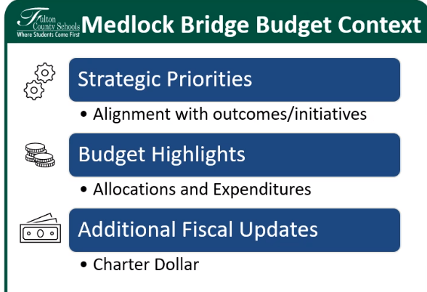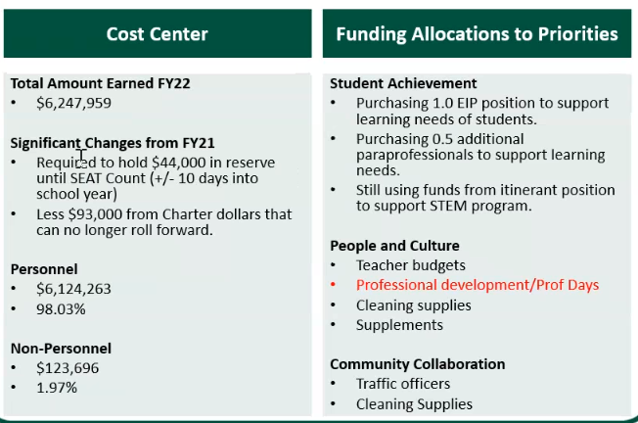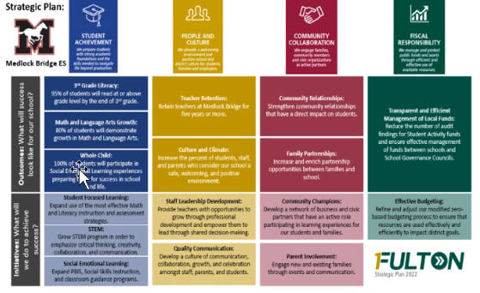

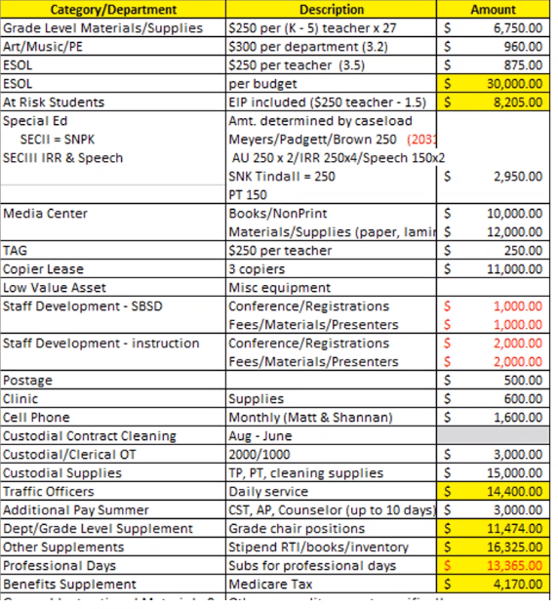

**4:36 Motion to approve the budget-**

Motion- Eisenberg

2nd Castel

unanimous ayes

**4:36 Superintendent Advisory Council Update**- will discuss at February meeting

Q & A from the sessions available through Mr. Stahl

**4:27 Vote to approving Charter dollars: $ 25,872 🡪 $26,000** for supplies discussed above grant applications (stem, math manipulatives, math multi-sensory program, reading resources and support materials, math center activities)

1st- Stahl

2nd Castel

unanimous ayes

**4:40- Agenda for March Meeting** – no additions

**4:42 P.M. Motion to Adjourn**

Motion – T. Eisenberg

Second- Fowler

Unanimously approved to adjourn