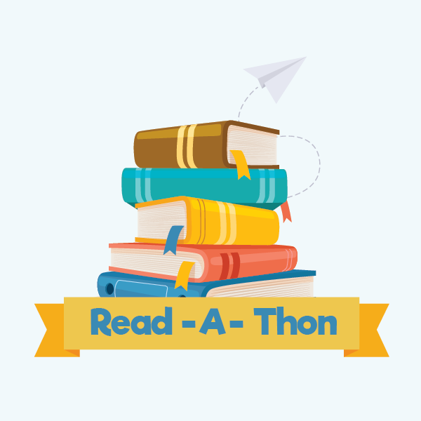

**March 18-April 7 Read- A-Thon Fundraiser: How to Participate**

* All Parkway and Glen Hills students will be sent home with a handout containing the log in instructions for each student’s personal Reaafun.com fundraiser page.
* Students can log in before the Read-A-Thon begins to check out their account and to go through the steps for parent authorization (so the student can request and accept sponsorships!).
* **March 18th is Kickoff Day!** Students should start logging their books/minutes read in their readafun.com account. Students can also email additional friends and family members to request sponsorships. **All donated funds will go straight back to students in the form of PTO/Foundation activities and initiatives!**
* Students will earn “Wisdom Coins” through Readafun.com to spend in the Online Owl Shop to accessorize their Owl Avatar. So fun!
* Individual prizes will be awarded to students who achieve certain minutes read milestones and the class in each grade with the most minutes read per student will earn a treat celebration!
* LET’S GET READING!!