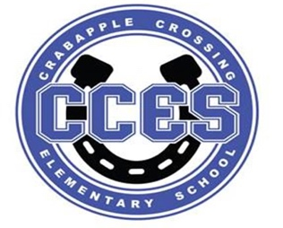
Crabapple Crossing Elementary
School Governance Council Meeting Agenda
Monday, February 12, 2024
Time: 4:00pm
Location: CCES Media Center
SGC Members: Dr. Tresa Cheatham, Principal| Barbara Halbert (Chair), Community Member| Laura York, Parent | Steve Vo, Parent (Parliamentarian)| Lauren Smith, Parent| Susan Huey, Teacher| Jill Belasick, Teacher (Vice-Chair)| David DeStefano, Appointed Staff| Sheila Halter, Appointed Staff | Brittany Griffin, Community Member
Time | Agenda Item | Owner
4:00pm | Call to Order, Roll Call, Meeting Norms, Community & Board Meetings | Halbert
4:02pm | Action Item: Approve Agenda | Council
4:03pm | Action Item: Approve January 8, 2024 Meeting Minutes | Council
4:04pm | Public Comment
4:14pm | Discussion Item: Cross Council | Halbert
4:19pm | Discussion Item: Superintendent's Parents Council Debrief | Smith
4:24pm | Discussion Item: SGC Elections | Council
4:30pm | Discussion/Action Item: Charter Funds Expenditures | Council
4:40pm | Discussion Item: FY 2024-2025 Budget Review | Cheatham/Council
4:50pm | Action Item: Vote on FY 2024-2025 Budget | Council
4:51pm | Information Item: Principal's Update | Cheatham
4:56pm | Information Item: PTO Update | Speers
5:01pm | Discussion Item: Items for Next Meeting’s Agenda on 3/18/2024 | Council
5:05pm | Action Item: Meeting Adjournment | Halbert

Lillie Pozatek Community Meeting: February 14, 2024 9:30am Manning Oaks ES

Katha Stuart Community Meeting: February 15, 2024 9:30am Roswell North ES

School Board Meeting: February 20, 2024 6:00PM South Learning Center

Meeting Norms: - Be Prepared and Engaged - Be Respectful of Other’s Opinions - Work for the Good of ALL Students

