SGC Meeting Attendance:
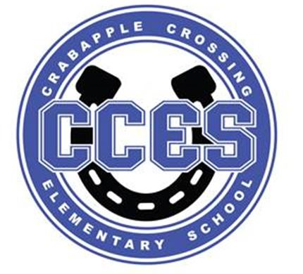Crabapple Crossing ES
School Governance Council SUMMARY
February 12, 2024
Dr. Cheatham, Principal | X
Barbara Halbert, Chair, Community Member | X
Jill Belasick, Vice-Chair, Elected Staff | X
Steve Vo, Parliamentarian, Parent | X
David DeStefano, Appointed Staff | X
Brittany Griffin, Community Member | X
Sheila Halter, Appointed Staff | X
Susan Huey, Elected Staff | X
Lauren Smith, Parent | X
Laura York, Parent | X
Jen Speers, PTO | X

SGC Meeting Action Items:
Motion | Time | By Whom | Second | Voting Results
Call to Order | 4:03pm | Barbara Halbert | --- | ---
Action Item: Approve Agenda | 4:05pm | David DeStefano | Sheila Halter | Unanimous
Action Item: Approve January 4, 2024 Meeting Minutes | 4:06pm | Susan Huey | Brittany Griffin | Unanimous
Action Item: Charter Funds Expenditures | 4:14pm | Jill Belasik | Sheila Halter | Unanimous
Action Item: Vote on FY 2024-2025 Budget | 4:28pm | Sheila Halter | Jill Belasik | Unanimous
Action Item: Adjourn Meeting | 4:59pm | Brittany Griffin | David DeStefano | Unanimous

Informational and Discussion Items:

- Discussion Item: Cross Council
- Discussion Item: Superintendent’s Parents Council Debrief
- Information Item: SGC Elections
- Discussion Item: Charter Funds Expenditures Proposals
- Discussion Item: FY 2024-2025 Budget Review
- Information Item: Principal's Update
- Information Item: PTO Update
- Discussion Item: Items for Next Meeting’s Agenda

