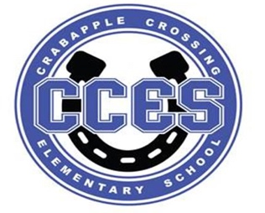
Crabapple Crossing Elementary
School Governance Council Meeting Agenda
Monday, January 8, 2024
Time: 4:00pm
Location: CCES Media Center
SGC Members: Dr. Tresa Cheatham, Principal| Barbara Halbert (Chair), Community Member| Laura York, Parent | Steve Vo, Parent (Parliamentarian)| Lauren Smith, Parent| Susan Huey, Teacher| Jill Belasick, Teacher (Vice-Chair)| David DeStefano, Appointed Staff| Sheila Halter, Appointed Staff | Brittany Griffin, Community Member
Time | Agenda Item | Owner
4:00pm | Call to Order, Roll Call, Meeting Norms, Community & Board Meetings | Halbert
4:03pm | Action Item: Approve Agenda | Council
4:05pm | Action Item: Approve November 13, 2023 Meeting Minutes | Council
4:07pm | Discussion Item: Superintendent's Parents Council Debrief | Smith
4:12pm | Information Item: 2024 SGC Elections - Possible Action Items | Halbert/Council
4:20pm | Action Item: Schedule Budget Committee Meeting | Council
4:25pm | Discussion Item: Council Initiatives | Council
4:30pm | Discussion Item: Charter Funds Expenditures Proposals | Council
4:35pm | Action Item: Vote on Charter Funds Expenditures | Council
4:37pm | Information Item: Principal's Update | Cheatham
4:45pm | Information Item: PTO Update | Speers
4:50pm | Discussion Item: Items for Next Meeting’s Agenda on 2/12/2024 | Council
4:55pm | Action Item: Meeting Adjournment | Halbert

Lillie Pozatek Community Meeting: January 11, 2024 9:30am Creek View ES

Katha Stuart Community Meeting: January 17, 2024 9:30am Holcomb Bridge MS

School Board Meeting: January 18, 2024 6:00PM North Learning Center

Meeting Norms: - Be Prepared and Engaged - Be Respectful of Other’s Opinions - Work for the Good of ALL Students

