SGC Meeting Attendance:
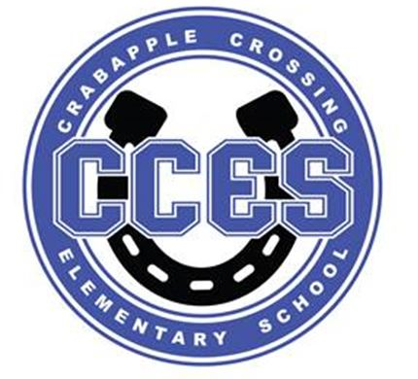Crabapple Crossing ES
School Governance Council SUMMARY
January 8, 2024
Dr. Cheatham, Principal | X
Barbara Halbert, Chair, Community Member | X
Jill Belasick, Vice-Chair, Elected Staff | X
Steve Vo, Parliamentarian, Parent
David DeStefano, Appointed Staff | X
Brittany Griffin, Community Member | X
Sheila Halter, Appointed Staff | X
Susan Huey, Elected Staff | X
Lauren Smith, Parent | X
Laura York, Parent | X
Rawlings Johnson, Assistant Principal | X

SGC Meeting Action Items:
Motion | Time | By Whom | Second | Voting Results
Call to Order | 4:02pm | Barbara Halbert | --- | ---
Action Item: Approve Agenda | 4:03pm | David DeStefano | Sheila Halter | Unanimous
Action Item: Approve November 13, 2023 Meeting Minutes | 4:04pm | Sheila Halter | Jill Belasik | Unanimous
Action Item: Schedule Budget Committee Meeting | 4:20pm | --- | --- | ---
Action Item: Vote on Charter Funds Expenditures | 4:35pm | Brittany Griffin | Sheila Halter | Unanimous
Action Item: Adjourn Meeting | 4:42pm | Brittany Griffin | Jill Belasik | Unanimous

Informational and Discussion Items:

- Discussion Item: Superintendent’s Parents Council Debrief
- Information Item: 2024 SGC Elections
- Discussion Item: Council Initiatives
- Discussion Items: Charter Funds Expenditures Proposals
- Information Item: Principal's Update
- Information Item: PTO Update
- Discussion Item: Items for Next Meeting’s Agenda

