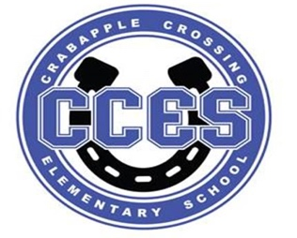
Crabapple Crossing Elementary
School Governance Council Meeting Agenda
Monday, November 13, 2023
Time: 4:00pm
Location: CCES Media Center
SGC Members: Dr. Tresa Cheatham, Principal| Barbara Halbert (Chair), Community Member| Laura York, Parent | Steve Vo, Parent (Parliamentarian)| Lauren Smith, Parent| Susan Huey, Teacher| Jill Belasick, Teacher (Vice-Chair)| David DeStefano, Appointed Staff| Sheila Halter, Appointed Staff | Brittany Griffin, Community Member
Time | Agenda Item | Owner
4:00pm | Call to Order, Roll Call, Meeting Norms, Community & Board Meetings | Halbert
4:03pm | Action Item: Approve Agenda | Council
4:05pm | Action Item: Approve October 16, 2023 Meeting Minutes | Council
4:07pm | Discussion Item: Website Audit | Halbert
4:10pm | Discussion Item: Superintendent's Parents Council Debrief | Smith
4:15pm | Discussion Item: Cross Council Meeting Debrief | Griffin
4:22pm | Discussion Item: Council Initiatives | Council
4:27pm | Discussion Item: Charter Funds Expenditures Proposals | Council
4:32pm | Information Item: Principal's Update | Cheatham
4:40pm | Information Item: PTO Update | Speers
4:45pm | Discussion Item: Items for Next Meeting’s Agenda on 1/8/2024 | Council
4:50pm | Action Item: Meeting Adjournment | Halbert

Lillie Pozatek Community Meeting: November 14, 2023 9:30am Alpharetta ES

Katha Stuart Community Meeting: November 15, 2023 9:30am Mountain Park ES

School Board Meeting: November 16, 2023 6:00PM South Learning Center

Meeting Norms: - Be Prepared and Engaged - Be Respectful of Other’s Opinions - Work for the Good of ALL Students

