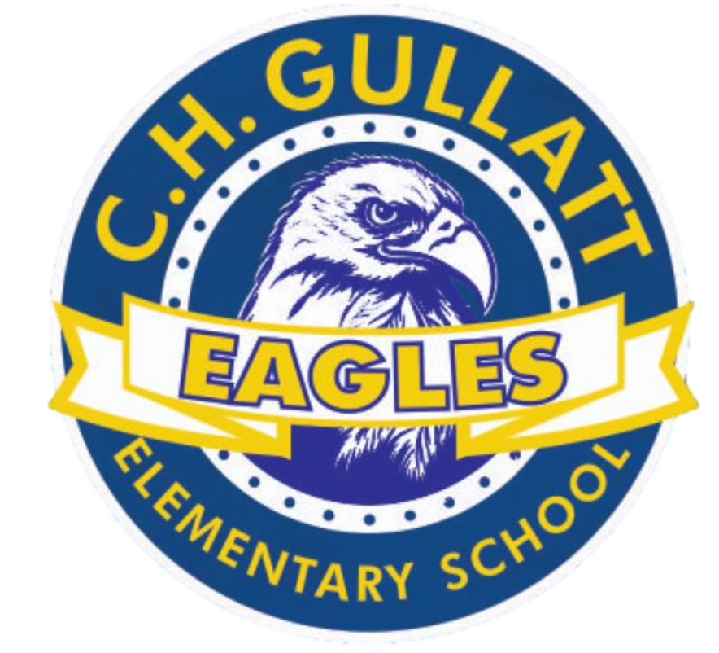

agenda

C.H. Gullatt Elementary School Governance Council

Date | time 10/24/2023 | 3:15pm | Location [TEAMS](https://teams.microsoft.com/l/meetup-join/19%3a0cee1ad7d856404cad9f9e04e270aede%40thread.skype/1691462017701?context=%7b%22Tid%22%3a%220cdcb198-8169-4b70-ba9f-da7e3ba700c2%22%2c%22Oid%22%3a%220ed7aae3-5676-4f95-81df-f04aa1c584dc%22%7d)

# SGC Members

Mrs. Shawanna Arnold, Principal | Mrs. Natalie Elie-Johnson, SGC Chair (Teacher) | Brandy Sims, Teacher | Tiffany Young, School Employee |Janay Pulliam, School Employee| Antonita Mercer, Parent, |Daisy Sanchez, Parent | Teresa Brown, Parent | Ms. Felicia Hilton, Community Member| Kelmikis Mitchell, Community Member

| Time | Item | Owner |
| --- | --- | --- |
| 3:15 pm | Call to Order | Elie- Johnson |
| 3:17 pm | Action Item: Approve Agenda | Elie- Johnson |
| 3:19 pm | Action Item: Approve September Meeting Minutes | Elie- Johnson |
| 3:22 pm | Discussion Item: Review SY23-24 Council Initiatives* | Elie- Johnson |
| 3:42 pm | Discussion Item: Activities/Fundraisers | Elie- Johnson |
| 4:05 pm | Discussion Item: Review Charter Dollar Expenditure | Elie-Johnson |
| 4:15 pm  4:25 pm  4:30 pm | Informational Item: Principal’s Update  Discussion Item: Fall Cross Council Meetings**  Discussion Item: Website Audits**   * Kudos to Alpharetta Elementary School for receiving a perfect score on their website audit.  Please see their website if you are looking for an exemplar from which to base your updates: [Alpharetta Elementary School SGC Website](https://www.fultonschools.org/domain/5704) * Team Picture? | Mrs. Arnold  Elie- Johnson  Young |
| 4:40 pm | Discussion Item: Draft Next Meeting Agenda | Young |
| 4:45pm | Action Item: Meeting Adjournment | Elie- Johnson |
|  |  |  |

# Meeting Norms

# Establish an agenda that is task oriented and process oriented |Honor the agenda by staying on task |Actively listen to team members |Play and be there (fully present, engaged, and begin all meetings with cameras on) |Come from a place of forgiveness, honesty, and best intentions |Equity of voice and efficacy| Confidentiality |No Shortcuts

**\* SY23-24 Council Initiatives:** Begin discussions to determine the focus of the council’s upcoming work. Lean on your school’s Semester Action Plan to ensure the work of the council is aligned with the goals and initiatives being targeted by the school leaders. Task the council with prioritizing 1 – 2 initiatives the SGC could lead or support throughout the year.

**\*\* Fall Cross Council Meetings: In early November, there will be series of Cross Council meetings meant to support SGCs by providing them a forum to work with other councils throughout the district and share feedback with the Governance & Flexibility Team. Each council should register up to two members to attend one of these sessions.**

The Governance Team is excited to share with you that we will be hosting a series of Cross Council meetings at the beginning of November.  These sessions will offer members the opportunity to work and hear from councils around the district and engage in discussions with the Governance & Flexibility Team.  The meetings will take place in-person at the dates/times/locations below.  We encourage all SGCs to select up to two members to attend one of the sessions and register to attend using the links below.  Note, each session will cover similar content, so your team does not need to register for multiple sessions.  Please work with your team to ensure your members are registered prior to the end of October.

* [Wednesday, November 1 (10:00am – 11:30am) – North Learning Center [Rooms 106/107/111]](https://nam11.safelinks.protection.outlook.com/?url=https%3A%2F%2Fwww.signupgenius.com%2Fgo%2F10C094AADA923A1FD0-fall&data=05%7C01%7Celien%40fultonschools.org%7C9b9de7437b8442e5f45308dbcff9fa91%7C0cdcb19881694b70ba9fda7e3ba700c2%7C0%7C0%7C638332444877902792%7CUnknown%7CTWFpbGZsb3d8eyJWIjoiMC4wLjAwMDAiLCJQIjoiV2luMzIiLCJBTiI6Ik1haWwiLCJXVCI6Mn0%3D%7C3000%7C%7C%7C&sdata=O%2F%2F7KMCy4ng%2BQ2mTCB0xYa9NylxMjrOtiXi9qbAYivw%3D&reserved=0)
* [Thursday, November 2 (2:00pm – 3:30pm) – FCS Admin Building [Room 176 A/B]](https://nam11.safelinks.protection.outlook.com/?url=https%3A%2F%2Fwww.signupgenius.com%2Fgo%2F10C094AADA923A1FD0-fall&data=05%7C01%7Celien%40fultonschools.org%7C9b9de7437b8442e5f45308dbcff9fa91%7C0cdcb19881694b70ba9fda7e3ba700c2%7C0%7C0%7C638332444877902792%7CUnknown%7CTWFpbGZsb3d8eyJWIjoiMC4wLjAwMDAiLCJQIjoiV2luMzIiLCJBTiI6Ik1haWwiLCJXVCI6Mn0%3D%7C3000%7C%7C%7C&sdata=O%2F%2F7KMCy4ng%2BQ2mTCB0xYa9NylxMjrOtiXi9qbAYivw%3D&reserved=0)
* [Friday, November 3 (10:00am – 11:30am) – South Learning Center [Rooms 410/412]](https://nam11.safelinks.protection.outlook.com/?url=https%3A%2F%2Fwww.signupgenius.com%2Fgo%2F10C094AADA923A1FD0-fall&data=05%7C01%7Celien%40fultonschools.org%7C9b9de7437b8442e5f45308dbcff9fa91%7C0cdcb19881694b70ba9fda7e3ba700c2%7C0%7C0%7C638332444877902792%7CUnknown%7CTWFpbGZsb3d8eyJWIjoiMC4wLjAwMDAiLCJQIjoiV2luMzIiLCJBTiI6Ik1haWwiLCJXVCI6Mn0%3D%7C3000%7C%7C%7C&sdata=O%2F%2F7KMCy4ng%2BQ2mTCB0xYa9NylxMjrOtiXi9qbAYivw%3D&reserved=0)

**\*\*\* Website Audits: Councils are encouraged to review their SGC website during their October meeting. The Governance & Flexibility Team will be completing website audits for all schools during the month of October. For a list of SGC website requirements, please review the SGC Website Audit Form.**