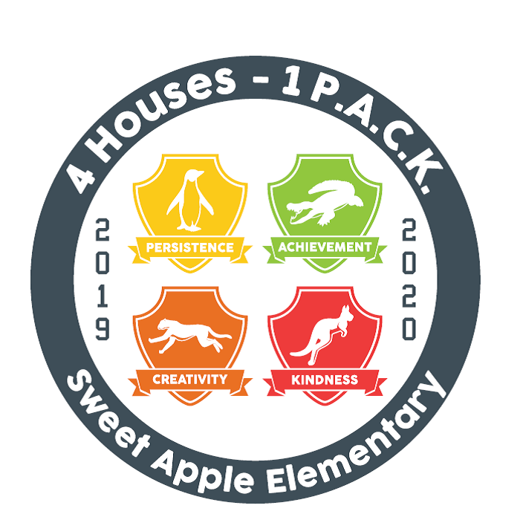
Summary of Action
Sweet Apple Elementary School Governance Council
Date | time April 28, 2022 |2:50pm Location Virtual Teams Meeting

SGC Member Attendance
Andy Allison, Principal |  | Shannon Coyne, Parent
Cindy Sulkowski, Appointed School Employee | X | Laura LaHara, Parent
Allie Kimbrell, Teacher | X | Jocelyn MacKinnon, Parent | X
Catherine Liebrock, Teacher | X | Krystian Morales, Community Member | X
Karin Alhadeff, Appointed School Employee | X | Kerry Griffin, Community Member
Guest Attendance: none

Agenda Items
SGC Elections | Parent University
Principals Update

Council Survey- Self Assessment and Principal Feedback Survey

Meeting Minutes
Action Items
Motion | Time | By Whom | Second By | Voting Results
Approve March Minutes | 2:50pm | Morales | MacKinnon | All in Favor
Approve April Agenda | 2:51pm | Sulkowski | MacKinnon | All in Favor
Meeting to Adjourn | 3:15pm | MacKinnon | Alhadeff | All in Favor
- We are still waiting to hear from Fulton County if we can do the surveys later and not in May.
- We have filled out our paperwork for all our Charter Dollars.
- SGC Elections- Moses and Sulkowski will both be on. We have not heard about the parent feedback.
- Principals Update- There is a hiring event at the Georgia World Congress Center on Saturday for Fulton County Schools. Summer School will be at Sweet Apple this summer. We are the biggest summer school site, and the End of the Year Parties are on and in person! Times were shared.
- Survey- sample agenda for the month and talking points. Self-assessment and principal’s survey.
- Parent University- Sulkowski gave a general overview of reading and math. Whole groups, small groups, and independent. How parents can help at home was also described. Consolo did an overview of GKIDS. Only 7 parents attended. It is hard finding a time that works. Maybe a survey to parents to see what times they would be available. QR Code at Sneak Peek for times parents would be available and topics of interest.
- Would it be possible to have a wrap up parent meeting as students transitions to the next grade level.
- We will meet over the summer to come up with the calendar of meetings for next year.
- We may need to meet to do the survey.
Next Meeting:, May 19, 2022, 2:50pm | Teams Meeting
July 21 for the next official meeting.
Motion to adjourn was made at 3:45pm and passed unanimously.

