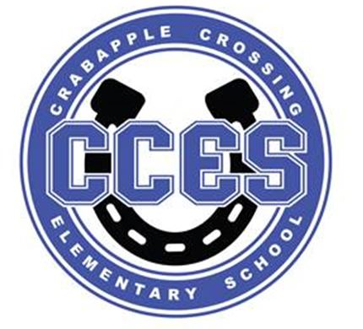Crabapple Crossing ES
School Governance Council SUMMARY
October 16, 2023
SGC Meeting Attendance:
Dr. Cheatham, Principal | X
Barbara Halbert, Chair, Community Member
Jill Belasick, Vice-Chair, Elected Staff | X
Steve Vo, Parliamentarian, Parent | X
David DeStefano, Appointed Staff | X
Brittany Griffin, Community Member | X
Sheila Halter, Appointed Staff | X
Susan Huey, Elected Staff | X
Lauren Smith, Parent | X
Laura York, Parent | X
Rawling Johnson, Assistant Principal | X
Katie Kinsey, Facilitator, Governance and Flexibility | X

SGC Meeting Action Items:
Motion | Time | By Whom | Second | Voting Results
Call to Order | 4:00pm | Jill Belasick | --- | ---
Action Item: Amended Agenda | 4:03pm | Lauren Smith | Sheila Halter | Unanimous
Action Item: Approve September 18 Meeting Minutes | 4:04pm | Brittany Griffin | Susan Huey | Unanimous
Action Item: Charter Funds Expenditures Proposals | 4:11pm | Dr. Cheatham | Lauren Smith | Susan Huey
Action Item: Adjourn Meeting | 4:39pm | David DeStefano | Susan Huey | Unanimous

Informational and Discussion Items:

- Discussion Item: Cross Council
- Discussion Item: Superintendent’s Parents Council
- Discussion Item: FCS Literacy Parent Units
- Discussion Item: SGC Initiatives for 23/24
- Information Item: Principal's Update
- Information Item: PTO Update
- Discussion Item: Items for Next Meeting’s Agenda

