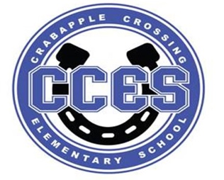
Crabapple Crossing Elementary
School Governance Council Meeting Agenda
Monday, October 16, 2023
Time: 4:00pm
Location: CCES Media Center
SGC Members: Dr. Tresa Cheatham, Principal| Barbara Halbert (Chair), Community Member| Laura York, Parent | Steve Vo, Parent (Parliamentarian)| Lauren Smith, Parent| Susan Huey, Teacher| Jill Belasick, Teacher (Vice-Chair)| David DeStefano, Appointed Staff| Sheila Halter, Appointed Staff | Brittany Griffin, Community Member
Time | Agenda Item | Owner
4:00pm | Call to Order, Roll Call, Meeting Norms, Community & Board Meetings | Halbert
4:03pm | Action Item: Approve Agenda | Council
4:05pm | Action Item: Approve September 18, 2023 Meeting Minutes | Council
4:06pm | Discussion Item: Cross Council Meetings 11/1 & 11/2 | Council
4:11pm | Discussion Item: Superintendent's Parents Council | Council
4:16pm | Discussion Item: FCS Literacy Parent Units | Council
4:21pm | Discussion Item: Charter Funds Expenditures Proposals | Council
4:31pm | Discussion Item: SGC Initiatives | Council
4:41pm | Information Item: Principal's Update | Cheatham
4:50pm | Information Item: PTO Update | Speers
4:55pm | Discussion Item: Items for Next Meeting’s Agenda | Council
5:00pm | Action Item: Meeting Adjournment | Halbert

Lillie Pozatek Community Meeting: October 17, 2023 6:00pm Alpharetta HS

Katha Stuart Community Meeting: October 18, 2023 6:00pm Roswell HS

School Board Meeting: October 19, 2023 6:00PM South Learning Center

Meeting Norms: - Be Prepared and Engaged - Be Respectful of Other’s Opinions - Work for the Good of ALL Students

