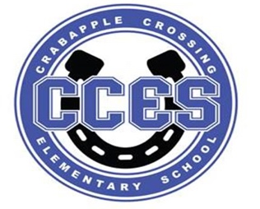
Crabapple Crossing Elementary
School Governance Council Meeting Agenda
Monday, September 18, 2023
Time: 4:00pm
Location: CCES Media Center
SGC Members: Dr. Tresa Cheatham, Principal| Barbara Halbert (Chair), Community Member| Laura York, Parent | Steve Vo, Parent (Parliamentarian)| Lauren Smith, Parent| Susan Huey, Teacher| Jill Belasick, Teacher (Vice-Chair)| David DeStefano, Appointed Staff| Sheila Halter, Appointed Staff | Brittany Griffin, Community Member
Time | Agenda Item | Owner
4:00pm | Call to Order, Roll Call, Meeting Norms, Community & Board Meetings | Halbert
4:03pm | Action Item: Approve Agenda | Council
4:05pm | Action Item: Approve August 21, 2023 Meeting Minutes | Council
4:06pm | Discussion Item: Introduction and Analysis of SGC Self-Assessment Surveys | Halbert/Council
4:16pm | Discussion item: Goals for SY 23/24 | Council
4:21pm | Action Item: Initiatives for SY 23/24 | Council
4:26pm | Discussion Item: SY 23/24 Charter Funds | Council
4:28pm | Action Item: Plans for SY 23/24 Charter Funds | Council
4:35pm | Information Item: Principal's Update | Cheatham
4:40pm | Information Item: PTO Update | Speers
4:45pm | Discussion Item: Items for Next Meeting’s Agenda | Council
5:00pm | Action Item: Meeting Adjournment | Halbert

Lillie Pozatek Community Meeting: October 17, 2023 6:00pm Alpharetta HS

Katha Stuart Community Meeting: October 18, 2023 6:00pm Roswell HS

School Board Meeting: September 21, 2023 6:00PM South Learning Center

Meeting Norms: - Be Prepared and Engaged - Be Respectful of Other’s Opinions - Work for the Good of ALL Students

