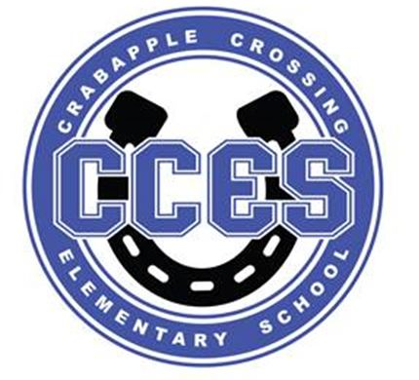Crabapple Crossing ES
School Governance Council SUMMARY
September 18, 2023

SGC Meeting Attendance:
Dr. Cheatham, Principal | X
Barbara Halbert, Chair, Community Member | X
Jill Belasick, Vice-Chair, Elected Staff | X
Steve Vo, Parliamentarian, Parent | X
David DeStefano, Appointed Staff | X
Brittany Griffin, Community Member
Sheila Halter, Appointed Staff | X
Susan Huey, Elected Staff | X
Lauren Smith, Parent | X
Laura York, Parent | X

SGC Meeting Action Items:
Motion | Time | By Whom | Second | Voting Results
Call to Order | 4:04pm | Barbara Halbert | --- | ---
Action Item: Amended Agenda | 4:05pm | Barbara Halpert | Sheila Halter | Unanimous
Action Item: Approve August 21 Meeting Minutes | 4:06pm | Jill Belasick | David DeStefano | Unanimous
Action Item: Cross Council | 4:07pm | --- | --- | ---
Action Item: Initiatives for 23/34 | 4:21pm | Susan Huey | Sheila Halter | Unanimous
Action Item: Plans for 23/24 Charter Funds | 4:31pm | --- | --- | ---
Action Item: Adjourn Meeting | 4:51pm |  |  | Unanimous

Informational and Discussion Items:

- Discussion Item: Introduction and Analysis of SGC Self-Assessment
- Discussion Item: Goals for 23/24
- Discussion Item: SY 23/24 Charter Funds
- Information Item: Principal's Update
- Information Item: PTO Update

