**Crabapple Crossing Elementary**

**School Governance Council Meeting Agenda**

Monday, August 21, 2023

Time: 4:00pm

Location: CCES Media Center

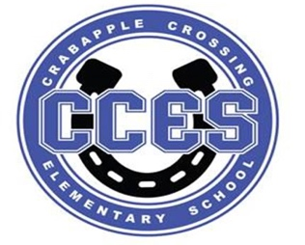

**SGC Members:** Dr. Tresa Cheatham, Principal| Barbara Halbert (Chair), Community Member| Laura York, Parent | Steve Vo, Parent| Lauren Smith, Parent| Susan Huey, Teacher| Jill Belasick, Teacher| David DeStefano, Appointed Staff| Sheila Halter, Appointed Staff

|  |  |  |
| --- | --- | --- |
| Time | Agenda Item | Owner |
| 4:00pm | Call to Order, Roll Call, Meeting Norms, Community & Board Meetings | Halbert |
| 4:03pm | Action Item: Approve Agenda | Council |
| 4:05pm | Action Item: Approve May 8, 2023 Meeting Minutes | Council |
| 4:08pm | Discussion Item: Member Introductions, Community Member Appointment | Council |
| 4:18pm | Action Item: Elect Officers (Chair, Vice Chair, Parliamentarian) | Council |
| 4:25pm | Action Item: Staff Standing Committees (Budget & Finance, Outreach & Communication, Principal Selection) | Council |
| 4:30pm | Action Item: Nominate Representative for Superintendent's Parent/Community Advisory Council | Council |
| 4:35pm | Action Item: Determine Meeting Schedule for SY23-24 | Council |
| 4:40pm | Information Item: Principal's Update | Cheatham |
| 4:48pm | Information Item: SY22-23 Charter Funds Update | Cheatham |
| 4:53pm | Information Item: PTO Update | PTO President |
| 4:58pm | Discussion Item: Items for Next Meeting’s Agenda | Council |
| 5:00pm | Action Item: Meeting Adjournment | Chair |

**Lillie Pozatek Community Meeting: August 24, 2023 9:30am New Prospect ES**

**Katha Stuart Community Meeting: September 14, 2023 9:30am Northwestern MS (with Pozatek)**

**School Board Meeting: September 21, 2023 6:00PM South Learning Center**

**Meeting Norms: - Be Prepared and Engaged - Be Respectful of Other’s Opinions - Work for the Good of ALL Students**