
AGENDA
Autrey Mill Middle School Governance Council
11/29/2021 | 7:45am |Room A150

SGC Members

Trey Martin, Principal | Erika Smith, Teacher |Danelle Chereck, Teacher | Courtney Hagans, Teacher | Amy Showfety, School Employee | Megan Bradley, Parent |Michelle Graves, Parent |Marcelis Baxter, Parent | Adam Lipman, Community Member | Yasser Jorio, Community Member
7:45am | Call to Order |  | Chair
7:47am | Action Item: Approve Agenda | Chair
7:50am | Action Item: Approve October Meeting Minutes |  | Chair
7:52am | Discussion Item: Principal’s Update |  | Principal
8:00am | Discussion Item: December SGC Meeting Exercise |  | All Members
8:25am | Discussion Item: Superintendent’s Advisory Council Update |  | Parent Rep
8:28am | Discussion Item: Set Next Meeting Agenda |  | Chair
8:30am | Action Item: Meeting Adjournment |  | Chair

Meeting Norms
Come Prepared | Be Respectful of Others’ Opinions | Work for the Good of All Students

Notes from the Governance and Flexibility Team
*** All Charter Dollar expenditures must be recorded using the Charter Dollar Expenditure Form to maintain adherence to Georgia Sunshine Laws and the FCS Charter Contract. Charter Dollars must be spent in accordance with FCS expenditure guidelines and are subject to the same restrictions as other funds in your cost center. In addition, any purchase made using Charter Dollars must be publicly voted on by your School Governance Council and recorded in your SGC meeting minutes. For examples of district supported Charter Dollars expenditures, please see the Charter Dollar Matrix.

December SGC Meeting Exercise: Aligning Charter Dollars to FCS 3 Big Rocks

Focus: | Strategic Budgeting (Charter Dollars)
Purpose/Outcome: | Frame Thinking about the Spending of our Charter Funds: SGC Members and Principal
Time: | 15-20 minutes
Facilitator: | Chair of the Budget and Finance Committee
Activator: | The facilitator invites all members of the SGC and Principal to quietly reflect for one minute on the 3 Big Rocks (Relationships & Routines, Tier I Instructions and Interventions).
Protocol: | - The facilitator passes out a copy or can project/share the Charter Dollar Spending Rubric for the SGC to view as well as the 3 Big Rocks  - The facilitator asks: “What programs and initiatives took place this fall?” “Are Charter Dollars needed to continue initiatives in the Spring?” The group may share ideas with the council.  - The facilitator asks: “What are ways that a new proposal may align with the 3 Big Rocks?”  - The facilitator asks the group “How can we use the Charter Dollar Rubric to ensure Charter Dollars are spent to create medium to high impact?”  - The SGC brainstorms for 3 minutes with the principal to generate ideas/proposals for spending remaining Charter funds. SGC Members can review the Charter Dollar Matrix for potential spending opportunities.  - The SGC Members will share out for the Parliamentarian to capture ideas/proposals.  *Consider opening proposals up to the staff to be considered by the SGC.
Next Steps: | - Plan Budget and Finance committee meeting to follow up on the feedback.  - Budget and Finance committee may do research to provide more information about proposal(s) to the SGC.  - Members provide expenditure for each proposal at the next SGC meeting.  - Feel free to invite experts to your next SGC meeting who may speak to the council about potential proposal ideas.

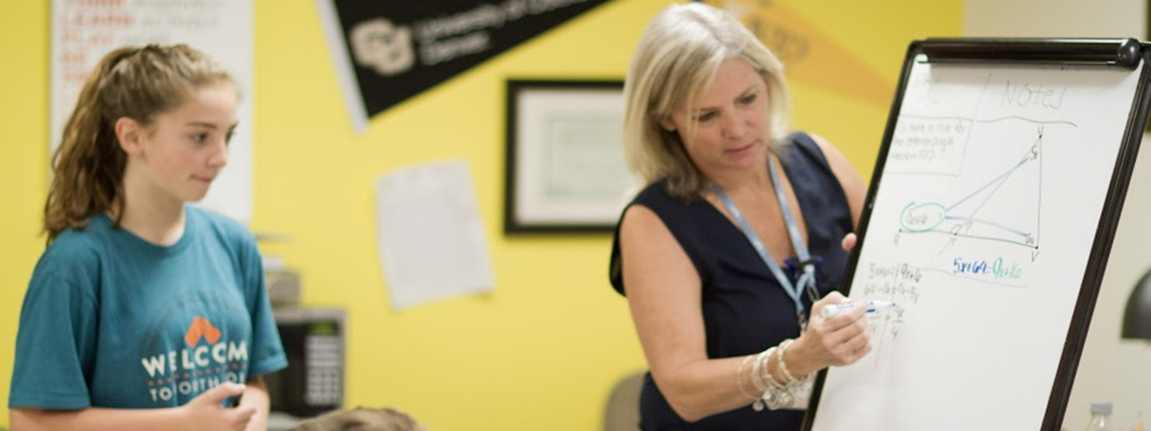
 | Minimum Priority  (1 point each) | Medium Priority  (2 points each) | High Priority  (3 points each)
Strategic Plan Pillars | Project does not align with the strategic plan | Project somewhat aligns with the strategic plan | Project definitely  Aligns with the strategic plan
Impact | Project impacts less than 25% of student body | Project impacts 50% or less of student body | Project impacts a majority of the student body
Student  Achievement | Project impacts one [insert outcome] | Project impacts two [insert outcome] | Project impacts all [insert outcome]
Usage | Item can only be used one to two times a year | Item can be used repeatedly throughout the year | Item can be used repeatedly over multiple years

SGC Charter Dollars Spending Rubric

Column Totals: ______________ _______________ ________________

Total Score (out of 12 possible points): _____________________

Fulton County 3 Big Rocks

