Squares
Directions:
- The player who spins the highest number goes first.
- Players take turns spinning the spinner and adding.
- They find a space on the board with that sum and place their counter or chip on it.
- The first player to make a square (see below) wins.
7 | 13 | 9 | 8 | 5 | 11
17 | 3 | 17 | 15 | 13 | 8
13 | 9 | 11 | 8 | 7 | 15
7 | 15 | 5 | 13 | 17 | 9
8 | 9 | 17 | 7 | 3 | 17
13 | 11 | 15 | 17 | 15 | 11
11 | 8
5 | 13

Squares Spinner
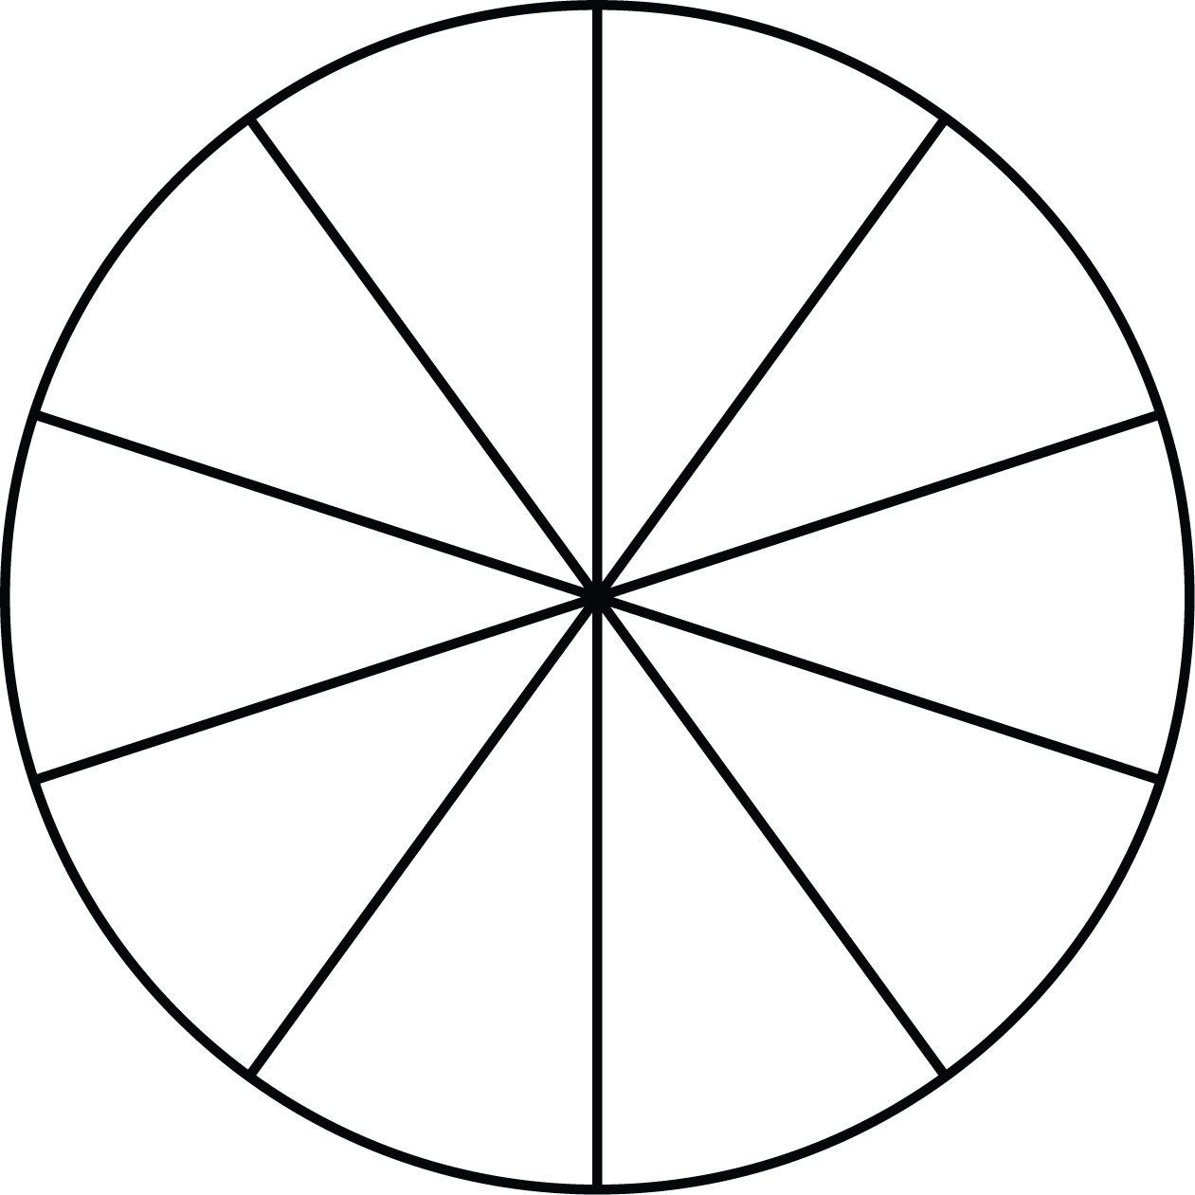
1 + 2
2 + 3

7 + 8

6 + 7

3 + 5

3 + 4

Spin Again

4 + 5
8 + 9

5 + 6

