Ratio Race
- Take turns spinning the spinner.
- Divide the number by 9.
- Record the quotient on the ratio table.
- The first player to complete the table wins.

Player’s Name: Player’s Name:
n | n ÷ 9
9
18
27
36
45
54
63
72
81
90

n | n ÷ 9
9
18
27
36
45
54
63
72
81
90

Ratio Race ÷9 Spinner
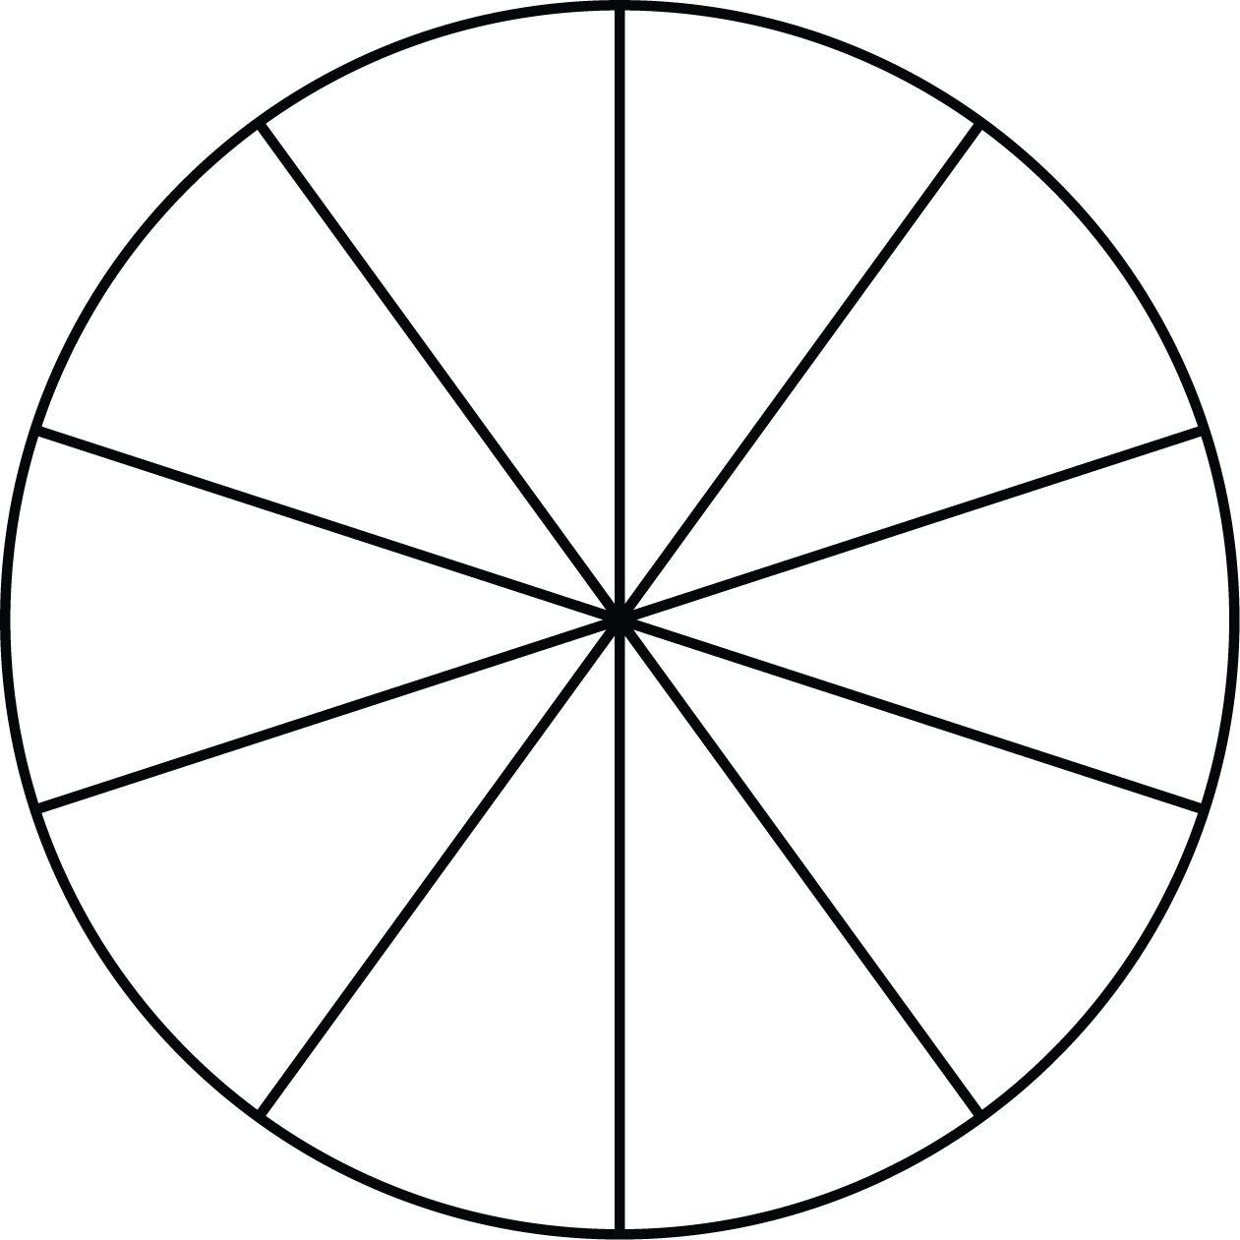
÷ 9
9
27
360
45
18
90
72
63
54
81

