Divide and Go
Directions:

- Spin the spinner and divide by 5.
- The quotient is the amount of points you earn.
- After each new spin, add your points to your total.
- Keep track of your points by placing a marker on the correct spot on the hundred chart.
- The first player to get exactly 100 points wins.

Example of playing the game:
Jim spins 45 and divides by 5 so he gets 9 points. He puts his marker on 9.

On his next spin, Jim spins 10 and divides by 5 to get 2 points. He then adds his 2 points to the 9 points he already had. He now has 11 points and moves his marker to 11 on his hundred chart.

1 | 2 | 3 | 4 | 5 | 6 | 7 | 8 | 9 | 10
11 | 12 | 13 | 14 | 15 | 16 | 17 | 18 | 19 | 20
21 | 22 | 23 | 24 | 25 | 26 | 27 | 28 | 29 | 30
31 | 32 | 33 | 34 | 35 | 36 | 37 | 38 | 39 | 40
41 | 42 | 43 | 44 | 45 | 46 | 47 | 48 | 49 | 50
51 | 52 | 53 | 54 | 55 | 56 | 57 | 58 | 59 | 60
61 | 62 | 63 | 64 | 65 | 66 | 67 | 68 | 69 | 70
71 | 72 | 73 | 74 | 75 | 76 | 77 | 78 | 79 | 80
81 | 82 | 83 | 84 | 85 | 86 | 87 | 88 | 89 | 90
91 | 92 | 93 | 94 | 95 | 96 | 97 | 98 | 99 | 100
Divide and Go ÷5 Spinner
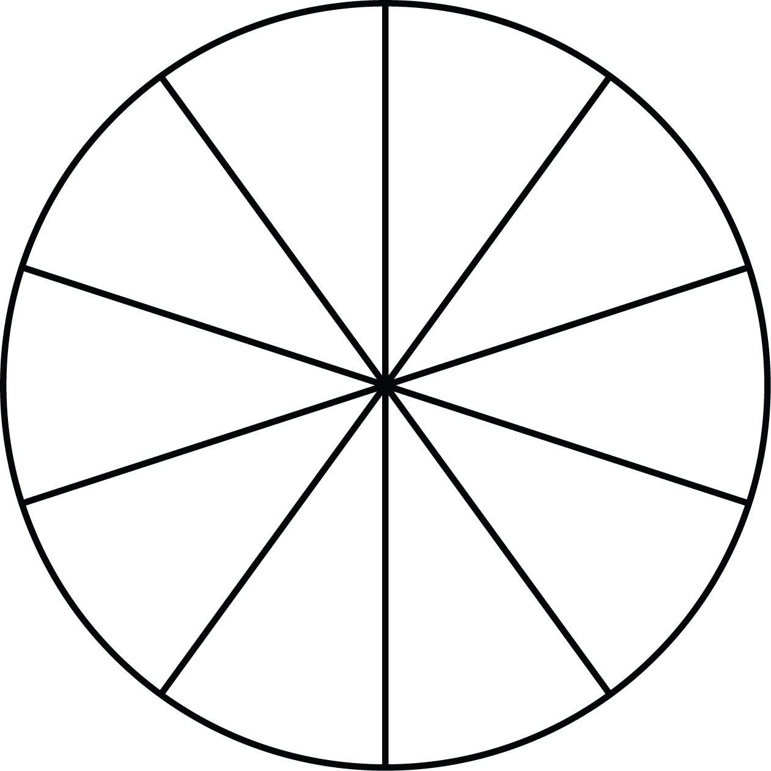
÷ 5
5
15
20
25
10
50
40
35
30
45

