Player’s Name:
Write to Divide
- Write the numbers 1, 2, 3, 4, 5, 6, 7, 8, 9, or 10 in each box.
- You can write a number more than once or not at all.
- Take turns spinning the spinner and dividing the number by 3.
- If you have that number in one of your boxes, cross it out.
- You can only cross out one number per spin.
- If you don’t have that number in any box, try again on your next spin.
- The first one to cross out all of your numbers wins.

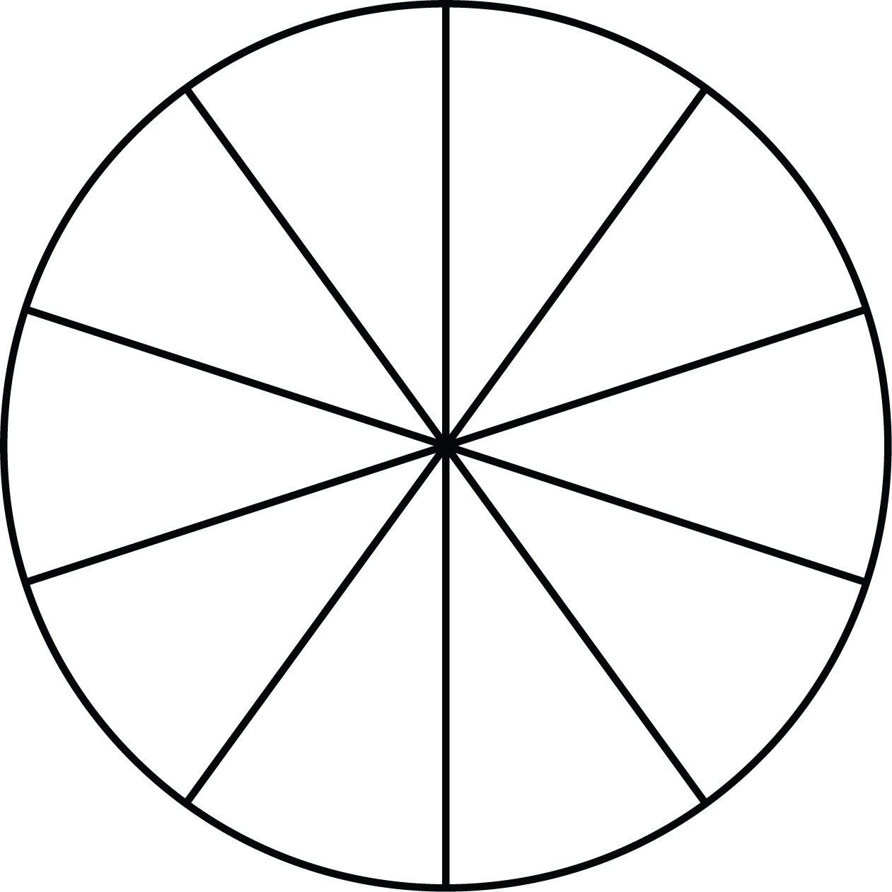
3
9
6

122
155
300
244
211
188
277
÷3

