Spin and Cover ÷4 Spinner
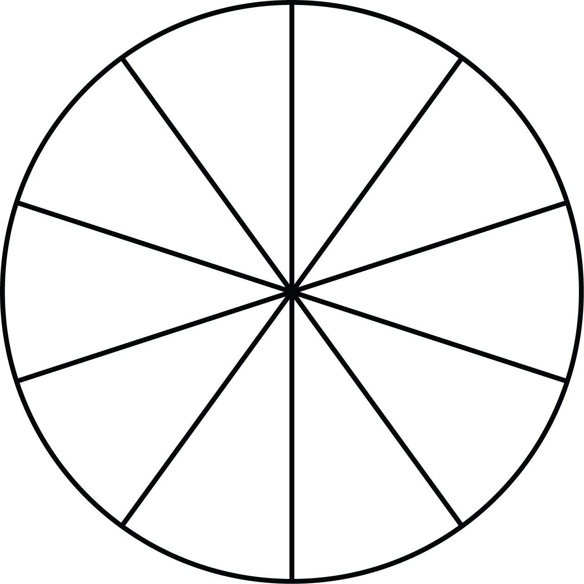
÷ 4
40
4
8
20
16
36
28
12
32
24

