SUPERINTENDENT’S MESSAGE
Students,
I welcome all of you to the Canton Public School District for the 2023 – 2024 school year. I am honored to be your superintendent and look forward to serving each of you. You must realize that your education is very important and your efforts will determine your success as a student today and as an adult in the future. Always strive to be the best person that you can be. Continue to develop good morals and values and follow the policies of your school district. Remember that your character and attitude are very important to your success in life. Again, follow the rules and study hard. Have a great school year!
Gary Hannah, Superintendent

MISSION STATEMENT
The mission of the Canton Public School District, with full participation of parents and the total community, is to enable all students to become analytical thinkers, self-directed lifelong learners and effective communicators who are prepared to continue their education and/or to enter the global workplace and to participate in society as responsible citizens.

OUR VISION
Children are our greatest asset and value. It is the responsibility to the parents, school and the community to serve as a perpetual bridge for the development of our children’s character and the enhancement of their ability to master data, interpret knowledge, and apply the practical principles of their mastery.
BELIEF STATEMENTS
All children can learn, but at different rates and in different ways.
Students must be actively involved in the learning process.
Education is a community effort.
It is the responsibility of the parents, the community, and the schools to be active participants in nurturing and educating our youth.
Family is a powerful influence on both children and the community.
Parents must be informed about and be involved in the education of their children.
Self-respect and self worth are essential to success.
The schools are the vehicles for students to develop the positive attitudes and goals that lead to a sense of motivation and self worth
High expectations for our children will produce higher achievement.
The schools provide the environment to model and reinforce higher goals for students.
Working together it is possible to change negative perceptions and environmental factors that affect student learning.
Civic organizations, businesses, churches, news media, and the schools must become active partners in change.

BOARD OF TRUSTEES

Johnny Brown………………………………………………………………………………………………Chairman
Lenderrick Taylor………………………………………………………………………………................Vice Chair
Shivochie Dinkins.………………………………………………………………………………………….Secretary
Peter Brown…………………………………………………………………………………………………...Trustee
Glen Lacey…………………………………………………………………………………………………….Trustee
Lisa Ross ............………………………………………………………….……………….School Board Attorney

Canton Public Schools does not discriminate on the basis of race, color, religion, national origin, sex, age, or disability in its programs or activities.

CENTRAL OFFICE PERSONNEL
Gary Hannah, Superintendent .………..........................…………....…………………………..601-859-4110
Farzette Jackson, Executive Secretary
Eula Ousley, Receptionist

Victoria Johnson, Executive Director of Curriculum & Instruction (Secondary)………..601-859-6720

Candra Nelson, Executive Director of Curriculum & Instruction (Elementary)…….........601-859-3372

Shoney Harris, Director of Early Learning
Eboni Sutherland, Secretary

Shelia Anthony, Director of Exceptional Services, 504 Coordinator……………...……….601-859-2179
Brittany Harvey, Case Manager
Tony Blackmon, Special Services Coordinator
Rodney Harris, Jr., Behavior Specialist
Ashley Gore, Secretary

Timothy Luckett, Director of Technology.………..….…………………………………………601-859-6850
Tungala Hardy, Secretary/MSIS Specialist
Thierno Bell, Computer Technician
Jarvis Brown, Computer Technician

LaToshia Stamps, Director of Federal Programs, Title IX Coordinator……………..........601-859-2359
Jacqueline Cotton, Bookkeeper

Anthony Bailey, Director of Human Resources & Student Support Services……………601-859-3089
Gloria C. Davis, Secretary
Shanton Kelly, Student Support Specialist

Margaret Beatty, Director of Child Nutrition......…………………….....................................601-859-6189
Rebekah Hamilton, Supervisor
Tami Rigby, Bookkeeper/Manager
Delisa Brown, Program Coordinator

Tony Foster, Director of Finance……………………………601-859-1152 / 601-859-2341 / 601-859-2260
Tracy Lewis, Assistant Director
LaShundra Smith, Payroll Clerk
Shawania Green, Accounting Assistant
Tresalyn Harris, Accounts Payable Clerk
Adrianne Travis, Fixed Assets Clerk
Jacqueline Davis, Purchasing & Insurance Clerk

Rodney Harris, Sr., Director of Maintenance/Transportation……………………………….601-859-5002
Joe Thompson, Supervisor
Erma J. Cole, Secretary

Beverly Luckett, Director of Public Relations………………………………………………….601-859-2367

Robert L. Jackson, III, Director of Security……………………………………………….........601-859-5325

TABLE OF CONTENTS
McNeal Principal’s Message, Mission, Vision, Expectatons, Goals, Motto, and Creed....……….........................13-14
Rueben B. Myers Canton School of Arts and Sciences Principal’s Message, Vision, Mission and Creed………15-16
Jimmie M. Goodloe Elementary Principal’s Message, Mission and Creed………………………………………17-18
Canton Elementary Principal’s Message, Vision, Affirmation, Expectations, Rewards and Consequence………19-20
New for the 2022-2023 School Year ………………………………………………………………………………..21

Elementary Schools General Information
COVID-19 Statement…………………………………………………………………………………………………23
School Attendance Tardiness & Excuses …………………………………….…………………………....................24
Promotion Notice..........................................................................................................................................................24
House Bill 1530 ……………………………….……………………………………………………………………..24
Fighting in School …………………………………………………………………………….……………………...24
Gang Activity or Association ………………………………………………………………………………………..24
Change of Address …………………………………………………………………………………………………..24
Asbestos Statement …………………………………………………………………………………………..............24
Notice of Asbestos Management Program …………………………………………………………...........................25
Video Surveillance …………………………………………………………………………………………………...25
Communicable Diseases ………………………………………………………………………..……………………25
Consent for Medical Treatment …………………………………………………………………….………………..26
Electronic Devices ……………………………………………………………………………...................................26
WEB 2.0 Social Network/Internet Web……………………………………………..……………………………….26
Emergencies/Illnesses/Injuries …………………..…………………………………………………...........................26
Emergency Drills & Weather Alerts …………………………………………………………………………………26
Enrollment Information ……………………………………………………………………..………. ……………....27
Lost and Found …………………………………………………………………..…………………………………...28
Professionalism …………………………………………………………………………………….………………...28
Care of Property ……………………………………………………………………………………………………...28
Receiving Gifts at School ………………………………………..…………………………………..........................28
Restricted Items ……………………………………………………………………………..………………………..28
Role of PTA/PTSA …………………………………………………………………..………………………………28
Telephone ……………………………………………………………………………………….……………………28
Transfers ………………………………………………………………………………………..…………………….29
Visitation/Conferences ……………………………………………………………………………………………….29
Withdrawal Information ……………………………………………………………………………………………...29
Dress Code General Guidelines …………………………………………………………………………………..29-30
Exceptional Education Services ………………………..…………………………………………………….............30
Homework ……………………………………………………………………..…………………………..................31
Mid-term Progress Reports …………………………………………………………………………………………..31
Report Cards …………………………………………………………………………………………........................31
Explanation of Grades ………………………………………………..……………………………............................31
Honor Roll………………………………………….…………………………………………………………………31
Textbook/Fines/Fees ……………………………………………………………………………………....................32
Child Nutrition Program ………………………………………………………………………………………….32-33
Insurance ……………………………………………………………………………….…………………………….33
Library ………………………………………………………………………………………….…………….............33
Transportation Services…………………………………………………………………………………………….....33
Bus Regulations…………………………………………………………………………………………………...33-34
Parent Transports …………………………………………………………………………..………………...............34
Student Arrival/Check-Out ………………………..…………………………………………………………............34
Field Trips …………………………………………………………………..………………………………..............34
Counselor ………………………………………………………………….…………………………………............34
Discipline Program ………………………………………………………………………………….....................35-38
Physical Restraint …………………………….………………………………………………………………………38
--Bullying ………………..………………………………………………………………………………………..38-39
Prescription Medication Protocol ………………..…………………………………………………..........................39
Non-Prescription Medication ………………….……………………………………………………………………..39
Parent-School Communication ……………….……………………………………………………...........................39

MIDDLE SCHOOL

Nichols Middle Principal’s Message …………………………………………………………………………………40
Porter Middle Principal’s Message, Vision, Mission and Creed …………………………………………………41-42
Handbook/Acceptable Use Acknowledgement Form………………………………………………………………...43
Field Trip Permission Request………………………………………………………………………………………..44
School General Information
Accommodations for the Disabled ………………………………………………………………………………….45
House Bill 1530 ……………………………………………………………………………………………………..45
Fighting in School …………………………………………………………………………………………………..45
Gang Activity or Association………………………………………………………………………………………..45
Asbestos Statement………………………………………………………………………………………………….45
Notice of Asbestos Management Program……………………………………………………………………….45-46
Video Surveillance…………………………………………………………………………………………………...46
Assemblies……………………………………………………………………………………………………………46
Bus Regulations, Misconduct & Consequences…………………………………………………………………..46-47
Cafeteria Procedures………………………………………………………………………………………………….47
Cell Phones/Electronic Devices………………………………………………………………………………………48
Change of Address and Telephone Numbers ………………………………………………………………………...49
Confidential Communications ……………………………………………………………………………….............49
Distribution of Literature …………………………………………………………………………………………….49
Dress Code/Free Dress …………………………………………………………………………………………...49-50
Violation of Dress Code ………………………………………………………………………………………….50-51
Eating/Drinking in School Building ………………………………………………….. …………………………….51
Emergency Closing of School………………………………………………………………………………………...51
Financial Responsibilities ……………………………………………………………………………………………51
Fire Drills …………………………………………………………………………………………………………….51
Late to Class ………………………………………………………………………………………………….......51-52
Lost & Found ……………………………………………….......................................................................................52
No Smoking Rule …………………………………………………………………………………………………….52
Parent Pick-Up/Drop-Off……………………………………………………………………………………………..52
Personal Conduct/Property …………………………………………………………………………………………..52
Photographs …………………………………………………………………………………………………………..52
Searches ……………………………………………………………………………………………………………...52
School Security ………………………………………………………………………………………………………52
Multi-Tiered System of Support (MTSS) ……………………………………………………………………………53
Telephone Use ………………………………………………………………………………………………..............53
Visitors ……………………………………………………………………………………………………………….53
Bookbags ……………………………………………………………………………………………………………..53
Computer Lab ………………………………………………………………………………………………………..53
Field Trips ……………………………………………………………………………………………………............53
Grades ………………………………………..............................................................................................................53
Guidance Services ……………………………………………………………………………………………………53
Active Parent …………………………………………………………………………………………………………54
Library/Media Center ……………………………………………………………………………………...................54
Marking Periods ……………………………………………………………………………………………………...54
Programs for High Potential & Gifted Students ……………………………………………………………..............54
Report Cards …………………………………………………………………………………………………………54
School Day/Week ……………………………………………………………………………………………………54
Scholastic Integrity …………………………………………………………………………………………..............54
Cheating/Definition/Penalties …………………………………………………………………………….............54-55
Explanation of Grades ………………………………………………………………………………………………..55
Scholastic Honors ……………………………………………………………………………………………............55
Schedule Changes ……………………………………………………………………………………………………55
Special Request for Specific Scheduling Assignment ……………………………………………………………….55
Testing ………………………………………………………………………………………………………………..55
Textbooks …………………………………………………………………………………………………………….56
Acceptable use of the Computers, Network, Internet, Electronic Communications, and information Systems
Policy, Violations & Consequences …………………………………………………………………………….........56
Visitation ……………………………………………………………………………………………………………..57
Free Education & Attendance ………………………………………………………………………………..............57
Absences/Excuses/Make-up Work .........................................................................................................................57-58
Mississippi Compulsory School Attendance Law …………………………………………………………………...58
Absence Notifications ………………………………………………………………………………………………..58
Check-out Procedure …………………………………………………………………………………………............58
63% Rule for Extra-Curricular or After School Participation ……………………………………………………….59
Emergency Permits ……………………………………………..................................................................................59
Late Arrival & Tardiness …………………………………………………………………………………………….59
Truancy ………………………………………………………………………………………………………………59
Withdrawals ………………………………………………………………………………………………….............59
Student Responsibilities …………………………………………………………………………………………..59-60
Abusive Language ……………………………………………………………………………………………………60
Assault of a Student or Employee ……………………………………………………………………………………60
Bullying & Cyber Bullying …………………………………………………………………………………………..60
Cutting Class …………………………………………………………………………………………………………60
Disciplinary Actions …………………………………………………………………………………………………61
Out-of-School Suspension Offenses ………………………………………………………………………................61
Insubordination …………………………………………………………………………………………………...61-62
Co-Curricular Activities ……………………………………………………………………………………………...62
Student Organizations ……………………………………………………………………………………..................62
Interscholastic ………………………………………………………………………………………………………..62
Sportsmanship ……………………………………………………………………………………………………….63
Extra Curricula Activities ………………………………………………………………………………………...63-64
Health Information …………………………………………………………………………………………………...65
Attendance Guidelines …………………………………………………………………………………….................65
Health Services ………………………………………………………………………………………………............65
Medications …………………………………………………………………………………………………………..65

HIGH SCHOOL

Principal’s Message, Mission…………………………………………………………………………………………66
Philosophy & School Statement of Belief ……….…………………………………………………………………..67
Goals for Canton High School Students ……………………………………………………………………..............67
Goals for High School Teacher & Staff ……………………………………………………………………………...67
Cars - Student Drivers………………………………………………………………………………………………...68
Motor Bikes and Motor Scooters……………………………………………………………………………………..68
Driving and Parking Information……………………………………………………………………………………..68
CHS Driver’s Policy…………………………………………………………………………………………………..69
Extra Curricula Activities…………………………………………………………………………………………….70
Eligibility Requirements for Student Offices ………………………………………………………………………...70
Grounds for Removal from Office……………………………………………………………………………………70
Extra Curricula Activities Eligibility Rules……………………………………………………………………….70-71
Student Council……………………………………………………………………………………………………….71
Mr. and Miss CHS……………………………………………………………………………………………………72
Grounds for Removal of Mr. and Miss CHS……………………………………………………………………...73-74
Principal’s Message (9th Grade Academy) …………………………………………………………………………...75
9th Grade Academy Creed ………………………………………………………........................................................76
9th Grade Academy Student Expectations …………………………………………………………………………....76
9th Grade Academy Student Morning Protocol……………………………………………………………….............76
9th Grade Academy Staff Expectations ………………………………………………………………………............76
9th Grade Academy Parent Expectations ……………………………………………………………………………..76
9th Grade Academy Ways for Students to Succeed…………………………………………………………………...77
9th Grade Academy Monthly Meetings with Principal, Parents & Guardians………………………………………..77
9th Grade Academy Culminating Project……………………………………………………………………………..77
9th Grade Academy Attendance Requirements………………………………………………………………………77
CPSD – Canvas Learning User Agreement and Parent Permission Form………………………………………..78-84

School General Information
School Attendance, Tardiness & Excuses ……………………………………………………………………………85
House Bill 1530 ……………………………………………………………………………………………………...85
Fighting in School ……………………………………………………………………………………………………85
Gain activity or Association ………………………………………………………………………………………….85
Asbestos Statement …………………………………………………………………………………………………..85
Notice of Asbestos Management Program ……………………………………………………………………….85-86
Video Surveillance …………………………………………………………………………………………………...86
Change of Address …………………………………………………………………………………………………...86
Communicable Diseases ………………………………………..................................................................................86
Consent for Medical Treatment ……………………………………………………………………………………...87
Emergencies/Illnesses/Injuries ……………………………………………………………………………………….87
Emergency Drills & Weather Alerts …………………………………………………………………………………87
Enrollment Information …………………………………………………………………………………………. 87-88
Lost and Found ……………………………………………………………………………………………………….88
Care of Property ……………………………………………………………………………………………………...88
Receiving Gifts at School ……………………………………………………………………………………………88
Restricted Items ………………………………………….. …………………………………………………………88
Electronic Devices……………………………………………………………………………………………………89
Role of PTO/PTSO …………………………………………………………………………………………………..89
Telephone …………………………………………………………………………………………………………….89
Transfers ………………………………………………………………………………………………………….......89
Visitation …………………………………………………………………………………………………………......89
Withdrawal Information ……………………………………………………………………………………………...89
Exceptional Education Services ……………………………………………………………………………………...90
Homework…………………………………………………………………………………………………………….90
Mid-term Progress Reports …………………………………………………………………………………………..90
Report Cards …………………………………………………………………………………………………………90
Explanation of Grades ………………………………………………………………………………………………..90
Textbook/Fines/Fees …………………………………………………………………………………………………91
Child Nutrition Program ……………………………………………………………………………………………..91
Cafeteria Behavior …………………………………………………………………………………………………...92
Library ………………………………………………………………………………………………………………..92
Transportation …………………………………………………………………………………………………….92-93
Parent Transports …………………………………………………………………………………………………….93
Transportation Services ………………………………………………………………………………………….…..93
Discipline …………………………………………………………………………………………………………….93

Canton High School / 9th Grade Academy
Student’s Rights & Responsibilities ………………………………………………………………………………93-95
Absentees/Tardies/Check-In/Check-Out …………………………………………………………………………….95
Senior Privilege ………………………………………………………………………………………………………95
Senior Research Project …………………………………………………………………………………………..96-97
Extended School Day ………………………………………………………………………………………………...97
Public Relations ……………………………………………………………………………………………………...97
Publicity Release ……………………………………………………………………………………………………..97
Work Study Programs ………………………………………………………………………………………………..97
ISS - In School Suspension …………………………………………………………………………………………..97
Discipline Review Committee ……………………………………………………………………………………….98
Drug Dogs ……………………………………………………………………………………………………………98
Dress Code ………………………………………………………………………………………………………..98-99
Instructional Supplies ……………………………………………………………………………………………….100
Report Cards/Grading ………………………………………………………………………………………………100
Grades & Privacy …………………………………………………………………………………………………...100
Grade Books ………………………………………………………………………………………………………...100
Student Evaluations………………………………………………………………………………………………….100
Promotion……………………………………………………………………………………………………………..99
Honor Roll …………………………………………………………………………………………………………..100
Credit Recovery …………………………………………………………………………………………………….101
Credit Recovery Plan …………………………………………………………………………………………….....101
9th Grade Academy Secondary Subject Choice Form ………………………………………………………………102
9th Grade Academy CPSD Graduation Requirements ……………………………………………………………...103
9th Grade Academy Course Offerings Worksheet …………………………………………………………………..104
Counseling Sessions ………………………………………………………………………………………………...105
Cumulative Records ………………………………………………………………………………………………...105
Transcripts ……………………………………………………………. ……………………………………………105
Media Center …………………………………………………………………………………………………..105-106
Canton Career Center
Registration …………………………………………………………………………………………………………107
Student Folders ……………………………………………………………………………………………………..107
Posted Announcements ……………………………………………………………………………………………..107
Financial Aid/Career Information…………………………………………………………………………………...107
Driving Regulations ………………………………………………………………………………………………...107
Enter/Exit Building …………………………………………………………………………………………………107
General Rules ……………………………………………………………………………………………………….107
Bell Schedule ……………………………………………………………………………………………….............108
Special Populations …………………………………………………………………………………………………108
Honor Society ………………………………………………………………………………………….…………...108
Organizations: NTHS, Skills USA, FBLA, HOSA, TSA, DECA ………………………………………………….108
Canton Educational Services Center
Principal’s Message & Overview …………………………………………………………………………………...109
Tardiness/Attendance ……………………………………………………………………………………………….109
Early Release …………………………………………………………………………………………………..109-110
Student Code of Conduct/Discipline Plan ……………………………………………………………………..110-111
Violations …………………………………………………………………………………………………………...111
School Rules/Consequences ………………………………. ………………………………………………….111-112
Dress Code/Consequences ……………………………………………………………………………………..112-113
Instructional Supplies ……………………………………………………………………………………………….113
Exceptional Services ………………………………………………………………………………………………..113
Professional Development ………………………………………………………………………………………….114
GED Program…………………………………………………………………………………………………..115-117
Compliance/Policies
Accessibility for American with Disabilities ……………………………………………………………………….118
Exceptional Students ………………………………………………………………………………………………..118
Constitutionally Protected School Prayer…………………………………………………………………………...118
Equal Educational Opportunities …………………………………………………………………………………...119
Homeless Students ………………………………………………………………………………………………….119
Migrant Students ……………………………………………………………………………………………………119
Complaints …………………………………………………………………………………….……………………119
Ell (English Language Learners) …………………………………………………………………………………...120
Parental Rights/Pupil Rights ………………………………………………………………………………………..120
Student Directory/Military Recruiters ……………………………………………………………………………...120
Abstinence-Plus Sex Education Policy ………………………………………………………………………...121-123
Bullying & Harassing Behavior ………………………………………………………………………………..124-125
Class Ranking & Grade Point Average ………………………………………………………………………..126-127
Discipline Plan …………………………………………………………………………………………………128-129
Grading & Assessment ………………………………………………………………………………………...130-131
Title I Parental Engagement……………………………………………………………………………………132-136
Literacy Based Promotion ……………………………………………………………………………………..137-138
RTI ………………………………………………………………………………………………………………….139
Secret Societies ……………………………………………………………………………………………………..140
Sexual Harassment ……………………………………………………………………………………………..141-143
Solicitation by Students …………………………………………………………………………………………….144
SPED Program …………………………………………………………………………………………………145-147
Students with Disabilities………………………………………………………………………………………148-152
Student Complaints & Grievances ……………………………………………………………………………..153-154
Social Media Websites ……………………………………………………………………………………………...155
Technology Appropriate Use Policy (Internet) ……………………………………………………………..…156-161
Student Directory Information Release Form …………………………………………………………………162-163



Dear Parents and Students

Welcome to THEE McNeal Elementary School, where we are Striving, Thriving, Achieving and Rising--Thee McNeal Way! I am honored to serve as your Instructional Leader for the 2023-2024 school year!

We know that the children of our community have great potential, and it takes all stakeholders to purposefully work together for their success. We believe that close cooperation between school and home is essential for your child's optimal educational experience because no significant learning occurs without a significant relationship. Here at McNeal, we are committed to providing our students with quality and engaging opportunities to think critically and problem solve which will in turn equip them with the necessary skills to compete in a competitive and global society.

The contents of this handbook is filled with important information regarding school policy and procedures. Parents and students should review the contents together. If you have any questions, please call McNeal's front office. We know that open and clear communication between school and home is important to the success of our educational program. We look forward to working with you and your child and to a wonderful, productive school year filled with rich academic experiences supported by technology and individualized, inclusive instruction! We appreciate your cooperation and support, and we welcome your suggestions and ideas for improvement.

With McNeal Pride,

Kara Paige, M.Ed.
Principal

Canton Public Schools does not discriminate on the basis of race, color, religion, national origin, sex, age, or disability in its programs or activities.

All-STAR Mission Statement
McNeal Elementary School, along with parents and community advocates, will strive towards academic excellence by providing a rigorous and relevant curriculum in a safe and orderly environment where learning is interactive and enjoyable.

All-STAR Vision
With high expectations of all stakeholders, we will provide a rigorous and relevant curriculum in a safe and nurturing environment. This will include research-based standards, teaching methods, and student-centered approaches. By embracing technology, diversity, and global awareness, students will become college and/or career ready. Our goal, in collaboration with our parents and community, is to
create an environment where students are empowered to recognize their strengths and to reach their maximum potential.

All-STAR Expectations
Show a positive attitude
Take responsibility
Actively participate
Respect self and others

All- STAR Goals
We are committed to the following goals:

• To teach all students not only how to read, but also to enjoy reading.
• To make sure that all students gain an understanding of mathematical concepts and the role that
math plays in all areas of life.
• To develop an interest in and an understanding of science.
• To write fluently for a variety of purposes.
• To use technology as a tool to enhance all areas of the curriculum.

All- STAR School Motto
Making Our Mark by Striving, Thriving, Achieving, and Succeeding!

All-STAR Creed
As a McNeal Tiger All-STAR, I believe that I can achieve success. As an All-STAR, I will do my part by being totally focused on student achievement. I will show a positive attitude, take responsibility, actively participate, and respect myself and others. I will do my best at all times because at McNeal Elementary, we are striving to reach high standards, thriving under sound instruction, achieving
authentic results, rising to global expectations, and succeeding at rigorous tasks!



Welcome to the 2023-2024 school year! We are excited to welcome our champions and their families back to another great, exciting and promising year here at “The Reub”!!! Dr. Thomas and I are honored and extremely excited to serve you as the instructional leaders of Reuben B. Myers Canton School of Arts and Sciences; where our mission is to provide enhanced educational experiences to all students where they are able to excel academically, morally and socially.
All of us at Reuben B. Myers are eager and excited to begin what promises to be a great year. We will work diligently to ensure that students are provided with academic experiences that are rigorous, relevant and help to build real world-connections; empowering them to become life-long learners and high achievers in an environment in which they feel valued, accepted and safe.
As we embark upon this exciting school year, we invite each of you to become an agent in the education of our children. We need your participation and your support! Working together
allows us all to meet the challenges of academic excellence in a positive, safe and nurturing
learning environment. Our doors are always open; welcoming your input.
Again, we welcome you to our wonderful learning community . . . where there are many minds on a mission to academic excellence. We look forward to working with each and every one of you as we journey into the 2023-2024 school year together.

Alphia R. Myers, Principal
Reuben B. Myers CSAS

Canton Public Schools does not discriminate on the basis of race, color, religion, national origin, sex, age, or disability in its programs or activities.

Our Vision
The vision of Reuben B. Myers School of Arts and Sciences is to become an A- rated Literacy Focused, Technological Elementary school that serves as a model for the state of Mississippi and beyond.

Our Mission
The mission of Reuben B. Myers School of Arts and Sciences is to provide an enhanced educational experience to students, parents and the community at large; whereby our students excel academically, morally and socially.

At RBMSAS, we are dedicated to a student-centered program that promotes academic excellence through an enriched, rigorous curriculum. As a staff, we are here to support all of you, by any means necessary, to ensure you reach your fullest academic potential. We look forward to working with you, our parents and the members of the community to provide a high-quality education that you all deserve.

This year, you can look forward to encountering a highly intensive and challenging academic program that will push you to work beyond your limits. However, I am confident that all of you have the capacity and ability to meet our expectations. Our goal is to ensure that all students become critical thinkers, active problem-solvers, inquisitive readers, diligent researchers and prolific writers. We do all of this to prepare you for the demands of the real-world so you may become productive citizens, become our future leaders, and contribute and/or give back something positive to the community.

I look forward to working with all of you and pushing you to all academic heights. On behalf of the staff of Reuben B. Myers School of Arts and Sciences, I want to again welcome all of you and thank you for being a part of the RBMSAS school community where SUCCESS IS NOT AN OPTION…..BUT AN EXPECTATION. We are truly on the path to GREATNESS!

Regards,

Reuben B. Myers School of Arts and Sciences
School Creed
We come to school to learn;
Therefore, I will do NOTHING to keep the teacher from teaching,
Or anyone, including myself, from learning.
I am RESPECTFUL!
I am SAFE!
I am PREPARED!
I will cooperate with all school personnel.
I will respect myself, others and the environment.
By acting this way,
I am Respectful, Responsible and Ready to Learn!
I AM A TIGER!

GOODLOE ELEMENTARY
Full Force with Excellence!
~ENCOURAGING EXCELLENCE EVERYDAY~

Marsha Warfield, Principal 551 Finney Rd.
Canton, MS 39046
PH. 601.407.1809

Dear Goodloe Families,

Welcome to the 2023 - 2024 school year! We are excited to welcome our students and staff back to school. We hope that you were able to relax and make special memories with your friends and families this summer. It is time to look forward to a beautiful new school year as we continue “Racing Towards Excellence” at Goodloe Elementary School!

Together with our dedicated staff, we strive to connect with students to help them feel valued, accepted, and safe. Our Goodloe motto of “Racing Towards Excellence as We Prepare for Tomorrow’s Opportunities” will continue to guide our mission to provide a rigorous, joyful, and inclusive school environment. We aim to encourage active student engagement to foster a lifetime of love for learning.

As we all know, a new year presents new opportunities, new faces, and new partnerships. Partnering with families is key to promoting a healthy social and emotional transition to school. We will continue to emphasize social-emotional learning while building our classroom communities. We encourage families to stay connected and informed by following our district website, our Facebook page, and announcements sent through Class Dojo.

I look forward to working with you and your family as we partner up to make this school year successful.

Sincerely,

Marsha Small-Warfield

Canton Public Schools does not discriminate on the basis of race, color, religion, national origin, sex, age, or disability in its programs or activities.

Goodloe Elementary School’s Mission
The mission of Goodloe Elementary is to provide opportunities for our children to learn and grow academically, personally, and socially in a safe, warm, and caring environment.

School Creed:
I believe in myself and my ability to exhibit excellence at all times. Because I am responsible for my life and all my actions, I will:
Possess a positive attitude
Act responsibly
Work and play safely and
Show respect
Therefore, I will listen, I will see, I will speak, I will feel, I will think, I will reason, I will read, I will write; I will do all of these things with one purpose in mind, to do my best, my very best, and not waste this day for this day will come no more.

Excellence is the ONLY option for me!


Have a BLAST at CES!!!
Believe, Lead, Achieve & Succeed Together
One Team, One Dream…CES to the Top!!!

365 Van Buren St.
Canton, Mississippi 39046
Main Office: 601-859-2400
Facebook: CantonElementary35
www.cantonschools.net

“You must never be fearful about what you are doing when it is right.”
Rosa Parks

Greetings!

Throughout CPSD and certainly at Canton Elementary School, Perseverance Continues to Conquer All! Because of the hard work of our students, teachers, parents, and community supporters, CES has been labeled Successful or higher since 2018! As a matter of fact, CES was an “A” school for the 2021-2022 school year!!!!! This accomplishment did not occur by chance. As always, we strive to continue to grow our students and challenge them to be the best they can be academically, emotionally, and spiritually.

We strive this academic year to continue to focus on the success and student achievement that has transformed our school over the past six years. All students possess the ability to learn and achieve at high levels. It is our desire to give our students the stable foundation that is needed to tackle the challenges that await them as they continue their educational journey. As your leader, I am dedicated to working alongside our students, staff, and you as we strive to reach our goals!

Sincerely,

Shalondia J. Washington
Principal, CES
CPSD Administrator of the Year 2021-2022

Canton Public Schools does not discriminate on the basis of race, color, religion, national origin, sex, age, or disability in its programs or activities.

CES Vision
Canton Elementary School will produce students who are focused, attentive, respectful, responsible, and self-disciplined life-long learners performing at or above grade-level in all academic subjects.

CES Student Affirmation
I can stay focused, take responsibility, actively participate, respect myself and others, and show self -control.
CES Parent Expectations
Support our school vision
Have high expectations
Assist with homework
Reinforce non-bullying behavior
Establish effective communication with teachers
CES Staff Expectations
Be Punctual
Be Professional
Be Respectful
Be Positive
Be Responsible
Be Ethical
Be a Role Model

CES Student Expectations
Stay focused
Take responsibility
Actively participate
Respect self and others
Show self- control

CES Rewards
PBIS Celebrations
Treat Tables
Positive Praise /Recognition/Post Cards
Class Dojo Points
Passes
WASH Crew Acknowledgement
STAR Student Status

CES Consequences
Verbal/ Written warning
Contact parent by phone, and send parent behavior letter home
Loss of privileges/time out in another classroom
Parent/Teacher Conference
Office Referral
In School Suspension
Out of School Suspension

*The principal has the flexibility to administer the discipline steps listed based upon the severity of the offense.

New for the 2022-2023 School Year

Uniforms will be optional for ALL students on Fridays ONLY. Guidelines for permissible attire must be followed. The Superintendent reserves the right to modify or remove this privilege at any time.

Students that choose to dress out of uniform on Friday in the District are expected to adhere to the dress code listed below:

- General grooming shall not be allowed in class. This includes but is not limited to brushing/fixing hair and applying makeup.
- Picks, combs, or other styling devices shall not be worn in hair.
- Shoes, sandals, or boots shall be always worn, with shoes being laced and tied. No cleats or tennis shoes with wheels. No house shoes/slippers are allowed.
- No tank tops, muscle shirts, halters, tops with spaghetti straps or tops that expose the midriff, when hands are raised above the head, shall be worn. Appropriate underclothing shall be worn. No clothing considered and designed as underclothing shall be worn as an outside garment. Underclothing shall not be exposed while worn underneath an outside garment. Any sleeveless shirt, blouse, or dress must be at least two (2) inches wide at the shoulder with no undergarment showing.
- Midriffs shall not be exposed at any time.
- Cleanliness of both dress and body is mandatory.
- Belt, if worn, shall be buckled.
- Fasteners designed for use with an article of clothing will be used appropriately at all times.
- Clothing with vulgar, indecent, or suggestive writing or symbols shall not be worn. No writing shall be on the seat of the pants.
- A student shall not wear any clothing or present himself or herself in a manner (such as cuts in the eyebrows, one pant leg or sleeve rolled up) that would identify him/her with gang or any other illegal activity. Further, a student shall not wear any clothing showing gang-related signs or written gestures.
- Clothing advertising tobacco, alcohol, weapons, ammunition, or drug shall not be worn.
- Unless prescribed, sunglasses shall not be worn inside the buildings.
- No clothing considered and designed as underclothing shall be worn as an outside garment.
- Shirts and blouses shall be buttoned or zipped unless designed for outside wear.
- Any article of clothing designed to cover the lower part of the body must come no higher than three (3) inches above the center of the knee. This includes dresses, skirts, overalls, skorts, shorts, etc. Skirts or dresses with slits, kick pleats, or any opening must have the top of the opening within three (3) inches of the middle of the knee.
- Hemmed, loose fitting walking or Bermuda shorts and skorts may be worn.
- Unacceptable outer wear for the lower part of the body includes: unhemmed, ragged-end-cutoffs, running shorts, soccer shorts, yoga/spandex pants/tights/jeggings/leggings, cut-off-warm-ups, gym shorts, pajamas or pajama-like material.
- All shirts must be tucked into the pants. Pants must be worn at or above the waist and a belt will be worn with any pants having belt loops. Sagging pants will not be tolerated.
- Jeans, shorts, and other garments with holes shall not expose skin or undergarments from the waist to 4 inches from the middle of the knee.
- No hats, caps, toboggans, head scarves, bandanas, wrist bands, sweat bands, hairnets, shower caps, stocking caps, do rags or hoods are allowed in the building, except for religious purpose. (ex. Hijab or other head coverings)
- Appropriate and adequate underclothing shall be worn.
- No see-through clothing shall be worn.
- No clothing top shall be so low in the front as to expose any part of the breast/cleavage or shall be excessively low in the back.
- Students with tattoos may be requested to keep them covered.
- Any style of clothing determined to be immodest in dress, such as skin- tight clothing, is prohibited.
- Trench coats or duster style coats are not allowed.
- Any style of clothing or accessory deemed unsafe shall not be worn. This includes long wallet/watch chains, heavy medallions, spiked jewelry, etc.
Modifications to the dress code may be allowed by school administrators for special occasions.
Any dress or personal appearance that the administration feels is disruptive or presents a safety hazard to the instructional process will be dealt with on an individual case basis.

ELEMENTARY SCHOOL GENERAL INFORMATION

Effective For the 2021-2022 School Year As A Result of COVID-19

Safety Considerations
- Students will be required to wear a mask/face-covering at all times, including the bus
- Students will have their temperature checked daily
- Frequent handwashing will be encouraged and expected throughout the day. The Center for Disease Control (CDC) recommend washing with soap and water for at least 20 seconds
- Social distancing will be strictly enforced in all areas of each building including the classrooms
- Hand sanitizer will be provided in each classroom and readily available in multiple locations throughout the building. If your child has sensitivity to hand sanitizer, please inform your child’s principal immediately
- All water fountains will be turned off
- Each building will be thoroughly cleaned and disinfected at the end of each day in addition to frequent wiping of surfaces during the day

Isolation, Contact Tracing, and Quarantine

Schools should continue to isolate and exclude COVID-19 infected students, teachers, and staff and continue contract tracing to identify exposed individuals for quarantine and exclusion from the school setting.

Procedures for Students and Staff who test positive for COVID-19
- Individuals who test positive for COVID-19 should be excluded from the work setting and remain in Isolation for a full 10 days from the onset of symptoms and are fever free for 24 hours (or excluded for 10 days from the date of the test if asymptomatic).
- Asymptomatic individuals with a positive rapid COVID-19 test who have a negative molecular based COVID-19 test within 48 hours of the rapid positive do not require further exclusion and may return to the school setting. This only applies to molecular based tests (i.e. PCR) and does not include antigen or antibody tests.
- Schools should continue Contact Tracing to identify all individuals who were in close contact to COVID-19 within the school setting or in extracurricular activities. Close contact is defined as 15 minutes of cumulative contact over a 24-hour period at <6 feet, with the following exceptions:
- Fully vaccinated persons in close contact with an infected person do NOT have to quarantine or get tested unless they develop symptoms.
- Anyone who have tested positive for COVID-19 within the past 3 months and recovered do not have to quarantine or get tested again as long as they do not develop new symptoms
- In the K-12 indoor classroom setting, unvaccinated individuals within 3 to 6 feet of an infected student do not have to quarantine if both students were wearing masks.
- In all other settings the standard definition of close contact applies.
- Students, teachers, and staff who are not fully vaccinated and are identified as close contacts to COVID-19 should be Quarantine for a full 14 days. There are additional options to the 14-day quarantine period from the school setting as follows:
- 10 day option: Quarantine can end after 10 days if the individual has no symptoms during the entire 10-day period, or
- 7-day plus test option: If the individual has no symptoms for 7 days and has a negative test result with any form of molecular based testing for the detection of COVID-19 RNA collected on day 5, 6, or 7 of the quarantine period, the quarantine period can be discontinued after 7 days, or
- Unvaccinated students and staff that are exposed to COVID-19 will not require exclusion from school for quarantine if they receive any type of COVID-19 testing every two days and remain asymptomatic. At the end of 7 days, testing is no longer required.

Exclusion When Sick
All students, teachers, and staff who have symptoms of any infectious illness, regardless of vaccination status, should stay home and be evaluated by their healthcare provider. Students, teachers, and staff shall not be allowed to return work until symptom and fever free for at least 24 hours, or if COVID-19 is diagnosed, until the isolation criteria for return to work are met.

SCHOOL ATTENDANCE, TARDINESS, AND EXCUSES
Regular school attendance and promptness are extremely important matters to the Canton Public School District. Time on task is essential if students are to succeed in their educational efforts. The right to attend the public school requires responsibility of both parents and students for school attendance each day. Tardiness, absences, dismissals, and suspensions are all problems that require action by school officials because each of these results in a loss of instructional time. Early dismissals are not granted after 1:30 p.m.

PROMOTION NOTICE
Beginning in the 2018-2019 school year, a student scoring at the lowest two achievement levels in reading on the established state assessment for 3rd grade will not be promoted to the 4th grade unless the student meets the good cause exceptions for promotion.
HOUSE BILL 1530
(As Passed the House and Signed by the Governor into Law)
AN ACT TO AMEND SECTION 37-13-91, MISSISSIPPI CODE 1972, To provide that a Compulsory –School Age Child who is absent more than 37% of the instructional day must be considered absent the entire day; To amend Section 37-151-5, Mississippi Code of 1972, To revise the definition of the terms “minimum School Term” and “Average Daily Attendance” as such terms are used for determining allocations to school districts under the adequate Education Program; and for related purposes.
FIGHTING IN SCHOOL
One on one fighting may result in a 10 day suspension. Fighting involving three or more students may result in suspension for forty five (45) days and placement at the Alternative School.
Students placed in the Alternative School are prohibited from attending graduation, prom, games, and any school sponsored activities. (Superintendent’s Discretion)
GANG ACTIVITY OR ASSOCIATION
Gangs which initiate, advocate, or promote activities that threaten the safety or well-being of persons or property on school grounds or disrupt the school environment are harmful to the educational process.
The use of hand signals, graffiti, or the presence of any apparel, jewelry, accessory, or manner of grooming which, by virtue of its color, arrangement, trademark, symbol, or any other attribute which indicates or implies membership or affiliation with such group, presents a clear and present danger and is prohibited. This is contrary to the school environment and educational objectives and creates an atmosphere where unlawful acts or violations of school regulations may occur.
Incidents involving initiations, hazing, intimidations, and/or related activities of such group affiliations that are likely to cause bodily danger, physical harm, or personal degradation or disgrace resulting in physical or mental harm to students are prohibited.

Canton Public School District shall enforce the above rule and attempt to ensure that any student wearing, carrying, or displaying gang paraphernalia or exhibiting behavior or gestures which symbolize gang membership and/or participating in activities which intimidate or affect the attendance of another student shall be subject to appropriate disciplinary action, in accordance with the disciplinary ladder.

CHANGE OF STUDENT’S ADDRESS
If at any time during the year there is a change of address or phone number (home or cell number), the school’s main office and the clerk’s office must be notified. It is the responsibility of the parent to notify the school. An actual physical address is needed, not a post office box number.
ASBESTOS STATEMENT
It is the policy of the Canton Public School District that no employee is expected to disturb or remove asbestos containing material as a part of their employment duties. Custodial and maintenance personnel are to report all damaged suspected asbestos containing material to the LEA designee.

NOTICE OF ASBESTOS MANAGEMENT PROGRAM
In accordance with the Asbestos Hazard Emergency Response Act (AHERA) regulations established by the EPA, all school districts are required to provide an annual notification to all parents, teachers, and employees regarding our asbestos management plan.
This annual notification informs all persons of their option to review the Asbestos Management Plan for our school district. To provide continuing management of the asbestos in our schools, all Asbestos-Containing Materials (ACM) are inspected every six months by an accredited asbestos inspector. Any changes to these materials are recorded in a surveillance report as part of the management plan.
Additionally, an accredited Asbestos Management Planner conducts a comprehensive inspection of all ACM’s every 3 years. This 3-year re-inspection has been performed as required and a copy has been filed with Mississippi Department of Education.
A copy of the Asbestos Management Plan is located in the principal’s office at each school. In addition, copies of all Asbestos Management Plans for the district are maintained in the central office located at 403 East Lincoln Street. If you are interested in reviewing this information, please contact the Director of Maintenance and Transportation at 601-859-6850 to schedule an appointment.
VIDEO SURVEILLANCE
The Board authorizes the use of surveillance cameras on district property, on school buses, in classrooms, and on district campuses. Because of the Family Educational Rights and Privacy Act and confidentiality, only authorized school personnel or law enforcement officials shall be permitted to view surveillance records.
Video cameras may be used in locations as deemed appropriate by the administration. The school is not responsible for loss or valuables or personal items that students may bring to school. Should a loss, occur, administrative time will not be used to investigate video records.
COMMUNICABLE DISEASES
Mississippi law provides that “it shall be unlawful for any child to attend any school, kindergarten, or similar type facility intended for the instruction of children, either public or private, unless they first have been vaccinated against those diseases by the State Health Officer.” In order to comply with this law all Canton Public School District students must present to the school of enrollment a Certificate of Compliance regarding vaccinations. Enforcement of this law will require removal of children from classes if they are not adequately immunized.
Students enrolling in the Canton Public School District from an out-of-state school must present the immunization compliance certificate.
Students enrolling in the Canton Public School District from a school within the state may be enrolled tentatively until the cumulative record is received.
Students (parents) withdrawing from the Canton Public School District will leave the certificate in the cumulative folder for transfer to the receiving school; however, if parents insist, the certificate of compliance may be given to the parents for transfer to the receiving school. The school will maintain a copy of the certificate in the cumulative record.
A student with a communicable disease (chicken pox, measles, etc.) shall remain at home until the disease is no longer a threat to that student or others. Principals should report to the health department any cases of communicable diseases that might pose a threat to the health of the school or community. When concerned with unique individual cases, the welfare of all students should be the prime consideration and individual cases resolved in consultation with the Mississippi State Department of Health.
Decisions regarding an HIV infected student shall be made on an individual basis with regard to the behavior, neurological development, and physical condition of the student and the expected type of interaction with others in that setting. These decisions shall be made using the team approach including the child’s physician, public health personnel, the child’s parent or guardian, and personnel associated with the educational setting. In each case, risks and benefits to both the infected student and to others in the setting shall be weighed. As conditions change, cases may be reevaluated.
A student who is absent from school because of illness due to communicable disease must present, upon return to school, a statement from a physician or the health officer certifying that the student is no longer contagious. No student is allowed to return to the classroom unless he/she has presented this statement. Please notify the school by phone when your child has a contagious disease.

CONSENT FOR MEDICAL TREATMENT
Parents/guardians are asked at the beginning of each school year to complete consent for medical treatment giving school officials permission to transport their child to the hospital in the event of an emergency requiring medical service. Every effort will be made to contact a parent/guardian in the event of an emergency.
ELECTRONIC DEVICES
CELLULAR PHONES/ELECTRONIC DEVICES ARE ALLOWED ON CAMPUS BUT ARE NOT TO BE VISIBLE.
These items include but are not limited to: (cell phones, pagers, iPods, mp3 players, CD players, beepers, cameras, PSP, Nintendo DS, or any portable audio or communication device that the principals deems to fall under this category. Schools are not responsible for any student’s electronic devices that may be lost or stolen while in the possession of the school.
If your electronic device is confiscated, during the first offense the parent may pick the device up from the office. On the second offense there will be the option to pay the office a ($25) twenty-five dollar fine for the return of the electronic device. It no fine is paid the school will hold the device until the end of the school year. NO EXCEPTIONS
WEB 2.0 SOCIAL NETWORKING
Students are prohibited from using any electronic communication device or engaging in any type of activities that are inconsistent with the educational process. Electronic communication devices, other electronic devices, or inappropriate activity include, but is not limited to, computers, cell phones, e-mails, texting, Facebook, my space, Twitter, sexting, bullying, cyber bullying, blogs, chat rooms, Instagram, Snapchat, etc.
Students, teachers, employees, and others are explicitly prohibited from participating in inappropriate social networking at all times. Conduct of this nature can have a detrimental impact at school; disrupt the educational process, and cause serious disciplinary action and/or legal ramification.
INTERNET/WEB
We now have the opportunity to share information with people all over the world using the Internet. The Internet is used in schools to access reference materials and resources around the world. Students must obtain permission from school staff before using the Internet, and the school makes substantive efforts to keep students out of inappropriate portions of the Internet. (See student responsibilities). A parent/guardian who does not wish his/her child to access the Internet should inform the principal of this request in writing.
EMERGENCIES/ILLNESS/INJURIES
If a student is injured or becomes ill during the school day, he/she should come to the principal’s office and his/her parents may be notified. The school must be able to contact parents/guardians or a designated adult. PARENTS MUST PROVIDE THE SCHOOL OFFICE WITH CORRECT, UP-TO-DATE TELEPHONE NUMBERS.
The principal will determine whether or not a student will be referred to the School Based Clinic. The clinic staff will attend to the student’s need based on acceptable medical standards for reasonable care.

EMERGENCY DRILLS & WEATHER ALERTS
Fire
A fire drill will be held during the first or second week of school and once during each month thereafter during the session. Fire alarm signal boxes have been placed in readily accessible places in corridors throughout the building. Students should pass rapidly and orderly out of the building through designated exits, go directly to the assigned area, and remain there until the signal is given to return to the building
Tornado
Periodic tornado drills will be held during school hours. Students will be assigned areas within the building that are designated as being most tornado resistant by the Mississippi Civil Defense Council. All instructions should be followed during the time of drills and during adverse weather warnings. An “all clear” signal will be sounded before students will be allowed to return to their assigned classrooms.

~ENROLLMENT INFORMATION~
Age Requirements
Students must be five (5) years old on or before September 1 of the current school term to enter kindergarten and six (6) years old on or before September 1 of the current school term to register for first grade.

Birth Certificates
All preschool, kindergarten, new first-graders, and out-of-state students new to Canton Public Schools are asked to submit a CERTIFIED BIRTH CERTIFICATE upon enrollment.
It shall be the responsibility of the person in charge of each school to enforce the requirement for evidence of the age of each student before enrollment. If the first prescribed evidence is not available, the next evidence obtainable in the order set forth below shall be accepted:
- A certified birth certificate;
- A duly attested transcript of a certified baptism showing the date of the birth and place of baptism of the child, accompanied by an affidavit sworn to by a parent, grandparent or custodian;
- An insurance policy on the child’s life which has been in force for at least two years;
- A bona fide contemporary Bible record of the child’s birth accompanied by an affidavit sworn to by the parent, grandparent or custodian;
- A passport or certified of arrival in the United States showing the age of the child;
- A transcript of record of age shown in the child’s school record of at least four (4) years prior to application, stating date of birth; or
- If none of these evidences can be produced, an affidavit of age sworn to by a parent, grandparent or custodian. Any child enrolling in Kindergarten or Grade 1 shall present the required evidence of age upon enrollment. Any child in Grades 2 through 12 not in compliance at the end of sixty (60) days from enrollment shall be suspended until in compliance.
Application for a birth certificate may be obtained at the Division of Public Health, State Board of Health, Vital Records, 2423 North State Street, Jackson, Mississippi. A fee is required for a certified copy.

Social Security Numbers
All students are asked to present their original social security card in order to enroll in the Canton Public School District. THIS INFORMATION IS OPTIONAL

Verification of Residence
Upon enrollment, each parent seeking to enroll a student must verify residency by submitting at least TWO of the following valid items numbered 1 through 7, except any document with a post office address. ALL OF THE ITEMS PRESENTED MUST BE CURRENT.
      - Filed Homestead Exemption Application form;
      - Mortgage Documents or property deed;
      - Apartment or home lease;
      - Utility bills;
      - Voter precinct identification;
      - Automobile registration;
      - Any other documentation that will objectively and unequivocally establish that the parent or guardian resides within the school district;
Students who change schools during the school year due to a change of address must present proof of residency before they can be enrolled.
Individuals having questions regarding the Verification of Residence policy are urged to call the Canton Public School District at 601-859-4110.

LOST and FOUND
All items found about the building should be taken immediately to the principal’s office. Also, inquiries about lost items should be made in the principal’s office. If the lost item has been turned in, a description of the item and the student’s name should be left with the person in charge of the lost and found desk.
Valuable articles such as money, purses, glasses, car keys, watches, and jewelry should be brought to the principal’s office where the items may be identified.

PROFESSIONALISM
All employees must maintain a professional relationship with students of the Canton Public School District. Inappropriate relationships with students are prohibited.

PROPERTY
Care of School Property
The walls in the buildings and the furniture in the various rooms – including the buildings and all the fixtures and equipment they contain - are provided at great expense by the citizens of the Canton Public School District through the use of tax money. Every student should not only refrain from defacing or destroying school property, but also make every effort to encourage friends and fellow students to exercise this kind of citizenship. Every student should take pride in keeping the buildings and the furniture in good repair and tidy.
The school board has employed a security officer who is responsible for protecting district property. The security officer will respond to any CPSD site when problems arise. If students are responsible for vandalism, these students will be required to pay damages.
Note: Equipment includes, but is not limited to, computers, all technology, and musical instruments.
RECEIVING GIFTS at SCHOOL
The delivery of candy, flowers, balloons, and other types of gifts to a classroom from an individual to a student will not be allowed. This includes holiday gifts.
RESTRICTED ITEMS
Please search your child’s book bag daily to ensure that they do not bring the following items to school accidentally or intentionally. The following items should not be brought to school. If the following items are confiscated, they will be taken from the student and kept in the front office until the student’s parent, legal guardian, or proper authority comes to the school to pick the items up. The school is not responsible for the items.
- Electronic devices including but not limited to radios, TVs, tape players, pagers, cellular phones, CD players, beepers, video games, tapes, CDs, iPods, MP3 player
- Food at school, in the classroom, or on campus (Exception: If approved as a part of the teaching and learning process – Prior approval by the principal required)
- Money, candy, gum, beverages, and other food items for sell or exchange
- Weapons (real or toy) or any item that may be used as a weapon
- Any other item (s) that may cause harm or is disruptive to the learning environment

ROLE OF PTA/PTSA
The mission of the Parent-Teacher Association is to strengthen the bond between the school and the home. We invite and urge all parents to join the PTA/PTSA and to participate in all projects, workshops and meetings.

TELEPHONE
Students will not use the office phones for personal calls, except in emergencies and with staff permission. With permission from the secretary or a principal, the student may call from the school to contact parents. In case of emergency or illness, calls for students are made through the principal’s office. In the event a student receives a call, that student will be called out of class only in the case of an emergency.

TRANSFERS
Students moving into the Canton Public School District from another school system shall be enrolled on the basis of their parent(s) or legal guardian(s) residence. Admission shall be conditional upon receipt of proper records from the previous school system and proof of residency requirements.
Enrollment of transfer students who have been previously dismissed and/or expelled from other schools may be denied if disciplinary procedures indicate that the general welfare of the school, students, or faculty would be affected. Any transfer student from a school or program (correspondence, tutorial, or home study) not accredited by a regional or state agency is given either a standardized achievement test(s) or teacher-made special subject test(s) to determine the appropriate classification of the student. (Mississippi Code 37-15-33)
Note: The administrative head of each public school shall ensure that each student applying for transfer shall be tested within thirty days after the filing of such application for transfer. Notice of the giving of such test(s) shall be given to the applicant not less than five days prior to the date of the administration of such test.
Cumulative records must show date of birth as verified by birth certificate or appropriate alternative documentation. If not recorded, transfer student must submit to the principal of the school a certified copy of his/her birth certificate or appropriate alternative documentation. The student will be withdrawn from school after 60 days if birth certificate verification has not been made.
Individuals having questions regarding the transfer policy are urged to call the Office of the Superintendent with the Canton Public School District at 601-859-4110.

VISITATION/CONFERENCES
We have an open door policy at each of our elementary schools. We encourage visitation that promotes a positive outcome. In order for our youth to become successful, everyone must take an active role. All visitors must report to the main office upon entering the building. Guarding instructional time is a priority, so we ask parents that desire a teacher conference time to please schedule them before and after school. Parents may schedule meetings with administrators or counselors as time permits. Please contact the main office to schedule a conference time.

WITHDRAWAL INFORMATION
Students who change schools due to change of address or by legal transfer must first withdraw from the old school. The withdrawing school will give the student the completed withdrawal form to take to the receiving school. All textbooks and library books shall be returned before withdrawal can be completed. Verification of residence of a new address must be presented at the time the student withdraws from school.
Parents of students planning to move from their present school should give the teacher at least one-day advance notice. This will give the teacher enough time to prepare records in order to facilitate their transfer to the new school. (Cumulative records will be sent to the new school upon request.)
DRESS CODE GENERAL GUIDELINES
Appropriate student dress and grooming are important factors in the safe and orderly operation of the schools. Each student’s appearance should reflect a positive image of the school and contribute to a distraction-free learning environment. Student dress shall not lead school officials to reasonably believe that any dress or grooming will disrupt, interfere with, disturb, or detract from school activities. In addition, no student’s dress shall create a health problem or safety hazard for the student or others. To maintain a safe and orderly environment, the school administration reserves the right to deem certain colors of clothing inappropriate. All students are required to adhere to the district dress code Monday through Friday. Students failing to abide by the guidelines will be subject to disciplinary action. Parents are expected to be knowledgeable and supportive of the dress code. Listed below are items that are unacceptable and not allowed.
*** ANY CLOTHING CONSIDERED BY THE PRINCIPAL OR HIS/HER DESIGNEE TO BE INAPPROPIATE SHALL NOT BE WORN

DRESS CODE
ALL Students
Basic Dress - solid colors only
- Khaki or navy blue pants, shorts, jumpers, or skirts
- Belt (solid black, brown, navy, or khaki)
- White, gold or navy blue oxford buttoned-down polo or golf-style shirt or blouse (long or short sleeves), no emblems
- Loafers (black or brown) or gym/tennis shoe
- Navy blue, white, or khaki cardigan or pullover sweater
- Navy blue, white, khaki, or gold socks or tights

1. Students are not to wear midriffs, halters, muscle shirts, low neck/back or cut out clothing.
2. Shirts advertising alcoholic beverages or those with obscene or questionable printing on them will not be permitted.
3. Students are to wear shoes at all times.
4. Students are not to wear cleats, hats or caps in the school building.
5. All fasteners designed for use with an article of clothing will be used appropriately at all times, with the exception of the top collar button.
6. Male students are not to wear earrings.

~ACADEMICS~
EXCEPTIONAL EDUCATION SERVICES
The Office of Exceptional Education Services is responsible for ensuring compliance with the Individuals with Disabilities Education Improvement Act-2004 (IDEA 2004) in the identification and evaluation (Child Find), eligibility, and individualized education programming for students with disabilities. The Office of Exceptional Education Services is also responsible for ensuring compliance with Section 504 of the Rehabilitation Act of 1973. Section 504 provides the services and aids necessary for students with disabilities, which significantly affect a major life activity, to participate in and benefit from public instruction. For more information concerning 504, call the Director of Exceptional Services at 601-859-2179.
CHILD FIND: The Canton Public School District participates in a statewide effort to identify, locate, and evaluate children with disabilities birth through 21 years of age who may have a physical, mental, communicative, and/or emotional disability. For more information, call the Director of Exceptional Services at 601-859-2179.
The Office of Exceptional Education Services provides a variety of support services to students with disabilities and regular education students. The services offered through this department include:
- Psychological services, including pre-school and school-age assessment
- Student Support Services
- Speech/language therapy
- Physical therapy
- Occupational therapy
- Augmentative communication services
- Special medical needs
- Behavioral intervention services
- Homebound education

HOMEWORK
Philosophy
The purposes of homework include the following: to enhance students’ achievement; to help students become self-directed, responsible, and independent learners; and, to communicate with families about what is happening in the classroom. Homework is a shared responsibility among the student, teacher, and family. In compliance with Board Policy, homework counts for 10% of a student’s grade in a course.
Parents can expect homework to be
    - Planned and well organized by the teacher.
    - Consistent with the needs and abilities of students.
    - Purposeful to students.
    - Reviewed with feedback given to students in a timely manner.
Homework may be assigned to be completed outside of the school day for
    - Practice and Review – to help students consolidate and master specific content, skills, and processes which have been presented in class.
    - Preparation – to help students gain the maximum benefits from future lessons.
    - Extension – to provide students with opportunities to transfer specific processes or concepts to new situations.
    - Creativity – to require students to integrate many concepts, skills, and processes in order to produce original responses.

MID-TERM PROGRESS REPORTS

Mid-term progress reports will be issued three times each school year as scheduled on the district calendar.

Progress reports will be given to students to take home with a duplicate kept by the school. Although an interim

evaluation may be issued at any time during the nine-week period if a student is in danger of failing, it is mandatory

that a mid-term progress report be sent home on the assigned date. It is the student’s responsibility to discuss the report with parents. Teachers may require the return of the report with the affixed signature of a parent.

REPORT CARDS
Report cards will be issued four times each school year. Parent/Teacher Conference times will be set throughout the school year to discuss student progress.

EXPLANATION OF GRADES
Kindergarten Numerical Grading Scale (1st – 5th)
E = Excellent 90 – 100 A = Excellent
S = Satisfactory 80 – 90 B = Satisfactory
IN = Improvement Needed 70 – 79 C = Improvement Needed
U = Unsatisfactory 65 – 69 D = Unsatisfactory
F = Failure 64 & below F = Failure

HONOR ROLL
Canton Public Schools promotes and supports individual achievement. A list of distinguished scholars (honor roll students) will be published each nine-week grading period. To recognize academic achievement, two honor groups will be named at the end of the nine-week grading period. To be eligible for inclusion in any of these groups a student must be classified as a full time student.
High Honor Roll – All A’s in enrolled courses
Honor Roll – All A’s and B’s in enrolled courses

TEXTBOOKS
Textbooks are made available to each student on a yearly basis.
Workbooks and other instructional supplies are purchased by the student through fees which are collected at the beginning of the school year.
Traditional student textbooks at the elementary and middle school level may not be assigned for English/Language Arts, Science and Social Studies, in Canton Public School District. Following best practices in literacy instruction, learning is facilitated for each student at their instructional level through leveled books/resources.
Canton Public School District’s high school students participate in the 1:1 Initiative, and have access to all instructional materials through e-books, internet, or Canvas learning instruction.
Note: Students will not be issued further textbooks if payment is not received for lost or damaged books.
STUDENT FEES, FINES, AND CHARGES
Section I: STUDENT CHARGES
Each student shall be informed that he/she is responsible for every textbook issued to him/her and that in the event a textbook is lost or damaged, charges will be assessed based on the condition of the textbook at the time it was issued. Students will not be issued a replacement textbook until fees/fines charges have been paid for lost/damaged textbooks.

Section II: STUDENT FEES
By authority vested in the superintendent by the Board of Trustees, reasonable fees, but not more that the actual cost, may be charged for the following:
      - Supplemental instructional materials and supplies, excluding textbooks.
      - Materials and supplies related to a valid curriculum educational objective, including transportation, and
      - Extracurricular activities and any other educational activities of the school district, which are not designated as valid curriculum educational objectives, such as band trips and athletic events.
Fees for supplemental instructional materials and supplies related to a valid curriculum educational objective, including transportation, shall be charged unless the pupil is unable to pay for reasons of financial hardship. Fees for identical materials, such as workbooks, will be the same at all schools. Fees for extracurricular activities and any other education activities of the school district which are not designated as valid curriculum educational objectives, such as band trips and athletic events, are exempt from the financial hardship waiver.

~HEALTH AND NUTRITION~
CHILD NUTRITION PROGRAM
Canton Public School District Child Nutrition Operations are administered through the United States Department of Agriculture, the Mississippi Department of Education, Office of Child Nutrition and the local School Board. Very comprehensive regulations must be followed in order for the school district to be eligible for federal funding. This district receives millions of dollars each year to operate the child nutrition program. It is our goal to serve well-balanced, nutritious meals to all the students, faculty and staff members of this district.

BREAKFAST
The breakfast program is available to all students. Only students arriving on late buses will served after the designated breakfast program. For breakfast, four items must be offered to all students. We have offer vs. serve for breakfast in all schools. Therefore, each child must take three items offered. Breakfast at nominal prices is furnished for students every day during the session in the school cafeteria.
Breakfast served in the Canton Public Schools meets the requirements of the National Breakfast Program and consists of the following components: ½ pint of milk (fat-free (unflavored or flavored) or low-fat (unflavored), at least 1 ounce equivalent of grains, ½ cup of fruits and/or vegetable. No separate requirement to offer meat/meat alternates in new SBP meal pattern.
All schools will begin serving breakfast between 7:00 a.m. – 7:50 a.m. Cafeteria doors will close at 7:50 a.m. Students already in the cafeteria will complete their meal and arrive to class on time.

LUNCH
Lunch served in the Canton Public Schools meets the requirements of the National School Lunch Program and consists of the following components: ½ pint of milk (fat-free(unflavored or flavored) or low-fat(unflavored), a bread serving, 1 oz./2 oz. of meat or meat alternate, and ¾ - 1 cup of two or more servings of vegetable/fruit.
Canton Public Schools has a closed lunch period. Students electing to bring their own lunches may eat in the lunchroom and may only purchase milk products to drink.

CAFETERIA BEHAVIOR
Student behavior in the cafeteria should be based on courtesy and cleanliness. This means leaving the area in the condition you like to live in. Students will go through lunch line without cutting and pay for the choice of food. Students are to remain in the cafeteria under the supervision of teacher until their lunch period is over. At no time will food be allowed outside the cafeteria. Students are to follow all local school behavior guidelines. Students should come thru the line in a single file. No book bags or large purses allowed thru the line.
INSURANCE
A group accident insurance policy is available to all members of the student body at a nominal cost when school activities begin each fall.

~SCHOOL SERVICES~
LIBRARY
Students with library permits may go to the library before, during, and after the school day to check out library materials. Books may be checked out of the library for two weeks, but may be returned in less time or renewed for a longer period. A fine will be charged for each school day when books are not returned on the date due unless the student is excused from payment of fines by the principal. Current magazines are to be read in the library or checked out overnight. Books, which are placed on reserve by teachers for a special unit of work, may be checked out of the library at the close of the school day, but must be returned before 8:15 the following morning.

TRANSPORTATION
Transportation is a privilege in the State of Mississippi. Students are responsible for ensuring that their conduct contributes to a safe and orderly atmosphere while being transported; to refrain from conduct which will endanger themselves, fellow students, or the general public; and to refrain from violating federal, state or local laws.
Only authorized students and school district personnel may ride or enter a school bus. It is unlawful for any person to abuse or interfere with any bus driver or district employee in the performance of their duties. Violations of these state laws are a misdemeanor offense and are subject to punishment of up to six (6) months in prison and/or a fine of up to $500.
BUS REGULATIONS
- Students must be at their assigned loading zone ten (10) minutes prior to the scheduled bus arrival time.
- The bus will only load or unload at assigned sites.
- Permission to ride another bus may be granted in emergency situations only, if approved by the district prior to request date.
- The bus driver and/or district reserve the right to assign seats at any time.

SCHOOL BUS RIDING RULES
As your professional school bus transportation provider, we want to make sure your child’s trip to and from school is as enjoyable as possible. We ALL play a role in achieving this goal. In order to get your child to school safe, on-time, and ready to learn, it’s important that he or she understands the school bus safety rules. Please discuss the rules listed below with your child prior to the start of school.
- No standing
- No eating or drinking on the bus
- Remain seated until your stop
- No smoking or tobacco on the bus
- No weapons or drugs
- Keep the aisle clear
- No bus vandalism
- Keep head, hands, and feet inside the bus
- Throwing objects on or out of the bus is prohibited
- Keep the noise level to a minimum
- No profanity
- No fighting
- Disrespect to the driver will not be tolerated
Any student causing a disturbance aboard a school bus shall be sent to the principal’s office by the bus driver for disciplinary action.
The bus driver completes a “Bus Discipline Form” and sends it to the office with the student:
1st offense – warning and parents notified in writing
2nd offense – (1) day suspension from the bus
3rd offense – five (3-5) days suspension from the bus
4th offense – ten (10) days suspension from the bus
5th offense – student and parents meet with the bus driver and the school disciplinary board:

The Principal has discretion in all offenses.
~TRANSPORTATION~
Bus drivers will not let students off buses before the staff is ready to receive them. Once a student is in route to school, he/she becomes the responsibility of the school district. Therefore, appropriate behavior required in the classroom is also required while a student is waiting at a bus stop and in route to and from school. Transportation is a privilege and may be revoked. Students who reside one mile or more from the school to which they are assigned are provided the opportunity of riding an assigned district operated school bus.

PARENT TRANSPORTS
Parents are to follow local school guidelines for drop off and pick up of children from school. Parents are to pull curbside so that the student is not endangered by having to cross the street between vehicles.
ARRIVAL
Children are not to arrive at school before 7:30 a.m. because teachers are not on duty until that time. Walkers and car riders do not need to be at school until 7:30 a.m. Please have your child at school on time and picked up on time. If you must get to school after 8:00 a.m., please make sure your child has breakfast at home.
CHECK-OUT PROCEDURES
In order to promote a safe and orderly school, family members MUST present a picture I.D. when signing student(s) out of school early. Also, only the person(s) listed on the checkout form will be allowed to check students out.
Parent(s) who insist on checking students out during an emergency or crisis will be asked to remain calm and be patient until the administrator(s) or office staff provides proper directives. All students must be signed out properly and will be released only to the individual(s) recorded on the student’s emergency sign-out list with proper identification.
FIELD TRIPS
Field trips are scheduled throughout the school year and will be part of the monthly newsletter. Field trips are a vital part of our learning experience. In order for students to participate in this activity, a field trip permission slip must be signed by the parent. A child without written permission will not be allowed to leave school. All permission slips and money must be returned to the school by the deadline date given. Students may be denied participation on field trips due to habitual behavior violations per the discretion of the principal.

SCHOOL GUIDANCE COUNSELOR
All of our Elementary Schools are privileged to have excellent guidance counselors that are available for academic needs and personal problems you or your child may need to discuss.

DISCIPLINE PROGRAM
Each student in the Canton Public School District is expected to conduct him/herself in an appropriate manner. Behaviors below are considered violations of the Code of Conduct and are subject to disciplinary actions:

Class I Behavior Standards
- Using abusive, or vulgar language (Related to another student that is spoken, written, or gestured)
- Excessively distracting other students/ creating disturbances in the classroom
- Leaving class without permission
- Violating the student dress code as outlined
- Having membership in fraternities, sororities, secret societies, and gangs
- Being unlawfully tardy or absent
- Displaying inappropriate affection in public
- Engaging in personal contact such as pushing and shoving
- Possession of any item(s) that has pornographic content
Authorized Disciplinary Consequences for Violating Class I Behavior Standards*
- Teacher gives warning
- Teacher-student conference
- Teacher contacts parent or legal guardian
- Teacher-Parent conference and/or detention (60 minutes) (at least one day’s notice must be given)
- Teacher recommends individual and/or group counseling from the school counselor
- Administrative, student, parent, and teacher(s) conference
- In-school suspension
- Other appropriate action deemed necessary by the principal within the policy guidelines

*All of these authorized disciplinary consequences are available for school staff as they deal with students who violate behavior standards. The nature and severity of individual actions will determine any final disciplinary action.

Class II Behavior Standards
- Habitual violations of Class I behavior standards (three or more violations)
- Harassing or threatening other students
- Initiating and/or Enticing a fight
- Purposeful intimidation and teasing (spoken, written, gestured, social media)
- Computer abuse (illegal accessing activity)
- Defacing school property (writing on desks or walls, etc.)
- Stealing- under $10.00 in value
- Using vulgar or profane language, acts, and/or gestures toward school personnel
- Cutting class

Authorized Disciplinary Consequences for Violating Class II Behavior Standards*
- Contact parents. Parents are financially liable for a child’s destructive acts toward school property or persons. If the school requests, the parent will be required to attend a disciplinary conference regarding acts of their children. Parents who willfully fail to attend a properly noticed conference may be guilty of a misdemeanor. Miss Code Ann. 37-11-53
- Corporal Punishment (as prescribed by Board Policy)
- Afterschool detention (60 minutes) ( at least one day’s notice must be given)
- 1-2 days in/out of school suspension ( parent conference required)
- Loss of privileges to all school activities (Ex. field trips, assemblies, etc.)
- A ten (10) day probation period violation will result in movement to Class III, IV, V
- Total restitution for any injury to others requiring medical attention, items stolen, or damaged
*All of these authorized disciplinary consequences are available for school staff as they deal with students who violate behavior standards. The nature and severity of individual actions will determine any final disciplinary action.

Class III Behavior Standards
- Habitual violations of Class II behavior standards (three or more violations)
- Vandalizing school property (non-gang related)
- Fighting (little or no injury)
- Visiting other schools without permission (trespassing)
- Petty theft- over $10.00 in value
- Intentionally providing false information to any school employee or member of the school board
- Conspiring to or creating a disturbance in the classroom, on the bus, on school property, or at any school function
- Propositioning, either verbally or in writing, someone to engage in a sexual act
- Habitually leaving school without permission, cutting classes, or not following proper procedures for leaving campus
- Refusing to surrender any item not allowed at school
- Being insubordinate, showing disrespect for authority or willfully, being disobedient
- Using, possessing, or handling tobacco and tobacco-related products (matches, lighter)

Authorized Disciplinary Consequences for Violating Class III Behavior Standards*
- One (1) to Three (3) days in/out of school suspension (parent conference required)
- Contact parent (Must attend counseling session with grade level counselor)
- Total restitution for any injury to others requiring medical attention, items stolen, or damaged
- Loss of privileges to all school activities (field trips, assemblies, etc.)
- Parents may be required to attend class with student
- Placement in Alternative setting
- Habitual violations of Class II behavior standards may receive up to ten (10) days suspension
- Removal from ladder if not referred to office for fifteen (15) days from date of return to school from in/out of school suspension
- A fifteen(15) day probation period violation will result in movement to Class IV, V, VI
*All of these authorized disciplinary consequences are available for school staff as they deal with students who violate behavior standards. The nature and severity of individual actions will determine any final disciplinary action.

Class IV Behavior Standards
- Habitual violation of Class III Behavior Standards (three or more violations)
- Burglarizing or unlawfully possessing school property
- Possessing or using fireworks
- Extorting
- Gambling
- Fighting (three or more students involved)
- Using abusive language or abusive behavior to district personnel
- Intimidating by placing someone in fear of their safety/bullying
- Vandalizing school property (gang related, gang graffiti)
- Committing burglary of a vehicle or unauthorized use of a vehicle parked on or near school property
with the intent to commit theft
- Setting off a fire alarm or vocalizing a false fire alarm
- Committing any other offense which the principal may reasonably judge in his or her professional
opinion to fall within the category (Any act committed in the community that adversely affects
the school climate and habitual violations of Class I, II, III behavior standards)

Authorized Disciplinary Consequences for Violating Class IV Behavior Standards*
- Habitual violations of certain Class I, II, and III Behavior Standards may result in placement in
Alternative School.
- Three (3) to five (5) days suspension
- A twenty (20) day probation period violation will result in movement to class (V), or (VI).
- Long-term suspension with recommendation of placement in the Alternative school program
- Total restitution for any injury to others requiring medical attention, items stolen or damaged
- Other appropriate action deemed necessary by the principal within district policy
*All of these authorized disciplinary consequences are available for school staff as they deal with students
students who violate behavior standards. The nature and severity of individual actions will determine any final disciplinary action. Students who commit infractions while on probation are entitled to due process as outlined in policy.

Class V Behavior Standards
- Habitual violations of Class IV behavior standards (three or more violations)
- Burglarizing or unlawful possession of school property
- Possessing, selling, or distributing alcohol
- Using alcohol
  - First offense will be suspension for a minimum of five (5) days
  - Second offense will be a recommendation for a long-term suspension or expulsion
- Possessing any item that has a shape, form, or appearance of or intended use as a weapon
- Physically and/or verbally assaulting students, teachers, administrators, or other staff members
- Using any written, gestured, or verbal communication to threaten students, teachers, administrators, or
other staff members
- Participating in or causing a disturbance at school or school related activities-riots, group/gang fights,
fights or similar disturbances
Authorized Disciplinary Consequences for Violating Class V Behavior Standards*
- Long-term suspension (more than ten-days) Suspension is defined as the loss of specified privileges in the K -12 program
- Other terms as determined by central office administrator
- Students who meet the entrance requirements for the Alternative School may attend that program
- Any compulsory school-age child who becomes involved in any criminal or violent behavior shall be removed from such Alternative School program, and with probable cause, the case will be referred to Youth Court.
- While on expelled or suspended status, a student is not allowed to enter the campus or building of any Canton Public School District during or outside of school hours, nor may the student attend any school-related activity on or off school property. To do so may make the student liable for arrest on grounds of trespassing as well as jeopardize such future chance of readmission to the school district.
- Loss of all privileges during time of suspension
Class VI Behavior Standards
- Engaging in a sexual act or committing an obscene act
- Committing robbery
- Possessing or using mace
- Possessing or using bullets
- Committing arson
- Possessing or using a deadly weapon
- Possessing, selling, or using any controlled substance
- Possessing any dynamite cartridge, bomb, grenade, mine, or powerful explosive
- Making a bomb threat
- Assault resulting in serious injury or simple assault on any school employee
- Sexual assault or sexual battery as defined in Mississippi law
- Rape
- Kidnapping
- Indecent liberties with a minor as defined in Miss. Code Ann. 97-5-23
- Assault involving the use of a weapon
- Possessing a firearm in violation of the law
- Murder
NOTE: Weapon is any BB gun, air rifle, air pistol, bowie knife, dirk, dagger, slingshot, leaded cane,
switchblade knife, blackjack, metallic or brass knuckles, razors and razor blades, and any sharp pointed or edged instrument except for those used as instructional supplies, unaltered nail files, and clips and tools used solely for food preparation, instruction, and maintenance on educational property.
Authorized Disciplinary Consequences for Violating Class VI Behavior Standards*
Students in any school who possess any controlled substance in violation of the Uniform Control
Substance Law a knife, handgun or other firearm or any other instrument considered to be
dangerous and capable of causing bodily harm or who commit a violent act on school property as
defined in Miss Code Ann, 97-37-17, shall be subject to automatic expulsion for one calendar year
by the superintendent or principal from each school.
The superintendent may modify period of time on a case by case basis. Such expulsion shall take
effect immediately subject to the constitutional rights of due process. Miss Code Ann. 37-11-18.
The superintendent or designee must immediately report to law enforcement agencies when there is a reasonable belief that an unlawful activity has occurred on school property or during a school activity. The superintendent or designee may be fined up $1,000.00, jailed for six months, or both, f or failure to report. When a report is received, law enforcement must immediately dispatch an officer and
arrest may be made if there is probable cause. Miss. Code Ann. 37-11-29
- Incentive is provided for the student to improve his/her behavior through provisions of a
probationary period that allows a student to remove himself/herself from the ladder by
improved conduct.
- A parent/guardian conference with an administrator is required before a student can return
to school after a suspension (Class III, IV, or V).
- A student may enter the ladder at any step, depending upon the nature of the offense.
- Return to the office, for disciplinary reasons during the probationary period prescribed in the plan will result in additional consequences.
- Failure to complete the consequences as designated will result in additional consequences.
- Loss of privileges means that during the time stated, the student cannot participate in
assemblies or any school function designated as an extra activity, including athletic events,
dances, plays, extra-curricular programs, field trips, school-sponsored activities, etc.

PHYSICAL RESTRAINT
In certain incidences, physical restraint may need to be administered. Physical restraint shall be used only in emergency situations, after other less intrusive alternatives have been tried and have failed or have been deemed inappropriate. Physical restraint is done with extreme caution. Only those members of school personnel who have been formally trained will administer physical restraint and under the following conditions:
When needed to protect a student and/or member of the school community from imminent, serious, physical harm or danger.
Each building Principal will identify staff members to serve as a school-wide resource to assist in ensuring proper administration of physical restraint.
BULLYING
Bullying is viewed as a form of dangerous and disrespectful behavior that cannot be permitted or tolerated at school. By definition “Bullying” means any overt act or combination of acts directed against a student by another student or group of students that:
- is repeated over time
- is intended to ridicule, humiliate, or intimidate the student
- occur before, during, or after the school day, on school property, on a school bus, or at a school-sponsored activity.
Students may anonymously report any acts of bullying to the teacher, instructional specialist, or principal. Parents/Guardians may file written reports of suspected bullying. Any staff member who witnesses such an act or receives a report of bullying must notify an administrator immediately. Administrators will investigate any written report that is filed and review any anonymously submitted report. The school will notify the parent/guardian of any student who commits a verified act of bullying and of the possible consequences of any further acts. The school will collect data on the number of reported acts of bullying and the number of verified acts of bullying and make that data available.

PRESCRIPTION MEDICATION PROTOCOL
Many children are able to attend regular school because of the effective use of prescribed medication in the treatment of chronic disabilities or illnesses. All students who are required to receive medication at school will need to sign a waiver that is kept on file in the front office along with a written notice from the physician. We advise that you ask your physician if the prescription MUST be given during school hours. (In many cases, medication that is ordered three times a day can be given before school, after school and before bed).

We will NOT accept prescription medications that do not comply with the following regulations:
- Written orders from a physician detailing the name of the student, the drug dosage, reason for giving and time medication is to be given this MUST be received by the school secretary before the medication can be given. A renewal of a long-term medication order is required each school year.
- Written permission from the parent/guardian of the student requesting that the school district comply with the physician's order.
- Students with chronic illnesses (seizure disorders, cystic fibrosis, diabetes, etc.), who are responsible for self-administering their medications will be allowed to continue the practice but medication shall be kept in the office.
- Medication must be brought to school in a container appropriately labeled by the pharmacy or physician. If it is necessary to have a dose during school hours, ask the pharmacist for two containers, filling one with the appropriate number of doses that will be needed for school time and the other container to be kept at home. This will decrease the likelihood of lost or forgotten medicine. Ask for plastic containers to avoid breakage of expensive medications.
- Medication will be kept in locked storage.
- Unused medication shall be destroyed or returned to parent/guardian for disposal.
- All medication must be brought to the school office by the parent or guardian. For safety reasons, students should not bring medicine to school on the bus.
- A student’s first dose of any medication they have not taken before should occur at home.
- Medication administered at school will be done by a trained designee.

NON-PRESCRIPTION MEDICATION
Non-prescription, over the counter medicines such as Tylenol, cough syrup, cough drops, Advil, Maalox, etc., will NOT be administered by school personnel under any circumstances.
PARENT-SCHOOL COMMUNICATION
The school will use various communication tools to sustain parental involvement. These may include calendar of events, newsletters, notes, media announcements, parent-conference forms, progress reports, and report cards to keep parents/guardians informed about school activities and their child’s academic progress.
Effective communication is one of the keys to success; therefore, when needing to request a conference with the teacher or an administrator, please call the school to make an appointment. We are here to assist you, when needed.
If you have a question or concern regarding your child or your child’s classroom, please talk first with the teacher. Should you have further questions, then please bring your concerns to the attention of the Principal.

Nichols Middle School

Welcome Letter

Tiger Nation,

I am honored and pleased to welcome you to the 2023-2024 school year! I am extremely proud to serve as the principal of this amazing learning community and continue supporting the Nichols Middle School students. This new school year promises a renewed dedication, focus, and energy to the teaching and learning mission.

I want to welcome all returning students, families, and our new families from other cities, states, or countries. We are excited to share all that NMS has to offer with you and believe you will soon feel, as we do, that NMS is a special place for all children.

The dedicated staff at NMS has worked tirelessly to finalize classes and schedules, fine-tune our instructional models, engage in professional learning opportunities, and update class routines and expectations to foster academic success. NMS teachers are eager to meet and begin this year's journey with their new students.

Our primary goal is to ensure student proficiency in core academic subjects, so we will continue to refine Tier I instruction, analyze data, conduct observations, and review classwork to guide instruction and intervention. We will work together to create a solid foundation for our students to become self-directed learners, collaborative teammates, creative thinkers, and responsible citizens.

I look forward to the start of the new school year and continuing our collaboration of providing your children with an effective and engaging educational experience.

Go Tigers!
Best regards,
Russell Evans
Principal


Canton Public Schools does not discriminate on the basis of race, color, religion, national origin, sex, age, or disability in its programs or activities.

Huey Lee Porter Middle School
551 Finney Road
Canton, MS 39 046
601-407-1820

Henry L. Doyle Jr., Principal
DeVonda Cheeks, Assistant Principal


Welcome to Huey Lee Porter Middle School! It is indeed a pleasure to be returning to HPMS for a 3rd year!!! I am so excited to continue this journey with you, the staff, students, parents, and community!

I am so honored to have been chosen yet again to serve as the principal of this great school which is named for a great principal. As I continue to keep the legacy alive, I can only hope that through my leadership, I continue to provide divine direction for our students.

In 2022-2023, we hit the refresh button, focused on “Turning Success into Excellence,” I challenged each of you, whether you were student, staff, parent, or community stakeholder, to continue to believe in this work! We believe and we accomplished!

We will AGAIN : Race toward excellence!
Overturn negative atmospheres!
Accelerate all learning!
Rise beyond expectations!

I look forward to collaborating with parents, staff, community leaders, and students to make this year even better than the last!

Educationally yours,

Henry L. Doyle, Jr.
Henry L. Doyle, Jr.
Principal

Canton Public Schools does not discriminate on the basis of race, color, religion, national origin, sex, age, or disability in its programs or activities.

“Turning Success Into Excellence!”

Our Vision: Where we are going…

To construct a safe, energetic, and successful school that embraces a high expectation of teaching and learning; empowers students to be productive, responsible, and creative; and builds a strong foundation for life-long learning.

Our Mission: How we will get there…

To provide students with access to educational excellence through the development of a positive school culture and climate that results from collaborative efforts from staff, parents, and community. This culture and climate will be developed through exhibiting commitment to learning, compassion for others, and acceleration at every level so that students leave Huey Porter Middle School focused and equipped for success.

Our School Creed: Substance for the journey…

I am a Tiger, a Huey Porter Middle School Tiger.
I’m turning my Success into Excellence!
I am an intelligent student! My destiny is in my hands.
I am a respectable student! I treat others as I would like to be treated.
I am a responsible student! I know life does not accept excuses.
I am a resourceful student! I will overcome obstacles which stand in my way.
I am a knowledgeable student! I know the decisions I make today, will affect the rest of my life.
I am a Tiger, a Huey Porter Middle School Tiger.
I’m turning my Success into Excellence!

“Turning Success Into Excellence!”

Porter/Nichols Middle School
Student Handbook

Student Name ___________Date: ___________Student ID #: ____

Homeroom Teacher: HR#:______________________

I have received my School Student Handbook for the 2023-2024 school year. I understand that it is my responsibility to read through the school’s policies/ procedures to clearly understand what is expected of me as a student.
I have received, read, and understand the Acceptable Use Policy and will comply with it. I understand that if I violate the policy, I am subject to the school district’s discipline and could be subject to Internet Service Provider (ISP), as well as local, state and federal legal recourse.
Student Signature: _
I have reviewed the 2023-2024 Student Handbook with my child.
As the parent of a student of the school district, I have received, read, and understand the Acceptable Use of the Computers, Network, Internet, Electronic Communications, and Information Policy. In addition, I reviewed this policy with my child and answered questions he/she asked. If either my child or I have further questions, I will contact the school. I agree to have my child abide by the requirements of the policy.

Parent(s)/ Guardian(s) Signature:

This sheet must be returned to the Main Office. Failure to do so does not absolve you from the rules/regulations/procedures as outlined in this handbook.

FIELD TRIP PERMISSION REQUEST
Throughout the school year, educational experiences may be provided which occur outside the school building. These experiences will be relevant and meaningful to the student’s curriculum. Such trips will provide the students with additional educational, social and environmental experiences. Students will be notified in advance of the time, date, destination and purpose of each trip. You may choose for your child not to attend a particular field trip simply by notifying the school office or homeroom teacher prior to the date of the trip. Please sign the space provided below and have your child return this form to his/her homeroom teacher immediately. Students failing to return this form with a parent/guardian signature will not be permitted to attend field trips during the current academic year.
IF YOUR CHILD IS REQUIRED TO HAVE PRESCRIBED MEDICATION WITH HIM/HER ON ANY FIELD TRIP, IT IS THE PARENTS’ RESPONSIBILITY TO PERSONALLY NOTIFY THE SCHOOL OFFICE BEFORE EACH SCHEDULED FIELD TRIP SO THAT ARRANGEMENTS CAN BE MADE TO COMPLY WITH YOUR REQUEST.
PLEASE CHOOSE ONE OF THE FOLLOWING:

- I hereby GIVE PERMISSION for my child to participate in educational trips, which will be conducted as part of the school programs. I understand that I will be provided individual forms for each trip in case I decide not to allow my child to attend. I recognize the fact that all possible, reasonable care and precaution will be taken to safeguard the students and that each educational trip is approved by Canton Public School District. I also authorize any emergency medical treatment, if such treatment shall be deemed necessary.

(Signature of Parent/Guardian) (Date of Signature)

OR
I hereby DO NOT GIVE PERMISSION for my child to participate in educational trips, which may be conducted as part of the school programs.

(Signature of Parent/Guardian) (Date of Signature)

GENERAL INFORMATION

ACCOMMODATIONS FOR THE DISABLED
Porter/Nichols Middle School provides accessibility for the disabled. Parents of a disabled child should contact the director of exceptional education services, 601-859-2179, for inquiries regarding appropriate placement of their child.
HOUSE BILL 1530
(As Passed the House and Signed by the Governor into Law)
AN ACT TO AMEND SECTION 37-13-91, MISSISSIPPI CODE 1972, To provide that a Compulsory –School Age Child who is absent more than 37% of the instructional day must be considered absent the entire day; To amend Section 37-151-5, Mississippi Code of 1972, To revise the definition of the terms “minimum School Term” and “Average Daily Attendance” as such terms are used for determining allocations to school districts under the adequate Education Program; and for related purposes.

FIGHTING IN SCHOOL
One on one fighting may result in a 10-day suspension. Fighting involving three or more students may result in a forty-five (45) suspension and placement at the Alternative School.
Students placed in the Alternative School are prohibited from attending graduation, prom, games, and any school sponsored activities. (Superintendent’s Discretion)
GANG ACTIVITY OR ASSOCIATION
Gangs which initiate, advocate, or promote activities that threaten the safety or well-being of persons or property on school grounds or disrupt the school environment are harmful to the educational process.
The use of hand signals, graffiti, or the presence of any apparel, jewelry, accessory, or manner of grooming which, by virtue of its color, arrangement, trademark, symbol, or any other attribute which indicates or implies membership or affiliation with such group, presents a clear and present danger and is prohibited. This is contrary to the school environment and educational objectives and creates an atmosphere where unlawful acts or violations of school regulations may occur.
Incidents involving initiations, hazing, intimidations, and/or related activities of such group affiliations that are likely to cause bodily danger, physical harm, or personal degradation or disgrace resulting in physical or mental harm to students are prohibited.
Canton Public School District shall enforce the above rule and attempt to ensure that any student wearing, carrying, or displaying gang paraphernalia or exhibiting behavior or gestures which symbolize gang membership and/or participating in activities which intimidate or affect the attendance of another student shall be subject to appropriate disciplinary action, in accordance with the disciplinary ladder.
ASBESTOS STATEMENT
It is the policy of the Canton Public School District that no employee is expected to disturb or remove asbestos containing material as a part of their employment duties. Custodial and maintenance personnel are to report all damaged suspected asbestos containing material to the LEA designee for appropriate response.
NOTICE OF ASBESTOS MANAGEMENT PROGRAM
In accordance with the Asbestos Hazard Emergency Response Act (AHERA) regulations established by the EPA, all school districts are required to provide an annual notification to all parents, teachers, and employees regarding our asbestos management plan.
This annual notification informs all persons of their option to review the Asbestos Management Plan for our school district. To provide continuing management of the asbestos in our schools, all Asbestos-Containing Materials (ACM) are inspected every six months by an accredited asbestos inspector. Any changes to these materials are recorded in a surveillance report as part of the management plan.
Additionally, an accredited Asbestos Management Planner conducts a comprehensive inspection of all ACM’s every 3 years. This 3-year re-inspection has been performed as required and a copy has been filed with Mississippi Department of Education.
A copy of the Asbestos Management Plan is located in the principal’s office at each school. In addition, copies of all Asbestos Management Plans for the district are maintained in the central office located at 403 East Lincoln Street. If you are interested in reviewing this information, please contact Mr. Rodney Harris at 601-859-5002 to schedule an appointment.

VIDEO SURVEILLANCE
The Board authorizes the use of surveillance cameras on district property, on school buses, in classrooms, and on district campuses. Because of the Family Educational Rights and Privacy Act and confidentiality, only authorized school personnel or law enforcement officials shall be permitted to view surveillance records.
Video cameras may be used in locations as deemed appropriate by the administration. The school is not responsible for loss or valuables or personal items that students may bring to school. Should a loss, occur, administrative time will not be used to investigate video records.

ASSEMBLIES
Students should proceed to the gymnasium in an orderly and quiet manner and sit according to the flow of traffic. Students should remain quiet and respectful to the presenter. Dismissal from an assembly should be orderly and quiet with a smooth flow of traffic.

BUS REGULATIONS
At the Bus Stop
- BE ON TIME, plan to be at the bus stop at least 5 minutes early.
- Respect the rights of property owners in the vicinity.
- Form a single line when bus is approaching.
- Parents are responsible for the behavior of their children before the bus arrives.
On the Bus
- District Policy – Safety, while riding the school bus, is a responsibility, which must be shared by all concerned – parents, students, and school officials. Parents must reinforce, with their children, the need to obey the rules. Students must obey all the regulations and encourage “would-be” violators to do the same.
The following regulations apply to anyone being transported to the Porter/Nichols Middle School for regular school runs during the normal school hours and for extra-curricular trips. Students who violate these rules may be denied bus service. The Canton Public School District’s primary objective is to provide safe bus service for its students.
The bus driver is in charge of the bus and students. It is the bus driver’s responsibility to report any incident to the appropriate school administrator as soon as possible, but within twenty-four (24) hour of the occurrence. School authorities reserve the right to assign students to specific seats on any or all buses when deemed necessary. All punishment for violations will be determined by the administration within a reasonable time.
- Regulations - All persons transported by the Canton Public School District shall not:
  - smoke, eat or drink on the bus
  - engage in scuffling, fighting, or other unwarranted acts
  - use profane, foul or indecent language
  - use the emergency exit unless permitted to do so by the driver
  - tamper with the bus or any of its equipment
  - regulate windows unless permitted to do so by the driver
  - extend any part of their bodies out of the window
  - throw any object(s) on the bus or out the window
  - litter the floor or the seats of the bus
  - stand or walk when the bus is in motion
  - place any article in the aisles or in front of the emergency exit
  - carry or use any potentially dangerous object including, but not limited to knives, firearms, matches, lighters, fireworks, water guns, scissors, etc.
  - transport any animal
  - board or debark any but their designated bus stop unless given written permission by a school official
  - behave in any manner which would endanger the health, safety or welfare of the driver by distracting the driver from his/her responsibility to operate the bus in a safe manner
- Bus Misconduct Consequences - In most circumstances, it is believed that a program of progressive disciplinary measures will be effective in correcting inappropriate bus conduct. Consequences such as warning, assigned bus seat, denial of bus privileges, or suspension may be administered at the discretion of the administrator based on the severity and/or frequency of the infraction.
Step 1: Student warned verbally, parents contacted.
Step 2: Student placed on bus probation.
Step 3: Driver reports student to his/her principal for three (3) day suspension from the bus. Parents are contacted for a conference with the principal before the student is permitted on the bus.
Step 4: Driver reports student to his/her principal for five (5) day suspension from the bus. Parents are contacted for a conference with the principal before the student is permitted on the bus.
Step 5: Driver reports student to his/her principal for ten (10) day suspension from the bus. Parents are contacted for a conference with the principal before the student is permitted on the bus.
Step 6: Student is removed from the bus for the rest of the year.
Severe Disruptions
The following inappropriate behavior may result in automatic suspension of transportation privileges: (includes field trips)
1. Fighting, pushing, or shoving which results in physical harm to another.
2. Physical harm or threat of harm to the driver (may result in an arrest).
3. Failure to give a correct name.
4. Property damage.
5. Refusing to follow the driver’s directions.
6. Possession or use of tobacco, drugs, alcohol or weapons
7. Exceptionally loud or distracting behavior that can/may result in a safety issue for the
driver and passengers
Note: All consequences are at the discretion of the principal.
Interference with School Buses
It is unlawful for any individual, other than a student scheduled to be a passenger upon a particular bus, a member of the public school administration or faculty, or a law enforcement official, to interfere in any way with the operation of a school bus. State law prohibits unauthorized boarding of school buses or interference with passenger boarding or leaving, under penalties of fine and/or imprisonment.

CAFETERIA PROCEDURES
Cafeteria service is provided for student convenience. A few simple rules will ensure that the cafeteria will function as intended. It is important for students to adhere to the following:
- Students are to behave maturely and considerately during lunch.

- Students must remain in the cafeteria and sit with their assigned teacher unless given permission to exit the cafeteria.
- Students shall purchase all necessary items before being seated and remain seated at their lunch tables until they are excused by their assigned teacher.
- Students purchasing food or preparing to go through the lunch line will wait their turn to be served (no cutting in front of others).
- Students shall return trays to the proper location.
- Students must be certain to clear their tables and place trash in the proper cans that are provided.
- Throwing of food, etc. is strictly prohibited.
- Loud, boisterous conduct of any kind will not be tolerated.
- Electronic devices, cell phones, etc. are prohibited.
- Students will not leave the cafeteria until they are dismissed.

Failure to comply with any of the above will result in disciplinary action at the discretion of an administrator.

CELL PHONES AND ELECTRONIC DEVICES
CELLULAR PHONES/ELECTRONIC DEVICES WILL NOT BE ALLOWED ON CAMPUS BY ANY CANTON PUBLIC SCHOOL DISTRICT STUDENT.
These items include but are not limited to (cell phones, pagers, iPods, mp3 players, CD players, beepers, cameras, PSP, Nintendo DS, or any portable audio or communication device that the principals deems to fall under this category. Schools are not responsible for any student’s electronic devices that may be lost or stolen while in the possession of the school.
If a student has an electronic device confiscated twice within the same school year, it will be held by the office until of the end of the year. (NO EXCEPTIONS)
*Note: If electronic devices are not claimed by the last day of school, parents will be given thirty days to claim the device(s) before the school dispose of them.
- Students found in possession of a cell phone during school hours will have their phone confiscated.

If a phone call must be made, phones are available in the main office.
- Students are not permitted to use camera phones for the purpose of taking pictures at Porter/Nichols Middle School or on buses. For more detail, see Camera Phones section below.
- Failure to comply will result in the following penalties:
1st Offense:
- The student’s electronic device will be confiscated.*
- If the student is caught with the device on school grounds during school hours, In-School Suspension will be assigned.
2nd Offense:
- The student’s electronic device will be confiscated.*
- A parent/guardian must come to the school office to claim the device and sign a contract concerning the student’s use of electronic devices.
- The student will receive (2) days of In -School Suspension.
3rd Offense:
- The student’s electronic device will be confiscated.*
- The student’s device will not be returned until the end of the school year.

Note: * Failure to turn the device over to staff member may result in further disciplinary action.
Outside of School Hours:
On school buses:
- Students may use electronic devices on field trips at the discretion of administration.
If electronic items are allowed, the bus drivers may ask students to terminate conversations or use of electronic devices if they are found to be disturbing or inappropriate.

On school district property:
- Cell phones are permitted at school events, such as plays, athletic events and concerts that are after hours. All those in attendance are asked to respect the participants and turn off their cell phones. Cell phone rings and/or conversations are disruptive and disrespectful.

Camera Phones:
- Cell phones with cameras may not be used to take pictures during or after school hours on school grounds or at school district sponsored events. Camera phones are not allowed in bathrooms,
locker rooms, etc. If a student is found taking pictures in school, whether appropriate or inappropriate, he/she will be referred to an administrator. The content of the pictures taken will determine the severity of the punishment. If pictures are deemed inappropriate, legal action may be taken.

Porter/Nichols Middle School is not responsible for theft or damage of electronic devices brought onto school district property.

CHANGE OF ADDRESS AND TELEPHONE NUMBERS
Please notify the school office immediately of any change in a pupil’s address or telephone number. Emergency numbers should be continuously updated.

CONFIDENTIAL COMMUNICATIONS
Porter Middle/Nichols School personnel will adhere to the guidelines of the HIPPA Laws in regards to confidential communications between students and school personnel. Let it be known that in cases where the health, safety or welfare of the student or other persons is clearly in jeopardy, information received in confidence from a student must be revealed to the principal, other appropriate authorities and the student’s parents/guardians.

DISTRIBUTION OF LITERATURE
No pamphlets, posters, flyers, or literature of any kind may be distributed or posted at Porter/Nichols Middle School without the direct approval of the administration.

DRESS CODE
The matter of student dress and appearance is primarily the responsibility of students and their parents. Good dress and grooming is a positive factor in creating an educational atmosphere conducive to serious academic study. Students are expected to maintain an appearance that is neither distracting nor detrimental to the educational process of the school.
THE FOLLOWING DRESS CODE APPLIES TO ALL STUDENTS MALE AND FEMALE: SHIRTS
Students, both male and female, attending Porter/Nichols Middle School will be required to wear gold, navy, or white shirts.
- All shirts must have a collar and be a polo style button down.
- All shirts must have sleeves, short or long.
- All students’ shirts must be tucked in and be the appropriate size.
- Only the top two buttons may be unbuttoned, there should be no cleavage visible
- All students must wear a solid white t-shirt under their outer shirts.(Only white t-shirts are permitted)
- There should not be any writing visible through students’ outer shirts from the t-shirt.
- Shirts cannot have large emblems on them of any kind.
PANTS/SHORTS (KHAKI & NAVY)
- Students may wear shorts that come at least to the crease on the back of the knee or longer.
- All students must wear a dark solid colored belt at all times.
- All students’ pants should be worn at the waistline at all times.
- Pants legs are not to be tucked in socks or shoes.
- No rubber bands on pants legs.
- Pants or shorts cannot be tight to the skin.
SKIRTS/DRESS (KHAKI & NAVY)
- Female students may wear skirts/dresses which come at least to the crease on the back of the student’s knee.
- No cleavage is to be visible.
SHOES
- No boots at any time, even for dress down days.
- No shoes with a heel that is more than 1.5 inches.
- All shoes must be closed toed and have a back.
SOCKS
- Socks are not to rise higher than the mid-calf when shorts or skirts are worn.
- Socks cannot be worn on the outside of pants.
OUTERWEAR
- Only white, gold, or navy school sweatshirts can be worn
- Hoods may be worn, but not inside the building

JEWELRY
- Female students are permitted to wear small matching earrings only. (NO LARGE FASHION EARRINGS)
- Students are not to wear any other items such as, key chains, lanyards, or any other items deemed disruptive to the school environment by the principal.

FREE DRESS
Free dress is a privilege and students are expected to wear clothing that is in good taste and appropriate for school. Clothes are not to have any holes and shirts are to be tucked in at all times. Free dress will be held on special occasions. On free dress days, clothing should not be revealing, form-fitting, oversized or ripped. On free dress days students must adhere to the District Dress Policy as outlined in the Student Handbook. Free dress is granted based upon the recommendation of the principal to the superintendent.
THE FOLLOWING ITEMS ARE NOT ALLOWED AT PORTER/NICHOLS MIDDLE SCHOOL.
- T-shirts of any type (Unless approved by administration on designated days)
- Tank tops or midriff tops
- Shirts tied in back
- Cropped shirts
- Athletic jersey knit polo
Pants/Slacks, etc.
- Tight, baggy or sagging pants/slack
- Pants/slacks with design or embellishments
- Plaid flannels
Shoes/slippers, footwear, etc.
- Slippers, house shoes, flip-flops, shower shoes, beach shoes, clogs, high spike heels, platform shoes or stilettos.
- No shoes with a heel height above 1.5 inches
- Boots of any kind are not to be worn to school at any time. Fishnet stockings, leggings, or opened foot tights
Accessories
- Oramental belts
- Oramental necklaces (males or females) Earrings (males)
- No tongue, nose, lip or eyebrow ring period
- Removable mouth appliances; gold or silver grills (males or females) No rubber bands on wrists or pant legs
- No tattoos uncovered (must be covered at all times) No designs in eyebrows
- No bandanas, hats or caps (baseball or otherwise) worn in the building
OTHER VIOLATIONS
- Camouflage
- Sleeveless, transparent or sheer materials
- Stretch, tight, or form fitting clothing
- Greek letters shirts, jackets, or other paraphernalia, or any lettering that can be mistaken as Greek or any group/gain affiliation
- No logos on any apparel
- Blazers or sweaters around the waist
- Apparel advertising alcoholic beverages, drug culture, obscene language or gestures, cartoon characters, etc.
Gym Dress Code:
- 8th Grade must wear SOLID NAVY SHIRTS ONLY
- 7th Grade must wear SOLID WHITE SHIRTS ONLY
- 6th Grade must wear SOLID GOLD SHIRTS ONLY
- Black/Navy Blue Shorts

CONSEQUENCES FOR UNIFORM VIOLATIONS:
1st offense - The parent will be required to bring appropriate clothing or pick up
the student.
2nd offense - Parent notified and student placed in ISS until he/she is in compliance.
The parent will be required to meet with an administrator in order for the student to return to school.
3rd offense - Student will be assigned to In-School Suspension or suspended from
school, whichever is deemed appropriate by the principal.
4th offense - Parent Conference with the Principal
5th offense & above – The incident will be treated as insubordination and punished with 3 days
out of school suspension or other disciplinary consequences.
THE SCHOOL PRINCIPAL HAS THE DISCRETION IN ALL OFFENSES, AND MAY SKIP ANY OF THE DISCIPLINARY STEPS HE/SHE DEEM APPROPRIATE FOR THE SITUATION.
THE PRINCIPAL HAS THE DISCRETION TO RECOMMEND TO THE SUPERINTENDENT CHANGES OR MODIFICATIONS TO THE DRESS CODE POLICY AT ANY TIME IN ORDER TO LIMIT DISTRACTIONS TO THE SCHOOL ENVIRONMENT.
If there is a concern regarding the dress or appearance of a student, the teacher may instruct the student to alter that appearance, and if warranted, the student may be referred to an administrator. If the administrator determines the dress or appearance is inappropriate, the problem will be discussed with the student and a parent will be notified to bring a change of clothing to school. Failure to comply with the above will result in disciplinary action at the discretion of an administrator.

EATING/DRINKING IN THE SCHOOL BUILDING
Porter/Nichols Middle School is an exceptional facility. Students are encouraged to assist in maintaining the character of our buildings. All litter must be placed in the appropriate collection containers. Food and drink are not permitted in the building during the school day except in approved areas such as the cafeteria or with approval of the administration. No outside food or drink can be brought into sporting events held in the gymnasium.

EMERGENCY CLOSING OF SCHOOL
Information regarding emergency closing of schools during periods of inclement weather, etc. will be announced over many of the following local radio and television stations:
WLBT; WJTV; WAPT; WMGO - 1370 AM
Parents will also be contacted by a Connect-Ed telephone message, email message or may consult the Canton Public School District webpage.

FINANCIAL RESPONSIBILITIES
Students are responsible for any financial obligation incurred including library books, fines, and lunch money. Students will be notified as to their obligations to the school. Obligations must be paid by the last day of the marking period/school year.
Textbooks will be collected and inspected at the end of the school year. Students will be assessed for damage caused to books. It is required that all text books be covered. If students lose their books or cannot return them to their classroom teachers at the end of the year, the student will be responsible for the replacement cost of the book.

FIRE DRILLS
When the alarm is sounded, students will arrange themselves in single file to leave the room. Students should not talk during a fire drill, and students should walk briskly, but not run. The teachers will leave the room last, close the doors, and follow directly behind the class. Teachers must have their emergency kit, roll book, and student count sheet. Exit directions are placed in each room to inform students of the proper exit to use. Everyone must leave the building.

LATE TO CLASS
Students arriving late to an assigned class or area without an admission slip are considered late.
- Students who claim valid reasons for being late must request a late slip to be signed by the staff member responsible for the student’s tardiness.
- Late slips co-signed as indicated above may be returned to the staff member who issued it to negate the late slip.
- Such co-signed late slips must be presented by the close of the school day.

Penalties for Violations of Late-Pass System
- 1 Tardy - Verbal Warning
- 2 Tardies - Verbal Warning and call to parent
- 3 Tardies - Parent Conference and one unexcused absence will be recorded
- 4 Tardies - One (1) In-School Suspension Day
- 5 Tardies & above - Issue a discipline form for repeated rules violation. The consequence may be
additional ISS
- Each student will start with a clean slate at the beginning of each marking period. When the consequences above are not effective in correcting a student’s excessive tardy problem, the situation will be reviewed by an administrator and appropriate action taken.

LOST AND FOUND
Please label all the children’s clothing and possessions to expedite locating lost articles. Check with the school secretary to claim lost articles.

NO SMOKING RULE
The Canton Public School District has declared all district property and buildings to be “smoke free.” Therefore, no smoking is permitted in the school building or anywhere on campus at any time.
PARENT PICK-UP/DROP OFF
Students are encouraged to use bus transportation provided by the school district.
  - If a parent is dropping a student off at school, they must drop their child off at the designated parent drop-off location in order to avoid the buses. Students can enter the building any time after 7:30a.m. and must report to the holding room until 7:55a.m.
  - A student who is coming to school after 8:05a.m. must be dropped off at the main entrance of the building and signed in by a parent/guardian. Since the student will be considered late, they must stop in the main office prior to going to class.
  - Students who are going to be picked up early for an appointment may be picked up at the main entrance. Parents must come into the main office to sign their child out. Parents or the person picking up the student must show valid ID. Any person picking up a student who is not the guardian must be on the student’s pick up list or they will not be released. If an emergency should arise, the determination to release a student will be made by the principal.
  - Students who are being picked up by parents at the end of the school day should be picked up at the designated parent pick-up location.

PERSONAL CONDUCT
Students are to behave respectfully to one another. Displays of affection, pushing, shoving, and hitting, as well as the use of abusive language in any form is not to occur on school property.
Middle School holds the firm opinion that school is not the appropriate place for displays of affection between students. Such displays are in poor taste and do not reflect proper respect for the individuals involved. Parental conferences may be scheduled and disciplinary responses directed at those students who are not willing to cooperate with this policy.

PERSONAL PROPERTY
Porter/Nichols Middle School does not accept any responsibility for students’ personal property when brought to school or to school-sponsored activities.

PHOTOGRAPHS
Individual photographs are taken of children each year as a service to parents. Photographs are made available at a cost and purchase of these pictures is voluntary. Notices are sent home prior to the date on which pictures will be taken.

SEARCHES
School officials are authorized to search a student’s personal possessions when there is reasonable suspicion that the student is violating law, Board policy or school rules, or poses a threat to the student or the school population.
Searches conducted by the administration may include but not be limited to utilization of certified drug dogs, metal detection units, or any device used to protect the health, safety and welfare of the school population

SCHOOL SECURITY
Each School is equipped with a camera security system. Visitors are to enter the school through the main entrance and report to the main office to receive a visitor’s badge.

MULTI-TIER SYSTEM OF SUPPORT (MTSS)
The MTSS is a vehicle through which assistance can be requested for any student who is “at-risk” of not succeeding. The primary purpose of the MTSS is to assess the student’s needs and design instructional interventions and strategies for those students who demonstrate learning and/or behavior problems that interfere with their success in the classroom and in the school environment. The team reviews and utilizes all of the possible resources within the school and/or grade-level basis and develops instructional interventions and strategies in order to more effectively assist students and improve academic achievement. The standardized procedures and process will be utilized throughout the school year to resolve issues, problems, or concerns related to the performance of students as identified by the teachers, parents, guardians, and administrators. The MTSS team will meet at least once every nine weeks during the school year.

TELEPHONE USE
There is no public telephone at Porter/Nichols Middle School. Use of the telephone in the main office by students during school hours will be for emergencies only. Students may not use personal cell phones during the school day.

VISITORS
Visitors are not permitted on Porter/Nichols Middle School’s campus unless the administration grants permission. Students are asked not to invite family members or visiting relatives and/or friends to visit school classes. All visitors must report to the school office before being granted permission to any other part of the building. An identification badge will be issued to each visitor and must be worn while on the Porter Middle School’s campus. In no case should a parent take a child from the school without signing the “check out book” in the office.

BOOK BAGS
Students should bring all books to school every day; with pens, pencils, paper and/or notebooks, and any other items requested by the teacher.

COMPUTER LAB
Students are permitted to use the computer lab in the library to take AR tests or complete school work. Each student must have a pass from a teacher to go to the library to use a computer and must have permission from the librarian.

FIELD TRIPS
Throughout the school year, educational field trips may be provided which will be used as a device for teaching and learning. These experiences will be relevant and meaningful to the student’s curriculum. Such trips will provide the students with additional educational, social and environmental experiences. Students will be notified in advance of the time, date, destination and purpose of each trip

GRADES
Term grades shall be determined from achievement on formal assessments (criterion-referenced tests, portfolios, oral presentations, projects, etc.) and achievement on assignments as noted above. For purposes of computation, each category (assessment and assignment) shall constitute an average of the numerical grades achieved in that category

The final report card includes final grade averages for all courses. Adding the appropriate points for each letter grade and dividing by the number of marking periods determines the final average. The plus and minus signs are not utilized for this purpose.
Due to a variety of circumstances, a student may receive an incomplete on the final report card. All necessary work to remove the incomplete must be done by the end of the term or the grade will automatically change to an “F”.
Assessments shall constitute 60% of the term grade and assignments shall constitute 40%.
Student Report Cards – will be issued to each student every nine weeks. In addition to course/subject area grades, reports will include term attendance data.
Progress Reports – will be issued to parents every four and a half weeks. The interim progress report will provide parents and students with the information regarding academic progress and/or identified areas of needed improvement.

GUIDANCE SERVICES
Guidance services are available for all students. These services include assistance with academic, social, and/or emotional issues including educational planning, interpretation of test scores, occupation/career information or any other question or concern the student would like to discuss with the counselor. Students wishing to visit a counselor should contact the secretary in the guidance office for an appointment.

ACTIVE PARENT
Parents are encouraged to use Active Parent, which offers a secure web-based opportunity to track their child’s attendance and academic performance, including marking period grades and interim grades. Questions about Active Parent may be directed to the school counselor at 601-407-1813 or 601-859-3741.

LIBRARY/MEDIA CENTER
The library/media center is an integral part of the middle school exploratory curriculum. The library’s objectives are to provide materials that will enrich and support the curriculum and personal needs of the user. Middle school students receive orientation in the use of the library facilities including career information resources. The instructional focus for strengthening library skills is reinforced with a unit in the reading curriculum that introduces periodical indexes, reference, and research tools.
To assure efficient use of the library, we encourage students to frequent the library to browse, check out a book, research or take an AR test. When in the library, students are expected to behave appropriately. All materials borrowed are assumed to be in good condition when checked out unless otherwise reported at that time. Students are held responsible for the condition of those materials upon their return. Students may be responsible to pay a fine for any overdue books in their possession that are not returned at the end of the school year. The library staff is present to help you in any way possible. Just ask for help.

MARKING PERIODS
The school year is divided into four marking periods, each approximately nine (9) weeks in length. A report card is issued to all students at the end of each marking period. A copy of the report card will be kept on file in the counselor’s office.

PROGRAMS FOR HIGH POTENTIAL AND GIFTED STUDENTS
Porter/Nichols Middle School recognizes its obligation to provide programs for its high potential and gifted students. It is further recognized that many of the basic education courses and activities now being offered in the middle school program are appropriate for these students. Students work with a teacher of the gifted through a pull-out program.

REPORT CARDS
Report cards are issued four times per year and are distributed at the end of the school day. End-of-year report cards are mailed to the student’s home address within a week after the end of the term. During any time of the year, if a student has an unsettled account, lost books or money owed, his/her report card will be withheld until the account is settled.

SCHOOL DAY/WEEK
Upon arriving at school, students will report to their holding rooms and then directly to homeroom. Students dropped off at school are required to report to breakfast or their homeroom by 8:00 a.m. The school day ends at 3:30 pm.

SCHOLASTIC INTEGRITY
According to Webster’s Dictionary, to cheat is to deal with dishonesty for one’s own gain. Students, if allowed to practice cheating, establish habits that are detrimental to the well-being of both the student and society in general. In addition, because of the competitive aspects of the academic process, fairness demands that we do everything possible to eliminate cheating. The administration, faculty and staff of Porter/Nichols Middle School enforce the following rules consistently.

CHEATING
If a student is caught using a cell phone or other form of technology to aid them in cheating, he/she will have the appropriate penalties for both cheating and cell phone use applied to them.

Definitions of Cheating

Level I:
- Looking on someone else’s test or quiz paper or passing on test information during a test.
- Reporting on a book one has not read or on a performance one has not seen.
- Submitting reports based on falsified or fictitious data or footnotes.
- Copying / submitting someone else’s work and claiming it as one’s own.
- Allowing another student to copy or use one’s work, research or notes for his/her own credit, or doing another student’s work for credit.
- Possessing “crib” notes, electronic devices such as cell phones or other unauthorized materials in class for use during a test or quiz.
- Being in unauthorized possession of or having made unauthorized use of a test or exam.
- Using a report or term paper previously submitted as a requirement for a previous class without the knowledge of the current teacher.

Level II
- A second Level I offense.
- Changing or altering a grade or a score on a test or in a grade book or other official record.
- Stealing testing materials or other academic information.

Penalties for Cheating

Penalty for a Level I Offense: The student will receive an “F” or a zero for the assignment, test, exam, etc. Notification of the offense and the assigned grade will be sent to the home of the student, to the appropriate assistant principal and to the appropriate guidance counselor.
Penalty for a Level II Offense: If in any particular class a student continues this practice, he/she may receive an “F” for the report period. Notification of the offense and the assigned grade will be sent to the home of the student, to the appropriate assistant principal and to the appropriate guidance counselor.

EXPLANATION OF GRADES
GRADE | NUMERICAL VALUE | DESCRIPTION
A | 90-100 | Superior Work
B | 80-89 | Above Average Work
C | 70-79 | Average Work
D | 60-69 | Below Average Work
F | 59 and below | Failing Work

SCHOLASTIC HONORS
Canton Public Schools promotes and supports individual achievement. A list of distinguished scholars (honor roll students) will be published each nine-week grading period. To recognize academic achievement, two honor groups will be named at the end of the nine-week grading period. To be eligible for inclusion in any of these groups a student must be classified as a full time student.
High Honor Roll – All A’s in enrolled courses
Honor Roll – All A’s and B’s in enrolled courses

SCHEDULE CHANGES
Careful planning must be exercised when selecting courses for the next academic school year. Staff assignments, class sizes, materials and course offerings are all dependent upon student requests; therefore, schedule changes must be held to a minimum to maintain the integrity and balance of a master schedule. Requests made prior to September 1st will be processed at the written request of the student and parent. Any errors, conflicts, omissions and additions to students’ schedules will be resolved as soon as possible.

SPECIAL REQUEST FOR A SPECIFIC SCHEDULING ASSIGNMENT
Each year principals receive numerous written and verbal requests from parents to have their child placed in a specific assignment. Unfortunately, it is not always possible to honor such requests. Consideration of educational, academic, and social factors are the primary determinants in placement decisions for every child. Please be advised that it is not possible to honor all request.

TESTING
Porter/Nichols Middle School’s testing program is designed to provide information concerning the proficiency of students in selected grades on standardized tests of academic achievement and aptitude. The results of these tests provide a continuing record of each student’s academic progress in comparison to national norms. They are also a valuable aid in identifying strengths and weaknesses in order to provide the best instructional program for the student. All middle school students in grades 6th- 8th will participate in state mandated tests as mandated by the State Board of Education.

TEXTBOOKS
Textbooks are made available to each student on a yearly basis.
Workbooks and other instructional supplies are purchased by the student through fees which are collected at the beginning of the school year.
Traditional student textbooks at the elementary and middle school level may not be assigned for English/Language Arts/Science/Social Studies, in Canton Public School District. Following best practices in literacy instruction, learning is facilitated for each student at their instructional level through leveled books/resources.
Canton Public School District’s high school students participate in the 1:1 Initiative, and have access to all instructional materials through e-books, internet, or Canvas learning instruction.
Note: Students will not be issued further textbooks if payment is not received for lost or damaged books.
ACCEPTABLE USE OF THE COMPUTERS, NETWORK, INTERNET, ELECTRONIC COMMUNICATIONS AND INFORMATION SYSTEMS POLICY
This policy is very detailed and is influenced by the latest court rulings. The policy can be found on the school district website. Below you will find an overview of the policy. We do emphasize that reading this overview is not a substitute for reading the complete policy. You may access the complete policy at the following web address: www.cantonschools.net

Levels of Violations
- No Violation

Guideline for Violations of a School District Acceptable Use Policy
  - A student accidentally comes in contact with an inappropriate site. The student backs out immediately and informs the teacher.
  - A legitimate site comes up as a blocked site.
- Minor Violation
  - A student is deliberately searching for restricted and/or inappropriate material.
  - Any violations of the Student Code of Conduct and/or school district policy at this level.
- Intermediate Violation (suspendable offenses)
  - A repeat offense of a Minor Violation
  - Sharing login or password information
  - Use of proxy servers or circumvention of network protection to download games, music, videos, etc.
  - Any violations of the Student Code of Conduct and/or school district policy at this level.
  - Modification of computer settings and/or applications.
- Serious Violation (suspendable and/or prosecutorial offenses)
  - A repeat offense of an Intermediate Violation.
  - Theft of login or password information.
  - Theft of data or material.
  - Damage to the computer systems, software, network, etc.
  - Intentionally disrupting the network or crashing the network.
  - Unauthorized access to network systems and/or data.
  - Using the computers and/or network for illegal activities.
  - Any violations of the Student Code of Conduct and/or school district policy at this level.
Possible Consequences for Violations
    - Warning
    - Suspension of Internet privileges
    - Suspension of computer privileges
    - Detention
    - School Suspension
    - Removal from computer program (class or lab)
    - Expulsion
    - Prosecution
    - Restitution

VISITATION
We encourage parents and community members to visit our schools. However, all visitors must report to the office and obtain a visitor’s pass before going to any other part of the building. STUDENT VISITORS ARE NOT ALLOWED.

ATTENDANCE

FREE EDUCATION AND ATTENDANCE
All persons residing in Mississippi between the ages of 6 and 21 years are entitled to a free and full education in the public schools. Parents or guardians of all children between the ages of 6 and 17 are required by the compulsory attendance law to ensure that their children attend an approved educational institution, unless legally excused.

ABSENCES/EXCUSES/MAKE-UP WORK
Students who have been absent from school are required to present an excuse to their homeroom teacher. This excuse must be signed by a parent or guardian and should be turned in on the day the student returns to school.
Arriving at School on Time
The first bell rings at 8:00 a.m.; the tardy bell at 8:05 a.m., and the dismissal bell at 3:05 p.m. Being on time is critical to Porter/Nichols Middle School’s success.
Attendance Policy
It is the belief of the Board of Trustees for the Canton Public School District that a student’s regular attendance in class directly affects his/her level of success. The attendance policy is designed to reward attendance at school and to provide guidelines for students to follow when absenteeism is unavoidable. Students must be present sixty-three percent of the day.
Attendance
The student must be present 63% of the school day to be considered present for the school day. The state law serves to ensure that parents/guardians have their children in school unless an absence is of absolute necessity.
Exception
Absences will be excused for students who miss school for school-related activities that have been approved by the principal.
Lawfully excused absences include the following:
- Illness or injury,
- Death or serious illness of a member of the immediate family,
- Medical or dental appointment, and/or court appearance,
- Conditions sufficient to warrant non-attendance (This will be determined solely by school authorities of the CPSD.)
Unlawful absences
  - Absences for reasons other than those listed above are unlawful.
  - Parental Liability
- If a child has not been in attendance/enrolled within fifteen (15) calendar days after the first day of school, or if a child has accumulated five unlawful absences, the principal or superintendent will report the absences to the Compulsory School Attendance Enforcement Office of the State Department of Education.
- Parents/guardians who refuse or willfully fail to adhere to this law will be guilty of negligence and educational neglect and, upon conviction, will be subject to a $1,000 fine and/or up to one year in jail in accordance with Section 97-5-39 (Mississippi Code, 1972)
Students should adhere to the following procedure when seeking an excused absence:
  - When it is necessary for a student to be absent from school, the parent/guardian is required to submit legal documentation or a doctor’s excuse to the office within 24 hours of the student’s return to class. These should be submitted directly to the office,
            - There is no limit to the number of doctor’s excuses that may be submitted.
            - Each student is limited to five (5) absences per 9 weeks.
  - In the event of extenuating circumstances, the parent/guardian may appeal to the building principal.
School administrators will determine the appropriateness or inappropriateness of absence documentation..
Process that will be followed:
The appeal must be directed to the school principal or his/her designee, must explain circumstances that led to the absences, and must include sufficient documentation. If the student was absent due to a long term illness, a letter from the doctor explaining the nature and length of the illness would be appropriate. Documentation from a doctor or officer of the court must be original and may be subject to verification. A fax originating from the appropriate office will be accepted.
MISSISSIPPI COMPULSORY SCHOOL ATTENDANCE LAW
This law requires that a student must attend school until he/she has reached the age of 17 years on or before September 1 of the school year in question.
Penalties for Absence
- A student will not be permitted to take part in any school-sponsored extracurricular competition, event, or practice on the same day that he/she is absent from school for more than 63% of the day. Administrative, school-sponsored, and medical reasons are exceptions.
- Any student who exceeds the maximum number of absences allowed for a nine-week, semester, or year-long course will not be allowed to leave school early for school-sponsored extracurricular activities.
- Any student who exceeds the maximum number of absences allowed will not be allowed to participate in special events including but not limited to awards ceremonies, class activities, and graduation exercises.
- Extenuating circumstances may exist and consideration for appeal will be given on a case by case basis; however, the facts concerning the absences must be well documented and submitted to the principal for review. Decisions for appeal will be determined by the school’s principal.
It is the student’s responsibility to make up all work assigned or covered during his/her absence. Upon return to school students will have two days for each day of absence to make up missed work assigned during the absence. Only work missed during legal absence may be made up and it is the student’s responsibility to approach teachers for the make-up assignments.

ABSENCE NOTIFICATION
Parents are asked to telephone the school before 9:00 a.m. on the morning of their student’s absence stating the reason for the absence. If no call is made to the school, the office will make all attempts to notify the parent at home or work.
CHECK OUT POLICY
When a student becomes ill or an emergency arises during the regular school day which may warrant early dismissal, the student must report to the office. Before the student will be allowed to leave school, the student’s parent or legal guardian, or person authorized by the parent on the student sign-out list in the attendance office must come to the school to sign out the student. The school administration reserves the option not to release a student from school if proper documentation is not presented. We respectfully ask that students not be checked out unless there is an emergency.
Parents must complete a sign out form in the presence of a school administrator or his designee. Parents, legal guardians or persons at least 18 years of age authorized by the parent (for early check-out) will be allowed to sign a student out. Parents must come to the office and update the sign-out list annually.
Check-out Procedures
- Parents/guardians must sign the student out of school. Only ONE person may come into the building to check out a student unless the person accompanying is a minor child who must be supervised.
- Picture ID MUST be presented to check out a student.
- Students must remain in the classroom until the parent/guardian or designee has reported to the school to personally sign the student out.
- All parents may fill out a form listing other adults that they will give permission to check their child out of school. The person checking the student out must be over 18 and on the student’s checkout list.
- A parent may come by the day before (or any time prior to check out time) and sign for the student to leave at a given time.
- If a child is not feeling well and a parent or approved adult cannot be reached, the student will be cared for by the school nurse or other designated personnel. In the event school administration cannot administer appropriate care, the student will be transported to the nearest medical facility at the expense of the parent/guardian.
This policy will also cover those students who must be released for a doctor’s appointment or other just reason.

63% RULE FOR EXTRACURRICULAR OR AFTER SCHOOL PARTICIPATION
Students are required to be present at school for a minimum of 63% of the school day in order to participate in after school activities or sports. In order to be at school 63% of the day, the student must not check in to school later than 10:00 a.m. or leave school prior to 12:00 p.m. The principal may modify the policy for extenuating circumstances.

EMERGENCY PERMITS
If a student has an appointment (doctor, dentist, etc.) scheduled during school hours, or if an extended period of absence is anticipated (educational trips, etc.), the student must present a written request from a parent or guardian to the attendance office at least one (1) day in advance of that absence. Students will be given an Emergency Permit form to present to all teachers whose classes they will miss during the planned absence in order that their team of teachers may be notified of the impending absence and make advanced assignments. The Emergency Permit is to be returned to the attendance office prior to the actual date of absence. Parents must report to the main office before the student leaves.

LATE ARRIVAL AND TARDINESS
Students are to report to class by 8:00 a.m. Students arriving to school after 8:05 a.m. will be considered late to school.
Lateness will either be excused or unexcused following the same guidelines as full-day absences. Students who have a legal reason for being tardy must bring in a parental note or a note from a doctor or dentist when arriving late.
Penalties for illegal lateness may range from detention to suspension depending on the frequency. Students who are late three times in a marking period may receive a detention; each subsequent late will result in a detention or further disciplinary action.

TRUANCY
The student who is habitually truant (fifth day of illegal absence) will be turned in to the Truancy Officer.

WITHDRAWALS
When withdrawing a child from the school, the parent should notify the Guidance Department in advance so that a transfer card can be prepared for the new district. The pupil who transfers to another district must return all textbooks, equipment, and library books before a transfer card is issued. The card is then to be presented to the school officials in the new district. By returning part of the transfer card, the new district will receive the necessary records, thus making the transfer complete. Parents of students planning to move from their present school should give the teacher at least one-day advance notice. This will give the teacher enough time to prepare records in order to facilitate their transfer to the new school.
Cumulative records will be sent to the new school upon request from the new school.

DISCIPLINE

STUDENT RESPONSIBILITIES
Student responsibilities include regular school attendance, conscientious effort in classroom work, and conformance to school rules and regulations. Most of all, students, along with administration and faculty, share the responsibility to develop a climate within the school that is conducive to wholesome learning and living.

No student has the right to interfere with the education of his/her fellow students. It is the responsibility of each student to respect the rights of teachers, students, administrators, and all others who are involved in the educational process. Students should express their ideas and opinions in a respectful manner.

It is the responsibility of the students to conform to the following:
      - Be aware of all rules and regulations for student behavior and conduct themselves in accord with them. Students should assume that, until a rule is waived, altered or repealed in writing, it is in effect.
      - Volunteer information in matters relating to the health, safety and welfare of the school community and the protection of school property.
      - Dress and groom to meet fair standards of safety and health, and not to cause substantial disruption to the educational process.
      - Assist the school staff in operating a safe school for all students enrolled therein.
      - Comply with federal, state, and school laws.
      - Exercise proper care when using public facilities and equipment.
      - Attend school daily and be on time at all classes and other school functions.
      - Make up work when absent from school.
      - Pursue and attempt to complete satisfactorily the courses of study prescribed by the state of Mississippi and local school authorities.
      - Report accurately and do not use indecent or obscene language in student newspapers or publications.

ABUSIVE LANGUAGE
A student who uses abusive, foul or otherwise offensive language while under the jurisdiction of the Porter/Nichols Middle School, may be excluded from extracurricular activities based upon administrative discretion.

ASSAULT OF A PORTER/NICHOLS MIDDLE SCHOOL STUDENT OR EMPLOYEE
A student who assaults another student or an employee of the Porter/Nichols Middle School while under the jurisdiction of the District may be penalized as follows:
  - A minimum of three (3) days exclusion from school;
  - Recommendation for extended exclusion based on the Student Code of Conduct;
  - Referral to the proper law-enforcement authority.

BULLYING & CYBER BULLYING
Porter/Nichols Middle School is committed to providing a safe, positive learning environment for all students and recognizes that bullying creates an atmosphere of fear and intimidation, detracts from the safe environment necessary for student learning, and may lead to more serious violence. Therefore Porter/Nichols Middle School prohibits bullying of any type by district students.
Bullying is defined as intentional electronic, written, verbal or physical act or series of acts directed at another student or students that is severe, persistent or pervasive and has the effect of doing the following:
(1) Substantial interference with a student’s education; (2) Creation of a threatening environment; (3) Substantial disruption of the orderly operation of the school. This includes cyber bullying.
Students who are being bullied are encouraged to promptly report such incidents to a teacher, guidance counselor or building administrator.
A student who bullies another student shall be subject to disciplinary action deemed appropriate by the school administrator and may include:
- Counseling within the school
- Parental conference
- Loss of school privileges
- Transfer to another classroom or school bus
- Exclusion from school-sponsored activities
- Detention
- Suspension
- Expulsion
- Referral for counseling/therapy outside of school
- Referral to law enforcement officials

CUTTING CLASS
Students who cut classes without proper excusal will receive a zero for all work missed, will not be permitted to make up work missed in that class and will be subject to the following penalties:
1st Offense Warning and contact parents
2nd Offense 2 days ISS and parent conference
3rd Offense 3 days ISS, parent contact
4th Offense 2 days after school detention and recommendation for TST
5th Offense 5 days OSS and review of TST
6th Offense 10 days OSS, review of TST and 45 day recommendation to alternative school
7th Offense Recommendation for alternative school for the remainder of the year

DISCIPLINARY ACTION
After School Detention is a time when a student is assigned to stay after school for an infraction of unacceptable student behavior. An administrator assigns students to Detention. Students who are assigned to Detention are to go to their assigned area immediately upon dismissal from the last period of the day. Each student is to have sufficient materials and books to be occupied constructively until the end of the detention period. If students do not bring materials with them, they will be assigned work by the Detention Supervisor. Students should also pick up their coats, etc. for the trip home, as they will not be permitted to return to classrooms after Detention Hall. Any student who fails to attend an assigned Detention will receive an additional detention hall assignment as a penalty and may be subject to suspension from school for repeated offenses. Detention is held on Tuesday and/or Thursday afternoons until 4:30 p.m. Parents are responsible for transportation.

In-School Suspension is held each day at Porter/Nichols Middle School. Students who are assigned to in-school suspension will receive their academic subject assignments in advance of their assigned in-school suspension date(s). Porter/Nichols Middle School reserves the right to use in-school suspension as a means of discipline. Students who are suspended in-school are prohibited from participating in all school activities, during or after school hours during the suspension period. The in-school suspension program is a disciplinary alternative designed to correct inappropriate behavior.
Students who are suspended from school are not provided with assignments from their teachers. It is the student’s responsibility to keep current with work missed while on suspension. Suspended students are afforded two days for each day of suspension to make up missed work upon return from suspension. NOTE: Students on in-school suspension or out-of-school suspension are not permitted to participate in extracurricular activities or attend any school functions during the period of suspension. Suspension begins at the end of the last regular day of attendance and ends the day the student returns to school.

Canton Educational Service Center is an alternative to out of school suspension and is intended for students suspended in excess of ten (10) school days. Here, students attend an alternative education program instead of the regular education program for the length of the suspension. Students who are suspended to the C.E.S.C. program are considered present in school and receive their academic assignments. Students are not permitted to participate in extracurricular activities or attend school functions during the period of suspension to the C.E.S.C. program.

OUT OF SCHOOL SUSPENSION OFFENSES
The following offenses are those which, when committed by a student of Porter/Nichols Middle School, may lead to exclusion:
- Repeated class cutting;
- Vandalism of school or personal property;
- Violation of any public law, e.g. theft, false alarms, etc.;
- Smoking on school district property;
- Possession, use or distribution of alcohol, narcotics, marijuana, drugs or any other dangerous or controlled substances or lookalikes, firearms, weapons, fireworks, explosives, incendiary devices, etc.
- Assault of a Porter/Nichols Middle School student or employee;
- Disruption of the school program by fighting, insubordination, abusive language, etc.;
- Failure to attend assigned After School Detention (s) or In School Suspension (s);
- Commission of any act which would endanger the health, safety or welfare of students or other school personnel;
- Deliberate and/or repeated disregard for and/or violation of the Student Code of Conduct. Suspended students are not permitted on school property or at school-sponsored events or activities during the suspension. Parents are NOT allowed to send students to school during the student’s suspension for any reason. Doing so will result in the student being picked up by campus security and taken back home or to the police station.

INSUBORDINATION
A student, who is adjudged to be insubordinate to a Porter/Nichols Middle School employee during the performance of his/her regular duties, may be suspended based upon administrative discretion.
Examples of insubordinate conduct include:
- Failing to comply with the directions of teachers, school administrators or other school employees in charge of students or otherwise demonstrating disrespect.
- Lateness, missing or leaving school without permission.
- Skipping detention.
- Skipping class
- Running in hallways.
- Making unreasonable noise.
- Using language or gestures that are profane, lewd, vulgar or abusive.
- Obstructing vehicular or pedestrian traffic.
- Engaging in any willful act which disrupts the normal operation of the school community.
- Trespassing- Students are not permitted in any school building, other than the one they regularly attend, without permission from the administrator in charge of the building.
- Computer/electronic communications misuse, including any unauthorized use of computers, software, or internet/intranet accounts; accessing inappropriate websites; or any other violation of the District’s Acceptable Use Policy.

EXTRACURRICULAR ACTIVITIES

CO-CURRICULAR ACTIVITIES
Each student is urged to participate in one or more extracurricular activities. There are athletic, music, and subject-oriented clubs, student government, publications, and interest groups. If you fall behind in your schoolwork, however, extra help and study time takes precedence over any extracurricular activity and you may be requested to drop the activity. Activities will be scheduled during the day (Activity Period) and after school at times convenient to the group or its advisor. No students are to remain in the school building after school unless they are requested to do so or are participating in activities supervised by an adult advisor. Only officially recognized groups may use the school building and its facilities. Transportation for after school is the responsibility of the parents.

The administrators of Porter/Nichols Middle School reserves the right to deny co-curricular activity participation to any student under the circumstances and conditions outlined below:
  - Upon a fair and reasonable evaluation of a student’s attitude, behavior, willingness to participate, cooperation and attendance, the coach/adviser of an activity may deny a student participation in that activity.
  - As a result of serious or repeated infraction(s) or violation(s) of school rules, an administrator may deny a student participation in an activity.
  - Students are not permitted to participate in co-curricular activities while excluded from school.
  - A student who is absent from school may not participate in a co-curricular activity on that date unless the building administrator in charge has granted prior approval.
STUDENT ORGANIZATIONS (TSA)
The mission of the middle school Technology Student Association, Inc. (TSA) is to provide leadership and support to TSA through educational programs and services. All information and Communication Technology I and II students are encouraged to join.

INTERSCHOLASTIC ATHLETICS
In order for a student to participate in the interscholastic athletic program at Porter/Nichols both the student and the parents/guardians must read and sign the Porter/Nichols Athletic Participation Code. The signed code of conduct agreement must be returned to the coach prior to the opening day of the season. A separate agreement form will be issued and must be signed for each sport in which a student chooses to participate. Athletes must be aware that they will be held responsible for adhering to the standards set forth in the Code and any other rules and regulations distributed by an individual coach to govern a specific team. Prior to a student participating in interscholastic athletics, the student must obtain a medical examination and written parental permission as required by the MHSAA. Forms can be obtained from the coach. All injuries occurring during interscholastic athletics must be reported to the coach who will make a referral either to the trainer or physician/emergency care facility.

Sixth Grade students are not permitted by the MHSAA to participate in interscholastic activities.
The Board of School Directors has complete responsibility for all athletic activities. It determines schedules, eligibility, financing, awards and any other items directly or indirectly connected to athletics and athletic team participation.

POLICY ON SPORTSMANSHIP
The ideals of good sportsmanship, ethical behavior and integrity permeate our culture. The values of good citizenship and high behavioral standards apply equally to all activity disciplines. In perception and practice, good sportsmanship shall be defined as those qualities of behavior, which are characterized by generosity and genuine concern for others. Furthermore, awareness is expected of the impact of an individual’s influence on the behavior of others. Good sportsmanship is viewed by the MHSAA as a concrete measure of the understanding and commitment to fair play, ethical behavior and integrity. The administrator reserves the right to eject any spectator whose conduct is detrimental to good sportsmanship. Misbehavior at sporting events may lead to prosecution or school disciplinary action.

Student Participants:
  - Treat opponents with respect; shake hands prior to and after contests as dictated by the sport protocol.
  - Respect the judgment of contest officials, abide by the rules of the contest, and display no behavior that could incite the fans.
  - Cooperate with officials, coaches and fellow participants to conduct a fair contest.
  - Accept seriously the responsibility and privilege of representing school and community.

Spirit Groups:
  - Lead desired crowd response using only positive cheers, signs and praise without demeaning or antagonizing opponents.
  - Treat opposing spirit groups and fans with courtesy and respect.
  - Know rules and strategies of the contest in order to cheer at proper times.
  - Recognize outstanding play of both teams.
  - Maintain enthusiasm and composure, serving as a role model of positive behavior.

Parents/Students and Other Fans:
  - Realize that a ticket is a privilege to observe a contest and support school activities, not a license to verbally assault others.
  - Respect decisions made by the officials.
  - Be a role model by supporting teams in a positive manner, including the content of cheers.
- Respect other fans, coaches and participants. Be a fan, not a fanatic.
Extra Curricula Activities
Extra Curricula Activities are an important part of the school’s curriculum and students are encouraged to participate in activities. Porter/Nichols Middle School offers various academic/leadership opportunities, clubs, and sports. Fighting may prohibit students from attending any school sponsored activities. (Principal’s Discretion)
*Note: Students will not be allowed to practice, play, or participate in any school activities if they do not come to school on the day of the activity.
Eligibility Requirements for Miss Homecoming
Eighth grade students are eligible to run for Miss Homecoming must have a grade average of 85 and be in good standing. Students must also submit two letters of recommendations from teachers to be considered.
Miss Homecoming will only be elected if there is a middle school homecoming football game.
Grounds for Removal of Miss Homecoming
The student who holds the title of Miss Homecoming is expected to adhere strictly to school guidelines as published in district and school handbooks. Any action(s) or infraction(s) that warrants disciplinary action(s) may be used for the removal of title from Miss Homecoming.
Eligibility Requirements for Mr. and Miss Porter/Nichols Middle School
- Each contestant must have maintained a 85 average during their 6th and 7th grade years of middle school. This information must be obtained from the counselor only.
- Each contestant must be an 8th grade student in good standing.
- Eligible students will be notified by the committee
- An interview of each contestant will be conducted by the members of the faculty committee. Contestants will be judged on the following factors:
  - Personality
  - Verbal skills
  - School spirit
  - Citizenship
  - School loyalty
- The interview score will count as 25% of the overall score.
- Contestants will present speeches to the faculty committee for judging and approval.
- The committee will arrange a presentation of the contestants to the student body.
- The names of the eligible contestants will be placed on a ballot. Voting will take place during homeroom.
- The finalist(s) will be selected by a 75% majority vote of the student body and 25% interview score. The student(s) with the highest combined total will serve as Mr. or Miss Porter/Nichols Middle School. The student(s) with the next highest combined total will be announced as the first runner-up.
- The finalist(s) will be announced during the coronation assembly program.

Grounds for Removal of Mr. and Miss Porter/Nichols Middle School
The student(s) who hold(s) the title(s) of Mr. or Miss Porter/Nichols Middle School is expected to adhere strictly to school guidelines as published in district and school handbooks.
Any action(s) or infraction(s) that warrants disciplinary action(s) may be used for the removal of title from Mr. or Miss Porter/Nichols Middle School.
Student Council
Grade requirements for specific honors or elected positions are listed in the Student Council By-Laws, which are available in the office.
Purpose:
1. Promote leadership by the students
2. Strengthen relations between students and teachers
3. Help maintain good conduct throughout the school
4. Assist the teachers and the principal on special occasions
5. Encourage students to accept responsibility
Membership:
- There will be four (2) members from each grade (6th, 7th, and 8th) .These members will serve as officers for their class and representatives on the Student Council. There will be an additional four (4) members who will be named by a teacher committee.
- There will an executive board which will consist of a Student Council President (8th Grade), Vice-President (7th Grade), Secretary, Treasurer, Historian and each of the class presidents. Student Council President must be an eighth grade student who has served on the Student Council for one year, Vice-president must be a 7th grader and has served on Student Council for at least one year and the positions of secretary, and treasurer may be held by any representative member. The Student Council President and Vice-president may not hold any other position.
- Candidates must have an overall academic average of 85% and must maintain this average during the entire school year.
- Candidates may not have been placed in ISS or on OSS for any reason for the semester prior to his/her term in office.
- Former Student Council members with a record of poor attendance WILL NOT be permitted to run for re-election!
- Signed parental permission/participation is required.
- Community service hours will be required. They may be gained during the school year. (Student Council members will also serve as their individual class president and vice-president. They must attend class meetings, and carry out duties assigned by the class sponsor.)

Elected Student Procedures
Students must:
- Have earned an overall cumulative 85 average for the previous academic year,
2. Obtain three (3) letters of recommendation from current faculty members and one
3. letter of recommendation from the school level administration based upon such characteristics as good
judgment, integrity, and maturity; and
4. Have no disciplinary referrals during the current school term.

HEALTH INFORMATION
If it is necessary for a student to take prescribed medication during the school day, the administration should be notified and the medication should be kept in a designated locked location.

ATTENDANCE GUIDELINES
Regular school attendance is expected; however, if the student is ill, he or she should not attend school. Please do not send your child to school in the morning IF:
- a fever of 100 degrees or more is present (students should be fever free 24 hours, without the aid of medications, to return to school)
- vomiting or diarrhea is present
- there is evidence of a severe head cold, persistent cough or severe sore throat
- there is evidence of a suspicious skin rash or other contagious condition.

The school should be notified if your child has a contagious disease such as chickenpox, pink-eye, ring worm, COVID-19, etc.
When an illness is serious enough to warrant the administration of medication, the parent or guardian should attempt to administer the medication before or after school hours. If it becomes necessary for a parent/guardian to send prescribed medication to school with a child, please notify administration to make arrangements.

HEALTH SERVICES
Students who become ill during the school day must request a pass from the teacher in charge and then report to the office. An exemption is made for emergency situations. Students who become ill or injured are not to use their cell phones to contact parents. Contact with parents will be made by the office. Injuries or illnesses that do not occur at school should be treated at home or by your family physician. If an injury or illness is judged to be a true medical emergency, transportation to a hospital will be arranged via ambulance.
Because of insurance regulations, it is essential that any injury sustained while in school, during school activities or on school buses be reported to the school immediately (no later than 24 hours after the occurrence).

MEDICATIONS
For the purposes of this policy, medication shall include medicines prescribed by a physician and any over- the-counter medicines. Before any medication may be administered to any student during school hours, there must be a written request by the parent giving permission of such administration.

When an illness is serious enough to warrant the administration of medication, the parent/guardian should attempt to administer the medication before or after school hours. If it is necessary for a student to take a prescribed medication or over-the-counter medication during the school day, the school must be notified by a parent/guardian and make arrangements. Students should not carry any medications, prescribed or otherwise, with them during the school day. All medications must be approved by administration first.

The medication should be in the original container and must be labeled with:
- the child’s name and grade
- the name of the medication
- the amount of the medication to be taken
d. the time the child is to take the medication
It is the parent’s responsibility to ensure an adequate supply of medication is available. Any changes in the dosage or time of administration require notification to administration by the parent and/or physician. If a child needs to have prescribed medication with him/her on any field trip, it is the parent’s responsibility to personally notify the school before each scheduled field trip so that arrangements can be made to comply with your request.

Students/parents are reminded of the following: The school district policy on drugs and alcohol defines distribution as delivering, selling, passing, sharing or giving any alcohol, drug, counterfeit chemical, anabolic steroid, or mood altering substance, as defined by policy, from one person to another.

Students are not permitted to self-administer medication during school hours without the presence of a designated person.

Tammy Cole, Counselor
Alexis Washington , Counselor
Fredricka Rivers, Admin. Asst.

Dr. Pamela Self, Principal
Edward Dunigan, Assistant Principal
Anita Nelson, Interventionist
Terwinda Banks, Academic Coach

CANTON HIGH SCHOOL



Welcome Back Tiger Scholars,

It’s a New Season: Winning with Accountability. A new school year presents the opportunity for a fresh start as we begin new classes with new faces, new practices, new procedures, and often new materials.

CHS Vision: An innovative high school of excellence inspiring scholar success.

CHS Mission: Leading the district in raising scholar performance and the graduation rate.

CHS Core Values: Integrity, Respect, Responsibility, Scholarship, Collaboration

This 2022-2023 school year, it is very important that faculty, staff, scholars, parents, and the
community work together in seeking ways to help Canton High School scholars to succeed inside the classroom, in the community, as well as on a global scale. We must continue to work as a team to turn our obstacles into steppingstones, our weaknesses into strengths, and more importantly our disasters into triumphs.

I’m looking forward to our success in this new school year and hope that you are too.

Sincerely,

Pamela S. Self, PhD
A-TEAM

Canton Public Schools does not discriminate on the basis of race, color, religion, national origin, sex, age, or disability in its programs or activities.

CANTON HIGH SCHOOL PHILOSOPHY
Every student who comes to Canton High School is worthy of respect, consideration, and the best professional guidance. We value and respect each student’s right to develop his/her own unique self according to those values he/she deems important. The development of these values is a major part of their educational process.
It is our obligation to challenge each student to achieve their personal potential. It is our responsibility to help him/her develop the knowledge, skills, and attitudes that will help him/her become an effective human being, one who is well-informed, able to perceive him/herself in essentially positive ways, and able to adjust in society.
The education of a student is not limited to experience in school, but includes all experiences including the manner and degree those experiences affect his/her thinking, attitudes, and behavior. We, therefore, need to combine our efforts with the home, community, and social agencies in order to utilize all resources for the benefit of the student.
As those who assume a major role in the student’s process of education, our most important consideration is “what happens” in the teacher-learning process while in school. Among all factors that enter into this process, the teachers are the most crucial. With the teacher’s own unique personality, the dynamics of relationships and learning in the classroom is influenced.
STATEMENT OF BELIEF
We Believe…
- All children can learn.
- Curriculum should be relevant to all scholars regardless of abilities/status.
- Scholars, teachers, parents, and administrators must be accountable in preparing students to meet real world challenges.
- Environment should be conducive to learning.
- Teachers, scholars and parents should have high expectations.
- Adequate material should be provided.
- Teachers should have a repertoire of teaching strategies and learning styles and the ability to implement them.
- Every scholar shall graduate from Canton High School College and Career Ready

GOALS FOR CANTON HIGH SCHOOL SCHOLARS
- Higher expectations lead to higher achievement. For that reason, Canton High School strives to ensure that:
- Every student will perform successfully in all educational endeavors.
- Each student becomes a teacher, (i.e., taking an active role in his/her own education by
teaching others what he/she learns).
- 100 percent of our students will be satisfied with their educational experience.
- 100 percent of our students will score above the national average on standardized tests.
- Upon graduation, 100 percent of our students will succeed in college or a chosen career.

GOALS FOR CANTON HIGH SCHOOL TEACHERS AND STAFF
- Every student is equally important, and Canton High School’s goal is to provide each and every one the best possible education. In support of that effort, the faculty and staff make the following commitment to our students:
- We will develop the whole person through a personalized curriculum, experienced instructions and responsive personal support
- We will implement a shift from a culture of rules and regulations to one of personal responsibility in order to ensure individual and program effectiveness.
- We will ensure every aspect of our educational system in student-centered.
- We will create a total learning climate that is conducive to the success of each person.
- We will fully involve our families in the education of their children.

CARS – STUDENT DRIVERS

DRIVING AND PARKING REGULATIONS
Once on the campus, students are asked to park their cars and proceed directly to the building. Students are not to sit in cars or be in the parking lot at any time other than the time upon arriving and departing. Extreme caution should be exercised at all times. Fast or reckless driving will not be allowed. Drives around the schools are considered to be an extension of the school’s parking lots.
1. Students will purchase a parking permit to drive his or her vehicle on campus.
2. Student must have a valid driver’s license and proof of insurance; and they must park in his/her designated area;
failure to do so will result in being towed at the owner’s expense.
3. Driving privileges will be revoked for any student who is tardy three (3) or more times during the nine weeks
grading period in which the infraction occurred.
4. All student drivers and his/her vehicles are subject to be searched.
5. Any student driver who fails to stop for the security officer will be recommended for expulsion.
6. Any parent or guardian who brings his/her child to school late three times during a nine week grading period will
conference with the principal, before their child can be admitted to class. If the tardiness continues, the parent
will be reported to the school attendance officer.

MOTOR BIKES and MOTOR SCOOTERS
It is a violation of the law to drive a motor scooter or motorbike without a driver’s license.

EXTRA CURRIULA ACTIVITIES
Extra Curricula Activities are an important part of the school’s curriculum and students are encouraged to participate in activities. Canton High offers various academic/leadership opportunities, clubs, and sports. Fighting may prohibit students from attending graduation, prom, games, and any school sponsored activities. (Superintendent's Discretion)
*Note: Students will not be allowed to practice, play, or participate in any school activities if they do not come to school on the day of the activity.
ELIGIBILITY REQUIREMENTS FOR STUDENT OFFICERS
Seniors are eligible to run for the following office:
- Mr. Canton High School
- MISS Canton High school
- Mr. Senior
- MISS Senior
- Student Government Association (SGA), President
- SGA Vice President
- SGA Secretary
- SGA Treasurer
- Homecoming Candidates

Must have a grade point average of 3.0 and be a senior in good standing (no suspensions, disciplinary, excessive tardiness, and attendance). The Senior Committee will interview each contestant, who is judged on personality, verbal skills, school spirit, citizenship and school loyalty. Total scores are based on 25% for the interview and 75% for majority vote.

GROUNDS FOR REMOVAL FROM OFFFICES
Students who hold an office are expected to adhere strictly to school guidelines as published in district and school handbooks. Any unethical, immoral, and fraudulent behaviors will result in immediate removal from office.

~EXTRA CURRICULA ACTIVITIES~
EXTRA CURRICULA ACTIVITIES - ELIGIBILITY RULES
Student Participation in Interscholastic Sports and Extra Curricula Activities
• “Satisfactory Progress towards Graduation” – District Determination
• MS Law – Student must maintain a grade point average of at least 2.0 or “C” average
• 9th Grade Begins H. S. Eligibility – Promoted to 9th grade, with at least an overall 2.0 or “C” average
• Semester Eligibility – Overall average of course grades must equal at least 2.0 GPA or “C”
• Fall 2015 Eligibility – Overall average of final grades must equal at least 2.0 GPA or “C”
• Grades for summer school, extended day/year programs, credit recovery classes, and correspondence courses must be earned prior to the beginning of the following semester or year.
ELIGIBILITY RULE
The MHSAA eligibility rules require each student participating in MHSAA sanctioned competitions to make “satisfactory progress toward graduation.” Each school district determines the requirements for “satisfactory progress toward graduation” through its graduation requirements. Each school district must interpret this according to its requirements.
Additionally, according to Mississippi law, a student must maintain a grade point average of at least 2.0 or a C average. This will be measured at the conclusion of the first semester using the semester averages of all the courses the student is taking. Students who do not have a 2.0 or a C average for the first semester will be ineligible for the second semester.
At the end of the school year, each student’s grade point average for the year will be assessed. This assessment will reflect the average for the entire year using the final grades for each course. If the student does not have a grade point average of at least 2.0 or a C average, he/she will become ineligible for the fall semester.
Students may attend summer school, extended school year, take correspondence classes, participate in credit recovery programs and take advantage of other related options to establish a 2.0 or a C average to regain eligibility. Students must complete these programs prior to the first day of the next year or the next semester.
In situations which require “judgment,” schools are directed to “interpret the rules for the benefit of the students.” If a student has done a significant “about face,” schools may request a hardship ruling for the student. Individual situations will be assessed. A 2.0 or “C” average may be calculated in two ways.
Grade Point Average
A = 4, B = 3, C = 2, D = 1, F = 0
Numerical Average all the semester or year-end averages and place the average in the local grading scale. If the overall average is a “C” or better, the student is eligible.

STUDENT COUNCIL
The Student Council is composed of a student president elected by the student body, a faculty sponsor, and representatives from each grade. The specific purposes of the Student Council are listed below.
- Provide leadership and citizenship training.
- Stimulate and develop a healthy school spirit and promote student activities.
- Promote democratic relationships between teachers and students within the student body.
- Encourage students to accept and discharge their responsibilities to the school.

The mission of Canton High School is to provide the secondary student, community, and parent with the best education possible. The general belief that all students can learn is supported by the philosophy reflected in Canton High School’s efforts to prepare students to be educationally sound, good citizens, and productive family members with life-sustaining skills enabling them to become self-supporting and contributing members of society regardless of socioeconomic status, family structures or circumstances.



MR. AND MISS CANTON HIGH SCHOOL
Please read the following rules and ensure that you are eligible, the complete the attached application and return to Mrs. Banks (office) or Ms. Grant (Rm. 207) at a date TBD.
MR. AND MISS CANTON HIGH SCHOOL RULES
l . The counselor(s) will check the scholastic records of students in the junior class to determine who has maintained a 3.0 grade point average.
- Each contestant must have maintained a 3.0 grade point average during the first two years of senior high school.
- Each contestant must be a junior in good standing.
- Eligible student must complete applications by the application deadline. NO EXCEPTIONS.
- An interview of each contestant will be conducted by the members of the faculty committee. Contestants will be judged on the following factors:
  - Personality
  - Verbal skills
  - School spirit
  - Citizenship
  - School loyalty
The interview will count as 25% of the overall score.
- Contestants will present speeches to the faculty committee for judging and approval before the auditorium presentation.
- The committee will arrange audio presentations (speeches) for the contestants.
- 8The names of eligible contestants will be placed on a ballot. Voting will take place during first period (homeroom).
- The finalist(s) will be selected by a 75% majority vote of the student body and 25% interview score. The student(s) with the highest combined total will serve as Mr. or Miss Canton High School for the following school year. The student(s) with the next highest combined total will be announced as the first runner-ups.
- The finalist(s) will be announced during the coronation assembly program. l l . Seniors are not allowed to vote for Mr. and Miss Canton High School.

GROUNDS FOR REMOVAL OF MR. OR MISS CANTON HIGH SCHOOL
The student who holds the title of Mr. or Miss Canton High School is expected to adhere strictly to school guidelines as published in district and school handbooks. Any unethical, immoral, and fraudulent behaviors will result in immediate removal from office.
Position applying for:
___Mr. Canton High School ___Miss Canton High School ___Homecoming Queen
___Miss Senior ___Miss Junior ___Miss Sophomore ___Miss Freshman
___Mr. Senior ___Mr. Junior ___Mr. Sophomore ___Mr. Freshman
___SGA President ___SGA Vice President ___SGA Secretary ___SGA Treasurer
PERSONAL INFORMATION
First Name Last Name Student Phone #
Parent/Guardian Name Parent/Guardian Phone #
Address City and State Zip Code
ACADEMIC DISCIPLINARY BACKGROUND
Classification Current GPA Have you failed any state tests?
List honors and achievements you received during your high school career. Also, list any positions held.
Have you ever been suspended? Yes No If yes, explain.

Have you ever been placed in ISS? Yes No If yes, explain.

Are there any disciplinary issues you feel the committee should know about?

COMMUNITY SERVICE
List organizations that you have been involved with that directly impact your community.
Organization Name Position Held Dates
Organization Name Position Held Dates
Organization Name Position Held Dates
ORGANIZATIONAL KNOWLEDGE AND PERSONAL ASSESSMENT (Additional page(s) may be attached)
In your own words, describe why you want to represent Canton High School in the position you chose.

How would you describe your school (building, teachers, administrators, students) to someone who has never been here before?

I understand that I will not be considered for any position unless my application is complete and submitted on time. Deadline: April 30 by 3:00 pm.
Signature Date

NGA Creed
I AM an NGA Freshman!
I will set my standards high.
I will motivate myself
I will assist others.
I will nurture.
I will grow.
I will achieve.
I AM a focused, positive-minded, NGA Freshman!

NGA Student Expectations
I will be Punctual.
I will be Respectful.
I will be a Motivator!
I will be Responsible!

NGA Student Morning Protocol
- If you will be eating breakfast, report to the cafeteria. NGA students are to only eat at the 1st table during the mornings.
- Clean your area at the table, and report to the designated holding room.
- Cellphones, smart watches, and/ or Earpieces are not allowed.
- Enjoy a book, read over your notes, meditate, and make sure you have completed your homework during this time.

NGA Staff Expectations
Everyone will work together.
We will share ideas daily.
We will help one another if facing any trials.
We will be punctual.
We will work closely with our NGA parents.
We will remain focused on why we are here.
We will use our time effectively.
We will know that our goal is to Nurture
We Will continue to Grow.

THE END RESULT FOR NGA WILL BE TO ACHIEVE THE A- STATUS!

NGA Parent Expectations
NGA parents will:
- check grades weekly on Active Resources
- engage in conversation about daily activities and concepts learned
- get to know the NGA staff
- be a part of the Ninth Grade Academy
- encourage and motivate the NGA student

Ways for Students to Succeed at the Ninth Grade Academy
- Ask questions when you do not understand; If you do not want to ask questions in front of your peers, write a note to your teacher or send him or her an email asking your question(s).
- Take clear and easy to understand notes.
- Read over your notes daily.
- Highlight key words that will help you learn the material and answer the questions.
- Ask your parent to help you at home review materials at home.
- Come to school every day, on time. (#attendance matters)
- Be in the classroom before the tardy bell rings seated with materials ready.
- Get to know the NGA staff. You will need letters of recommendations.
- Take time to listen first and then ask questions.
- Put your cellular phone down and pick up a book!
- Research colleges and careers. Have an idea about your career path.
- Get to know the counselor.
- Do your homework!
- Complete your culminating project.
- Work with your mentor and document the completed tasks.
- Understand that it is okay to make a mistake once, but you must learn from that mistake.
- Build your resume. (See your counselor)
- Start collecting volunteer hours. Pay attention to the Announcement Board near the office.
- Walk away from ALL disagreements.
- Bullying Is not tolerated. See the counselor. Talk to an adult. Do Not Keep Quiet.

Monthly Meeting with the Principal (Parents & Guardians)
- In order to keep all parents and stakeholders abreast of what is going on at NGA, there will be scheduled monthly meetings.
- The meetings will be scheduled after school. Daycare will be provided.
- Light refreshments will be served.
- See calendar for the meeting dates and times.

Culminating Project
The Ninth Grade Academy Culminating Project will consist of three parts: a completed Freshman Portfolio; service or experience that applies the knowledge he/she gained during the research phase, including a minimum of 15 hours of independent work and regular contact with a mentor; and an 8-10 minute oral presentation of their portfolio and project to a panel of judges. Students will use a variety of methods to complete their projects, including use of the school and local library and the internet for research; using student-produced PowerPoint, photographs, posters or videotapes to enhance their oral presentation; and using word processing/publishing programs to write and edit their research paper. The Culminating Project curriculum will be presented in English and Keystone classes through the use of this manual, and there will be many opportunities for students to meet with staff members and use school resources throughout the year.

Attendance Requirements:
Dropouts are those students who leave school without earning a diploma/alternative certificate or legitimately transferring to an accredited public or non-public school program resulting in a high school diploma. Students transferring to a community-based GED program are considered as dropouts.
Students are considered tardy beginning at 8:00 a.m. The student must be signed in by a parent or guardian if he or she is tardy, excluding late busses.
Late dismissals end at 2:45 p.m. Instructional time must be protected daily.
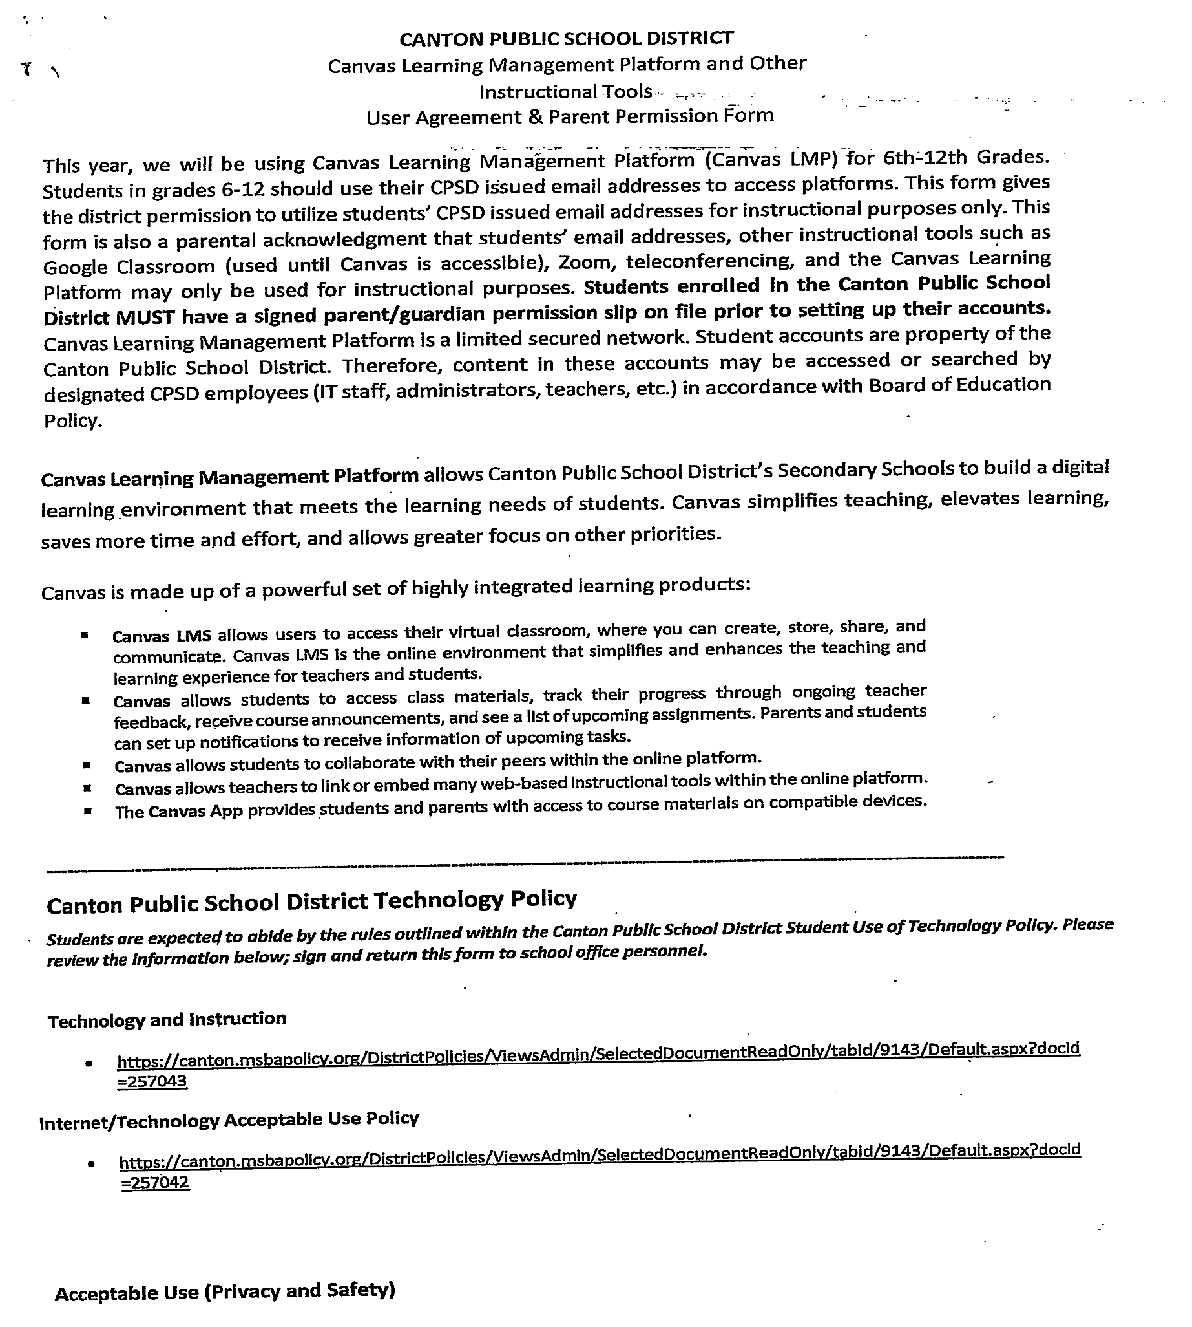
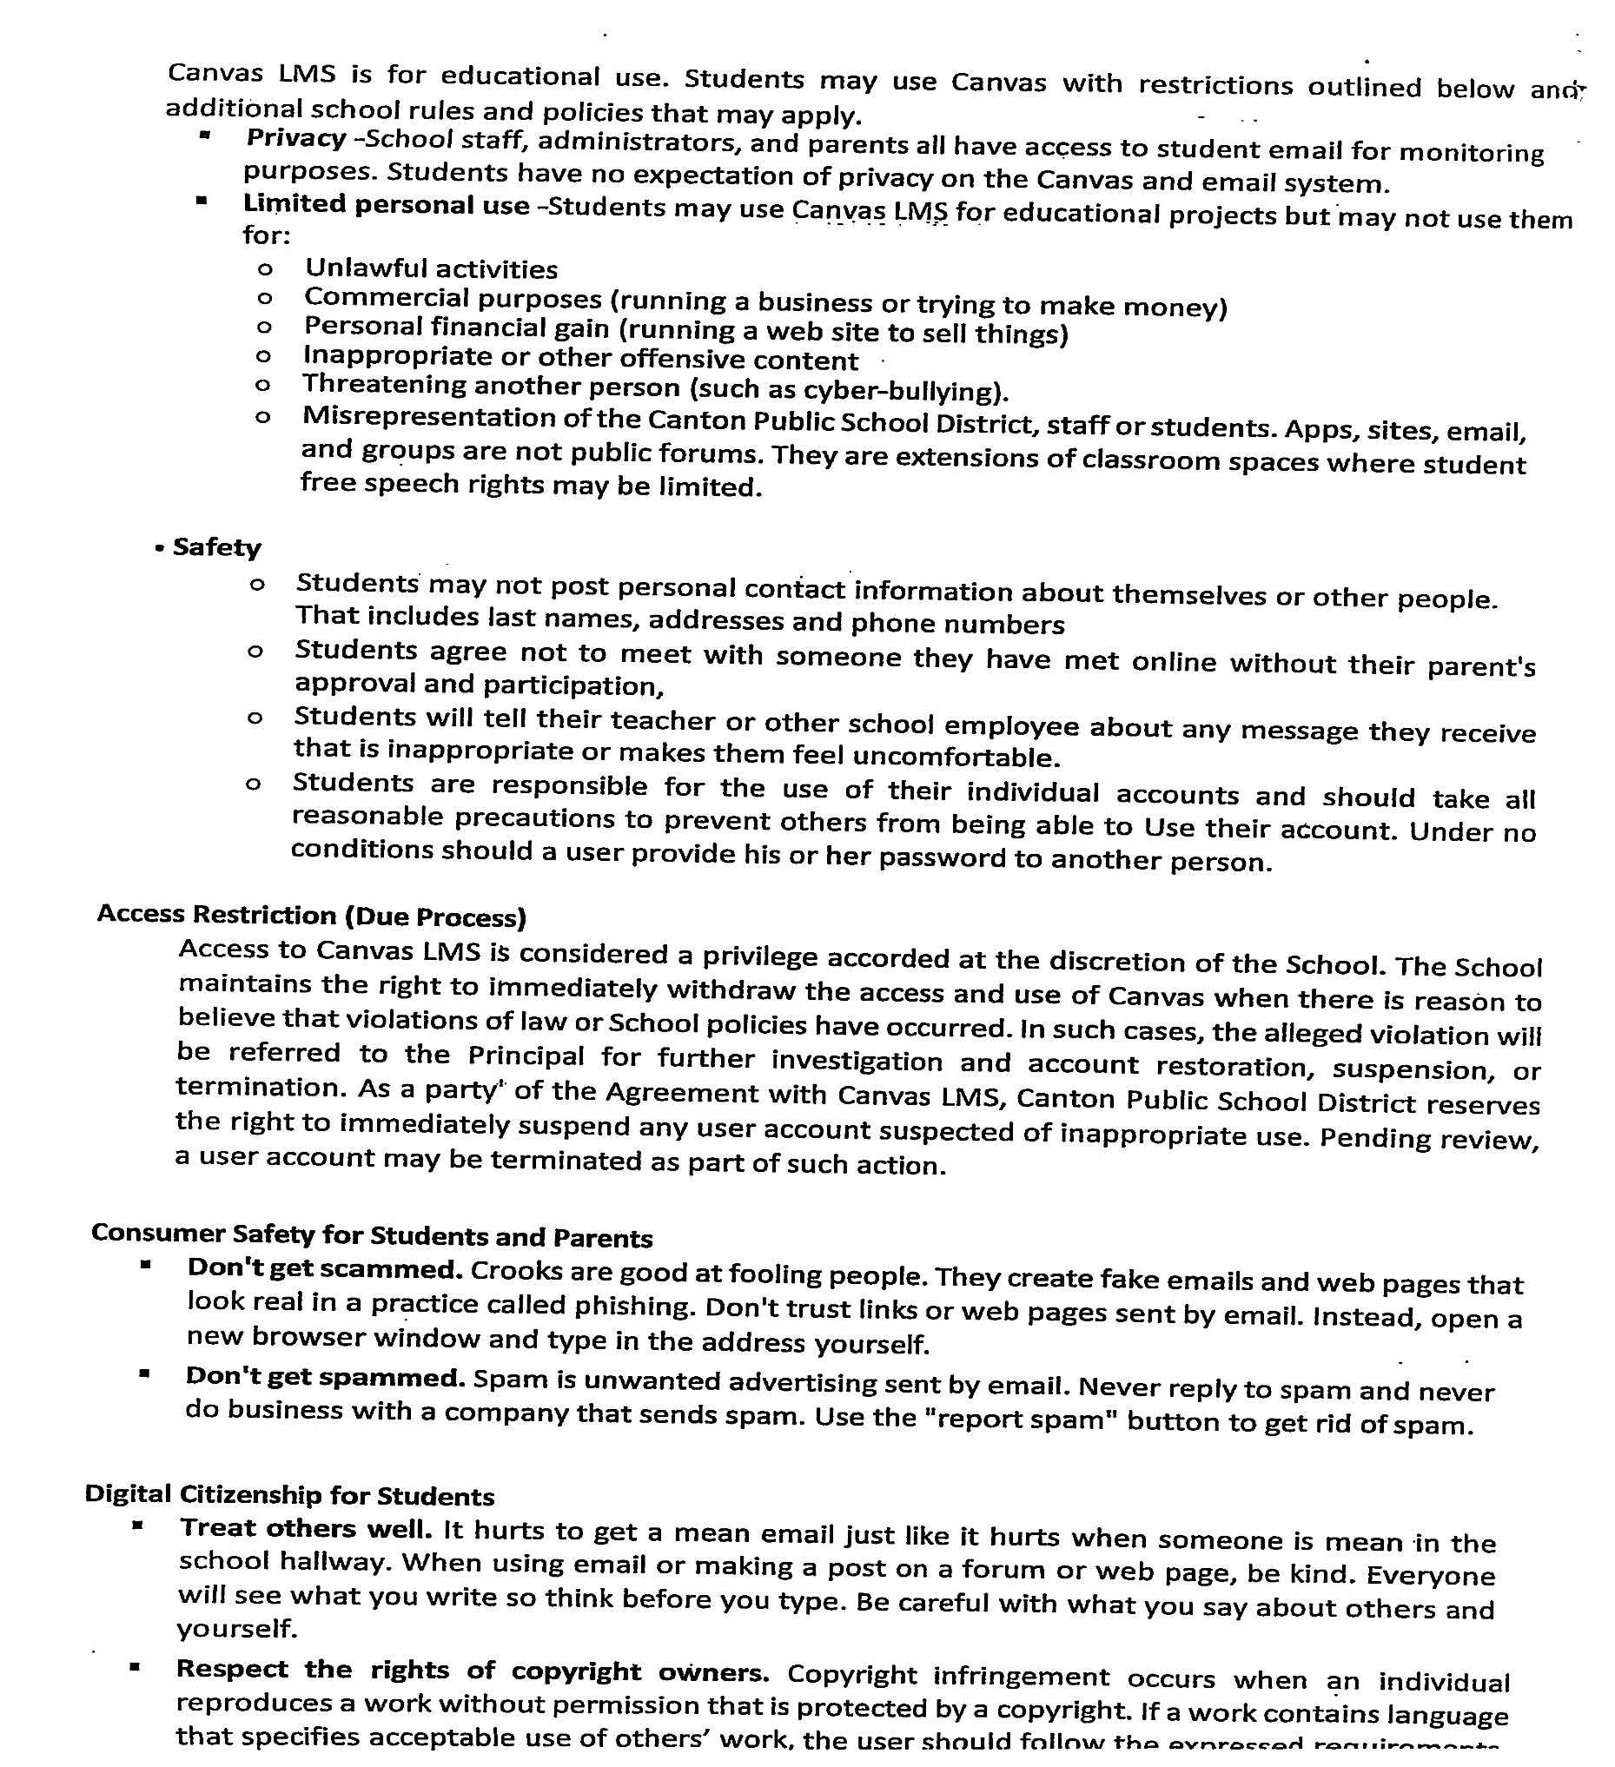
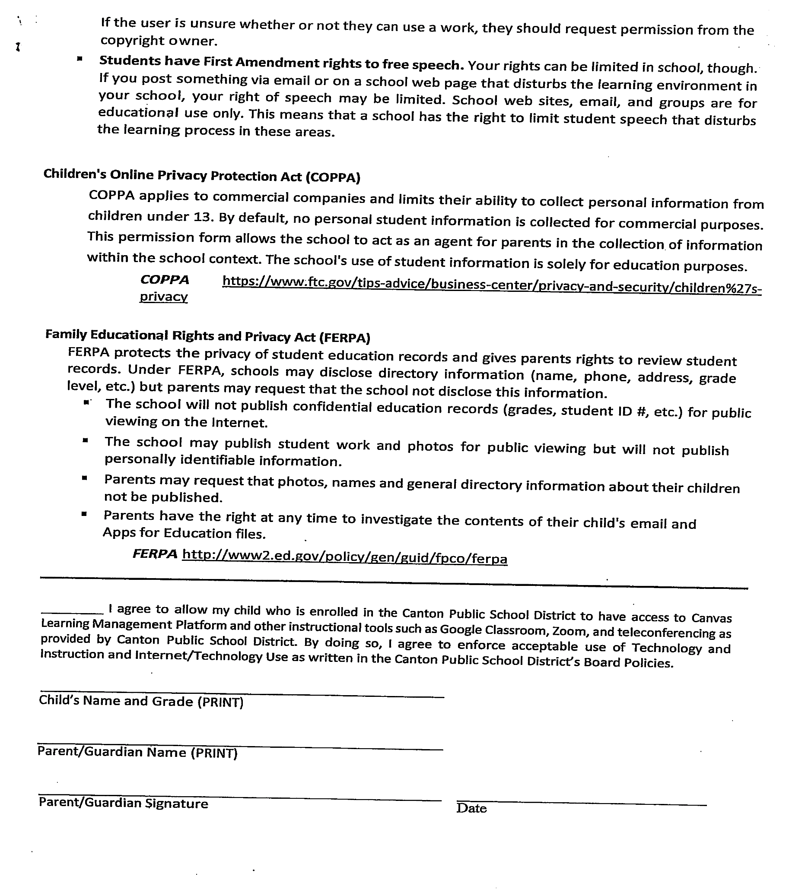
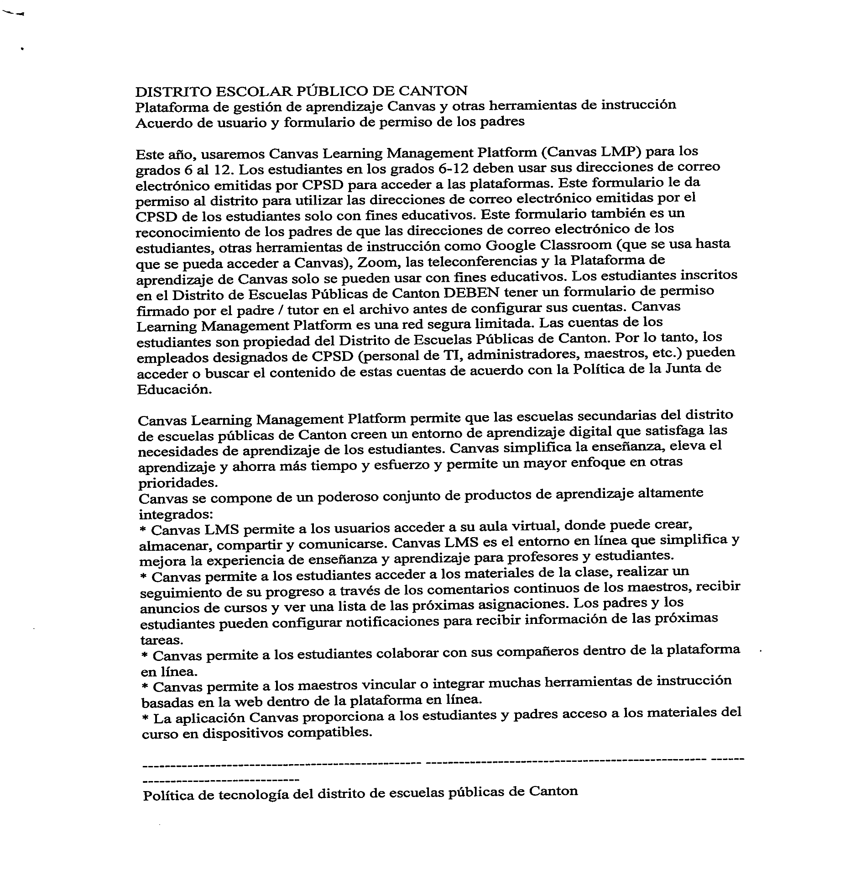
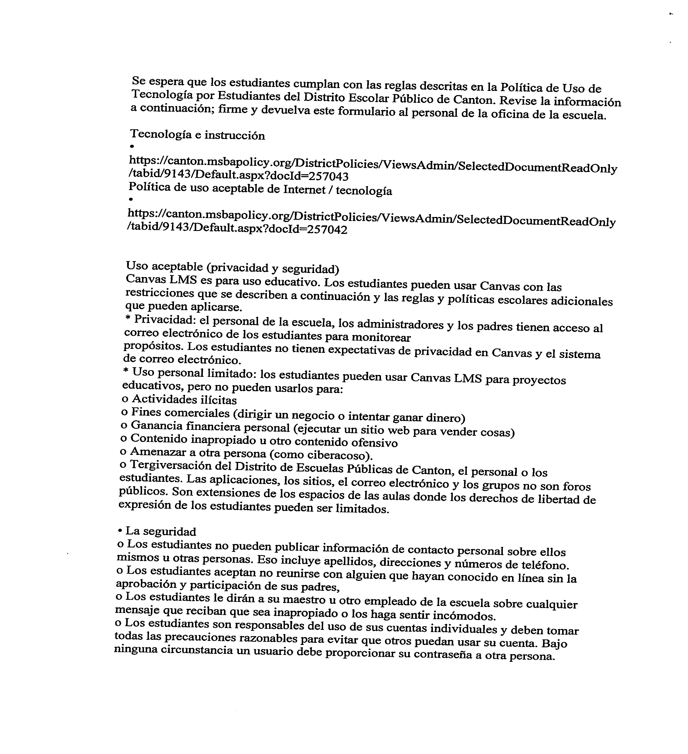
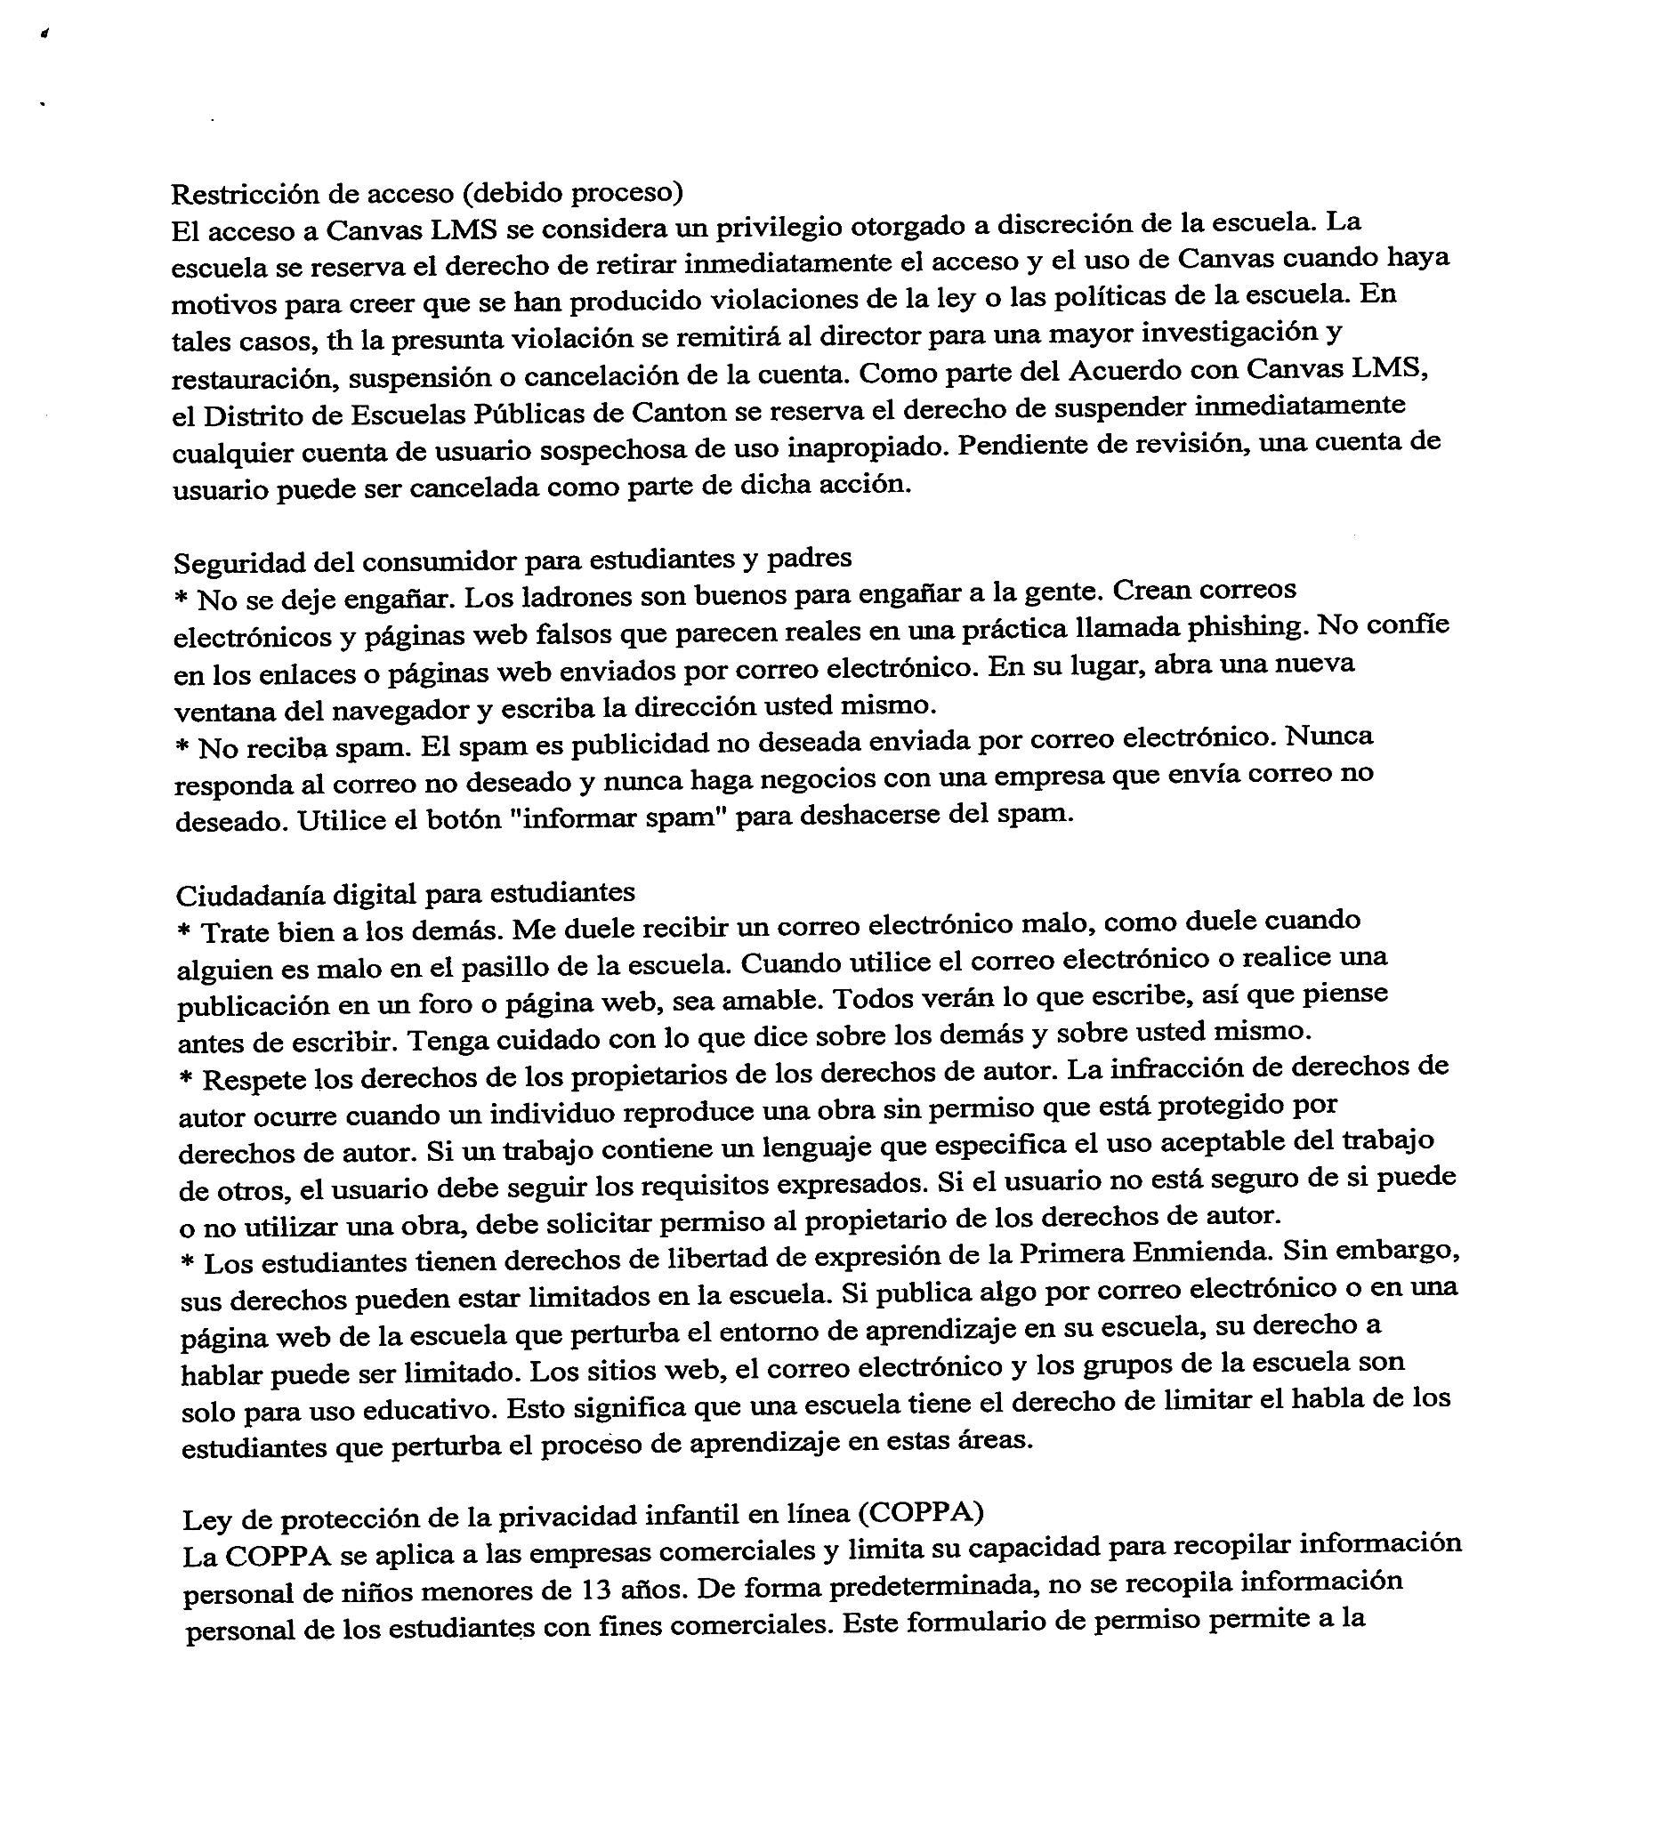
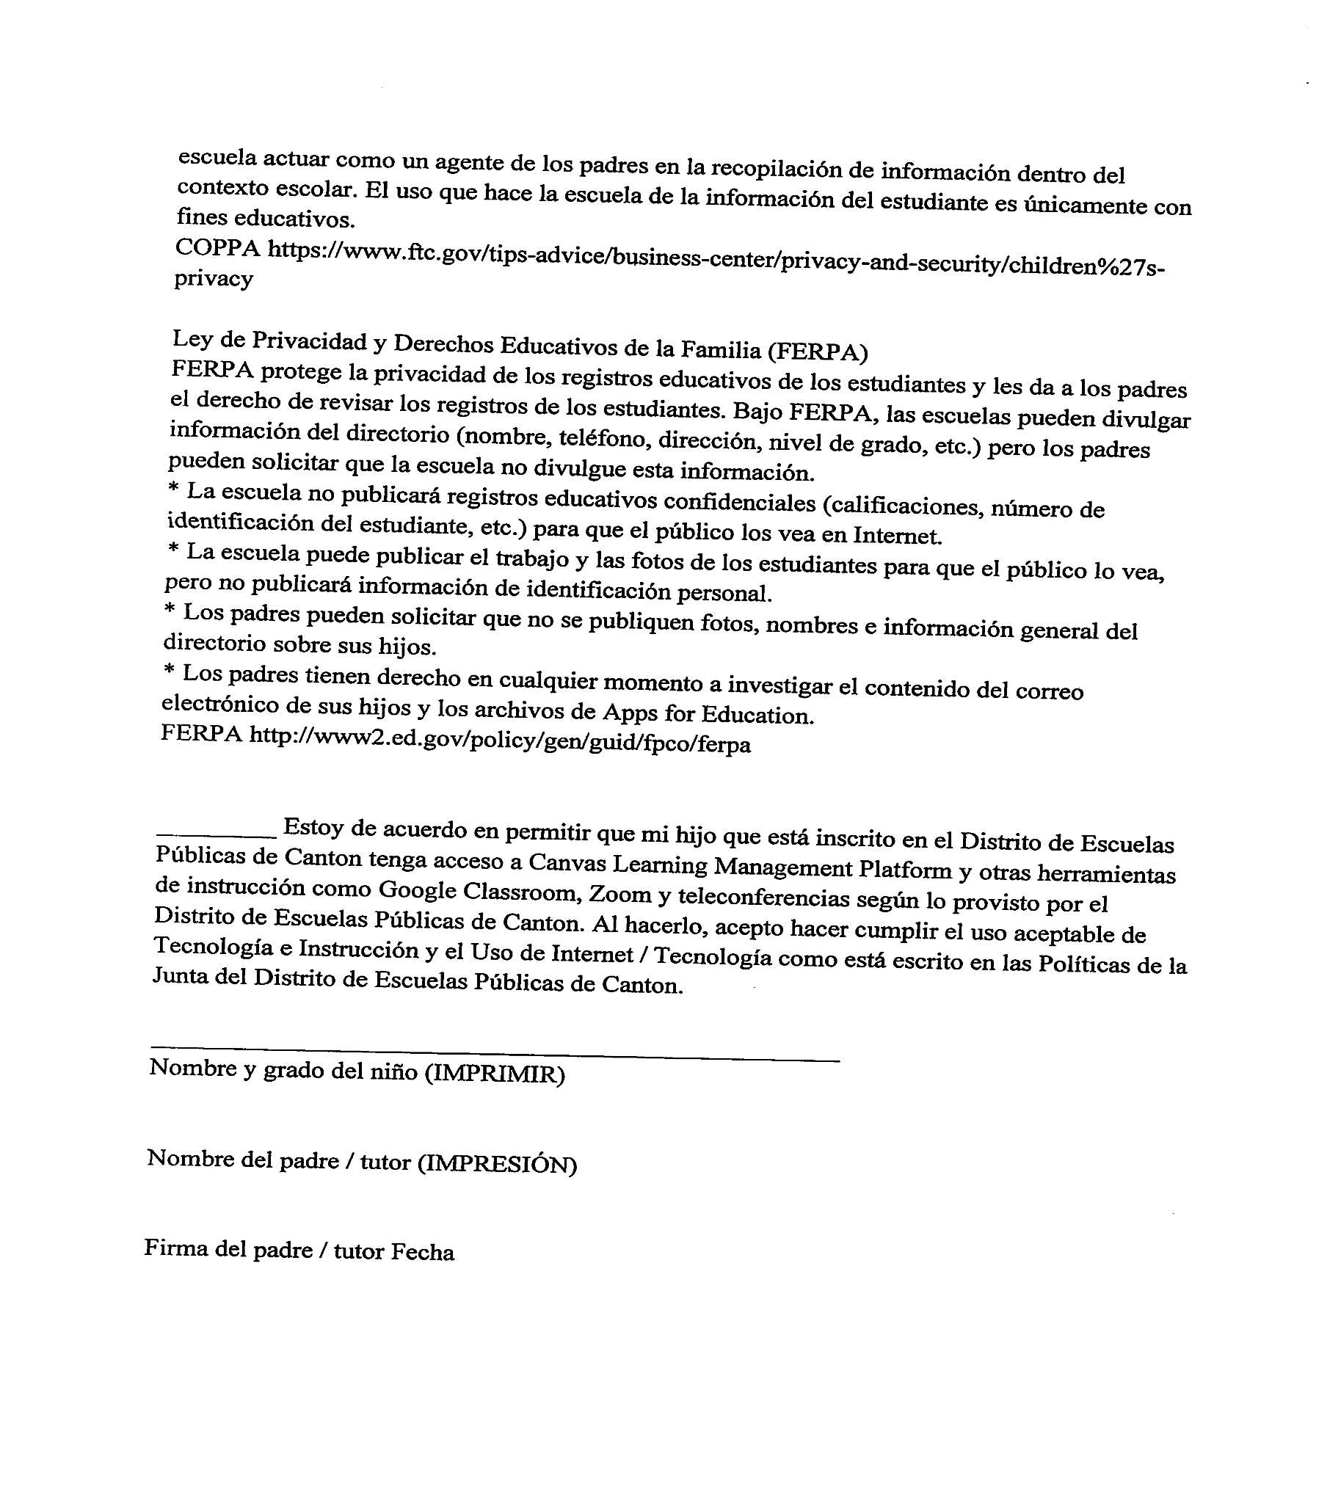

SCHOOL ATTENDANCE, TARDINESS, AND EXCUSES

Regular school attendance and promptness are extremely important matters to the Canton Public School District. Time on task is essential if students are to succeed in their educational efforts. The right to attend the public school requires responsibility of both parents and students for school attendance each day. Tardiness, absences, dismissals, and suspensions are all problems that require action by school officials because each of these results in a loss of instructional time. The student must be present 63% of the school day to be considered present for the school day.

HOUSE BILL 1530
(As Passed the House and Signed by the Governor into Law)
AN ACT TO AMEND SECTION 37-13-91, MISSISSIPPI CODE 1972, To provide that a Compulsory –School Age Child who is absent more than 37% of the instructional day must be considered absent the entire day; To amend Section 37-151-5, Mississippi Code of 1972, To revise the definition of the terms “minimum School Term” and “Average Daily Attendance” as such terms are used for determining allocations to school districts under the adequate Education Program; and for related purposes.
NOTE: Beginning in the 2014-2015 school year, a student scoring at the lowest achievement level in reading on the established state assessment for 3rd grade will not be promoted to the 4th grade unless the student meets the good cause exceptions for promotion.
FIGHTING IN SCHOOL
One on one fighting may result in a 10 day out of school suspension. Fighting involving three or more students may result in suspension for forty-five (45) days and placement at the Alternative School. Students placed in the Alternative School are prohibited from attending graduation, prom, games, and any school sponsored activities. (Superintendent’s Discretion)
GANG ACTIVITY OR ASSOCIATION
Gangs which initiate, advocate, or promote activities that threaten the safety or well-being of persons or property on school grounds or disrupt the school environment are harmful to the educational process.
The use of hand signals, graffiti, or the presence of any apparel, jewelry, accessory, or manner of grooming which, by virtue of its color, arrangement, trademark, symbol, or any other attribute which indicates or implies membership or affiliation with such group, presents a clear and present danger and is prohibited. This is contrary to the school environment and educational objectives and creates an atmosphere where unlawful acts or violations of school regulations may occur.
Incidents involving initiations, hazing, intimidations, and/or related activities of such group affiliations that are likely to cause bodily danger, physical harm, or personal degradation or disgrace resulting in physical or mental harm to students are prohibited.
Canton Public School District shall enforce the above rule and attempt to ensure that any student wearing, carrying, or displaying gang paraphernalia or exhibiting behavior or gestures which symbolize gang membership and/or participating in activities which intimidate or affect the attendance of another student shall be subject to appropriate disciplinary action, in accordance with the disciplinary ladder.
ASBESTOS STATEMENT
It is the policy of the Canton Public School District that no employee is expected to disturb or remove asbestos containing material as a part of their employment duties. Custodial and maintenance personnel are to report all damaged suspected asbestos containing material to the LEA designee for appropriate response.
NOTICE OF ASBESTOS MANAGEMENT PROGRAM
In accordance with the Asbestos Hazard Emergency Response Act (AHERA) regulations established by the EPA, all school districts are required to provide an annual notification to all parents, teachers, and employees regarding our asbestos management plan.
This annual notification informs all persons of their option to review the Asbestos Management Plan for our school district. To provide continuing management of the asbestos in our schools, all Asbestos-Containing Materials (ACM) are inspected every six months by an accredited asbestos inspector. Any changes to these materials are recorded in a surveillance report as part of the management plan.
Additionally, an accredited Asbestos Management Planner conducts a comprehensive inspection of all ACM’s every 3 years. This 3-year re-inspection has been performed as required and a copy has been filed with Mississippi Department of Education.
A copy of the Asbestos Management Plan is located in the principal’s office at each school. In addition, copies of all Asbestos Management Plans for the district are maintained in the central office located at 403 East Lincoln Street. If you are interested in reviewing this information, please contact Mr. Cleo Brooks at 601-859-6850 to schedule an appointment.

VIDEO SURVEILLANCE
The Board authorizes the use of surveillance cameras on district property, on school buses, in classrooms, and on district campuses. Because of the Family Educational Rights and Privacy Act and confidentiality, only authorized school personnel or law enforcement officials shall be permitted to view surveillance records.
Video cameras may be used in locations as deemed appropriate by the administration. The school is not responsible for loss or valuables or personal items that students may bring to school. Should a loss, occur, administrative time will not be used to investigate video records.
CHANGE OF STUDENT’S ADDRESS
If at any time during the year there is a change of address or phone number (home or cell number), the school’s main office and the clerk’s office must be notified. It is the responsibility of the parent to notify the school. An actual physical address is needed, not a post office box number.
COMMUNICABLE DISEASES
Mississippi law provides that “it shall be unlawful for any child to attend any school, kindergarten, or similar type facility intended for the instruction of children, either public or private, unless they first have been vaccinated against those diseases by the State Health Officer.” In order to comply with this law all Canton Public School District students must present to the school of enrollment a Certificate of Compliance regarding vaccinations. Enforcement of this law will require removal of children from classes if they are not adequately immunized.
Students enrolling in the Canton Public School District from an out-of-state school must present the immunization compliance certificate.
Students enrolling in the Canton Public School District from a school within the state may be enrolled tentatively until the cumulative record is received.
Students (parents) withdrawing from the Canton Public School District will leave the certificate in the cumulative folder for transfer to the receiving school; however, if parents insist, the certificate of compliance may be given to the parents for transfer to the receiving school. The school will maintain a copy of the certificate in the cumulative record.
A student with a communicable disease (chicken pox, measles, etc.) shall remain at home until the disease is no longer a threat to that student or others. Principals should report to the health department any cases of communicable diseases that might pose a threat to the health of the school or community. When concerned with unique individual cases, the welfare of all students should be the prime consideration and individual cases resolved in consultation with the Mississippi State Department of Health.
Decisions regarding an HIV infected student shall be made on an individual basis with regard to the behavior, neurological development, and physical condition of the student and the expected type of interaction with others in that setting. These decisions shall be made using the team approach including the child’s physician, public health personnel, the child’s parent or guardian, and personnel associated with the educational setting. In each case, risks and benefits to both the infected student and to others in the setting shall be weighed. As conditions change, cases may be reevaluated.
A student who is absent from school because of illness due to communicable disease must present, upon return to school, a statement from a physician or the health officer certifying that the student is no longer contagious. No student is allowed to return to the classroom unless he/she has presented this statement. Please notify the school by phone when your child has a contagious disease.

CONSENT FOR MEDICAL TREATMENT
Parents/guardians are asked at the beginning of each school year to complete consent for medical treatment giving school officials permission to transport their child to the hospital in the event of an emergency requiring medical service. Every effort will be made to
EMERGENCIES/ILLNESS/INJURIES
If a student is injured or becomes ill during the school day, he/she should come to the principal’s office and his/her parents may be notified. The school must be able to contact parents/guardians or a designated adult. PARENTS MUST PROVIDE THE SCHOOL OFFICE WITH CORRECT, UP-TO-DATE TELEPHONE NUMBERS.
The principal will determine whether or not a student will be referred to the School Based Clinic. The clinic staff will attend to the student’s need based on acceptable medical standards for reasonable care.
EMERGENCY DRILLS & WEATHER ALERTS
Fire
A fire drill will be held during the first or second week of school and once during each month thereafter during the session. Fire alarm signal boxes have been placed in readily accessible places in corridors throughout the building. Students should pass rapidly and orderly out of the building through designated exits, go directly to the assigned area, and remain there until the signal is given to return to the building.
Tornado
Periodic tornado drills will be held during school hours. Students will be assigned areas within the building that are designated as being most tornado resistant by the Mississippi Civil Defense Council. All instructions should be followed during the time of drills and during adverse weather warnings. An “all clear” signal will be sounded before students will be allowed to return to their assigned classrooms.
~ENROLLMENT INFORMATION~
Age Requirements
Students must be five (5) years old on or before September 1 of the current school term to enter kindergarten and six (6) years old on or before September 1 of the current school term to register for first grade.
Birth Certificates
All preschool, kindergarten, new first-graders, and out-of-state pupils new to Canton Public Schools are asked to submit a CERTIFIED BIRTH CERTIFICATE upon enrollment.
It shall be the responsibility of the person in charge of each school to enforce the requirement for evidence of the age of each pupil before enrollment. If the first prescribed evidence is not available, the next evidence obtainable in the order set forth below shall be accepted:
- A certified birth certificate;
- A duly attested transcript of a certified baptism showing the date of the birth and place of baptism of the child, accompanied by an affidavit sworn to by a parent, grandparent or custodian;
- An insurance policy on the child’s life which has been in force for at least two years;
- A bona fide contemporary Bible record of the child’s birth accompanied by an affidavit sworn to by the parent, grandparent or custodian;
- A passport or certified of arrival in the United States showing the age of the child;
- A transcript of record of age shown in the child’s school record of at least four (4) years prior to application, stating date of birth; or
- If none of these evidences can be produced, an affidavit of age sworn to by a parent, grandparent or custodian. Any child enrolling in Kindergarten or Grade 1 shall present the required evidence of age upon enrollment. Any child in Grades 2 through 12 not in compliance at the end of sixty (60) days from enrollment shall be suspended until in compliance.
Application for a birth certificate may be obtained at the Division of Public Health, State Board of Health, Vital Records, 2423 North State Street, Jackson, Mississippi. A fee is required for a certified copy.
Social Security Numbers
All students are asked to present their original social security card in order to enroll in the Canton Public School District. (THIS INFORMATION IS OPTIONAL)
Verification of Residence
Upon enrollment, each parent seeking to enroll a student must verify residency by submitting at least TWO of the following valid items numbered 1 through 7, except any document with a post office address. ALL OF THE ITEMS PRESENTED MUST BE CURRENT.
      - Filed Homestead Exemption Application form;
      - Mortgage Documents or property deed;
      - Apartment or home lease;
      - Utility bills;
      - Voter precinct identification;
      - Automobile registration;
      - Any other documentation that will objectively and unequivocally establish that the parent or guardian resides within the school district;
Students who change schools during the school year due to a change of address must present proof of residency before they can be enrolled.
Individuals having questions regarding the Verification of Residence policy are urged to call the Canton Public School District at 859-4110.
LOST and FOUND
All items found about the building should be taken immediately to the principal’s office. Also, inquiries about lost items should be made in the principal’s office. If the lost item has been turned in, a description of the item and the student’s name should be left with the person in charge of the lost and found desk.
Valuable articles such as money, purses, glasses, car keys, watches, and jewelry should be brought to the principal’s office where the items may be identified.
PROPERTY
Care of School Property
The walls in the buildings and the furniture in the various rooms – including the buildings and all the fixtures and equipment they contain - are provided at great expense by the citizens of the Canton Public School District through the use of tax money. Every student should not only refrain from defacing or destroying school property, but also make every effort to encourage friends and fellow students to exercise this kind of citizenship. Every student should take pride in keeping the buildings and the furniture in good repair and tidy.
The school board has employed a security officer who is responsible for protecting district property. The security officer will respond to any CPSD site when problems arise. If students are responsible for vandalism, these students will be required to pay damages.
Note: Equipment includes, but is not limited to, computers, all technology, and musical instruments.
RECEIVING GIFTS at SCHOOL
The delivery or exchanging candy, flowers, balloons, and other types of gifts to school or classroom from an individual to a student will not be allowed.
RESTRICTED ITEMS
Please search your child’s book bag daily to ensure that they do not bring the following items to school accidentally or intentionally. The following items should not be brought to school. If the following items are confiscated, they will be taken from the student and kept in the front office until the student’s parent, legal guardian, or proper authority comes to the school to pick the items up. The school is not responsible for the items.
- Electronic devices including but not limited to radios, TVs, tape players, pagers, cellular phones, CD players, beepers, video games, tapes, CDs, iPods, MP3 player
- Food at school, in the classroom, or on campus (Exception: If approved as a part of the teaching and learning process – Prior approval by the principal required)
- Money, candy, gum, beverages, and other food items for sell or exchange
- Weapons (real or toy) or any item that may be used as a weapon
- Any other item (s) that may cause harm or is disruptive to the learning environment

Electronic Devices
ELECTRONIC DEVICES CELLULAR PHONES/ELECTRONIC DEVICES ARE ALLOWED ON CAMPUS BUT ARE NOT TO BE VISIBLE.

These items include but are not limited to: (cell phones, smartwatches, blue tooth devices, airbuds airpods, pagers, iPods, mp3 players, Apple/Android watches, CD players, beepers, cameras, PSP, Nintendo DS, or any portable audio or communication device that the principals deems to fall under this category. Schools are not responsible for any student’s electronic devices that may be lost or stolen while in the possession of the school.

If your electronic device is confiscated, during the first offense the parent/guardian may pick the device up from the office. On the second offense the school will hold the device until the end of the school year. NO EXCEPTIONS. Failure to turn the device in, will result in disciplinary actions.
ROLE OF PTO
The mission of the Parent-Teacher Organization is to strengthen the bond between the school and the home. We invite and urge all parents to join the PTO and to participate in all projects, workshops and meetings.
TELEPHONE
Students will not use the office phones for personal calls, except in emergencies and with staff permission. With permission from the secretary or a principal, the student may call from the school to contact parents. In case of emergency or illness, calls for students are made through the principal’s office. In the event a student receives a call, that student will be called out of class only in the case of an emergency.
TRANSFERS
Students moving into the Canton Public School District from another school system shall be enrolled on the basis of their parent(s) or legal guardian(s) residence. Admission shall be conditional upon receipt of proper records from the previous school system and proof of residency requirements.
Enrollment of transfer students who have been previously dismissed and/or expelled from other schools may be denied if disciplinary procedures indicate that the general welfare of the school, students, or faculty would be affected. Any transfer student from a school or program (correspondence, tutorial, or home study) not accredited by a regional or state agency is given either a standardized achievement test(s) or teacher-made special subject test(s) to determine the appropriate classification of the student. (Mississippi Code 37-15-33)
VISITATION
We encourage parents and community members to visit our schools. However, all visitors must report to the office and obtain a visitor’s pass before going to any other part of the building.
WITHDRAWAL INFORMATION
Students who change schools due to change of address or by legal transfer must first withdraw from the old school. The withdrawing school will give the student the completed withdrawal form to take to the receiving school. All textbooks and library books shall be returned before withdrawal can be completed. Verification of residence of a new address must be presented at the time the student withdraws from school.
Parents of students planning to move from their present school should give the teacher at least one-day advance notice. This will give the teacher enough time to prepare records in order to facilitate their transfer to the new school.
Cumulative records will be sent to the new school upon request.

~ACADEMICS~
EXCEPTIONAL EDUCATION SERVICES
The Office of Exceptional Education Services is responsible for ensuring compliance with the Individuals with Disabilities Education Improvement Act-2004 (IDEA 2004) in the identification and evaluation (Child Fund), eligibility, and individualized education programming for students with disabilities. The Office of Exceptional Education Services is also responsible for ensuring compliance with Section 504 of the Rehabilitation Act of 1973. Section 504 provides the services and aids necessary for students with disabilities which significantly affect a major life activity to participate in and benefit from public instruction. For more information concerning 504, call Latisha Sargent, Director of Exceptional Services at 601-859-2179.
CHILD FIND: The Canton Public School District participates in a statewide effort to identify, locate, and evaluate children with disabilities birth through 21 years of age who may have a physical, mental, communicative, and/or emotional disability. For more information, call the Director of Exceptional Services at 601-859-2179.
The Office of Exceptional Education Services provides a variety of support services to students with disabilities and regular education students. The services offered through this department include:
- Psychological services, including pre-school and school-age assessment
- Student Support Services
- Speech/language therapy
- Physical therapy
- Occupational therapy
- Augmentative communication services
- Special medical needs
- Behavioral intervention services
- Homebound education

HOMEWORK

All homework assignments will be an outgrowth to attain mastery of the MS College and Career Readiness Standards being studied in the classroom.

MID-TERM PROGRESS REPORTS

Mid-term progress reports will be issued three times each school year as scheduled on the district calendar. Progress reports will be given to students to take home with a duplicate kept by the school. Although an interim evaluation may be issued at any time during the nine-week period if a student is in danger of failing, it is mandatory that a mid-term progress report be sent home on the assigned date. It is the student’s responsibility to discuss the report with parents. Teachers may require the return of the report with the affixed signature of a parent.

REPORT CARDS
Report cards will be issued four times each school year and will be available for pick up on the designated day by each school. Parents may meet with their child’s teacher to discuss student reports and also be able to set up a conference with them for longer meetings.

EXPLANATION OF GRADES
GRADE | NUMERICAL VALUE | DESCRIPTION
A | 90-100 | Superior Work
B | 80-89 | Above Average Work
C | 70-79 | Average Work
D | 60-69 | Below Average Work
F | 59 and below | Failing Work

TEXTBOOKS
STUDENT FEES, FINES, AND CHARGES
Textbooks are made available to each student on a yearly basis.
Workbooks and other instructional supplies are purchased by the student through fees which are collected at the beginning of the school year.
Traditional student textbooks at the elementary and middle school level may not be assigned for English/Language Arts/Science/Social Studies, in Canton Public School District. Following best practices in literacy instruction, learning is facilitated for each student at their instructional level through leveled books/resources.
Canton Public School District’s high school students participate in the 1:1 Initiative, and have access to all instructional materials through e-books, internet, or Canvas learning instruction.
Note: Students will not be issued further textbooks if payment is not received for lost or damaged books.
Section I: STUDENT CHARGES
Each student shall be informed that he/she is responsible for every textbook and MacBook issued to him/her and that in the event a textbook or MacBook is lost or damaged, charges will be assessed based on the condition of the textbook and MacBook at the time it was issued. Students will not be issued a replacement textbook until fees; fines/charges have been paid for lost/damaged textbooks and MacBooks.

Section II: STUDENT FEES
By authority vested in the superintendent by the Board of Trustees, reasonable fees, but not more than the actual cost may be charged for the following:
      - Supplemental instructional materials and supplies, excluding textbooks.
      - Materials and supplies related to a valid curriculum educational objective, including transportation, and
      - Extracurricular activities and any other educational activities of the school district, which are not designated as valid curriculum educational objectives, such as band trips and athletic events.
Fees for supplemental instructional materials and supplies related to a valid curriculum educational objective, including transportation, shall be charged unless the pupil is unable to pay for reasons of financial hardship. Fees for identical materials, such as workbooks, will be the same at all schools. Fees for extracurricular activities and any other education activities of the school district which are not designated as valid curriculum educational objectives, such as band trips and athletic events, are exempt from the financial hardship waiver.
~HEALTH AND NUTRITION~
CHILD NUTRITION PROGRAM

The Canton Public School District participates in the Community Eligibility Provision. This is a new alternative to the traditional meal application process associated with the United States Department of Agriculture (USDA) National School Breakfast and Lunch Programs. CEP alleviates the burden on families by eliminating household applications, while helping schools reduce costs associated with collecting and processing those applications.

All Canton Public Schools students will receive FREE breakfast and lunch meals during the 2018-2019 school years as part of the Community Eligibility Program (CEP). It provides an alternative approach for offering school meals to the local educational agencies and schools in low income areas, instead of collecting individual applications for free and reduced price meals. The CEP allows school meals to all students through the National School Lunch and School Breakfast Programs.

Students need nutritious meals to perform at their absolute best and it is the mission of the Canton Public Schools Child Nutrition Department to ensure that each student receives the nutritional support they need to succeed.

CAFETERIA BEHAVIOR
Rules
- Teachers should accompany their students to the cafeteria each day and thru the line. Make sure you leave your table clean upon departure.
- Teacher's purchasing a breakfast/lunch must present tray to cashier. It cannot be covered up.
- Students are allowed to choose items to eat each day.
- Students need to learn their lunch number/ name for eating each day.
- Students should not be allowed to crowd the line or the cashier. Single lines should be maintained at all times.
- Students must choose all items before leaving the line. They should not be allowed to return to the line.
- Do not make your child pick up milk if they do not want it. Throwing milk away is a waste.
- Students cannot be denied chocolate milk during the meals. It has been proven that chocolate milk do not make a child hipper. You cannot use this as punishment at any time.
- Students are allowed to purchase extra food items upon receiving lunch/breakfast. You cannot deny a child from purchasing extra food items.
- No teachers, school administrators or students are allowed to charge meals.
- No book bags or large purses are allowed thru the lunch line.
- In-kind meals are only for employees directly involved in the preparation, serving, cleaning and the operation of the cafeteria. A school employee that is not involved in the food service operation is not eligible for an in-kind meal. Only cafeteria staffs are allowed to eat an in-kind meal.
- No sodas are allowed in the cafeteria or on campus during school hours.
- Students must tell their name or input their lunch number upon arrival at the cashier stand.

Offer vs Serve
Offer versus Serve (OVS) allows students to decline a certain number of food items in the meal being offered. The goal is to minimize plate waste and allow student choice. For lunch, students must be offered all five required food items: one serving each of Meat/Meat Alternate, Milk, Grains/Bread; and two servings of Vegetables/Fruits. Students have the option to decline components of their choice up to a maximum of two. Therefore, the student must choose three of the five components offered for lunch and three of the four components offered for breakfast. Condiments and desserts are not considered a component. There is not a reduction in the per plate cost of a reduced or full price student meal as a result of OVS. OVS is available at all schools.
Special Dietary Needs
A parent requesting a special diet for a student must submit a request from a licensed medical doctor. The request will not be honored upon parental request without medical authorization and documentation. The completed form can be submitted to the Director's Office or mailed to: Office of Child Nutrition 403 East Lincoln St., Canton, MS 39046.
Competitive Food Rule
No food is to be sold on the school campus for one (1) hour before the start of any meal service period. The school food service staff shall serve only those foods that are components of the approved Federal Meal patterns being served (or milk products) and such additional food as necessary to meet the caloric requirements of the age group being served. With the exception of milk products, a student may purchase individual components of the meal only if the full meal unit also is being purchased. Students who bring a lunch from home may purchase milk products.

~SCHOOL SERVICES~
LIBRARY
Students with library permits may go to the library before, during, and after the school day to check out library materials. Books may be checked out of the library for two weeks, but may be returned in less time or renewed for a longer period. A fine will be charged for each school day when books are not returned on the date due unless the student is excused from payment of fines by the principal. Current magazines are to be read in the library or checked out overnight. Books, which are placed on reserve by teachers for a special unit of work, may be checked out of the library at the close of the school day, but must be returned before 8:15 the following morning.
~TRANSPORTATION ~
Bus drivers will not let students off buses before the staff is ready to receive them. Once a student is in route to school, he/she becomes the responsibility of the school district. Therefore, appropriate behavior required in the classroom also is required while a student is waiting at a bus stop and is in route to and from school. Transportation is a privilege and may be revoked. Students who reside one mile or more from the school to which they are assigned are provided the opportunity of riding an assigned district operated school bus.
PARENT TRANSPORTS
Parents are to follow local school guidelines for drop off and pick up of children from school. Parents are to pull curbside so that the student is not endangered by having to cross the street between vehicles.
Law enforcement officers will assist if students are placed in danger.
TRANSPORTATION SERVICES
Transportation is a privilege in the State of Mississippi. You are responsible for ensuring that your conduct contributes to a safe and orderly atmosphere while being transported; to refrain from conduct which will endanger yourself, your fellow students, or the general public; and to refrain from violating federal, state or local laws.
Only authorized students and school district personnel may ride or enter a school bus. It is unlawful for any person to abuse or interfere with any bus driver or district employee in the performance of their duties. Violations of these state laws are a misdemeanor offense and are subject to punishment of up to six (6) months in prison and/or a fine of up to $500.
BUS REGULATIONS
- Students must be at their assigned loading zone ten (10) minutes prior to the scheduled bus arrival time.
- The bus will only load or unload at assigned sites.
- Permission to ride another bus may be granted in emergency situations only, if approved by the district prior to request date.
- The bus driver and/or district reserve the right to assign seats at any time.
SCHOOL BUS RIDING RULES
As your professional school bus transportation provider, we want to make sure your child’s trip to and from school are as enjoyable as possible. We ALL play a role in achieving this goal. In order to get your child to school safe, on-time, and ready to learn, it’s important that he or she understands the school bus safety rules. Please discuss the rules listed below with your child prior to the start of school.
- No standing.
- No eating or drinking on the bus.
- Remain seated until your stop.
- No smoking or tobacco on the bus.
- No weapons or drugs.
- Keep the aisle clear.
- No bus vandalism.
- Keep head, hands, and feet inside the bus.
- Throwing objects on or out the bus is prohibited.
- Keep the noise level to a minimum.
- No profanity
- No fighting
- Disrespect to the driver will not be tolerated

DISCIPLINE
It is essential for students to attend a safe and orderly learning environment daily that is conducive to learning. We expect students to follow all school rules. However, we know that students sometimes make poor choices which may lead to the violation of school rules that foster our behavioral expectations
STUDENT’S RESPONSIBILITIES
- Canton High School belongs to you -- the student. The school’s only purpose is to provide you with the best education possible. The faculty and staff are here to help you succeed now and in your future, but the most important ingredient in your educational success is you. It’s up to you to take advantage of your classroom opportunities and to decide what extracurricular activities you want to explore. It is up to you to make the commitment to being a good student, a good friend and a good person.

- Please read the entire student handbook. Although some issues are directed primarily to your parents/guardians, it is your responsibility to understand all the requirements outlined in this handbook. By understanding your rights and responsibilities as a student, you can take a more active role in your school and in your own educational success.
Student’s Rights and Responsibilities
Education
- Rights: You have the right to a public education regardless of gender, race, religion, national origin, disability, parenthood, marital status, economic status, or any reasons not related to your individual capabilities.
- Responsibility: You are responsible for avoiding actions or activities, individually or collectively which interfere with the right of any person to a public education.
Learning Environment
- Rights: You have the right to an orderly school and classroom environment which will promote learning for all students.
- Responsibilities: You are responsible for ensuring that your actions do not disrupt the classroom environment or school activities.
Expression
- Rights: You have the right to express yourself in speech, writing, or symbolism within the boundaries of the law and policies of the school system.
- Responsibilities: You are responsible for ensuring that such expression does not disrupt the educational process, present health or safety hazards, damage public property, infringe on the rights of others, or violate the law or school board policies.
Possession and Distribution of Literature
- Rights: You have the right to possess and distribute literature including but not limited to newspapers, magazines, leaflets and pamphlets within the law and board policies.
- Responsibilities: You are responsible for ensuring that the distribution (or possession) of literature will not conflict with or infringe upon school activities, infringe on the rights of others or contain racial or ethnic slurs, obscenity or harassment. The building principal will determine the time, place and manner of distributions.
Religion
- Rights: You have the right to your own religious beliefs.
- Responsibilities: You are responsible for ensuring that in exercising your own religious freedom you do not violate other students’ constitutional rights to religious freedom.
Peaceful Assembly
- Rights: You have the right to peaceful assembly.
- Responsibilities: You are responsible for securing approval of school facilities for an assembly, for discussing with an administrator the appropriateness of the facility for the proposed function and for ensuring that such assembly does not disrupt the educational process. If adequate supervision is not available, such assembly cannot be held.

Privacy
- Rights: You have the right to protection from unlawful searches and seizures without reasonable cause of your person and/or your personal possessions.
- Responsibilities: You are responsible for contributing to your own safety. You must not endanger yourself, other students, school personnel or the general public by possessing material or objects which are potentially hazardous and/or prohibited by federal, state or local law, or prohibited by school board policy.
Transportation
- Rights: Transportation is a privilege in the state of Mississippi. Responsibilities: You are responsible for ensuring that your conduct contributes to a safe and orderly atmosphere while being transported; to refrain from conduct which will endanger yourself, your fellow students, or the general public; and to refrain from violating federal, state or local laws.

ABSENTEES/TARDIES/CHECK-IN/CHECK-OUT
- Absentee excuses must be brought on the day the student returns to school.
- Students must be in the classroom when the tardy bell rings.
- Students who are habitually tardy for school/class will be placed in In-School Suspension at the discretion of the administration.
- All students who drive to school or their parents bring them after 8:00 a.m. must be checked in by parent/guardian.
- All students who are in the halls when the tardy bell rings, will report to In-School Suspension.
- Students must be present sixty-three percent (63%) of the school day.
- Check outs before 1:00 will result in an absence.
- Students should not be checked out during the 7th period without a medical or principal’s excuse.
- Students may not be checked out more than 5 times during the school year.
Any parent or guardian who brings their child to school late three times during a nine week grading period will have to attend a conference with the principal before their child can be admitted to class. If the tardiness continues, the parent will be recommended to the school attendance officer.
SENIOR PRIVILEGES and EARLY DISMISSAL
- Seniors on early dismissal must sign out in the main office every day.
- Seniors cannot request early release if they have not passed ALL SATP Exams, met all graduation requirements, not currently passing all enrolled courses. In addition, seniors must have a 2.7 cumulative GPA in August of their Senior year.
- Students are required to purchase a parking permit in order to drive his or her vehicle on campus.
- Students must have a valid driver’s license and insurance. They must park in their designated parking space. Students that do not park in their designated parking space will be towed at their expense.
- Students that are late three times for school will have his/her driving privileges revoked during the nine week period in which the infraction occurs.
- All student drivers and their cars are subject to be searched.
- Any student driver who fails to stop for the security officer will not be allowed to drive for the remainder of the school year, due to safety issues.
- Seniors meeting the above CPSD guidelines for early dismissal will be allowed to leave at the beginning of their designated period.
- If the Senior does not leave campus at their designated time, they will be placed in a class for the remainder of the school year.

Senior privileges can be revoked by the Principal at any time.

Canton High School
English IV
2019-2020 Senior Research Paper Project

The Senior Research Paper is a Literature-based project designed to reinforce the Mississippi English Language Arts Framework and most recently, the College and Career Readiness Standards adopted by the Mississippi Department of Education. This project is also designed to prepare students for the college readiness goal of the Common Core State Standards. Students undertake the challenge of exploring a piece of literature (fiction or non-fiction) and producing a sophisticated expository writing in response.

By twelfth grade, teachers and students can use the research process as a guide to writing a college-level, thesis-driven research paper of at least 2100-3000 words (7-10 pages). Students will demonstrate this process through the following:

- Exploring their own thoughts in selecting topics (novels/novellas) that are meaningful to them.
- Choosing a research topic based on a clear understanding of the author’s goals with the novel/novella
- Demonstrating information literacy in outlining effective research strategies
- Facing consequences of these decisions in relation to long-term academic goals
- Monitoring their own progress, setting goals, and meeting deadlines
- Working (i.e., communicating) with their peers, faculty, and others in professional ways
- Producing written, oral, and hands-on evidences of learning
- Demonstrating evidence of active learning
- Modeling independent learning

The Senior Project is designed to be a yearlong effort. This introduction describes the specific requirements and expectations for each component of the project.

Overview of the Senior Project

The Senior Project consists of six (6) phases:
- The Preparation for the Research Paper
- The Research Paper
- The Compilation of a Portfolio
- The PowerPoint
- The Presentation of a Completed Project

The Research Paper
Each student is to complete a research paper that contains a thesis to be supported through research evidence. Selection of a topic takes considerable thought, and it should lead to a final presentation.

The Portfolio
The portfolio is a collection of specific writings completed throughout the year that include (non-exhaustive):
Parent Acknowledgement Form | Letter of Intent | Annotated Bibliography | Note Cards | Research Paper
Letter of Intent | Outline and Introductory Paragraph | Journal Articles

The Presentation
The presentation occurs before the Senior Project Panel with an eight to ten minute speech with five components: preparation (7 assignments), paper, PowerPoint, presentation and portfolio. The presentation and portfolio experiences provide the student with an opportunity to synthesize the paper, project, and self-growth journey using communication skills related to knowledge depth, listening, explaining, defending, and comprehending.

The PowerPoint
The PowerPoint is a visual compilation of the research paper. Students will design an original PPT that captures the most important aspects of their project. In addition, students must be able to present a compilation of primary and secondary sources used in their research.
EXTENDED SCHOOL DAY
With proper notification of extended school day, transportation will not be accepted as an excuse for not being in attendance. Hopefully, with the use of extended school, we can decrease the number of failures. Parents will be notified in a timely manner.
PUBLIC RELATIONS
You are the best public relations agent in the Canton Public School District. The way you perform in your vocational/academic training, the way you feel about your fellow students, how you help keep your school, and how you characterize yourself carry a strong message to the community. If possible, it says the Canton Public School District is serious about career education and preparation for the world of work.
PUBLICITY RELEASE
To highlight our students’ accomplishments, Canton High School occasionally provides photographs and audiovisual images of students and non-confidential information about students to the media. The district also uses this information in videos and publications about the schools. Non-confidential information includes but is not limited to: photographs, names, ages and descriptions about awards, certificates, diplomas or participation in school-related and extracurricular activities. In the case of athletes, weight and height may also be used.
Once parents/guardians have received this notice and had the opportunity to object, the Family Education Rights and Privacy Act of 1974 allows the district to make public non-confidential information about our students without specific permission from a parent/guardian. Any parent/guardian who does not want information about his/her child or the child’s visual/audio images used in print or electronic media, should notify the principal in writing within ten (10) days of the start of school.
WORK STUDY PROGRAMS/EARLY RELEASE: BASED ON THE NEW GRADUATION REQUIREMENTS AND ACT SUBSCORES IN ENGLISH AND MATH

ISS – IN SCHOOL SUSPENSION
- Only the administration or appointee can assign a student to ISS.
- There will be absolutely no talking.
- Do not speak unless spoken to.
- Do not get out of your seat without permission.
- If you have any questions, you must raise your hand to be recognized.
- No eating or drinking is allowed.
- All electronic devices are prohibited.
- Students are to go to the restrooms together at designated time periods.
- Students are not allowed to leave ISS for any reason(s).
- Lunch will be brought to the students in ISS.
- Students who accumulate five or more visits to ISS will be recommended for a 45 day placement at the Alternative School.
- Students who are placed in ISS must complete all assignments given.
- Students who refuse to go to ISS will receive one (1) or more days of Out of School Suspension (OSS), but must complete the initial day assigned to ISS upon their return to school.
- Any violations of rules while assigned to ISS may result in suspension.
- Absolutely no sleeping in ISS.
- Disrespect to the instructor will not be tolerated.
- Athletes who are assigned to ISS five times will not be eligible to play in current week’s games.
DISCIPLINE REVIEW COMMITTEE
In some cases, the district may request a district discipline review committee to review students’ records, investigate the misconduct, and make recommendations. Such referral will be made at the discretion of the superintendent. Any behaviors considered criminal in nature will be reported to the appropriate law enforcement authorities and will result in referral to the court system. Such behavior will also result in a recommendation for expulsion. Examples include:
- Homicide
- Rape
- First degree arson
- Kidnapping
- Weapons (any object that is used to try and inflict injury to another)
- Drugs and/or mood modifiers
DRUG DOGS
Canton High School may use trained dogs to conduct a general search to locate drugs on or near school facilities or grounds, and in vehicles as directed by the Superintendent or his/her designee.
STUDENT DRESS CODE
The dress code is being instituted because it is paramount that we maintain a safe and orderly environment; that is conducive to the education of our students. Among numerous other reasons, a dress code ensures that all outsiders to the school are readily identifiable. In addition, the faculty and staff of CHS have found that there is a significant need to provide guidance to our student population on proper dress in different aspects and occasions of their lives.
MALE/FEMALE BASIC DRESS CODE SOLID COLORS ONLY
Slacks/ Skirts:
- Khaki and Navy slacks, skirts, or skorts
- Shorts, skirts, or skorts cannot be more that 2 inches above the knee
- Capris and walking shorts are allowed
- All bottoms are to worn at the natural waistline
- Slacks are to be appropriately sized to eliminate bagging or sagging.
Shirts/Blouses/Tops:
- Solid navy blue tops only
- Short or long-sleeved
- Polo or golf style only
- Any shirt or blouse worn under the navy blue shirt must be without a collar.
- Shirts must be tucked in pants with belts showing, no blousing. All tops must be the appropriate size.
Dresses:
- sleeved dresses that are khaki
- No more than two inches above the knee.
- All dresses without sleeve must be worn with a navy blue top/blouse underneath.
Belts
- Brown, Black or Khaki
Socks:
- Solid White, brown, black, blue, or khaki only
Outerwear:
- Ties, if worn, are solid color khaki, brown or navy blue.
- Solid Navy, Brown, or Black Only
- Hoodless - No hoods should be worn in the building
- Acceptable outerwear is cardigans, sweaters, light weight jackets or blazers. An appropriate top must be worn under the outerwear. The sweater or jacket must not be any more than one size too big or small.

Not Allowed:
The following items listed below are unacceptable and not allowed.
Shirts, tops, jersey etc.
- T-Shirts of any type
- Tank tops or midriff tops
- Shirts tied in back
- Cropped shirts
- Athletic jersey knit polo
Pant/Slacks etc.
- Baggy or sagging pants/slacks
- Pants/slacks with design or embellishments
- Cargo pants or painter pants
- Plaid flannels
- Any type, or color denim jeans or jackets
Shoes/slippers, footwear etc.
- Slippers, house shoes, flip-flops, shower shoes, beach shoes, clogs, high spike heels or platform shoes
- Army boots or any laced up boots coming to the calf and above
- Snow boots
- Stilettos
- No shoes with a heel height above 2.5 inches
- Fishnet stockings, leggings, or opened foot tights
Accessories
- Ornamental belts
- Ornamental necklaces (males and females)
- Earrings for males.
- No tongue, nose, lip, or eyebrow ring period
- Removable mouth appliances; gold or silver grills (males or females)
- No rubber bands on wrists and pant legs
- No tattoos uncovered(must be covered at all times)
- Hair Styles (no mohawk, spike, punk and/or designs or lines cut in the hair. Hair length must be of even distribution.)
- No bandanas, hats or caps (baseball or otherwise) worn in the building

Other Violations
- Camouflage
- Sleeveless, transparent or sheer materials
- Stretch, tight, or form fitting clothing
- Greek letter shirts, jackets, or other paraphernalia, or any lettering that can be mistaken as Greek
- No logos on any apparel
- Blazers or sweaters around the waist
- Apparel advertising alcoholic beverages, drug culture, obscene language or gestures, cartoon characters, etc.
Students failing to abide by the above guidelines will be subject to the disciplinary procedures as follows:
*** ANY CLOTHING CONSIDERED BY THE PRINCIPAL OR HIS/HER DESIGNEE THAT IS INAPPROPIATE SHALL NOT BE WORN
Students failing to abide by the above guidelines will be subject to the disciplinary procedures as follows:
1st offense In School Suspension 1 day
2nd offense In School Suspension 2 days
3rd offense Parent Conference with the Principal
4th offense Out of School Suspension 3 days

INSTRUCTIONAL SUPPLIES
You are expected to report to each class with the proper materials (pencils, paper, books, MacBook, etc.)

REPORT CARDS/UNIFORM GRADING POLICY
Report cards are issued at the end of every nine-week period, with progress reports going home every four and one-half weeks.

STUDENT GRADES AND PRIVACY
Under no circumstances is a teacher to permit a student to help grade student work. This not only refers to subjective evaluations, but to the handling of mechanical devices as well. No student is to be allowed to be aware of another student’s grade(s). The “Family Education Rights and Privacy Act” guarantees absolute privacy to all students concerning their academic progress and evaluation.

GRADE BOOKS
Grade books will be kept as neatly and as accurately as possible. List each class roll alphabetically if possible. Grades should be kept by some understandable system in case there is a change of teachers. All new additions or drops should be enrolled/dropped on the effective date shown on the add/drop slip. Since the teachers’ grade book/spreadsheet is final, grades for each nine-week period, both semesters, and the yearly average should be recorded plainly. Make sure each grade book/spreadsheet is plainly identified by the teacher’s name and subject area.

STUDENT EVALUATIONS
Teachers will give frequent tests to evaluate each student’s progress, including one major evaluation per week. At the end of the first nine-weeks of each semester a summative test will be given to evaluate a student’s progress over that period and at the end of each semester, a summative exam will be given to evaluate a student’s progress over that entire period. Each exam will be averaged with a value of one fourth of the corresponding grading period. Assigned student homework shall be evaluated.

PROMOTION

High School – Grades 9-12
Promotion in grades 9 through 12 shall be based upon each pupil's accumulation of earned course units (Carnegie units). The core curriculum, which includes state and district competencies and objectives, requires a final grade of 60 - 100 in each subject before Carnegie units will be awarded.

HONOR ROLL
To recognize academic achievement, three honor groups will be named at the end of the nine-week grading period. To be eligible for inclusion in any of these groups a student must be classified as a full time student.
HIGH HONOR ROLL – All A’s in enrolled courses
HONOR ROLL – All A’s and B’s in enrolled courses

CREDIT RECOVERY
Students must earn a 50 average to attend an extended year program in any school district.
Students who have not received a passing score on the required state tests of Algebra I, Biology, English II and U.S. History will not be allowed to attend any extended year program or summer school for these courses in any school district.

Credit Recovery Plan
The Mississippi Department of Education has defined credit recovery as “a course-specific, skill-based learning opportunity for students who have previously been unsuccessful in mastering content/skills required to receive credit or earn promotion” (MDE, February 2008). The Canton Public School District has established a Credit Recovery Plan in an effort to increase students’ chances for graduation.
- Structure of the Program
- Credit Recovery will be offered on a tuition basis for students seeking credit during the summer and a non-tuition basis for students seeking credit during the school year.
- Students may not use either the computer-based program or the summer program to satisfy Subject Area Testing Program (SATP) state requirements.
- Students must fail a course with a minimum grade of 50 to be eligible for credit recovery.
- Students shall not remain in the computer-based program for more than one school year.
- Students shall not remain in the summer program for more than one summer term.
- The principal shall determine the maximum number of recovery courses that a student may take in a school year or summer term.
- Admission to and removal from the Credit Recovery Program
- Students must complete an application to be considered for credit recovery.
- Students must be recommended for credit recovery by their teacher or a school counselor.
- Students who fail to complete the requirements of the program will not earn course credit.
- Instruction
- The Credit Recovery Program operated during the school year will utilize a computer-
based program designed to be used in a lab setting.
- The Credit Recovery Program operated during the summer will consist of traditionally structured
courses with direct instruction.
- Teachers and facilitators will be provided with professional development prior to the start of any
credit recovery course.
- Content and Curriculum: The curriculum used in the Credit Recovery Program shall be based on
the Mississippi Curriculum Frameworks competencies and objectives.
- Grades: Students will receive a final grade of 70 after successful completion of the requirements
for a recovery course (both summer and computer-based)

Cluster ___________________
Pathway __________________
___Traditional Pathway Option
___Career Pathway Option
___District Pathway Option
9th Grade Academy
Secondary Subject Choice Form

Name: ________________________________________________________________________
Last First Middle

Current Grade: ____________________ MSIS ID: __________________________

Parent/Guardians Information

Name: _________________________________________________________________________

Street Address: __________________________________________________________________
City Zip Code:

Home Phone_________________ Cell Phone __________________ Work Phone: ________

GENERAL INFORMATION
- All 9th Graders are required to select or review their Career Cluster and Pathway during the Fall of their Freshman Year to make sure their ISP (Individual Success Plan) is up to date.
- Students will receive Carnegie Units for successfully completing and passing the following course in 8th grade:
- CCR Math 8
- CCR Algebra I
- ICT II
- Foreign Language
- Course offerings are subject to change.
- See Guidance Counselor for CPSD Graduation Requirements
- MS Scholars must have a 2.5 or higher Cumulative GPA; see Guidance Counselor for Details
- All incoming 9th graders must have a COMPLETE Student Planning Tool with a parent/guardian signature.

Grade Level Classification
Beginning of Grade | Number of Units  Needed for Students Graduating  2022 & Beyond | Important Note
10 | Student Must Have a Minimum of 7 | *
11 | Student Must Have a Minimum of 14 | *
12 | Student Must Have a Minimum of 21* | *Students must have earned units in CCR English I, CCR English II and CCR English III to be classified as a Senior.

9th Grade
CPSD Graduation Requirements
Area | Traditional Diploma Option  Class of 2022 and Beyond |  | Alternate Diploma Option  Class of 2022 and Beyond |  | Career & Technical Endorsement Option  Class of 2022 and Beyond |  | Academic Endorsement Option Class of 2022 and Beyond |  |  | Distinguished Academic Endorsement Option Class of 2022 and Beyond
Area | Units | Courses | Units | Courses | Units | Courses | Units | Courses |  | Units | Courses
English | 4 | English I  English II | 4 | Alternate English Elements I-IV | 4 | English I  English II | 4 | English I  English II |  | 4 | English I  English II
Math* | 4 | Algebra I | 4 | Alternate Math Elements I-III  Alternate Algebra Elements | 4 | Algebra I | 4 | Algebra I |  | 4 | Algebra I
Science** | 3 | Biology I | 2 | Alternate Biology Elements  Alternate Science Elements II | 3 | Biology I | 3 | Biology I |  | 4 | Biology I
Social Studies | 3 ½ | Mississippi Studies ½  World History 1  U.S. History 1  U.S. Government/ ½  Economics ½ | 2 | Alternate History Elements (Strands: U.S. History and World History)  Alternate Social Studies Elements (Strands: Economics and U.S. Government) | 3 ½ | Mississippi Studies ½  World History 1  U.S. History 1  U.S. Government/ ½  Economics ½ | 3 ½ | Mississippi Studies ½  World History 1  U.S. History 1  U.S. Government/ ½  Economics ½ |  | 4 | Mississippi Studies ½  World History 1  U.S. History 1  U.S. Government/ ½  Economics ½
Physical Education | ½ | Physical Education or Band or NJROTC | ½ | Physical Education or Band or NJROTC | ½ | Physical Education or Band or NJROTC | ½ | Physical Education or Band or NJROTC |  | ½ | Physical Education or Band or NJROTC
Health | ½ | Comprehensive Health or Family/Individual Health or  NJROTC I and II | ½ | Alternate Health Elements | ½ | Comprehensive Health or Family/Individual Health or  NJROTC I and II | ½ | Comprehensive Health or Family/Individual Health or  NJROTC I and I |  | ½ | Comprehensive Health or Family/Individual Health or  NJROTC I and I
Arts | 1 | From MDE approved list (500 course numbers) | 1 | From MDE approved list (500 course numbers) | 1 | From MDE approved list (500 course numbers) | 1 | From MDE approved list (500 course numbers) |  | 1
College and Career Readiness | 1 | *Must occur in the student’s junior or senior year, or in the student completion of a 4- year sequence. | 4 | Career Readiness I-IV (Strands: Technology, Systems, Employability, and Social) | ½ | *Must occur in the student’s junior or senior year, or in the student completion of a 4- year sequence. | 1 | *Must occur in the student’s junior or senior year, or in the student completion of a 4- year sequence. |  | 1 | Must occur within one semester of graduation
Life Skills Development |  | Not Required | 4 | Life Skills Development I-IV (Strands: Technology, System, Personal Care, and Social) |  | Not Required |  | Not Required
Technology or Computer Science | 1 | Keystone required (9th Grade) Exploring Computer Science |  |  | 1 | Keystone required (9th Grade) Exploring Computer Science | 1 | Keystone required (9th Grade) Exploring Computer Science |  | 1 | Keystone required (9th Grade) Exploring Computer Science
CTE Electives | 4 | Suggested but not required! | 4 | Suggested but not required! | 4 | Must complete a four-course sequential program of study | 4 | Suggested but not required! |  | 4 | Suggested but not required!
Additional Electives | 5 ½ | Electives must meet the advanced elective requirements in the IHL CPC | 2 | Electives must meet the advanced elective requirements in the IHL CPC | 3 ½ | Electives must meet the advanced elective requirements in the IHL CPC | 7 ½ | Electives must meet the advanced elective requirements in the IHL CPC |  | 8 | Electives must meet the advanced elective requirements in the IHL CPC
TOTAL | 24 |  | 24 |  | 26 |  | 26 |  |  | 28

*The allowable mathematics courses that can be taken which are higher than Algebra I are as follows: Geometry, Algebra II, Advanced Algebra, AP Calculus AB/ AP, CCR Advanced Math Plus, and any developmental mathematics course may not be included in the three/four mathematics courses required for graduation; however, they may be included in the general requirements of elective units for graduation.

** Students entering and completing a two-year program in Health Science or Engineering may earn two science units for graduation.

***ICT II or one earned unit in any of the courses listed in the Business and Technology Framework is accepted in lieu of these two ½ unit courses. ICT II may be taken in the eighth grade for Carnegie unit credit.

****See your school counselor for additional requirements and the Program of Study on the back page.

9th Grade Academy Course Offering Worksheet

Student Name: _________________________________________MSIS ID: ______________

Career Cluster: ___________________________ Career Pathway: ____________________

Student will select a total of 7 credit courses.
ENGLISH – 1 Credit

_____ English I
_____ *English I (Honors)
* Student must have an A/B in English 8 include copy of Term 3 report Card*

MATH – 1 Credit

____ Algebra I*
*State Mandated Test/ Pass for Graduation*
_____ Foundations of Algebra
______ Honors Geometry
* Only completers of 8th Grade Algebra I*

SCIENCE – 1 Credit
_____ Biology I*
_____ Biology I (Honors)*
_____ Genetics/Zoology (½ Credit)
_____ Foundations of Biology

*State Mandated Test/Pass for Graduation

SOCIAL STUDIES – 1 Credit

____ MS Studies (½ Credit)
____ MS Studies (Honors) (½ Credit)
____ Intro to World Geography (½ Credit)
____ Intro to World Geography (Honors)
(½ Credit)

ELECTIVES
_____ Visual Arts I (1 Credit) 500110 _____NJROTC (1 Credit) 280311
_____ General Music (1 Credit) 500971 _____ Band (1 Credit) 509901
_____ Beginner Band (1 Credit) 509901 _____ 9th Grade Choir (1 Credit) 500940
_____ Health (½ Credit) 340133 _____ PE Sports (1 Credit) 340113
_____ Drug Education (½ Credit) 340142
_____ Resource Management (½ Credit) 200129

* EDGENUITY (Online Courses) *

_____ Health (½ Credit) 450452 _______ Spanish I (1 Credit) 450466
_______Spanish II(1 Credit) 450467
_____ Sociology (½ Credit) 450465 _______ Psychology (½ Credit) 450456

ADVANCED ELECTIVES

____ Spanish I (1 Credit) ____ Spanish II (1 Credit) _____ Adv. World Geography (1 Credit)

*Criteria must be met to take online courses*

CERTIFICATE PROGRAM
___ Alternate English I ___ Alternate Math I ___ Alternate Biology Elements

___ Life Skills Development I ___ Career Readiness

Student Signature: _____________________________________________ Date: ____________

Parent Signature: ______________________________________________ Date: ____________
Your signature indicates that you have reviewed and approved the selected courses.

COUNSELING SESSIONS
Individual counseling session and follow-up are available between each student and the counselor. Group counseling sessions will be announced in advance for the student's benefit. Counseling service to students are based upon the following counseling assignments:
- Cole- A-J (10-12)
- Yancey- K-Z (10-12)

CUMULATIVE RECORDS
Transferring records: Upon request of another educational institution, the counselor will forward a student's educational record. This is in compliance with the federal and/or state requirements of The Family Educational Act and Privacy Act. Canton Public Schools are no longer required to secure parental or eligible student's written consent to forward educational records to other educational institutions. Parents and eligible student have the right under The Family Educational Right and Privacy Act to:
- Inspect and review education records (34 CFR 99.10)
- Seek to amend education records (34 CFR 99.20,99.21, and 99.22)
- Consent to the disclosure of personally identifiable information from education
records excerpt as specified by law (34 CFR 99.30 and 99.31)
TRANSCRIPTS
Students may request two transcripts, which will be sent to any designated college, training agency, or employment office without charge. Additional copies shall be furnished upon payment of a transcript fee of $5.00 per copy. Transcript fees shall be paid at the time requests are made (in writing) to the school. Upon the payment of transcript fee, a receipt shall be issued to the student.
When transcripts are required by colleges to supplement partial listings of high school credits previously filed with the college by the school office, no charge shall be made to the student for the final copy, provided that a fee has been previously paid, or the request can be classified under the category of free transcript service.
The policy governing the fee for transcripts applies to requests from students to furnish transcripts to sources classified as colleges, universities and/or other institutions of higher learning, military services, or prospective employers who request high school records for evaluation of scholastic performance. School initiated transcripts to other sources will be authorized by the high school principal on the basis of the purposes to be served by the school and without cost to the student.
No request for transcript will be granted unless given prior approval by the person named in the request.
MEDIA CENTER
The Canton High School Media Center is located off the main hallway near the office complex. The Media Center contains over 7500 volumes of selected books suitable for reading and reference work. In addition, daily newspapers and current magazines are available. Computers are also available for student use. The Library is a place designated for study and research; it is not to be used as an area for socializing. In addition, students are not to congregate in the common areas adjacent to the Media Center. Library policies and procedures of Canton High School are listed below:
- Books may be checked out for a period of two weeks. At the end of two weeks, the student may renew the book if that book is not on reserve. An overdue charge of five cents per day will be charged on each over-due book. The fine on each book will not exceed $1.50. Students will not be allowed to check out books until all overdue books and fines have been cleared.
- No more than two books will be checked out by one student unless that student is doing research. A student doing research may check out three books.
- Students will be issued library cards.
- Reference books will not ordinarily circulate out of the library. In some cases the books may be checked out at 3:15 p.m. and returned by 8:30 a.m. the following day. A fine of five cents per hour will be charged for each hour the book is late.
- If a book is lost or damaged, the book must be paid for by the end of the nine-week period. The student will not be allowed to check out another book until the lost book has been cleared. A written receipt will be given for each book that is paid for by the student. If the book is later returned, the student will be refunded all except the original fine owed on the book. The amount charged for the book will be the cost of the book when new.
- Magazines and vertical file material will not be checked out the library.
- All rules of the school apply in the library in addition to the specific library rules.
- If a student comes to the library to do research work; the student must bring a pass from the teacher. The teacher will indicate the time that the student leaves the classroom and the time returning to class. If there is no time indicated to leave, the student will remain in the library the entire period.
- All students coming to the library (except with a class) must sign in on the proper sheet.
Students reporting to the library from class must have a signed note from a classroom teacher stating that the student needs to do research. Students coming to the library from classes must stay the entire period unless another time is stated on the pass.
- Students must return all library materials used and push chairs under the tables before leaving. All paper or other materials must be cleared from the tables and floor.
- Upon leaving the library, students are asked to open books to the pocket in order that the librarian can check the date due to make sure that books have been properly checked out.
- Students should leave any library books that have been pulled from the shelves on the tables in order that they may be properly replaced on the shelves.
- Any student who cuts or otherwise damages any magazine or book will pay for the replacement of the magazine or book.
- All students withdrawing from school must be cleared by a librarian before leaving.
- Library passes will not be accepted from a substitute teacher.
- Students may have pages duplicated on the copy machine at the cost of ten cents per copy.

CANTON CAREER CENTER
487 North Union Extension (601) 859-3984 (Office)
Canton, MS 39046 www.cantonschools.net (601) 859-1401 (Fax)
Michael Ellis, Director Richard Austin, Counselor

Registration
Canton Career Center accepts any student grade 10 - 12 who meets the attendance requirements for the Canton Public School System. Students should pre-register for Canton Career Classes with their High School Counselor during the same time pre-registration is held for other courses.

Student’s Folder Requirements
All students MUST have an application, health information form, class schedule and test data on file at the Canton Career Center.

Posted Announcements
Important notices or bulletins are posted within each area or on the bulletin boards. Students are encouraged to read all posted bulletins in order to keep abreast of the activities at the Career Center.

Financial Aid and Career Information
Applications, forms, booklets, pamphlets on financial aid, decision-making, colleges, and employment outlook information can be found in the Counselor’s office or the Student Information Center.
Driving Regulations
Under the following conditions students may bring their personal vehicles:
- Students who have special one-day-at-a-time permission to bring their vehicle in one of the vocational programs.
- Students are not permitted to have or transport passengers in their cars.

Entering and Exiting the Building
So that traffic will flow easily, all students enrolled at the Canton Career Center will enter and exit through the main entrance. The buses will stop at the main entrance to let students off and to pick them up. Loud noises, running, and crossing over from one side to the other will not be allowed.
All students are required to ride the bus from the home school to the Career Center. Students are not allowed to drive their personal vehicles without prior approval from the Director.
Mutual respect between fellow students and the bus driver is important. Loud noise, fighting, throwing articles in or outside buses, or verbal abuse by any student while in route to the Career Center will not be tolerated and such action is subject to suspension.

General Rules
The Canton Career Center is the vocational component of the Canton Public School District and Canton High School. Therefore, students are expected to adhere to the same rules and regulations at the Career Center as the ones followed at Canton High School. Student handbooks covering codes of conduct will be given to respective students at their "Home" school. Students who fail to observe these standards will be subject to discipline by the director and principal. In all cases where suspension is necessary, parents and "Home" school will be notified. When a student is suspended from the Career Center, he/she is suspended from the "Home" school and vice versa.
- In addition to Canton High School dress code, students at the Career Center are required to dress appropriately for the specific program in which they participate.
- Permission slips to bring a car to the Career Center for the purpose of being repaired must be picked up in the Director's office, signed by the Director, auto body or auto mechanics instructor, high school principal and returned to the Director at least one day in advance of requested date.
- All tools and equipment will be properly returned and stored at the end of each class period. All students are encouraged to have accident insurance.
- Any student leaving the premises without permission will be suspended.
DUE TO THE NATURE OF VOCATIONAL TRAINING, THE CAREER CENTER HAS ADDITIONAL REGULATIONS THAT MUST BE FOLLOWED. THESE REGULATIONS ARE SPECIFIC TO EACH PROGRAM AND WILL BE COVERED AND TESTED BY THE PROGRAM INSTRUCTORS.
Canton Public Schools does not discriminate on the basis of race, color, religion, national origin, sex, age, or disability in its programs or activities.

CANTON CAREER CENTER BELL SCHEDULE
Planning Period 1st Period
Block I 2nd & 3rd Period
Block II 4th & 5th Period
Block III 6th & 7th Period

Special Populations Personnel
At the secondary level, the 1998 Carl D. Perkins Act identifies the following categories of special populations which include the following: (1) individuals with disabilities; (2) individuals from economically disadvantaged families, including foster children; (3) individuals preparing for nontraditional training and employment; (4) single parents, including single pregnant girls; (5) individuals with barriers to educational achievement, including individuals with limited English proficiency.
Special Populations personnel are assigned to the categories of individuals and provide direct and indirect instructional services to special populations as defined and identified in the 1998 Carl D. Perkins Act. Special Populations services are to focus on the recruitment, enrollment, instruction, retention, completion, placement, and follow-up of special populations preparing for high skill, high wage occupations and/or nontraditional employment in new and emerging careers.
NATIONAL TECHNICAL HONOR SOCIETY
National Technical Honor Society (NTHS) is a non-profit, educational organization established to honor excellence in career and technical education. NTHS is committed to providing an organization free from discrimination based upon age, gender, race, class, economic status, ethnic background, sexual orientation, physical ability, and religious or cultural considerations. In order to become a member of NTSH, student candidates must meet the following criteria:
- Overall GPA of 3.0 or higher on a 4.0 scale
- GPA for technical program or major 3.25 or higher
- One or more faculty and/or staff recommendations
- Active involvement in student government, career/technical student organization, civic or service organization(s)
Upon meeting the above criteria, the individual student organization sponsors the student for membership in NTHS. Canton Career Center is a member school for the National Technical Honor Society and promotes the purpose and standards of conduct for NTH.
STUDENT ORGANIZATIONS
The following student organizations are a part of the Canton Career Center’s career and technical curriculum and students are encouraged to join the organization representing the student’s respective area.
SKILLS USA
SKILLS USA is the only national organization designed exclusively for trade, industrial, technical students and advisors. The purpose of SKILLS USA is to bring together students with common interests so that they can exchange ideas, discuss problems, share common purposes, and develop leadership skills.
FBLA
Future Business Leaders of America (FBLA) is the national organization for all high school students participating in business and office programs. The purpose of this organization is to provide, as an integral part of the instructional program, additional opportunities for secondary students in business and office education to develop vocational and career supportive competencies and to promote civic and personal responsibilities.
HOSA
The Health Occupations Student Association is the National Organization for students in both the secondary and post secondary Health Occupations Programs. This organization sponsors competition in most health-related fields at the district, state and national level. Several levels of competition exist for students in this organization.
TSA
The mission of the Technology Student Association, Inc., is to provide leadership and support to TSA through educational programs and services.
DECA
Distributive Clubs of America (DECA) offers its members exciting opportunities to participate in a challenging variety of activities. DECA provides the opportunity to meet new people, make contacts, and learn skills and travel.

CANTON EDUCATIONAL SERVICES CENTER
529 Mace Street  (601) 859-5010 (Office)
Canton, MS 39046 www.cantonschools.net (601) 859-5012 (Fax)
Koche Anderson, Principal
Principal’s Message

The 2023-2024 is progressively approaching us. I would like to welcome each and everyone to the Canton Public School System. Here at the CESC we are truly dedicated to developing not only the intellect of the child, but also the character of the child. We are committed to providing the best possible services to all schools and the students within those schools. Our motto here at the Canton Educational Service Center is,” The Only Thing I Can’t Achieve Is That Which I Have Not Attempted.” We are dedicated to the vision of the district.

Koche’ Anderson, Principal

Overview
Establishment of the Alternative School Program: Students are placed at the Alternative School based on the decision of the Hearing Committee, Superintendent, Youth Court, or parental request, initiated during the 1993 – 1994 school year. Mississippi Code of 1972 Section 37-13-92
The major goal of an alternative school is to provide opportunities for students not succeeding in the traditional classroom setting. A semi-annual program assessment will be conducted by the superintendent or his/her designee. Students who fail to meet the guidelines of CESC will be recommended to the superintendent for expulsion. The Canton Educational Services Center maintains an open-door policy. However, we do request that visitors notify the office at least (24) twenty-four hours prior to visitation.
TARDINESS
Student(s) arriving to school late, after 8:00, must be signed in by a parent.
ATTENDANCE
- If a student is absent, he/she must have an excuse when he/she returns to school.
- If a student is absent three (3) or more consecutive days she/she must be accompanied by a parent upon his/her return. Students will not be able to stay on campus if they return without a parent. They must also have an excuse and produce documentation if the student is returning from a detention center, training school, or any type of long/short term facility.
- All students must serve their full-term at the alternative school. If a student is assigned 45 days, he/she must serve all 45 days. If he/she is absent, the days missed will be added to his/her previous release date.
- Documentation from the truancy officer will be placed in students’ files.
- Students will receive release letters when they have served All of their time. Students can only be released early by the Superintendent of Canton Public School District.
- Students must adhere to CESC dress code. (Khaki long pants, white shirt, and white gym shoes)

EARLY RELEASE
- Early Release Criteria (2011-2012): In order to be considered for early release, a student must have satisfied the following criteria:
  - Regular attendance
  - Absolutely no suspension
  - Absolutely no fighting

Canton Public Schools does not discriminate on the basis of race, color, religion, national origin, sex, age, or disability in its programs or activities.

  - Follows school rules and classroom rules
  - Follow dress code
  - Successfully complete all assignments and projects
  - Respect staff and other students
  - Students who are assigned here for drugs and disrespect of the administration and faculty and staff are not eligible for early release. (The early release referral will be presented to the Superintendent for approval)
- Behavior Modification Goals
  - All students are required to attend counseling sessions with the counselor pertaining to academics, attendance, and behavioral issues.
  - All students are required to attend schedule sessions with mentors, community leaders, business leaders, Region 8 Staff, career sessions, and parent/teacher conferences. These sessions are scheduled through the counselor.
- In order for a student to exit the Alternative School on his/her assigned exit date, the student must have satisfied the following: one-hundred 100%) attendance rate, satisfactorily completed assignments, tests, projects, quizzes, clearance from all of his/her teachers, counselors, and administrator. Documentation of the student stay is maintained in the office. Documentation will include academic progress, attendance, participation, behavioral issues, and etc. Exceptions are granted for extenuating circumstances based on documented and substantiated evidence.
STUDENT CODE OF CONDUCT/DISCIPLINE PLAN
- Student Code of Conduct/Discipline Plan
  - Upon entering the Alternative School, the student and parent must attend the in –processing meeting prior to admittance to the Alternative School.
  - During the in- processing meeting all academic, rules and procedures, policies, questions and answers, and behavioral concerns will be addressed.
  - The administrator, parent, student, counselor, and teachers will all sign the in – processing form. The parent and student will sign for a copy of the in – processing form and handbook. A copy of this form will be maintained in the student folder in the office.
  - Students are expected to follow all rules of the Alternative School and the district discipline program.
  - Students placed in the Alternative School will not exceed one calendar year or a specified time given by the Superintendent or district disciplinary committee. Student(s) placement to the Alternative School can only be reduced by the Superintendent.
  - Any compulsory-school-age child who has been suspended for more than ten (10)
days or expelled from school, except for any student expelled for possession of a weapon or other felonious conduct may be assigned to CESC if space is available.
  - Any compulsory-school-age child referred to such alternative school based upon
a documented need for placement in the alternative school program by the parent, legal guardian or custodian of such due to disciplinary problems may attend CESC, with the superintendent’s approval.
  - Any compulsory-school-age child referred to such alternative school program
by the dispositive order of a chancellor or youth court judge, with the consent of the superintendent
  - Any compulsory-school-age child whose presence in the classroom, in the determination of the District Superintendent or Principal, is a disruption to the educational environment of the school or a detriment to the best interest and welfare of the students and teacher of such class as a whole, may be assigned to CESC.
- Individual Instruction Plan (IIP) and Individual Behavioral Plan (IBP) are required for Alternative students.
  - If the student has been a discipline problem at their home school, a behavioral plan should accompany the student upon his/her arrival to alternative school.

- Guidelines:
  - Teachers are required to track students’ performance during their assignment at CESC.
  - All teachers/students are required to keep a portfolio for each class.
  - Teachers will use the state curriculum Common Core Standards
  - Progress reports are due twice each nine weeks.
  - Students are required to complete assignments, tests, projects, quizzes, and etc. before he/she is eligible to return to his/her school.
  - All grades recorded at CESC will be sent to the students’ home school.
  - The students’ home school teachers/counselors/administration are responsible for sending students’ assignments to CESC.
  - Report Cards are issued at the end of each grading period.
  - Students who have excelled in attendance, academically, and behaviorally will be rewarded
j. Students who are absent consistently are reported to Truancy Personnel.
k. Students attending CESC must have a clearance from all of his/her
teachers, counselor, and administrator before he/she is eligible to return to
their home school. They must also have an exit letter.
VIOLATIONS
THE ADMINISTRATION OF CESC HAS DISCRETION IN ALL DISCIPLINE MATTERS.
  - Students who commit any of the violations listed below shall be subject to disciplinary action and subject to expulsion.
  - Fighting
  - Participating in group/gang fighting
  - Using weapons or any device used as a weapon
  - Smoking or using tobacco products on campus
  - In possession of or using illegal drugs, prescribed drugs used illegally and over the counter drugs/medicine used illegally shall be subject to expulsion
  - Students who appear to be under the influence of an illegal substance or prescribed medication, and his/her behavior is not conducive to the school environment will be detained. The student will be placed in the holding area until a parent/guardian, truant officer, and Canton School District Security personnel are notified. The student will be escorted off campus.
  - Threatening to commit physical harm to another student
  - Threatening to commit physical harm to an administrator, or faculty and staff member
  - Using profanity directed towards an administrator, or faculty and staff
  - Being insubordinate towards an administrator, or faculty and staff on the second offense; shall be subject to expulsion, as defined by CPSD policy.
  - Inappropriate use of the internet to harass students
  - Leaving CESC without permission
  - Students who violate their probation
  - Student(s) who are suspended twice for not following the guidelines and rules of CESC
SCHOOL RULES
- Students are to walk to the right and arm length apart in the hallway.
- Students are not allowed to talk in the cafeteria or hallway.
- Students are not to be in the hallway or restroom unsupervised.
- Students will be searched daily. Under reasonable suspicion, the administration, school safety officer, and the director of district security have the right to search students and his/her personal belonging, in order to provide a safe and orderly school environment.
- Students are not permitted to drive vehicles on campus.
- Students fighting on campus will be suspended and escorted off campus by the Canton School District Security personnel.
- Communication/electronic devices are not allowed. These items include but are not limited to cell phones, pagers, iPods, mp3 players, CD players, beepers, cameras, PSP, Nintendo DS, or any portable audio or communication device that the principal deems to fall under this category. Students who bring these items to school are automatically suspended because these items are NOT ALLOWED in alternative school.

CONSEQUENCES
Students who commit the following violations (3) three times; shall be subject to suspension:
a. Disrupting the educational process.
b. Insubordination
c. Failure to follow classroom rules and procedures.
d. Failure to follow CESC rules and procedures.
STUDENT DRESS CODE
The dress code is being instituted, because it is paramount that we maintain a safe and orderly environment; that is conducive to the education of our students. Among numerous other reasons, a dress code ensures that all outsiders to the school are readily identifiable. In addition, the faculty and staff of CESC have found that there is a significant need to provide guidance to our student population on proper dress in different aspects and occasions of their lives.
The parent/guardian is totally responsible for his/her child’s apparel. Students who are not dressed properly will not be allowed to attend class. The parent will be notified by phone. The dress code for CESC is listed below.
    - Must adhere to the dress code (Khaki and White only)
    - Pants must be regular length (males and female) NO SHORT PANTS
    - Must wear white polo shirts and shirts are to be worn inside
    - Under shirt must be white
    - Must wear a belt
    - Coats, pullover sweat shirts, and sweaters must be left in an area designated by the administration, not in the regular classroom. These items will be returned to the student at the end of the school day.
    - Only white athletic shoes
    - Students are permitted to wear skull caps to school, but not inside
Not Allowed: The following items listed below are unacceptable and not allowed.
Shirts, tops, jersey etc.
- T-Shirts of any type
- Tank tops or midriff tops
- Shirts tied in back
- Cropped Shirts
- Athletic jersey knit polo
Pant/Slacks etc.
- Baggy or sagging pants/slacks
- Pants/slacks with design or embellishments
- Cargo pants or painter pants
- Short pants or caprice (males or females)
- Plaid flannels
- Any type, or color denim jeans or jackets
- Pants that are rolled up or tied up
Shoes/slippers, footwear etc.
- Slippers, house shoes, flip-flops, shower shoes, beach shoes, clogs, high spike heels or platform shoes
- Army boots or any lace up boots coming to the calf and above
- Snow boots
- Stiletto heels
- No shoes with a heel height above 2.5 inches
- Any shoes having the colors that may be tied to gang membership or can be deemed inappropriate by the principal or his/her designee shall not be worn.
- Fishnet stockings, leggings, or opened foot tights

Accessories
- No jewelry of any kind
- No fashion buckles
- Ornamental belts
- Ornamental necklaces (males and females)
- Earrings for males
- No tongue, nose, lip, or eyebrow ring period
- Removable mouth appliances; gold or silver grills (males or females)
- No rubber bands on wrists and pant legs
- No tattoos uncovered(must be covered at all times)
- Hair Styles (no mohawk, spike, punk and/or designs or lines cut in the hair. Hair length must be of even distribution.)
- No bandanas, hats or caps (baseball or otherwise) worn in the building
- Book bags
- Large shoulder purses

Other Violations
- Camouflage
- Hooded clothing of any type or style
- Sleeveless, transparent or sheer materials
- Stretch, tight, or form fitting clothing
- Greek letter shirts, jackets, or other paraphernalia, or any lettering that can be mistaken as Greek
- No logos on any apparel
- Blazers or sweaters around the waist
- Apparel advertising alcoholic beverages, drug culture, obscene language or gestures, cartoon characters, etc.
CONSEQUENCES
- Students who are identified for not wearing a belt will be given a violation for each
occurrence. (male and female) After 3 belt violations, the parent will be notified and the student will be sent home until he/she gets a belt.
2. Students with baggy or sagging pants will be given a violation for each occurrence.
Students with more than (2) two violations; shall be subject to suspension and placed
on probation. Students violating probation; shall be subject to expulsion.
3. Students who do not follow the dress code twice; shall be subject to suspension.
Students who are suspended more than twice for not obeying the dress code; shall be
subject to expulsion.


Dear Canton Public School District’s Families and Friends,
It is our honor and a pleasure to welcome you to the 2023 – 2024 school year! We hope you all have had a relaxing and exciting summer break. We are extremely proud to serve as coordinators of the newly implemented High School Equivalency Program. As we can all attest, the last few years have been challenging, but this program is designed to bridge the gap caused by life’s challenges and unforeseen circumstances. Students at the High School Equivalency Program will understand that there are several paths to become successful. It is our goal to ensure that these champions will have opportunities to explore careers, colleges, and technical programs.
Our dedicated staff has been working tirelessly to finalize classes and schedules, fine-tune our instructional models, engage in professional learning opportunities, and update class routines and expectations. These practices will contribute to the goal of fostering academic success. In addition, many of the campus construction projects have been or are close to being completed. Our teachers are eager to meet their new students and begin this year’s journey with them. Our primary purpose is to confirm that our students successfully obtained their General Education Diploma. Upon completion of the program, students will have a clear path to their next steps in life. They will have a clear understanding that they are all champions in our eyes because they decided that giving up is not an option. Below will be our daily affirmation. Please join us as we encourage all our students to become champions:

ON BEING A CHAMPION
A champion is a winner, A hero...
Someone who never gives up even when the going gets rough.
A champion is a member of A winning team...
Someone who overcomes challenges even when it requires creative solutions
A champion is an optimist. A hopeful spirit...
Someone who plays the game, even when the game is called life...
Especially when the game is called life.
There can be a champion in each of us,
If we live as a winner, If we live as a member of the team,
If we live with a hopeful spirit, For life.
by Mattie Stepanek
Sincerely,

Monica L. McGhee and Dr. Shelethia McGruder, Program Coordinators

Canton Public Schools does not discriminate on the basis of race, color, religion, national origin, sex, age, or disability in its programs or activities.

Canton Public School District
High School Equivalency Program

Mission Statement:
Canton Public School District’s High School Equivalency Program, in partnership with its parents, teachers, students, and community, seeks to provide individualized instruction that caters to the college and career readiness needs of all students.

Vision Statement:
Our vision is to provide a nurturing and safe environment where students can successfully complete their secondary academic experience while working towards personal, academic, and career goals.

MOTTO:
Harnessing
Students’
Excellence and
Potential

Goals:
- 70% of the enrollees will successfully complete HSEP.
- 70% of students will enter post-secondary studies or the workforce.
- 100% of students will be informed about the college/FAFSA application process.
- Cultivate partnerships with all stakeholders.

CARS – STUDENT DRIVERS

DRIVING AND PARKING REGULATIONS
Once on the campus, students are asked to park their cars and proceed directly to the building. Students are not to sit in cars or be in the parking lot at any time other than the time upon arriving and departing. Extreme caution should be exercised at all times. Fast or reckless driving will not be allowed. Drives around the schools are considered to be an extension of the school’s parking lots.

1. Students will NOT have to purchase a parking permit to drive his or her vehicle on campus.
2. Students must have a valid driver’s license and proof of insurance; and they must park in his/her designated area; failure to do so will result in being towed at the owner’s expense.
3. Driving privileges will be revoked for any student who is tardy three (3) or more times during the nine weeks grading period in which the infraction occurred.
4. All student drivers and his/her vehicles are subject to be searched.
5. Any student driver who fails to stop for the security officer will be recommended for expulsion.
6. Any parent or guardian who brings his/her child to school late three times during a nine week grading period will conference with the program coordinators before their child can be admitted to class. If the tardiness continues, the parent will be reported to the school attendance officer.

MOTOR BIKES and MOTOR SCOOTERS
It is a violation of the law to drive a motor scooter or motorbike without a driver’s license.

ATTENDANCE

SCHOOL ATTENDANCE, TARDINESS, AND EXCUSES

Regular school attendance and promptness are extremely important matters to the Canton Public School District. Time on task is essential if students are to succeed in their educational efforts. The right to attend public school requires responsibility of both parents and students for school attendance each day. Tardiness, absences, dismissals, and suspensions are all problems that require action by school officials because each of these results in a loss of instructional time. The student must be present 63% of the school day to be considered present for the school day.

Furthermore, HSEP students are required to log a minimum of 15 academic hours per week and 27 total CTE hours to successfully complete the program. If students have absences, they are required to make up the deficient hours within a week. Failure to do so may result in dismissal from the program.

HSEP DISCIPLINE

In addition to the Canton Public School District’s established discipline program, If HSEP students commit Class 5 or Class 6 offenses, they will be required to either attend Canton Educational Services Center for the remainder of the school year or be expelled from the district (dependent upon the recommendations of the district hearing committee). They will NOT be eligible to return to the High School Equivalency Program.

Please refer to the district’s discipline program.

ACADEMICS
INSTRUCTIONAL SUPPLIES
Students coming to school must bring all necessary materials to school each day, if not, the student will receive a violation. Students must have paper, a pen and a pencil everyday before being admitted to class.
EXCEPTIONAL SERVICES
Exceptional education students assigned to CESC will receive service by an exceptional education teacher. All records and I.E.P.’s are the responsibility of the home school. Exceptional education students are required to adhere to all CESC and district’s guidelines and rules.
a. Students are required to successfully complete all home school assignments and CESC assignments.

PROFESSIONAL DEVELOPMENT
Professional Development will be ongoing throughout the school year. There will be planned sessions to allow CESC teachers to collaborate with the middle and high school teachers in their respective discipline. Teachers will also collaborate via email, telephone, and through written correspondence.

FEDERAL AND STATE COMPLIANCE
ACCESSIBILITY FOR AMERICANS WITH DISABILITIES (504/ADA/IDEA)
In the provision of services to students and employees with both physical and learning disabilities, the Canton Public School District complies with Section 504 of the Rehabilitation Act, the Individuals with Disabilities Education Act, and the Americans with Disabilities Act.
STATEMENT OF POLICY FOR EXCEPTIONAL STUDENTS AND STUDENTS WITH DISABILITIES
Each student enrolled in the exceptional education program has the right to participate in a planned educational program to meet the specific needs of the child according to that child’s disability, through means of an Individual Educational Plan (IEP). This program is designed to provide training and an opportunity for all children to take a rightful place in a democratic society. Questions or concerns may be directed to Shelia Anthony, Director of Exceptional Services, in the Canton Public School District, in Canton, Mississippi, or call (601) 859-2179.

CONSTITUTIONALLY PROTECTED SCHOOL PRAYER
The Canton Public School District does not prohibit constitutionally protected school prayer.

EQUAL EDUCATIONAL OPPORTUNITIES

The Canton Public School District grants equal educational opportunities to all qualified persons regardless of race, creed, color, gender, national origin, marital status, religion, or disability.

It is the intent and desire of the Canton Public School District Board of Education that equal educational opportunities be provided in any and all educational programs and activities.

All inquiries regarding compliance should be directed to:

Ms. LaToshia Stamps, Title IX Coordinator or Director of the Office of Civil Rights

Canton Public School District Dept. of Health, Education and Welfare

403 East Lincoln Street Washington, D.C

Canton, MS 39046

601.859.4110

latoshiastamps@cantonschools.net

LEGAL REFERENCE: MS Code 37-‐15-‐35; 1972 Educational Amendments, Title IX; 1964 Civil Rights Act, Title VI; 1973 Rehabilitation Act, Section 503 & 504; 45 CFR Part 84 and Part 86; Brown vs. Board of Education, 347 U. S. 483 (1954); Mississippi Public School Accountability Standards.

HOMELESS STUDENTS:

When a child is determined to be homeless as defined by the Stewart B. McKinney Act, enrollment action in the best interest of the child shall be taken, pursuant to federal guidelines and Board policy.

MIGRANT STUDENTS:

When a child is determined to be migrant as set forth under Title I, Part C, Public Law 103-‐382 of the Elementary and Secondary Education Act, enrollment action in the best interest of the child shall be taken, pursuant to federal guidelines and Board policy. The Canton Public School District is a part of a migrant consortium which is coordinated by Mississippi State University. Any questions may be directed to:

Executive Director
Mississippi Migrant Service Center
1004 North Jackson Street
Mississippi State University
Starkville, Mississippi 39759

LEGAL REFERENCE: MS Code 37-‐15-‐35; 1972 Educational Amendments, Title IX; 1964 Civil Rights Act, Title VI; 1973 Rehabilitation Act, Section 503 & 504; 45 CFR Part 84 and Part 86; Brown vs. Board of Education, 347 U. S. 483 (1954); Mississippi Public School Accountability Standards.

COMPLAINTS

A parent/guardian or eligible student may file a written complaint regarding an alleged violation by the District of the Family Educational Rights and Privacy Act. All such complaints should be directed to:

Family Policy Compliance Office

U.S. Department of Education

400 Maryland Avenue

SW Washington, D.C. 20202-‐4605

LEGAL REFERENCES: MS Code 37-‐15-‐1; 37-‐15-‐2, 37-‐15-‐3, 37-‐15-‐4; Family Educational Rights and Privacy Act of 1974, 20 USC Section 1232; Individuals with Disabilities Education Act; No Child Left Behind Act; National Defense Authorization Act.

English Learners (ELs) and Immigrant Children and Youth (IG)
The mission of the Canton Public School District (CPSD) is to meet the needs of all students by providing challenging learning experiences in a collaborative, concerned community committed to producing life-long learners. In compliance with the Every Student Succeed Act (2015), Public Law 114-95, the Canton Public School District has established a plan that addresses not only the English proficiency and academic education of identified English Learners and Immigrant Children and Youths, but the emotional physical, psychological, and cultural aspects of a student’s adjustment in a new culture.
Students identified as EL and IG as defined by Public Law 114-95 shall receive English Language Acquisition services as required by Section 3115 of the Every Student Succeed Act and Board Policy. Service for students is determined individually based on the Home Language Survey, which is completed at the time of student enrollment, and the state adopted English Language Proficiency Screener as mandated by the Mississippi Department of Education.
In addition to, the CPSD has the obligation to ensure meaningful communication with EL/IG parents in a language they can understand and to adequately notify EL/IG parents of information about any program, service, or activity that is called to the attention of non-EL/IG parents. At the school level, this essential information includes but is not limited to information regarding: language assistance programs, special education and related services, IEP meetings, grievance procedures, notic es of nondiscrimination, student discipline policies and procedures, registration and enrollment, report cards, requests for parent permission for student participation in school activities, parent-teacher conferences, parent handbooks, gifted and talented programs. For more information, call 601-859-2359.

PARENTAL RIGHTS PURSUANT TO THE PROTECTION OF PUPIL RIGHTS AMENDMENT (PPRA)
PPRA governs the administration to students of a survey, analysis, or evaluation that concerns one or more of the following eight protected areas:
- Political affiliations or beliefs of the student or the student’s parents;
- Mental or psychological problems of the student or the student’s family;
- Sex behavior or attitudes;
- Illegal, anti-social self-incriminating, or demeaning behavior;
- Critical appraisals of other individuals with whom respondents have close family relationships;
- Legally recognized privileged or analogous relationships, such as those of lawyers, physicians, and ministers;
- Religious practices, affiliations, or beliefs of the student or student’s parents; or
- Income (other than that required by law to determine eligibility for participation in a program or for receiving financial assistance under such program).
PPRA also concerns marketing surveys and other areas of student privacy, parental access to information, and the administration of certain physical examinations to minors. It is the goal of the Canton Public School District to balance researchers’ need for information that will be used to assist public schools with students’ right to privacy. The school district will notify parents if their children will be monitored or surveyed by researchers. The notification will include the dates of the proposed research activities and will contain instructions on how to exclude their child from the activities. Parents also have the right to review curriculum materials and survey instruments and procedures before they are used with their child. The school district will annually inform parents in the event it administers any health or physical screening and furnish parents the opportunity to exclude their children if they so choose.
OTHER PARENTAL NOTIFICATION RIGHTS
Parents in Title I schools and Title I supported programs have a right to information on the professional qualifications of their child’s classroom teacher. Parents are entitled to be informed if their child is not taught by a “highly qualified” teacher, as defined by federal and state statutes and regulations, for four consecutive weeks. In the elementary schools, a highly qualified teacher is one who has passed a state test demonstrating subject knowledge and teaching skills, possesses a bachelor’s degree or higher, and has a state certificate. In the middle and high schools, a highly qualified teacher is one who passed a state test in the subject areas that he or she teaches or successfully completes an academic major or equivalent course work, graduate degree, or advanced certification or credentials in each subject taught, has a bachelor’s degree or higher, and is certified. Parents also have a right to know if a school within the Canton Public School District has been identified for school improvement, corrective action, or restructuring and to be informed of the option to then transfer or receive supplemental educational services.

PARENT RIGHTS REGARDING STUDENT DIRECTORY INFORMATION AND INFORMATION RELEASED TO MILITARY RECRUITERS
The Family Educational Rights and Privacy Act (FERPA) give parents certain rights with respect to their children’s education records, including directory information. Directory information means information contained in an education record of a student that would not generally be considered harmful or an invasion of privacy if disclosed. It includes, but is not limited to, the student’s name, address, telephone listing, electronic mail address, photograph, date and place of birth, dates of attendance, grade level, enrollment status, participation in officially recognized activities and sports, weight and height of members of athletic teams, degrees, honors, and awards received, and the most recent educational agency or institution attended.
In the event that the Canton Public School District provides either post secondary educational institutions or prospective employers of secondary students access to its school campuses, it must also provide military recruiters the same type of access. The school district must also provide, upon the request of military recruiters, the names of students, their address and telephone numbers unless the secondary school student or the parent has requested that the school not release this information without prior written parental consent.
Unless the parent or guardian notifies the Canton Public School District otherwise within five days after notification by receipt of the Handbook for Students and Parents, consent is implied for the Canton Public School District to release directory information to others including military recruiters.
This implied consent includes the release of student information, or for non-directory information such as student work, for use in the following ways:
- On the Canton Public School District’s web site;
- The web site will use student’s first name and/or name and last initial only. Personal information such as home address, phone number or names of family members will not be used. Any information that indicates the physical location of a student at a given time other than attendance at a particular school or participation in school activities will not be used;
- Schoolwork may include, but is not limited to, art, written papers, class projects, and computer projects;
- In material printed by the school or the Canton Public School District or printed by publishers outside the Canton Public School District;
- Printed material may include a child’s full name;
- Printed material may include, but is not limited to, school directories, yearbooks, programs, brochures, newspaper articles, and print advertisement;
- In videos produced and broadcast by the Canton Public School District or produced and broadcast by news organizations and others who receive approval from the Canton Public School District.
(A Student Directory Information Denial Form is available from each school’s office OR PARENTS MAY SUBMIT A LETTER REQUESTING THE SAME
ICG
Abstinence-Plus Sex Education
The board of trustees of the Canton Public School District believes that every student has the right to accurate information concerning the prevention of pregnancy and sexually transmitted infections. The board is committed to fostering community partnerships that educate both students and parents about this important topic.
The Canton Public School District seeks to affirm its commitment to creating healthy and responsible teens in the district by fully complying with the Mississippi Code of 1972, Annotated, Section 37-13-171, and by:
Adopting educational programs designed to help students and parents take action to reduce rates of teen births and sexually transmitted infections and integrating such programs into already established classes, and
Establishing principles, guidelines, and strategies for implementing effective sex education programs, referred to in state law as “Abstinence-Plus” education programs.
The district shall utilize a comprehensive, age-appropriate, evidenced based, medically accurate, and free of fear and shame based strategies Abstinence-Plus curriculum from the list of curricula approved and recommended by the Mississippi Department of Education (MDE), including as one choice the curricula of Abstinence-Plus developed by the Mississippi Department of Human Services and the Mississippi Department of Health, if such curricula are on the MDE’s approved curriculum list.
Abstinence-Plus Sex Education
The board adopts a MDE-approved “Abstinence-Plus Education Curriculum” and requires the implementation of such program and curriculum in the Canton Public School District effective at the beginning of the 2015-2016 school year.
Furthermore, the board of trustees:
1. Requires that such program is taught by trained, qualified instructors;
2. Requires ongoing training and professional development opportunities for those responsible for teaching abstinence-plus education;
3. Prohibits any teaching that abortion can be used to prevent the birth of a baby;
4. Requires boys and girls to be separated into different classes when sex-related education is discussed or taught;
5. Prohibits instruction and demonstrations on the application and use of condoms; and
6. Requires he district’s designee to carry out the functions of those strategies to promote consistency in the administration of the program developed by the Mississippi Department of Health.
Definition
Abstinence-Plus education is a grade and age appropriate school curriculum that includes every component of the following, plus any other programmatic or instructional components approved by the MDE:
- the social, psychological, and health gains to be realized by abstaining from sexual activity, and the likely negative psychological and physical effects of not abstaining;
- the harmful consequences to the child, the child's parents and society that bearing children out of wedlock is likely to produce, including the health, educational, financial and other difficulties the child and his or her parents are likely to face, as well as the inappropriateness of the social and economic burden placed on others;
- that unwanted sexual advances are irresponsible and teaches how to reject sexual advances and how alcohol and drug use increases vulnerability to sexual advances;
- that emphasizes abstinence from sexual activity before marriage, and fidelity within marriage, as the expected norm and the only protection that is 100% effective against unintended pregnancy, sexually transmitted diseases, HIV when transmitted sexually, and related health problems;
- the current state law related to sexual conduct, including forcible rape, statutory rape, paternity establishment, child support and homosexual activity; and
- that a mutually faithful, monogamous relationship in the context of marriage is the only appropriate setting for sexual intercourse.
- any other age and grade appropriate, medically accurate material such as contraceptives (excluding instruction and demonstrations on the application and use of condoms), the nature, cause and effects of sexually transmitted diseases, including HIV/AIDS, along with a factual presentation of the risks and failure rates.
Parental Rights
Each school providing instruction or any other presentation on human sexuality in the classroom, assembly or other official setting shall be required to provide no less than one (1) week’s written notice thereof to the parents of children in such programs of instruction. The written notice must inform the parents of their right to request the inclusion of their child for such instruction or presentation. The notice must also inform the parents of the right, and the appropriate process, to review the curriculum and all materials to be used in the lesson or presentation. Upon the request of any parent, the school shall excuse the parent’s child from such instruction or presentation without detriment to the student.
Procedures
The superintendent, or his/her designee, shall establish procedures to support this policy. The superintendent will provide the board with an annual report on the outcomes of the Abstinence- Plus education program. If funding is available, this report shall include quantitative as well as qualitative analysis of the program and shall include the perspective of students, teachers, and parents/guardians.
Review of Policy
This policy will be reviewed on an on-going basis in accordance with the Board’s policy review process. This policy shall comply with all applicable provisions of the Mississippi Code of 1972, Annotated, including but not limited to code sections 37-13-171, 37-13-173, 37-13-175, as amended and with all other applicable federal and state laws.
No Child Left Behind Requirement
No Child Left Behind prohibits the use of funds authorized under this Act to be used to:
1. Develop or distribute material, or operate programs or courses of instruction directed at youth, that are designed to promote or encourage sexual activity, whether homosexual or heterosexual,
2. Provide sex education or HIV-prevention education in schools unless that instruction is age appropriate and includes the health benefits of abstinence, and
3. Operate a program of contraceptive distribution in schools.
Legal Ref: Miss. Code Ann. Sections 37-13-171, 37-13-173, 37-13-175
SOURCE: Canton Public School District
Canton, Mississippi
DATE: April 10, 2012
REVISED: June 19, 2015

District: Canton Public School District
Section: J - Students
Policy Code: JDDA - Bullying

BULLYING OR HARASSING BEHAVIOR
The Board of Trustees of the Canton Public School District prohibits bullying or harassing behavior of students, school employees, or volunteers. The Canton Public School District will make every reasonable effort to ensure that no person or school employee is subjected to bullying or harassing behavior by other students or other school employees.
1. Definitions Bullying or harassing behavior is any pattern of gestures or written, electronic, or verbal communications, or any physical act or any threatening communication, or any act reasonably perceived as being motivated by any actual or perceived differentiating characteristic that:
- places a student or school employee in actual and reasonable fear of harm to his or her person or damage to his or her property, or
- creates or is certain to create a hostile environment by substantially interfering with or impairing a student's education, including but not limited to educational performance, opportunities, or benefits.
A "hostile environment" means that the victim subjectively views the conduct as bullying or harassing behavior and the conduct is objectively severe or pervasive enough that a reasonable person would agree that it is bullying or harassing behavior.
The above conduct constitutes bullying if that conduct interferes with a student's education or substantially disrupts the operation of a school.
Bullying or harassing behavior will not be condoned or tolerated when it takes place on school property, at any school-sponsored function, or on a school bus, or when it takes place off school property when such conduct, in the determination of the school superintendent or principal, renders the offending person’s presence a disruption to the operation of the educational environment of the school or a detriment to the best interest and welfare of the pupils and teacher of such clas3s as a whole.
The District encourages anyone who has witnessed or has reliable information that a student or school employee has been subject to any act of bullying or harassing behavior to report the incident to the appropriate school official. Retaliation or reprisal against any person, including a victim, a witness, or another person, who in good faith provides information concerning an incident of bullying or harassing behavior, is prohibited.
The Canton Public School District recognizes the fundamental right of every student to take “reasonable actions” as may be necessary to defend himself or herself from an attack by another student who has evidenced menacing or threatening behavior through bullying or harassing.

“Reasonable action includes, but is not limited to, promptly reporting the bullying or harassing
behavior to a teacher, principal, counselor, or other school employee.
These procedures shall be appropriately placed in District personnel policy handbooks, and school
handbooks that include discipline policies and procedures, and any other policy or procedures that deals
with student or employee behavior.
The School Board directs the superintendent or designee to design and implement procedures for
reporting, investigating, and addressing bullying and harassing behaviors.
Legal Reference: MS Code of 1972 37-11-67 and 37-11-69
Original Adopted Date:
7
/
1/2010
Approved/Revised Date:
9
/
8/2020
Record Id:
257049
COMPLAINTS OF BULLYING OR HARASSING BEHAVIOR - PROCEDURES
I. Procedures for Reporting a Complaint
- Any student, school employee, or volunteer who feels he/she has been a victim of bullying or harassing behavior or has witnessed or who has reliable information that a student, school employee, or volunteer has been subject to bullying or harassing behavior shall report such conduct to a teacher, principal, counselor, or other school official. The report shall be made promptly, but no later than five (5) calendar days after the alleged act or acts occurred. (HB 263-D)
- The school official shall complete a “Bullying/Harassing Behavior” complaint form which shall include the name of the reporting person, the specific nature and date of the misconduct, the name(s) of the victim(s) of the misconduct, the name(s) of any witness(es) and any other information that would assist in the investigation of the complaint. The report shall be given promptly to the principal or superintendent who shall institute an immediate investigation. Complaints against the principal shall be made to the superintendent, and complaints against the superintendent shall be made to the Board chairman. The complaint shall be investigated promptly. (HB 263-F)
- Parents or guardians will be notified of the nature of any complaint involving their student. The district official will arrange such meetings as may be necessary with all concerned parties within five (5) working days after initial receipt of the complaint by the District. The parties will have an opportunity to submit evidence and a list of witnesses. All findings related to the complaint will be reduced to writing. The district official conducting the investigation shall notify the victim and parents as appropriate when the investigation is completed and a decision regarding disciplinary action, as warranted, is determined. (HB 263 - C)
- If the victim is not satisfied with the decision of the district official, he/she may submit a
written appeal to the superintendent. Such appeal shall be filed within ten (10) working days after receipt of the results of the initial decision. The superintendent will arrange such meetings with the victim and other affected parties as deemed necessary to discuss the appeal. The superintendent shall provide a written decision to the victim’s appeal within ten (10) working days.
- If the victim is not satisfied with the decision of the superintendent, a written appeal may be filed with the Board. Such appeal shall be filed within ten (10) working days after receipt of the decision of the superintendent. The Board shall, within twenty (20) working days, allow the victim and parents as appropriate to appear before the Board to present reasons for dissatisfaction with the decision of the superintendent. The Board shall provide a written decision within ten (10) working days following the victim’s appearance before the Board.
- If, after an investigation, a student is found to be a victim of bullying, such student shall not face disciplinary action on the basis of that student's use of “reasonable self-defense was in response to the bullying.” (HB 263-G & 2).
- If the victim of bullying is a student with disabilities, disciplinary action for the offender shall comply with the requirements of federal law including the Individuals with Disabilities Education Act (20 USCS Section 1400 et seq.) (HB 263-H)
The school district shall maintain and make available a list of counseling services to any student who is a victim of or a witness to bullying, or who engages in bullying. The following list of the types of counseling and support services are available to any victim of or a witness to bullying. This list is presented as a guide that by no means limits this school district from including other additional support services. (HB 263-E)
Counseling options offered by the district include, but are not limited to the following:
  - School/District Counseling
  - Conflict resolution training
  - Anger Management training
  - Problem solving skills training (proactive, constructive, relationship-building)  Social skills training)
Support may be provided by the school district through the assistance of the any of the following agencies:
  - Mississippi Department of Education
  - Mississippi Department of Health
  - Mississippi Department of Human Services - Juvenile Services Department
  - Community/Family Public or private community-based mental health services
  - Faith-based services
  - Law enforcement agencies
The procedures for reporting bullying shall also be posted on the district website. (HB 263-3)
Legal Reference: MS Code of 1972 37-11-67 and 37-11-69
Original Adopted Date: 7/1/2010
Approved/Revised Date: 10/10/2017
Record Id: 215427

.
Bullying or Harassment Complaint Form
A student or school employee may file a complaint of bullying or harassment pursuant to Board policy. Complete this form and submit to the building principal or superintendent. Complaints against building principals should be submitted to the superintendent. Complaints against the superintendent should be submitted to the Board chairman.

1. Date complaint filed_________________ Date of alleged incident/misconduct_____________
2. Time and location of alleged incident_____________________________________________
3. Name of person submitting complaint_____________________________________________
Address___________________________________________ Phone No.___________________
4. The complainant is a: _____Student _____Employee
Grade of student__________ School___________________________________________
Position of employee________________________ Work Location________________________
5. Have you reported this incident to anyone else? _____Yes _____No
If yes, who? ___________________________________________________________________
If no, then why not? ____________________________________________________________
6. Complaint filed against________________________________________________________
7. The alleged offender is a: _____Student _____Employee
Grade of student__________ School___________________________________________
Position of employee________________________ Work Location________________________
8. Who was involved in the bullying/harassing?

List names:
1.
2.
3.
4.
5.
9. Specifically describe the conduct or incident giving rise to the suspicion of bullying or harassment. Attach additional sheets, if necessary.
_________________________________________________________________________________________
_________________________________________________________________________________________
_________________________________________________________________________________________
10. Were there any witnesses? _____ Yes (If yes, list them below.) _____No

List names:
1.
2.
3.
4.
5.
Signature_________________________________ Date______________________________

I agree that all of the information on this form is accurate and true to the best of my knowledge.
Response to Complaint

Administrator/Superintendent receiving complaint form_________________________________
Date you became aware of this incident______________________________________________
Include and attach written statements of alleged facts by the witnesses and the student(s) accused of bullying or harassment.

Signature_______________________________ __Date_________________________

District: | Canton Public School District
Section: | I - Instructional Program
Policy Code: | IHEA - Class Ranking

CLASS RANKINGS AND GRADE POINT AVERAGE
The Canton School District's Board of Education authorizes the superintendent or designee to develop guidelines for recognizing the rank in class of graduating seniors. The procedures for calculating student rank are to provide an accurate indication of the true academic achievement of the student in comparison with other students in his/her graduating class.
Grades received in physical education, choir, band, computer discovery, learning strategies, employability skills, and music are not used in computing the academic grade point average. The counselor will inform students of prerequisite courses before scheduling.
The district utilizes numerical grade point averages to compute and determine the ranks-in-class of graduating seniors. Rank in class is defined as the comparison of a student's academic performance with those of the members of his/her graduating class.
l. The valedictorian shall be that student who holds the highest overall numerical grade point average computed from all grades in designated courses earned from the time the student entered ninth grade or earned Carnegie Units during the eighth grade through the end of the third nine weeks grading period of the senior year.
- The salutatorian shall be designated as the student holding the second highest overall numerical grade point average computed from all grades in designated courses earned from the time the student entered 9th grade or earned Carnegie Units during the eighth grade through the third nine weeks grading period of the senior year.
- The historian shall be the student who holds the third highest overall numerical grade point average computed from all grades earned from the time the student entered the 9th grade or earned Carnegie Units during the eighth grade through the third nine weeks grading period of the senior year.
- To be considered valedictorian, salutatorian, or historian, a student must have attended Canton High School during the entirety of the 11th and 12th grades. Rank in class after the valedictorian, salutatorian, or historian shall be based upon GPA only.
The following procedures will be used to calculate class rankings for entering 9th graders for school years 2007-2008, 2008-2009, and 2009-2010:
- Seniors having an overall numerical GPA of 95-100 from all grades earned from the time the student entered the ninth grade or earned Carnegie Units during the eighth grade through the third nine weeks grading period of the senior year shall be graduated with highest honors.
- Seniors having an overall numerical GPA of 85-94 from all grades earned from the time the student entered the ninth grade or earned Carnegie Units during the eighth grade through the third nine weeks grading period of the senior year shall be graduated with honors.
- Grades used to determine class rank shall be computed on the semester grade for all courses approved by the Commission on School Accreditation. Students who are meeting requirements for special education shall not be included in the class rank.
- Students entering ninth grade shall be advised of the method of calculating class rank and grade point average during scheduling sessions. GPA will be calculated to three decimal places and will not be rounded up. GPA will be based on requirements for students entering the 9th grade year
and calculated on a yearly basis.
The following procedures will be used to calculate class rankings for entering 9th graders for
school years 2010-2011:
- Seniors having an overall numerical GPA of 90-100 from all grades earned from the time the student entered the ninth grade or earned Carnegie Units during the eighth grade through the third nine weeks grading period of the senior year shall be graduated with highest honors.
- Seniors having an overall numerical GPA of 89-80 from all grades earned from the time the student entered the ninth grade or earned Carnegie Units during the eighth grade through the third nine weeks grading period of the senior year shall be graduated with honors.
- Grades used to determine class rank shall be computed on the semester grade for all courses approved by the Commission on School Accreditation. Students who are meeting requirements for special education shall not be included in the class rank.
- Students entering ninth grade shall be advised of the method of calculating class rank and grade point average during scheduling sessions. GPA will be calculated to three decimal places and will not be rounded up. GPA will be based on requirements for students entering the 9th grade year and calculated on a yearly basis.
SOURCE: Canton Public School District
Canton, MS
DATE: June 14, 201 1
Last Review Date: Review
Original Adopted Date: 6/14/2011
Approved[Revised Date: 4/9/2015
Record Id: 136894

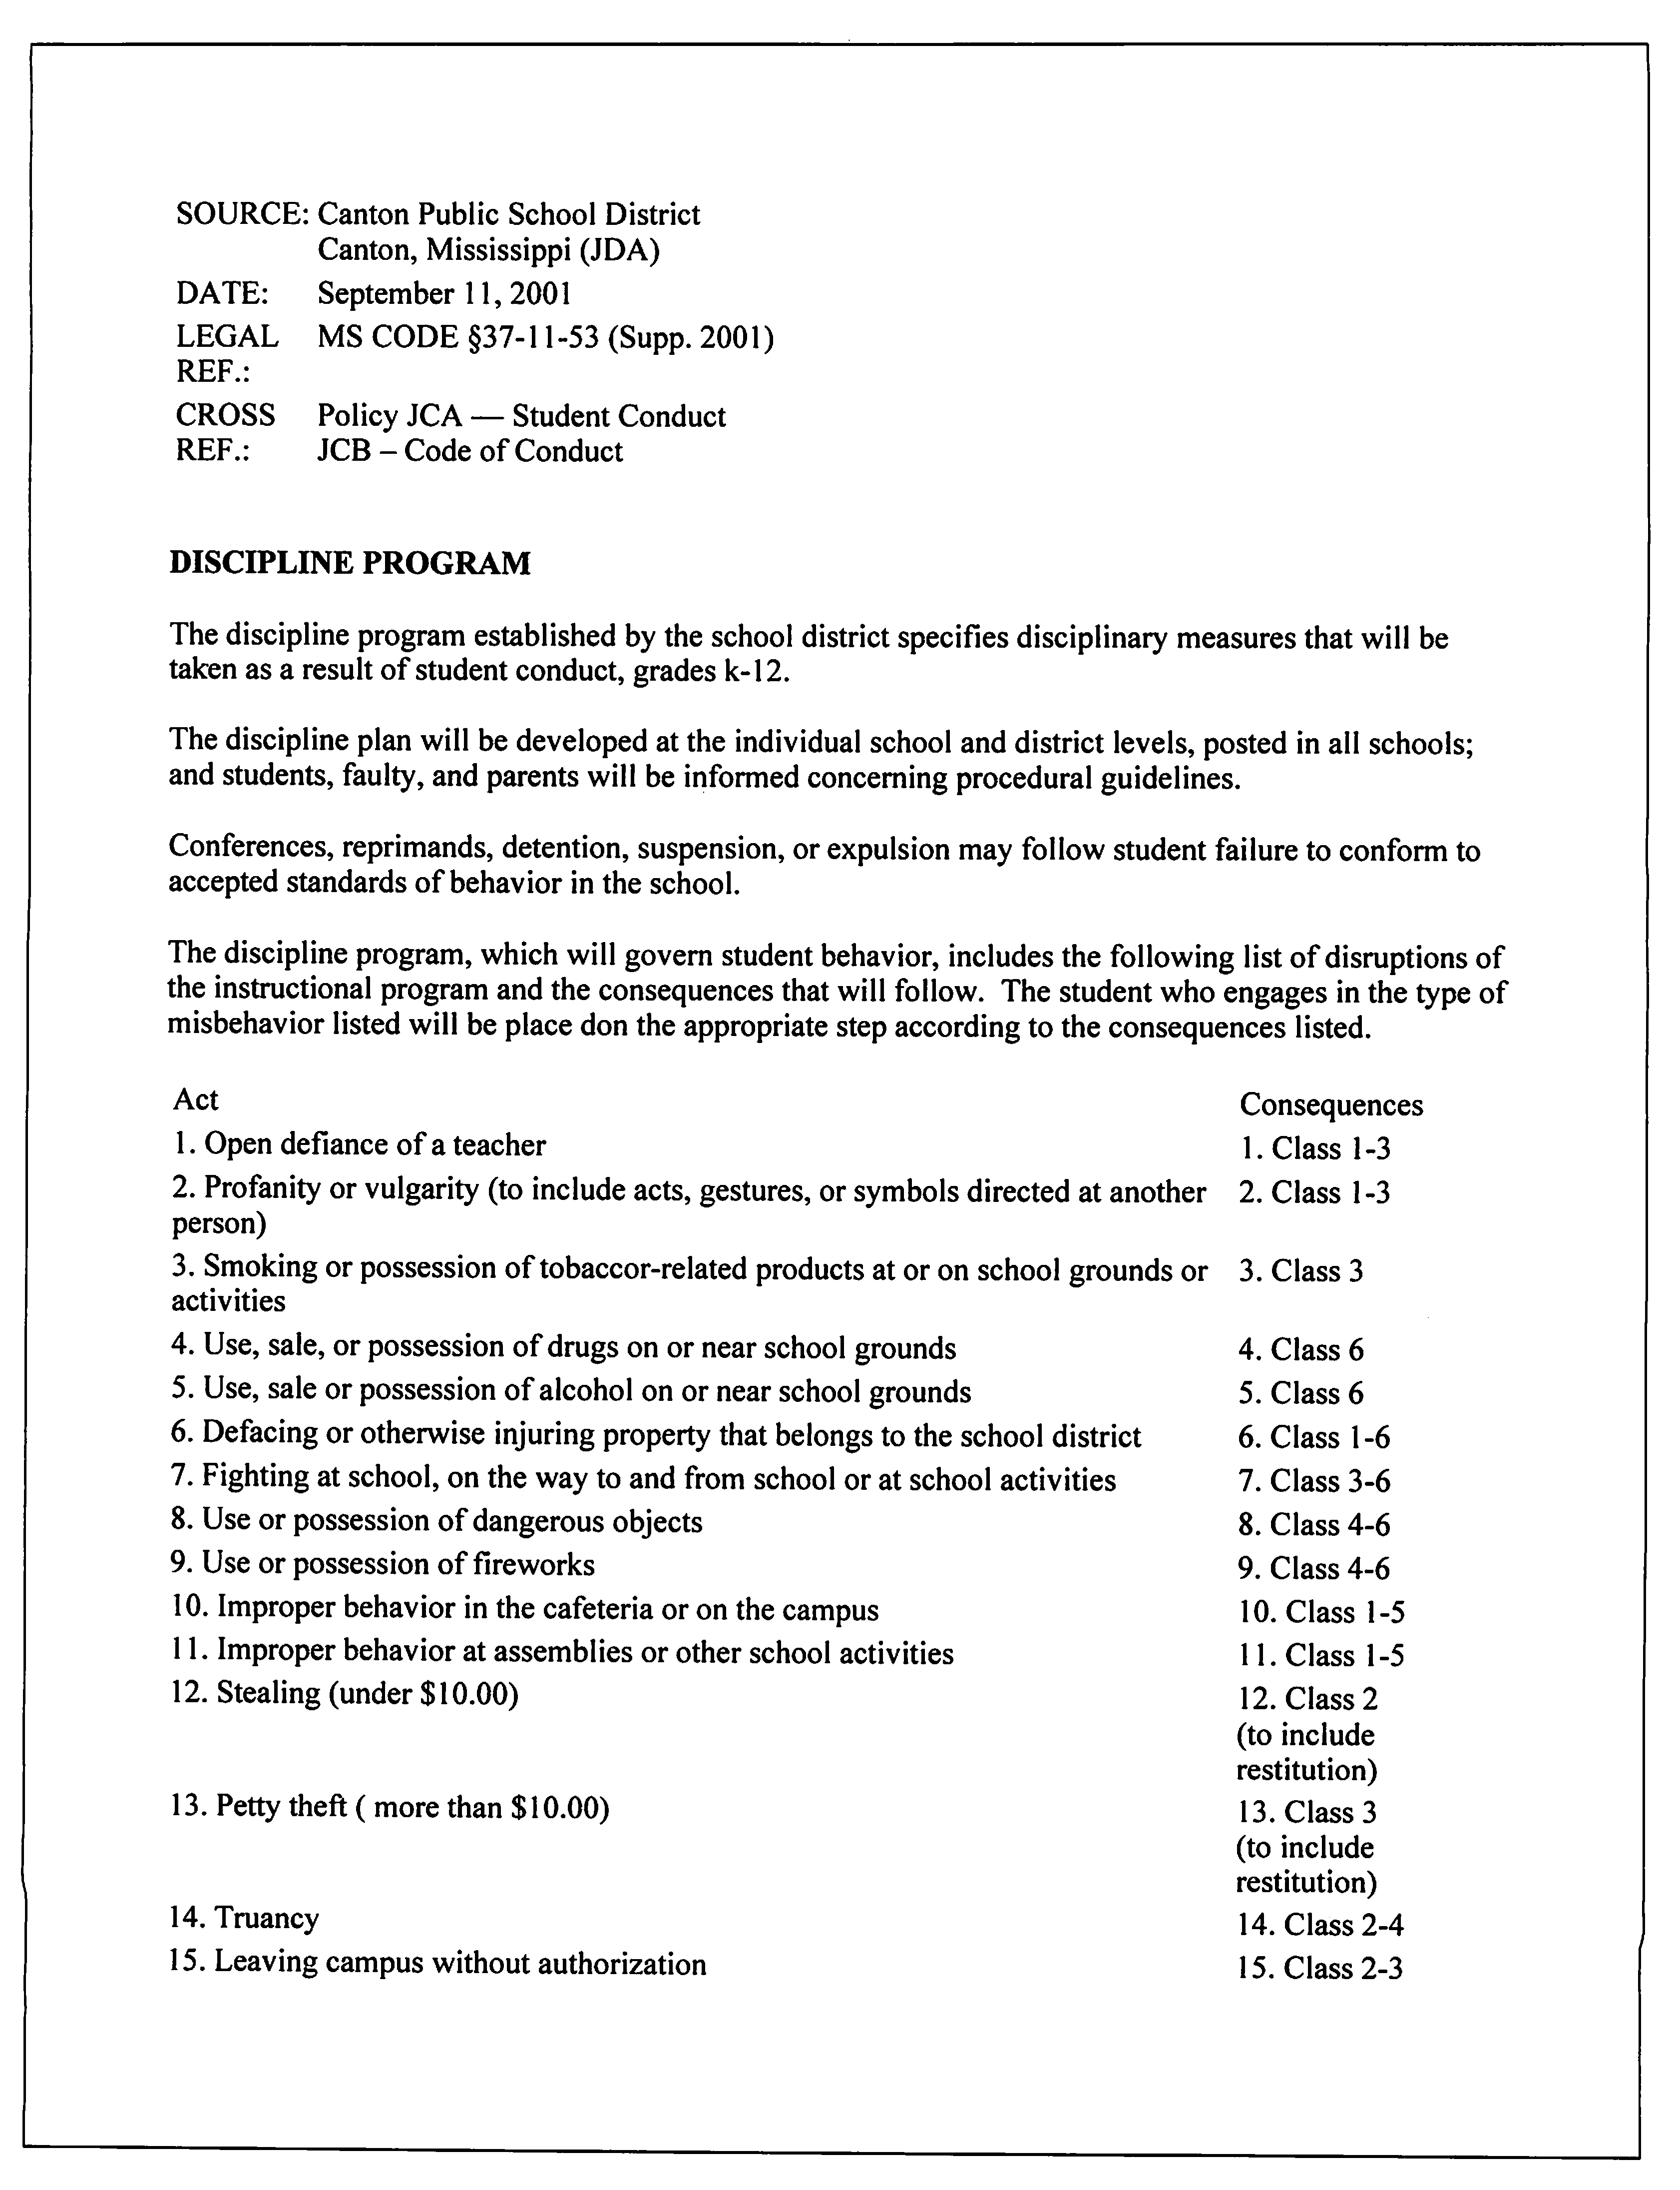

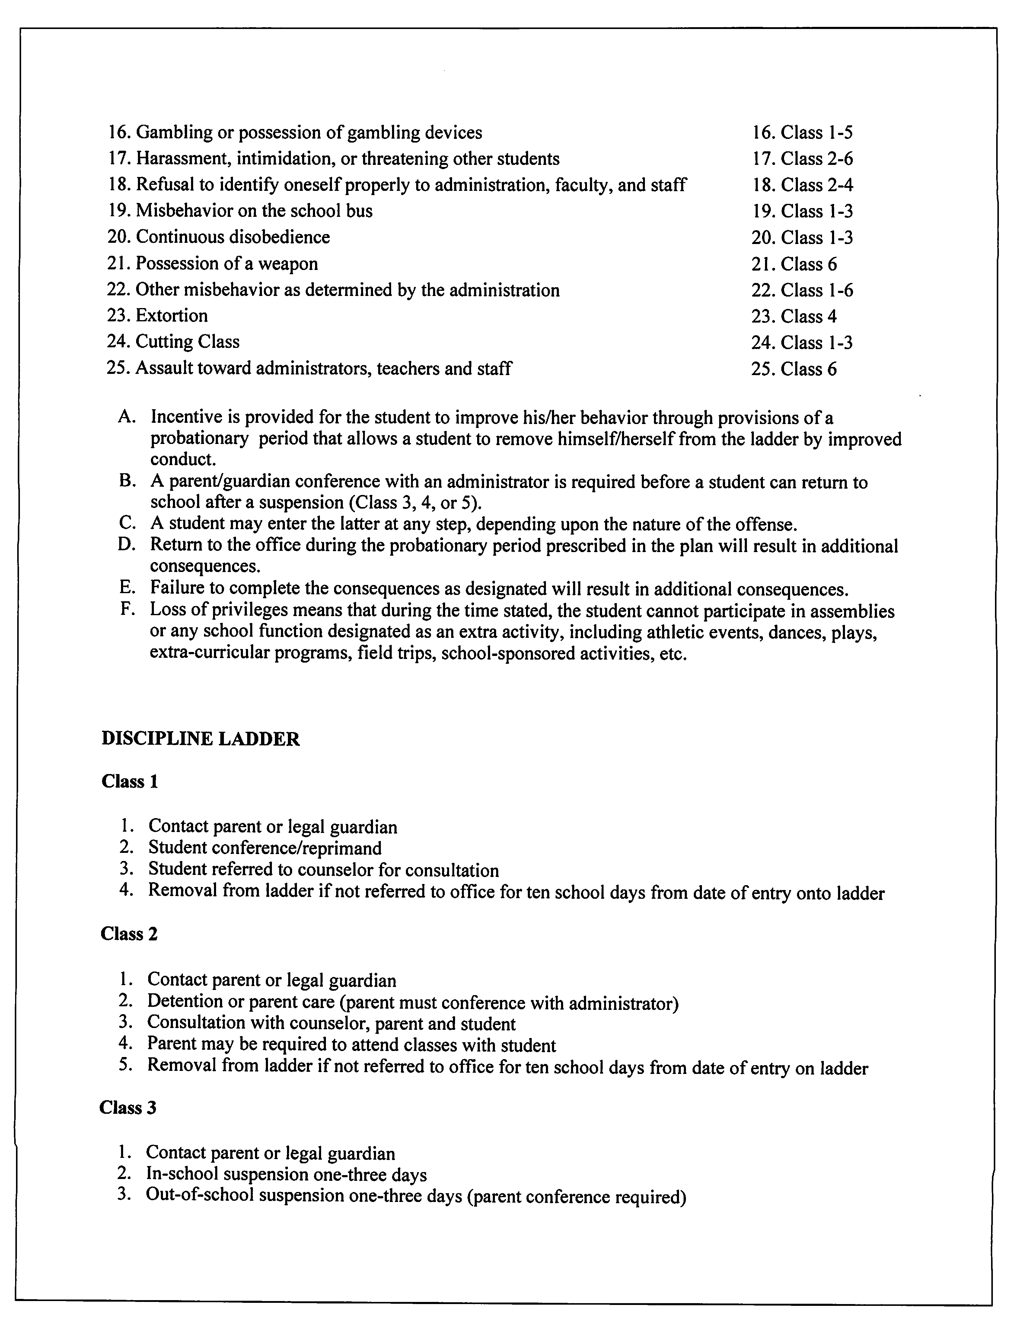

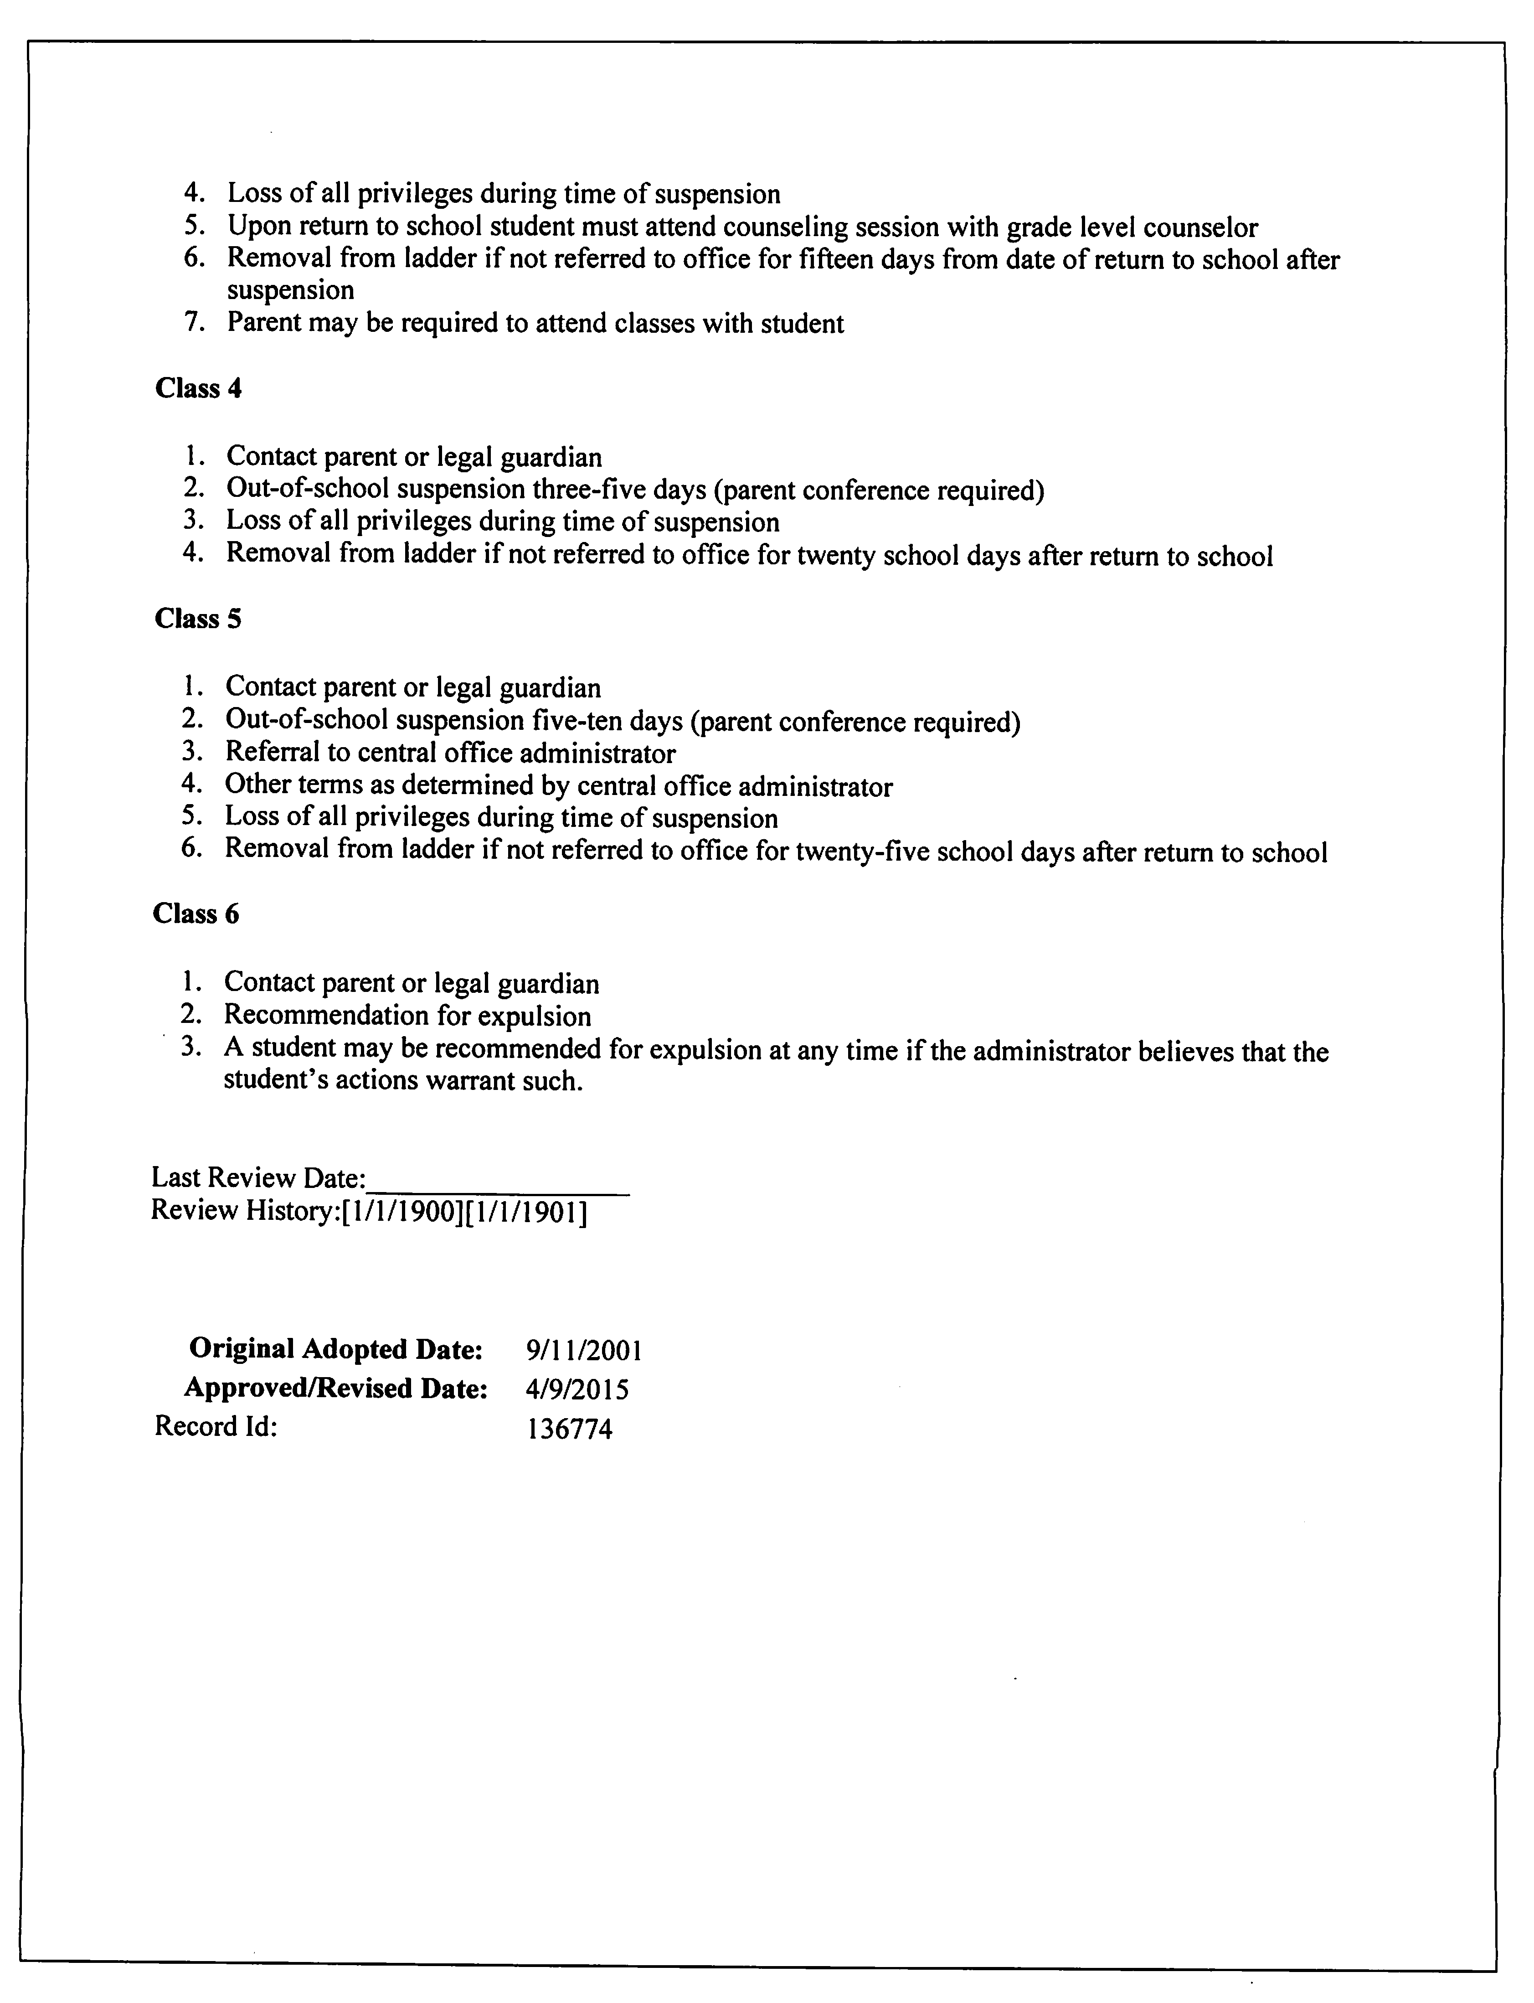

District: Canton Public School District
Section: I – Instructional Program
Policy Code: IHA – Grading System

GRADING AND ASSESSMENT

The evaluation of student progress is a continuous responsibility of each member of the professional staff and requires the highest professional skill. The primary purpose of the grading system is to provide students and parents with a composite statement of educational progress in a specified period of time for the student in selected areas of learning. The administration shall issue regulations to ensure that the grading system is uniform throughout the school system at the primary, elementary, middle, and high school levels. The grading/assessment system shall conform to the following guidelines:
- Official reporting of grades shall be on a nine-week basis. Progress reports are issued to every student every 4 ½ weeks.
- Grades shall reflect a student’s progress in meeting the objectives of a course through a variety of evaluative measures, i.e., text assignments (oral and written); class participation; special projects and assignments; research; various activities; special contributions; and tests, checklists, and quizzes.
- The receiving school shall accept transfer grades provided that the course taken is compatible with local and state regulations. The principal, or designee, shall have the authority to interpret and translate transfer grades into the district’s grading system.
- Grades shall be maintained numerically by the teacher and reported as a numerical grade for grades second through twelve.
- In reporting student grades for second grade and third grade, students will receive numerical grades for reading, language, and math. Students will receive non-point grades for social studies and science subjects (S= Satisfactory, N= Needs Improvement, U= Unsatisfactory).
- Teachers shall maintain accurate records that reveal how they have determined each student’s grades.
- A uniform method of determining the weight or value of different types of assignments/activities shall be devised for computing the term average, semester average, and final grade in all courses.
- Any grade below 60 (for middle and high schools) or below 65 for elementary schools the teacher must show teacher support team documentation with a portfolio of interventions that address the student’s deficiencies.
- Cheating is prohibited, and the student caught cheating will receive a zero. Parents will be notified that day by the teacher and the school.
- All grades in the Canton Public School District shall be recorded and reported on the proper forms approved by the district. Absences, conduct, and behavioral grades will be reported independently from academic achievement. Grades shall be issued each nine weeks (4 times per year) in all classes and in all schools. Grading scales will be uniform throughout the district at the middle and high school and at all elementary schools.

Elementary School Grading Scale
Grade | Non-Point Grade | Numerical Grade | Description
A | E | 90-100 | Excellent
B | S | 80-89 | Satisfactory
C | IN | 70-79 | Improvement Needed
D | U | 65-69 | Unsatisfactory
F | F | 64 and below | Failure

Middle School and High School Grading Scale
Grade | Numerical Value | Description
A | 90-100 | Excellent
B | 80-89 | Above Average Work
C | 70-79 | Average Work
D | 60-69 | Below Average
F | 59 and below | Failing Work

11. Students in the Canton Public School District Elementary Schools are recognized as High Honor Roll scholars when a grade of A (90-100) is earned in each core academic class. Grades earned in non-academic classes (i.e. counseling, library, music, art, P.E., and computer) will not be used to determine students’ eligibility for High Honor Roll status.
12. Students in Canton Public School District Elementary Schools are recognized as Honor Roll scholars when grades of A (90-100) and B (80-89) are earned in each core academic class. Grades earned in non-academic classes (i.e. counseling, library, music, art, P.E., and computer) will not be used to determine students’ eligibility for Honor Roll status.
13. Students shall also receive numerical grades for ancillary instructional programs including but not limited to Saturday School, Extended School Year, and Summer Reading. These grades will be calculated as daily grades.
14. In reporting student grades for students in kindergarten and first grade, teachers will use a combination of parent conferences, progress reports, and a Standards Based Performance Report Card, which indicate the achievement of students in mastering the concepts and skills appropriate to those levels. Students in grades Kindergarten and First Grade students will not receive numerical grades for reading, language, math, science, and social studies. Students will receive non-point grades in these subjects (M= Mastery, P= Making Progress Toward Mastery, I= Improvement Needed, and U= Unsatisfactory).
15. Students in Kindergarten, first, and second must meet the minimum mastery of academic skills.
A monthly progress report will be used to communicate the independent reading levels of students as measured by Renaissance STAR Reading.
16. Parents/legal guardians will be notified of unsatisfactory work. If student does not show improvement at the end of the first semester, the parent/legal guardian will be notified every 30 days of their academic progress. Parents will be notified approximately 30 days before the end of school year if the student may be retained. A parent conference is to be scheduled and documented each notification.
Teacher Support Team
Each school must have a Teacher Support Team (TST) implemented in accordance with process developed by the MDE. The Teacher Support Team (TST), which operates under the jurisdiction of the principal, is the problem-solving unit responsible for interventions developed at Tier III.
The Canton Public School District adheres to the Mississippi Department of Education guidelines regarding certain mandatory referrals to TST. Failure to make adequate progress following Tier I and Tier II, students will be referred to the TST if any of the following events occur:
A. Students in grades 1-3 who have failed one (1) grade;
B. Students in grades 4-12 who have failed two (2) grades;
C. Students who failed either preceding two (2) grades and have been suspended or expelled for more than 20 days in the current school year;
D. Students scoring at the Minimal and Basic Levels on the Grade 3 Language Arts assessment;
E. A student is promoted from grade 3 to 4 under a good cause exemption of the Literacy-Based Promotion Act. Referrals to the TST must be made within the first twenty (20) days of a school year if the student meets any of the criteria A-E stated above.
Any student suspected of having a disability or experiencing significant academic and /or behavioral difficulties should be referred to the school’s TST for review. If a student’s parents request an evaluation for their child, that student should be referred to the TST. The TST procedures should be followed whether a teacher or a parent makes the referral. The student’s information will be reviewed by the school TST for the purpose of designing effective interventions and making appropriate recommendations for the student. Written documentation of the request made, the information reviewed, and the decisions/recommendations of the TST must be kept on file at the school. Student Interventions must address:
- The student’s specific, diagnosed skill deficiencies as determined (or identified) by diagnostic assessment data;
- The goals and benchmarks for growth;
- How progress will be monitored and evaluated;
- The type of instruction services and interventions the student will receive;
- The evidence-based reading instructional programming the teacher will use to provide reading instruction, addressing the areas of phonemic awareness, phonics, fluency, vocabulary, and comprehension;
- The strategies the student's parents are encouraged to use in assisting the student to achieve reading competency; and
- Any additional services the teacher deems available and appropriate to accelerate the student's reading development.
Promotion and Retention Criteria for Elementary Schools
Kindergarten
Kindergarten students must master 70% of the reading/language arts and mathematics standards.
Grade 1
First grade students must master 70% of the reading/language arts and mathematics standards.
Grade 2
Second grade students must pass reading, language arts, and Mathematics with a yearly average of 65 (D) or above.
Grade 3
Third grade students must pass reading, language arts and mathematics with a yearly average of 65 (D) or above and satisfy the requirements for the Literacy-Based Promotion Act (LBPA). The yearly average shall be determined by averaging the two semester numerical grades.
Grade 4 and 5
Fourth and fifth grade students must pass reading, language arts, mathematics, social studies, and science with a yearly average of 65 (D) or above. The yearly average shall be determined by averaging the two semester numerical grades.
Grades 6-8: Students must pass the following core content courses to be promoted to the next grade: 6th -8th English Language Arts, 6th -8th Mathematics, 6th -8th Science, and 6th -7th Social Studies. Eighth grade students may be promoted to the 9th grade without passing 8th grade Social Studies because it is credit-based; However, not passing this credit-based course could result in students not graduating on time if the credits are not recovered. If Algebra I is offered in 8th grade, students can be promoted to the 9th grade without passing Algebra I because it is credit-based; however, not passing this credit-based course could result in students not graduating on time if the credit is not recovered.

Classification for grades 9th -12th is based upon satisfactory completion of required credit hours at each grade level as determined by the Mississippi Department of Education.
Grading Changes
(1) No school board member, school superintendent, assistant superintendent, principal, guidance counselor, other teachers, coaches, or other administrative staff members of the school or the central staff of a local school board shall attempt, directly or indirectly, to change, alter, or otherwise affect the grade received by a student from his/her teacher.
(2) (a) A teacher's determination of a student's grade as a measure of the academic achievement or proficiency of the student shall not be altered or changed in any manner by any school official or employee other than the teacher.
(b) A school official or employee having authority provided under formally adopted written rules and procedures adopted by the local school board to change a student's grade can take such action only upon it being determined that the grade is an error or that the grade is demonstrably inconsistent with the teacher's grading policy.
(3) Any local school district or personnel employed by the school district who violates the provisions of the law shall cause the local school district or school to be subject to losing its accreditation in the manner determined by the policies and procedures of the State Board of Education.
The grading system shall be included in all student handbooks.
The superintendent or designee shall establish procedures to support this policy.
SOURCE: | Canton Public School District  Canton, MS 39046
DATE: | June 14, 2011
REVISED: | October 12, 2021
Last Review Date:__________________
Review History:[1/1/1900][1/1/1901]

Adopted Date: 6/14/2011
Approved/Revised Date: 10/12/2021

District: Canton Public School District
Section: L - Organizational Relations
Policy Code: LAA - Title I Parental Engagement

TITLE I PARENT ENGAGEMENT

NOTE: Schools receiving federal ESEA funds are required to have a parent engagement policy.

The Canton Public School District Board of Education endorses the parent engagement goals of Title I and encourages the regular participation by parents of Title I eligible children in all aspects of the program. The education of children is viewed as a cooperative effort among the parents, school, and community. In this policy, the word "parent" also includes guardians and other family members involved in supervising the child’s education.

Pursuant of federal law, this district will develop jointly with, agree on with, and distribute to parents of children participating in the Title I program a written parent engagement policy.

A meeting of the parents of participating Title I students will be held annually to explain the goals and purposes of the Title I program.

Parents will be given the opportunity to participate in the design, development, operation, and evaluation of the program for the next school year and to participate in planning activities, to offer suggestions, and to ask questions regarding policies and programs. Parents will be encouraged to attend the meeting and
to become involved.

In addition to the required annual meeting, at least three (3) additional parent meetings shall be held, at various times of the day and/or evenings, for the parents of children participating in the Title I program. Notices will be sent to the parents and articles will appear in the local newspaper advising parents and interested persons of the meetings. These meetings shall be used to provide parents with:

1. Information about programs provided under Title I;
2. A description and explanation of the curriculum in use, the forms of academic assessment used to
measure student progress, and the proficiency levels students are expected to meet;
3. Opportunities to formulate suggestions and to participate, as appropriate, in decisions relating to the education of their children; and
4. The opportunity to bring parent comments, if they are dissatisfied with the school’s Title I
program, to the district level.

Title I funding, if sufficient, may be used to facilitate parent attendance at meetings through payment of transportation and childcare costs.

The parents of children identified to participate in Title I programs shall receive from the school principal and Title I staff an explanation of the reasons supporting each child’s selection for the program, a set of objectives to be addressed, and a description of the services to be provided. Parents will be advised of their children’s progress on a regular basis. Opportunities will be provided for the parents to meet with the classroom and Title I teachers to discuss their children’s progress. Parents will also receive information and training that will assist them in helping their children at home and at school.

Each school in the district receiving Title I funds shall jointly develop with parents of children served in the program a "School-Parent Compact" outlining the manner in which parents, school staff and students share the responsibility for improved student academic achievement in meeting state standards. The School- Parent Compact shall:

Describe the school’s responsibility to provide high-quality curriculum and instruction in a supportive and effective learning environment enabling children in the Title I program to meet the state’s academic achievement standards;

Indicate the ways in which each parent will be responsible for supporting their children’s learning, such as monitoring attendance, homework completion, monitoring television watching, volunteering in the classroom, and participating, as appropriate, in decisions related to their child’s education and positive use of extracurricular time; and

Address the importance of parent-teacher communication on an on-going basis, with at a minimum, parent-teacher conference, frequent reports to parents, and reasonable access to staff.

NOTE: Districts with more than one school participating in a Title I program may wish to consider the establishment of a district-wide parent advisory council.

CROSS REF.: Policies LA Parental Engagement

LAB Title I Parent Engagement Regulations
Original Adopted Date: | 9/14/2004
Approved/Revised Date: | 9/8/2020
Record Id: | 257059

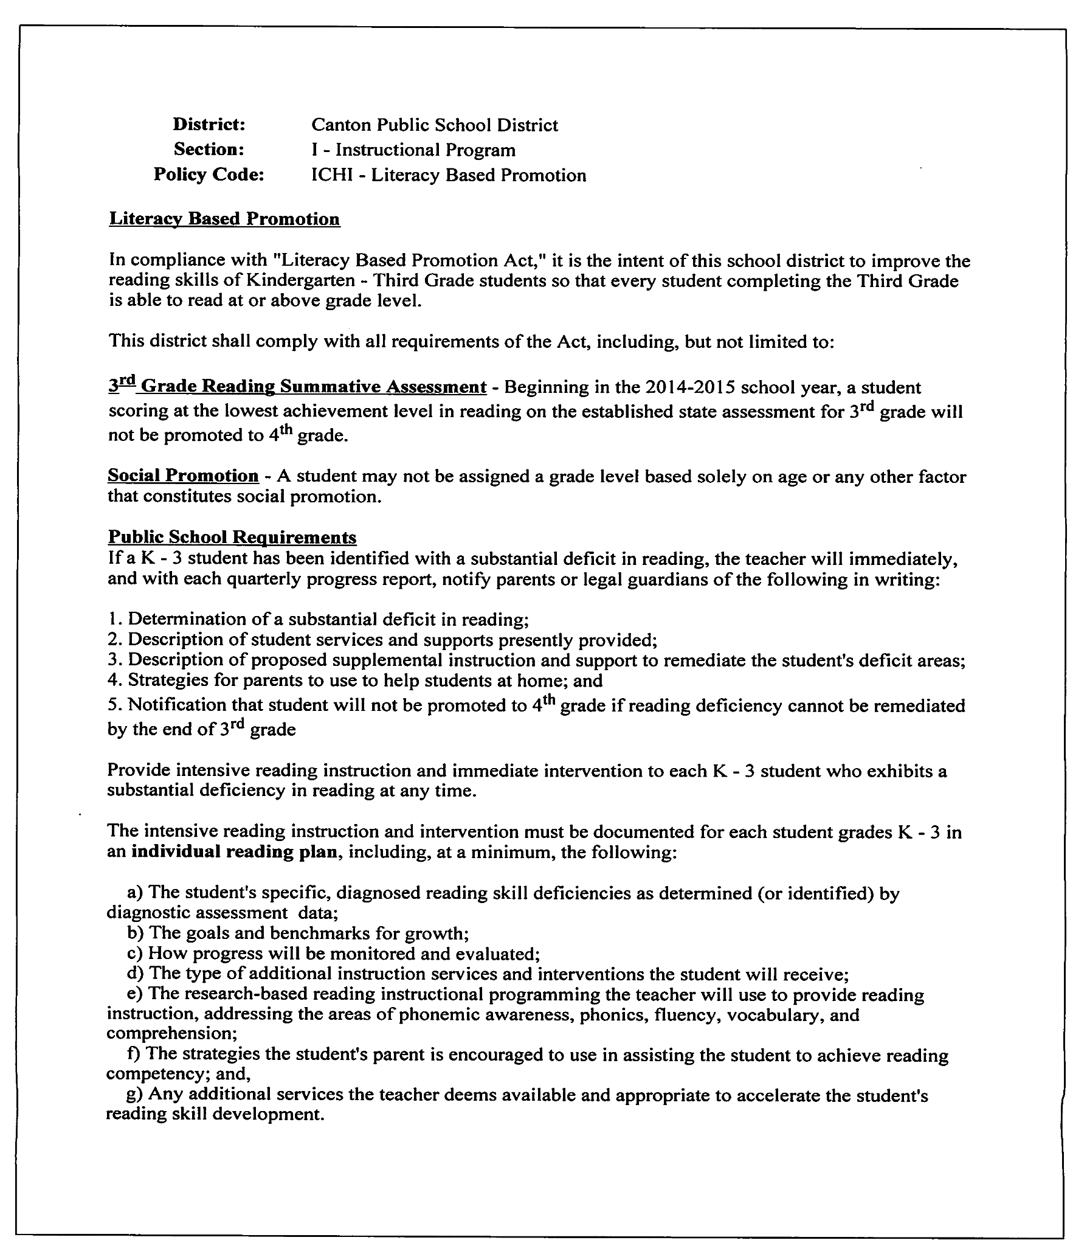
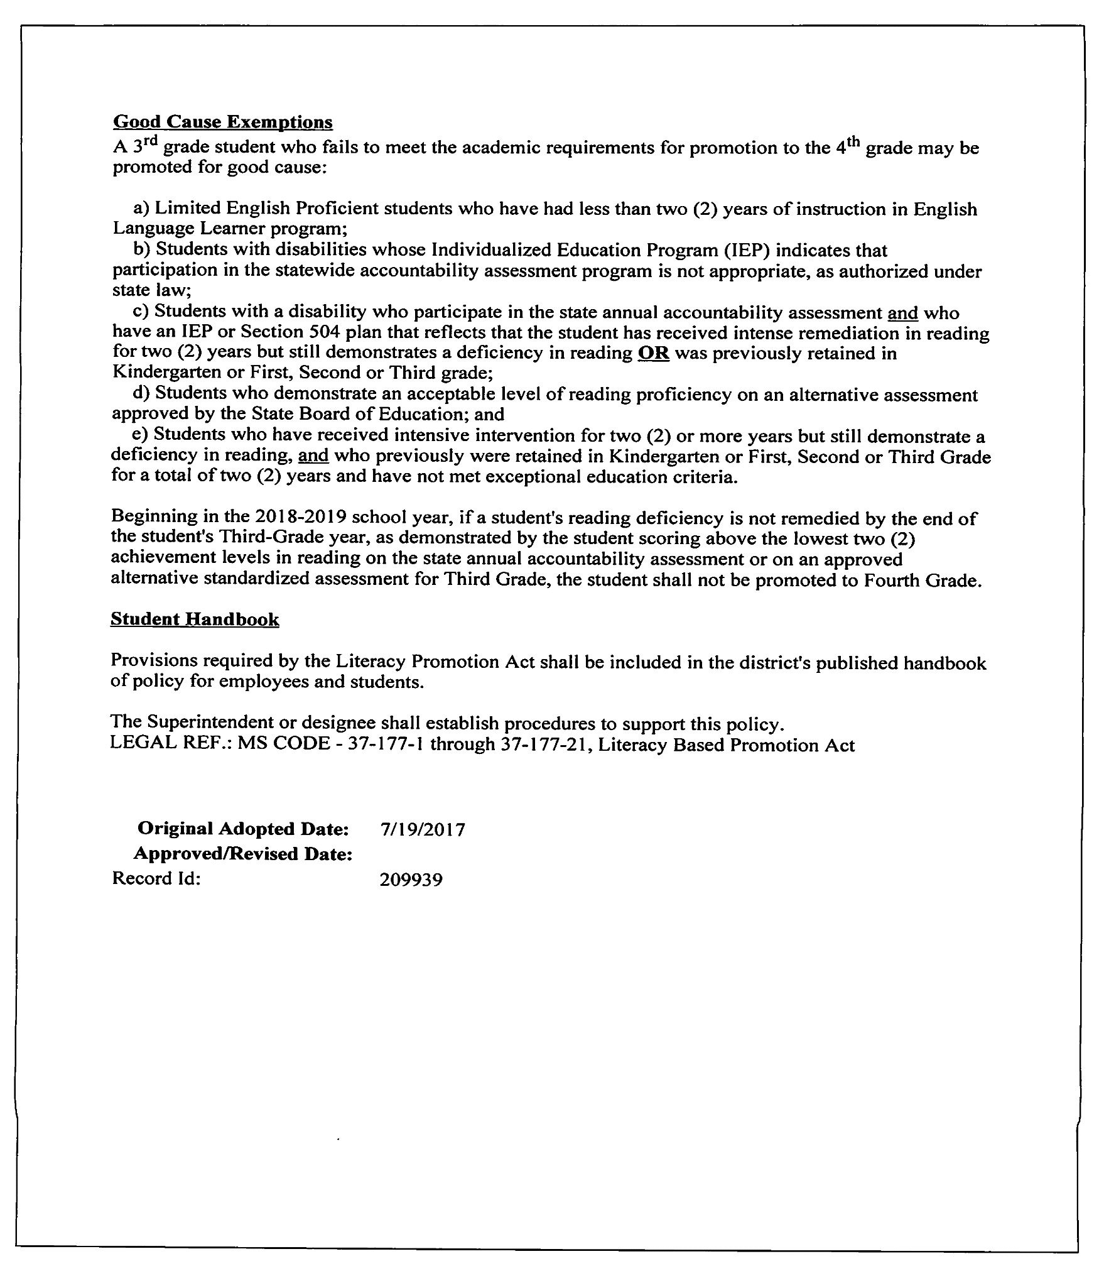
Response to Intervention (RtI) / Multi-Tiered Systems of Support (MTSS) – All STUDENTS
- RtI/MTSS is a single, well integrated, multi-tiered service delivery system through scientifically based research, instructional and behavioral practices that are applied to every student.
- This is a comprehensive and coordinated framework for:
- Monitoring students’ acquisition of skills; and,
- For responding to the lack of progress with appropriate levels of intervention.
Mississippi Department of Education (MDE) shall requires an instructional model designed to meet the needs of every student. The model shall consist of three tiers of instruction.
Tier 1: Quality classroom instruction based on MS Curriculum Frameworks and College and Career Readiness.
Tier 2: Focused supplemental instruction
Tier 3: Intensive interventions specifically designed to meet the individual needs of students.
- Teachers should use progress monitoring information to (a) determine if students are making adequate progress, (b) identify students as soon as they begin to fall behind, and (c) modify instruction early enough to ensure each and every student gains essential skills. Monitoring of student progress is an ongoing process that may be measured through informal classroom assessments, benchmark assessment instruments, and large-scale assessments.
- If strategies at Tiers 1 and 2 are unsuccessful, students must be referred to the Teacher Support Team (TST). The TST is the problem-solving unit responsible for interventions developed at Tier 3. Each school must have a Teacher Support Team (TST) implemented in accordance with the process developed by the MDE. The chairperson of the TST shall be the school principal as the school's instructional leader or the principal's designee. The designee may not be an individual whose primary responsibility is special education. Interventions will be:
- designed to address the deficit areas;
- research based;
- implemented as designed by the TST; and,
- supported by data regarding the effectiveness of interventions.
After a referral is made, the TST must develop and begin implementation of an intervention(s) within two weeks. No later than eight weeks after implementation of the intervention(s) the TST must conduct a documented review of the interventions to determine success of the intervention. No later than 16 weeks after implementation of the intervention(s), a second review must be conducted to determine whether the intervention is successful. If the intervention(s) is determined to be unsuccessful, then the student will be referred for a comprehensive assessment.
In addition to failure to make adequate progress following Tiers 1 and 2, students will be referred to the TST for interventions as specified in guidelines developed by MDE if any of the following events occur:
A. Grades 1-3: A student has failed one (1) grade;
B. Grades 4-12: A student has failed two (2) grades;
C. A student failed either of the preceding two grades and has been suspended or
expelled for more than twenty (20) days in the current school year; OR
D. A student scores at the minimum level on any part of the Grade 3 or Grade 7
Mississippi Curriculum Test Second Edition.
E. A student is promoted from grade 3 to under all “Good Course Exemption” of the Literacy Based Promotion
act
Referrals to the Teacher Support Team must be made within the first twenty (20) school days of a school year if the student meets any of the criteria A-E stated above.

Behavioral plans will be required for the 2011-2012 school year and beyond for all students recommended for suspension and students in the RtI/MTSS referral process.

JHCAA
SECRET SOCIETIES
It shall be unlawful for any pupil attending the public schools of this state to become a member of or to belong to or participate in the activities of any high school fraternity, sorority, or secret society as defined in Section 371137.
This school board shall prohibit fraternities, sororities, or secret societies in all high schools under its jurisdiction. It shall be the duty of said school board to suspend or expel from high schools under its control, any pupil or pupils who shall be or remain a member of or shall join or promise to join, or be pledged to become a member of, any public high school fraternity, sorority or secret society, as defined in section 371137.
It shall be unlawful for any person not enrolled in high school to solicit any pupil enrolled in high school, to join or pledge himself or herself to become a member of any high school fraternity, sorority, or secret society, or to solicit any pupil to attend a meeting thereof or any meeting where the joining of any such high school fraternity, sorority, or secret organization shall be encouraged.
Any person, firm or corporation violating any of the provisions of this section shall be guilty of a misdemeanor and upon conviction thereof shall be fined not less than twenty-five dollars ($25.00) nor more than one hundred dollars ($100.00) for each and every offense.
Student behavior that harasses or threatens other students or school personnel will not be tolerated. This district shall treat hazing, as defined in MS Code 97-3-105 and stalking, and as defined in MS Code 97-3-107, as serious offenses subject to criminal prosecution.
SOURCE: Canton Public School District
Canton, Mississippi (JHCAA)
LEGAL REF.: MS CODE as cited; 37-11-37 thru 45; 97-3-105 & 107
CROSS REF.: Policy JCA — Student Conduct
DATE: November 10, 1987
REVIEWED: February 11, 1997
REVISED: March 11, 2003

District: Canton Public School District
Section: G - Personnel
Policy Code: GBR - Sexual Harassment
SEXUAL HARASSMENT
Title IX of the Education Amendments of 1972 is an anti-discrimination law that states no person in the United States, on the basis of sex, shall be excluded from participation in, be denied the benefits of, or be subjected to discrimination under any educational program or activity receiving federal financial assistance. The policy of this board forbids discrimination against any employee or applicant for employment on the basis of sex. The board of education will not tolerate sexual harassment activity by any of its employees. This policy similarly applies to non-employee volunteers who work subject to the control of school authorities.

The Canton Public School District has appointed an employee to serve as the Title IX Coordinator for the district. This person is authorized to coordinate the district’s compliance efforts under this law. Because this policy is not amended each time the Title IX Coordinator changes, please contact the superintendent, the federal programs director, or any principal to request the name and contact information of the current Title IX Coordinator. The Title IX Coordinator is also identified with specificity in the district’s student handbook, faculty handbook, and on the district website.
DEFINITIONS
“Actual knowledge” means notice of sexual harassment or allegations of sexual harassment to the Title IX Coordinator or to any employee of the school district. All employees of the district are mandatory reporters under Title IX.
The “complainant” is the person who is alleged to be the victim of sexual harassment.
“Deliberate indifference” is when a district’s response is clearly unreasonable in light of known circumstances.
An “educational program or activity” includes any location, event, or circumstance over which the educational institution exhibits substantial control over both the alleged harasser and the context in which the harassment occurred. This includes programs or activities which occur on-campus or off campus and can involve the use of email, social media, or other technologies. 34 C.F.R. § 106.44(a)
A “formal complaint” of sexual harassment is defined as a document filed by a complainant or signed by the Title IX Coordinator alleging sexual harassment against a respondent and requesting that the district investigate the allegations.
The “respondent” is the individual who has been reported to be the perpetrator of the sexual harassment.
“Sexual harassment” is defined as conduct on the basis of sex that meets one or more of the following:
- An employee of the recipient conditioning the provision of an aid, benefit or service of the educational institution on an individual’s participation in unwelcome sexual conduct (quid pro quo sexual harassment);
- Unwelcome conduct determined by a reasonable person to be so severe, pervasive, and objectively offensive that it effectively denies a person equal access to the educational institution’s education program or activity; or
- Conduct on the basis of sex that meets one or more of the following: “Sexual assault” as defined in 20 U.S.C. 1092(f)(6)(A)(v), “dating violence” as defined in 34 U.S.C. 12291(a)(10), “domestic violence” as defined in 34 U.S.C. 12291(a)(8), or “stalking” as defined in 34 U.S.C. 12291(a)(30)
“Supportive measures” are non-disciplinary, non-punitive, individualized services offered as appropriate, as reasonably available, and without fee or charge to a complainant or a respondent before or after the filing of a formal complaint or where a complaint has not been filed. Supportive measures should be designed to restore or preserve equal access to the educational program or activity without unreasonable burdening the other party. Examples of supportive measures include, but are not limited to:
- Counseling
- Course Modification
- Schedule Changes
- Increased Monitoring or Supervision
If the district does not offer supportive measures, the records should document why the response was not clearly unreasonable under the known circumstances.
INDIVIDUALS AND CONDUCT COVERED
These policies apply to all students and employees of the Canton Public School District, and third parties, persons hired to provide contracted services, and persons volunteering at school activities. Conduct prohibited by these policies is unacceptable in all academic, educational, extracurricular, athletic, and other programs of the school, whether those programs occur on campus, on a bus, or at another location away from campus. Individuals who violate these policies will be subject to disciplinary action, up to and including suspension or expulsion (if a student) or suspension or termination of employment (if any employee), and in egregious situations, law enforcement officials will be notified as required by law.
REPORTING
Any person may report sex discrimination or sexual harassment regardless of whether the person is the alleged victim. These reports may be made in person, by mail, by telephone, or email to the Title IX Coordinator, or by any other means that results in receipt by the Title IX Coordinator. For K-12 educational institutions, actual notice of sexual harassment is notice of sexual harassment or allegations of sexual harassment made to any employee.
Consistent with Title IX, a school must respond when:
1. The school has actual knowledge of sexual harassment;
2. That occurred within the school’s education program or activity;
3. Against a person in the United States.
Nothing in this policy or any other policy impedes or precludes a student, the student's parents, a school employee, or school officials from directly reporting to law enforcement officials any behavior that constitutes a violation of criminal law or any applicable laws.
It is prohibited to knowingly make a false discrimination, harassment, or retaliation report or provide false information in an investigation. Individuals who knowingly file a false or misleading complaint alleging harassment, discrimination or retaliation or provide false information in an investigation are subject to appropriate disciplinary actions.
RETALIATION
The Canton Public School District encourages reporting all incidents of discrimination or harassment. Retaliation is prohibited against any person for the purpose of interfering with Title IX rights or because the person participated, or refused to participate, in any manner in a proceeding under Title IX regulations. The district must keep confidential the identity of a person who complains of or reports sexual harassment, including parties and witnesses, except as permitted by law to carry out the purpose of the regulations. 34 C.F.R. § 106.71
Retaliation against an individual for reporting harassment or discrimination or for participation in an investigation of a claim of harassment or discrimination is a serious violation of this policy and, like harassment or discrimination itself, will subject an individual to disciplinary action.

RECORDS
Any records related to reports of sexual harassment must be kept for a minimum of seven (7) years, including:
- Investigative Records
- Disciplinary Records
- Remedies
- Appeals
- Records of action taken including supportive measures
The district must also retain for seven (7) years any materials used to train Title IX Coordinators, investigators, decision-makers, and any employee designated to facilitate an informal process. Training materials will also be posted on the district website.

LEGAL REF.: 1972 Education Amendments, Title VII and Title IX, Clery Act, 20 U.S.C. § 1092(f),
Violence Against Women Act, 34 U.S.C. § 12291(a)
CROSS REF.: Policies GAAA Equal Opportunity Employment
GAE-R Licensed Staff Complaints and Grievances GAEA Staff Protection
Last Review Date:__________________
Review History:[1/1/1900][1/1/1901]
Original Adopted Date: 3/11/1997
Approved/Revised Date: 10/13/2020
Record Id: 279300
SOLICITATION BY STUDENTS
It is not the goal of the school system to sell for the purpose of profit-
making. Consequently, any selling
to the public for this purpose or any other profit-making activities should be avoided. The high schools
will be permitted one selling campaign per club to the public for this purpose annually, however. This
should receive the closest of supervision. Any alteration of this policy may come only upon direct
permission of the superintendent.
Last Review Date:__________________
Review History: [1/1/1900][1/1/1901]
District:
Canton Public School District
Section:
J - Students
Policy Code:
JKB - Solicitation by Students
SOURCE:
Canton Public School District
Canton, Mississippi (JKB)
DATE:
November 10, 1987
REVIEWED:
March 11, 1997
REVIEWED:
March 11, 2003
Original Adopted Date:
11/10/1987
Approved/Revised Date:
4
/
8/2015
Record Id:
136744
District: Canton Public School District
Section: I – Instructional Program
Policy Code: IDDF – Special Educational Programs

SPECIAL EDUCATION PROGRAMS
Canton Public School District’s special education programs shall be provided in accordance with applicable state and federal legislation and regulations, including the Individuals with Disabilities Education Act (IDEA) of 2004, State Board Policy Chapter 74, Rule 74.19 and Section 504 Rehabilitation Act of 1973.
FREE APPROPRIATE PUBLIC EDUCATION (FAPE)
A Free Appropriate Public Education (FAPE) must be available to all children enrolled in Canton Public School District who have been determined to be eligible for special education services and whose parents reside within the district, including children who:
- Are between the ages of three (3) and twenty (20) years;
  - Including children from the date of their third birthday; and
  - Including youth who are twenty (20) years of age on or before September 1st, even if they will turn twenty-one (21) years of age during the school year;
- Have been suspended or expelled from school;
- Are placed in a residential facility or long-term medical facility.
Once a child is determined to be a child with a disability and eligible for special education and related services, he/she is entitled to receive a FAPE until one of the following events occurs:
a. The child exceeds the age of eligibility for FAPE under State law (NOTE:
Children can continue their education if they turn twenty-one (21) after
September 1.);
b. A child ages eighteen (18) to twenty-one (21) years old who was not identified as
a child with a disability in his/her last educational placement prior to
incarceration;
c. The child graduates from secondary school with a standard high school diploma;
d. The child is determined through an evaluation to no longer be a child with a
disability;
e. The child moves to another state; or
f. The parent revokes consent for special education and related services.
A FAPE requires the provision of specially-designed instruction, related services and other accommodations or modifications necessary to meet the unique needs of a child with a disability. To receive a FAPE, a child with a disability must have access to and make progress in the general education curriculum and receive educational benefit in his/her least restrictive environment (LRE). A FAPE must be based on the child’s individual needs and not based on a disability category.
DEFINITIONS
An exceptional child shall be defined as any child as herein defined, in the age range birth through twenty (20) years of age with an intellectual disability, hearing impairments (including deafness), speech or language impairments, visual impairments (including blindness), emotional disturbance, orthopedic impairments, autism, traumatic brain injury, other health impairments, or specific learning disabilities and, by reason thereof, needs special education and related services. Such children shall be determined by competent professional persons in such disciplines as psychology, special education, speech pathology and social work. Such professional persons shall be approved by the State Department of Education.
As defined by state law, the following definitions apply:
- "Free appropriate public education" (FAPE) means special education and related services provided by local educational agencies that:
  - Have been provided at public expense, under public supervision and direction, and without charge;
  - Meet the standards of the State Department of Education;
  - Include an appropriate preschool, elementary, or secondary education; and
  - Are provided in conformity with the individualized education program required under IDEA, applicable federal and state regulations and relevant court cases.
- "Individualized education program" or IEP means a written statement for each child with a disability that is developed, reviewed, and revised in accordance with the requirements under IDEA, applicable federal and state regulations and relevant court cases.
- "Related services" means transportation, and such developmental, corrective, and other supportive services (including speech-language pathology and audiology services, psychological services, physical and occupational therapy, recreation, including therapeutic recreation, social work services, counseling services, including rehabilitation counseling, orientation and mobility services, and medical services, except that such medical services shall be for diagnostic and evaluation purposes only) as may be required to assist a child with a disability to benefit from special education, and includes the early identification and assessment of disabling conditions in children.
- "Special education" means specially designed instruction provided by local educational agencies, at no cost to parents, to meet the unique needs of a child with a disability, including instruction conducted in the classroom, in the home, in hospitals and institutions, an in other settings. This term also includes instruction in physical education.
- "Supplementary aids and services" means aids, services, and other supports that are provided in regular education classes or other education-related settings to enable children with disabilities to be educated with nondisabled children to the maximum extent appropriate in accordance with the least restrictive environment requirements under IDEA, applicable federal regulations and relevant court cases.
- "Consent" means agreement in writing from the parent of a child with a disability pertaining to the activities as required under IDEA and the Family Educational Rights and Privacy Act. This school district shall ensure that the
parent:

i. | Has been fully informed of all information relevant to the activity for  which consent is required;
ii. | Understands the activity for which consent is required; and
iii. | Understands that the granting of consent is voluntary and may be  revoked at any time prior to the time the activity is conducted.

- "Transition services" means a coordinated set of activities for a student with a disability that:
i. | Is designed within an outcome-oriented process, which promotes movement from school to post-school activities, including post-secondary education, vocational training, integrated employment (including supported employment), continuing and adult education, adult services, independent living, or community participation;
ii. | Is based upon the individual student's needs, taking into account the student's preferences and interests;
iii. | Includes instruction, related services, community experiences, the development of employment and other post-school adult living objectives, and, when appropriate, acquisition of daily living skills and functional vocational evaluation.

The Mississippi Public School Accountability Standard for this policy is standard 17.
LEGAL REF.: MS CODE as cited; ' 37-23-1 and '37-23-133 et seq.
1973 Rehabilitation Act, Sec. 504; P. L. 94-142 as cited
Mississippi Public School Accountability Standards
CROSS REF.: Policies IB Instructional Goals
IHE - Promotion and Retention
IHF - Graduation Requirements
II - Testing Program

Last Review Date:__________________
Review History:[1/1/1900][1/1/1901]

Adopted Date: 1/10/2006
Approved/Revised Date: 9/14/2021

District: Canton Public School District
Section: I – Instructional Program
Policy Code: IDDFA – Students with Disabilities

POLICIES RELATED TO THE EDUCATION OF DISABLED CHILDREN

Child Find Policy

Each year the school district will have an awareness campaign aimed at finding unserved disabled children. When a child suspected of being disabled is referred, he/she will be evaluated and, if found to be eligible, placed either in an existing class or on a waiting list with plans for the provision of a free appropriate public education to him/her in accordance with applicable state and federal laws and court decisions.

Canton Public School District’s Child Find (CF) policy requires the ongoing, district-wide process of child identification, location, and evaluation of children with suspected disabilities. The Child Find process may not be limited by the number per or time of year the request is received. Local school district personnel are continuing the search for children with disabilities from birth through 21 years of age.

Early identification of children in need of special education services is critical to each child. Furthermore, this information gathered from contacts with parents and other agencies will be used to determine present and future program needs as progress is made toward the goal of providing a free appropriate public education (FAPE) to all children with disabilities.
The child-find coordinator works with the local Head Start, Welfare, Health and Mental Health agencies, as well as local education agencies, physicians, licensed day care providers, local juvenile correctional facilities, and other individuals to identify and locate children, including, special populations, who may be in need of special education services. Special populations include:
- Homeless children
- Wards of the state
- Private school children
- Children advancing from grade-to-grade
- Highly mobile and/or migrant children
§300.301, 300.111(A)(C)

Information which could identify an individual child will be maintained by the district and will be provided to other agencies only in accordance with the Family Educational Rights and Privacy Act (FERPA) and the Individuals with Disabilities Education Act (IDEA). As a parent, you are guaranteed the right to inspect any such information about your child and to challenge its accuracy. Access to this information is forbidden to any unauthorized person without informed written consent. If you have questions regarding the collection, maintenance, and use of data about your child you may call (601)859-2179.

CHILD FIND PROCEDURES

The Child Find Coordinator is responsible for district-wide coordination of the planning and implementation of child identification, location, and evaluation efforts of children (birth through age 21) who have disabilities (regardless of the severity of the disability), and who are in need of special education and/or related services. Verbal and written Child Find referrals are accepted year round. If at any time, an individual suspects that a student residing in Canton Public School District has a disability, please contact the Child Find Coordinator so that the Child Find process may begin.

Dr. Shelia N. Anthony, Child Find Coordinator
Canton Public School District
403 E. Lincoln Street
Canton, MS 39046
Phone: (601)859-2179

In collaboration with the District Teacher Support Team (DTST) and following implementation of the Multi-Tier System of Supports and Services (MTSS) (except for those students who have conditions that adversely affect their educational performance and for whom interventions would not change the status of the impairment), if the intervention process is unsuccessful, it is the responsibility of the Child Find Coordinator to ensure that the following referral-to-placement procedures are followed:

- When a written or verbal Child Find request is made, the Multidisciplinary Evaluation Team (MET) composed of the parent, the child (if appropriate), and qualified professionals will meet within fourteen (14) calendar days to review the request including all pertinent existing documentation. (The parent must be invited to participate; however, if the parent is unable to attend, the MET team must proceed.)
- If the MET determines that the need for an evaluation is substantiated, Prior Written Notice (PWN), Informed Parental Consent, and Procedural Safeguards: Your Family’s Special Education Rights will be given to the parent within seven (7) calendar days of the meeting. The MET must obtain informed written consent from the parent before it can proceed with an initial evaluation (i.e., no individual assessments may be conducted prior to obtaining this consent). The student will be evaluated in all areas related to the suspected disability by qualified personnel. After securing informed written parental consent to conduct an evaluation, the MET has a maximum of sixty (60) calendar days in which to complete the evaluation, except for the following specific situations:

    - The parent repeatedly fails or refuses to produce the child for the evaluation.
    - The child transfers to another public agency after the timeline has begun but before eligibility could be determined.
    - The MET is using ongoing progress monitoring data collected to determine the child’s Response to Intervention (RTI) as a method for identifying a Specific Learning Disability (SLD), the data do not clearly indicate the presence or absence of a disability at the end of the sixty (60) day time period, and the public agency and the parent mutually agree in writing to extend the time period.

- If the MET determines that the need for an evaluation is not substantiated, Prior Written Notice and Procedural Safeguards: Your Family’s Special Education Rights will be given to the parent within seven (7) calendar days of the meeting. In these cases, the MET may refer the child to the Teacher Support Team (TST) for focused supplemental instruction or intensive interventions using the MTSS Instructional Model to promote the child’s success in the general education curriculum.

- If the student meets eligibility criteria, an Individual Education Program (IEP) will be developed within 14 days and written parental permission is obtained prior to the provision of special education and/or related services.

- IEPs of all students receiving special education services are reviewed at least once annually.

- A comprehensive re-evaluation will be conducted at least once every 3 years to determine if the student’s needs have changed and if he/she continues to meet the Individuals with Disabilities Education Action (IDEA) eligibility criteria.

Under the provisions of Child Find, it is required to identify, locate, and evaluate all children suspected of having a disability in a timely manner and to ensure that no procedures or practices, including Response to Intervention (RTI) procedures or practices, result in delaying or denying this process. Canton Public School District has an obligation to ensure timely evaluations of children suspected of having a disability whether or not the child has participated in the MTSS model prior to an evaluation. Therefore, if a child suspected of having a disability is identified through Child Find procedures or a request for evaluation is made by a parent, guardian, representative of a public agency or others acting on behalf of a child, the district may not delay or deny the evaluation on the basis that the child has not participated in the RTI process.

SECTION 504

Under Section 504, the District has the responsibility to identify, evaluate, and if the student is determined to be eligible, afford access to appropriate educational services. Prior to determining eligibility under 504, it is the district’s policy to first follow its procedures for a comprehensive evaluation for services under the Individuals with Disabilities Education Act (IDEA), including the implementation of the MTSS process. If the parent or guardian disagrees with the determination made by the district, he or she has a right to a hearing with an impartial hearing officer.

The following person has been designated as the Section 504 Coordinator and will handle all 504 referrals/requests for students in Canton Public School District:
Dr. Shelia N. Anthony, 504 Coordinator
Canton Public School District
403 E. Lincoln Street
Canton, MS 39046
Phone: (601)859-2179

DISCIPLINE POLICY FOR STUDENTS WITH DISABILITIES

Canton Public School District may suspend any student for certain violations of the student code of conduct. Students with disabilities will adhere to the same rules of conduct as a student without a disability. State and federal regulations related to students with disabilities will be followed when implementing discipline procedures district-wide.

CHANGE OF PLACEMENT

A student with a disability who is removed from his/her current placement for more than 10 school days must continue to receive educational services. This is to allow the student to continue to participate in the general education curriculum in another setting, continue to progress toward meeting goals outlined in his/her Individualized Education Program (IEP), and receive, as appropriate, a functional behavioral assessment (FBA), and behavioral intervention services that are designed to address the student’s behavior.

Students with disabilities have special protections under the Individuals with Disabilities Education Act (IDEA) of 2004, State Board Policy Chapter 74, Rule 74.19 and Section 504 Rehabilitation Act of 1973 when they exhibit behaviors that violate the student code of conduct and require a removal from the current educational setting. In these cases, school district personnel, the parent, and relevant members of the IEP Committee must determine if the behavior(s) are a manifestation of the child’s disability or if the proposed disciplinary action constitutes a change in their educational placement.

While Canton Public School District serves the majority of long-term suspended students in a school-based setting, some students have such unique or intense needs that the committee makes a recommendation for other placements. In cases where this is found appropriate, a Change of Placement form must be completed and the frequency/duration of services must be reviewed and/or revised based on the needs of the individual student and outlined in the students’ IEP. A review of the services is conducted every 45 days to determine if the recommended placement continues to be appropriate to meet the student’s needs.

MANFESTATION DETERMINATION REVIEWS (MDR)

After 10 school days of suspension, whether consecutive or cumulative, the child’s IEP Committee must meet to determine whether the student’s behavior is a manifestation of his/her disability. A removal from current placement is generally termed as an out-of-school suspension (OSS), in-school suspension (ISS) if special educational services are not provided, or a removal from the bus, if special transportation is a related service on the student’s IEP.

Before being placed at Canton Educational Services Center (CESC), a student with disabilities must have IEP behavior goals and a Behavior Intervention Plan (BIP) in place if prior history of behavior violations has been documented. The only exception is for student violations involving drugs, weapons, and/or serious bodily injury.

If the school administrator recommends placement at CESC, the student is suspended for no more than 10 days (unless for drugs, weapons, and/or serious bodily injury) and the parent is notified of the suspension.
Unless parents agree to waive their right to prior notice and can participate in the Manifestation Determination Review (MDR) on the date the student is removed, the school personnel must send the parent the MDR notice, the Procedural Safeguards notice, and schedule the meeting within 10 days of the change of placement. If the parent agrees to waive notice and go forward with the MDR, all appropriate personnel including members of the IEP committee must be present.

Prior to the removal of any student with disabilities for more than 10 cumulative days in a school year, the Director of Exceptional Services must be notified.

Parent can waive their right to a disciplinary hearing. If they do so, the IEP Committee will meet to complete an MDR and review and/or revise the IEP.

If the parent chooses to proceed with a disciplinary hearing, the IEP Committee, including the parent, will complete the MDR prior to the disciplinary hearing.

During the MDR meeting the IEP committee will review all data, including the current IEP, to determine if the behavior violation was caused by the child’s disability, had a direct and substantial relationship to the child’s disability, or was the direct result of district’s failure to implement the IEP.
If the behavior is determined to be a manifestation of the student’s disability, the IEP Committee will review the IEP and determine if any additional services and/or revisions to the BIP or behavior goals are needed. No further disciplinary action will be taken and the student will return to his/her previous placement unless parents and school personnel agree to remove the student to an Interim Alternative Education Setting (IAES).

If the behavior is NOT a manifestation of the student’s disability, the disciplinary hearing will go forward. The recommendation of the hearing committee will be upheld, and the student may be disciplined to the same extent that students without disabilities would be disciplined for similar behavior violations.
Following the hearing, if a disciplinary removal is recommended, an IEP meeting must be held at CESC to determine the provision of services in the student’s new placement and a Change of Placement form must be completed. The IEP of any student placed at CESC must be reviewed within 45 days.

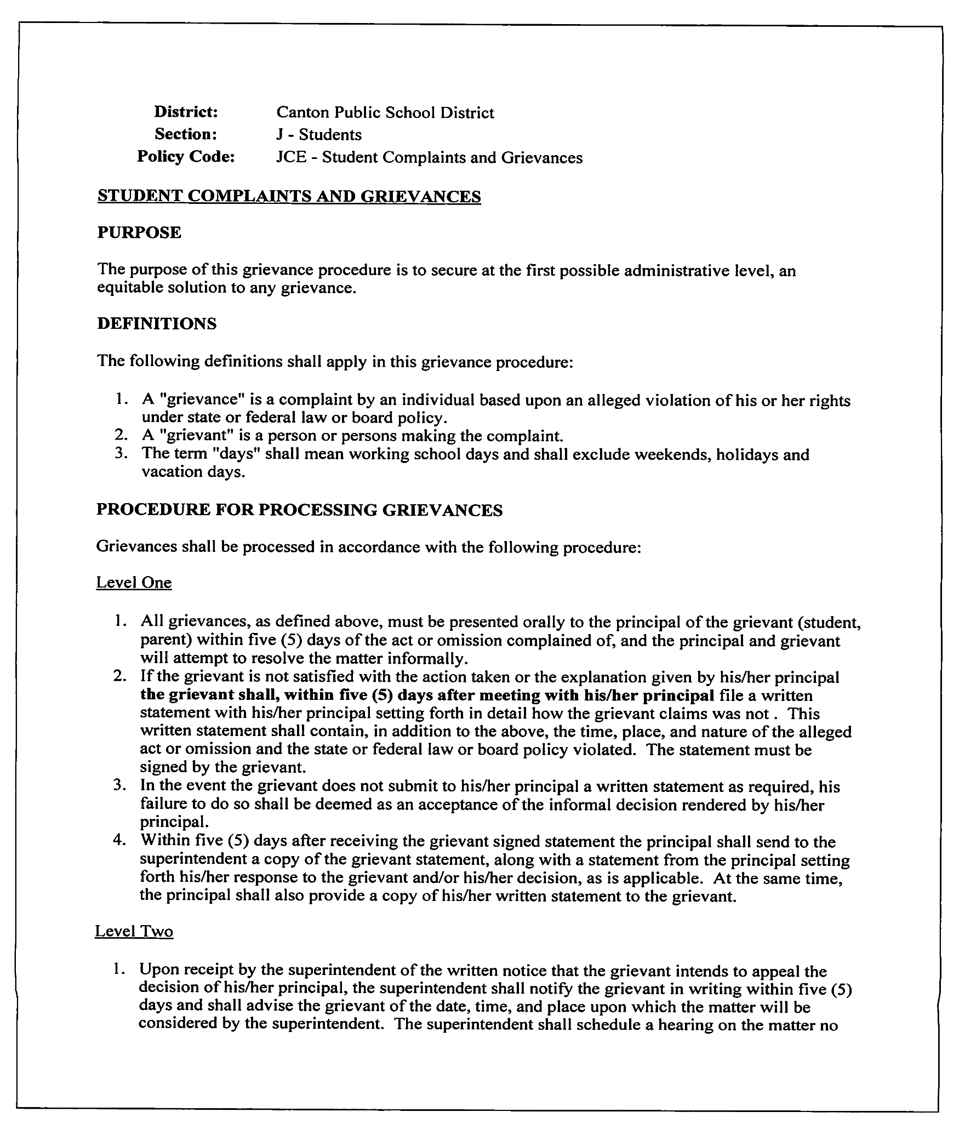
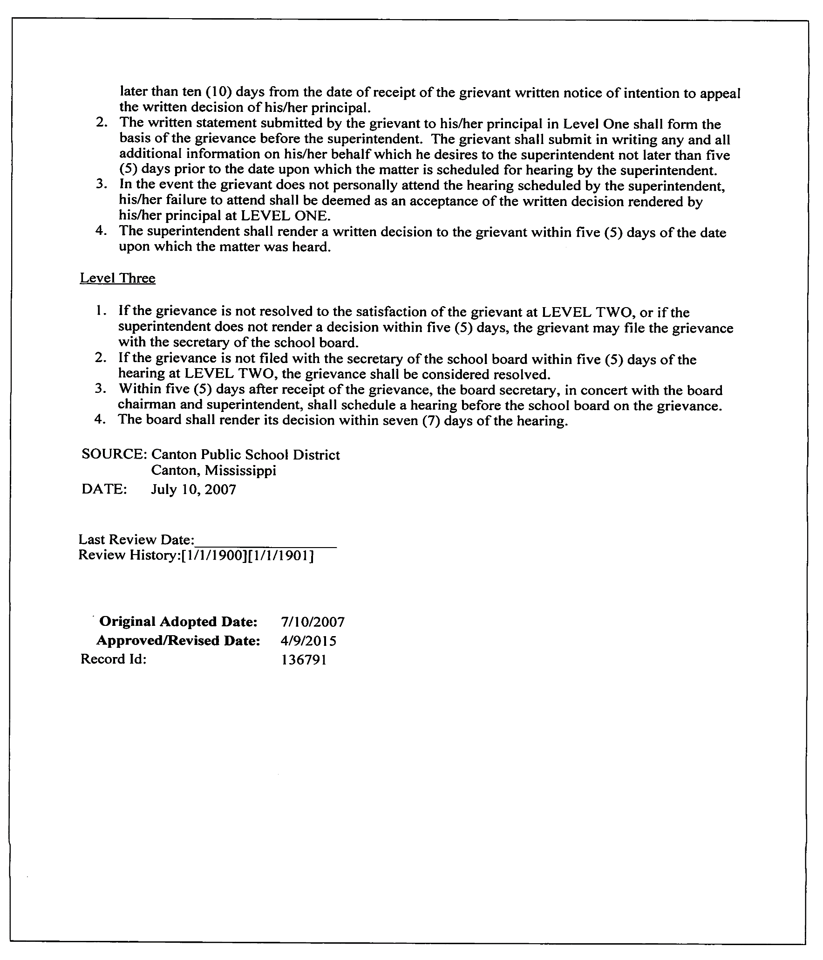
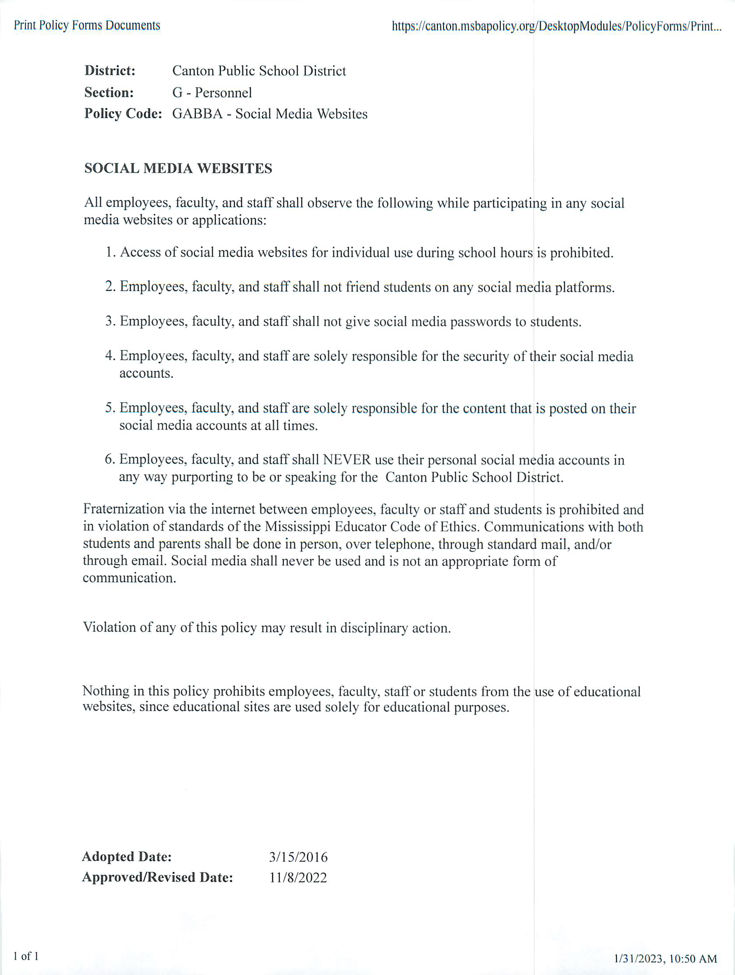
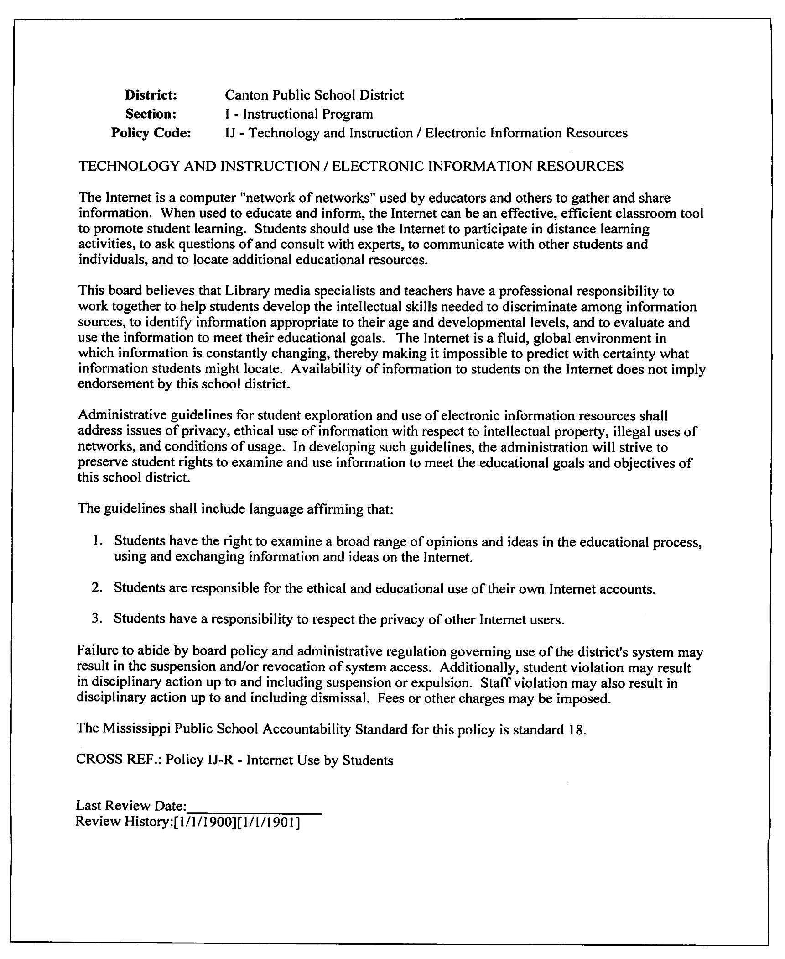

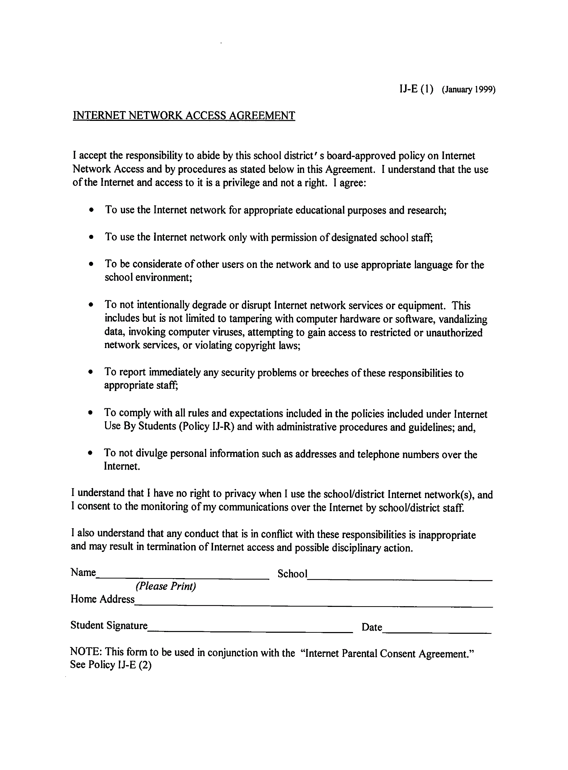
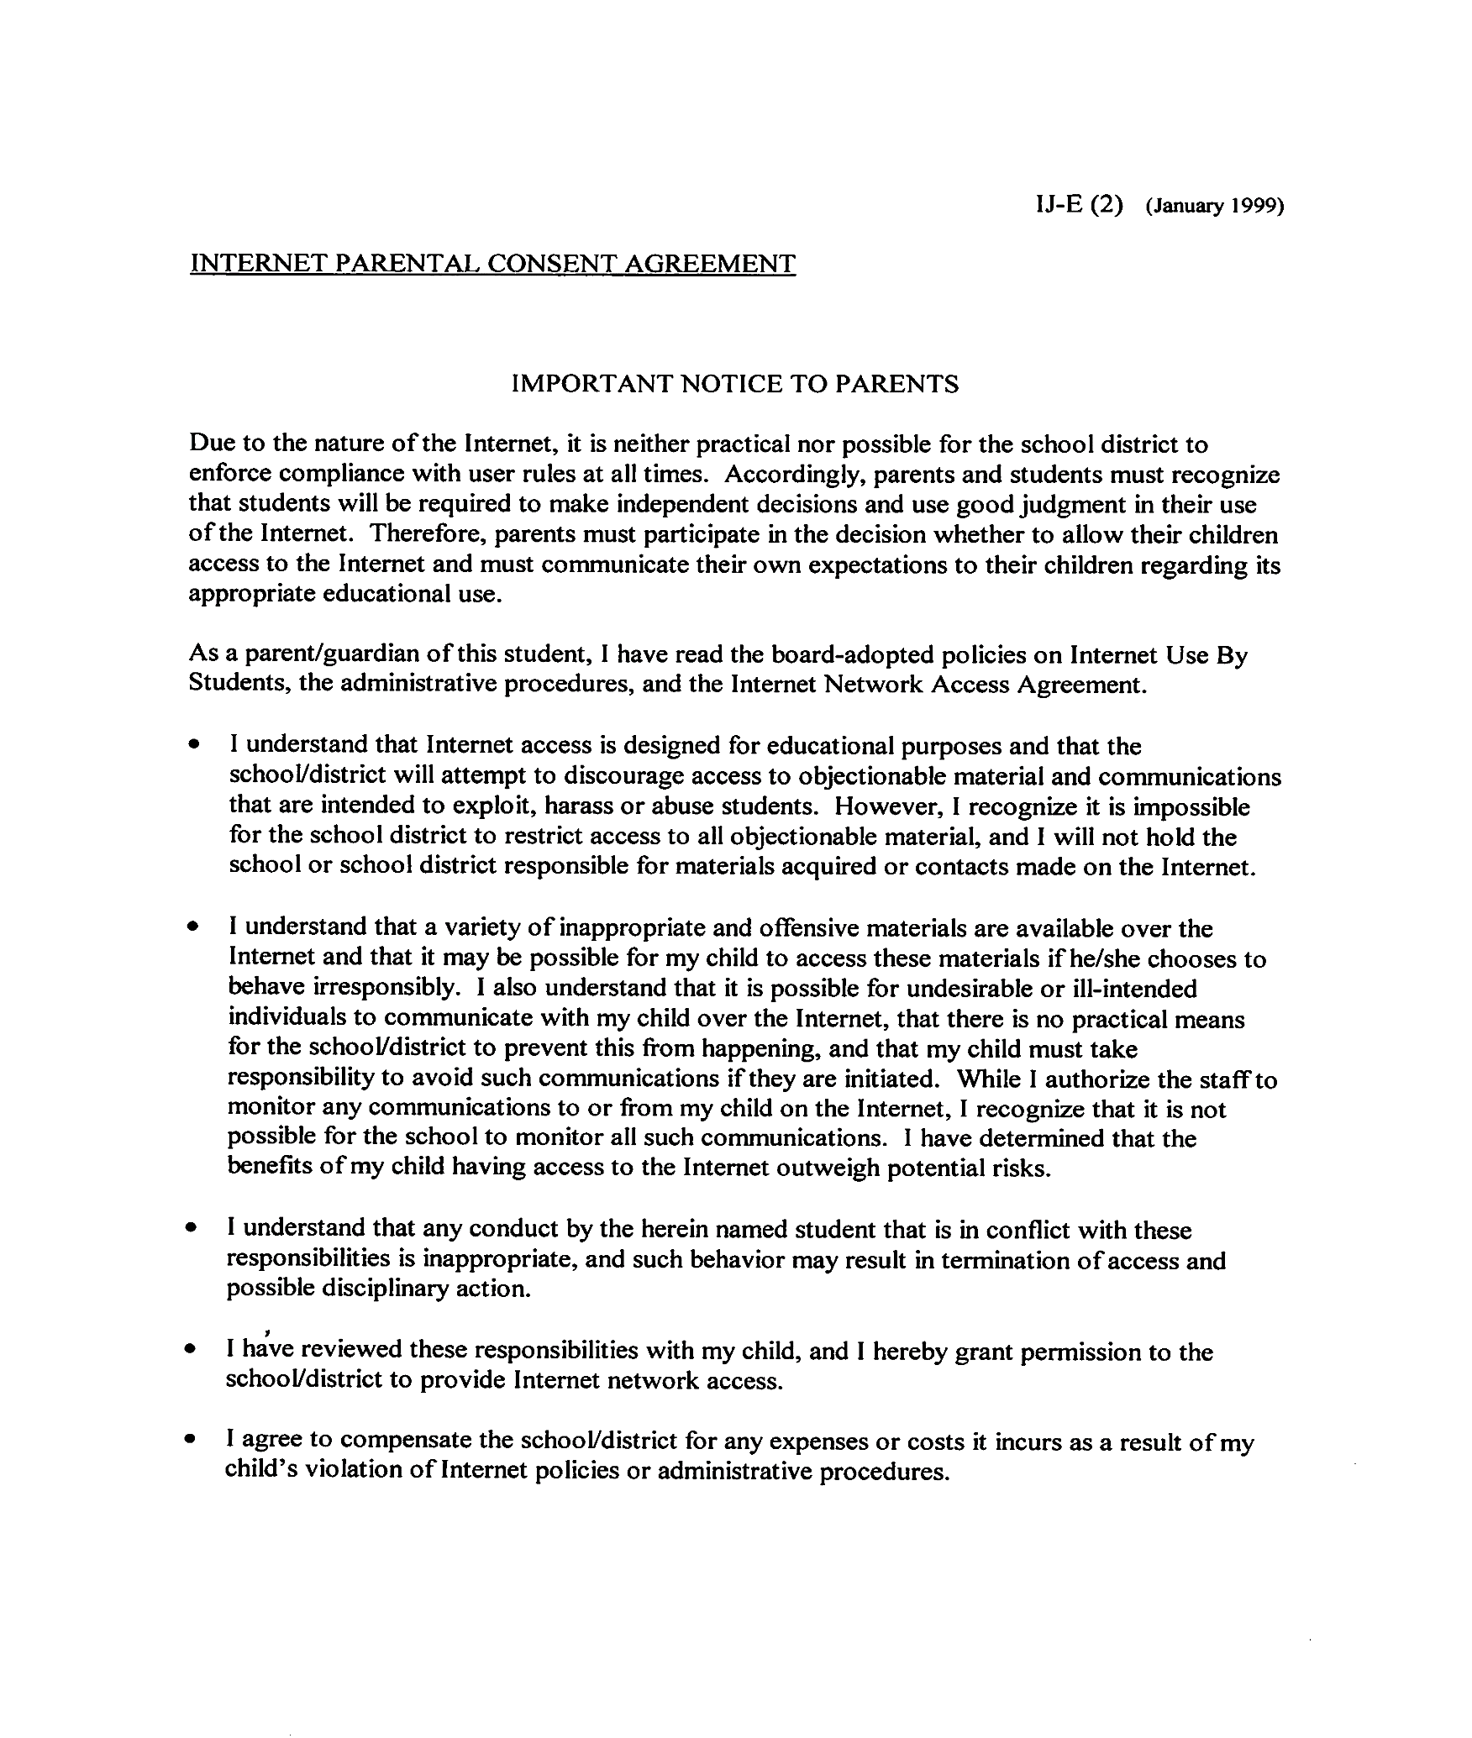
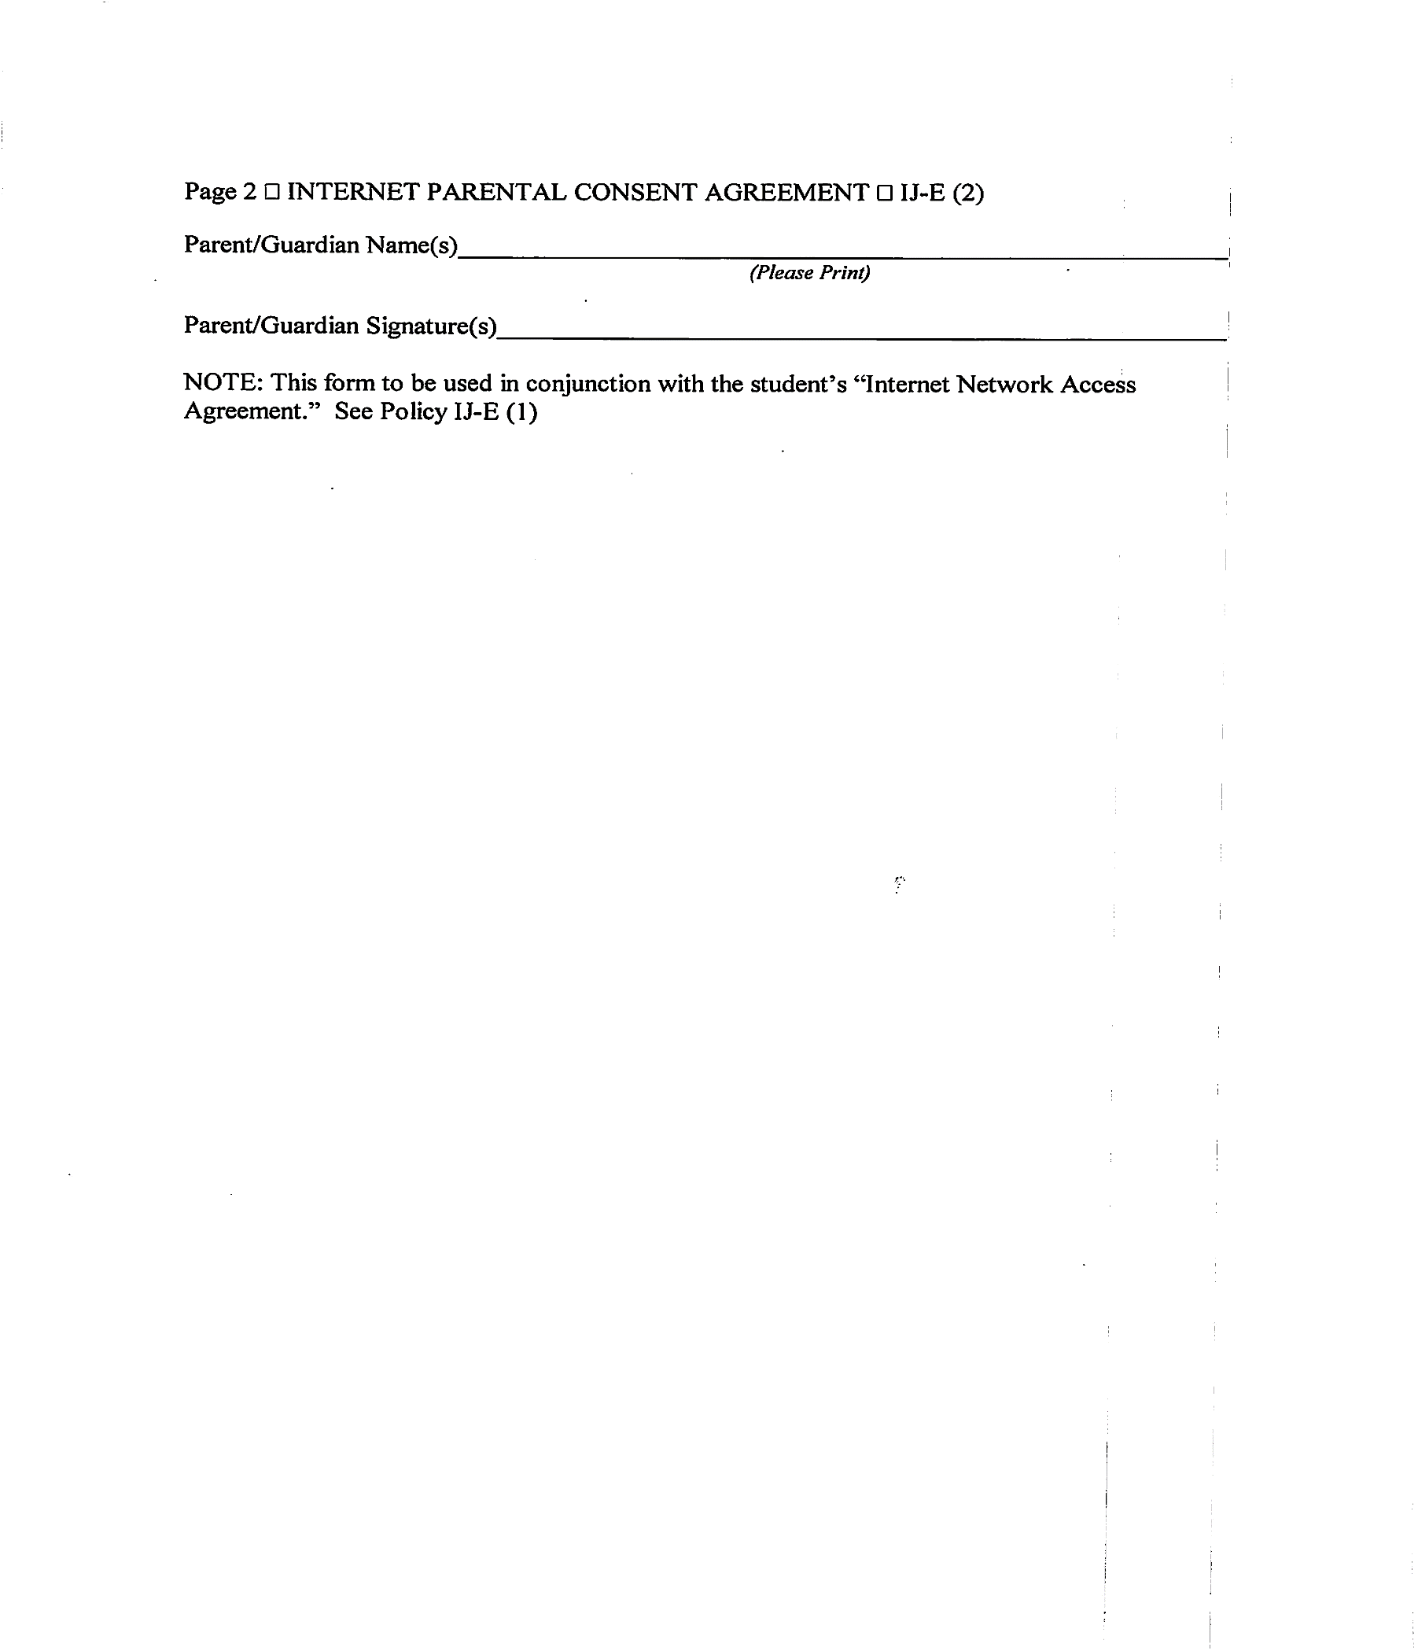
District: | Canton Public School District
Section: | I - Instructional Program
Policy Code: | IJ-R - Internet/Technology Acceptable Use Policy

INTERNET/TECHNOLOGY ACCEPTABLE USE POLICY
The Canton School Board endorses student use of the internet and other district technology for learning and educational research. Use of district technology includes participation in distance learning activities, asking questions of and consulting with teachers, communicating with other students and individuals, and locating material to meet the educational needs of the student.
Students will be educated about appropriate and safe online behavior. All reasonable efforts will be made to ensure that students are not accessing inappropriate or unrelated material. Students are to utilize the district’s computers, networks, and internet services and other district technology for school-related purposes only. Any student who uses district technology for personal or non-academic purposes will be subject to disciplinary action in accordance with district policy, the student code of conduct, and state law.
Students using the internet, district computers, networks, and/or other district technology shall comply with all applicable board policies and administrative procedures. The school board, through its administrative staff, reserves the right to monitor, without prior notice, all computer and internet activity by students. This includes filtering software along with other electronic monitoring systems. While teachers and other staff will make reasonable efforts to supervise and monitor student use of district technology, they must have student and parent cooperation in exercising and promoting responsible use. Staff and students should have no expectation of privacy in their use of district computers or other technology.
The Superintendent or his/her designee reserves the right to eliminate use of the district’s computer systems or other district technology by any student at any time.
Inappropriate communications or other unacceptable uses or abuse of all district technology is prohibited. Specifically prohibited is any illegal use, or use that is a violation of board policies, procedures, or school rules including, but not limited to, those prohibiting harassment, discrimination, bullying, defamation, violence, threatening, infringement of copyright or trademark laws, use involving obscene or pornographic materials, or use that harms the reputation of the school district or its employees or disrupts the educational environment.
This board makes no assurances of any kind, whether expressed or implied, regarding any internet services provided. Neither the individual school nor school district is responsible for any damages the student/user suffers. Use of any information obtained via the Internet is at the student's own risk. This board and school district specifically denies any responsibility for the accuracy or quality of information or software obtained through its services.

PROHIBITION OF OBSCENE MATERIALS
All digital or online resources or any database provided in this district by a vendor or other entity shall contain technology protection measures that:
- Prohibit and prevent a person from sending, receiving, viewing, or downloading materials that are inappropriate or obscene; and
- Block, or otherwise prohibit and prevent, access to obscene and inappropriate materials as defined under MS Code 37-11-81.
INTERNET ACCESS AGREEMENT
In order for a student to gain access to the Internet, the student and student's parent(s) / guardian(s) must sign an Internet Access Agreement.
The superintendent is authorized to amend or revise the following board-approved initial administrative procedure as he/she deems necessary and appropriate consistent with this policy. The superintendent is further authorized to amend or revise the Internet Network Access Agreement with the advice of board counsel.
It must be understood by all concerned that the global and fluid nature of the Internet network's contents makes it extremely difficult for the board to completely regulate and monitor the information received or sent by students. As such, the board cannot assure parents that students will be prevented from accessing undesirable materials or sending or receiving objectionable communications.

CROSS REF.: Policies EI - Computer Software Usage
IJ - Technology and Instruction / Electronic Information Resources
IJB - CIPA Policy-Acceptable Use
IJBD – Responsible Use of District Issued Technology

Original Adopted Date: 12/10/2019 Approved/Revised Date: 07/17/2023

STUDENT CONSENT AND RELEASE FORM

Student’s Name _________________________________ School ___________________

Parental Rights Regarding Student Consent and Release
The Family Education Rights and Privacy Act (FERPA) gives parents certain rights with respect to their children’s education records, including directory information. This means information contained in an education record of a student that would not generally be considered harmful or an invasion of privacy if disclosed. It includes, but is not limited to, the student’s name, address, telephone listing, electronic mail address, photograph, date and place of birth, major field of study, dates of attendance, grade level, enrollment status, participation in officially recognized activities, and sports, weight and height of members of athletic teams, degrees, honors, and awards received, and the most recent educational agency or institution attended.
Unless the parent or guardian notifies the Canton Public School District, consent is implied for the Canton Public School District to release information.
Implied consent includes the release of student directory information, information released by others who received approval from the Canton Public School District, or for non-directory information such as student work, for use in the following ways:
1. On the Canton Public School District Web site:
● The web site will use student’s first name and/or first name and last initial only. Personal information such as home address, phone number, or names of family members will not be used. Any information that indicates the physical location of a student at a given time other than attendance at a particular school or participation in school activities will not be used.
● School work may include, but is not limited to art, written papers, class projects, and computer projects.
2. Any materials printed by the school or the Canton Public School District or printed by publishers outside the Canton Public School District:
● Printed material may include a child’s full name
● Printed material may include, but is not limited to, school directories, yearbooks, programs, brochures, newspaper articles, and print advertisements.
3. In videos produced and broadcast by the Canton Public School District or produced and broadcast by news organizations and others who receive approval from the Canton Public School District.
STUDENT/PARENT HANDBOOK
The Student/Parent Handbook is to help your son/daughter gain the greatest possible benefit from his/her school experience. The district needs your help and cooperation. Please read and discuss the handbook with your child. It is the responsibility of both the parent and the student to be knowledgeable and abide by the standards, policies and procedures of the Canton Public School District. The Student/Parent Handbook is available online www.cantonschools.net
I hereby release the Canton Public School District and those acting with its permission and upon its authority, of and from any liability, responsibility or claim that may arise by reason of any exercise of the authority granted above.
_____ I grant permission for information on my child to be published by the Canton Public School District or to be released to any other publisher outside the Canton Public School District.
_____ I deny permission for information on my child to be published by the Canton Public School District or to be released to any other publisher outside the Canton Public School District.

Parent/Guardian Signature: _________________________________ Date: ___________
The Student Consent and Release Form is available in the Student/Parent Handbook and in the Student Registration Packet.

CONSENTIMIENTO DEl ESTUDIANTE Y FORMA DE LIBERACIÓN

Nombre del Estudiante _________________________________ Escuela_______________
Derechos de los Padres con Respecto al Consentimiento del Estudiante y Liberación
La Ley de Derechos Familiares de Educación y Privacidad (FERPA) da a los padres ceros drenches con respect a los registries de educación de sus hijos, incluso la información de la guía. Esto significa que la información contenida en un expediente de educación de un estudiante que por lo general no se considera dañina o una invasión de la privacidad si es revelada. Esto incluye, pero no limitado a, el nombre del estudiante, dirección, número telefónico, dirección de correo electrónico, fotografía, fecha y lugar de nacimiento, campo principal de estudio, fechas de asistencia, grado escolar, estatus de inscripción, la participación en actividades oficialmente reconocidas y deportes, peso y estatura de los miembros de equipos atléticos, grados, honores y premios recibidos, y la más reciente agencia educativa o institución asistida.
A menos que el padre o tutor notifique al Distrito de las Escuelas Públicas de Cantón y consentimiento ha sido dado al Distrito de las Escuelas Públicas de Cantón para divulgar información. consentimiento tácito incluye la liberación de información de la guía de los estudiantes, la información publicada por otros que recibieron la aprobación del Distrito de las Escuelas Públicas de Cantón, o de información no directamente, tales como el trabajo del estudiante, para el uso de las siguientes maneras:
1. En el Sitio Web del Distrito de las Escuelas Públicas de Cantón:
● El sitio web usara el primer nombre del estudiante y / o la inicial del primer nombre y del apellido solamente. La información personal como dirección, número de teléfono o nombres de los miembros de la familia no se va a utilizar. Cualquier información que indica la ubicación física de un estudiante en un momento determinado que no sea la asistencia a una escuela en particular o la participación en las actividades escolares no se utilizarán.
● El trabajo escolar puede incluir, pero no se limitara al arte, trabajos escritos, proyectos de clase y proyectos de computacion.
2. Cualquier material impreso por la escuela o el Distrito de las Escuelas Públicas de Cantón o impresos por las editoriales fuera del Distrito de las Escuelas Públicas de Cantón:
● El material impreso puede incluir el nombre completo de un niño
● Material impreso puede incluir, pero no limitado a, directorios de la escuela , anuarios, programas, anuncios impresos folletos, artículos de periodic, y publicidad impresa.
3. En los videos producidos y transmitidos por el Distrito de las Escuelas Públicas de Cantón o producida y transmitida por las organizaciones de noticias y otros que reciben la aprobación del Distrito de las Escuelas Públicas de Cantón.
MANUAL PARA LOS ESTUDIANTES/PADRES
El Manual para los Estudiante / Padres es para ayudarle a su hijo / hija obtener el mayor beneficio posible de la experiencia en la escuela. El distrito necesita de su ayuda y su cooperación. Por favor, leer y discutir el manual con su hijo-hija Es la responsabilidad de los padres y del estudiante para estar informados y acatar las normas, políticas y procedimientos del Distrito de las Escuelas Públicas de Cantón. El Manual para los Estudiante / Padres está disponible en los siguientes lugares: en línea www.cantonschools.net, oficina central, oficina de la escuela, libreria de la escuela, y en la Libreria Publica de Canton, 102 Priestley Street in Canton, Mississippi.
Yo libero al Distrito de las Escuelas Públicas de Cantón y quienes actúen con su autorización y en su autoridad, y de toda obligación, responsabilidad o reclamación que pueda surgir con motivo de cualquier ejercicio de la autoridad concedida anteriormente.
_____ Yo doy permiso para obtener información sobre mi hijo que será publicado por el Distrito de las Escuelas Públicas de Cantón o para ser publicado por cualquier otro editor fuera del Distrito de las Escuelas Públicas de Cantón.
_____ Yo niego el permiso para obtener información sobre mi hijo que será publicado por el Distrito de las Escuelas Públicas de Cantón o para ser publicado por cualquier otro editor fuera del Distrito de las Escuelas Públicas de Cantón.
Firma de los Padres / Tutor: _________________________________ Fecha: _________
El consentimiento del estudiante y la forma de liberción está disponible en el Manual del Estudiante / Padre y en el Paquete de Inscripción Estudiantil.

