

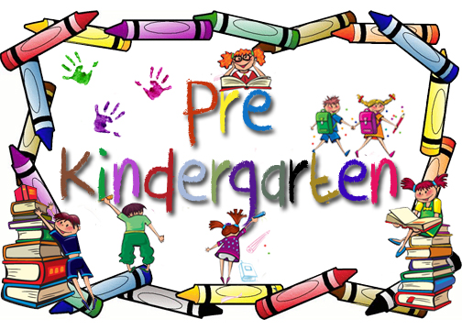

**CANTON PUBLIC SCHOOL PRE-Kindergarten HANDBOOK**

**2023-2024**

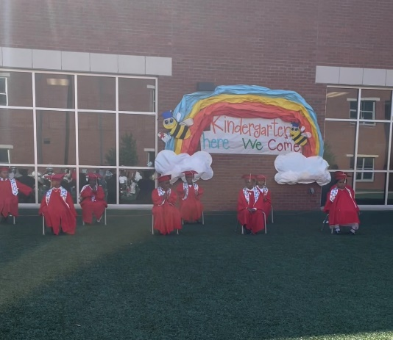 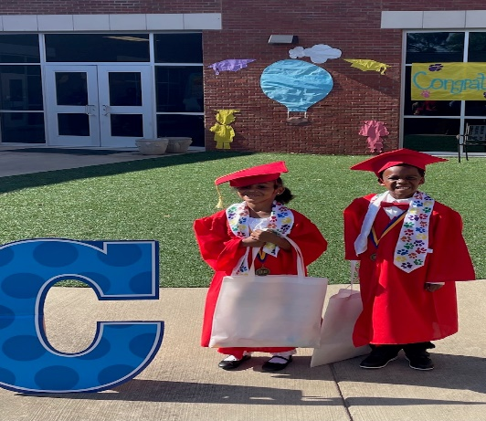

**WELCOME TO PRE-KINDERGARTEN (Pre-K)!**

**Dear Parents,**

Welcome to what will be a fantastic pre-kindergarten year!  As we begin this new school year, we pledge to you, our students and parents, that this will be a wonderful year of engaging, meaningful and rigorous work in our classrooms, along with some fun and special times and events.

During the 2023-2024 school year, we will continue to build upon and refine our foundation of work, with none being more important than continuing to build upon our tradition of preparing students to become well-rounded by educating them both socially and academically. Our staff of highly qualified professional educators is committed to providing students many opportunities --- both inside and outside of the classroom --- for high caliber and quality learning, continual growth, leadership opportunities, and achieving at a high level of excellence!  We pledge that this will be our focus daily, and we invite and encourage you, our students and parents, to work in partnership with us to seize these opportunities.

We know that it can be challenging as students transition from being at home to being in a school environment. This booklet is intended to help you and your child understand and prepare for this new adventure. With your partnership, I am confident that we will prevail in doing so! So, remember to stay on top of *your* ABC’s by checking on your child’s attendance, behavior, and course work. We look forward to working with you this year!

Your partner in education,

Gary Hannah,

Superintendent

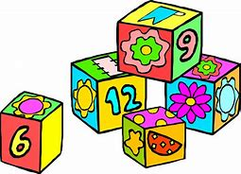

Director’s Message

Dear Early Childhood Family Member:

Thank you for enrolling your child in the Canton Public School District’s Early Childhood Education Program. By choosing to have your child participate in our program, you have made a commitment to invest in your child’s education.

The purpose of this handbook is to help you understand this unique educational program, to explain the goals and objectives and to offer suggestions that will help you and your child be successful in the Pre-Kindergarten/Preschool Program and throughout his or her educational matriculation.

We also want you to know we value your support and input. Never hesitate to contact a member of our early Childhood team who can assist you during your child’s Pre-Kindergarten or Preschool experience. We are pleased to have you and your child as part of our school family.

On behalf of the entire Early Childhood team, we welcome your famiy to the program and we hope this first school year will be the beginning of a lifetime of learning. Thank you for sharing your child with us!

Shoney Harris, Ed.S

Director of Literacy & Early Childhood Education

Parent and Student Acknowledge Form

This Parent Handbook provides inforamtion to the parents of students enrolled in the Early Childhood Pre-Kindergarten program in Canton Public School District.

May signature verifies that I have received a copy of the handbook and I have access to an electronic copy.

I understand that the parent handbook is a work in progress and changes to this document can be made throughout the school year.

Student (Print): _________________________________________________________________

Parent or Guardian (Print):________________________________________________________

Parent or Guardian Signature:______________________________________________________

Date:_________________________________________________________________________________

**After reviewing this handbook, please sign and return this form to your child’s teacher.**

**WHAT IS PRE-KINDERGARTEN?**



*Pre-Kindergarten is a program designed to meet the needs of children ages 4 or 5. It offers the opportunity to build a solid foundation for academic, social, physical, emotional, and motor development. To build this foundation, children are prepared using the Mississippi College Career Readiness Standards for developmental readiness and academic readiness. Through whole class, small group, partner, and individual learning activities, pre-kindergarteners will develop into successful, independent learners who are well-prepared for first grade and beyond.*

SECTION 1

**PRE-KINDERGARTEN PROGRAM GOALS**

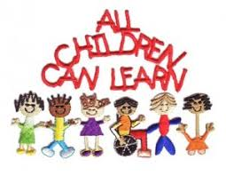

1. **One of the pre-kindergarten program’s goals is to prepare students to be READY in four areas:**

**1. Academic Development**

* 1. Develop thinking and learning strategies
  2. Develop awareness of language and literacy
  3. Develop listening, speaking, and reading abilities
  4. Develop writing abilities
  5. Develop number, spatial, and statistical sense
  6. Develop sense of relationships and patterns
  7. Develop an understanding of the world around them

1. **Social and Emotional Development**
   1. Develop a positive and realistic self-concept
   2. Develop independence
   3. Share, co-operate and learn from others
2. **Physical and Motor Development**
   1. Learn and practice safety
   2. Take care of and respect his or her body
   3. Develop movement and coordination of the body and movements
   4. Participate in and enjoy movement

**B. Another pre-kindergarten program goal is to prepare families to be READY in five areas:**

1. **Safe and Consistent Environment**
2. Being able to reach you in the event of an emergency- contact numbers
3. Consistent mode of transportation to and from school
4. Notifying school of changes
5. Authorized individuals having access to your child
6. To check-out students, individual MUST have a valid photo ID and notification from parent and guardian
7. **Promote Good Health**
   1. Ensure your child gets enough sleep (10-12 hours)
   2. Eat a balanced diet (especially breakfast)
   3. Develop habits of cleanliness and independent hygiene
   4. Have eyesight, hearing, teeth, and general health checked
   5. Update immunizations as directed
   6. Keep them home when they are ill (provide contact numbers to the school)
   7. Call school to inform absences
8. **Steady and Supportive Relationships** 
   1. Invest time and attention
   2. Understanding of your child’s preferences and hobbies
   3. Building a positive, loving home environment
9. **Home Responsibility**
   1. Making their bed and keeping room tidy
   2. Dressing themselves and choosing their own clothes
   3. Answering the telephone and dialing numbers
   4. Assigning chores
   5. Putting their shoes on independently
   6. Cleaning up after eating
10. **Parent and School Collaboration**
    1. Attending Parent and Teacher Conferences
    2. Visiting your child’s classroom
    3. Volunteering in child’s classroom and school
    4. Attending your child’s school PTO meetings
    5. Volunteering your talents, skills, and profession

**REQUIREMENTS FOR ENROLLMENT**

SECTION 2

1. **Entrance Age**
2. **Required Age**

A child is eligible for a pre-kindergarten program if they reach four years of age on or before September 1.

1. **Required Documentation**

A birth certificate and current immunization record (Form 121) are required for all pre-kindergarten students and shall be presented to the proper school authority.

1. **Requirements for enrollment of children in public school:** [**MS Code § 37-15-9 (2013)**](https://law.justia.com/citations.html)

(1) Except as provided in subsection (2) and subject to the provisions of subsection (3) of this section, no child shall be enrolled or admitted to any pre-kindergarten which is a part of the free public school system during any school year unless such child will reach his fifth birthday on or before September 1 of said school year, and no child shall be enrolled or admitted to the first grade in any school which is a part of the free public school system during any school year unless such child will reach his sixth birthday on or before September 1 of said school year. No pupil shall be permanently enrolled in a school in the State of Mississippi who formerly was enrolled in another public or private school within the state until the cumulative record of the pupil shall have been received from the school from which he transferred. Should such record have become lost or destroyed, then it shall be the duty of the superintendent or principal of the school where the pupil last attended school to initiate a new record.

(2) Subject to the provisions of subsection (3) of this section, any child who transfers from an out-of-state public or private school in which that state's law provides for a pre-kindergarten enrollment date subsequent to September 1, shall be allowed to enroll in the public schools of Mississippi, at the same grade level as their prior out-of-state enrollment, if:

(a) The parent, legal guardian or custodian of such child was a legal resident of the state from which the child is transferring;

(b) The out-of-state school from which the child is transferring is duly accredited by that state's appropriate accrediting authority;

(c) Such child was legally enrolled in a public or private school for a minimum of four (4) weeks in the previous state; and

(d) The superintendent of schools in the applicable Mississippi school district has determined that the child was making satisfactory educational progress in the previous state.

1. **Compulsory-School-Age and Withdrawal: Mississippi Code § 37-13-91**

(f) “Compulsory-school-age child” means a child who has attained or will attain the age of six (6) years on or before September 1 of the calendar year and who has not attained the age of seventeen (17) years on or before September 1 of the calendar year; and shall include any child who has attained or will attain the age of four (4) years on or before September 1 and has enrolled in a full-day public school pre-kindergarten program.

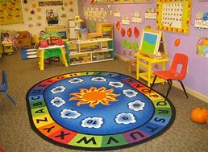

SECTION 3

**CURRICULUM, MATERIALS, AND ASSESSMENTS**

1. **Curriculum**

Pre-Kindergarten programs use a research- and evidence-based comprehensive curriculum that is designed to prepare children to be ready for kindergarten, with emphasis in early literacy, and is aligned with the Mississippi Early Learning Standards for Classrooms Serving Three-Year-Old Children and the Mississippi Early Learning Standards for Classrooms Serving Four-Year-Old Children. Mississippi Code Annotated § 27-103-159 defines “evidence-based program” as “a program or practice that has had multiple site random controlled trials across heterogeneous populations demonstrating that the program is effective for the population.” Additionally, the curriculum contains thematic units of activities and ideas designed to provide children the opportunities and experiences needed to master the performance standards in the Mississippi Early Learning Standards for Classrooms Serving Three-Year-Old Children and the Mississippi Early Learning Standards for Classrooms Serving Four-year-Old Children. Visit www.mdek12.org/EC for a current listing of approved curricula. Lesson planning documents should reflect Early Learning Standards that are targeted through each lesson and learning center activities that are used throughout the thematic unit.

1. **Learning Centers**

a. **Daily Use** Instructional delivery shall be organized primarily using a variety of learning centers. A minimum of five (5) different learning centers shall be organized, arranged, and labeled so they are accessible to all children for a minimum of 120 minutes per day in full day programs and 60 minutes in part/half day programs. The MDE recognizes the definition of learning centers as identified in literature as “distinct areas in a classroom that offer various materials and opportunities for hands-on learning at individually appropriate levels”. (Copple & Bredekamp, 2006). In addition, NAEYC (2007) publications state that learning centers:

• Engage students in learning

• Promote development of the whole child Early Learning Guidelines for Classrooms Serving Three- and Four-Year-Old Children 3

• Integrate multiple subject matters so that learning happens in a meaningful context

• Assess student understanding and knowledge through observation and authentic assessment practices

• Foster a love of learning

Learning centers provide children with hands-on opportunities to practice learning and thematic unit concepts. Learning relies heavily on experiential, hands-on activities. Each early learning classroom must include the following:

• Primary Centers for each classroom contain a book/library center, math/manipulative center, and creative art center.

• Additional integrated learning centers are added to address child interest and support current learning topics so that at least five (5) integrated learning centers are available.

• Available space in learning centers should be sufficient to accommodate simultaneous use by the number of children enrolled in the classroom while maintaining appropriate numbers of children in each learning center.

• Children have access to fiction and non-fiction books and writing materials during learning center time and throughout the day that are appropriate to the child’s developmental state.

• Worksheets are inappropriate for use at this developmental level, and should not be a part of the curriculum.

• Learning centers should offer a variety of activities and materials for simultaneous use by children.

In addition to the three (3) primary learning centers identified in this section, additional learning centers may include those from the list below to meet the minimum requirement of five (5) integrated learning centers per classroom. Except for the three (3) primary centers identified previously, the remaining learning centers shall be rotated and changed throughout the year. The following is a list of possible learning centers.

• Science Center

• Oral Language/Phonemic Development Center

• Cooking Center Early Learning Guidelines for Classrooms Serving Three- and Four-Year-Old Children 4

• Blocks, Wheel Toys, and Construction Center

• Sand and/or Water Center

• Woodworking Center

• Music Center

• Listening Center

• Dramatic Play

• Creative Writing Center

• Social Studies Center

• Technology Center

• Motor Development Center

b. **Space Limitations** If space is limited, some of the centers may be combined.

c. **Use of Classroom Technology** Computers and similar technological devices are only to be used in the classroom as instructional tools.

1. **Resource Materials** Teachers use, at a minimum, the resources developed by the Mississippi Department of Education in curriculum planning such as the Mississippi Early Learning Standards for Classrooms Serving Three-Year-Old Children and/or the Mississippi Early Learning Standards for Classrooms Serving Four-Year-Old Children, Mississippi Teaching Strategies for Classrooms Serving Four-Year-Old Children, and the Developmental Checklist for Three and Four-Year-Old Students. Other resources such as the Kindergarten Readiness Assessment: Next Steps for Districts, School District Pre-K Determination Guidance, Mississippi Guide to Starting a Title I Pre-K Program and the Kindergarten Transition Plan are also available for programs to access. These materials can be found at [www.mdek12.org/ec](http://www.mdek12.org/ec).
2. **Educational Materials**
3. Requirement for Equipment and Educational Materials The initial expenditure for any new equipment, instructional materials, and consumable supplies must be adequate to equip a classroom of a maximum capacity of 14 three-year-old or 20 four-year-old children. Classroom teachers should select instructional materials that are most suited for their classrooms and the developmental needs of their students.
4. Requirement for Instructional and Consumable Materials the Pre-Kindergarten program will replenish the consumable supplies and instructional materials in each classroom at least once per year. Additional information on materials can be found at www.mdek12.org/ec in the document titled “Mississippi Guide to Starting a Title I Pre-Kindergarten Program.”

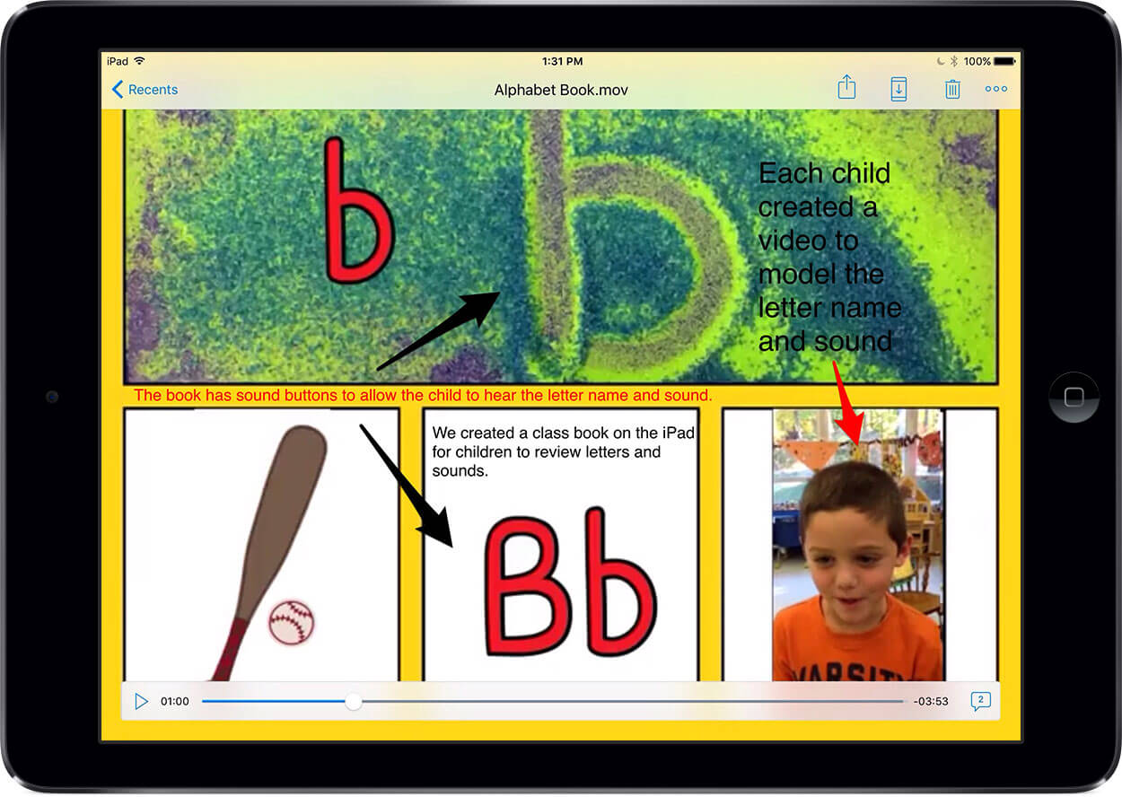

1. **Assessment**
2. **Requirement for Assessment and Screening**

A continuous evaluation through a variety of techniques, procedures, and tools is used to determine each child’s needs. Information obtained from ongoing assessments is reflected in lesson plans to address children’s needs collectively, as well as individually.

• All schools conduct vision and hearing screenings for all Pre-Kindergarten students within the first 45 days of the beginning of school.

• All physical or developmental screening results are reviewed and all necessary education or developmental referrals made within 30 days of the initial screening.

• Programs will conduct the comprehensive early learning observational assessment with Pre-Kindergarten children as described in the program assessment section below.

• While the Multi-Tiered System of Supports (MTSS) is not required for prekindergarten students, districts can develop and utilize their own procedures for determining what intervention services, if any, Pre-Kindergarten students may receive, bearing in mind that interventions cannot be used to delay or deny an evaluation for special education services to a student who is suspected of having a disability.

• It is recommended that students who show deficits on developmental screenings be given an intervention, which may be administered and documented by the classroom teacher. The student can then be given a follow-up screener to determine if the intervention was successful. If the student has not made sufficient progress, an additional intervention may be put in place, or the student may be referred for an evaluation for special education services, if data collected support the suspicion of a disability. When making a referral, districts should follow their Child Find procedures.

1. **Recommended Screening**

A comprehensive health screening (Early and Periodic Screening, Diagnosis, and Treatment-EPSDT) or a standard physical conducted by a child’s health care provider or health department is recommended for all pre-kindergarten students. EPSDT screenings/standard physicals should be conducted within 45 days of the beginning of school by either a private health care provider of the parents’ choosing, or through school resources such as school nurses, or the local Department of Health. Parents are strongly encouraged to attend screenings conducted at the school. A standard physical form is submitted for all screenings conducted by a private health care provider.

1. **Requirement for Standardized Testing**

All four-year-old-students participating in public Pre-Kindergarten shall be administered the state approved kindergarten readiness assessment. Paper and pencil standardized tests are not appropriate measures for three or four-year-old children. Any technology based assessment should be administered using touch-based technology devices. Children should know how to use a mouse. Therefore, multiple opportunities to practice using a mouse must be given.

1. **Requirement for Individualized Assessments**

School districts containing Pre-Kindergarten programs collaborate with Mississippi’s state-recognized birth to three-year-old provider, First Steps, to formulate a plan regarding services. This plan ensures any child currently receiving services continues to receive services based on the Individualized Family Service Plan (IFSP) or an Individualized Education Plan (IEP). Each school district should follow Child Find procedures as stated in Individuals with Disabilities Education Act (IDEA). Children who are determined eligible shall receive services as stated in the child’s IEP.

1. **Requirement for Documentation**

Teachers use observational checklists to measure the child’s progress according to the Mississippi Early Learning Standards for Classrooms Serving Three-Year-Old Children and the Mississippi Early Learning Standards for Classrooms Serving Four-Year-Old Children (e.g. curriculum based, teacher-generated, or MDE developed Pre-Kindergarten checklists). At least one additional method of assessment is used in real time through technology for children in a four-year-old program (e.g. Mississippi’s Prekindergarten Readiness Assessment). Principals shall ensure that prekindergarten teachers discuss child progress with kindergarten teachers throughout the year.

At a minimum, each classroom serving four-year-old children must develop a transition folder to follow each child to kindergarten. The folder must contain the following:

• End-of-year Kindergarten Readiness Assessment Score/Summary Sheet Early Learning Guidelines for Classrooms Serving Three- and Four-Year-Old Children 7

• End-of-year developmental screening results (if the classroom completes a spring or end-of-term screening).

• End-of-year results from other assessments used in the classroom

• A school-issued final report card/skills checklist OR a completed Developmental Checklist for 4-Year-Old Students (located here: [www.mdek12.org/EC)](http://www.mdek12.org/EC))

• A child information sheet containing some or all of the following (a sample sheet is located here: [www.mdek12.org/EC)](http://www.mdek12.org/EC)):

o Child’s name, date of birth, preferred name, photo, languages spoken

o Parents’ names (and/or other adults/ caregivers), address, phone, and preferred time and way to contact (in accordance with school policy)

o Child’s favorite things (activity, toy, food, color, book, center, etc.)

o Child’s play and learning styles

o Child’s skills and proficiencies

o Child’s areas of growth and what they do not like to do

o Child’s personality/temperament traits

Work samples (2 or 3 samples that demonstrate the child’s capabilities). May include:

o Free art

o Guided art

o Writing sample

o Learning center products (e.g., block construction)

**Organizational Procedures and Staff**

**A. ORGANIZATION**

1. **Requirement for Teacher-Child Ratio**

The teacher-child ratio for classrooms serving three-year-olds is 1:7 maximum. The teacher-child ratio for classrooms serving four-year-olds is 1:10 maximum. If an assistant teacher is assigned in the pre-kindergarten classroom for the entire day, the teacher-child ratio for classrooms serving three-year-olds does not exceed 2:14 maximum at any time, while the teacher-child ratio for classrooms serving four-year-olds does not exceed 2:20 maximum at any time. Classrooms of mixed three and four-year-olds follow the Early Learning Guidelines for Classrooms Serving Three-Year-Olds including the teacher child ratio. The maximum classroom group size does not exceed 14 children maximum at any time.

1. **Requirement for Length of School Day and Term**

The length of the full-day school year will be no less than 1,080 instructional hours in no less than a 180-day school year, which results in six hours of instruction per day. The length of the half-day school day will be no less than 540 instructional hours in no less than a 180-day school year, which results in three hours of instruction per day. {Mississippi Code Annotated § 37-13-63 & 67}

1. **Requirements for Instructional Day**

The instructional day includes all aspects of the child’s day (e.g. learning center activities, large and small group activities, individual instruction, and guided physical activity). At a minimum, the instructional day in a full-day program includes 360 instructional minutes (6 hours), 40 minutes of physical activity, 120 minutes of learning centers, and 30 minutes of quiet/rest time. At a minimum, the instructional day in a half-day program includes 180 (3 hours) instructional minutes, 20 minutes of physical

activity, 60 minutes of learning centers, and quiet/rest time as appropriate for the children. Additional information on these requirements is in Section II of this document.

1. **Requirements for Physical Activity**
2. **Full Day Program** Applies to programs offering six or more hours of instruction per day. Children engage in physical activity for a minimum of 40 minutes, and a maximum of 60 minutes during a full-day program. The minutes assigned to physical activity do not have to occur continuously or consecutively. Weather permitting, physical activity takes place outside. Outdoor play experiences will occur unless a weather advisory is in effect, or the play space is unsafe due to damp or wet conditions. If outdoor play is not possible per one or more of these conditions, teachers provide 40 to 60 minutes of indoor physical activity documented in lesson plans.
3. **Half Day Program** Applies to programs offering fewer than six hours of instruction per day. Children engage in physical activity for a minimum of 20 minutes, and a maximum of 30 minutes during a half-day program. The minutes assigned to physical activity do not have to take place continuously or consecutively. Outdoor play experiences will occur unless a weather advisory is in effect, or the play space is unsafe due to damp or wet conditions. If outdoor play is not possible per one or more of these conditions, teachers provide 20 to 30 minutes of indoor physical activity documented in lesson plans.
4. Requirement for Quiet Time Children in full-day programs engage in a minimum of 30 minutes and a maximum of 60 minutes of quiet time daily. Children in part-day programs that are less than six (6) hours in length are not required to rest, but are provided quiet time as appropriate. Activities during quiet time may include individual activities, looking at books/ reading, listening to books on tape, drawing, or resting, as appropriate for each individual student.
5. Requirement for Nutritional Provision All full-day programs provide a minimum of one meal per day. Meals meet nutritional requirements identified in the USDA National School Breakfast/Lunch Program Guidelines or the USDA Child and Adult Care Food Program (CACFP) Guidelines, whichever is applicable.

***7.SAMPLE* Full Day Pre-Kindergarten Schedule**

|  |  |  |  |
| --- | --- | --- | --- |
| **Time** | **Activity** | **Minutes** | **Instructional Time** |
| 7:30-8:00 | Phonics First | 30 minutes | Yes |
| 8:00-8:55 | Story Time/Move to Learn/Phonics First | 55 minutes | Yes |
| 8:55-9:10 | Story Time/Comprehension | 15 minutes | Yes |
| 9:10-11:20 | Small Rdg. & Math Group Centers | 120 minutes | Yes |
| 11:20-11:40 | Lunch | 20 minutes | No |
| 11:40-12:45 | Whole Group Rdg. | 55 minutes | Yes |
| 12:45-1:30 | Quiet Time | 30 minutes | Yes |
| 1:30-1:50 | Speaking Listening/Mini Lesson | 35 minutes | Yes |
| 1:50-2:10 | Physical Education | 30 minutes | No |
| 2:10-2:30 | Math Whole Group | 30 minutes | Yes |
| 2:30-3:30 | Dismissal/Teacher Planning | 60 minutes | No |

*Meal times for this age group should be a learning time. Promotion of different skills can be learned during meal time such as taking turns, pre-reading and pre-math skills, problem solving skills, fine motor skills, etc. Teachers should discuss concepts with children that support social and emotional, physical development, speaking and listening, approaches to learning and science standards.

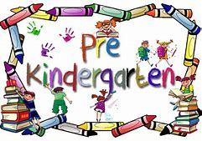

**B. STAFF**

SECTION 4

1. **Required Certification for Teachers for August 2020**

The pre-kindergarten teacher credentialing will change effective August 1, 2020.

By August 1, 2020, 50% of teachers in each district will meet the requirements described below. By August 1, 2022, 100% of regular education Pre-Kindergarten teachers in each district will meet the requirements described below.

Special Education Pre-Kindergarten teacher requirements are newly announced within the Mississippi Early Learning Guidelines for Classrooms Serving Three- and Four-Year-Old Children, therefore; 50% of Special Education classroom teachers must meet this requirement by August 1, 2020, and 100% of Special Education classroom teachers must meet this requirement by August 1, 2022.

The Office of Educator Licensure will continue to oversee the obtainment of endorsements. The Office of Early Childhood will be responsible for any other components of qualification.

1. **Requirement for Professional Development**

All teaching staff (teachers and assistant teachers) and program administrators complete at least fifteen contact (15) hours of professional development annually for program instructional staff specific to the education of prekindergarten children. Administrators that manage pre-kindergarten teachers shall gain the required hours of professional development through online or on-site training. This variety of content could include program administration, parent engagement, and early childhood instructional content approved or offered by the Mississippi Department of Education and/or Mississippi Department of Health.

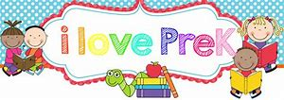

**FAMILY ENGAGEMENT AND TRANSPORTATION**

SECTION 5

**Family Engagement and Transportation**

**A. GUIDELINES FOR FAMILY ENGAGEMENT**

Families are viewed as a partner and the child’s first teacher. Teachers provide parents with information and resources that could help their children. Parents have opportunities to volunteer in the classroom and participate in enrichment opportunities.

1. Requirement for Family Handbook Each pre-kindergarten program develops and distributes a family handbook that addresses the program philosophy, goals and specific information unique to the program (e.g. curriculum, credentials, and assessments.) This information may be included in the district handbook, but should be clearly identified for parents.

2. Requirements for Family Communication Teacher/parent conferences are conducted at least three times during the pre-kindergarten year to inform parents or guardians of child’s progress. The first parent conference at the beginning of the year consists of an information gathering session from the parent. Additional winter and spring conferences consist of a progress update to the parent. If documented attempts to meet with parents or other responsible persons fail, telephone conferences can be substituted. Communication is conducted on a regular basis. Communication between school and home could consist of notebooks/folders, newsletters, conferences, emails, and phone calls.

3. Requirements for Volunteer Participation Parents, guardians, and community members are encouraged to participate in various activities such as developing learning games for home or classroom use, sharing information with the class about their work skills or profession, or sharing their talents through conducting music and/or art activities. Volunteers are not in the classroom without a teacher or assistant teacher present and are not used to meet the minimum adult-to-child ratio. Volunteers that serve in a school more than 120 hours per school year participate in an orientation session, sign a confidentiality agreement, and consent to a background check that is conducted by the district.

**B. TRANSPORTATION**

1. Requirement for Transportation

All transportation is optional except for children with IEPs. Transportation requirements regarding children with IEPs are determined by the IEP Committee.

1. Requirement for School Bus Safety All pre-kindergarten programs choosing to transport children adhere to Mississippi Code Annotated § 37-41-3. All liability and related expenses are the responsibility of the pre-kindergarten program. The National Highway Transportation Safety Association (NHTSA), Federal Code: 45 CFR 1310.15 (a), requires that all head start children, children preschool age or younger ride in Child Safety Restraint Systems (CSRS). Child Safety Restraints include car seats, safety vests or built in child restraints such as seat belts. In addition to the National Highway Transportation Safety Association (NHTSA) Guidelines, the following caregiver ratio should be followed when transporting children.

• If five (5) to sixteen (16) Pre-Kindergarten children are being transported on a bus, one (1) caregiver in addition to the driver should be on the bus.

• If seventeen (17) to thirty-two (32) pre-kindergarten children are being transported on a bus, two (2) caregivers in addition to the driver should be on the bus.

• Caregivers should be 18 years of age or older and an agency employee.

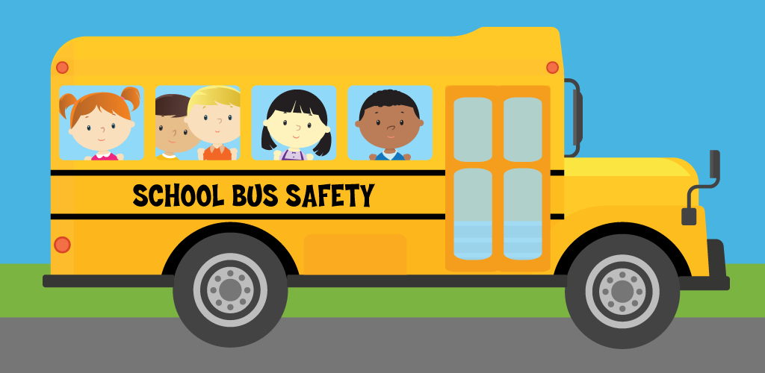

**Parent Teacher Conference**

Parent-Teacher Conferences

Teacher conferences are opportunities to report your child’s progress, and for the teacher and the parents to get acquainted. The teacher and parent discusses how they can work together to enable the child has a successful school year. Parent-teacher conferences are always welcomed and scheduled throughout the year. Your attendance is strongly encouraged.

**Grading**

Our Early Childhood program does not issue number grades for our early learners. However, during parent- teacher conferences, your child’s teacher will provide you with the Mississippi Early Learning Standards Checklist, Letter Grade Report Cards, Kindergarten Readiness Report, Renaissance, Brigance, MKAS 2, and goals pages from your child’s Individual Education Plan (IEP).

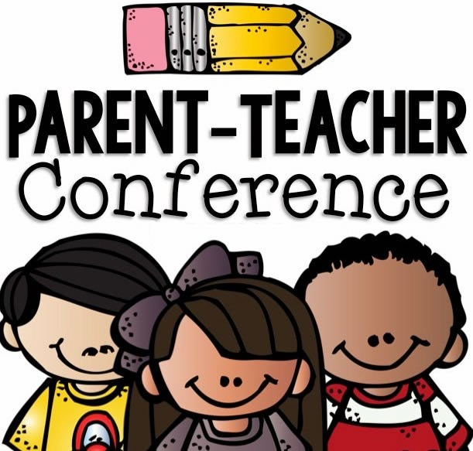

**Family Guide**



**Family Guide to Mississippi’s Early Learning Standards for Four-Year-Old Children**

The Mississippi Early Learning Standards provide the foundation for instruction in classrooms as teachers use these goals to plan instruction and activities for your child. The following is a variety of activities you can use at home to extend your child’s learning. For a complete listing of the standards, please visit our website at www.jackson.k12.ms.us.

**Language and Literacy**

|  |  |
| --- | --- |
| **Children will develop skills in listening for a purpose** | |
| In the classroom, your child may… | Ideas to support your child at home… |
| Follow along and respond appropriately to music and movement activities such as the “Hokey Pokey”.  Respond verbally to books and stories  Listen to books or stories on CD at the listening center. | Play some classic games like “Simon Says” or “Mother May I?” “Give 1-step commands at first and then progress to 2 or 3 steps. “Simon says turn around then clap your hands then touch your toes.”  Reads a favorite story together and ask your child to give a signal each time he/she hears a particular word. For example, “Clap your hands when you hear me say the word bear.” |
| **Children will learn to discriminate the sounds of language** | |
| In the classroom, your child may… | Ideas to support your child at home… |
| Identify common environment sounds or animal sounds.  Clap hands for syllables in names or other familiar words.  Substitute different beginning sound for common words.  Repeat finger plays and poems such as “Humpty –Dumpty” | Go outside and identify sounds you hear.  Teach your child some hand clapping chants or jump rope rhymes you remember from childhood.  Play silly rhyming games and substitute sounds.  Recite nursery rhymes together. Emphasize the rhythm and rhyme that you hear. |
| **Children will develop skills in listening for a purpose** | |
| In the classroom, your child may… | Ideas to support your child at home… |
| Create a story for a wordless book.  Help create a language experience charts after participating on a field trip. | Talk to your child while you are engaged in household activities like cooking, gardening or fix-it chores. Explain what you are doing and tell them the names of the tools you are using. Spatula, spade or wrench will soon become part of your child’s growing vocabulary.  Discuss the day’s events after your return from an outing or special event. |

**Language and Literacy**

|  |  |
| --- | --- |
| **Children will develop expressive language (speaking) skills** | |
| In the classroom, your child may… | Ideas to support your child at home… |
| Ask questions for information and to solve problems.  Engage in turn taking conversations.  Tell real or make-believe stories. | Give your child lots of opportunities to engage in conversation with adults.  Let them order for themselves in a restaurant or answer the telephone using phrases you have rehearsed ahead of time.  Create silly stories together while you are riding in the car or while you are waiting at a restaurant. |
| **Children will learn to discriminate the sounds of language** | |
| In the classroom, your child may… | Ideas to support your child at home… |
| Use puppets or flannel board to retell a story.  Identify letters using alphabets playdough cutters.  Discuss the characters in a story. | Practice reading environment print- street signs, store names, favorite foods.  Cut out logos from the ad section of the newspaper or the grocery store circular. Paste them on paper or put them in a photo album to make a book that your child will love to read often.  Discuss books with your child after reading them together. Ask “How” and “Why” questions to extend their learning.  Use newspaper and magazines for letter find activities. Children love to find and circle letters in their names. |
| **Children will develop skills in listening for a purpose** | |
| In the classroom, your child may… | Ideas to support your child at home… |
| Uses scribble writing and letter-like forms.  Copy words cards at the writing center. | Invite your child to “write when you write”.  Let your child write on old calendars, order forms, check registers or grocery lists. Provide a “grown-up” pen or pencil.  Encourage all forms of writing, from scribbling to forming letters. |

**Mathematics**

|  |  |
| --- | --- |
| **Children will develop an understanding of numbers** | |
| In the classroom, your child may… | Ideas to support your child at home… |
| Count in finger plays or rhymes.  Match blocks with animals in the block center in one-to-one correspondence.  Count sets of objects during group time or independent play.  Participate in putting together large floor puzzles. | Build one-to-one correspondence by letting your child set the table. Show him how to put one plate, one cup and fork at each place.  Develop the concept of part to whole by doing puzzles. Make your own puzzles by cutting apart magazine pictures and gluing them back together again.  Encourage counting frequently in daily routines, such as counting the forks as you put them away. Create games around counting common objects, such as counting the number of doors, windows, telephones in your home.  Choose books from your local library that encourage counting. |
| **Children will sort and classify objects** | |
| In the classroom, your child may… | Ideas to support your child at home… |
| Sort the counting objects into groups according to color or size.  Sort through a box of classroom buttons and makes up rules for organization. | Let your child put away flatware by sorting all the knives, forks and spoons.  Have your child help sort laundry before you wash by putting all the socks in in a pile, all the shirts in a pile, and all the towels in a pile.  Let your child play with collections of similar items, such as a box of shells or buttons. Have your child tell you how they chose to group and organize them. |

**Mathematics (cont.)**

|  |  |
| --- | --- |
| **Children will create and duplicate simple patterns** | |
| In the classroom, your child may… | Ideas to support your child at home… |
| Snap, clap, or stomp a rhythmic pattern.  Create a pattern using manipulative toys, such as peg boards, or color block.  Recognize patterns in the environment. | Point out the way items are arranged at the grocery store. “Look, here is where all the cereal goes. And all of the frozen food is over here.”  Let your child help you put away groceries according to a plan- all the cans together, all the refrigerated items together.  Play some music with a strong beat and clap hand and knees in an alternating pattern. Or face each other and clap your hands together and then clap your own hands. Say the pattern together, “Clap together, clap, together, clap, together”. Add a third motion to increase the difficulty-clap, together, knees, clap, together, knees. |
| **Children will develop a sense of space and understanding of basic shapes** | |
| In the classroom, your child may… | Ideas to support your child at home… |
| Find common shapes in the environment.  Combine the unit blocks to make new shapes.  Use positional words such as over, under, behind. | Make a SIGN-BINGO game by drawing shapes on a piece of paper- circle, square, triangle, and octagon. Then watch for those shapes in signs as you ride along. When you spot a triangular YIELD |
| **Children will develop measuring skills** | |
| In the classroom, your child may… | Ideas to support your child at home… |
| Measure water in the sensory table.  Place objects in order according to size.  Use classroom | Cook together and allow your child to measure ingredients. Or put a set of measuring cups and spoons in your child’s tub. Encourage him/her to fill and empty the cups. Ask which hold more? Pour from one cup to the other. How many small cups does it take to fill a bigger cup?  Provide your child with objects such as paperclips to measure items in your household…. Whose shoe is longer? Dads or brothers? |

**Approaches to Learning**

|  |  |
| --- | --- |
| **Children will develop skills in initiative and exploration** | |
| In the classroom, your child may… | Ideas to support your child at home… |
| Select new activities during free play or center time.  Make patterns using colored feathers and sticks.  Complete classroom chores without being asked.  Take initiative to create and complete a project without adult assistance.  Organize outdoor game to play with friends. | Encourage your child to create and complete a project by herself/himself.  Provide a wide variety of materials for him/her to explore, including books on a range of topics.  Encourage him/her to try new things.  Prompt him/her to ask questions. |
| **Children will develop skills in attentiveness and persistence** | |
| In the classroom, your child may… | Ideas to support your child at home… |
| Read a book his/her teacher has read many times in class.  Tie her/his friend’s shoelaces when they become untied.  Walk all the way across the balance beam on the playground.  Race with friends to zip jacket faster.  Build a tall tower in the block area attempting several times to balance a long block on the top.  Attempt to draw a picture of an animal he/she saw on a recent class trip, sticks with the task until the picture is completed. | Recognize, point out, and reward persistence.  Demonstrate how he/she can set out to master something and move through setbacks to do so.  Resist solving problems for him/her. Try to let them figure it out and step in only when you are absolutely certain that he/she has done all they can. |

**Science**

|  |  |
| --- | --- |
| **Children will use processes of science to increase understanding of the environment** | |
| In the classroom, your child may… | Ideas to support your child at home… |
| Observe collections of natural items in the science area.  Identify objects by touch. | Go on a nature walk and collect small items as you walk along. Try to collect several samples of each item- leaves, rocks, or twigs. When you get home, ask your child to look carefully at each rock, for example and find ways that they are different- shape, color, size. |
| **Children will develop a sense of space and understanding of basic shapes** | |
| In the classroom, your child may… | Ideas to support your child at home… |
| Identify healthy foods.  Sort the plastic food in the dramatic play area into groups of fruit and vegetables.  Discuss safety rules for the playground. | Talk about the different colors of healthy foods.  Make a simple chart and have your child color in a square for each food she wats during a day- a brown square for cereal or a green square for broccoli. At the end of the day, have him/her decide if they “ate a rainbow”. |
| **Children will develop measuring skills** | |
| In the classroom, your child may… | Ideas to support your child at home… |
| Draw a picture of the weather outside.  Read an article thermometer and record observation in a weather journal. | Look at the night sky for several weeks around the same time and locate the moon. Is it behind a tree, over the garage, or across the street? Does it change place? Does it seem higher or lower in the sky? Does it change shapes? Invite your child to draw a picture showing all the different ways he has seen the moon.  Talk to your child about the weather. Does it feel hot, cold, or windy? Or is it cloudy or rainy? |

**Science (cont.)**

|  |  |
| --- | --- |
| **Children will learn about life science** | |
| In the classroom, your child may… | Ideas to support your child at home… |
| Observe the life cycle of insects or amphibians.  Use picture cards and match animals with their offspring.  Assist with planting a tree or other plant. | Look under rocks or around the foundation of your house to discover the tiny crustaceans called “Roly Polies” or “pull bugs”. Put them in a plastic jar lid with some soil and a small rock and watch them move around. Talk about what all living things have in common – they move, breathe, eat. Ask your child why he thinks they are called “pill bugs”. (They curl up in a ball when they are touched.). After an hour or so, put them back where you found them. |
| **Children will learn about physical science** | |
| In the classroom, your child may… | Ideas to support your child at home… |
| Describe how water flows through a tube in the sensory table.  Describe the difference between liquid and solid objects. | During bath time, provide several different objects for your child to play with in the tub- a rubber duck, a metal spoon, and a plastic bowl, for example. Talk about why some sink and some float. Do some “experiments” to see if you can change what they do. Fill the bowl with water, for example, to see if it will sink.  Put an ice cube in a bowl and watch it melt. Check it every few minutes and discuss the changes your child sees. Or, make homemade Popsicles by adding your child’s favorite drink to ice cubes trays and placing plastic wrap over the top of the tray and inserting a Popsicle stick. Let your child predict what will happen and then observe the tray every thirty minutes to check the changes. |

**Physical Development**

|  |  |
| --- | --- |
| **Children will participate in gross motor activities** | |
| In the classroom, your child may… | Ideas to support your child at home… |
| Peddle and steer a tricycle.  Walk on a balance beam.  Climb a slide ladder.  Walk, gallop, jump, and run in rhythm to simple tunes and music patterns. | Show your child how to roll sock together to make a ball and practice tossing them into an empty laundry basket.  Make a bean bag by filling a small zip-lock bag with beans or rice and taping securely closed. Encourage your child to balance the bean bag on different parts of the body. Can she walk with it on her shoulder? Jump with it on his/her head?  Play the motor the minor game. Face your child and ask him/her to copy your movements- put hand on head, touch nose, etc..…. Then switch places and you copy his movements. |
| **Children will participate in fine-motor activities** | |
| In the classroom, your child may… | Ideas to support your child at home… |
| Tear paper or tape.  Use a paper punch.  Use writing tools.  Use scissors and art materials  String beads or put pegs into boards.  Work with play dough. | The kitchen is a great place to develop the fine motor skills and eye-hand coordination needed for handwriting. Give your child lots of opportunities to use tongs, tweezers, spatulas, hand juicers, and clothespins. Learn to use chopsticks together if you don’t already know how.  Provide writing utensils for your child daily. Give them reasons to write. Can you help me write this recipe or make a list for the store?  Let your child cut magazines or newspapers before you recycle.  String O-shaped cereal on lengths of yarn and hang over an outside bush or tree limb for the birds and squirrels to empty. |

**Creative Expression**

|  |  |
| --- | --- |
| **Children will explore creative expression through visual art** | |
| In the classroom, your child may… | Ideas to support your child at home… |
| Use makers, paint, crayons, modeling clay, collage materials, play dough.  Explain a painting or drawing to another person.  Show interest in illustration in books or pieces of artwork in the environment. | Give your child markers or crayons and a variety of surfaces to draw on- newspaper, waxed paper, foil, pages from an old phone book, cardboard, or Styrofoam.  Make some homemade paint from food color and water or food and liquid starch. Or add water to backyard soil for a wonderful “mud paint”.  Put some shaving cream on a ray and finger paint to music.  Visit a museum or art gallery and talk to your child about what they see. Explain what an artist is. Let your child become an artist at home. |
| **Children will participate in music and movement activities** | |
| In the classroom, your child may… | Ideas to support your child at home… |
| Create a movement that responds to the beat of a record.  Use props to respond with expression to music of various tempos.  Sing a song with the group during circle time.  . | Help your child learn about different kinds of music. Find the jazz on the radio and listen together for a while. Talk about the sounds of the instruments and how the music makes you feel. Then try a different station with a different style of music.  Roll a section of newspaper tightly and tape it together in several places to form a stick. Cut it in half and make a pair. Turn on some lively music and encourage your child to play his/her drumsticks on a variety of surfaces around the house- the kitchen table, the back of the sofa, his own knees. What makes the best drum?  Sting songs together. Sing in the car, at home or outside. Recall some from your own childhood. |

**Creative Expression (cont.)**

|  |  |
| --- | --- |
| **Children will use** | |
| In the classroom, your child may… | Ideas to support your child at home… |
| Use props to refill familiar stories.  Participate in different forms of dramatic play.  Use symbolic materials to represent real objects. | Fill a cardboard box with old scarves, hats, purses and other dress up props. Invite your child to dress up and act out a favorite slogan, song or jingle.  Practice making faces together in front of a mirror. Who can make the scariest face? Who can look the most surprised?  Use your hand or another object to pretend it is a phone. Carry on a pretend phone conversation with your child. |
| **Children will learn about physical science** | |
| In the classroom, your child may… | Ideas to support your child at home… |
| Invite the teacher to be the student whole playing pretend school.  Use dolls in dramatic play to act out “Rumpelstilltskin”.  Tell another student that dragons are not real.  Create a fire station with props during center time, decide on the location of the “fire,” who needs to be rescued and who will be the firefighters. | Try giving your child choices in their play area. Rotate different things into the mix so he/she has to learn to do different activities with each item.  Create a prop box with a variety of items that requires him/her to use their imagination.  Avoid toys and activities that spell everything out for him/her and leave nothing to the imagination. |

**Social Studies**

|  |  |
| --- | --- |
| **Children will develop confidence and positive self-awareness** | |
| In the classroom, your child may… | Ideas to support your child at home… |
| Participate in classroom jobs and contribute to the classroom community.  Identify community workers in the puzzles, stories or pictures on the wall.  Pretend to be a store salesperson or mail carrier during dramatic play. | On a trip to the grocery store, point out the different jobs people do- bag groceries, scan the food, or stack the vegetables. Emphasize the jobs that they do – not the titles. “That man is cutting up the meat and putting it in packages so we can buy it.”  Go out and meet the person who delivers your mail (or cleans the street or helps people cross.) Help your child write a thank you note to them for the jobs they do.  Assign your child regular household jobs. Talk about how everyone in the family should help make the home a comfortable place to live. |
| **Children will develop respect for differences** | |
| In the classroom, your child may… | Ideas to support your child at home… |
| Read a story about a child with a disability or about people from other cultures.  Learn some words of other languages.  Taste snack from another culture. | Look through magazines and cut out “people pictures.” Point out differences in skin color, hair color or style. Use positive words to talk about each color – warm brown, clear blue etc…….  Visit outdoor festivals or ethnic celebrations. Try out new foods and recipes. Read books together like Everyone Cooks Rice by Norah Dooley or Bread, Bread, Bread by Ann-Morris. |
| **Children will develop geographic thinking** | |
| In the classroom, your child may… | Ideas to support your child at home… |
| Draw a sample map of classroom or school.  Build a familiar street with blocks.  Identify objects that are near and far.  Take a walking field trip to explore the community. | Hide a small treasure and give your child directions for the search using positional/directional words. “Go out the door and across the porch. Look under the tree.”  Point out landmarks along a familiar path – from home to school, for example. “Next the bus will turn right at the Blockbuster sign.”  Help your child make a simple map of his/her room. Draw the outline of the room on a piece of paper. Point out the windows of the room on a piece of paper. Point out the windows and doors. Invite him/her to draw their bed and other furniture in the room. Help them with locations. “Your bed is right here, under the window.” For added fun, draw the furniture on a separate piece of paper and cut out. Then she can rearrange it to make a new room. |

**Social and Emotional Development**

|  |  |
| --- | --- |
| **Children will develop confidence and positive self-awareness** | |
| In the classroom, your child may… | Ideas to support your child at home… |
| Describe self-using several basic characteristics.  Make choices during independent play.  Become aware of the uniqueness of each individual. | Make and “I Can” can with your child. Cover a clean can with paper and decorate it. Each week, write a new skill on a strip of paper (“I can hop on one foot,” I can feed the dog.” “I can sing a new song”) and place it in the can.  Look through photos with your child often. Point out how she has grown and changed over time. |
| **Children will develop curiosity, initiative, self-direction and persistence** | |
| In the classroom, your child may… | Ideas to support your child at home… |
| Become involved with classroom materials without teacher prompting.  Select additional materials to complete a project.  Complete a challenging puzzle. | Make plans for independent “time alone” play. Talk with your child afterwards and encourage him to tell you about what he did.  Give your child some choices throughout the day. “Should we get out the LEGOS or the play dough now? Would you like noodle soup or tomato soup for lunch? |
| **Children will increase the capacity for self-control** | |
| In the classroom, your child may… | Ideas to support your child at home… |
| Provide ideas to make the classroom run smoothly.  Follow simple rules.  Understand and follow the daily schedule.  Use words to express frustration. | Remind your child that every place has it own rules. Practice being quiet in the library, and waiting your turn at the bank or the ice cream store.  Take turns speaking or listening. During dinner let each person take turn “in the spotlight” to share something about their day.  Listen while your child speaks. |
| **Children will develop interpersonal and social skills** | |
| In the classroom, your child may… | Ideas to support your child at home… |
| Greet the teacher or other adults when arriving at school.  Give assistance to peers who are trying to solve problem such as zipping coats or tying shoes.  Cooperate with other children during dramatic play or in building block structures. | When reading with your child, talk about how the book characters feel. Point out their facial expressions, their actions and their words. Say “show me how you look when you’re disappointed,” or “how do people look when you’re disappointed,” or “how do people look if they’re excited?” |

**MDE Resources**

SECTION 6

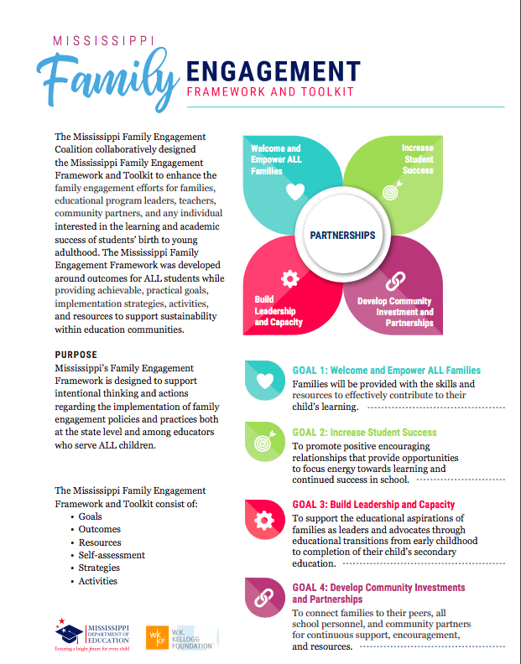

SECTION 7

**MDE Resources**

Accelerating Learning as We Build Back Better: <https://www.forbes.com/sites/lindadarlinghammond/2021/04/05/accelerating-learning-as-we> build-back-better/?sh=314f515e6722

Building Positive Relationships with Young Children: <https://challengingbehavior.cbcs.usf.edu/docs/building-positive-relationships-with-young-children.pdf>

Calming/Self-Managing Resources:

Help us Calm Down: <https://challengingbehavior.cbcs.usf.edu/docs/Calm-Down_Poster_EN.pdf>

Help us Stay Calm: https://challengingbehavior.cbcs.usf.edu/docs/Stay-Calm_Infographic.pdf

Darling-Hammond, L., & Edgerton, A. (2021, April 5). Accelerating Learning as We Build Back Better. Forbes. Retrieved from: <http://forbes.com/sites/lindadarlinghammond/2021/04/05/accelerating-learning-as-we-build-back-better/>

Life is Good Playmakers - The Healing Power of Optimism: https://www.lifeisgood.com/kidsfoundation/playmakers-work.html

Mississippi Department of Education Office of Child Nutrition: <https://www.mdek12.org/OCN>

Mississippi Museum of Natural Science: <https://www.mdwfp.com/museum.aspx>

Mississippi State University Extension Service: <http://extension.msstate.edu/>

Overcoming COVID-19 Learning Loss:

<https://www.edweek.org/leadership/overcoming-covid-19-learning-loss/2020/08>

Rebuilding the Pyramid: Reconnecting After a Break: https://challengingbehavior.cbcs.usf.edu/docs/Rebuilding-the-Pyramid.pdf

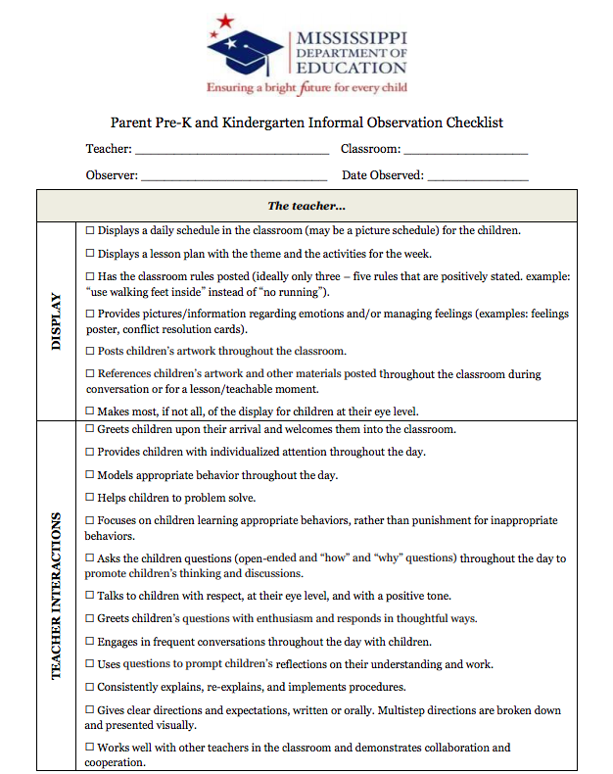

**REFERENCES**

SECTION 8

SECTION 9

Mississippi Department of Education Pre-Kindergarten Guidelines, 2018

Mississippi Secretary of State, Mississippi Codes and Statutes, July 26, 2018

