**A. Contact Information:**

Mrs. Wendy Sierra

East View HS, Rm 110

512-943-1800, ext. 8061

sierrawa@georgetownisd.org

**B. Course Description:**

The purpose of this course is for students to understand how our government was created, how it functions, and encourage them to be active citizens in the communities and nation.

Beyond the required content of this class, my sincere hope is students will take what they learned and apply it their whole adult lives to 1) think critically and make rational decisions as citizens living in a democratic society, and 2) respectfully and productively engage in civil dialogue with those who they disagree with.

**C. Materials Needed Everyday:**

1. Chromebook Fully Charged 3.Pencil / Pens

2. Earbuds w/ Microphone (compatible with Chromebook) 4. Binder -or- Folder

##### D. Grading Policy

Test/Major Projects = 70% Daily Work = 30%  
As a semester class, each quarter is 40% of your grade; semester exam is 20% of your final grade.

**1. Test/Major Projects (70%)**

All test and major projects will be announced at least one week in advance. It is your responsibility to notify me if you are going to be or are absent. Make-up assignments in this category will be done at a mutual convenient time for the student and teacher.

**2. Daily Work (30%)**

This includes all work that is graded that is not a test or major project. Quizzes, homework, class work, etc. will be counted as daily work. All daily work is assigned to strengthen your understanding of the content in order to help prepare you for all tests and projects. All daily work is to be turned-in by the due date (for face to face classes the time shall be the start of the class period, for remote learning the time shall be the posted time on Google Classroom).

**E. Late Work, Make-Up Work, & Failed Test**

**1. Late Work**

Based on GISD guidelines, the following penalties apply to late daily work assignments: -10 on the 1st day; -20 on the 2nd day; -30 on the 3rd day. No credit can be earned after 3 days. However, students will still be expected to grasp the concepts/terms for tests, semester exams regardless of whether they earn credit for those overdue assignments.If you are absent from class for any reason it is your responsibility to both check Google Classroom and see me when you are absent.  **2. Make-Up Work**

Students are expected to complete daily work and major grades within 2 calendar days per absence. For multiple absences, students are expected to contact the teacher for due dates on make-up work. Students shall receive a zero for any assignment or test not made up within the allotted time. Within this framework, the maximum time allowed shall be determined at the discretion of the teacher according to the individual circumstances.

Whenever you are absent from class for any reason it is your responsibility to complete assignments you missed on Google Classroom and make arrangements with me for quizzes and tests you missed. If you know in advance you will be out of class, you are encouraged to make arrangements ahead of time.

**Please Note:**Any assignments and/or tests missed as a result of truancy will be unable to be made-up. Truancy is defined as being absent from class without the parent’s permission -or- absent from school without the principal’s permission.

**3. Failed Test Policy**

Students are allowed to retake unit tests (not a project or final exam) for a maximum score of 70%. Students have 5 days to retake the test from the time it is returned. Retakes will not be given during the regular class time. Retakes are only given during tutorials.

***Students who receive a zero grade resulting from truancy or a violation Academic Integrity shall NOT be eligible for a retest.***

**F. Tardy Policy**

On time, every time. No tardy pass = unexcused. You are an adult.

**G. Electronic Devices:**

Personal electronic devices (i.e. smartphones) are only allowed to be used when permission is given. There are numerous research articles about the detriments of electronic device use in class and how the brain actually works. Likewise, students are expected to focus on their assigned AP Government classwork on their chromebooks, rather than work for other courses or non-school related websites. Students are expected to be fully engaged in AP Government for the 50/90 minutes we are together in class. If this guideline is not followed, it will result in disciplinary action, including a disciplinary referral to the office.

**H. Your Class is a Diverse Learning Community**

Students come from a variety of backgrounds and beliefs, so every student needs to feel secure in expressing their opinion in class, especially on controversial issues. The goal of this class is NOT indoctrination into any political viewpoint, but rather, to explore multiple political philosophies and critically analyze the strengths and limitations of each. To foster that spirit in our class and country, students are expected to share their views civilly, so that no one feels insulted or threatened. While students should freely express their ideas, students will also practice the skill of communicating tactfully; mean spiritedness and personal attacks will NOT be tolerated.

**I. Behavioral Expectations**

* Be civil (mean spiritedness/personal attacks of those with differing views will NOT be tolerated).
* Be considerate of peers and instructors.
* Inquire and work hard.
* Act mature.

**J. Tutorials**

During remote learning, tutorials will be M & W 1:40-2:40

During face to face, tutorials will be every morning from 8:15-8:45. Please note that EVHS policy has changed, so students will be required to have a written pass to go to tutorials this year, and teachers are limited to 4 students per tutorial per day.

**J. Textbook**

United States Government. McGraw Hill Education. (Can be accessed through EVHS ClassLink account.connected.mcgraw-hill.com )

**K. Course Content:**

Because 2020 is an election year, these units will likely be done out of order so students can engage more fully with the November elections.

1. Origins of the American Government (ch 1-2)

2. US Constitution (ch 3)

3. Federalism (ch 4)

4. Branches of Government (ch 5-6, 9, 11, 13-14)

5. Rights (ch 15-16)

6. Political Process (ch 10, 17-20)

**L. EVHS Google Meets Guidelines**

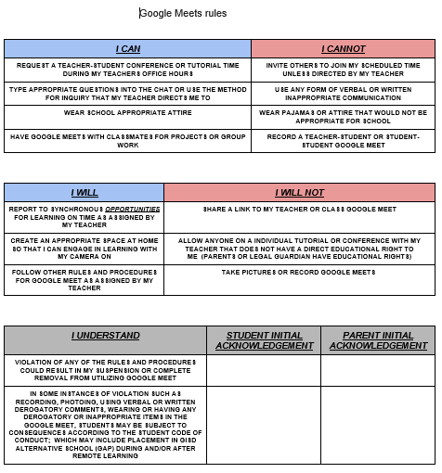

**M.** **Miscellaneous**

Due to the unprecedented nature of the Covid-19 pandemic and upheaval that has brought schools, I reserve the right to update the syllabus as required by GISD policies and/or to respond to changing circumstances. Announcements will be made if any changes are made to the syllabus.