PBIS Virtually:

PAWS Laws at Home

**What is PBIS?**

PBIS stands for School-Wide Positive Behavioral Interventions and Supports. It is a framework that schools use to establish a positive culture. Through clear expectations, acknowledgements, and supports we strive to improve the emotional, behavioral, and academic outcomes for all students. Spalding Drive is a recognized PBIS school, and we will continue to use PBIS virtually. That means that all students are taught the same expectations, they are rewarded for meeting those expectations, and they receive supports when they are unable to mee them. Below you will learn more about PBIS at Spalding Drive.

**Our School-Wide Expectations:**

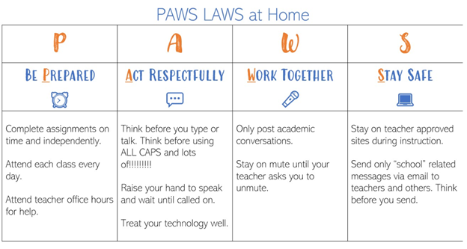

**Acknowledgements & Rewards:**

Our PAWS Laws represent our expectations, and students are rewarded daily for meeting those expectations through our PBIS Rewards App. Parents may use the PBIS APP to check their child’s point total. Both children and parents may view point totals on PBIS Rewards through Classlink as well.

Throughout the year children l have an opportunity to spend their points earned at our virtual school store. Items for sale include:

* Co-Anchor the morning Announcements- 220 pts
* Lunch with Principal – 200 pts
* Lunch with AP – 200 pts
* Principal/AP reads class a story- 150 pts
* Eat lunch with teacher 125 pts
* Teach a lesson – 120 points
* Read a book to a class- 100 pts
* Virtual Show and Tell (a favorite place in your house or item)- 75 pts
* Wear a hat to class -50 pts
* PJ day-50 pts
* Bring your pet or stuffed animal to class- 50 pts
* Choose your virtual background – 30 pts
* Choose a brain break -20 pts

In addition, four times a year, celebrations occur. Students that have achieved the minimum required points for that period will be invited to a virtual celebration. Students who have not earned the celebration never receive consequences for not attending the celebration. Our first celebration will occur October the 9th, and students will need to have earned 100 PBIS points to attend.

**How Can Parents Support PBIS and Online Learning?**

