Steps for Ordering Transcripts Using Naviance

Visit: Fultonschools.org
Select: ClassLink
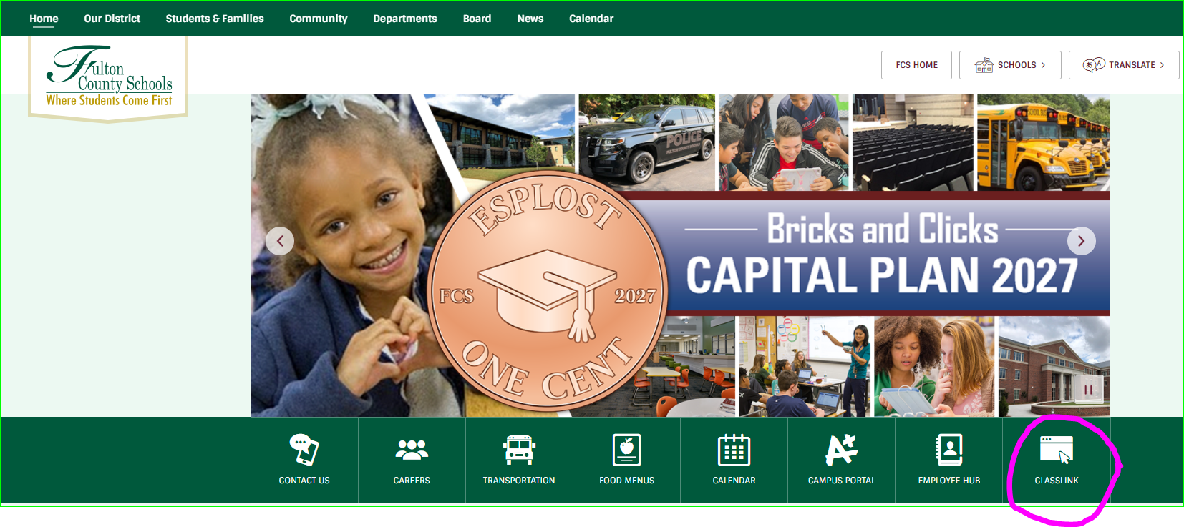

Username: (Student’s ID number)
Password: (Student’s Date of Birth) ext. 01/04/1999 TYPE 01041999
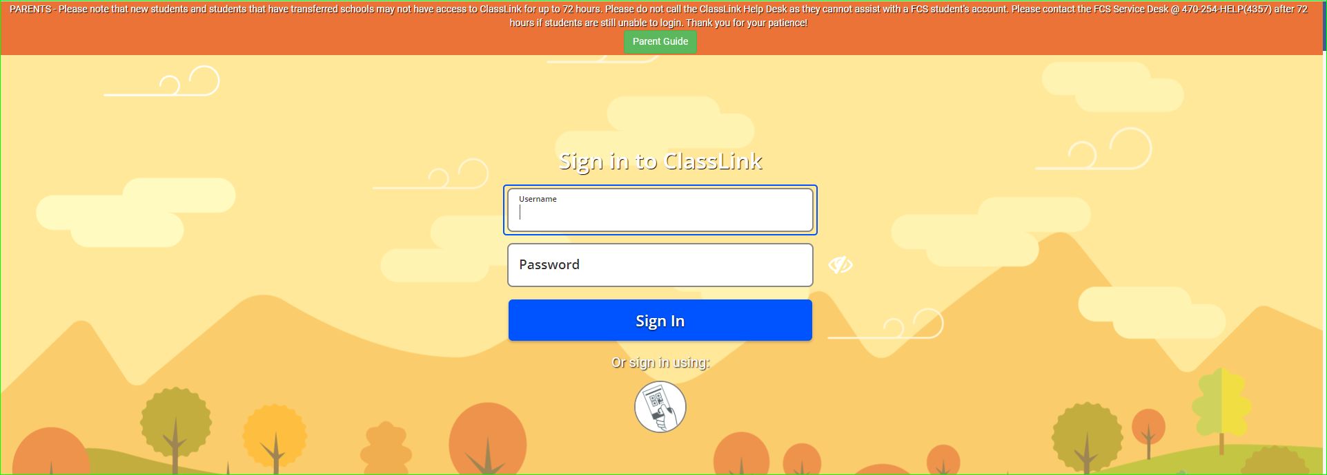
Select Naviance Icon
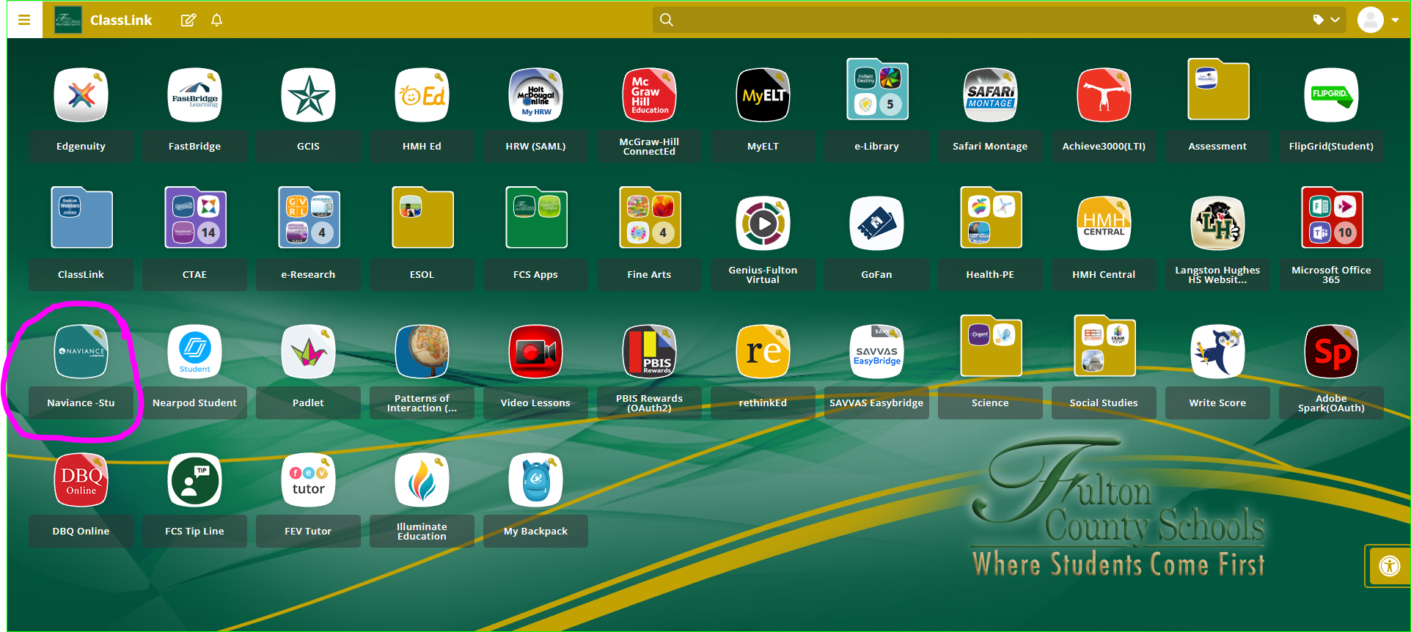

Check Messages: select the Message/Mail Icon
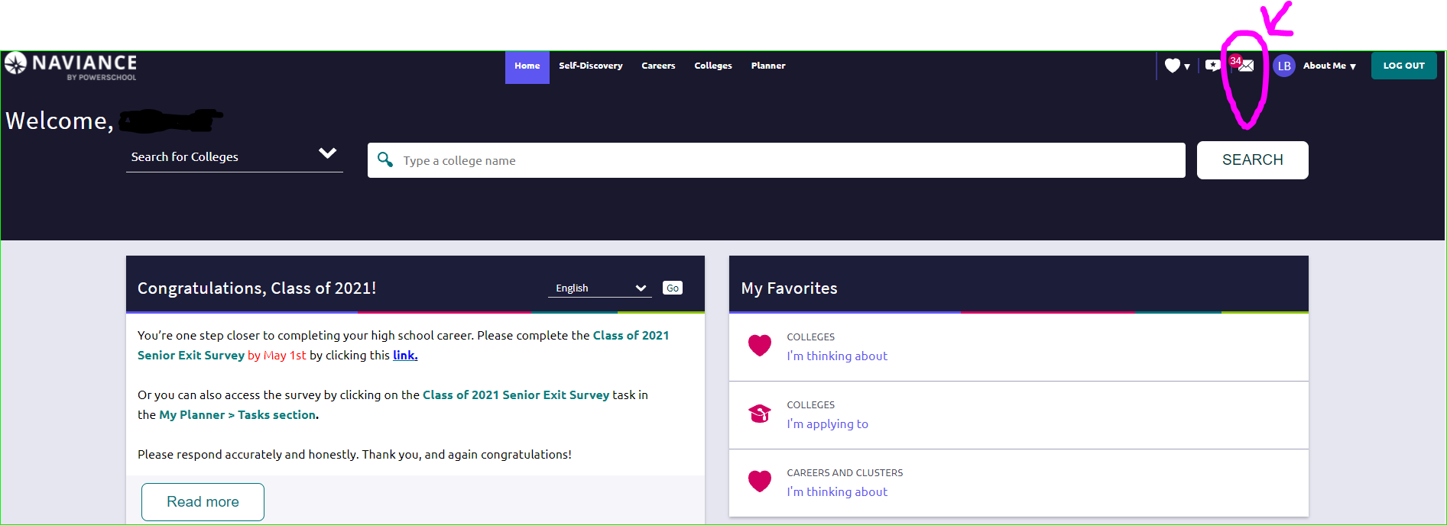

Select “Colleges” and “Colleges I’m Thinking About”
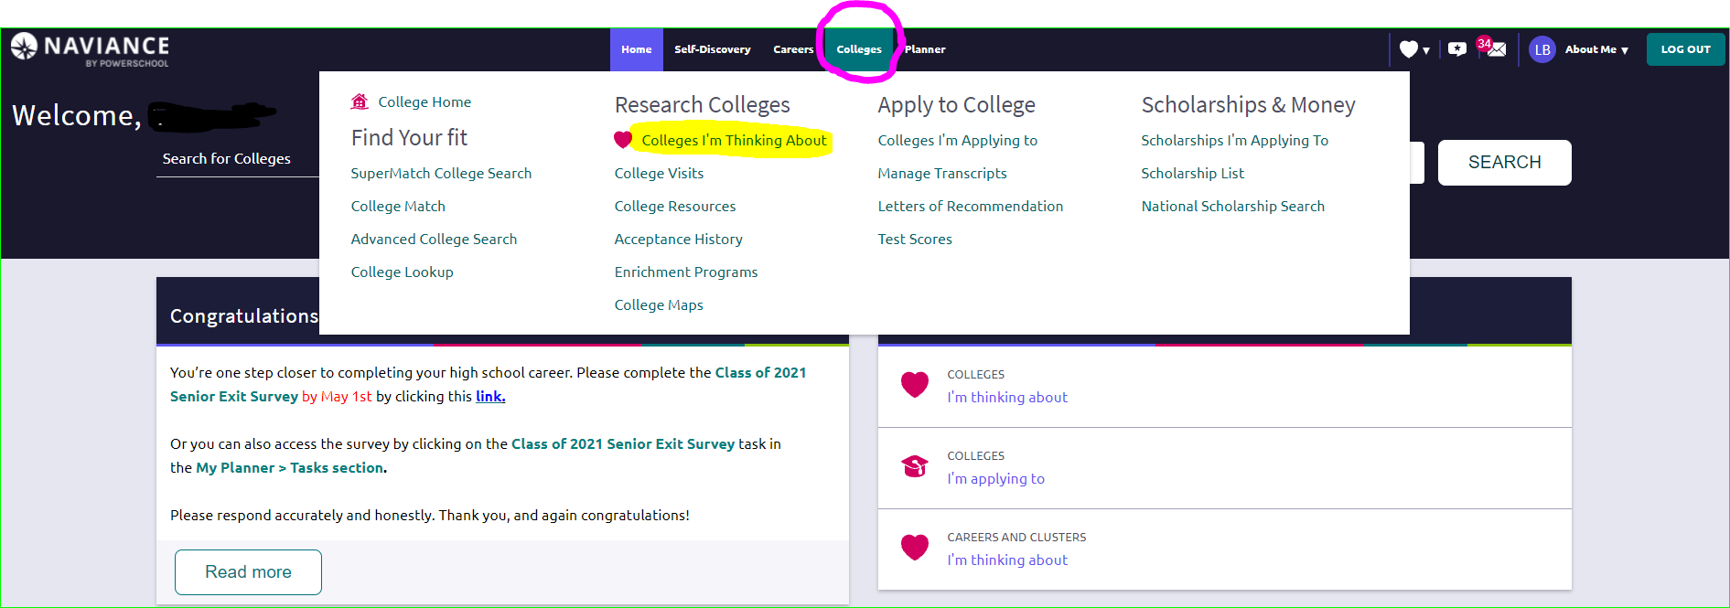

Select “Add Colleges to List”
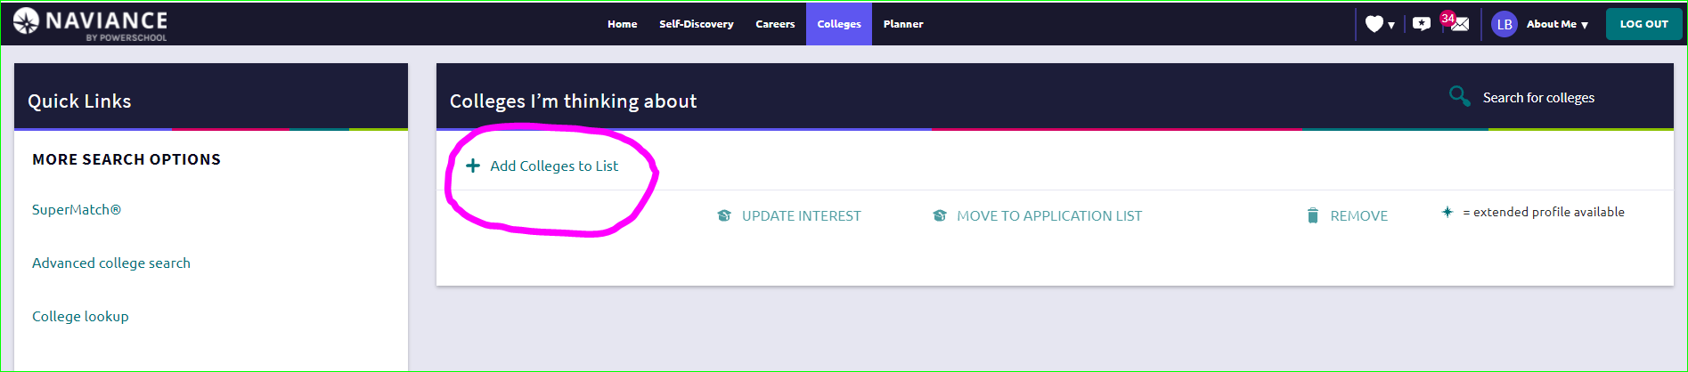

Use “Quicklist” to search for college of choice
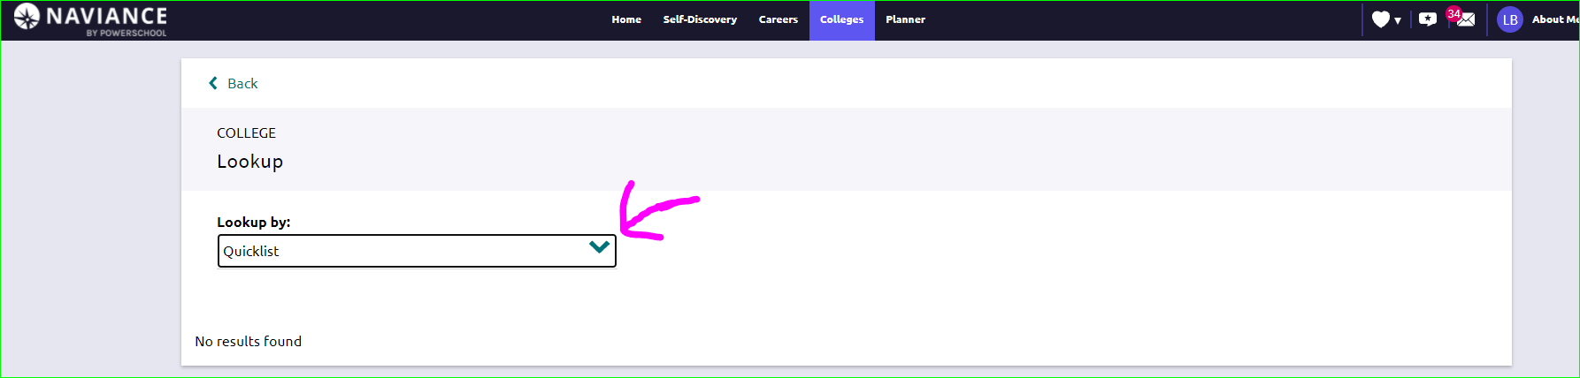

Add the college to your favorites
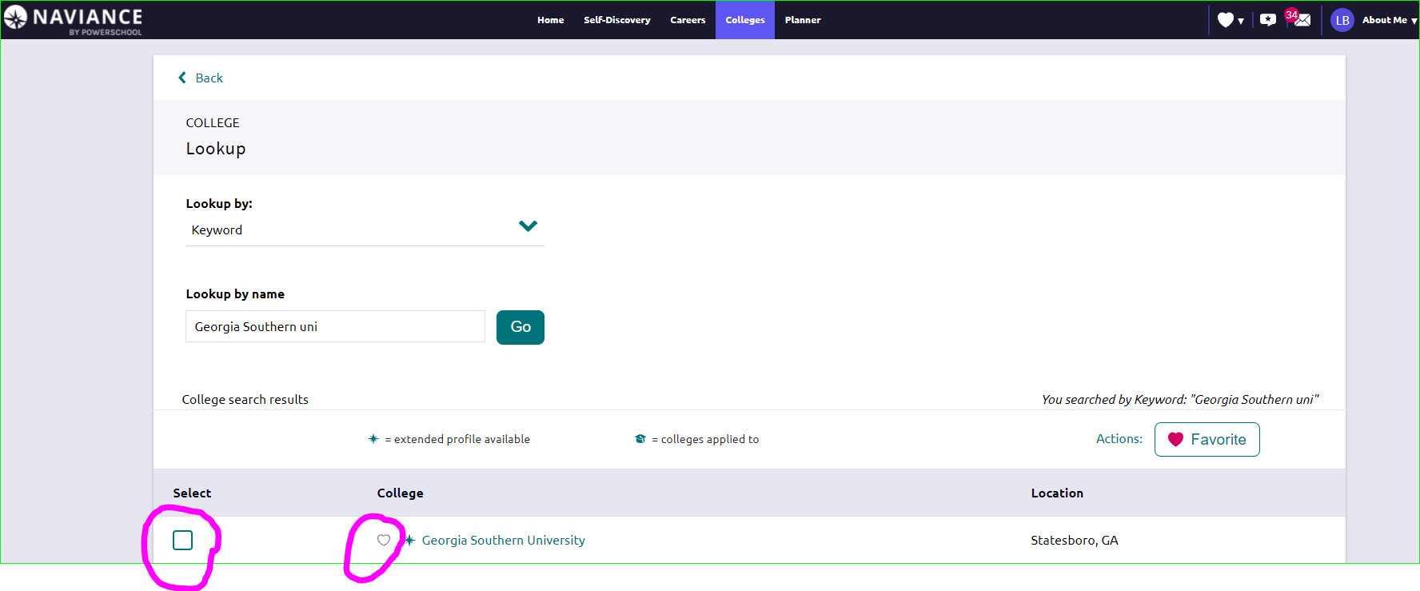
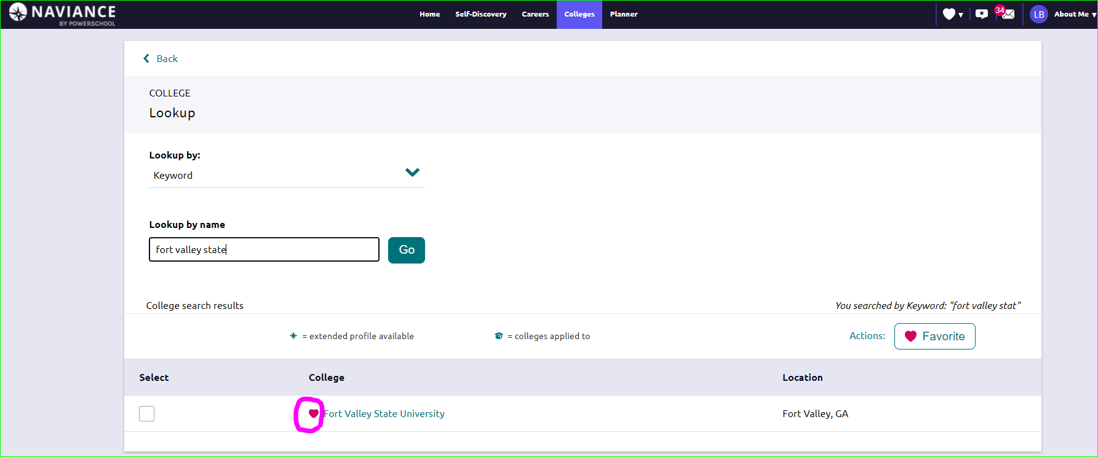

Select “Colleges” and “Colleges I’m Thinking”
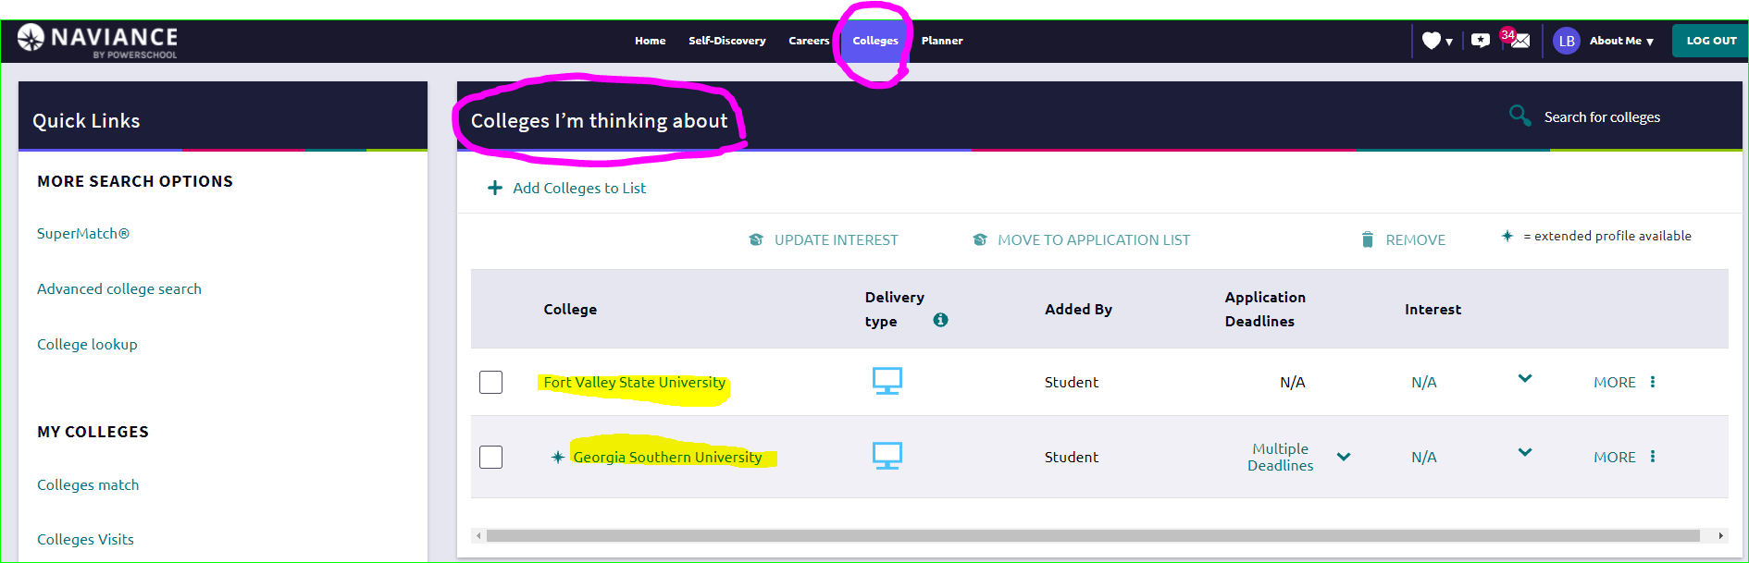
Select all colleges on the list that should receive student’s transcript. It can be multiple.
Select “Move to Application List”
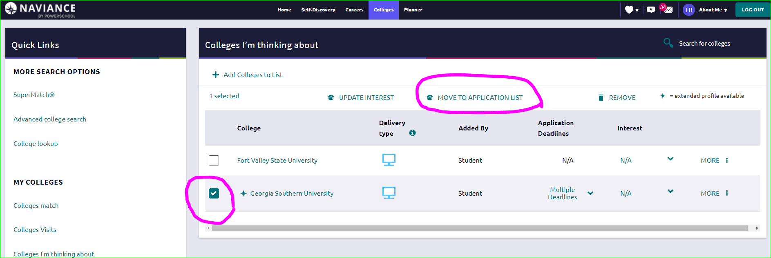

Select application deadline
Select “I’ve already sent my application”
Select “Add and request transcripts”
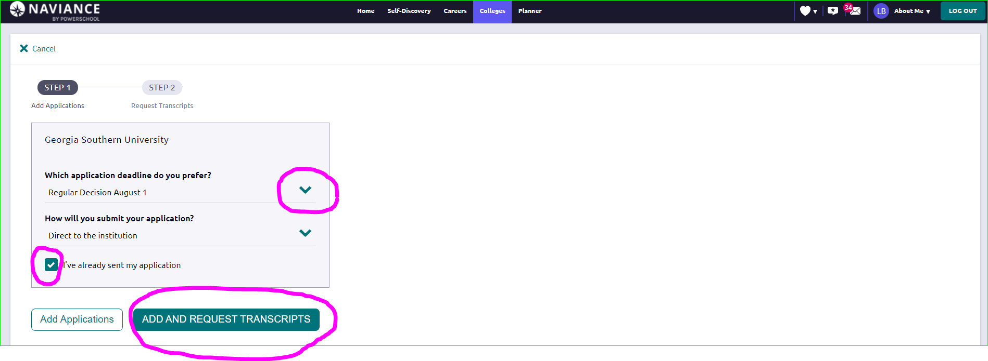

Select type of transcript being requested.
Initial – The first time sending the transcript to the school
Mid-Year – Transcript being sent between January – May (including semester 1 grades of senior year)
Final – Transcript sent after grades from both semesters of senior year have posted (After graduation - May). DO NOT REQUEST FINAL TRANSCRIPT UNTIL MAY OF SENIOR YEAR.
Indicate colleges that should receive the transcript.
Select “Request and Finish”
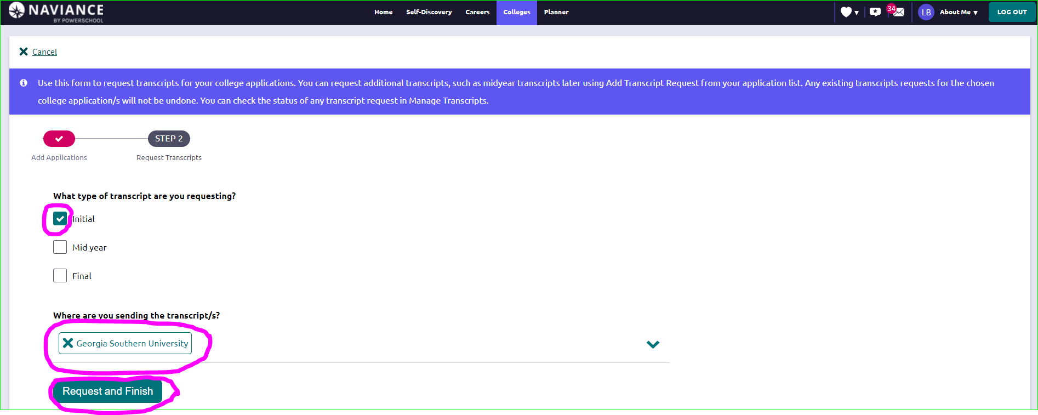

Other Resources:
Counseling Website (Naviance): https://www.fultonschools.org/Page/19036
Video: Requesting College Transcripts: https://www.screencast.com/t/LMtSIif3e1
Video: Common App and Matching Naviance: https://www.screencast.com/t/gxEQkElyo1
Video: Letter of Recommendation Requests: https://www.screencast.com/t/yFlgLhUy
Handout: Building a Resume on Naviance: https://www.fultonschools.org/cms/lib/GA50000114/Centricity/Domain/3667/How%20to%20Build%20a%20Resume%20on%20Naviance.pdf

