Behavior Expectations | Classroom  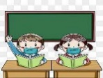 | Restroom  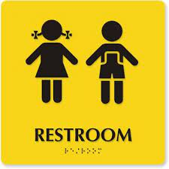 | Cafeteria  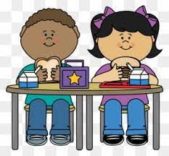 | Hallway  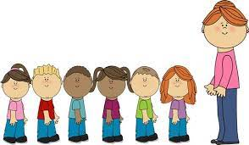 | Recess  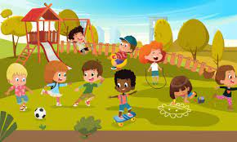 | Buses  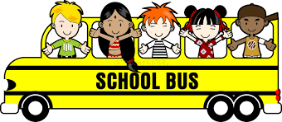 | Gym  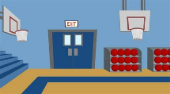
High Expectations | We will:  Try our best and ask for help  Follow classroom rules | We will:  Use the restroom for intended purposes | We will:  Use an inside voice  Walk in the cafeteria | We will:  Walk silently with quiet feet  Walk directly to our destination | We will:  Enter and exit the building quickly and quietly | We will:  Arrive to school and home safely  Use quiet voices | We will:  Try our best  Follow directions
Accept  Responsibility | Follow directions the 1st time  Have all materials ready | Keep our restroom clean  Use soap and water for washing hands | Keep our area clean and throw away our trash | Walk on the black line on the right side in the hallway | Play safely in approved areas  Use equipment properly | Stay seated and face forward  Keep hands and objects inside of the bus | Clean up after ourselves  Use equipment properly
Want to Succeed | Focus and complete all assigned work on time | Use the restroom quickly and quietly | Stay in our seat until dismissed | Listen for directions | Follow directions | Follow the rules on the bus | Follow directions  Try our best
Kindness Matters | Use our kind words and actions | Wait patiently for our turn | Be polite to all staff members  Use table manners while eating our own food | Keep our kind hands and feet to ourselves | Have good sportsmanship | Use appropriate language  Keep our kind hands and feet to ourselves | Use our kind words  Include others
Show Respect | Respect the teacher and other students | Respect other’s privacy and school property | Keep our personal space | Respect the work of others in the classroom and the hallway | Solve conflicts peacefully | Always listen to the bus driver | Listen to the teacher  Respect our equipment
* Report problems to an adult

